FROM THEORY TO PRACTICE ON NUCLEAR SECURITY

(THE EXPERIENCE OF GKTC)
S.S. DRAPEY
Training Center for Physical Protection, Control and Accounting of Nuclear Material,
Institute for Nuclear Research, NAS of Ukraine
Kyiv, Ukraine
Email: sdrapej@mpca.kiev.ua

V.I. GAVRYLIUK
Training Center for Physical Protection, Control and Accounting of Nuclear Material,
Institute for Nuclear Research, NAS of Ukraine
Kyiv, Ukraine
Email: center@mpca.kiev.ua

O.P. ROMANOVA
Training Center for Physical Protection, Control and Accounting of Nuclear Material,
Institute for Nuclear Research, NAS of Ukraine
Kyiv, Ukraine
Email: romanova@mpca.kiev.ua

A.V. HAVRYLIUK-BURAKOVA
Training Center for Physical Protection, Control and Accounting of Nuclear Material,
Institute for Nuclear Research, NAS of Ukraine
Kyiv, Ukraine
Email: romanova@mpca.kiev.ua

Abstract

GKTC is a part of the Ukrainian State System of training, retraining and advanced training of nuclear security specialists. During the years of activity GKTC has prepared and delivered about 300 national nuclear security training courses. More than 4500 Ukrainian specialists of about 90 institutions and organizations have raised their level of skills at these training courses.
In 2012 an Exterior Training Site “Complex of Engineering and Technical Means of Physical Protection System” (ETS) with central and backup alarm stations and training classroom was constructed. ETS is a unique site in Ukraine where both GKTC staff and courses participants can create situations in real time that may occur at the facilities as a result of social and political nature events. ETS is very useful for Ukrainian specialists because such training cannot be conducted at operational nuclear facility without reducing the security level.
In 2018 “NPP with Elements of Physical Protection System” Interactive complex (IC) was created. The use of this IC during the training process will stimulate creative activity and analytical thinking of the courses participants and allow them to acquire the skills they need to perform their duties.

Introduction

Since the early years of its independence Ukraine faced an impending need for training and qualification upgrading of specialists of nuclear power sector, it was considered as one of the key condition of safe operation of nuclear facilities. An important support in this activity was provided to Ukraine by international organizations, as well as governments of different countries. The program for Ukrainian professional staff training in nuclear material physical protection, control and accounting began within the framework of the Agreement dated 18 December 1993 between the State Nuclear and Radiation Safety Committee of Ukraine and the US Department of Defense that governed the development of national physical protection and nuclear material control and accounting system aimed to ensure non-proliferation of nuclear weapons from Ukraine. This Agreement is the “implementing” to the Treaty between Ukraine and the United States on assistance to Ukraine in elimination of strategic nuclear arms and non-proliferation of nuclear weapons of mass destruction dated 25 October 1993. Training on physical protection, control and accounting of nuclear material of Ukrainian specialists was started by lecturers and instructors of National Laboratories of the US Department of Energy and was supported with funding provided by the US Government. Mr. George Kuzmycz personally, an expert of the United States Department of Energy (DOE), who had been seconded to Ukraine as the authorized DOE representative for implementation of the Agreement between the State Committee for Nuclear and Radiation Safety of Ukraine and the US Department of Defense had made important contribution to the Ukrainian training capacity building between 1994 and up to his tragic death in December 1997.
In an effort to regulate the organization and implementation of training programs for Ukrainian specialists on physical protection, control and accounting of nuclear material the Cabinet of Ministers of Ukraine by its Decree No. 488-Р of 3 September, 1997 commissioned the Institute for Nuclear Research, National Academy of Sciences of Ukraine (KINR) to organize and deliver training and qualification upgrading on control and accounting of nuclear materials, physical protection of nuclear facilities and nuclear material; and to use international aid to build training capacity on physical protection of nuclear facilities and nuclear material, and control and accounting of nuclear material in Ukraine.
To realize the established tasks KINR with the assistance of the Ministry for Environment Protection of Ukraine and supported with financial and technical assistance of US DOE established the Training Center for Physical Protection, Control and Accounting of Nuclear Material named after George Kuzmycz (GKTC) that was accommodated in one of the KINR buildings.
GKTC was officially opened on October 8, 1998.

- GKTC TRAINING ACTIVITY AREAS

GKTC training activity is based on the Systematic Approach to Training. Aiming to ensure maximum satisfaction of needs in support and upgrade qualification of Ukrainian nuclear security specialists GKTC fulfill needs analysis and training plans and programs of GKTC that are periodically revised.
Major areas of GKTC training activity include:
- Support and upgrading of qualification of specialists on nuclear facilities and nuclear material physical protection.
- Support and upgrading of qualification of specialists on physical protection of the objects intended for management of radioactive waste or sources of ionizing radiation.
- Support and upgrading of qualification of officers of National guard units at nuclear facilities, officers of National Police and personnel of the Anti-Terrorist Center under Security Service of Ukraine (ATC SSU).
First years training at GKTC was delivered primarily by lecturers and instructors from US DOE National Laboratories; Ukrainian lecturers and instructors were also involved in programs aimed to capacity building of Ukrainian specialists. At that time GKTC policy was to obtain training materials from US tutors and to use their support in knowledge and skills transfer to Ukrainian specialists, as well as to find potential lecturers and instructors between Ukrainian students. Thus GKTC accumulated the necessary volume of training materials and form core staff of lecturers and instructors consisted of representatives of National Academy of Sciences of Ukraine, State Nuclear Regulatory Inspectorate of Ukraine, National Guard of Ukraine, Ministry of Energy and the Environment of Ukraine, Ministry of Interior of Ukraine, Security Service of Ukraine, National Nuclear Energy Generating Company ENERGOATOM, as well as other organizations and institutions.
Between 1998 and 2014, GKTC has operated under financial and methodology support of the US Department of Energy.
Effective 2015, GKTC has been working in the Global Nuclear Security Programme of the US Defence Threat Reduction Agency. Throughout 2016 – 2019, GKTC has developed subject-matter programs and training materials for 32 courses including 24 for personnel of the Guard units of National Guard of Ukraine (NGU), 3 for personnel of ATC SSU, 2 for the National Police, as well as 3 programs and training guides for State Enterprise “Ukrainian State Association “Radon” (Radon).

- GKTC OBJECTIVES

Initially, GKTC pursued the following objectives:
- to implement systematic approach to organization of specialists training and qualification upgrading on nuclear security;
- to develop training curricula and programs to support and upgrade qualification of specialists on nuclear material physical protection, control and accounting, on nuclear security culture and computer security;
- to develop training materials (training course plans, manuals, practical training guides, visual training aids);
- to develop draft regulatory and legal acts on PP, MC&A, nuclear security culture;
- to provide an advisory support in nuclear material physical protection, control and accounting to organizations and individual experts involved in nuclear security;
- to organize working meetings to assess sufficiency and effectiveness of current regulatory documents on nuclear material physical protection, control and accounting, involving representatives of the state regulatory and control agencies, public authorities and experts in physical protection, control and accounting of nuclear material;
- to propagate an experience in physical protection of nuclear facilities and nuclear material, and control and accounting of nuclear material towards activities involving protection of other hazardous objects.
When implementing its goals GKTC cooperates with State Nuclear Regulatory Inspectorate of Ukraine, Ministry of Energy and the Environment of Ukraine, the State Emergency Service of Ukraine, State Agency of Ukraine on Exclusion Zone Management, National Academy of Sciences, Main Headquarters of the National Guard of Ukraine, Security Service of Ukraine, National Police of Ukraine, operating organizations and licensees, and leading Ukrainian experts on MPC&A.
After conducting a lot of courses in the theoretical direction, GKTC sets itself the task of introducing more practical classes into its training courses. Developed and implemented courses consist of 30-80% of theoretical material and 70-20% of practical exercises according to the course topic.
GKTC has developed and conducts courses on the following area:
Physical Protection:
Topics of the courses on physical protection for nuclear facilities personnel
- Physical Protection as an Element of the National Security (Course duration is 20 hours)
- Fundamentals of PP of Nuclear Facilities and Nuclear Materials (Course duration is 36 hours)
- Fundamentals of Physical Protection of RAW and SIRs (Course duration is 36 hours)
- Introduction to Physical Protection for Pro Forces (Course duration is 36 hours)
- Introduction to Physical Protection Systems Design (Course duration is 36 hours)
- Analysis and Modeling of Physical Protection Systems (Course duration is 36 hours)
- Physical Protection Systems Performance Testing (Course duration is 36 hours)
- Vulnerability Assessment Methodology (Course duration is 36 hours)
- Physical Protection Procedures (Course duration is 36 hours)
- Management of Engineering and Technical Means of PP System (Course duration is 36 hours)
- Security Transportation (Course duration is 36 hours)
- Vital Area Identification (Course duration is 36 hours)
- Physical Protection System Management (Course duration is 72 hours)
- Ensuring of Continuous Functioning of Effective Physical Protection System (Course duration is 36 hours)
- Physical Protection for Instructors on PP from NPP Training Centers (Course duration is 36 hours)
- CAS: Destination, its Operators, Functions (Course duration is 144 hours)
Topic of the course on physical protection for personnel of NGU
- Physical Protection System Guard Unit Functions (Course duration is 36 hours)
- Ukrainian Legislation on Physical Protection and Military Guarding (Course duration is 24/40 hours)
- The Insider Threat (Course duration is 12/40 hours)
- Introduction to Physical Protection (Course duration is 40 hours)
- Role and Tasks of Guard Unit Within the Physical Protection System of NPP (Course duration is 40 hours)
- Guards in Physical Protection System During Transportation of NМ (Course duration is 40 hours)
- Physical Protection Procedures (Course duration is 40 hours)
- Engineering and Technical Means of Physical Protection System Performance Testing (Course duration is 40 hours)
- Operation of Engineering and Technical Means of PPS by the Guard Unit (Course duration is 40 hours)
- Theoretical Aspects of Computer Security (Course duration is 40 hours)
- Practical Aspects of Computer Security (Course duration is 40 hours)
- Psychological Aspects of Performance of Duty by Guard Unit Personnel (Course duration is 40 hours)
- Response to and Mitigation of Radiation Incidents (Course duration is 40 hours)
Topic of the course on physical protection for personnel of Radon
- Transportation Security (Course duration is 40 hours)
- Fundamentals to Physical Protection (Course duration is 40 hours)
- Nuclear Security Culture (Course duration is 24 hours)
Topic of the course on physical protection for personnel of National Police
- Introduction to physical protection (Course duration is 36 hours)
- Role in Anti-Sabotage Cooperation Plan (Course duration is 36 hours)
- Means of access control to NM. Means of intrusion detection (Course duration is 36 hours)
Topic of the course on physical protection for personnel of ATC SBU
- Introduction to Physical Protection (Course duration is 24 hours)
- Vulnerability Assessment (Course duration is 36 hours)
- Transportation Security (Course duration is 32 hours)
Courses for Nuclear Material Control and Accounting Experts of Operators:
- Ukrainian legislation on control and accounting of nuclear material (Course duration is 36 hours)
- Fundamental Course on Control and Accounting of Nuclear Material (Course duration is 36 hours)
- State System for Control and Accounting of Nuclear Material (SSAC). System for Nuclear Material Control and Accounting within and outside Nuclear Facilities (Course duration is 36 hours)
- Nuclear Material Control and Accounting Computer Aided Systems (Course duration is 36 hours)
- Methods for Nuclear and Radioactive Material Safe Handling, Detection, and Measurement (Course duration is 36 hours)
- Nuclear Material Non-Destructive Analysis: Gamma-Spectrometric and Neutron Methods (Course duration is 36 hours)
- Devices for Nuclear Material Access Control and Intrusion Detection Equipment (Course duration is 36 hours)
- Nuclear Material Physical Inventory (Course duration is 36 hours)
For most practical courses, there are conditions for primary training or participation in a previous course. Sometimes, to attend a practical course, participants must listen to two or more pre-training courses.

- GKTC infrastructure and training facilities

To conduct practical training GKTC has a developed infrastructure that was developed with the financial and methodological support of the Department of Energy US, DTRA, methodological support of other international organizations and support of the Ukrainian government.

GKTC is located on the ground floor of the KINR central building and has in its possession lecture rooms and laboratory classes outfitted to the latest academic standard.
Computer classroom consisting of15 workstations is designed to develop students’ skills on work with software used for nuclear material physical protection, control and accounting issues, for example:
- to analyze the effectiveness of the physical protection system and determine the capability of detecting and neutralization of violators, such programs as EASI and SAVI are installed and used;
- for practical tasks to control and account nuclear material a special program package AIMAS is installed.
Also computer classroom uses for entering students’ knowledge testing and final testing of students’ knowledge obtained during the training.
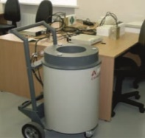
GKTC has laboratory for non-destructive analysis of nuclear material on the territory of KINR research reactor. Laboratory has neutron analysis class consisting of three workplaces designed for 9 participants, gamma analysis class with 5 workplaces designed for 15 participants and a results discussion room.
Neutron analysis class equipment includes:
- neutron detection systems for practical classes on neutron non-destructive methods of nuclear material analysis;
- active counter of neutrons and neutron-neutron coincidences to measure Uranium-235 mass;
- passive counter of neutrons and neutron-neutron coincidences to measure Plutonium-239 mass.
Gamma-ray analysis class equipment includes:
- gamma spectrometers with NaI and HPGe detectors used in practical classes on non-destructive gamma-ray methods of nuclear material analysis;
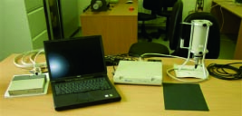
- portable spectrometer for practical classes on non-destructive analysis of nuclear materials and radioactive sources;
- portable radiation detectors (for both gamma and beta radiation) used in practical classes on nuclear material and radioactive source control methods.

  - Radiation control laboratory

A lot of training courses have topic on the issues of radiation safety for different categories of participants who have the different experience of working in dangerous radiation conditions.
To train participants using personal dosimetry devices and mobile portable spectrometric devices, we created a laboratory for dosimetry monitoring and protective means against ionizing radiation (Radiation control laboratory).
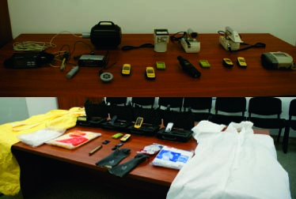
This Laboratory includes:
- TerraM personal dosimeters;
- TLD dosimeters;
- DKS-02PN CADMIUM search dosimeters;
- MKS-11GN Spektra survey meters;
- Virtuoso radiation survey system for food, soil, construction materials etc.;
- Inspector 1000 digital portable radioisotope identification device with scintillation detector for professional spectrometry;
- MKS-AT1117M ATOMTEX survey meter with external detector probes;
- Polimaster MKS-RM1401K survey meter;
- DRBP-03 survey meter;
- Whole-body protection suites;
- Personal protective equipment (shoe covers, gloves, respiratory protection masks, hats);
- Set of calibration sources;
- Laboratory equipment (containers, tongues etc.)

“NPP with Elements of Physical Protection System” Interactive complex

To design new or upgrade old physical protection systems, as well as to determine the vulnerability of physical protection systems, a 3D model of a hypothetical nuclear facility “NPP with Elements of Physical Protection System” Interactive complex was created (see fig.1). Now it has no analogues in the world.
IC includes the following components:
• NPP mock-up with physical protection elements;
• associated software and hardware suite.
IC is used to design a system of NPP physical protection and defense. A unique hardware and software complex is designed to scan PPS elements, process the received information and determine the effectiveness of hypothetical systems offered by trainees or design organizations. After processing the received information, the program carries out 3D overcoming and generates projection systems in the numerical and 3D views of the result.
IC serves as a tool to enhance efficiency of physical protection training targeted at National Guard personnel and physical protection specialists based on application of advanced technologies in the training process. IC based training stimulates creative activity, analytical thinking and provides knowledge and skills the students need to perform their physical protection functions.

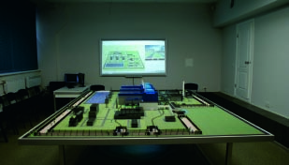
FIG. 1. NPP with Elements of Physical Protection System” Interactive complex.

Exterior Training Site “Complex of Engineering and Technical Means of Physical Protection System”

ETS imitating physical protection system of facilities was built on the KINR territory in order to improve GKTC capabilities in nuclear security personnel training. ETS has unique complex of engineering and technical means of physical protection system(see fig.2).
ETS is designed for:
• advanced training of senior managers of nuclear facilities and radioactive waste handling sites in order to facilitate with modern engineering and technical means which are used in physical protection systems;
• advanced training of physical protection staff and guard units personnel on operating control and technical maintenance of physical protection systems during normal operation, in case of emergency and contingency situations at the facility;
• carrying out field exercises for relevant personnel of anti-terrorist entities in order to perfect their actions during executing anti-terrorist operations;
• testing of technical means for compliance with the requirements of legislation before the decision on their utilization in the specific physical protection system is made.
ETS is unique site in Ukraine where GKTC staff and the courses participants can create in real time situations that may occur at the facilities as a result of social and political nature events. It is clear that such training cannot be hold at functioning nuclear facility without reducing the level of security.
This means that the major objective of GKTC is to ensure effective training of NS personnel to develop the skills and experience sufficient for the operating equipment deployed in a Physical protection system, to conduct performance testing of such equipment, to carry out vulnerability assessment, as well as to train Physical protection and Pro-force personnel on operations during abnormal and emergency situations.
Two year ago Exterior training site and other GKTC’s facilities were used for conducting “Performance Testing for Performance Assurance” training course for representatives of the National Guard of the Republic of Kazakhstan. There were involved instructors from the USA and Ukraine.

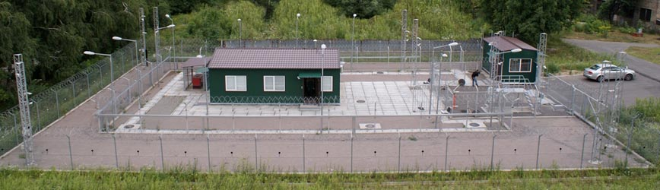
FIG. 2 Complex of Engineering and Technical Means of Physical Protection System.

GKTC is a permanent organizer of annual Ukrainian MPC&A Conferences

Since 2003 GKTC organizes and holds Ukrainian Conferences on Physical Protection, Control and Accounting of Nuclear Material. These Conferences are the sole forum for experts in nuclear security from ministries, institutions, nuclear facilities and other radiation-hazardous objects of Ukraine.
Annual Conferences on Physical Protection, Control and Accounting of Nuclear Material contribute to fulfillment by Ukraine of international treaties and of its commitments and they make an important contribution into national security assurance.
The purpose of these Conferences is to facilitate interaction among Ukrainian professionals in the field of nuclear security and Ukrainian regulatory bodies to enhance their communication and to strengthen their collaboration in order to promote and advance the nuclear security and nuclear security culture in Ukraine. Additionally, specialists from other countries participate and take valuable information back to share with colleagues in their countries.
In September 2019 the 16th Ukrainian Conference on Physical Protection, Control and Accounting of Nuclear Material was conducted at city Lviv under sponsor support by the Swedish Radiation Safety Authority and Norwegian Radiation Protection Authority (see fig.3).
The 16th Conference contributed to the exchange of experience and knowledge among experts on physical protection, control and accounting of nuclear material in terms of:
- Physical protection issues;
- Issues of concern of the State System of Control and Accounting of Nuclear Material;
- Staffing of the physical protection, control and accounting of nuclear material;
- Nuclear security culture. Evaluation of the nuclear security conditions;
- Interaction of nuclear safety and nuclear security;
- Improvement of the interaction mechanism for participants of the objective interaction plan, of the regional and State interaction plans;
- Gender issue (impact of gender stereotypes) in nuclear security activities;
- Cyber security in the nuclear security area;
- The architecture (structure) of detection of nuclear materials in illicit trafficking and response for such events. Nuclear forensics;
- Improvement of the legal framework on physical protection, control and accounting of nuclear material.
Participants of the Conferences were experts from the State Nuclear Regulatory Inspectorate of Ukraine, Ministry of Energy and Coal Industry of Ukraine, SE NNEGC “Energoatom”, Nuclear Power Plants, National Guard of Ukraine, National Academy of Sciences of Ukraine, State Border Guard Service of Ukraine, National Police of Ukraine, Ministry of Interior of Ukraine, Ministry of Education and Science of Ukraine, Ministry of Health of Ukraine, Anti-Terrorist Center of the Security Service of Ukraine, State Agency of Ukraine on Exclusion Zone Management, State enterprise “East mining-processing combine”, Kyiv Research and Design Institute “Energoproject”, and representatives from international organizations and institutions.
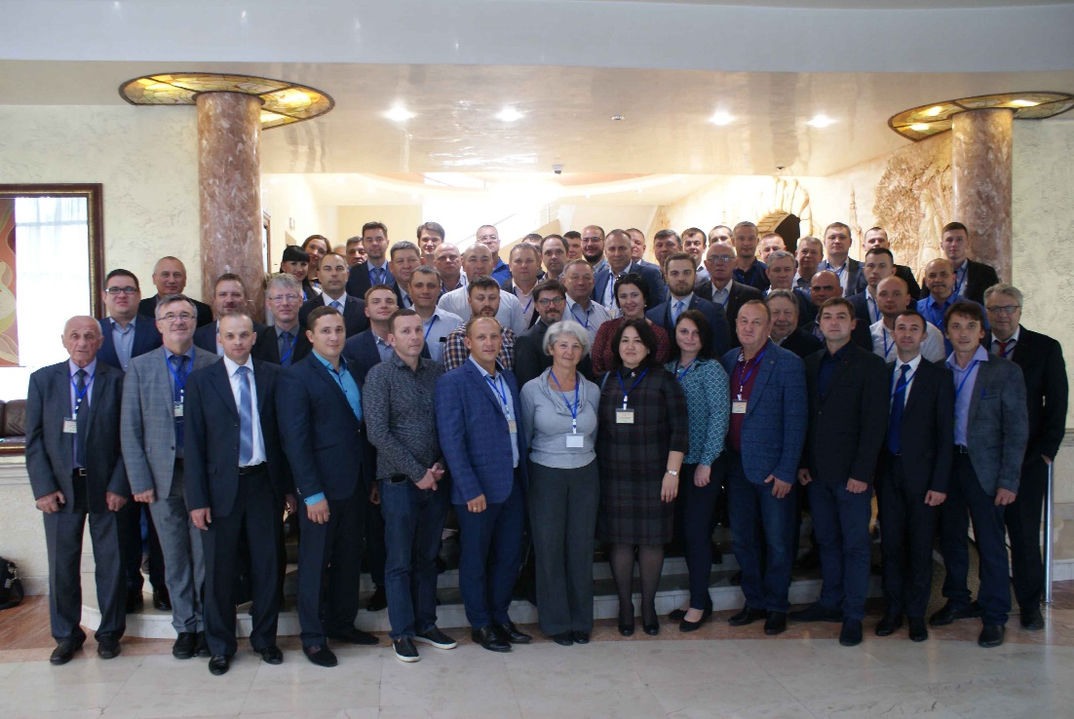
FIG. 3 Participants of the 16th Ukrainian Conference on Physical Protection, Control and Accounting of Nuclear Material
In September 2020 the 17th Ukrainian Conference on Physical Protection, Control and Accounting of Nuclear Material will be held on the base of Rivne nuclear power plant.
The following issues will be considered:
- Organization and implementation of physical protection during the movement and transportation of spent nuclear fuel, high-level waste, sources of ionizing radiation of the I-III categories;
- Improvement of the interaction mechanism for participants of the objective interaction plan, of the regional and State interaction plans;
- Improvement of the legal framework on physical protection (NM, NF, RAW, SIRs), control and accounting of nuclear material;
- Management of risks in the area of nuclear security;
- Current problems of control and accounting of RAW and SIRs;
- Gender issue (impact of gender stereotypes) in nuclear security activities;
- Problems of providing mental health for the physical protection personnel, personnel of guard units;
- Ways to ensure the qualification of specialists in the field of physical protection, control and accounting of NM, the guard units’ personnel in accordance with the requirements of the legislation, individual threats and challenges to nuclear security;
- Cyber security in the nuclear security area;
- The architecture (structure) of detection of nuclear materials in illicit trafficking and response for such events. Nuclear forensics;
- Physical protection of NF at the stage of the “decommissioning” life cycle (Chornobyl NPP experience);
- Issues of concern of the State guarantee system;
- Training of personnel of units of National Guard of Ukraine, which provides NF and NM guarding;
- Interaction of units of the National Police of Ukraine with subjects of physical protection, control and accounting of nuclear and radioactive materials;
- Status of implementation and operation of complexes of engineering and technical means of PP systems of NF in accordance with the requirements of the legislation;
- Interaction of nuclear safety and nuclear security.
Conduction of such Conferences is an important activity for establishing interaction and information exchange among experts of physical protection of radioactive materials and related facilities, for control and accounting of nuclear material of operating companies, central executive authorities that implement state regulation and management, Security Service of Ukraine, National Guard of Ukraine, State Border Guard Service of Ukraine, National Police of Ukraine, Ministry of Interior of Ukraine, and educational institutions of Ukraine.
The Conference contributes to improvement of the interaction among the physical protection system subjects, nuclear facility and radiation-hazardous objects’ operators regarding prevention and revealing of attempts of sabotage, nuclear terrorist acts and other malicious actions against radioactive materials and related facilities.

GKTC basic training principles

Having experience in training and a good technical base, during the training process GKTC bases on a system of effective training principles, such as:
- consciousness and activity;
- visibility;
- systematic and consistent;
- strength;
- accessibility;
- the connection between theory and practice.

The principle of consciousness and activity
The implementation of this principle is carried out by observing the following rules in the training:
- Understanding the goals and objectives of tasks - a clear presentation of such tasks, explanations of importance and significance.
- It is trained so that student understands what, why, and how to do it, and never mechanically perform any training actions without realizing them.
- We logically link something new in GKTC with the known.
- We put students in situations that require them to identify and explain the discrepancies between theoretical calculations and practical realizations of situations.
- Whenever possible, we learn to find and distinguish between the main and the secondary in the studied, to highlight the main, seek first of all to understand and master the main.

The principle of visibility
In training, the practice of visualization is often used. Consider some which are used in GKTC:
- Memorization of objects represented in kind (in pictures or models) is better, easier and faster than memorization of the same objects presented in verbal, verbal or written form.
- Student abstraction is understood more easily when it is supported by concrete facts, examples and images; to reveal them, we use various types of visibility.
- We use visibility not only for illustration, but also as an independent source of knowledge for creating problem situations.

The principle of systematic and consistent
In our activities, the principle of systematic and consistent training is implemented by observing many training rules, important among which are the following:
- We use schemes, plans to ensure that students learn the knowledge system. We divide the content of the educational material into logically completed parts, implement them sequentially and teach students to do this.
- In preparing the courses, we use a proven scheme for the formation of theoretical knowledge: a) we establish the object and subject; b) present the foundations of the theory; c) disclose the tools of the theory; d) explain the consequences of the theory; d) show the limits of the application of this theory.
- We often repeat the previously learned to ensure systematic and consistent training.
- Do not forget that understanding the system requires logic, and its formation - emotions. We train energetically, with a lift, we use vivid facts from life.
- At the end of the training, generalization and systematization must be conducted.
- We recognize that the formed system of knowledge is the most important means of preventing their forgetting. Forgotten knowledge is quickly restored in the system, without it - with great difficulty.
- All our courses are presented in an inextricable sequence, so that everything today consolidates yesterday and paves the way for tomorrow.

The principle of strength
The process of solid learning is very complex. A number of studies have shown, for example, that in many cases involuntary memorization is even more productive than voluntary. A modern understanding of the mechanisms of educational activity, leading to a solid assimilation of knowledge, allows you to add to the traditional and some new learning rules:
- We believe that in modern learning, thinking dominates memory.
- We prevent the memory of the wrongly perceived or that the listener did not understand. The student should remember well meaningful.
- The material requiring memorization is represented by short rows: what we carry in our memory should not have vast dimensions.
- We do not begin to study the new without first forming the two most important qualities: interest and a positive attitude towards it.
- We rely on the fact established by science: an important form of strengthening knowledge is their independent repetition by students. Therefore, we widely and often use mutual learning processes.
- We always follow the logic of learning, for the strength of knowledge, logically linked together, always exceeds the strength of assimilation of disparate, little interconnected knowledge.

The principle of accessibility
The principle of accessibility is based on the law of the thesaurus: only that which is available to a person is consistent with his thesaurus. The Latin word thesaurus means "treasure." In a figurative sense, this refers to the volume of knowledge, skills and ways of thinking accumulated by a person.
We use the classic rule of the principle of accessibility: from easy to difficult, from known to unknown, from simple to complex:
- Teaching, we proceed from the level of preparedness and development of students. We teach, based on their capabilities. We study and take into account the students' life experience, their interests, and developmental features.
- Our training is always in a state of tension. When she is absent, listeners are weaned to work at full strength. The pace of learning is practically regulated by the students themselves. For accessibility, we widely use analogy, comparison, juxtaposition, opposition.
- We make it easier for students to learn concepts by comparing them with opposing or contradicting them.
- We introduce new concepts as a logical consequence of the cognitive task.
- We don’t respond to a fleeting glimpse of thought, but we feed on using it as the beginning of knowledge.
- At the first stages of training, we study not the entire volume of knowledge, but only the main thing, so that the students thoroughly grasp the main thing, then, when consolidating, we introduce new examples, facts that clarify the studied.
- In our courses, accessibility does not mean ease of learning, and the teacher’s function is not to infinitely facilitate the work of students in self-acquisition, comprehension and assimilation of knowledge: to help, direct, obscure the incomprehensible through the intelligible, give the tip of the thread for independent analysis.

The principle of the connection between theory and practice
This principle is based on many psychological principles that play the role of natural principles:
- The quality of training is checked, confirmed and guided by practice;
- Practice – a criterion of truth, a source of cognitive activity and an area of ​​application of learning outcomes;
- The more knowledge acquired by students in their key moments interacts with life, applied in practice, the higher the consciousness of learning and interest in it.

The practical implementation of the principle is a series of rules:

- When teaching, go from life to knowledge or from knowledge to life: the connection “knowledge - life” is necessary.
- We teach students to test and apply their knowledge in practice.
- In our educational process, we harmoniously connected mental activity with practical activity, in the process of which 80-85% of knowledge is acquired.
- Encourage students to work independently to acquire knowledge; using the connection of learning with life as an incentive for self-education.
- We develop, consolidate and transfer the success of the listener from one type of activity to another: from episodic success to high permanent achievements.

SUMMARY

Any training that is not secured by a sufficient amount of practice is ineffective. But for effective practical training, just desire is not enough, sufficient material and technical base is needed.
Having the material and technical base, this is also just a pile of iron without having specialists for setting up, repair and training.
GKTC has everything that is necessary for the proper training of students at the highest level.
GKTC has highly qualified personnel, high-tech technical base and training facilities.
During the process of the courses formation GKTC uses the latest techniques and technologies, and most importantly, GKTC has the support of domestic and foreign colleagues and organizations.

