Review the Assessment Methodologies for Nuclear Security for Research Reactors and Associated Facilities (RRAF)
S. ADU
Nuclear Regulatory Authority, Ghana
s.adu@gnra.org.gh

P.K. GYEKYE
Nuclear Regulatory Authority, Ghana
p.gyekye@gnra.org.gh

A. SFETSOS
NCSR Demokritos, Greece
ts@ipta.demokritos.gr

J. TSOUROUNAKIS
NCSR Demokritos, Greece
johnt@ipta.demokritos.gr

M. K. SNELL
Sandia National Laboratories
mksnell@sandia.gov

D.S. SHULL
International Atomic Energy Agency
d.shull@iaea.org

Mr A. S. A. LIGAM
Malaysian Nuclear Agency Bangi
alfred@nm.gov.my

R. M. CUSHNIE.
Jamaica ICENS
Ronmcrea.cushnie@uwimona.edu.jm

E. REED
U.S. Nuclear Regulatory Commission
Elizabeth.Reed@nrc.go

Abstract
The security of research reactors and associated facilities are subject to regulatory assessment. Regulatory oversight is designed to ensure that the physical protection system meets the required regulatory standards nationally and internationally. Though the intention of this paper is to evaluate a physical protection system to be effective against a defined adversary, it may not always be fully effective under all facility states and adversary conditions and scenarios. The reasons could be the differing expert opinions concerning the effectiveness of physical protection system elements and measures as well as the variety of adversary attributes and characteristics as defined by each Member State. Additionally, it is not always clear how detection, delay and response relate to each other during a security event. This paper summarizes the work conducted by the authors working on the International Atomic Energy Agency (IAEA) Coordinated Research Project (CRP) on “Nuclear Security for Research Reactors and Associated Facilities (RRAFs) J02006” and more specifically, Task 1. The Hypothetical Atomic Research Institute (HARI) is under development by the IAEA and was used as a model facility for this study. The Institute consists of a research reactor facility, radioisotope production facility, fuel element fabrication facility, gamma irradiation facility, waste processing and storage facility, and administrative and facility support facilities. The study considered only the research reactor facility in the HARI.

Key Words: NUSAM methodology, HARI

- INTRODUCTION
Research Reactors and Associated Facilities (RRAF) have traditionally played a key role in nuclear science and applications. Their unique characteristics, such as co-location with other facilities for academic and production purposes as well open access to researchers and students for the promotion of the free exchange of ideas may result in inherent physical protection deficiencies. Additionally, the variety of research reactor designs, uses, power levels, fission product inventories, attractiveness of targeting materials for theft and/or sabotage actions, funding arrangements, and staffing levels precludes the standardization of physical protection measures and approaches. As a result, each research reactor facility must balance their mission of research and/or production with the States goal to ensure the protection of the public and environment.

- OBJECTIVE OF CRP J02006 TASK 1

The main objective of this CRP is to apply the Nuclear Security Assessment Methodologies (NUSAM) in Ref. [1] results which are a performance-based methodological framework in a systematic, structured, comprehensive and appropriately transparent manner for Research Reactors and Associated facilities. The framework will be used to assess the physical protection system of nuclear and other radioactive materials, as well as associated facilities and activities within regulatory control. Although, not documented in detail in this paper, it will discuss which methodology to apply for RRAFs: Simple, Complex, or a combination of methodologies. The objective of the CRP is to provide an environment for the sharing and transfer of knowledge and experience, and to provide guidance on, and a practical example in assessing the physical protection of RRAFs.

- METHODOLOGY

This case study focuses upon the use of the Vulnerability of Integrated Security Analysis (VISA) methodology approach, which for this study will produce qualitative results but with the substitution of numerical values can be used for quantitative results [1].

  - Facility Description
The case study is based on the HARI being developed by IAEA [2]. HARI is a hypothetical research facility that contains a 10 MW(th) research reactor, a radioisotope production facility, a low-enriched uranium fuel fabrication facility, a gamma irradiation facility, and a waste treatment and storage facility. The research reactor facility also contains a Category II quantity of prototype fresh mixed oxide (MOX) fuel rods (UO₂ + PuO₂). The IAEA physical protection recommendations are used as a basis for regulatory requirements for the RRAF evaluation. Figure 1 presents the layout of HARI and also indicates selected physical protection elements and locations and amounts of nuclear and other radioactive materials in use and storage.
The HARI publication is currently under development and has not been finalized yet, thus this initial analysis is provided based on the draft version of HARI during the CRP Task 1 meetings of July 2018 and June 2019.
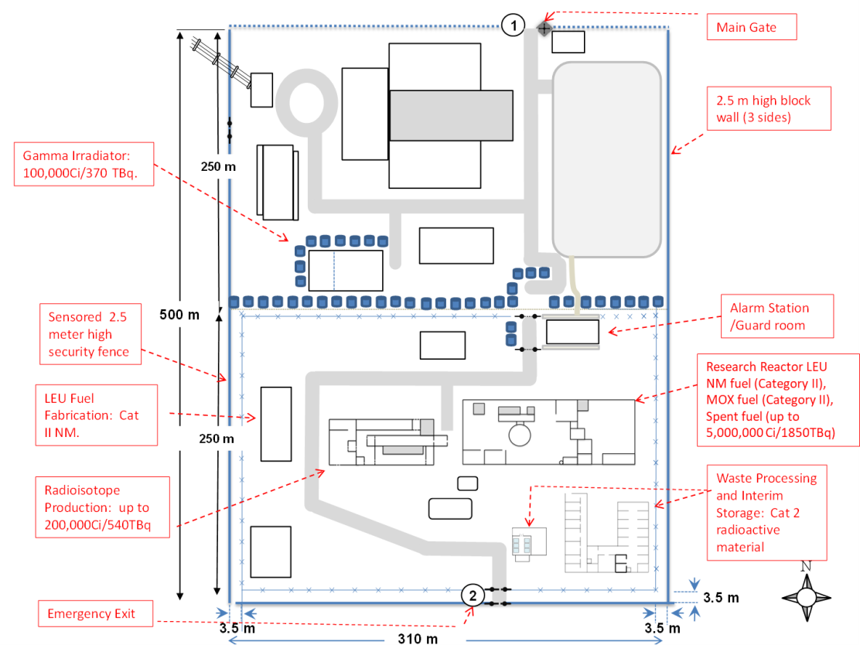
Research Reactor LEU NM fuel (Category II), MOX fuel (Category II), Spent fuel (up to 5,000,000 Ci/1850TBq)
FIG.1. HARI SITE LAYOUT AND IDENTIFIED TARGET MATERIAL LOCATIONS [1]
  - Model and Implementation

For the purposes of this paper only a VISA analysis is presented. VISA is an analysis methodology intended to determine in a qualitative or quantitative approach the effectiveness of physical protection measures for the protection of nuclear materials and nuclear facilities and associated facilities and associated activities against unauthorized removal on nuclear material or sabotage. For this study, the qualitative approach will be demonstrated.

VISA can be used to enhance general awareness of all parties responsible for the protection of assets or response to events. It can be used to validate security plans and procedures, planned changes or upgrades, assess the types of systems needed to the prevention of, protection from, mitigation of, and response to a defined security incident. It is an excellent tool to determine the effectiveness of the physical protection system and security program understanding. This method identifies strengths as well as areas for improvement. During a VISA simulation exercise, subject matter experts are encouraged to discuss in depth issues and collaboratively examine areas of concern to solve physical protection measure deficiencies.

- ANALYSIS OF THE RESULTS
The analysis was based on the HARI description. Using the information from the CRP Task 2, Risk Prioritization Ranking Scheme, the Radioisotopes Production Filter Waste (RPFW) is identified as the most attractive dispersal target for sabotage within the HARI facility. The CRP Task 2 Risk Prioritization Ranking result is shown in Figure 2.
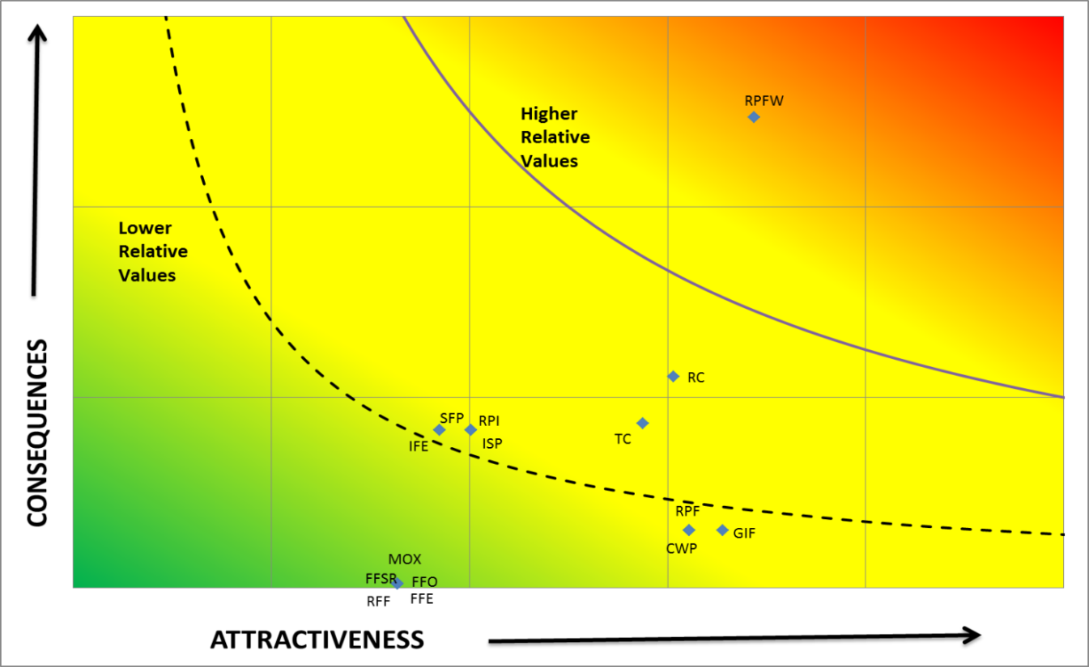
FIG. 2 HARI RELATIVE RISK RANKING ASSESSMENT
The Task 1 team used VISA to analyze the sabotage baseline scenario (see 4.1) to determine the effectiveness of the PPS and to introduce physical protection upgrades (see 4.2). A scenario for unauthorized removal of nuclear material was analyzed for the HARI facility (see 4.3).

  - Scenario Results: RPF Waste Filters - Baseline (Sabotage)
Using a step ladder, the four person adversary team climbs over the LAA fence and the PA alarmed fence on west side of the facility. The adversaries move to the northeast corner of the Radioisotope Production Facility (RPF) building where two adversaries place an explosive charge on the re-enforced concrete wall. They retreat, taking safe cover for detonation of the explosives. Following the explosive, they return and clear the rubble and enter Room B where contaminated ventilation system waste filters are stored. They removed the waste filters from their original positions and carry them just outside the RPF building and using explosives, they detonate the filter to produce a radioactive dispersal. Table 1 illustrates the scenario timeline of events.

TABLE 1. VISA TIMELINE RESULTS - BASELINE SABOTAGE
Sabotage Base Case
Threat: 4 adversaries + active nonviolent insider |  |  |  |  | Target: Ventilation System Waste Filters
Step | Step time | Cuml Time | RF time | Step Description | P_{S} | P_{A} | P_{I} | P_{N} | Step Score
 | Sec | Sec | Sec
1 | 48 |  |  | Using a step ladder to climb over the LAA fence on west side (4 adversaries) 4 X 12s. No sensors or CCTV coverage. Table I.11 NUSAM page 83 | VL | VL | VL | H | VL
2 | 48 |  |  | Using the step ladder to climb over the PA alarmed fence on west side (4 adversaries) 4 X 12s. Defeat of alarmed fence. Table I.11 NUSAM page 83 | VL | VH | VL | H | VL
3 | 70 |  |  | Adversaries move from the PA fence to the RPF building (175m) - no CCTV coverage and random guard patrol is very low sensing and assessment (ref page 100 NUSAM Table IX.11) | VL | VL | VL | H | VL
4 | 30 |  |  | Two adversaries place explosive charge on the re-enforce concrete wall (15 sec). They retreat taking safe cover (15 sec) for detonation. | VL | VL | VL | H | VL
5 | 174 | 174 | 450 | First explosive charge is detonated (assuming 1 stage explosive for concrete structure 120s, 2 stages eliminate reinforced bar 54s). Table I.9 page 82 NUSAM. Building pressure differential alarm activated. CAS dispatches response. | VH | VH | VL | H | VL
6 | 15 | 189 | 435 | Two adversaries entered the room B where ventilation system waste filters are kept. (Assessment by ACS guard and guard at the reactor building - VH if they see it) | M | VH | VL | H | VL
7 | 120 | 309 | 315 | Two adversaries setup explosive charge outside of the building and at the same time, 2 adversaries enter the building. Filters are in open storage in the room. The Adversaries remove 12 filters (10kg each) from their storage positions and carry them just outside the RPF building. The waste filters are stacked up over the explosive charges. Total activity of 7743 TBq. Two adversaries make six trips each (2 waste filters) for 10s each trip. | VH | VH | VL | H | VL
8 | 30 | 339 | 285 | Adversaries retreat and detonate the filters explosive with remote device. | VH | VH | VL | H | VL
 |  |  |  | SYSTEM EFFECTIVENESS |  |  |  |  | VL
The total Response Time is assumed to the 450 seconds after detection. From the results, the adversaries achieved their mission at 339 seconds after detection which is 285 seconds prior to response arrival, therefore interruption is Very Low. The probability of neutralization is assumed High since there are 8-10 responders to 4 adversaries. The overall system effectiveness is considered Very Low.

  - Scenario Results: RPF Waste Filters - Upgrade (Sabotage)
The same scenario as illustrated in 4.1 was analysed with the proposed upgrades of adding another sensor alarm along the protected area perimeter to reduce the likelihood of using a ladder to avoid sensing by the alarmed fence. The added sensor provides sensing between the outer and inner PA fence. Additionally filter locking cages were installed in filter room to increase delay times for removal. Table 2 illustrates the scenario timeline of events.

TABLE 2. VISA TIMELINE RESULTS - UPGRADE SABOTAGE
Sabotage Upgrade Case
Threat: 4 adversaries + active nonviolent insider |  |  |  |  | Target: Ventilation System Waste Filters
Step | Step time | Cuml Time | RF time | Step Description | P_{S} | P_{A} | P_{I} | P_{N} | Step Score
 | Sec | Sec | Sec
1 | 24 | 12 | 450 | Using a step ladder to jump over the LAA fence on west side (4 adversaries) 4 X 12s. New sensor system installed between LAA and PA fence to detect adversaries attempting to bridge the PA. Detected at 12s. Table I.11 NUSAM page 83. CAS guard dispatch rover or command building guard to assess. | VH | VH | VH | H | H
2 | 48 | 60 | 402 | Using the step ladder to jump over the PA fence on west side (4 adversaries) 4 X 12s. Table I.11 NUSAM page 83 | VH | VH | VH | H | H
3 | 70 | 130 | 332 | Adversaries move from the fence to the RPF building (175m) - no CCTV and random guard patrol very low (ref page 100 NUSAM Table IX.11) | VL | VL | VH | H | VL
4 | 30 | 160 | 302 | Two adversaries place explosive charge on the re-enforce concrete wall (15 sec). They retreat taking safe cover (15 sec) for detonation.
5 | 174 | 334 | 128 | First explosive charge is detonated (assuming 1 stage explosive for concrete structure 120s, 2 stages eliminate reinforced bar 54s). Table I.9 page 82 NUSAM. Pressure differential alarm activated. The Critical Detection Point occurs in this step. | VH | VH | VH | H | H
6 | 215 | 549 | -87 | Two adversaries entered the room B where ventilation system filters are kept. Breaching delay time for new filter cages is 200s total. (Assessment by ACS guard and guard at the reactor building - VH if they see it) Armed response arrives. | M | VH | H | H | M
7 | 120 | 669 | -207 | Two adversaries setup explosive charge outside of the building and at the same time, 2 adversaries enter the building. Filters in open storage. They removed 12 filters (10kg each) from their original positions and carry them just outside the RIPF building. Filters stack up at charges. Total activity of waste filters is 7743 TBq. 2 adversaries carry 6 times each with 10s each time. | VH | VH | VL | H | VL
8 | 30 | 699 | -237 | Adversaries retreat and detonate the filters explosive with remote device. | VH | VH | VL | H | VL
 |  |  |  | SYSTEM EFFECTIVENESS |  |  |  |  | H

The modeled upgrades were effective from the point that detection (sensing and assessment) occurred between the Limited Access Area boundary and the protected area boundary. Additional significant delay was added to the adversary task time in the RFP filter storage room. Table 2 illustrates the major timeline of events for the upgrade. The total Response Time is assumed to the 450 seconds after detection. From the results, the adversary task time was increased to 669 seconds and the probability of interruption increased to Very High. The probability of neutralization is assumed High since there are 8-10 responders to 4 adversaries. The overall system effectiveness is considered High.

  - Scenario Results: Research Reactor Facility – Base Case (Theft)
Using a ladder, the four person adversary team climbs over the LAA fence and the PA alarmed fence on east side of the facility. The adversaries move to the auxiliary entrance to the Research Reactor building where three adversaries break the glass door and enter the building. They move to the reactor hall doors and breach them with explosives and remove the fresh fuel target quantity from the facility. The adversaries then move twenty-five fresh MOX fuel elements to the protected area perimeter and LAA boundary and load the material into a vehicle and depart the area. Table 3 illustrates the scenario timeline of events.

450
TABLE 3. VISA TIMELINE RESULTS - BASELINE THEFT
THEFT Base Case

Threat: 4 adversaries + active nonviolent insider |  |  |  |  | Target: Fresh MOX Fuel Rods
Step | Step time | Cuml Time | RF time | Step Description | P_{S} | P_{A} | P_{I} | P_{N} | Step Score
 | Sec | Sec | Sec
1 | 40 |  |  | Using ladder to jump over the LAA fence on east side (4 adversaries) 4 X 10s | VL | VH | VL | H | VL
2 | 40 |  |  | Using ladder to jump over the PA fence on east side (4 adversaries) 4 X 10s | VL | VH | VL | H | VL
3 | 10 |  |  | Adversaries move from the fence to the auxiliary entrance to the reactor building (10m) - no CCTV and guard patrol very low | VL | VL | VL | H | VL
4 | 15 |  |  | 2 adversaries break 2 glass doors with hammer- BMS defeated (no glass-break sensor). 3 adversaries moving inside the building and 1 remains outside the building | VL | VL | VL | H | VL
5 | 35 |  |  | 3 adversaries moving to stairway (20m) to the 3 floors up (20m) to SAS (35m). Assessment from interior camera but no sensors are installed. | VL | VH | VL | H | VL
6 | 45 | 45 | 450 | Adversaries breach the outer reactor hall door with 2 kg explosive. 30s from database plus 15s facility specific distance. Assessment from interior camera and the door sensor provides sensing. (The outside adversary cuts the protected area perimeter fence and breaches LAA brick wall with explosives and returns to enter the building). | VH | VH | VH | H | H
7 | 35 | 80 | 415 | Adversaries breach the inner reactor hall door using 2 kg explosive. 30s from database plus 5s facility specific distance. Assessment from interior camera and the door sensor provides sensing. | VH | VH | VH | H | H
8 | 32 | 112 | 383 | The adversaries move to the fresh fuel storage room (5m - 2s) and breaches the hardened door (30s) with explosives. Door alarm and interior camera provide sensing and assessment. The Critical Detection Point occurs in this step. | VH | VH | H | H | H
9 | 120 | 232 | 263 | Adversaries taking 12 prototype MOX fuels. 45 kg per person. 4 adversaries carry total of 12 fuel element (3 each) to the entry door of the building. Adversaries exit the vault down stair to the front door (80m). | VH | VH | M | H | M
10 | 40 | 272 | 223 | Adversaries move from the doors back to the perimeter wall (20m) | VL | VH | L | H | VL
11 | 25 | 297 | 198 | Load fuel in the truck | VL | VH | VL | H | VL
12 | 45 | 342 | 153 | Move back to the vault (100m) | VH | VH | VL | H | VL
13 | 120 | 462 | 33 | Adversaries taking 13 prototype MOX fuels. 45 kg per person. 4 adversaries carry total of 13 fuel element (3 or 4 each plus) to the entry door of the building. Adversaries exit the vault down stair to the front door (80m). | VH | VH | VL | H | VL
14 | 40 | 502 | -7 | Adversaries move from the doors back to the perimeter wall (20m) | VL | VH | VL | H | VL
15 | 35 | 537 | -42 | Load fuel in the truck and drive away | VL | M | VL | H | VL
SYSTEM EFFECTIVENESS |  |  |  |  |  |  |  |  | H

The total Response Time is assumed to the 450 seconds after detection.
From the results, adversaries didn’t manage to achieve their mission because Armed Response arrived before they drive away (Step 14). The probability of neutralization is assumed high since there are 8-10 responders to 4 adversaries. The overall system effectiveness is considered high.
GENERAL OBSERVATIONS
The observation of the VISA methodology was to evaluate the use base on the strength and weakness or limitation.
  - Visa Strengths and Weaknesses

5.1.1 Strengths
- It can be used as a qualitative or quantitative approach
- It is easy to show the comparison of the task time and the response time
- It is more descriptive in terms of what are the key elements and activities of the overall assessment
- It is more flexible to go over the actions
- The conducting time is less than a table top (TT) as described in Ref [1]
- It is very useful tool for evaluating the PPS
- Counter measures can be easily identified at each specific step. It can easily calculate where there is a lack of P_{S} P_{A}, P_{I} and P_{N} in a given PPS step or element.
- Can determine the Critical Detection Point (CDP) as compared to a TT
- It is useful for assessing the assumed response time
- VISA is more standard methodology for assessing as compared to various TT methodologies as described in reference [1]
- May use but does not require a large number of experts to analyze a scenario

5.1.2 Weaknesses/Limitations
- It is subjective based on SME judgment
- It is a single path scenario too. It does not show multiple path as compare to other automated/computerized methods
- The results can be driven by a strong personality
- There is no detail on adversary and response force interaction activities as compare to TT methodologies
- Does not effectively assess command and control
- One person approach may not consider diverse views of other experts for input

- CONCLUSION

The VISA proved adequate for the application of evaluating the effectiveness of the physical protection system at a research reactor facility. The following represents the conclusions of the working group team:
1) VISA proved useful, however with the absence of site-specific performance tested data, analysis would be difficult.
2) VISA provides a clear stakeholder understanding of protection element (P_{S} P_{A}, and P_{I}) effectiveness for analyzed scenarios.
3) Other analysis tools are recommended to address the VISA limitation to determine neutralization values.

- REFERENCE
[1] INTERNATIONAL ATOMIC ENERGY AGENCY, Nuclear Security Assessment Methodologies for Regulated Facilities, IAEA-TECDOC-1868, IAEA, Vienna (2019).
[2] INTERNATIONAL ATOMIC ENERGY AGENCY, Hypothetical Atomic Research Institute (HARI), General Description (13 March 2017 DRAFT), Vienna (2017).

