**ESTABLISHING AND DEVELOPING AN EFFECTIVE**

**NUCLEAR SECURITY CULTURE**

**AT REGULATORY BODIES**

M. A. Samei

Nuclear and Radiological Regulatory Authority

Cairo, Egypt

Email: [alisamia_2000@yahoo.com](mailto:alisamia_2000@yahoo.com)

S. E. Shaban

Nuclear and Radiological Regulatory Authority

Cairo, Egypt

Email: [smh_elsaid@yahoo.com](mailto:smh_elsaid@yahoo.com)

M. H. Hazzaa

Nuclear and Radiological Regulatory Authority

Cairo, Egypt

R.A. El-Tayebany

Nuclear and Radiological Regulatory Authority

Cairo, Egypt

**Abstract**

Nuclear security requires preventing, detecting and responding to a robbery, destroy, physical access, prohibited move or any other harmful acts concerning nuclear or other radioactive materials or their related installations. Nuclear security awareness is the set of people, entities and agencies' features, attitudes and behaviors that function as a way of improving nuclear security. This study describes the elements of workplace culture such as values, beliefs, behaviors and attitudes) and the factors that encourage a strong culture of security. The study explains the strategic role that security plays in corporate governance and the need to put organizational management systems in place that support it. In addition, this study explains what is involved in creating a comprehensive security program that supports security culture. It also emphasizes the need to communicate effectively with staff and develop training programs that help staff understand that security is important, and that they have security responsibilities. The study also emphasizes the need for leadership to create an effective whistle blowing policy, conduct self-assessments of security culture, and effectively manage the relationship with external stakeholders. Finally, the study clarifies the difference between nuclear culture of safety and security.

**Keywords:** Nuclear Security, Security Culture, Security Awareness.

1. INTRODUCTION

In order to avoid, identify and respond to illegal or deliberate prohibited actions including or oriented to nuclear or radioactive substances, relevant installations, and related activities, most countries have developed or reinforced their national nuclear security systems [1].

The regime of nuclear security is a segment of the general security regime of a country. It incorporates radioactive and nuclear substances throughout their entire life, whether that substance is controlled or not, and related facilities and related activities [2]. The nuclear security policy represents the duty of the government to save individuals, properties, communities, and the atmosphere from the negative consequences of any events related to nuclear security [3].

* 1. **The Regime of Nuclear Security**
* Legal and regulatory structure and management frameworks and policies regulating radioactive substance security, other radioactive materials, related infrastructure, related activities;
* Entities trying to ensure the application inside the Country of the legislative, regulatory and management system for nuclear security;
* Nuclear security schemes and procedures for the prevention, identification and reaction to incidents related to nuclear security.

Series No. 20 of IAEA Nuclear Security, Objective and Essential Elements of a State's Nuclear Security Regime (the basic principles of nuclear security) [4] set out the key components of a domestic nuclear security regime. Culture of nuclear security is necessary for the development and enhancement of nuclear security.

1. ROLES AND RESPONSIBILITY OF INSTITUATIONS AND INDIVIDUALS

Developing a suitable culture of nuclear security includes persons in a wide range of different fields and entities that need to operate together to be powerful.

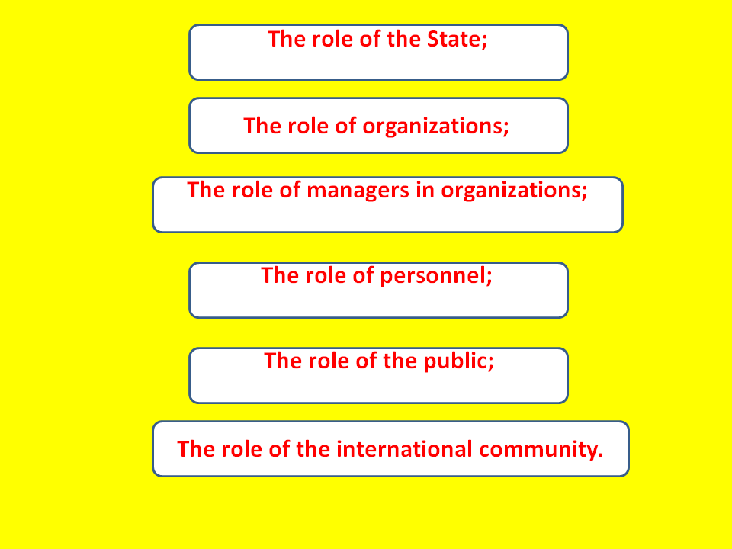

*Fig.1. Roles and responsibilities of different entities.*

* 1. **The State's job**

**-** Taking responsibility for setting up a legislative and regulatory structure to promote an appropriate culture of nuclear security;

**-** Security policy setting ;

**-** Offering confidential information and services security

**-** Setting up a legal structure

**-** Distribute and coordinate responsibilities, in particular for the competent authorities concerned

**-** Establish mechanisms for the coordination of information and data exchange

**-** Joint crisis management and emergency response drills

**2.2. Organizations ' Function**

Within a government, different agencies such as authorities, consumers of radioactive materials, nuclear facility operators, border and customs officials, and radioactive material conveyors have obligations concerned with how to protect radioactive substances. The regulatory and legal framework of a country provides a framework for the security policies of an entity that determines the working environment and influences the human behavior of staff.

* 1. **Managers in Organizations**
* Responsible for ensuring acceptable levels of security-related conduct and quality
* Develop systematic processes for decision-making
* Maintenance of better communication
* Include technical training and education
* Verify that workers are given the chance and understand and appreciate their role in improving nuclear security
  1. **Employees/Personnel**
* Responsible for their own actions
* Encouraged to guarantee nuclear security
* Behave in a way that identifies the conditions and possible consequences of their behavior.
* Adhere to the procedures of the facility
* Do not disclose details that may weaken security
  1. **Public**

• Be aware that security is an important factor for the installation of the plant

• Knowing the security information can't be revealed

* 1. **International Community**

• Offer additional advice and help for developing the institutional infrastructure.

• Support countries in fulfilling their responsibilities and duties.

1. CHARACTERISTICS OF NUCLEAR SECURITY CULTURE

A commonly used model of institutional culture derives the features of an active nuclear security culture mentioned here [5]. The three-layer system is widely valid to nuclear facilities and entities, covering power plants, nuclear facilities, reactors, transport facilities of nuclear materials, and consumers of radioactive sources, other hazardous material handling/store facilities, including customs and border control organizations. The following sections define each of these layers.

* Consider the nuclear security culture as a symbol of professionalism, competence, and obligation for all players involved in the defense of nuclear substances and nuclear facilities



*Fig. (2): Nuclear security culture.*

Nuclear security culture's features are values, behaviors, and management [5] tools, a suitable assembly leading to more appropriate nuclear security.

1. MANAGEMENT SYSTEMS

Employee productivity is affected by management performance and the implementation of work performance criteria, specifications, and standards, education, recorded protocols, information management, etc [6,7]. Thus, a successful nuclear security attribute is a well-developed management tool. Examples of management tool components are shown in Fig. (3) and further details are given below.

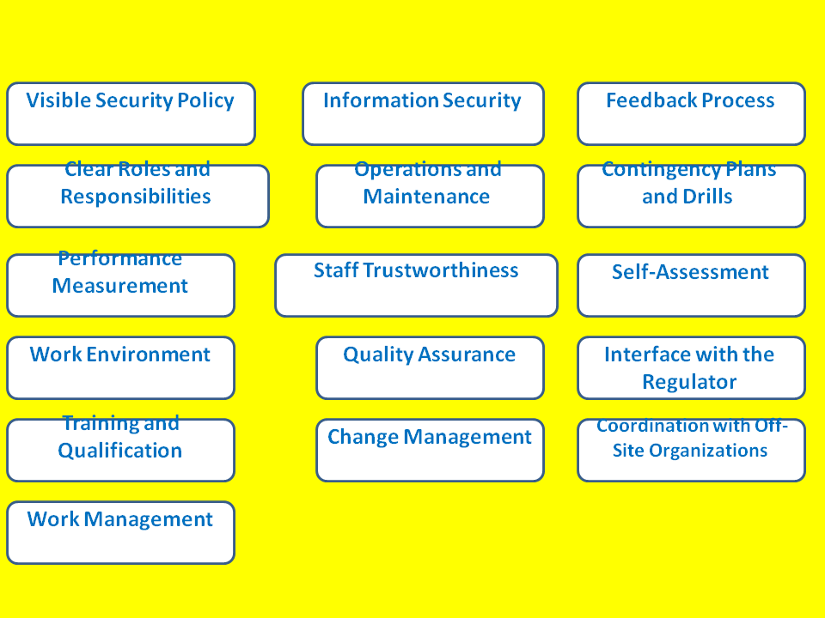

*Fig. (3): The components of Management tool.*

1. NUCLEAR SAFETY CULTURE AND NUCLEAR SECURITY CULTURE
   1. **Safety Culture**

"This collection of attributes and behaviors in groups and individuals that identifies the nuclear plant safety concerns, as an overarching priority, receive the attention due to their importance on the basis of:

* Openness
* Transparency
* Information Sharing
  1. **Security Culture**

"The collection of persons, groups, and institutions ' features, attitudes, and behaviors that serve as a way of defending and enhancing nuclear security."

* Compartmentalization
* Secrecy/Confidentiality
* Classification

1. CONCLUSION

The culture of nuclear security is an essential part of the construction of a nuclear security system that results in a robust nuclear security regime. To establish and maintain a nuclear security culture, state organizations and individuals should practice their roles and responsibilities in a right manner. Edgar Schein’s model for working with organizational cultures is of a great importance to develop this culture. Assessment and developing of beliefs, attitudes, behavior and management systems lead to more effective nuclear security.

REFERENCES

[1] IAEA- INTERNATIONAL ATOMIC ENERGY AGENCY, Nuclear Verification and Security of Material: Physical Protection Objectives and Fundamental Principles, GOV/2001/41, also contained in the amendment to the CPPNM, (2001)

[2] IAEA- INTERNATIONAL ATOMIC ENERGY AGENCY, Code of Conduct on the Safety and Security of Radioactive Sources, CODEOC/2004, (2004).

[3] IAEA- INTERNATIONAL ATOMIC ENERGY AGENCY, Measures to Improve the Security of Nuclear Materials and Other Radioactive Materials Including Radioactive Sources, GC(45)RES/14,(2001).

[4] IAEA - INTERNATIONAL ATOMIC ENERGY AGENCY, Nuclear Security: Global Directions for the Future (Proc. Int. Conf. London, 2005), 262 (2005).

[5] IAEA- INTERNATIONAL ATOMIC ENERGY AGENCY, The Management System for Facilities and Activities, Safety Standards Series No. GS-R-3, (2006).

[6] IAEA- INTERNATIONAL ATOMIC ENERGY AGENCY, Application of the Management System for Facilities and Activities, Safety Standards Series No. GS-G-3.1, (2006).

[7] SCHIEN, E.H.,” Organizational Culture and Leadership”, 3rd Ed., Jossey-Bass, San Francisco, USA, (1997).