Approach for Harmony of 3S (Safety, Security and Safeguards) in Japan

OKU Hirotaka
Division of Nuclear Security, Radiation Protection Department, the Secretariat of the Nuclear Regulation Authority
Tokyo, Japan
Email: hirotaka_oku@nsr.go.jp

Abstract

In order to secure public safety with utilization of nuclear fuel material, etc., it is important to avoid mutual interference of 3S (safety, security and safeguards) as well as take politic measures. Since September 2012, the Nuclear Regulation Authority Japan (NRA) that has jurisdiction unitarily over these regulations has made an effort toward the harmonization of these regulations through the developed “Code of conduct on nuclear security culture” and “Policy statement on nuclear safety culture” that contain the harmonization of nuclear safety and security. The paper shows the overall measures of NRA for harmonizing 3S.

INTRODUCTION
The regulation of nuclear safety, security and safeguards based on the Act for the Regulations of Nuclear Source Material, Nuclear Fuel Material and Reactors (Reactor Regulation Act) have the common purpose of contributing to the protection of the lives, health and property of citizens, preservation of the environment, and national security of Japan, but there is a possibility that these regulations rely on one another and intervene mutually.
Although Reactor Regulation Act does not provide its regulatory requirements as if they could be mutually related to at some areas, the NRA that has jurisdiction unitarily over these regulations has made an effort toward the harmonization of these regulations, for example, through the developed “Code of conduct on nuclear security culture” [1] and “Policy statement on nuclear safety culture” [2], which contain the harmonization of nuclear safety and security.
For advancing measures aiming at achieving the harmonization of 3S at a higher quality level, the NRA began the system of the trustworthiness check of NRA staff in April 2018, based on the suggestion provided though IAEA’s Integrated Regulatory Review Service (IRRS) mission (received in January 2016) that clarified the issue about the development of mechanism for the integrated regulatory management of nuclear safety and security [3]. In addition, NRA began the trial operation of the nuclear inspection system that unifies the inspection regarding nuclear safety and security in October 2018.

BACKGROUND
IAEA INSAG-24 (The Interface between Safety and Security at Nuclear Power Plants) (2010) [4] shows the points to be noted for achieving the harmonization of nuclear safety and security, etc. IAEA TECDOC-1801 (Management of the Interface between Nuclear Safety and Security for Research Reactors) (2016) [5] provides the technical guideline for the harmonization of nuclear safety and security. The IAEA continues its consideration for achieving the harmonization of nuclear safety and security through the discussion of numerous Technical Meetings.
The concept of 3S was advocated in “Milestones in the Development of a National Infrastructure for Nuclear Power” (2007) [6], which identifies items that should be provided by the country trying to introduce a nuclear power plant. At the G8 Hokkaido Toyako Summit (2008), based on the situation that a growing number of countries worldwide had expressed their interest in nuclear energy, the agreement that ensuring 3S should be the basis for introducing nuclear energy infrastructure was adopted as the international initiative [7].
In those days, in Japan, it was difficult to achieve the harmonization of the regulation over different aspects of nuclear activities, because plural government authorities had jurisdiction over safety and security regulation separately. But at the present time, Nuclear Regulation Authority (NRA: established in September 2012) has jurisdiction unitarily over all aspects of nuclear regulation including 3S.
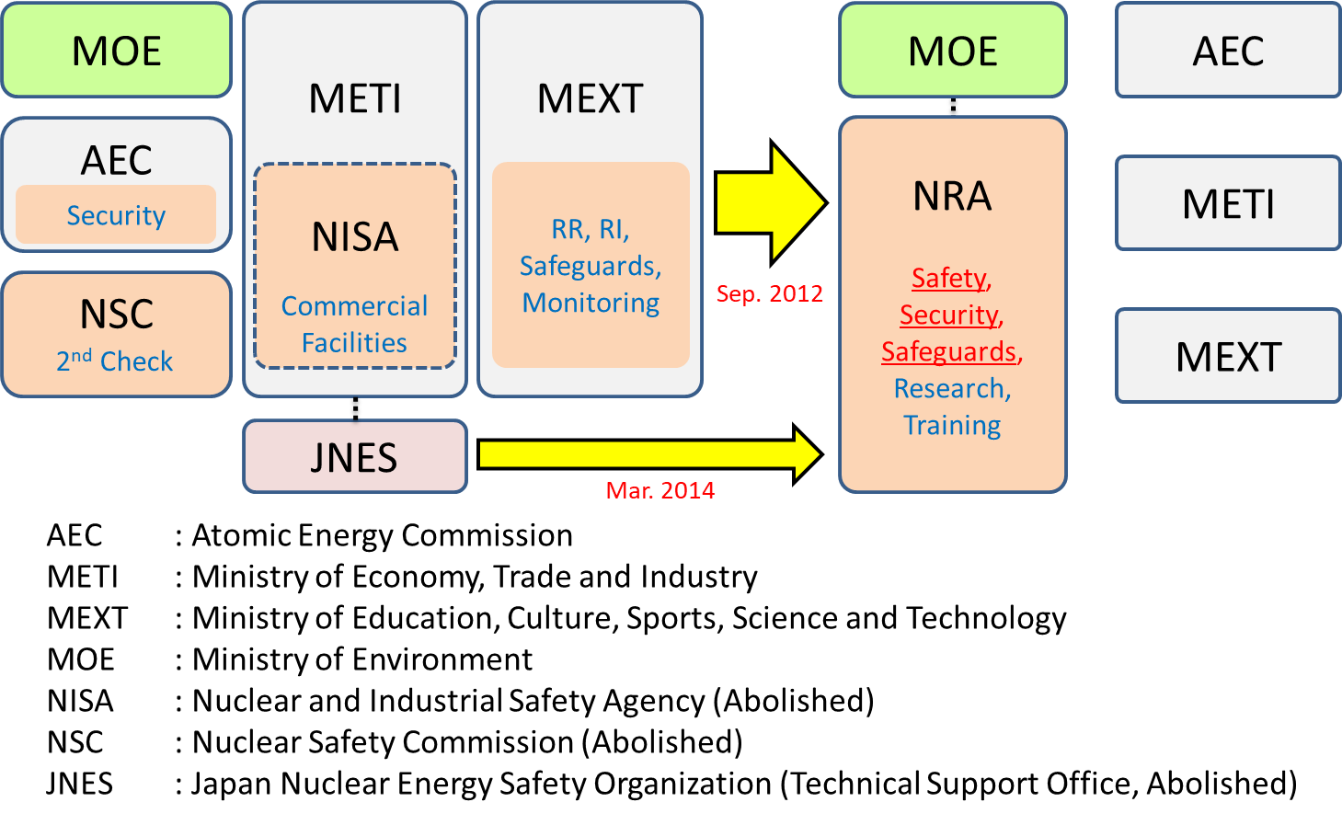
FIG. 1. Integration of nuclear regulatory enforcement functions.

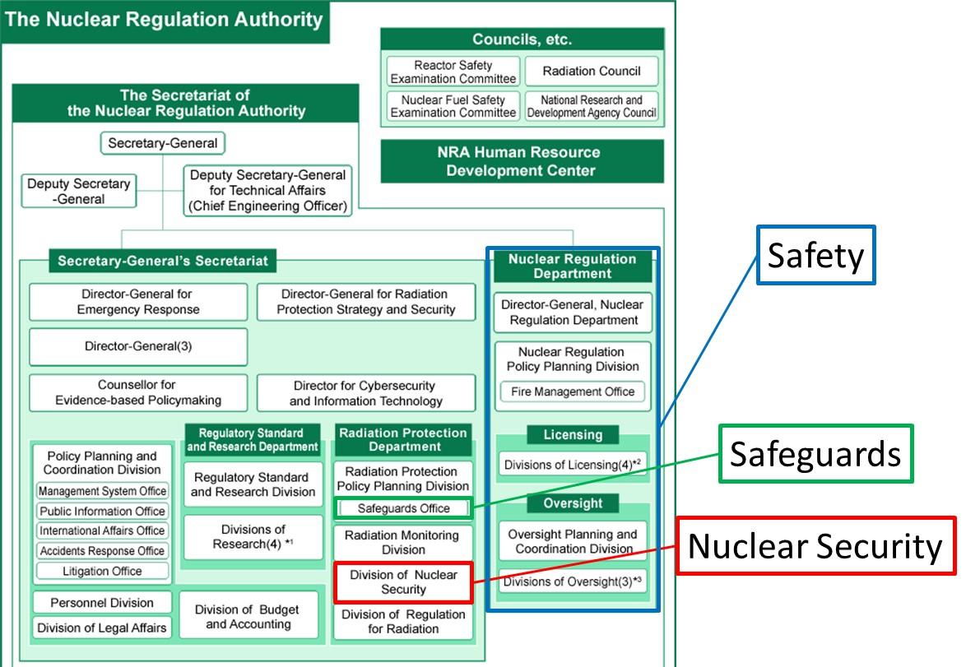
FIG. 2. Divisions that takes charge of 3S regulation in NRA.

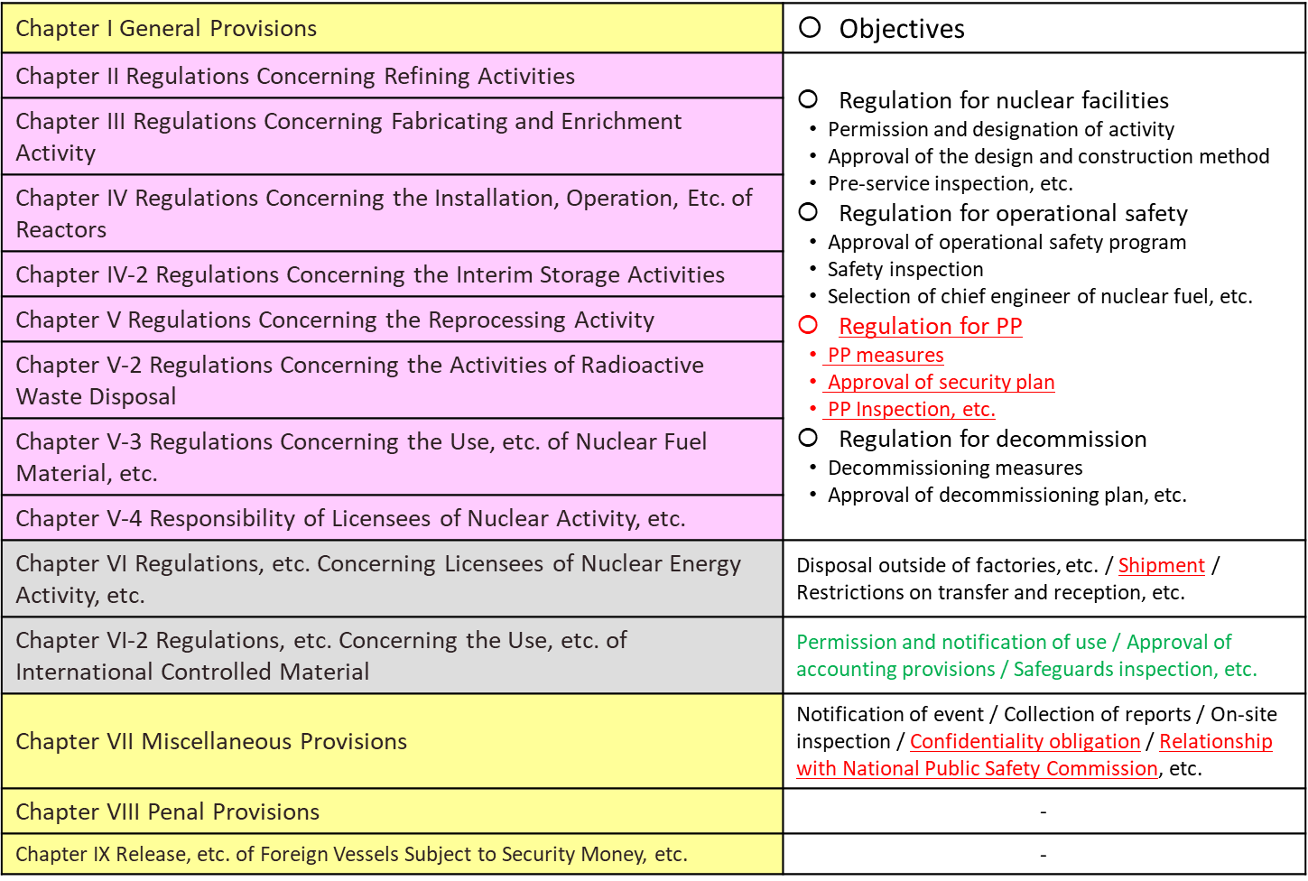
FIG. 2. 3S regulation under Reactor Regulation Act.

MEASURES FOR the HARMINIZATION OF 3S
The NRA showed its policy to make an effort toward the harmonization of nuclear safety and security and clarified this policy in “Code of conduct on nuclear security culture” [1] and “Policy statement on nuclear safety culture” [2]. For the harmonization of the 3S, NRA is promoting the following approach.

Review
Licensing group of Nuclear Regulation Department takes charge of review for nuclear safety (e.g. approval of the design and construction method). Division of Nuclear Security takes charge of review for approval of security plan.
Since developing the code of conducts, NRA has enhanced cooperation with relevant divisions by exchanging information of review, but there are still some cases of interference with other regulatory measures. The examples of interference are as follows.

SAFETY → SECURITY
The measure which the ground of the peripheral protected area is plastered by mortar for a fire protection connects in the state which tends to get over a barrier in the border of the peripheral protected area.

SECURITY → SAFETY
Replacement of a door of the central control room for making sure of delayed performance has an influence on the shielding performance and earthquake resisting, etc. of the central control room.

SAFETY → SAFEGUARDS
The aseismic reinforcing work in the facilities causes visual field defect of inspection monitor.

SECURITY → SAFEGUARDS
The licensee cannot give the photograph filmed by an IAEA inspector, because the information regarding physical protection is included in this photograph.

As the review for safeguards, the NRA reviews for approval of accounting provisions that are formulated for ensuring proper accounting for and control of material by licensees.
The safeguards measures need to enforced in such a way as to conform to nuclear safety based on the agreement with the IAEA. But, the procedure related to safeguards implementation to avoid possible interference with other regulatory measures is not defined. Actually, the case that the measure for safeguards interfered with safety occurred in 2015.

SAFEGUARDS → SAFETY
The fire caused by a monitoring device has an influence on safety in facilities.

As a result of the discussion in April and September 2018, the NRA takes the measures for 3S harmonization regarding review. The measures are as follows.

Information sharing:
- The information regarding nuclear safety and security (e.g. installation of the new system, remodelling of existing facilities and change of operational procedures, etc.) is shared with relevant divisions.

Coordination to avoid interference:
- When the NRA receives applications for permission and authorization regarding any of 3S measures, the division in charge of this application shares information with other relevant divisions and tries to exclude interference as much as possible.

Inspection
Under the current Reactor Regulation Act provides the inspection regarding nuclear safety and the inspection regarding security are treated as different inspections. The inspection regarding nuclear safety is conducted by the inspectors who are stationed at NRA’s regional office, while the inspection regarding security is conducted by the inspectors that are stationed at the NRA headquarters.
It was decided that the inspection regarding nuclear safety and security are to be unified as the nuclear regulation inspection. The NRA began the trial operation of the nuclear regulation inspection in October 2018 towards the full operation of this new inspection system from April 2020.
Furthermore, the inspection regarding safeguards is conducted by outside agency, and safeguards inspection system is not affected by the introduction of this new system of nuclear regulation inspection.
As a result of the discussion in April and September 2018, the NRA takes the measures for 3S harmonization regarding inspections. The measures are as follows.

Qualification and training:
- In the nuclear regulation inspection system, the title of inspectors regarding nuclear safety and security are unified to be “the nuclear inspector”.
- Because necessary knowledge and experience are different for the inspector regarding nuclear safety and security, new qualification system that started in 2018 sets specific requirements for each nuclear safety and security in technical training courses and accordingly, assigns an appropriate field in charge based on the obtained qualifications either for nuclear safety or nuclear security.

Information sharing:
- However, if the inspector regarding nuclear safety notices a measure or situation undesirable for security or safeguards during an inspection, the inspector directly informs the noticed matter to relevant divisions by telephone, etc.
- If the inspector regarding security or inspector of safeguards notice a measure or situation undesirable for nuclear safety, the inspector informs the noticed matter to relevant divisions as necessary.

Coordination to avoid interference:
- The relevant divisions check the shared information. And if the interference is concerned, the relevant divisions try to exclude the interference as much as possible by coordinating or cooperating with a licensee and the IAEA, as necessary.

System maintenance
The NRA staff members who are responsible for the regulation of one of 3S related matters take training and educational courses for other areas of 3S to obtain necessary knowledge for the harmonization effort of 3S.
The NRA began the system of trustworthiness check of NRA staff in April 2018 to ensure appropriate management and control of information that contains physical protection secrets and other sensitive information. The NRA is considering to expand the scope of the trustworthiness check to include the inspectors who are stationed at NRA’s regional offices for the purpose to mitigate possible obstructs for information sharing necessary for the conduct of nuclear regulation inspections.

Role and responsibility of licensees
The NRA guides licensees to recognize and be reminded that the licensee bears primary responsibility for managing the nuclear facilities, while trying to achieve the harmonization of 3S and prompts them to take necessary measures.
The NRA conducted several hearings from licensees about the system and operational situation, etc. regarding the management of 3S. The results of these hearings are as follows.

- Comparatively large-scale licensees (Reactors, Reprocessing and Fabricating, etc.) provided the procedure (e.g. check the documents, etc. with relevant divisions) to exclude the interference with other regulation measures in the stage of design by the office routine regulations.
- The licensees that entrusts the judgment for performing such a procedure to only the design charge post were confirmed. But this licensees recognized the problem of such a situation and worked at improvement.
- As for comparatively small-scale licensees (University and use facilities, etc.), because limited staffs take charge of plural 3S measures, the interference with other regulation measures is excluded needless to provide the particular procedure.

Institutionalization
Reactor Regulation Act provides measures regarding 3S for ensuring the public safety associated with utilization of nuclear power. But because the provisions about these measures are not closely related, systematic measures are needed for making a connection with mutual provisions.
The NRA will consider about institutionalization after accumulation of the experience regarding harmonization of 3S.

SUMMARY
The contents of 3S measures are respectively different. Because such a measures can have unintended adverse effects on the one or the other, it is necessary to manage 3S in an integrated manner.
NRA is advancing measures regarding harmonization of 3S by making the best of features that NRA unitarily has jurisdiction over 3S regulation while promoting association with relevant divisions.
NRA promotes mutual understanding of NRA staffs who take charge of 3S and aims at enhancing effectiveness of nuclear regulation through various measures.
ACKNOWLEDGEMENTS
I would like to thank staffs of Nuclear Regulation Policy Planning Division, Oversight Planning and Coordination Division, Safeguard Office and Division of Nuclear Security for carefully proofreading the manuscript.
References
- The Code of Conduct on Nuclear Security Culture, NRA, Japan (2015).
- The Policy Statement on Nuclear Safety Culture, NRA, Japan (2015).
- Integrated Regulatory Review Service (IRRS) Mission to Japan, IAEA, Japan (2016).
- The Interface between Safety and Security at Nuclear Power Plants, INSAG-24, IAEA, Vienna (2010).
- Management of the Interface between Nuclear Safety and Security for Research Reactors, TECDOC-1801, IAEA, Vienna (2016).
- Milestones in the Development of a National Infrastructure for Nuclear Power, IAEA, Vienna (2007).
- International Initiative on 3S-Based Nuclear Energy Infrastructure, G8 summit 2008 Hokkaido Toyako (2008).

