Nuclear Material Accounting & Control

(NMAC) for Practitioners: A New Approach

to International Training on

NMAC Concepts
J.B. Marlow
Los Alamos National Laboratory
Los Alamos, United States of America
Email: jmarlow@lanl.gov

R. K. Larsen
International Atomic Energy Agency
Vienna, Austria

L. Brownell
National Nuclear Security Administration
United States Department of Energy
Washington D.C., United States of America
Abstract
In August 2018, the Nuclear Security Division of the International Atomic Energy Agency (IAEA) presented the first-ever pilot International Training Course (ITC) on "Nuclear Material Accounting & Control (NMAC) for Practitioners" in conjunction with the United State Department of Energy/National Nuclear Security Administration Office of International Nuclear Security (NA-21.1) and Los Alamos National Laboratory (LANL). The course curriculum, based on IAEA Nuclear Security Series No. 25-G, Use of Nuclear Material Accounting and Control for Nuclear Security Purposes at Facilities, was developed collaboratively with experts from IAEA Member States who contributed their knowledge and experience to enhance the material with real-world examples. With the IAEA NMAC implementing guide 25-G providing the overarching framework, the course provided the opportunity for “deep dives” into key topics of operational interest to NMAC practitioners, such as the evaluation of measurement control data and proper selection of controls for various facility types. Another key goal of this course, with its emphasis on practitioners, was to provide hands-on experience and opportunities for nuclear material measurement and selection of controls. This was met with over thirty percent of the two-week course spent in the laboratory, working with nuclear material standards available at LANL. The course culminated in a day-long Capstone exercise which served as a final integrated test, putting to work the material covered in the preceding weeks. Feedback from the participants was extremely positive, with great benefit realized by the ability to incorporate the concepts being taught into an authentic environment. The hands-on component was recognized as extremely valuable, providing concrete benefits for the participants to take back to their facilities. The addition of a hands-on International Training Course in NMAC tailored to practitioners from facilities worldwide contributes to strengthening the nuclear security regime and represents an outstanding addition to the IAEA’s flagship courses in nuclear security.

INTRODUCTION
The IAEA has long had a robust training programme on the principles of NMAC for nuclear security, both as a computer based course [1], and as awareness level courses [2]. However, a need was recognized for a course for NMAC practitioners, analogous to what is done at the International Training Course on the Physical Protection of Nuclear Facilities and Nuclear Facilities [3], where participants put into practice for themselves the content of the course in hands-on learning and practical, integrated exercises. Thus, was born the concept of a hands-on course for NMAC; a course specifically targeted for practitioners who would benefit from detailed, practical information on the implementation of NMAC measures.
The target audience for this course was both personnel from facilities and from Competent Authorities. Both personnel responsible for implementation of NMAC at their facilities and facility operations personnel were included, as it is vitally important that operations personnel understand the interplay of NMAC with operations and vice versa. Individuals from the Competent Authorities were sought who have responsibility for:
- Developing NMAC related regulations;
- Inspecting and assessing NMAC functions at facilities;
- Overseeing and resolving NMAC irregularities at facilities or in transport.
The schedule for the development of the course was ambitiously set for less than one year, with the project initiation in fall of 2017, and the pilot conducted in August 2018. Success under such a tightly constrained schedule was only possible with outstanding communication, integration and hard work amongst all stakeholders.

Course preparation
This section details the development of the lecture modules, selection of instructors, and selection of the teaching venue.

Content Preparation
As described earlier, the foundational international guidance document for the course was IAEA Nuclear Security Series No. 25-G, Use of Nuclear Material Accounting and Control for Nuclear Security Purposes at Facilities [4]. This document was supplemented with other IAEA documents for specific subjects. Supplemental documents included the following, listed by technical area:
- Nuclear Security definitions [5]
- Physical Protection [6]
- Information/Cyber Security [7]
- Nuclear Material Accounting terms [8]
In addition to IAEA guidance documents, recommendations and good practices were also pulled from international standards. Specifically, these included:
- Measurement Control [8]
- Calibration of measuring and test equipment [10]
Subjects covered in lectures included the interplay between NMAC and other elements of nuclear security, including physical security, information security and cyber security. NMAC topics included records and procedures; material balance area (MBA) establishment, physical inventory taking (PIT), material-unaccounted-for (MUF) evaluation; nuclear material measurements, including both destructive and non-destructive analysis; measurement quality control; controls, including tamper indicating devices (TIDs) and item and process monitoring; resolution of irregularities; and performance testing.
Draft lecture content was prepared by Los Alamos National Laboratory based on materials collected from IAEA training events and materials developed for U.S. bilateral partner engagements. These materials were vetted and substantively revised at a Consultancy Meeting (CM) held in Vienna in February 2018. The CM included experts invited by the IAEA representing the Russian Federation, the Islamic Republic of Iran, the French Republic, Japan, the Kingdom of Morocco, the Arab Republic of Egypt, and the United States of America. The content went through an instructional design process [11] to maximize the utility and sustainability of the course. In addition to the lectures, student and instructor notes were also prepared.

Instructor Selection
The cadre of international instructors that presented the course were selected from the experts that attended the CM, when available, with the addition of several in-house consultants from the IAEA. LANL personnel guided the hands-on portions of the course, due to the health and safety training requirements for handling nuclear material. LANL instructors were supplemented with other U.S. NMAC experts that facilitated the final integrated, or Capstone, exercise, to ensure that there was a high instructor to participant ratio.

Venue Selection
The IAEA and DOE/NNSA selected LANL as the venue to host this initial pilot course for several reasons.
First, the Non-proliferation and National Security Training Centre [12], colloquially nicknamed “the Schoolhouse” at LANL was purpose-built to host large international nuclear security and safeguards courses. Training is the single, dedicated mission of the facility. Its design enables hands-on education in several key ways.
The TA-66 Schoolhouse permanently houses a wide variety of encapsulated nuclear material standards, as well as numerous radioactive sealed sources. These include uranium standards of various enrichments, plutonium standards in a variety of physical forms safely packaged for handling in a laboratory learning environment, a configurable low enriched uranium power reactor test assembly and a fresh high enriched uranium Material Test Reactor research reactor element. This wide variety of nuclear fuel cycle materials allows participants to gain experience in measuring the mass and isotope of the actual target materials they may encounter at their facilities and deepens their technical understanding by applying principles in practice.
The TA-66 Schoolhouse also houses a wide variety of non-destructive assay equipment, such as the participants might have at their home facility. Both quantitative and qualitative, gamma-ray and neutron-based equipment is available for the participants to explore, use and understand. In addition to the facilities available at the TA-66 schoolhouse, LANL has a large variety of other facilities relevant to NMAC, such as destructive chemical analysis laboratories, that can be used for tours, observations and demonstrations; these facilities were included to enhance the course as described later in the paper.
Access to the Schoolhouse is straightforward, with no health and safety dress-out requirements, as all the nuclear material standards and sealed sources are packaged for safe handling in open environments and rigorously checked for containment integrity. Additionally, only LANL personnel, with the required health and safety training, directly handle the radioactive materials, although all participants are allowed, encouraged even, to set up the non-destructive assay instruments and operate the data collection and analysis laptops. This access efficiency allows for more time to be spent learning in the laboratory or lecture room, without substantial time lost to logistics. Furthermore, participants of all nationalities have the same access as U.S. citizens, allowing for an effective learning environment.
Lastly, the TA-66 Schoolhouse is, in fact, an actual LANL Material Balance Area, exemplifying good NMAC and nuclear security practices in the day-to-day operations that the participants experience. The MBA custodians for the facility are always on-hand to explain operation of the facility and answer participant questions. It is hard to imagine a more immersive experience.

Course execution
The pilot ITC on NMAC for Practitioners was held at LANL August 18-28, 2018. This section details participant selection, lecture topics, and exercises, including the final Capstone scenario.

Participant Selection
The course was truly an international event, with twenty-four participants from over fifteen Member States as well as instructors from another half-dozen countries, including the People's Republic of Bangladesh, the Federative Republic of Brazil, the Arab Republic of Egypt, the Republic of Ghana, Hungary, the Republic of India, the Republic of Indonesia, the Hashemite Kingdom of Jordan, the Republic of Kazakhstan, the Republic of Korea, Malaysia, the United Mexican States, Romania, the Kingdom of Thailand, the Republic of Turkey, the United States of America, and the Socialist Republic of Vietnam. Participants were nominated by their Member States, and then selected by the IAEA to have a mix of facility NMAC, facility operations, and Competent Authority representatives. Participants were limited to twenty-five in number for the pilot course, and numerous strong candidates had to be turned away due to this space restriction. The numbers of nominated applicants certainly is evidence of a strong interest and need for this course in the international community.

Presentation Topics
The course was comprised of seventeen lectures, interspersed with exercises and observations described further below, over a nine-day period of instruction. The agenda was grouped around the topic order presented in IAEA Nuclear Security Series No. 25-G, [4], and included the following:
- NMAC for Nuclear Security
- NMAC Concepts;
- Interfaces with Other Elements of Nuclear Security;
- Information and Computer Security;
- NMAC Records;
- Physical Inventory Taking (PIT);
- Calculation and Evaluation of Material Unaccounted For;
- Nuclear Material Measurements;
- Destructive Analysis of Nuclear Material for Nuclear Security;
- Non-destructive assay-Gamma Measurements;
- Non-destructive assay-Neutron Measurements;
- Measurement Quality Control;
- Nuclear Material Controls;
- Good Practices for a Program to Control Tamper Indicating Devices;
- Item and Process Monitoring;
- NMAC during Nuclear Material Movements;
- Investigation and Resolution of Irregularities;
- NMAC System Assessments and Performance Testing.
As this course was specifically designed for practitioners, there was a focus on practical implementation of accounting measurements and their associated quality assurance requirements. There was also a detailed examination of various types of nuclear material controls available for facilities to implement, and practical guidance on selection and implementation of those control at facilities. Whilst none of these measures are prescriptive, the course was intended to help practitioners understand the range of techniques, technologies and options that could be implemented at their facilities, and for Competent Authorities to understand the impact of each option on a NMAC structure. Each lecture concluded with a series of questions, where participants selected their answer anonymously using a Classroom Response System referred to as a “clicker.” The results of each clicker question were reviewed by the instructor to ensure that all participants understood lecture concepts before moving forward.
In addition to the lectures, there were also several special presentations drawn from the experience and expertise of the instructors. These talks included:
- An introduction to the IAEA Division of Nuclear Security;
- A presentation on the importance of NMAC to nuclear security;
- A history of LANL;
- A history of the meaning of controls.
These special talks, although not part of the formal curriculum, deepened the participants understanding of the origin and context of NMAC.
The final course lectures are archived in full on the IAEA Nuclear Security portal (NUSEC) [13].

Exercises and Observations
One of the interesting features of the field of NMAC is that it encompasses several distinct disciplines. As an NMAC practitioner, one might be a statistician, a chemist, a non-destructive assay measurement expert, an expert in the development of TIDs, a procedure writer or numerous other disciplines. One of the objectives of this practitioner’s course was expose the participants to various aspects of the NMAC system-even it was not in their own specialty or in use at their home facility- to better understand the interplay between the elements of the NMAC system, and to illustrate the principles of defence in depth.
In addition to the Capstone exercise, described below, several other observations and hands-on exercises were conducted throughout the course. These included:
- A small group exercise to create Material Balances Areas in a hypothetical facility;
- A small group exercise to calculate Material-Unaccounted-For for a hypothetical facility;
- Hands-on measurement of plutonium, uranium and other sealed sources with a variety of gamma-ray instruments; participants rotated through several stations to keep instructor to student ratios high;
- Hands-on measurement of plutonium, uranium and californium with a variety of passive and active neutron instruments; participants rotated through several stations as was done in the gamma measurement lab;
- A large group measurement control exercise.
Observation opportunities included:
- A tour of a calorimetry laboratory; calorimetry has long been the “gold standard” of non-destructive assay measurements in the U.S. domestic NMAC program;
- A tour of the clean chemistry laboratory, demonstrating several classes of mass spectrometers and discussing chemical sample preparation techniques;
- An observation of an actual TID removal and replacement on a nuclear material standard, with the actual MBA custodians for the TA-66 Schoolhouse following their procedures and administrative requirements (such as two-person rule) as well as updating the LANL NMAC accounting system;
- An observation of an actual nuclear material transfer between MBAs within LANL, again illustrating the implementation of actual procedures, controls, separation of duties and other NMAC features.
The exercises and observations were strategically used amongst the lectures to get the participants up and moving, keep up interest and emphasize key topics of the lectures. The participants were also alerted that the skills they practiced throughout the week would be used in the Capstone scenarios.

Final Integrated Exercise-Capstone
During the Capstone exercise, the participants were afforded the opportunity to conduct a nuclear material physical inventory taking, apply and remove tamper indicating devices; use procedures tailored to the scenarios; make nuclear material measurements; investigate and resolve irregularities that were planted in the scenario; and report to relevant authorities. The participants were divided into three smaller groups for the Capstone exercise with instructors and a facilitator familiar with the scenario. Each group presented their scenario, process, irregularity and resolution to all the participants in a briefing the following day.
The Capstone scenarios required a considerable preparation effort from the course development team to create a set of procedures, forms, props and roles that would work for each of the three scenarios, and afford each group to exercise all aspects of the NMAC system. The procedures and forms were also deliberately created to reflect good NMAC practices; for example, forms required the signatures from two separate individuals occupying different roles. Physical props were created, such as cans of nuclear material (some mock and some real), mock vaults, actual TIDs (both wire cable and adhesive styles) for the participants to apply and remove and measurement equipment including scales, and gamma and neutron non-destructive assay instruments. Two participants are pictured in Fig. 1 removing red TID residue from an adhesive TID on a container of actual nuclear material in preparation for applying a new TID as part of Capstone scenario 3.
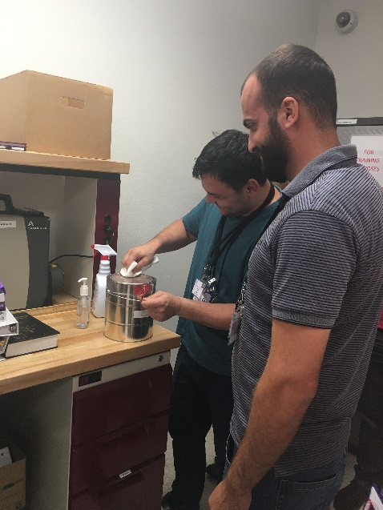
Fig. 1. Participants Constantin Sumanariu (L) and Alaaddin Alnajjar remove TID adhesive residue (seen in red), from a container of nuclear material in preparation to apply a new TID.
Role-playing badges were also used to emphasize to the participants the roles that they were occupying and the limits/extent of their authorization. The role badges also catalysed discussions about training, qualification and authorization. Thus, the role badges, procedures, and forms led to numerous useful discussions about how a sustainability programme supports an NMAC programme.
The Capstone exercise was rehearsed in full twice- once with just LANL instructors, and then again with the Capstone facilitators, who had no previous exposure to the scenarios. Both rehearsals were invaluable for refining the content and supporting procedures, forms and props. Close coordination and communication were conducted within LANL as well to ensure that all actual requirements for nuclear material control were met whilst the material was used in training (for example, “hidden” in an unmarked can). The guest instructors also arrived to LANL a day early for an instructor preparation day to walk through the Capstone scenarios with the LANL team and facilitators so they could use and understand the scenarios prior to guiding their groups through them.
Each Capstone scenario is detailed below.

Capstone Scenario 1
In this scenario, a container with a broken TID was discovered during a routine PIT. This precipitated an irregularity investigation. Under coaching from the facilitator, the group split up with one team searching for the missing material, and a second using non-destructive assay techniques to characterize the suspect container to verify that material is in fact missing. In characterizing the compromised container, the team discovered that the gross weight of the container was correct but the isotopic composition of the material was not correct (it was depleted uranium instead of high enriched uranium) and the uranium-235 mass was incorrect. The team verified the calibration and measurement control status of their instruments. During the material search, the laboratory was thoroughly scoured for hidden material, as shown in Fig. 2. , and material was found in a nearby can labelled “Empty “outside of the vault. The “Empty” can was characterized to confirm that the found material matched the missing nuclear material
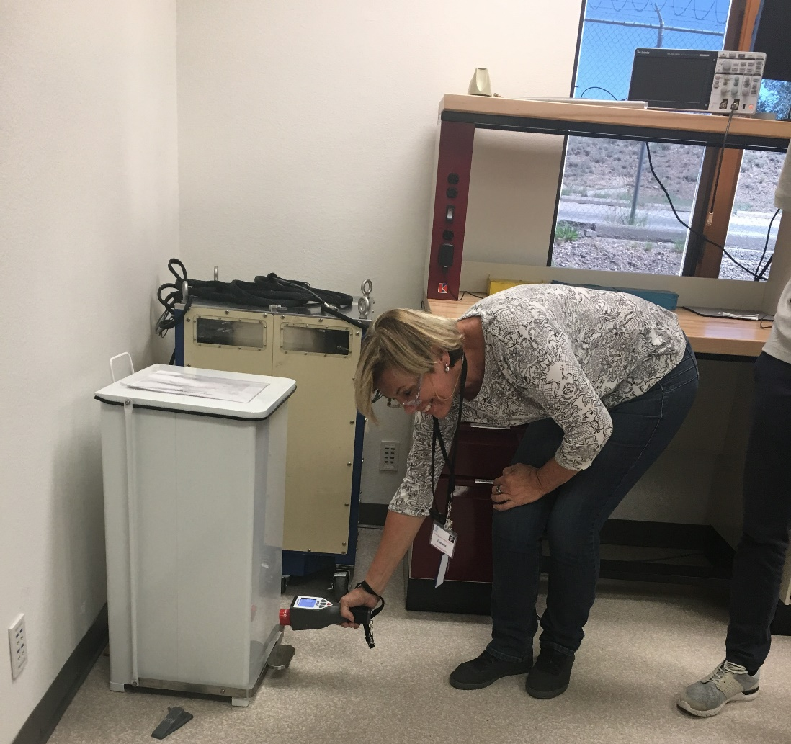
Fig. 2. Participant Glaucia Tanzillo Santos uses a hand-held gamma detector to search a container of trash for the “missing” nuclear material.
The group then investigated the cause of this irregularity, which pointed at a violation of the two-person rule by the senior MBA custodian while the vault was open.

Capstone Scenario 2
In this scenario, the group discovered an irregularity during a routine PIT, where a container present in the vault is not on the NMAC accounting system, and the one on the accounting system is not physically in the vault. A material search and PIT of all the vaults in the MBA revealed that a container from one vault was swapped with a container with a very similar number from another vault in the MBA. Since neither container matched the NMAC accounting system, an irregularity investigation procedure was triggered. The group then characterized both containers to confirm the veracity of the container information. As the gross weight, isotopic composition, and nuclear material mass of the container all matched the NMAC accounting system, they concluded that the containers were in the wrong place.
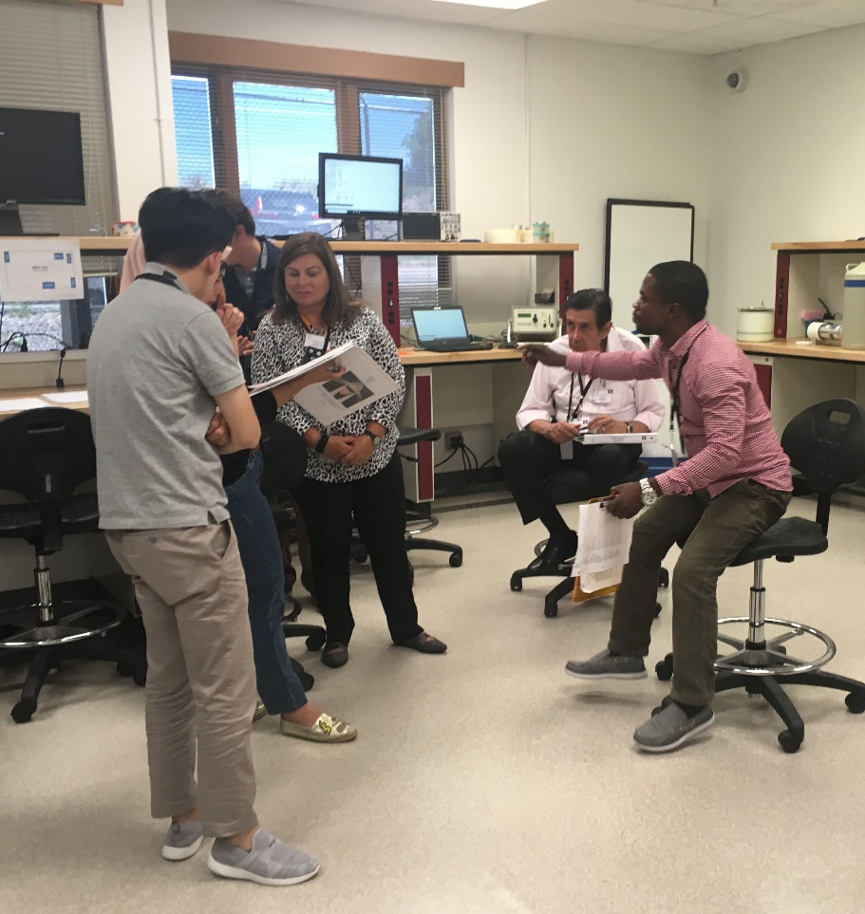
Fig. 3. Capstone Scenario 2 facilitator Geneva Johnson (centre) engages her group to discuss next steps in the irregularity investigation.
The irregularity investigation revealed that both items were received into the MBA at the same time and put in the same position in the wrong vaults within the MBA.

Capstone Scenario 3
In this scenario, a container was found in the vault that is not recorded in the NMAC accounting system. During PIT, the group discovered that the relevant container does not have a corresponding entry in the NMAC accounting system. Following the irregularity investigation procedure, the group characterized the found container with weighting, gamma measurements, as shown in Fig. 4 and a neutron measurement. Although there was no corresponding entry in the NMAC accounting system, they observed that the gross weight, isotopic composition, and nuclear material mass of the container all match the label on the container. The instructors and facilitators ensured that participants confirmed calibration and measurement control status of their instruments. The group ensured that a proper entry into the NMAC accounting system was made and recognized the need to initiate an investigation into the root cause of the irregularity. Careful examination of the receipt log for the MBA showed that while the item was recently shipped into the MBA and assigned to the vault location in which it was found, the NMAC system updated column was never initialled. Since the item entry wrapped to a second page of the shipping manifest, the group concluded that the container could have been simply forgotten by the NMAC department and the incident an accident. They also recognized that an insider may have staged the mistake or not given the second page to the NMAC department to steal the nuclear material later. The facilitators highlighted that the lack of its entry into the NMAC system prevented it from being accounted for altogether, and that this could be a very difficult event to catch.
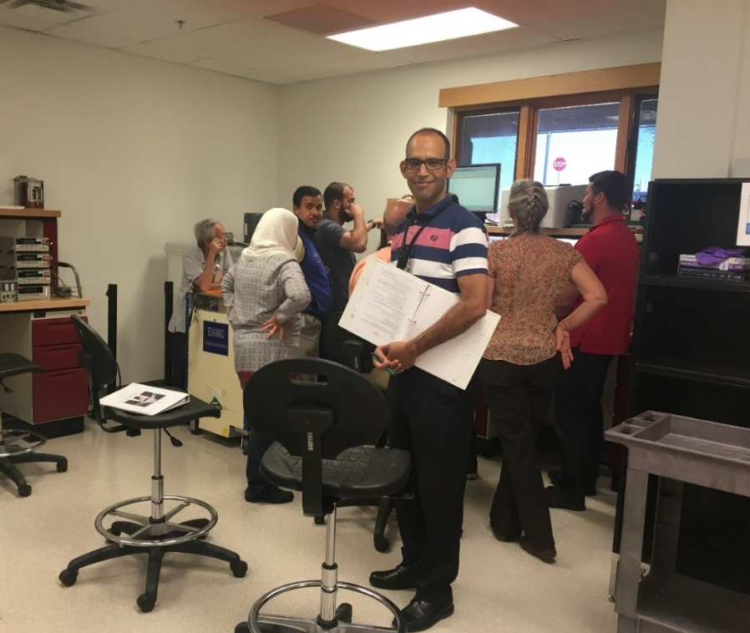
Fig. 4. Instructor Abdeljalil Jraut guides his group through Capstone Scenario 3; participants in the background are completing a gamma measurement on a “discovered” nuclear material item.

lessons learned and next steps
At the conclusion of the pilot course, course surveys were completed by all participants, pictured in Fig. 5. The comments were universally positive about the value of such hands-on training, and the pilot course received high marks for relevance to the participants’ responsibilities in their home organizations. The primary lessons learned included:
- The clear need to expand participant numbers to fulfil demand;
- The clear value of the Capstone exercise using nuclear material and actual equipment;
- The value and necessity of rehearsing the Capstone scenarios;
- The value and necessity of Capstone facilitators who had practiced the Capstone scenarios prior.
Fig. 5. Participants, instructors and LANL course staff at the completion of the pilot course.
ACKNOWLEDGEMENTS
The authors would like to express appreciation to the U.S. DOE/NNSA Office of International Nuclear Security for their support of this pilot course.
References
- IAEA, Nuclear Material Accounting and Control (NMAC) for Nuclear Security (24 September 2018), www.iaea.org/resources/online-course/nuclear-material-accounting-and-control-for-nuclear-security (access permission required from IAEA)
- IAEA, National Training Course Use of Nuclear Material Accounting and Control (NMAC) for Nuclear Security Purposes at Facilities, Iraq (hosted in Jordan) (2-6 April 2017) www.elearning.iaea.org
- Baum, g., 27th International training course on physical protection of nuclear materials and nuclear facilities, Report No. SAND2018-10973R, Sandia National Laboratories, Albuquerque, New Mexico, USA, 2018 internal report, Organization, Location, Year.
- Use of nuclear material accounting and control for nuclear security purposes at facilities, IAEA Nuclear Security Series No. 25-G, IAEA, Vienna (2015)
- Nuclear Security Glossary, IAEA Nuclear Security Series Glossary v1.3, IAEA, Vienna (2015)
- Nuclear Security Recommendations on Physical Protection of Nuclear Material and Nuclear Facilities, INFCIRC No. 225 Rev.5, IAEA, Vienna (2011).
- Computer Security of Instrumentation and Control Systems at Nuclear Facilities, IAEA Technical Guidance No. 33-T, IAEA, Vienna (2016)
- Nuclear Material accounting Handbook, IAEA 2015Services Series No. 15, IAEA, Vienna (2008)
- American National standard, for methods of Nuclear Material Control-Measurement Control Program-Non-destructive Assay Measurement Control and Assurance, ANSI N15.36-2010 (2010)
- American National standard, for Calibration Laboratories and Measuring and Test Equipment—General Requirements, ANSI/NCSL Z540-1-1994 Part I (1994)
- DOE, Instructional Analysis/Developer Fundamentals, https://ntc.doe.gov (access permission required from DOE)
- Martin, O., Non-proliferation and National Security Centre TA-66 Training and Research Facility, Report No. LA-UR-16-21380, Los Alamos National Laboratory, Los Alamos, New Mexico, USA 2016
- IAEA, Nuclear Security portal, https://nusec.iaea.org/Portal/Default.aspx (access permission required from IAEA).

