International Conference on Nuclear Security
Vienna, Austria, 10-14 February 2020

BIOGRAPHICAL SUMMARY FOR SPEAKERS
NAME: | Fadhil Hawi Mizban
SESSION # | Physical protection systems: evaluation and assessment
PAPER TITLE: | Challenges of maintaining the security of radioactive sources of categories 1,2 and 3 in case of abnormal conditions
AFFILIATION/COMPANY: | Iraqi Radioactive Sources Regulatory Authority (IRSRA)
SHORT BACKGROUND FOR INTRODUCTION (2-3 LINES) to be included in the IAEA Conference and Meetings App: | Fadhil Hawi Mizban, Nuclear Engineer, Master Degree in radiation protection ,Director of Research and Development in Iraqi Radioactive Sources Regulatory Authority (IRSRA), along the past 15 years work in field of safety and security of radioactive Sources, instrumentation and calibration , radiation emergency, search and recover of lost sources..

Release of Electronic Presentation

I agree that my electronic presentation provided at the International Conference on Nuclear Security: Sustaining and Strengthening Efforts to be held at the IAEA’s Headquarters in Vienna, Austria, from10 to 14 February 2020 is included in the conference proceeding and made available in the IAEA Conference and Meetings App as a PDF.

Signature

______________ 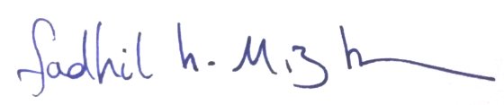__________________

Please complete and return this form by email to:
Technical officer@iaea.org by 27 January 2020

