Security harderning of low dose laboratory irradiator- Gamma Chamber

D. K. SAHOO
Board of Radiation and Isotope Technology
Navi Mumbai, India
Email: dksahoo@britatom.gov.in

P. SRIVASTAVA
Board of Radiation and Isotope Technology
Navi Mumbai, India
Email: piyush@britatom.gov.in

- K. KOHLI
Ex-Board of Radiation and Isotope Technology
Navi Mumbai, India
Email: cebrit@gmail.com

G. GANESH
Ex-Board of Radiation and Isotope Technology
Navi Mumbai, India
Email: ganeshg.gg@gmail.com

Abstract

Board of Radiation and Isotope Technology (BRIT) is engaged in production and supply of various radiation based equipment such as laboratory irradiators, blood irradiators, radiography devices etc. These devices are used in various institutions such as university, hospital and industries. Different sources such as Co-60, Ir-192 and Cs-137 etc. are used in these devices. These radiation based devices with source are transported in the public domain and they are kept in the universities, research centre, hospitals etc. without much security. Hence, these radiation devices are much more vulnerable to sabotage than other devices which remain in nuclear establishments. Security of sources in these devices becomes more important. Gamma chamber which is widely used in universities and hospitals & research institutions was studied for its security hardening. These equipment are self-shielded devices in which a number of Co-60 source pencils are placed in a cylindrical cage. The Gamma chambers are type approved as equipment and as a transportation package conforming to various national and international safety standards. But these Gamma chambers were not earlier designed keeping in view the security aspects which has become more relevant now. There is need to secure such devices against different malicious acts. A mock drill was conducted to remove the sources from the Gamma chamber at the installation site. Two people were given a basic idea of the equipment, a few tools and a drawing to take away the source and record the adversary time. Based on the mock drill a number of design features are incorporated. The paper covers details on the mock drill conducted on the Gamma chamber and a number of modifications which have been carried out in the design of these equipment to increase the adversary time such that it is greater than the expected response time. The study will help in design modification of similar equipment carrying radioactive material.

Keywords: Gamma chamber, Response time, Adversary time

INTRODUCTION
Board of Radiation & Isotope Technology (BRIT), a unit of Department of Atomic Energy, India is manufacturing and supplying low dose laboratory irradiator called Gamma chambers to various university and research centres. These Gamma chambers are used for number of research applications and are based on Co-60 radiation sealed sources. Sectional view of a typical Gamma chamber is shown in Fig. 1.The Gamma chambers are self-shielded devices in which number of Co-60 source pencils are placed in a cylindrical cage. The cage surrounds a cylindrical sample chamber in which the material to be irradiated is placed. The irradiation takes place when the sample chamber is brought in front of the cage containing the Co-60 pencils. The sample chamber is part of an electrically driven drawer assembly which can move up and down as desired. For putting the samples for irradiation, the drawer is moved up fully so that the sample chamber comes out of the shield to enable the cover of the sample chamber to be removed. After placement of materials for irradiation, time needed for irradiation to deliver the desired radiation dose is set on the control system which then initiates movement of drawer to the irradiation position and then bring it up after the set irradiation time. BRIT earlier used to make Gamma chamber model GC-900 in which the sample chamber had a volume of 900 cc. Another model GC-4000A was introduced which had a sample chamber volume of 4000 cc. Both these models which were using carbon steel as material of construction have now been discontinued. BRIT currently makes GC-1200 and GC-5000 models with sample chamber volume of 1200 and 5000 cc respectively. Both these models are using austenitic stainless steel as material of construction. All the Gamma chamber models are having similar design features and have an especially designed transportation crate to facilitate the transportation within the country or for export. The Gamma chambers are designed keeping in view the requirements as specified in ANSI Standards [1] for self- contained irradiators as well as transport packages [2-3]. The Gamma chambers are approved for transportation by road, sea as well as by air.
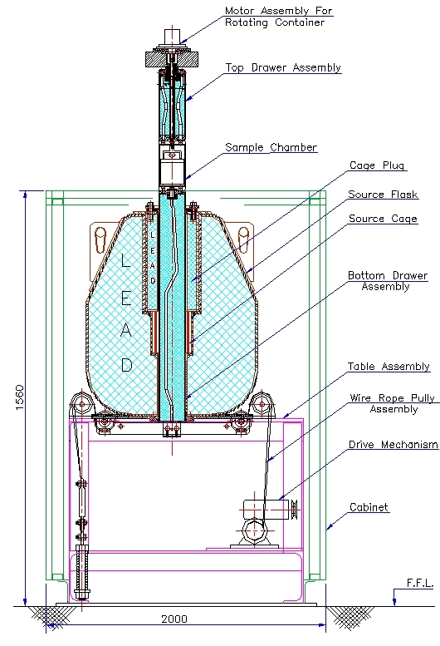

Fig. 1. Sectional View of a Typical Gamma Chamber

The Gamma chambers in India are type approved as a device and a transportation package separately by Atomic Energy Regulatory Board. The design of these conforms to American National Standard – ANSI/HPS N 43.7 - 2007 for Safe Design and Use of Self Contained Dry Storage Gamma Irradiator (Category –I) [1]. Stringent requirements of safe transportation of radioactive materials as stipulated in various national and IAEA safety standards are to be met in design of the irradiator. The design must meet the Type B (U) requirements for both normal and accidental conditions of transport. However, the design of Gamma chambers did not take account of security considerations [4-6]. Two scenarios can be considered in security of a Gamma chamber:

- Theft of radioactive material into a makeshift shielding container for utilizing it later
- Blasting of the Gamma chamber when it is installed or during transportation to spread the radioactive material
The paper is limited to the theft of radioactive material from the Gamma chamber during transport or at its installed position. A mock sabotage was carried out on the Gamma chamber to study the security aspects. The paper describe concepts involved in design modifications to ensure that the adversary task time - the time an adversary may take to remove and take away the radioactive material is much larger than the response time for security forces to thwart such an attempt.

Method

Security Response Time
The response time (T_{r}) is the time which may be needed by security forces to reach the Gamma chamber installation on getting an alarm on the possible sabotage attempt. The Gamma chamber is enclosed in a cover which needs to be opened before any attempt of theft can take place. Gamma Chamber installations are in a secured boundary which cannot be breached in normal circumstances. Considering that there can be a breach in the boundary by the adversary and he is able to reach the Gamma chamber installation which may be part of a large complex, then time required for security forces to reach such an installation on getting an alarm is expected to be not more than 30 minutes.

2.2 Adversary task time

Adversary task time (Ta) is time needed by a well-trained adversary or adversaries equipped with necessary tooling to remove and take away the radioactive material from Gamma chamber. Higher adversary time indicates the equipment to be “secured”. The security features of radiation based equipment should be designed according to equation 1.
T_{r} < Ta (1)

An exercise was carried out on the existing design of Gamma chamber to get an idea about the adversary time. A set of two trained persons with necessary tooling and makeshift shielded container were considered. The tooling included a general purpose tool kit, eye bolts, D-shackles, chain pulley block with a folding stand, trolley etc. which can be easily carried. Fig. 2 depicts the four stages in removal of sources in such an exercise.

Fig. 2(a). Removal of outer cabinet |  | Fig. 2(b). Removing the cage plug
Fig. 2(c). Removing the source cage  with pencil | Fig. 2(d). Taking away container with source

Fig. 2. Stages showing removal of sources in the exercise
To have access to the cage containing radioactive source, one has to first remove the outer cabinet as shown in Fig. 2(a). The top part of the drawer assembly can be detached by removing the socket head cap screws which enable removal of the cage plug which secure the source cage. Fig. 2(b) shows the removal of cage plug. The bottom drawer which is attached to a wire rope and drive arrangement for movement of the drawer assembly can obstruct the access to the source. Cutting the wire rope can make the bottom drawer to fall by gravity and give access to the source cage. The source cage consists of set of tubes with a flange on each side and can be pulled up once the drawer falls as shown in Fig. 2(c). The source can be transferred to a makeshift container and taken away as shown in Fig. 2(d). As it emerged, the time required for such a task was much lower than the desired 30 min response time as mentioned before.

3.0 Design modifications

The following paragraphs describe the concepts involved in number of modifications which has been incorporated to increase the adversary task time. The exact details of these modifications are not presented here for obvious reasons. The underlying concepts only are covered.

  - Adoption of alarm switch

In order to access the shielded housing containing the radioactive sources, the top cover of outer cabinet has to be removed. A switch with concealed wiring has been incorporated with the cover which will initiate an alarm once it is detached from the housing.

  - Use of additional socket head cap screws with fine pitch

Cage plug is securing the cage with number of hexagonal headed bolts in the earlier design. In order to increase the time of removal of bolts, more number of countersunk hexagonal headed cap screws with fine pitch are added in addition to the existing hexagonal bolts which attach the top plug with the main body of the cask as shown in Fig. 3.

  - Hurdle in attaching the Allen key

In order to make it more cumbersome and time consuming, the screw heads are filled by steel buttons as shown in Fig. 4. Without removal of steel buttons, it is not possible to use the Allen key and filling up the cavities hides the socket head cap screws on the lead plug also. This will considerably increase the amount of time in removing the cage plug.

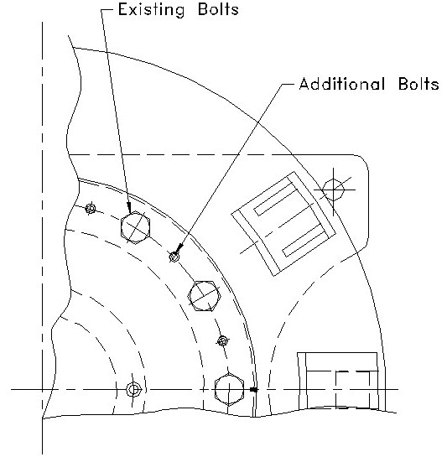  Fig. 3. Sketch of Top view showing arrangement of bolts and screw | 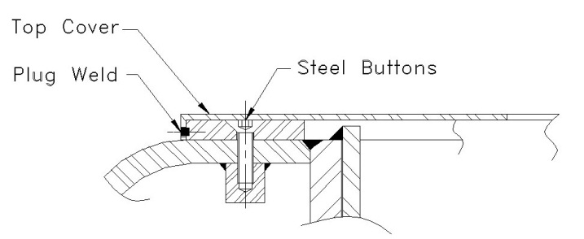  Fig. 4. Sketch of top cover plug welded with flange of cage  plug.

  - Hidden cover over the screws

To provide further hindrance in access to the cage plug, a cover plate as shown in the Fig. 4 is put which itself will be plug welded on the side at three places in an orientation which will be recorded and kept with the manufacturer only. The outside surface of the cover plate will be kept polished to hide the welds. It will not easily identifiable to locate the position of plug welds.

  - Modification in drawer design

In the earlier design, once the wire rope was cut bottom drawer fell by gravity making easy access to the source cage. In order to avoid the falling of bottom drawer an electrical plunger at the bottom of the drawer as shown in Fig. 5 is provided which can be operated by motive power only and for which a system password is needed. In addition, a stopper plate is attached to the bottom drawer to prevent it from lifted up from the top. These mechanical restraints will make the task difficult and the adversary time even longer.

  - Modification in source cage design

In the earlier design, there was no cover on the inside of the source cage. A stainless steel cover called source guard is now provided on the inner periphery of the source cage to prevent attachment of any hook to the cage to facilitate its removal as shown in Fig. 6. In addition, source cage is modified in such a way that a specific tool is required to grapple it which can be done only in hot cell with the help of the grappling tool.

Fig. 5. Actuator with plunger arrangement with the bottom drawer | Fig. 6. Modified source cage

The above features are expected to make the adversary task time to be several hours. In fact, absence of some particular gadget or vital information may make the attempt impossible to be completed.

- Conclusion
Radiation technology based equipment like Gamma chamber can be an easy target to persons with mala fide intent as these are widely used in Hospitals and Universities where public access is there. Earlier design of such devices did not account for security considerations. There may be a possibility to remove radioactive sources from such equipment by trained persons with mala fide intent before security forces can respond to it. Fresh thinking has been given to security aspects and many features have been introduced which make the adversary task time to be much longer than the security response time to effectively prevent any such attempt.

ACKNOWLEDGEMENT
The authors thank the entire team of REPF workshop, Gamma chamber assembly group, V.V.S.S. Prasad, A. S. Gengje, S. S. Bhoir, C. M. Panchal & S. P. Vaidya for providing necessary support. Special thanks to S. Gaikwad and Ravi More for providing to carry out this mock drill.

REFERENCES
[1] ANSI- AMERICAN NATIONAL STANDARDS INSTITUTE, Safe Design and Use of Self Contained Dry Storage Gamma Irradiator (Category –I), ANSI/HPS N 43.7 (2007)
[2] IAEA – INTERNATIONAL ATOMIC ENERGY AGENCY, Regulations for the Safe Transport of Radioactive Material, SSR-6(Rev.1), (2018).
[3] AERB - ATOMIC ENEGY REGULATORY BOARD, Safe Transport of Radioactive Material, AERB/NRF-TS/SC-1 (Rev.1), (2015)
[4] ATOMIC ENERGY REGULATORY BOARD, Safety Guide on ‘Security of Radioactive Sources in Radiation Facilities’, AERB/RF-RS/SG-1, Mumbai, India, (2011).
[5] ATOMIC ENERGY REGULATORY BOARD, Safety Guide on ‘Security of Radioactive Material during Transport’, AERB/NRF-TS/SG-10, Mumbai, India (2008).
[6] IAEA – INTERNATIONAL ATOMIC ENERGY AGENCY, Security of Radioactive Sources, IAEA Nuclear Security Series no. 11, (2009)

