# NUCLEAR SECURITY MEASURES TO ADDRESS BEST PRACTICES ASSOCIATED WITH NUCLEAR/RADIOLOGICAL THREATS FOR MAJOR PUBLIC EVENTS

S. BUNTMAN

U.S. Department of Energy/National Nuclear Security Administration, Office of Nuclear Incident Policy and Cooperation (DOE/NNSA)

Washington, D.C., United States of America

Email: [steven.buntman@nnsa.doe.gov](mailto:steven.buntman@nnsa.doe.gov)

R. MAURER

U. S. Department of Energy/National Nuclear Security Administration, Mission Support and Test Services, LLC, Remote Sensing Laboratory (DOE/NNSA)

Andrews AFB, Maryland, United States of America

S. WHITE

U.S. Department of State, Embassy Panama City (DOS)

Panama City, Panama

L. HERRERA

Panama Ministry of Health, Directorate of Public Health, Department of Radiation Health

Panama City, Panama

Abstract

The U.S. Department of Energy/National Nuclear Security Administration (DOE/NNSA), International Atomic Energy Agency (IAEA), U.S. Department of State’s Export Control and Related Border Security Program (EXBS), and the Government of Panama unified and coordinated an approach that demonstrated best practices for nuclear security measures for Major Public Events (MPEs), as outlined in the IAEA Nuclear Security Series 18 (NSS-18), at the 2019 World Youth Summit in Panama City, Panama during January 22-27, 2019. This paper will outline the key factors which resulted in a successful, safe and secure event with no radiological or nuclear incidents.

## INTRODUCTION

Major Public Events (MPEs) are challenging environments in which to conduct nuclear security measures. Many of these events are conducted at the national level and involve long lead time planning efforts and cooperation among a large number of local, state, and federal agencies. The country hosting the event works on national planning guidance specifically for these types of events. These events typically also have international interest whether through attendance by participants from many countries, including Heads of State, to high profile television and media coverage. Examples of high profile MPEs include sporting events, such as the Olympic Games and World Cup Competitions, and political/economic events such as the G20 and ASEAN Summits. With extensive international media coverage, these high profile MPEs provide an attractive target for radiological/nuclear terrorism or criminal act. Although the radiological/nuclear threat risk at MPEs is typically low, the economic and political consequences of such an incident would be catastrophic.

The requirements for MPE security, preparedness, and operational capabilities for nuclear/radiological monitoring, detection, and surveillance have steadily increased in recent years. The intent is to not only protect the public from an incident or attack, but also to deter terrorists by displaying a strong readiness capability. A potential target will look more daunting to a terrorist with the presence of visible security and law enforcement, including metal detectors, x-ray machines, and explosive detectors at pedestrian entrances. Of equal importance is having monitoring and response team’s ready to respond to chemical, biological, and nuclear/radiological incidents. This requires joint planning, coordination, and preparedness (e.g. training, drills, and exercises) to ensure a harmonized and effective operational structure among all participating first response and security organizations.

The threat of nuclear or radiological terrorism is of great concern to countries hosting MPEs. Since MPEs are planned long in advance, terrorist groups have time to prepare their own malevolent actions for such events. The work of the IAEA, U.S. DOE/NNSA and Member States continues to be central to meet the challenges associated with the safe and successful implementation of MPEs. The IAEA, DOE/NNSA and other Member States have been working to develop guidelines based on best practices and lesson learned from previous events, as noted in the IAEA Nuclear Security Series No. 18, Nuclear Security Systems and Measures for Major Public Events, Implementing Guide [1]. These requirements need to be periodically reviewed and shared to maintain a strong nuclear security structure for MPEs.

## PLANNING AND PREPAREDNESS

Nuclear security planning for MPEs requires interagency cooperation, especially among the radiation experts and law enforcement personnel whose work areas may not normally overlap. Front line officers (FLO) can be readily trained to use radiation pagers at pedestrian portal entrances to interdict individuals causing alarms. They should work in close coordination with radiation experts and law enforcement to adjudicate the alarms. By leveraging FLO, radiation experts and law enforcement personnel, the overall effect is force multiplication. By managing and supervising the efforts of the recently trained teams, the radiation experts can advise on tactics and techniques as well as adjudicate alarms and suspicious detector readings. Integration of first responders, event security screeners, and law enforcement personnel into the overall security operation should be coordinated early in the planning process.

Panama executed their new national concept for emergency preparedness and response associated with major public events by operationalizing an interagency team to manage CBRNE prevention and response, and integrating specialists and equipment from DOE/NNSA, Export Control and Related Border Security Program (EXBS) and the IAEA. Panama’s response teams demonstrated best practices for interagency coordination and ensured advanced capabilities were in place to prevent, counter, and respond to nuclear/radiological terrorism threats. Their unified approach enhanced coordination between civilian and military organizations, and ensured the teams were prepared to meet the nuclear security requirements for the event.

The coordinated effort was organized under a nuclear security plan that addressed security for potential threats and the capability to respond to terrorist incidents or criminal acts. The Panama CBRNE Unit coordinated its functions within Task Force San Miguel Arcángel (FTC-SMA), a group established by Executive Decree 129 of April 5, 2017 and included all of the security sections. This Executive Decree establish a protocol for response to events and serves as Panama’s legal framework for interagency coordination to address this type of events. Within this group, the sharing of knowledge and expertise, exchange of technological resources, and preparatory exercises were conducted to gain experience to implement the nuclear security measures required for complex MPE events.

In order to meet the challenges associated with implementation of the Panama CBRNE Response Teams, additional technical support and training was requested from the IAEA and the US. DOE/NNSA to provide specialized training, technical, and advisory assistance that focus on nuclear security measures for MPEs. The training courses included basic radiation principles, radiological/nuclear hazards and threats, radiation detection systems, radiation search/survey operations, alarm interdiction and adjudication, and source recovery. The courses were interactive and included detection equipment hands-on training as well as field exercises with radiation sources in the event venues. In addition, the IAEA and U.S. DOE/NNSA supplemented the Panama CBRNE teams with additional radiation detection equipment. The U.S. DOE/NNSA also provided an advisory team for the MPE to provide technical and scientific assistance as well as access to U.S. technical reach-back capabilities.

## DETECTION EQUIPMENT AND OPERATONAL TECHNIQUES

One of the key considerations to effective planning and response is radiation detection equipment. The equipment may consist of a variety of instruments, such as radiation pagers, backpack detectors, and vehicle mounted detection systems. Each radiation detection instrument is designed with a specific purpose. Some instruments are designed for operational safety, such as personal dosimeters to measure radiation exposure or health physics instruments to survey for radiation contamination. These instruments generally are readily available at most radiation facilities and laboratories but are not that useful for nuclear security operations at an MPE.

The best practice for nuclear security operations at an MPE is to use high sensitivity detectors for the detection of gamma and/or neutron radiation. Figure 1 shows a radiation pager, a backpack detector, and a vehicle mounted detection system. Each of these instruments was specifically designed to search for and locate radiation sources. The personal radiation pager (PRD) is the least expensive radiation detection instrument and the most commonly used instrument at MPEs worldwide. The PRD contains a high sensitivity, scintillation detector. The PRD detector, however, is relatively small (1 cm diameter x 2 cm length), but provides the sensitivity required for detection when the radiation source is in close proximity. As such, these detectors are used to monitor people entering an MPE through a single file checkpoint.

 



FIG 1. Examples of a radiation pager (left), a radiation backpack detector (middle), and the SPARCS vehicle mounted detection system (right). At top, pre-event training workshop for Panama responders on MPE practical field training with radiation detection instruments and radiation sources.

The best practice for performing radiation monitoring of people at an MPE is at the entrance checkpoint where the individuals are screened by a magnetometer and their bags and other items are scanned by an x-ray machine. The most common practice is for the security officer at the checkpoint to wear a PRD on their belt. It should be noted that it is important for the security officer to be in close proximity to those entering the checkpoint in order to provide the highest probability of detection. As an individual approaches the checkpoint, the security officer controlling the flow of traffic, directs them to the magnetometer and x-ray machine. While the individual is next to the security officer, the PRD is scanning for radiation from both the individual and their bag contents. The standard pedestrian security checkpoint then also functions as a portal monitor for radioactive materials (Figure 2). If an alarm occurs on the PRD, the security officer follows the security protocols to interdict the individual and request technical assistance. A technical expert assigned to that location, along with a police officer, will escort the individual to a secondary inspection area to conduct an interview, take additional measurements of the dose rate and identify the radioisotope, and adjudicate the alarm. Figure 3 shows a radiation expert conducting radioisotope identification with a RIID after detecting the box with a PRD during a routine search.



FIG 2. Example of an MPE pedestrian checkpoint with a magnetometer, x-ray machine, and security front line officer with a radiation pager.



FIG 3. Panama team member detects radiation from a construction gauge using a radiation pager and identifies the radioisotope using a RIID.

The backpack radiation detector (Fig. 1) has a larger, more sensitive radiation detector (30 times more sensitive than the PRD) and is used to conduct pre-event baseline background search/surveys of the MPE venues. With its higher sensitivity, the backpack detector can detect radiation sources at greater distances, i.e. 10’s of meters. For example, the backpack detector is an excellent tool to search/survey a large sports stadium or conference centre. A team of 6-8 operators with backpack detectors are able to conduct a thorough, high sensitivity baseline search/survey of a stadium venue in 4-6 hours. The key to effective baseline search/survey is to understand the backpack detector detection range. Using this information, an expert team leader can formulate a survey strategy that is optimized to cover 100% of the stadium venue. For example, the operator does not have to walk every row of the seating area to conduct the survey as the backpack detector field-of-view extends over multiple rows. A common strategy with a backpack detector is to walk every 3-5 rows as shown in Figure 4. The use of the backpack detector for baseline search/surveys at MPEs is a recognized best practice.

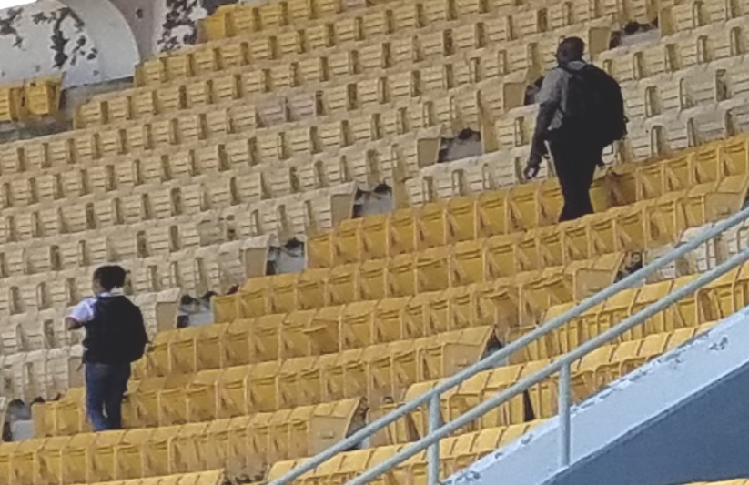

FIG 4. Backpack detector baseline search/survey of a stadium prior to an MPE using an optimized grid search pattern.

For building complexes such as conference centres, the backpack detector is used to search/survey the lobby, main hall, hallways, open areas, offices, storage areas, and mechanical areas, as well as the external grounds. At open area parks, fan fests, and outdoor festivals, the backpack detector is used to search/survey large crowds and parks. Open areas present challenges for radiation detection since there are no controlled entry points. The open area environments of a venue should also be monitored whenever activities are occurring during the MPE.

The U.S. DOE/NNSA Spectral Advanced Radiological Computer System (SPARCS) vehicle mounted detection system has high sensitivity detectors to search/survey for radiation sources in parking lots and garages, and roadways and streets near the MPE. With even larger detector sizes, the sensitivity provides a detection range of 10’s of meters while moving at low driving speeds. The search/survey operations involve driving at speeds of 5-10 km/h through parking lots and garages to provide an effective survey for radiation sources concealed in vehicles (Figure 5). When driving the roadways and streets, the detection system is used to search/survey the vehicles parked along the streets as well as any containers or concealments near the street that could potentially be used to conceal a radiation source. Using the vehicle mounted detection systems, a large roadway area can be surveyed in a short period of time. The best practice is to conduct multiple vehicle surveys leading up to an MPE and additional surveys during the event. The detector system should be mounted on the side of the vehicle closest to the parked vehicles in order to provide the highest probability of detection.

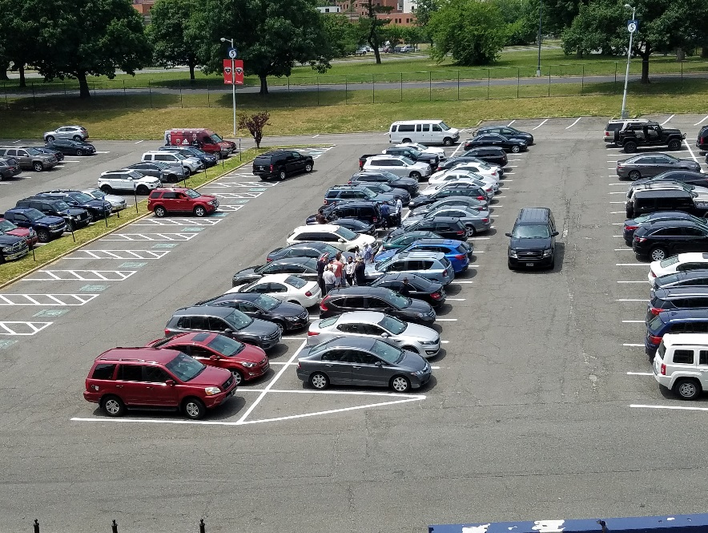

FIG 5. A vehicle mounted detection system is used to conduct a baseline search/survey of cars in parking lots and garages and parked along roadways.

The vehicle detection systems record the radiation data along with the GPS coordinates. This data can be overlaid on street maps or satellite imagery to provide emergency managers situational awareness of field operations during the MPE. Examples of several mobile surveys in around venues in Panama City are shown in Figure 6.



FIG 6.Representative SPARCS mobile track data overlaid on satellite imagery showing two areas surveyed during the Panama MPE. The color of the data points indicates the level of radiation detected, and in these images, was varying levels of natural background radiation.

## PRACTICAL EXPERIENCE

The U.S. DOE/NNSA and the IAEA have provided nuclear security support since 2006 to countries hosting MPEs. This support includes specialized training, detection technologies, technical and advisory support, and assistance with procedures to support national infrastructures in order to detect and respond to criminal and unauthorized activities involving nuclear or radioactive material out of regulatory control (MORC). The IAEA, U.S. DOE/NNSA, and other Member States have been working to develop guidelines based on best practices and lessons learned from previous MPEs. The U.S. DOE/NNSA can also offer technical and advisory assistance, such as detection equipment, to augment the Host Countries capabilities, an advisory team to support nuclear security measures, and technical reach-back capabilities at the request of the host country or IAEA.

Panama’s first experience with hosting an MPE that needed nuclear security measures what the 2015 Summit of the Americas, which brought together 40 Heads of State and a large quantity of other foreign dignitaries. The Inauguration of the Panama Canal Expansion in 2017 again challenged Panama to provide security for Heads of State and Presidents of the world’s major shipping companies. The many interinstitutional coordination challenges and lessons learned from these two events resulted in the passing of Executive Decree 129 as a way of establishing lines of command to address future needs and events. Executive Decree 129 is unique that it brought together over 160responders from multiple ministries that were trained as a unified team with coordinate command structure for both planning and implementation of CBRNE security measures

## 5. CASE STUDY – 2019 WORLD YOUTH SUMMIT

The 2019 World Youth Summit was designed to promote youth appreciation for the Catholic Church and a means of getting their voice heard from around the world. This Summit is held every two or three years. The organizers estimated that 600,000 pilgrims attended the final Mass conducted by the Pope and up to 150,000 pilgrims at various venues around the city.

Operational nuclear security training was provided to 120 first responders from 6 Ministries known as the CBRNE team. The CBRNE mission was to provide security for 12 venues throughout Panama City and activities associated with the Pope’s visit. The CBRN team leaders provided support and advisory assistance for pre-event activities to include a readiness exercise at one of primary venues, pre-event venue sweeps, choke point location recommendations, and alarm interdiction and adjudication. This included assistance with developing briefing products from the SPARCS vehicle mounted system (maps showing the data tracking results), alarm interdiction and adjudication (several hits to include industrial gauges, medical, NORM, and false alarms), equipment maintenance/repairs for U.S. DOE/NNSA, IAEA, and Panama equipment. At the request of Panama, the U.S. DOE/NNSA and IAEA provided: 205 PRDs, 15 radiation backpacks, 23 radioisotope identifiers (RIID), 2 high purity germanium identification systems (HPGe), and 2 SPARCS vehicle mounted detection systems.

This was Panama’s first event under the new Decree 81 of April 2018 that the National Security Council, under the orders from the Presidency, brings together an inter-agency team to handle CBRNE prevention and response. The team consisted of the National Border Police, National Air and Naval Service, National Police Explosive Unit, National Customs Authority, Palace Guard and Directorate of Public Health. In this structure, all response Ministries fall under the operational control of Public Security during a potential CBRNE event. Once formed, they become a CBRNE Unit. The addition of U.S. DOE/NNSA and IAEA detection equipment provided the CBRNE Unit the capability to implement a unified approach to supporting each of the 12 venues and simultaneous security operations. Each search/survey team, choke point entrance monitoring team, and emergency response team had a CBRNE member with radiation detection capabilities with reach-back access to the central Technical Operations Centre (TOC).

Panama executed their new national concept for emergency preparedness and response associated with MPEs by operationalizing an interagency team to manage CBRNE prevention and response, and integrating specialists and equipment from U.S. DOE/NNSA, U.S. DOS, and the IAEA. Panama’s response teams demonstrated best practices for interagency coordination and ensured advanced capabilities were in place to prevent, counter, and respond to nuclear/radiological terrorism threats and criminal acts. The unified approach enhanced coordination between civilian and military organizations, and ensured the teams were prepared to meet the nuclear security requirements for the event.

The CBRNE security measures implemented in the planning of an MPE is a complex task that requires a high degree of coordination, information sharing and collaboration. The international community through the U.S. DOE/NNSA, IAEA, and U.S. DOS provided radiological/nuclear emergency response training to Panama radiation and security experts prior to the event. This training provided practical field operations using best practices and detection equipment to search/survey the venue facilities, parking areas, and surrounding roadways for radiological and nuclear materials. To enhance the CBRNE team resources, additional radiation detection equipment was provided to ensure the nuclear security measures could be implemented at all of events and venues.

Response teams and security personnel conducted pre-event baseline surveys of the venues to ensure no radiological or nuclear materials were present. Once the venues were surveyed and deemed clear, they were locked down with strict access controls. Those attending the events were screened for radiological and nuclear materials at the pedestrian and vehicle security entrances. In addition, CBRNE expert teams were on standby to rapidly respond in case of an incident.

The coordinated effort was organized under a nuclear security plan that addressed security for potential threats and the capability to respond to terrorist incidents or criminal acts. The Panama CBRNE Unit coordinated its functions within Task Force San Miguel Arcángel (FTC-SMA), a group established by the new decree and included all of the security sections. Within this group, the sharing of knowledge and expertise, exchange of technological resources, and preparatory exercises were conducted to gain experience to implement the nuclear security measures required for complex MPE events.

Presented below are several best practices and lessons learned from the pre-event, main event, and emergency response aspects that the U.S. DOE/NNSA and IAEA have gained by supporting numerous national and international MPEs. Each venue will be different, but the basic strategy is the same: a) develop a robust nuclear security plan that addresses a wide range of security concerns, b) practice the plan in advance through tabletop exercises and field training events, and c) implement a unified interagency command structure incorporating both security officials and radiation experts.

Pre-Event Best Practices

* Pre-event baseline search/surveys ensure that venues are clear of anomalous radiation sources and provide the response teams situational awareness of the venues in case a response is required during the MPE. These surveys also are used to identify in advance natural radiation hotspots caused by naturally occurring radioactive material (NORM)
* Pre-event baseline search/surveys are coordinated in advance with venue and vehicle checkpoint security and occur prior to lockdown
* Security teams are briefed in advance and understand the basic operational requirements of using radiation detection instruments to ensure 100% survey coverage
* Radiation backpacks and vehicle mounted systems allow for high sensitivity surveys of large venues in minimal time

Lesson Learned

* Lack of coordination with venue security in advance causes delays in the survey team accessing the venues
* Security should be notified in advance of the types of survey equipment that is brought into the venue. Often, they are not aware of the number and size of the detection equipment used and required for these events;

## SUMMARY

The Panama CBRN Unit along with the U.S. DOE/NNSA, IAEA, and U.S. DOS, formed a unified command organization and coordinated an approach for MPE best practices as outlined in NSS-18 at the 2019 World Youth Summit in Panama City, Panama during January 22-27, 2019. The coordinated effort and the implementation of national security plans and best practices resulted in a safe and secure event with no radiological or nuclear incidents.

The threat of nuclear or radiological terrorism is of great concern to countries hosting MPEs. Since MPEs are planned long in advance, terrorist groups have time to prepare malevolent actions for such events. The work of the IAEA, U.S. DOE/NNSA and Member States continues to be central to meet the challenges associated with the safe and successful implementation of MPEs. The IAEA, U.S. DOE/NNSA and Member States have been working to develop guidelines based on best practices and lesson learned from previous events, as noted in the IAEA Nuclear Security Series No. 18 “Nuclear Security Series Implementing Guide on Nuclear Security Systems and Measures for Major Public Events.” These requirements are periodically reviewed and shared to maintain a strong nuclear security structure for MPEs.

REFERENCES

[1] IAEA Nuclear Security Series No. 18, Nuclear Security Systems and Measures for Major Public Events, Implementing Guide (2012).