Design of the Physical Protection Training Laboratory:
Strengthening Effort to Sustain Nuclear Security Capacity Building, BATAN’s Experiences
Teguh Asmoro¹, Khairul Khairul^{2,} Fatmuanis³, Naoko Noro⁴
¹ Center for Informatics and Nuclear Strategic Zone Utilization BATAN, Serpong Nuclear Research Complex, PUSPIPTEK Area, Serpong 15314, Tangerang-Indonesia, teguhasm@batan.go.id
² Center for Informatics and Nuclear Strategic Zone Utilization BATAN, Serpong Nuclear Research Complex, PUSPIPTEK Area, Serpong 15314, Tangerang-Indonesia, khairul@batan.go.id
³ Center for Education and Training, BATAN, Jl. Lebak Bulus Raya, Pasar Jumat, Indonesia, fatmuanis@batan.go.id
⁴Integrated Support Center for Nuclear Nonproliferation and Nuclear Security/Japan Atomic Energy Agency, Japan, noro.naoko@jaea.go.jp

Abstract
National Nuclear Energy Agency (BATAN), has the commitment to implement nuclear security in accordance with the requirements set in the Amendment to Convention of Physical of Nuclear Material and Physical Protection and Code of Conduct of Safety and Security of Radioactive Source. In order to develop nuclear security capacity building focus on human resources, based on BATAN Chairman Regulation 14/2013, The Center for Education and Training (CET) has the duty to perform education and training, especially in the field of nuclear science and technology including nuclear security. Developing the nuclear security program requires proper infrastructures comprised of competent human resources, competence based training program, and adequate training facilities and laboratories that meet IAEA program. This is achieved through Nuclear Security Support Center (NSSC), in order to strengthen sustainable nuclear security.
BATAN in cooperation with IAEA, US DOE, ISCN/JAEA in developing a nuclear security program, has to improve the human resources competence until the advance level through the internally or externally organized regional and international trainings. Nuclear security in BATAN is under the auspices of Bureau for Legal, Public Relations and Cooperation (BHHK) and supported by technical nuclear facilities, while CET is responsible for organizing the training program to fulfill the human resources competence for nuclear security. In addition, CET also has implemented a regional training program by instructors with national and international experience. The cooperation with the Integrated Support Center for Nuclear Nonproliferation and Nuclear Security of Japan Atomic Energy Agency (ISCN/JAEA) for capacity building of Indonesia, involving BATAN CET, began in 2015. This bilateral cooperation includes ISCN/JAEA assistance for designing and implementing Physical Protection Training Laboratory at CET.
In developing nuclear security capacity building, BATAN still has a limitation in providing a laboratory for physical protection system to perform the exercise. In the past training, it has been done in factual nuclear facilities. Physical protection laboratory consists of mock up facility and its physical protection system, detection system lab, delay system lab, assessment system lab, support system maintenance lab, detection lab for secondary check and Integrated System of PP. This paper will also describe Indonesia-ISCN/JAEA cooperation program and its achievements, and it serves as a good reference for collaboration among training centers in the region.
Keywords: human resources, training, detection, delay, assessment, training tool

- Introduction
The National Nuclear Energy Agency (BATAN) has a commitment towards implementing nuclear security, in accordance with the Amendment to the Convention of Physical of Nuclear Material and Physical Protection and Code of Conduct of Safety and Security of Radioactive Sources.
In addition, BATAN refers to Government Regulation No. 54/2012 regarding Safety and Security in Nuclear Installations, Government Regulation No. 33/2007 regarding Safety and Security of Ionized Radiation Utilization, BAPETEN Chairman Regulation No. 01/2009 regarding Physical Protection Requirements for Nuclear Facilities and Materials, and BAPETEN Chairman Regulation No. 6/2015 regarding the Security of Radioactive Sources. To comply with the Global Nuclear Security Regime as well as with the National Nuclear Security Regime as outlined above, the Chairman of BATAN signed the Nuclear Security Policy on 30 January 2015. It has become the reference for all working units, for both administrative offices and nuclear facilities, to implement nuclear security measures in BATAN.
BATAN manages and utilizes nuclear materials and radioactive sources for its research program, thus safety and security issues are important for the entire workforce. Therefore, awareness or knowledge regarding nuclear security and physical protection needs to be introduced to employees. This will help employees to understand that credible threats exist in the BATAN nuclear facilities. Thus, BATAN needs to formulate training programs on nuclear security and physical protection, with the International Atomic Energy Agency (IAEA) syllabus as the main reference. In addition, BATAN has sent personnel working on nuclear security to various nuclear security and physical protection training programs overseas, to ensure that the proper knowledge and understanding are attained.
Employees who have completed the overseas training are mandated to share their acquired knowledge through training or knowledge-sharing sessions. As BATAN has multiple different facilities distributed throughout the region, these facilities possess different kind of risk. This adds urgency to BATAN’s nuclear security awareness programs, so that sabotage and theft might be mitigated and prevented.
Nuclear security capacity building focuses on developing human resources. Thus, based on BATAN Chairman Regulation No. 14/2013, the Center for Education and Training (CET) has been assigned the role and responsibility of performing education and training in the field of nuclear science and technology, including nuclear security. Developing a nuclear security program requires proper infrastructure such as competent human resources through the competence-based training program. It also needs adequate training facilities such as laboratory equipped with detection system, access control system, video surveillance system and integrated system, assessment and response. Physical protection system laboratory design in the Serpong Nuclear research complex was established by the cooperation of CET alongside with Center for Informatics and Nuclear Strategic Zone Utilization (PPIKSN) and Bureau for Legal, Public Relations and Cooperation (BHHK). This is a manifestation of BATAN’s commitment to develop nuclear security and physical protection knowledge in compliance with the IAEA program, through the Nuclear Security Support Center (NSSC). The establishment of this laboratory under the auspices of CET/NSSC/BATAN acts as a guarantor of sustainable improvement on nuclear security and physical protection system knowledge. This effort is also an implementation of the IAEA-Nuclear Security Series No. 30-G, Sustaining a Nuclear Security Regime, particulary at the operational level [1].
Multiple methods have been used by BATAN to develop its employees’ knowledge on nuclear security (including physical protection system, nuclear security culture, and nuclear security culture self-assessment). Among them is cooperation with international organizations and overseas centers of excellence. This cooperation also involves the states operating nuclear power plants, as in general they have higher capability to conduct nuclear security and physical protection training. In summary, BATAN has established a cooperation with IAEA, the United States Department of Energy (US DOE), King’s College London, along with Integrated Support Center for Nuclear Nonproliferation and Nuclear Security/Japan Atomic Energy Agency (ISCN/JAEA) for various nuclear security knowledge training programs. For these training programs, CET/BATAN has developed a graded training scheme, starting with the fundamental/basic level, intermediate level, and advanced level. Basic level training can be completed in CET/BATAN; however for the intermediate and advanced level training, BATAN sends their employees to IAEA-organized trainings. These attempts aim to train a technical expert/subject matter expert on nuclear security, who are then capable of delivering the course to South East Asian participants, moreover to the Interregional Training Course.
In BATAN’s organizational structure, the body responsible for nuclear security is BHHK, supported by the technical nuclear facilities in the five BATAN nuclear research complexes. The body responsible for human resources competence in nuclear security is CET, in its role in organizing nuclear security training programs. CET has also conducted a regional training program delivered by instructors with national and international experiences.
In developing nuclear security capacity building programs, BATAN is still limited by the lack of a laboratory for physical protection systems, to perform various exercises. Past training has been done in factual nuclear facilities. It is thus necessary to develop a physical protection laboratory to support the nuclear security capacity building, especially for the training program.
- The Design of the Physical Protection Laboratory
CET/BATAN has conducted several physical protection trainings for the BATAN employees, with security unit and physical protection system officers as the participants. Further, BATAN has conducted regional training on security of the radioactive sources and physical protection, i.e. IAEA-Regional Training Course on Physical Protection and Security Management for Research Reactor. BATAN also became a three-time host for the Regional School on Security, supported by IAEA. In 2020, Indonesia will become the host for said training program for the fourth time. These trainings held by BATAN adhered to the IAEA-Nuclear Security Series No. 31-G, Building Capacity for Nuclear Security [2], to build nuclear security capacity through training programs.
Generally, physical protection training programs are held in a classroom, with the participants later visiting nuclear facilities in order to observe the embedded physical protection equipment. It should be noted that the host is not supposed to reveal or show the embedded physical protection equipment locations, as they hold sensitive information. This problem is anticipated by the introduction of a physical protection system laboratory, using a mock-up facility. This laboratory will greatly help the participants to gain more insights on the detection, delay, and response on the physical protection equipment [3]. A physical protection system laboratory (PPS) is situated in the Serpong nuclear research complex, is 28 x 12 m in size and has several inner rooms. This laboratory can accomodate up to 6 PPS exercises in a year, with 20–30 participants. These participants are expected to improve the management and maintenance of the physical protection systems.
The PPS laboratory provides these following facilities:
- Contraband Detection Room
This room is used for contraband detection equipment exercise.
The available equipment are as follows:
- Metal Detector
- Check Gate Metal Detector
- Survey Meter
- Explosive Detector
Training participants are expected to be capable of doing the exercise of:
- Using contraband detection equipment
- Capable of detecting people who attempt to smuggle dangerous metal goods using the metal detector component of a check gate detector.
- Capable of searching and finding the smuggled metal goods using a handheld metal detector.
- Capable of searching and finding the smuggled explosive materials using an explosive detector.
- Capable of searching and finding people who attempt to smuggle nuclear materials and radioactive sources using a handheld surveymeter.
- Capable of finding hazardous materials inside people’s bags using an x-ray machine.
- Detection System Room
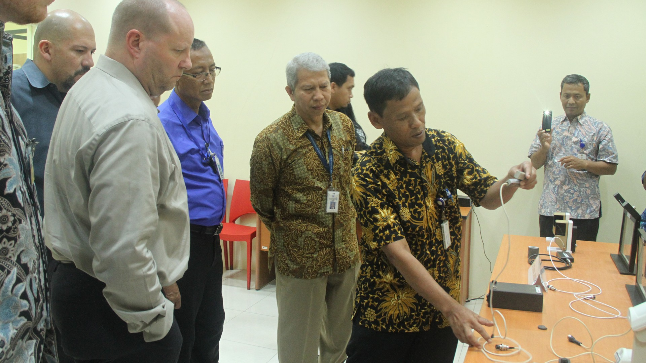
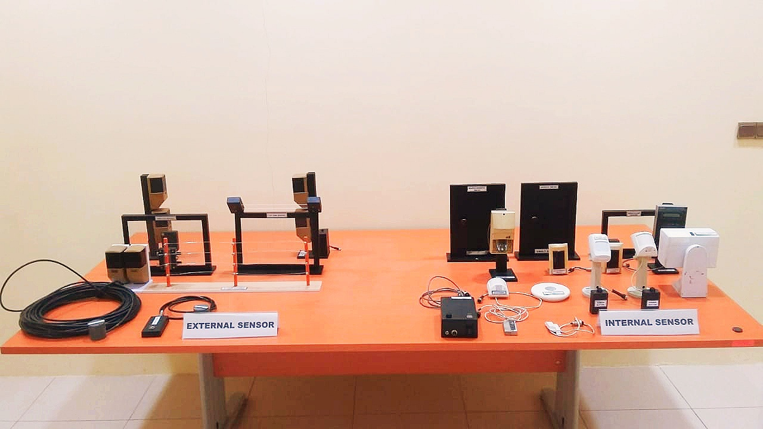
This laboratory is used for the external and internal sensor or detection system exercise.

Figure 1. Detection System Laboratory

The available equipment are as follows:
- Internal sensors:
  - Magnetic Switch.
  - Balance Magnetic Switch.
  - Passive Infrared (PIR).
  - PIR Dual Tech.
  - PIR 360˚.
  - Break Glass Sensor.
- External sensors:
  - Active Infrared Sensor.
  - Microwave Sensor.
  - Taut Wire Sensor.
  - E–Field Sensor.
  - Seismic Sensor.
  - Vibration Sensor.
Training participants are expected to be able to:
- Understand the mechanism of the external and internal sensors.
- Understand the strengths and weaknesses of each sensor.
- Understand the characteristics of each sensor.
- Understand the detection pattern of each sensor.
- Equip the sensors properly.
- Understand the sensor probability.
- Camera Assessment Exercise Room
This room is used for the camera assessment system exercise.
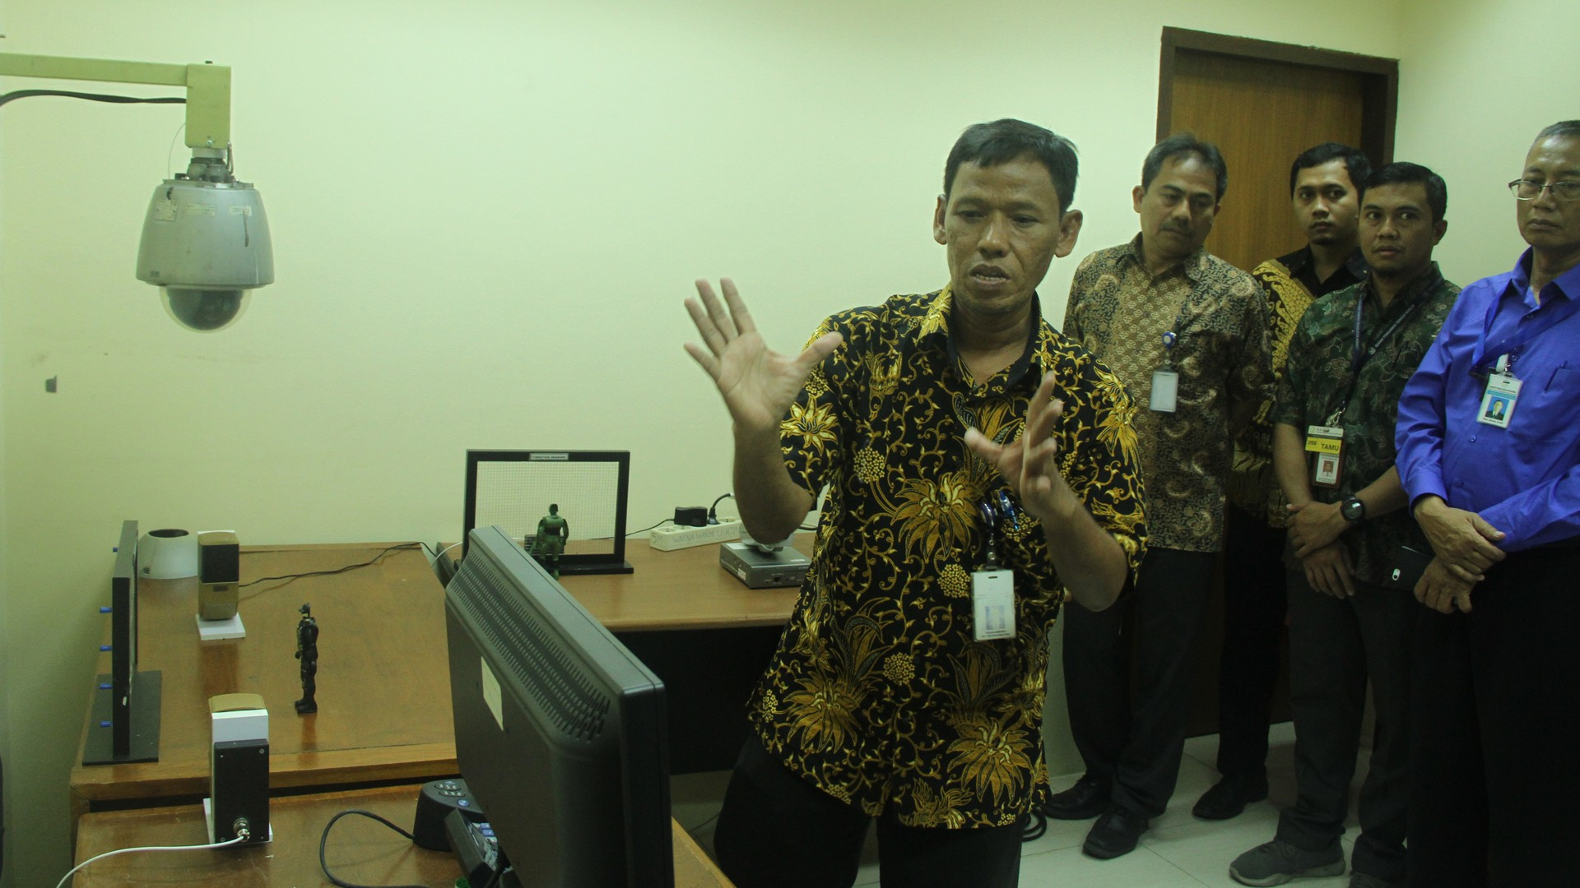
Figure 2. Camera Assesment Exercise Room
The available equipment are as follows:
- Analog Camera.
- IR Camera.
- Day/Night Camera.
- IP Camera.
- PTZ Camera.
- Encoder
- DVR/NVR.
Training participants are expected to:
- Understand the function and utility of each assessment camera.
- Understand and operate the DVR/NVR.
- Understand the mechanisms of analog cameras and digital cameras.
- Distinguish analog cameras from digital cameras.
- Distinguish the IR cameras from day/night cameras.
- Configure the camera assessment system.
- Configure the camera’s motion-detection video (VMD).
- Convert the recording format from the standard H 264 to MP4.
- Backup Recorded data to other media (thumb drives or CD).
- Access Control System Room
This room is used for the access control equipment system exercise.
The available equipment are as follows:
- Interface Access Control.
- Proximity Card.
- Proximity Reader Sensor.
- Proximity Reader & PIN Sensor.
- Biometric Sensor.
- Electromagnetic Lock.
- Exit Button Switch.
- Emergency Exit.
Training participants are expected to:
- Understand the mechanism of proximity reader sensors, proximity readers with PIN, and biometric sensors.
- Distinguish from the single reader access control system from double reader access control system.
- Operate the single reader access control system and double reader access control system.
- Complete data entry of the employees’ cards and names into the access control system database, adjusting each individual’s access level.
- Configure the access control system so hardware and software can synergize.
- Integration of Physical Protection System Exercise Room
This room is used for the integration of physical protection system exercise.
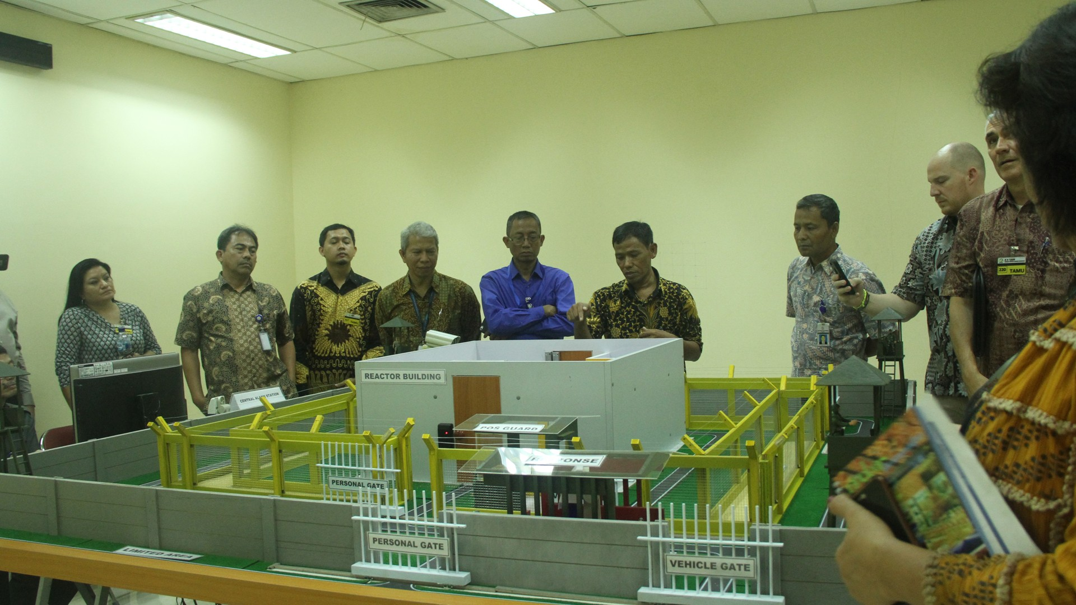

Figure 3. Exercise Room of the Physical Protection System Integration

The available equipment are as follows:
- Detection System
- Access Control System
- Camera Assessment System
Training participants are expected to:
- Illustrate the complete set of PPS equipment in one location (detection, access, control system, and camera assessment).
- Understand the alarm communication displayed in the monitor.
- Understand the mechanism of direct assessment of the camera (pop-up) when the sensors fire off the alarm.
- Understand how to connect one device to another device.
- Understand how to configure and integrate between alarm management system (AMS), access control system (ACS), and video management system (VMS).
- Understand how to configure the system as a whole, so hardware and software can synergize.
- Potential Training Course
CET BATAN has formulated the training plans for the training programs on the physical protection system laboratory. This plan is to develop the training on this laboratory, consisting of both national and international scale trainings. These trainings are expected to increase the competence of the security unit and PPS operator, PPS maintenance unit, system development, and equipment testing before getting equipped in the desired location.
The formulation of the training program is adhere to the trainings from the IAEA-Nuclear Security Series No. 12, Educational Program in Nuclear Security [4]. The program is adjusted to the needs and capabilities of BATAN. Moreover, the program is referencing to the training modules/syllabuses developed by the US Department of Energy, with Sandia National Laboratory and Pacific Northwest National Laboratory, and with Integrated Support Center for Nonproliferation and Nuclear Security (ISCN)/Japan Atomic Energy Agency (JAEA). These mentioned organizations are the international partners of CET-BATAN for the nuclear security capacity building, particularly on developing the knowledge on physical protection system.
The formulated trainings proposed by CET-BATAN is in the training scheme, with levels are as follows:
  - Introductory Level: Awareness
- Nuclear security
- Nuclear security culture
- Basic Training Level: (Fundamental/Principle, Regulation, Codes)
- Physical Protection Security Management of Nuclear Material and Nuclear Facility
- Physical Protection Security Management of Radioactive Sources
- Regional School on Nuclear Security
- INFCIRC/225/Revision 5
- Nuclear Material Accounting and Control (NMAC/Safeguard)
- Intermediate Training Level: Specific, Technical Aspects
- Physical Protection Security Management for Medical Facility
- Physical Protection Security Management for Reactor Research
- Physical Protection and Prevention Measures against Sabotage
- Physical Protection Measure Against Insider Threat
- Contingency Plan
- Gap Analysis on INFCIRC/225/Rev.5
- Performance Testing of the Physical Protection System
- Inspection of Physical Protection System
- Evaluation of Physical Protection System
- Nuclear Material Accounting and Control (Safeguards) for Supervisor
- Computer Security
- Intelligent Security
- Nuclear Crime Scheme
- Security Investigation
- Nuclear Forensics
- Nuclear Security in Transport of Nuclear Material and Radioactive Source
- Nuclear Security Management System
- Equipment of Physical Protection System
- Advance Training Level: Expertise, Trainer (Subject Matter Expert)
- International Training Course on Physical Protection System Design and Evaluation
- International Training Course on Physical Protection System for Inspection
- Vulnerability Analysis of Physical Protection system
- Train-the-Trainers for Nuclear Security Culture Self-Assessment Team
- Train-the-Trainer on Physical Protection of Security Management
- Train-the-Trainers on Vulnerability Assessment
- Regional Cooperation with ISCN/JAEA
Integrated Support Center of Nuclear Nonproliferation and Nuclear Security (ISCN) is the Center of Excellence (COE) in Asia, which was established in 2010 under Japan Atomic Energy Agency (JAEA) based on the national commitment at the Nuclear Security Summit in Washington DC in April 2010. One of the missions of ISCN is capacity building support for countries mainly in Asia through training activities. JAEA is the sole comprehensive nuclear energy R&D institute in Japan, and it has research reactors and other research facilities. As the nuclear facility operator, JAEA has long experience in implementing nuclear non-proliferation (safeguards) and nuclear security. ISCN utilizes those experiences and expertise to support Asian countries.
ISCN uses needs-oriented approach to its training activities, and develops training curriculum that matches the needs of the course participants. According to the needs survey conducted by ISCN, it identified that there was high demand for practical hands-on training on the physical protection. It developed the Physical Protection Exercise Field where real security devices such as intrusion detection sensors, CCTV system, entry control system, prohibited item detection, delay elements and mock Central Alarm Station. With the support from U.S. Department of Energy (DOE), ISCN designed the Physical Protection Exercise Field and developed training curricula using this training tool, and started to use the Physical Protection Exercise Field for its nuclear security training from 2012. Its regional training course on physical protection of nuclear materials and facility (RTC on PP) uses lectures, in-class group exercises and hands-on exercise at Physical Protection Exercise Field. RTC on PP is a two-week training course, and the participants spend two days at the Physical Protection Exercise Field to deepen their understanding of the features of each security devices and learn the basic concept of good physical protection system design.
In 2015, Indonesia and ISCN launched new cooperation program which both BAPETEN and CET-BATAN joined to strengthen their capacity. The cooperation includes visiting researcher program, train-the-trainer course, joint nuclear security culture self-assessment and support of PPS Laboratory at CET-BATAN.
For the visiting researcher program, CET-BATAN has sent one staff to ISCN every year from 2015. The visiting researcher spends about 6 weeks at ISCN to learn several topics on nuclear security, and when they return to CET-BATAN, they will be the training instructor of such specific topic. CET-BATAN researchers visited ISCN’s Physical Protection Exercise Field to study the design of the PPS Laboratory, and how to use that Laboratory for training. Visiting researchers also learned how to conduct performance testing using the intrusion detection sensors and CCTV system at the Physical Protection Exercise Field. ISCN instructor also visited CET-BATAN to further support the development of PPS Laboratory, and assisted the physical protection training course at CET-BATAN. CET-BATAN and ISCN will continue cooperating to further enhance functions of PPS Laboratory and develop hands-on exercises.

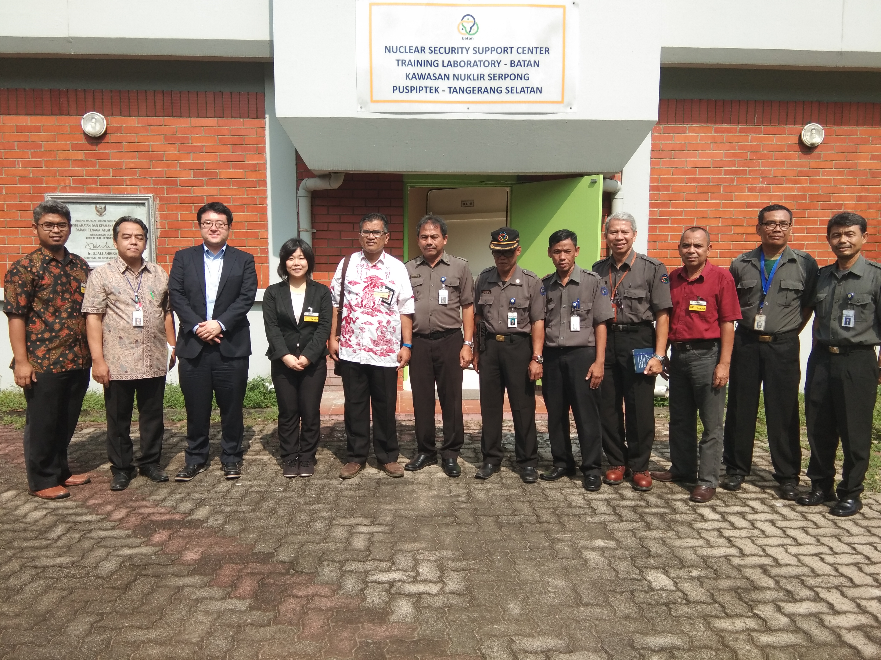
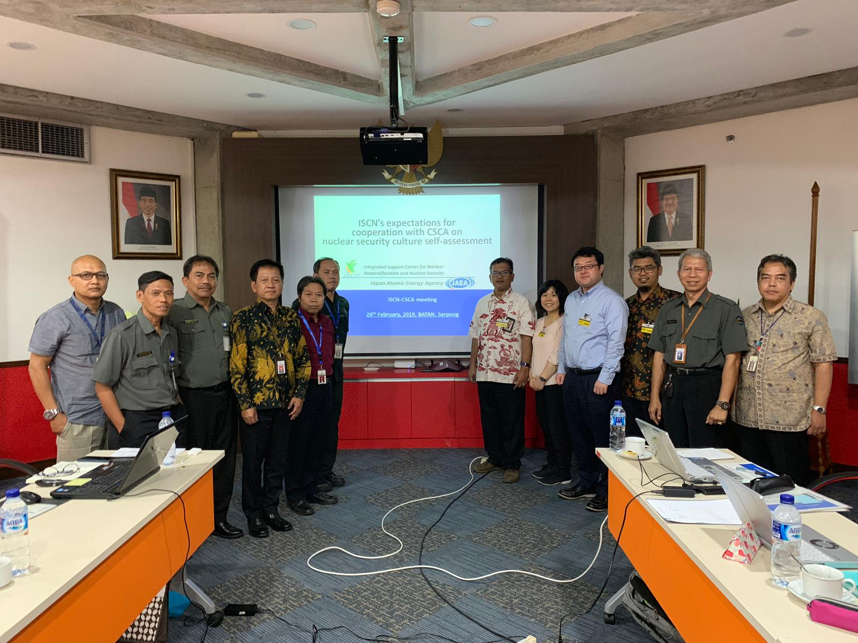
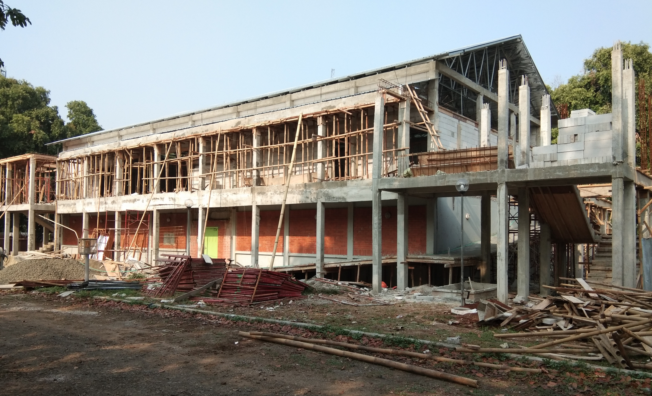

Figure 4. Classroom for Lab Training of PPS
Figure 5. ISCN/JAEA's at NSSC Serpong Site

Since 2019, Center for Security Culture and Assessment of BATAN (CSCA/BATAN) and ISCN started technical exchange about how to conduct Nuclear Security Culture Self-Assessment. BATAN conducted nuclear security culture self-assessment in 2012-2013 as the first country in the world. Based on regional cooperation and mutual benefit amongst other center of excellence in the region, therefore BATAN agreed to collaboration with ISCN. ISCN hosted the first joined workshop with CSCA/BATAN to learn from experts of CSCA/BATAN in September 2019, in Tokai, Japan. As these examples illustrate, BATAN-ISCN cooperation is a good practice of regional cooperation between training centers to enhance their capacity as well as strengthen nuclear security in the region.

- Conclusion

Indonesia has implemented global nuclear security regime, through the training programs formulated by the CET-BATAN. This attempt is expected to sustain the nuclear security, particularly on the facility-level. The development of physical protection system laboratory is expected to increase the competency of BATAN employees on the physical protection system subject, specifically for the nuclear security unit.
Sustaining this training program requires management commitment, primarily on the financial and human resources support. Moreover, maintaining the cooperation with the International Atomic Energy Agency (IAEA), Integrated Support Center for Nonproliferation and Nuclear Security (ISCN)/Japan Atomic Energy Agency (JAEA), and with partners such as U.S. Department of Energy and U.S. Department of State, on developing human resources capability in nuclear security, will greatly foster the implementation of nuclear security in Indonesia.

- References

[1] International Atomic Energy Agency, IAEA Nuclear Security Series No. 30-G Sustaining a Nuclear Security Regime Implementing Guide. Vienna: International Atomic Energy Agency, 2018.
[2] International Atomic Energy Agency, IAEA Nuclear Security Series No. 31-G Building Capacity for Nuclear Security Implementing Guide, no. July. Vienna: International Atomic Energy Agency, 2018.
[3] M. L. Garcia, The Design and Evaluation of Physical Protection Systems, Second Edi. Sandia National Laboratory: Butterworth-Heinemann, 2008.
[4] International Atomic Energy Agency, IAEA Nuclear Security Series No. 12 Educational Programme in Nuclear Security Implementing Guide. Vienna: International Atomic Energy Agency, 2010.
[5] Y. Naoi, K. Robertson, and N. Noro, “The Capacity-Building Support Activities of the Integrated Support Center for Nuclear Nonproliferation and Nuclear Security of the Japan Atomic Energy Agency,” Int. J. Nucl. Secur., vol. 2, no. 1, p. 13, 2016.

