**INDUSTRY ENGAGEMENT TO ESTABLISH A**

**ROBUST SECURITY APPROACH TO MOBILE**

**RADIOACTIVE SOURCES**

E. HUNSICKER

Department of Energy, National Nuclear Security Administration

Washington, DC, United States of America

Email: Erika.hunsicker@nnsa.doe.gov

B.KLUSE

Pacific Northwest National Laboratory

Richland, WA, United States of America

M. CARR

Pacific Northwest National Laboratory

Richland, WA, United States of America

B.HIGGINS

Pacific Northwest National Laboratory

Richland, WA, United States of America

**Abstract**

The U.S. Department of Energy/National Nuclear Security Administration’s Office of Radiological Security (ORS) collaborates with partner countries across the world to enhance the security of radioactive sources that are used for legitimate purposes. Defining and implementing a robust security approach across any industry that uses radioactive material requires strong coordination with multiple stakeholders. In the case of mobile radioactive sources, such as those used in the oil, gas, and geo-physical industries (also referred to as the well-logging and radiography industries), the fact that the sources move through various operational and regulatory jurisdictions increases the number of stakeholders and makes security more challenging. Success depends on the ability to look at the operational use holistically, identify the stakeholders that would be involved if a source was lost or stolen, and identify roles and responsibilities of these stakeholders to accommodate proper notification, adjudication and response to a security incident.

The mobile radiological sources used in the well-logging and radiography industries are of sufficient curie quantities to be categorized as desirable material for malicious actors. Beyond the security risk posed by these sources, there is also an understanding of the potential damage, both reputational and monetary, that a lost source would have on the licensee and the industry overall. Identifying and communicating the risk these sources pose with impacted stakeholders is a critical first step in developing a security approach.

Common day-to-day operations within both industries drive the unique security challenge of mobile sources. From storage facilities, transportation vehicles, temporary storage locations, and use in the field, each phase creates challenges regarding source control and accountability. All aspects of the operational use of these sources needs to be fully understood in order to address security equipment enhancements, policies, procedures, and training.

This paper will leverage more than ten years of experience that ORS has gained working closely with industry partners and mobile radiological source users across the well-logging and radiography industries. It will identify the risk posed by mobile radiological sources, clearly define the operational phases of each industry, identify security best practices of mobile sources, and discuss what long-term, sustainable security looks like within these industries. In addition, it will explore areas of a robust security approach that are not commonly given priority in these industries, such as alarm adjudication and response.

## INDUSTRY ENGAGEMENT AND THE IDENTIFIED SECURITY CHALLENGES OF MOBILE RADIOACTIVE SOURCES

### Well-Logging Operational Phase

Well-logging operations use radioactive sources to characterize exploration and production wells for the oil and gas industry across the globe. These sources are transferred from storage bunkers to transport containers and are then inserted into the well-logging tools at the job site. Approved personnel handle the sources with specialized tools and have detailed safety procedures that they are required to follow. The operational use of well-logging radioactive sources can be summarized in the following three phases:

* **Storage** – the location where the well-logging radioactive source(s) are stored when not in use, referred to as the “home base.” This includes any fixed location where the sources are kept for an extended period when not in use. Configurations of home base storage rooms vary from site to site and the approach for storage varies from company to company, as well as country to country. Sources are commonly stored in either vault-type configurations or shielded containers. When the source is transported to the field, it is either moved to a separate transport container or transported in the same container in which it is stored.
* **Transport –** is the span of time during which the sources are moved to/from the storage room, placed within a transport container and/or on a vehicle and transported to/from the location of use.
* **Field Use –** the sources are loaded to/from the well-logging tools and lowered down into the geologic formation to perform the analysis

### Industrial Radiography Operational Phase

Radiography cameras (also commonly referred to as projectors) contain a radioactive source within shielding. These cameras are used for legitimate non-destructive testing purposes around the world. Although there are three main manufacturers of radiography cameras in the United States, the cameras themselves are of various sizes and configurations. The operational use of radiography cameras can be categorized into the following three phases:

* **Storage** –where the radiography cameras are stored when not in use. Often referred to as the “home base.” This includes any fixed location where the camera is kept for an extended period. Configurations of home base storage arrangements vary from site to site and the approach for storage varies from company to company, and from country to country.
* **Transport** –the phase when the source is removed from the home base and placed within the transport vehicle. This phase continues until the radiography camera arrives at the location where it will be used in the field. Transport vehicle configurations and security requirements vary greatly between companies, as do the requirements for how the cameras are stored during transport. The transport phase also includes the period when the source is in the vehicle returning from the field to home base.
* **Field Use** – phase in which the radiography camera is in use, away from transport vehicle.

## SECURITY BEST PRACTICES FOR MOBILE RADIOACTIVE SOURCES – STORAGE/HOME BASE

ORS deploys a target-out-approach when addressing the security of a home base location for mobile radioactive sources. Acknowledging that many home base locations within the well-logging and industrial radiography industries are often large warehouses where the primary day to day work is not centered on rad work, this approach focuses security enhancements on the smallest and most cost-effective footprint of the home base. A target room is defined as the room where the radioactive sources are stored within a home base.

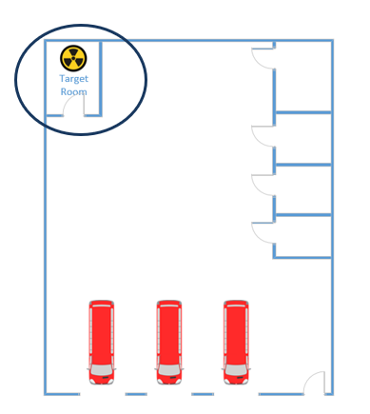

FIG. 1. Target Room within a Home Base

Focusing on a target room allows security enhancements to be installed to help increase the overall system effectiveness by: (1) improving the probability of detection; (2) increasing delay times (the time adversary needs in order to access the material); and (3) enhancing responder effectiveness (the timeliness of notifying responders to give them as much time as possible to arrive in strength and the training to help them respond accordingly to the act). Examples of security enhancements focuses at improving Detect, Delay and Response are identified below:

* Delay
* Established perimeter walls, barriers, doors, true ceilings
* Chains/padlocks to secure mobile sources in place or secure in-ground vault lids
* Minimum number of openings (i.e., doors, windows)
* Detection
* Access control
* Motion Sensors
* Door contacts (i.e., balanced magnetic switches)
* Assessment
* CCTV with infrared illuminators viewing entrance and interior of target room
* Digital video recorder/network video recorder
* Redundant Alarm Monitoring/Notification
* Onsite (when applicable)
* Offsite (UL-listed alarm monitoring station or equivalent)

## SECURITY BEST PRACTICES FOR MOBILE RADIOACTIVE SOURCES – TRANSIT AND FIELD USE

Mobile radioactive sources used in the well-logging and industrial radiography industries are most vulnerable when they are in transport or use in the field. The International Atomic Energy Agency (IAEA) Nuclear Security Series No. 11 [1] states “sources used in field applications (e.g., radiography and well-logging) are typically contained in devices designed for portability and are frequently transported between job sites. The ease of handling of these devices and their presence in vehicles outside secured facilities make them attractive for unauthorized removal.”

Addressing this vulnerability requires an ability to track the mobile sources throughout the operational use cycle. While there are numerous fleet management systems commercially available, they are limited to tracking of the transit vehicle itself and provide no direct monitoring of the mobile radioactive source equipment. The mobile source transit security system (MSTS) has been developed by ORS in close collaboration with key industry partners to increase situational awareness during transit and field use. Unique systems have been developed for the well-logging and industrial radiography industries. These systems are designed to be cost-effective, reliable, and robust, with the capability to complement existing security systems and operational procedures. Wi-Fi communication through a telematics device on the transport vehicles provides near-real time alerts and alarms to a home base through a MSTS-specific software. A description of the industry-specific MSTS systems and the key components is provided below.

## INDUSTRIAL RADIOGRAPHY MSTS SYSTEM

### Persistent Monitoring Tag (PM-Tag)

Integrated into the jacket or bolted onto the radiography camera, the PM-Tag communicates (Fig. 2) alerts and/or alarms to the secure transport box (STB) through a Bluetooth Low Energy (BLE) device or to the home base through the cellular communication module within the PM-Tag. The PM-Tag includes a solid-state radiation detector that detects the source’s presence within the radiography camera and tamper detection on the PM-Tag housing.

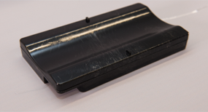 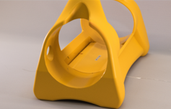

FIG. 2. PM-Tag and a QSA 880 Sentinel Jacket with Integrated PM-Tag

### Secure Transport Box (STB)

Padlocked to a mounting plate in the transportation vehicle, the STB stores the radiography cameras on the truck (Fig. 3). The STB charges the camera’s PM-Tag through a wireless Qi charging technology. The STB also maintains a BLE connection to the PM-Tag to monitor the presence of the source. The STB communicates status and alerts via the MSTS system’s telematics (cellular).

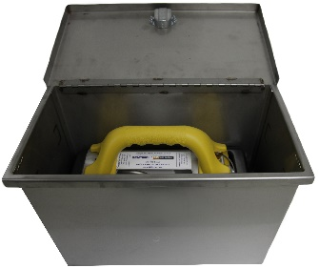

FIG. 3. STB with QSA 880 Sentinel

### Telematics

The telematics device located on the transport vehicle provides a cloud-based service for communication. The MSTS system communicates via cellular means to transmit data from the PM-Tag to the telematics device.

### Data Cloud

The MSTS system transmits data to the cloud. A remote monitoring station with the appropriate software can pull data from the cloud server to monitor status and alerts from the MSTS system. This portion of the system is provided by a cloud service provider.

The PM-Tag and the STB are the primary components of the MSTS system installed on the radiography camera and transport vehicle. To maintain continual operation when in storage, the MSTS system has several components that are integrated into the storage room located at the home base. MSTS system components specific to the home base are described as follows:

### Persistent Monitoring Tag Charging Mat (PM-Mat)

The PM-Mat is similar to the STB. It provides a docking station for the radiography camera and PM-Tag while in storage (Fig. 4). The PM-Mat can be installed within a storage room or a storage container.

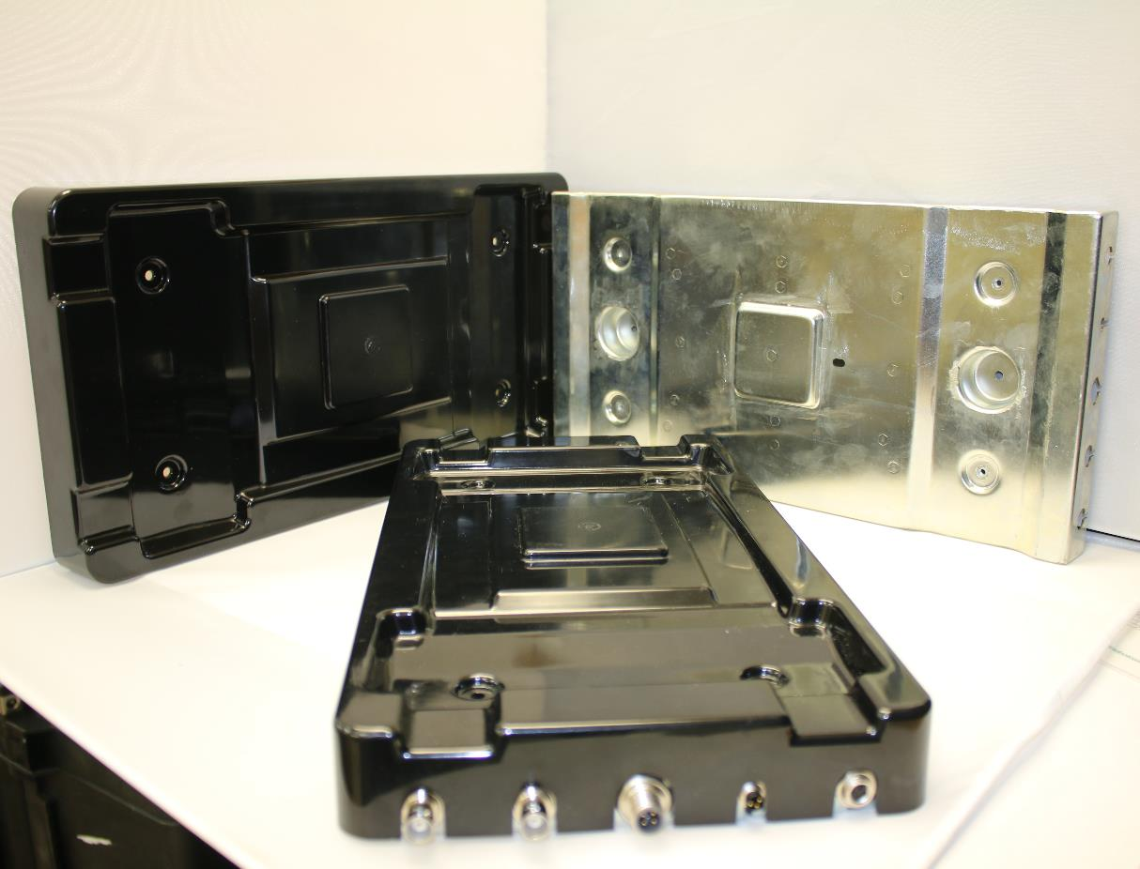

FIG. 4. PM-Mat for storage location

### Vault Control Unit (VCU)

The VCU is the computer processing portion for the home base storage location. The VCU communicates with the PM-Mat(s) while the cameras are in storage.

### Home Base Station Computer and Monitoring Application Software

The status and alerts transmitted from the MSTS system can be downloaded from the cloud provider. This is accomplished via a monitoring software application on a computer.

### Integrated Secure Container (ISC)

The ISC is a stand-alone container, developed by ORS, which incorporates detection equipment, access control, PM-Mat(s), VCU, and features that enhance overall delay (Fig. 5). These containers can hold up to 12 radiography cameras and are an option for facilities that do not have separate storage rooms within their home base facility.

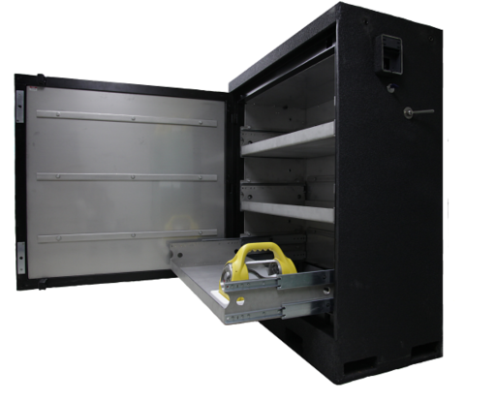

FIG. 5. ORS Integrated Secure Container

Beyond security, this holistic approach provides a user with enhanced operational benefits, including the ability to monitor radiation readings of each camera, maintain electronic controls of cameras while they are in storage, and identify who accessed the storage rooms. Procedures are a critical component to any security strategy and the introduction of technological solutions for detection and assessment require updates to internal procedures and protocols with local response agencies.

## INTEGRATION OF MSTS WITHIN RADIOGRAPHY

ORS has system integration activities ongoing with QSA Global, Inc., Industrial Nuclear Co (INC), and Source Production & Equipment Company (SPEC). These three radiography camera manufacturers represent a large percentage of the radiography camera market. A bolt-on system has been developed for camera manufacturers who do not have an integrated solution. These systems are fixed to the exterior of the radiography camera and house the PM-Tag. Functionality of the PM-Tag is the same as the integrated system. All MSTS system designs for radiography will accommodate a single design of the STB and PM-Tag Mat. This will allow use of the STB and PM-Tag Mat interchangeably for sites that may have multiple makes and models of cameras.

## WELL-LOGGING MSTS SYSTEM

### Master Control Unit (MCU)

Mounted inside of the transport vehicle where the sources are stored, the MCU (Fig. 6) is the central controller for the well-logging MSTS system. It monitors and processes all data coming from the eTag(s) and rTag (see below) in the system and sends out status and alerts from the system via the telematics components (satellite and/or cellular). The MCU is recharged using the truck’s power.

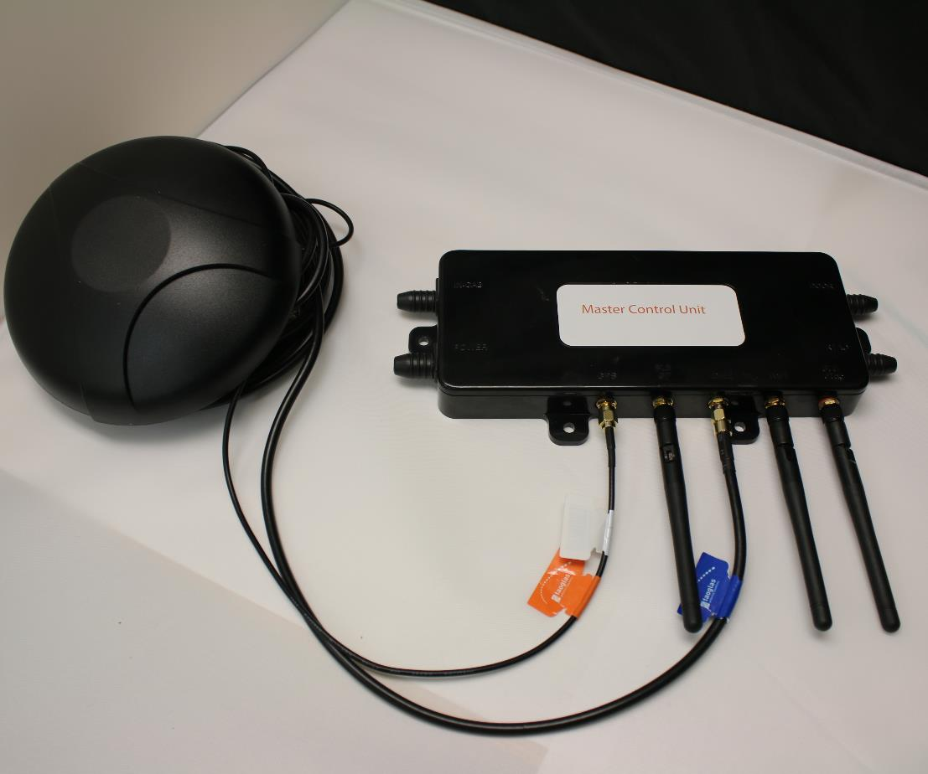

FIG. 6. Master Control Unit

### Radiation Tag (rTag)

The rTag (Fig. 7) houses the solid-state radiation detector that monitors changes in radiation levels indicating a change in the source’s status (i.e., within its storage container, in use/outside storage, or absent). The rTag sends alerts and/or alarms to the MCU through BLE. The rTag is charged using the truck’s power.

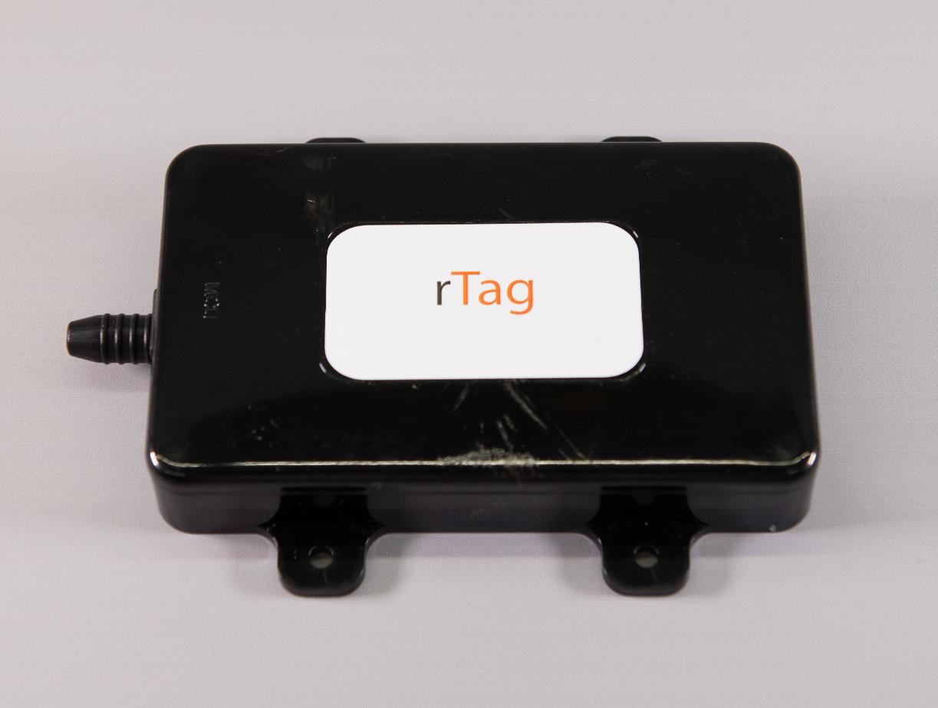

FIG. 7. rTag

### Electronic Tag (eTag)

Attached to the shielded source container being tracked, the eTag (Fig. 8) provides tracking status through BLE to the MCU to monitor presence of the item. Tamper detection is integrated into the eTag.

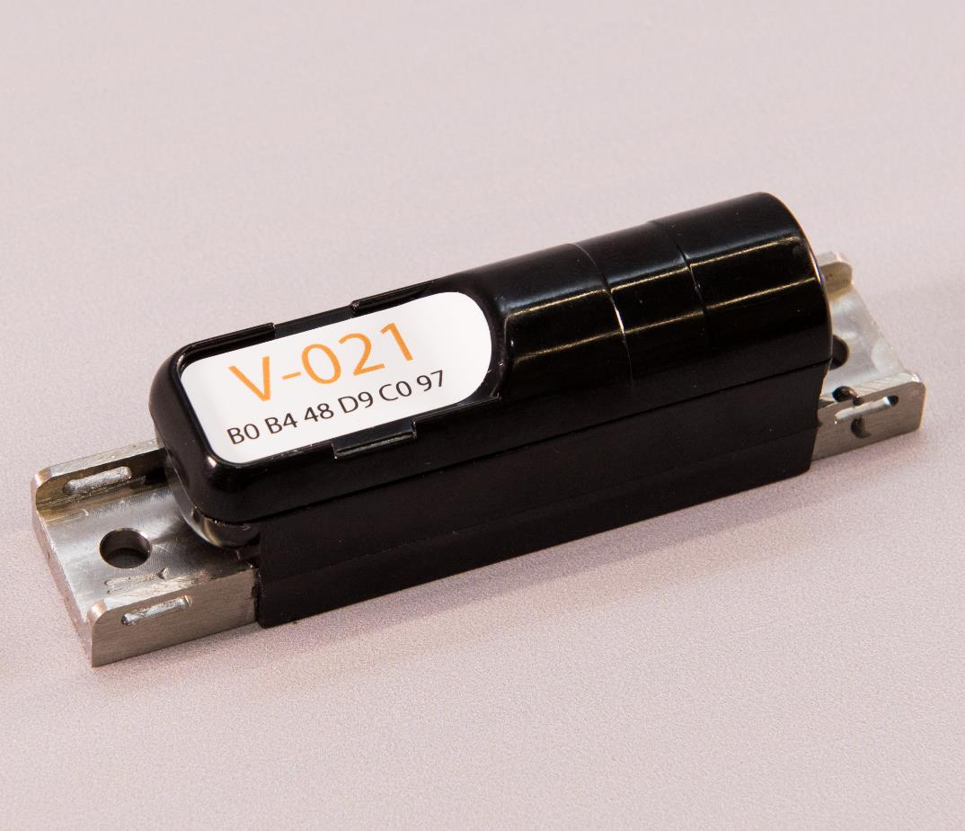

FIG. 8. eTag

### In-Cab Unit (ICU)

Located in the cab of the truck, the ICU (Fig. 9) provides MSTS status and alarms to the driver in the cab of the truck via colored light indicators. It also provides a duress capability to the driver that is transmitted through the MCU.

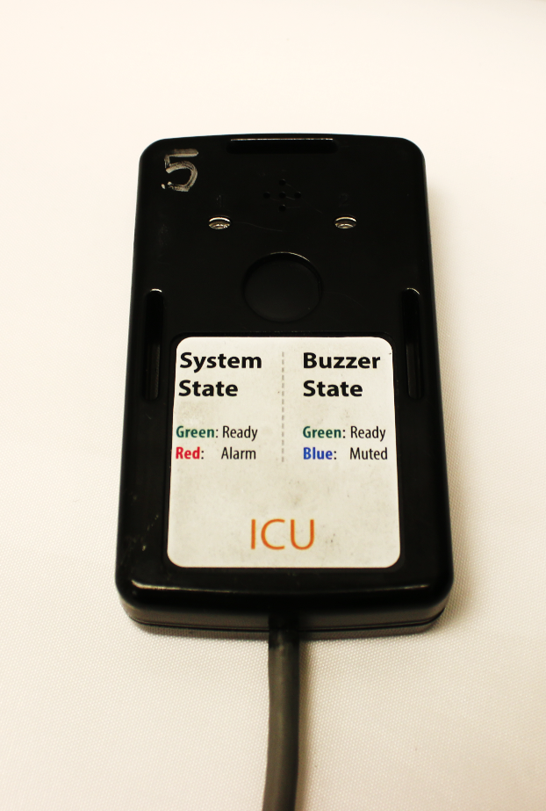

FIG. 9. In-Cab Unit

To maintain situational awareness when in storage, the home base security system (HBSS) is installed within a target room to monitor eTags. The HBSS is powered using facility power and comprises an MCU and rTag. If sources are stored in transport containers, the eTags can remain on the container, providing continuing monitoring of the container and source. eTags can also be fixed to the source handling tools to track their location. HBSS should be considered an additional element to the overall security of a home base/storage room and complement the other intrusion detection system components.

## INTEGRATION OF MSTS WITHIN WELL-LOGGING

The well-logging MSTS system uses a secured web-based application to monitor the status of the system during operation. A smartphone or tablet is used to access the web-based application that is hosted on the MCU. Authorized users use the web-based application to identify the status of the system. Users can select as status: 1) Checking the source out of storage, 2) placing the source in the transport vehicle, 3) setting the system to transport, and 4) arriving at a job site and identifying that the source is in use. This requires that policies and procedures are established to ensure that authorized users understand how to place the system in the proper setting. The system also has the capability to establish a pre-determined route that the transport vehicle is taking to a job site, triggering notifications should the vehicle travel outside the established route.

When in use, the system will send alerts and alarms to the web-based application that can be accessed by authorized users from the well-logging company. These alerts and alarms should be fully understood and integrated into a site’s security procedure to assist with timely notification to responding agencies. While in storage, the MSTS system is one component of a holistic security strategy, and when in the field it provides increased situational awareness of the location of the source and the status of the source.

## MOBILE RADIOACTIVE SOURCES RESPONSE ENGAGEMENT

Unlike fixed facilities that use radioactive material (i.e., hospitals, academia, research, sterilization, etc.), response organizations in general have a low understanding of what mobile radioactive sources are, how they are used, or when/where they are used. In the United States there is no requirement to report the movement of mobile radioactive sources to law enforcement. When an incident of concern occurs, both mobile source users and law enforcement agencies struggle to effectively communicate what the problem is, where the last known location was, and what to do next. Additionally, mobile sources routinely leave a home base in one location and may travel hundreds of kilometers to a job site where they will be used, crossing multiple response jurisdictions along the way.

ORS has recently developed a response engagement strategy for mobile radioactive sources that focuses on licensees and law enforcement to try to remove the communication gap and better educate both parties on the risks posed by these sources and the necessary response needed if an incident occurs. The first step is to make sure the licensees know who to call and what to say if an event occurs. In the United States there are between 14,000 and 15,000 sperate State and local law enforcement agencies which makes reaching each agency highly unlikely. As a result, ORS has focused its law enforcement engagement on the Federal Bureau of Investigation (FBI) Weapons of Mass Destruction coordinators and State Police in each of the 50 states. By focusing the response strategy on these two agencies, ORS has cut the target audience from 15,000 to less than 100.

The intent of the ORS response engagement strategy for mobile radioactive sources is to develop a “common operating picture” for how a licensee reports loss/theft and how local law enforcement interpret and respond to the incident. Training for licensees must focus on who the appropriate agencies are to contact (in the United States it is the FBI WMD coordinator and State Police) and what key words they need to use when reporting a loss/theft of mobile radioactive material. Clear description of the missing equipment, radioactive material involved, transport vehicle involved, and location of the incident is all critical information that will assist in a more effective response. Once notified, agencies such as the State Police can then push out notifications to other local law enforcement agencies to assist in the response.

General awareness training for law enforcement agencies is also being developed by ORS. Material and/or videos that clearly describe what the mobile radioactive source equipment looks like, common transport vehicles used, and the properties of the material is all information that law enforcement agencies can work into their general radioactive material training.

PNNL-SA-148572