PREPAREDNESS AND IMPLEMENTATION OF NUCLER SECURITY PLAN FOR MAJOR PUBLIC EVENTS IN VIETNAM

Author: Than Thi Ngoc Mai
Vietnam Agency for Radiation and Nuclear Safety
Hanoi, Viet Nam
Email: ttnmai@most.gov.vn

Co-author: Mr. NGUYEN Tuan Khai
Director General, Vietnam Agency for Radiation and Nuclear Safety
Hanoi, Viet Nam
Email: ntkhai@most.gov.vn

Abstract
Nuclear security for major public events (MPE), such as a sporting event or a high-level political meeting is very important for each country, and the organization of these events presents unique security challenges, including possible threats involving nuclear or other radioactive material. Understanding these challenges, Viet Nam requested support from the International Atomic Energy Agency (IAEA) to prepare and implement Nuclear Security Plans for several MPEs.
With the support from the IAEA, Viet Nam have implemented security plans for Hung King Temple Festival in 2016, APEC Summit in 2017 in Da Nang, and DPRK-US Summit in Ha Noi in 2019. In order to execute these Security Plans, we developed Nuclear Security for MPE Architecture including the participation of various ministries and agencies under management of the Prime Minister, and a Joint Action Plan for the MPEs was developed between Viet Nam and the IAEA.
The paper presents our experience and lessons learned in implementing nuclear security activities to ensure the security of these major public events

I. National structure for response to nuclear security events
As defined in the Prime Minister Decision No. 884/QD-TTg dated 16 June 2017 on approving National Radiological and Nuclear Emergency Response Plan, the following Ministers are responsible for response to nuclear security events, including major public events:
- Under Ministry of Public Security (MPS):
- General Department of Security is responsible for assisting the Minister in managing and administering foreigner security.
- Vietnam Leaders Security Command (K10) of MPS is responsible for protecting senior officials of the Party and State of Vietnam, and providing protection for their offices, activities and conferences when they are attending.
- The Vietnam Agency for Radiation and Nuclear Safety (VARANS) is the regulatory body, responsible for safety, security and safeguards in the field of nuclear energy.
- The Local Police, Provincial Departments of Science and Technology, and Local Fire brigade, Medical, Military Units have the main responsibility for ensuring general security in the area.
- The General Department of Vietnam Customs are responsible for control of import and export at exit, entry and transit points, and combating against smuggling or illegal transportation of goods, including nuclear and other radioactive material.
- The Ministry of National Defence manages, coordinates and supervises military affairs, including all military units, paramilitary units, and similar agencies in the country.
- Other Ministries involved include the Ministry of Health, the Ministry of Transportation, etc.

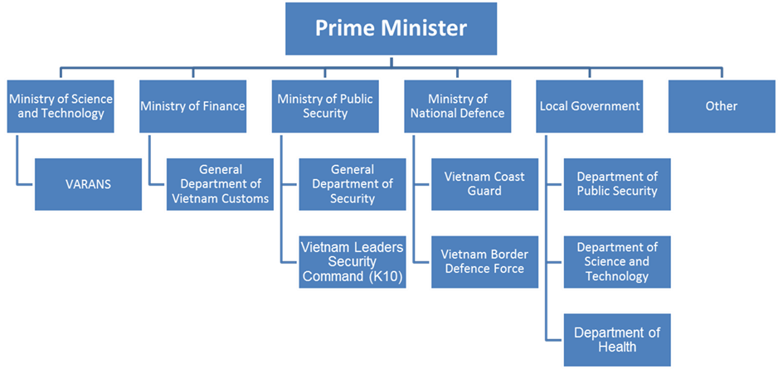

Figure 1. National structure for response to nuclear security events

II. Implementation of nuclear security for major public events in Viet Nam

1. Nuclear Security Plan for Hung King Temple Festival
Hung King Temple Festival event was the first major event that Viet Nam applied measures to ensure nuclear security under the guidance of the IAEA Nuclear Security Series publications No.18 "Nuclear Security Systems and Measures for Major Public Events".
After consultations with the IAEA, the Vietnam Leader Security Command (K10) requested support from the IAEA for the implementation of nuclear security measures at the festival, to be held in Phu Tho Province, Viet Nam from 11 - 16 April 2016. As such, a Joint Nuclear Security Action Plan for Hung King Temple Festival was established between the IAEA and K10. The objective of the plan is to define the tasks to be jointly implemented by the Vietnamese authorities and the IAEA Division of Nuclear Security to enhance Viet Nam capability for carrying out nuclear security measures in the framework of the festival.
The relevant agencies involved in the organization of the Hung King Temple Festival security plan are the Ministry of Public Security, local police and other agencies of Phu Tho province, and VARANS in cooperating with the IAEA Nuclear Security Division and the U.S. DOE/NNSA.
To prepare the nuclear security response preparedness, VARANS had organized 03 coordination meetings with the IAEA, US. NRC and relevant competent authorities (March 2015, August 2015 and April 2016) to discuss on threat assessment, international assistance and nuclear security arrangements for the festival. Four training courses were organised with topics on Nuclear Security Systems and Measures for Major Public Events; Information Exchange in Incidents of Nuclear and Other Radioactive Material out of Regulatory Control; Responding to Nuclear Security Events at venues and other strategic locations, and Radioactive sources searching. In addition, representatives from VARANS and relevant competent authorities participated in 4 technical visits to Brazil and the United States to study and exchange experience on nuclear security for major public events.

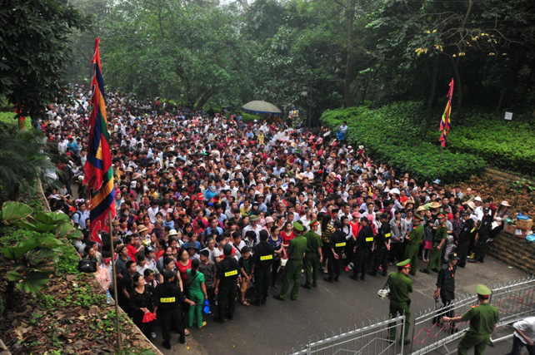
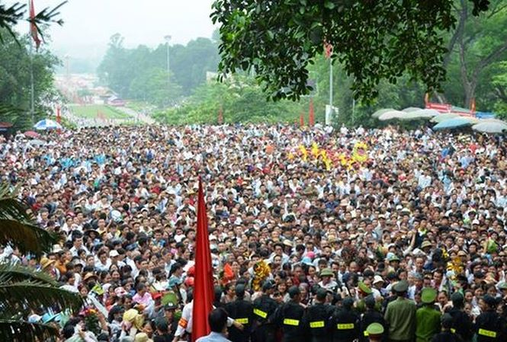

Figure 2. Hung Kinh Temple Festival

VARANS in cooperation with K10 and Phu Tho police also organized several training courses on radiation safety and emergency response for K10 (25 persons) and local police and involved organizations (Phu Tho police – 200 persons), VARANS (9 persons). Furthermore, K10 developed nuclear security scenarios and carried out exercises to enhance prevention, detection and response capability.
Before the event, K10 and VARANS deployed instruments to the local authorities in order to carry out tasks such as selecting sites where radiation detection instruments would be installed, performing acceptance tests, developing and testing detection and response procedures, and performing pre-event radiological surveys and background mapping.
After comprehensive preparedness process, K10 developed nuclear security plan and arrangements for implementing the developed plan for the Hung Kinh Temple Festival and submitted to Ministry of Public Security for approval.

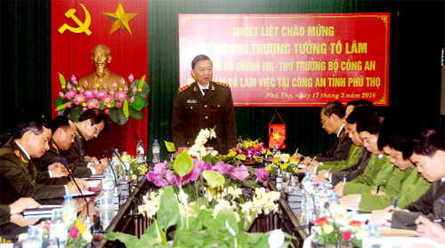

Figure 3. Meeting of MPS officials to prepare for Hung Kinh Temple Festival
In implementing nuclear security for the Festival, security personnel and detection equipment were structured into 3 levels as follows:
Level 1: using Personal radiation detectors (PRDs), SPACRCs, Backpacks and Linear Detectors for primary checks in order to detect radiation elevation and personnel in this Level are to coordinate with Level 2 in the case of suspect objects to be detected;
Level 2: using Radioactive Isotope Identifier Device (RIIDs), Backpacks and Inspectors for secondary detection after receiving information of suspected radiation elevation from Level 1, personnel in this Level should cooperate with Level 3 to deal with radiation events;
Level 3: using HPGe(s), Contamination detectors, emergency response equipment and protective equipment to respond to radiation incidents

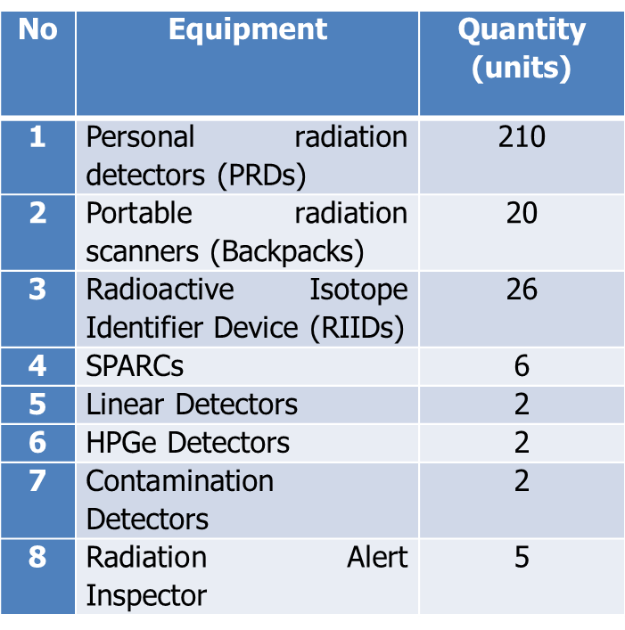

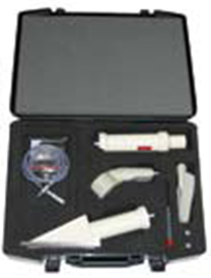
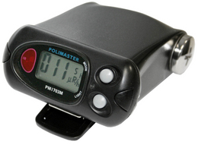
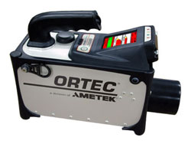
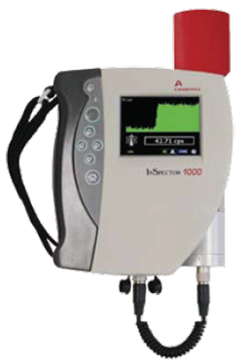

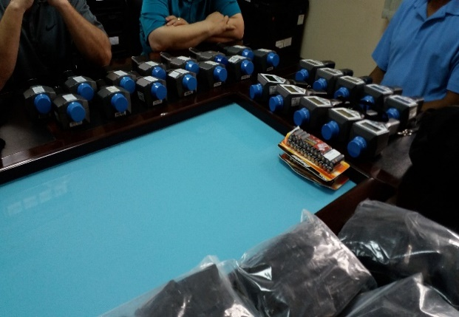
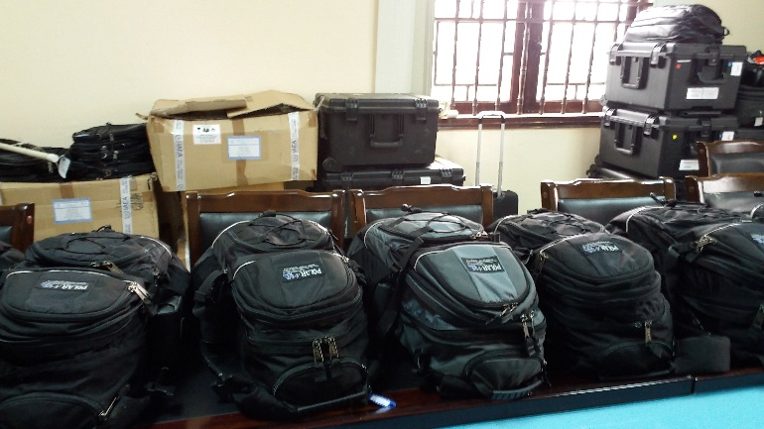

Figure 4. Quantity and types of equipment used for Hung Kinh Temple Festival

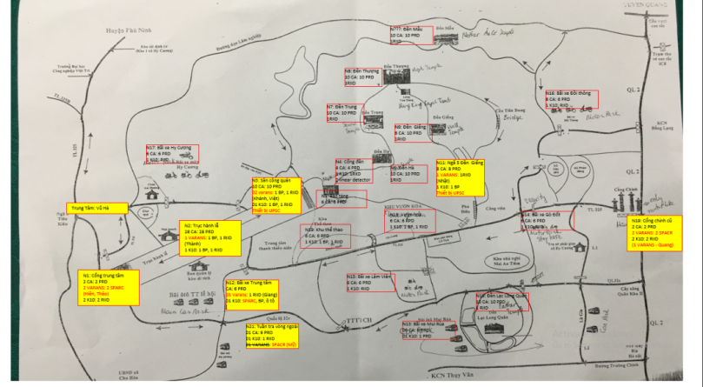

Figure 5. Distribution of equipment at the site

Due to careful and thorough preparation, the operation was successful. No radiation incident was detected. This contributed to the improvement of capabilities of all personnel and organizations involved, providing valuable experience in the implementation of nuclear security measures for major public events.

2. Nuclear Security Plan for Asia-Pacific Economic Cooperation (APEC) Summit 2017
The APEC Summit 2017 was held in Da Nang City. This is the second time that Viet Nam hosted this type of APEC meetings, with the first being in 2006.
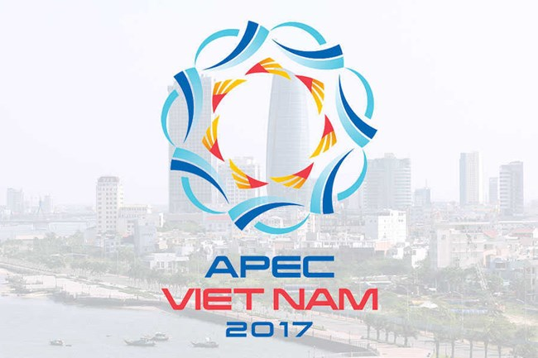
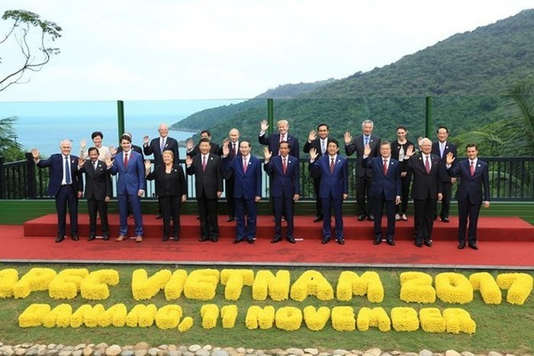

Figure 6. APEC Summit 2017

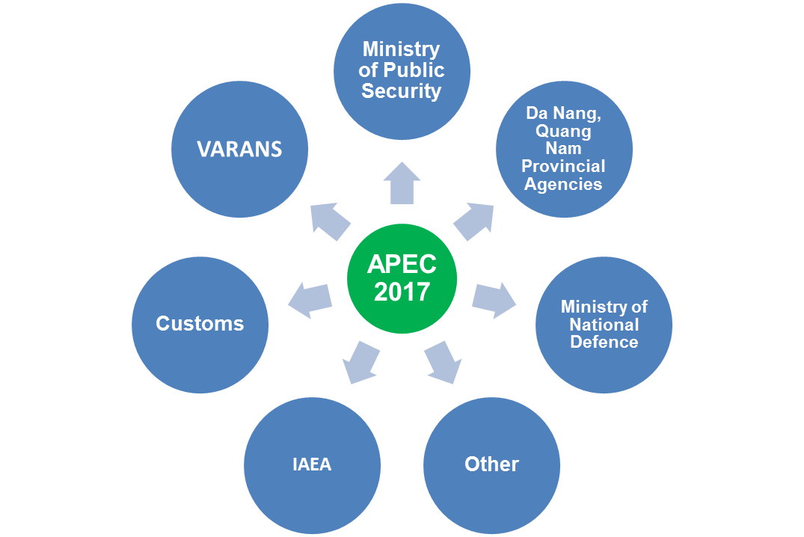
With the experience gained from Hung King Temple Festival, Viet Nam’s authorities were confident in providing nuclear security for the event. The organizations involved were the Ministry of Public Security (K10), the Ministry of National Defence, VARANS, the Customs, Local agencies (Da Nang and Quang Nam provinces) and relevant organizations, with the support from the IAEA.

Figure 7. Organizations involved in implementation of nuclear security for APEC Summit 2017

In order to prepare for the implementation of nuclear security measures for the event, Viet Nam organized a coordination meeting with IAEA in March 2017 to discuss threat assessment, international assistance and nuclear security arrangements to ensure appropriate level of nuclear security measures to be implemented.
With the equipment provided by the IAEA, on 25 September 2017, VARANS handed over the equipment to Customs (Da Nang customs ) and K10. In October 2017, VARANS provided training for Da Nang customs and K10. The topics included Nuclear Security Systems and Measures for Major Public Events, Information Exchange in Incidents of Nuclear and Other Radioactive Material out of Regulatory Control, Responding to Nuclear Security Events at venues and other Strategy locations, and Radioactive sources searching.

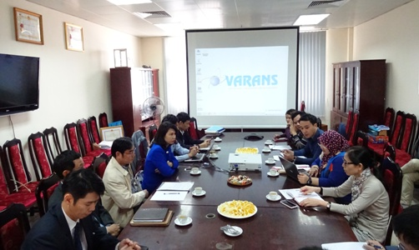

Figure 8. Coordination meeting with the IAEA

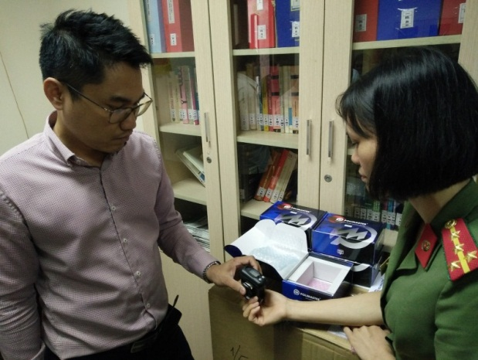
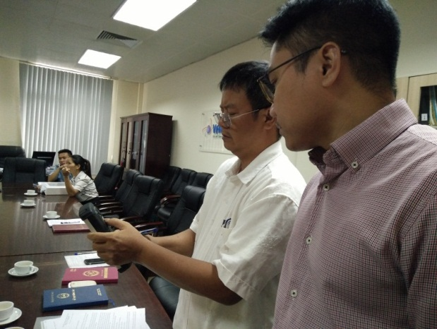

Figure 9. Provision of training to police and customs officers

As the regulatory body, VARANS temporarily ceased the authorization for transportation of nuclear materials and radioactive sources through Da Nang, Quang Nam and neighboring provinces. In addition, Da Nang, Quang Nam and neighboring provinces established strict control over the routes in the area, and Da Nang Customs established radioactive control posts at Da Nang International Airport and Da Nang Seaport.

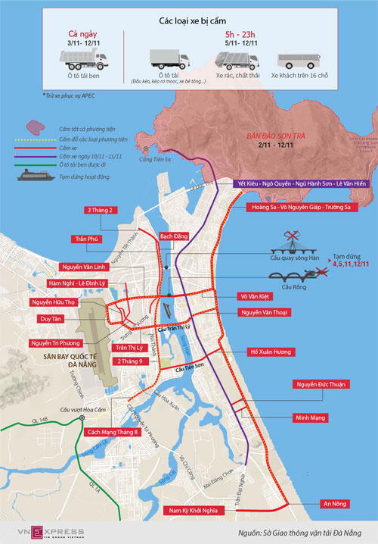

Figure 10. Restriction of vehicle transport in Da Nang

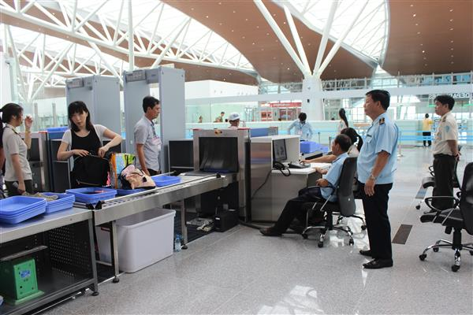

Figure 11. Scanning of passengers by customs

No | Equipment | Quantity (units)
1 | Personal radiation detectors (PRDs) | 10
2 | Portable radiation scanners (Backpacks) | 4
3 | Radioactive Isotope Identifier Device (RIIDs) | 3
4 | SPARCs | 6
5 | HPGe Detectors | 2
6 | Contamination Detectors | 2

Figure 12. Types and quantity of equipment used for APEC Summit 2017

Similar to the Hung King Temple Festival, the security personnel and equipment were structured into 3 Level, including:
Level 1: using RPDs and Backpacks for primary checks in order to detect radiation elevation and personnel in this Level are to coordinate with Level 2 in the case of suspect objects to be detected;
Level 2: using RIIDs, Backpacks and Inspectors for secondary detection after receiving information of suspected radiation elevation from Level 1, personnel in this Level should cooperate with Level 3 to deal with radiation events;
Level 3: using HPGe(s), Contamination detectors, emergency response equipment and protective equipment to respond to radiation incidents.
As such, the implementation of nuclear security as part of the general security has contributed to the success of the Summit.

3. Nuclear security plan for Democratic People's Republic of Korea – the United States of America Hanoi Summit 2019
Based on experience from the previous events, Viet Nam organized successfully Democratic People's Republic of Korea (DPRK) – United States (US) Hanoi Summit 2019, although time for preparation was limited.
During this event, the Ministry of Public Security and other relevant local agencies were responsible for ensuring security protection of the event, especially ensuring security at the border in Lang Son province and other strategic locations in Hanoi. VARANS collaborated with security agencies in providing training for police officers and supporting their activities relating to nuclear security.

4. Advantages and Challenges

The implementation of nuclear security for the above mentioned major public events was successful due to the fact that we received the great attention and support from the Government. In addition, the Ministry of Public Security and other competent authorities has made great effort in conducting thorough and comprehensive preparedness activities. Furthermore, we received the valuable support from the IAEA and the US regarding the provision of experts, equipment, and training.
However, during organization of these events we faced some challenges such as: the site/facility characteristics are complicated with substantial large space; the agencies involved in implementing nuclear security measures at the event were inexperienced, especially the local police. We also recognize that the coordination mechanism among the participating agencies needs to be improved.

III. Conclusion
Through the implementation of nuclear security plans for the MPEs, we recognize that it is important to have the involvement of the Government, the Ministry of Public Security and relevant Ministries. The support of the IAEA and the US on providing experts, equipment, training, and materials is greatly valuable. The effort of the organizations involved and comprehensive preparedness also played an important role for the implementation of nuclear security plans to be successful. We also found that security for MPEs needs comprehensive planning, systematic preparation and effective implementation of the nuclear security plan at the MPE.
We believe that conducting such nuclear security activities is an important step in improving the capability of and providing experience for organizations and individuals involved in planning and implementing nuclear security measures at other major public events in the future.
Acknowledgement
The authors would like to sincerely thank colleagues from VARANS and all those involved in the implementation of nuclear security measures for the above mentioned major public events. Their efforts are greatly appreciated as for this paper to be presented at this Conference.

