Sensitive detection of special nuclear materials
for RPM applications
based on gamma-fast neutron coincidence counting

D.M. TROMBETTA
Royal Institute of Technology
Stockholm, Sweden

C. SUNDARAM
Royal Institute of Technology
Stockholm, Sweden

K. AXELL
Swedish Radiation Safety Authority
Stockholm, Sweden

B. CEDERWALL
Royal Institute of Technology
Stockholm, Sweden
Email: cederwall@nuclear.kth.se

Abstract

The ability to detect small amounts of special nuclear materials (SNM) in radiation portal monitors (RPM) is one of the critical links in the nuclear security chain. RPMs are designed to compare the measured radiation flux, primarily neutrons and gamma rays, with predefined thresholds when vehicles or other objects and/or persons are passing through them. In this paper we report on the development of an organic scintillator-based RPM prototype system with high intrinsic neutron- and gamma-ray efficiency. The system uses fast time and energy correlations between detected neutrons and gamma rays as an additional detection modality for achieving enhanced sensitivity for SNM with low false alarm rates. Imaging of SNM materials within the field of view is made possible using the gamma-fast neutron detection mode. The system also features limited radionuclide identification capabilities. Initial measurements and computational simulations using the code MCNP (Monte Carlo N-Particle), version 6.2 have been carried out in order to benchmark the system performance with respect to the ANSI N42.35-2016 industry standard.

1. INTRODUCTION
The detection of special nuclear materials (SNM) in Radiation Portal Monitors (RPMs) is one of the critical links in the nuclear security chain. The IAEA Incident Trafficking Database (ITDB) 2019 Fact Sheet reported 5 interceptions of nuclear or radioactive materials that involved confirmed or likely acts of trafficking or malicious use in 138 member states. Since 1993, this group of incidents (Group I) sum up to 285 events including highly enriched uranium, plutonium, and plutonium beryllium neutron sources - the majority involving gram quantities [1]. RPMs are designed to compare the measured radiation flux, primarily neutrons and gamma rays, with predefined thresholds when persons, vehicles, packages or other objects are passing through them. They typically consist of an array of radiation sensors placed in one or more vertical pillars, together with the associated electronics. Occupancy sensors are used to determine when the system should perform measurements and when to update the background radiation levels and alarm thresholds. Sometimes video cameras are also used to record persons, vehicles or other objects passing through the RPM. Both gamma and neutron sensing is essential for the detection of plutonium, which can easily be shielded for its gamma radiation. An alarm is triggered if relevant measures of the radiation emitted from the source of interest are above predefined threshold levels. Such alarm levels needs to be related to the normal background radiation and how background events may trigger false alarms due to statistical fluctuations is a critical point for the design of RPM systems. The higher the specificity of the sensor signals used for determining the alarm criteria the higher will be the “signal-to-background” ratio and consequently the lower will be the resulting false alarm rate (FAR). For a given, acceptable FAR the RPM should perform with the highest possible sensitivity. In addition, it is desirable that the RPM is able to distinguish radiation from naturally occurring radioactive materials (NORM) or from medical isotopes in persons in order to suppress nuisance alarms.
The majority of RPMs designed to detect neutrons makes use of ³He proportional counters which are thermal neutron detectors typically surrounded by moderating materials. Due to the global shortage of ³He there is a large interest in developing ³He free systems [2]. In addition to proportional counter systems replacing ³He with other high-neutron-absorption cross section materials like boron and lithium there is also an increasing focus on fast-neutron detection based on organic scintillators, high-pressure ⁴He systems [3] etc. Although both detector categories have proven to be efficient in detecting nuclear and radioactive materials, there are important issues related to “nuisance” alarms and difficulties in detecting small quantities of SNM, in particular in shielded environments, reported in the literature.
A novel approach [4] that addresses these issues utilizes the high multiplicity and short time-of-flight of gamma rays and their short time correlations with fast neutrons as a unique signature of materials that undergo spontaneous or induced fission, such as SNM. Making use of gamma-fast neutron coincidence counting as an additional detection modality in parallel with standard singles gamma and neutron counting the system sensitivity can be increased significantly, while neutron-neutron coincidence counting often is prohibitively inefficient. Efficient imaging of SNM materials within the field of view is also made possible using the gamma-fast neutron detection mode. Moreover, the use of coincidences adds to the system an enhanced capability of quantifying the material in question, expanding the applications from prevention of nuclear material trafficking to accountability and control.

2. RPM DESIGN

Hardware design
The KTH prototype RPM is an organic scintillator-based double-sided RPM. In its current configuration it is well suited for different package/conveyor as well as pedestrian RPM applications. Organic scintillators have a high gamma-ray and neutron efficiency as well as excellent neutron/gamma pulse shape discrimination properties. The neutron detection efficiency also compares favourably with standard ³He-based systems [5]. The system geometry follows the ANSI N42.35-2016 industry standard [6] and is modular and therefore easily scalable. In addition to high gamma-ray and neutron detection efficiencies the system additionally makes use of the novel method of prompt fast-neutron and gamma-ray coincidence detection to significantly enhance the detection and identification of special nuclear materials (SNM) [4].

FIG. 1. Basic geometry of the RPM prototype system showing the two detection assemblies and the mechanical support structure. The height of the support structure is 2m and the horizontal distance between the front faces of the detection assemblies is 1.0m, in accordance with the ANSI N42.35-2016.
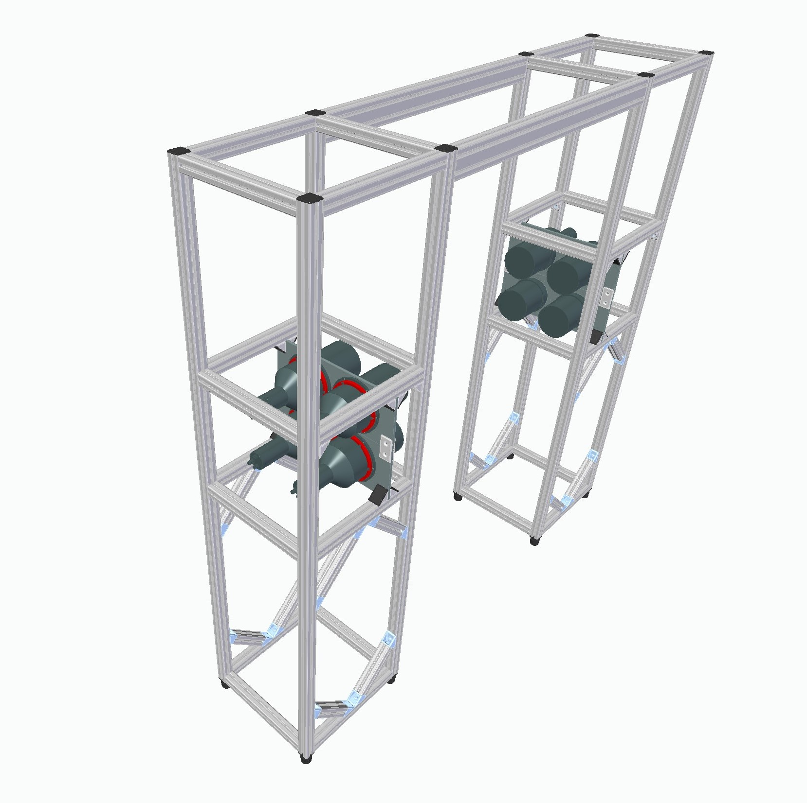

The KTH RPM prototype system consists of two pillars with one detection assembly in each pillar. Each detection assembly consist of several detector cells. In its current configuration a total of eight 127 mm diameter by 127 mm length cylindrical EJ-309 scintillator [7] cells are arranged in two two-by-two arrays, see Fig. 1. The support structure is designed to accommodate up to 20 horizontally oriented detector cells in each pillar and additionally ten detector cells at the top of the structure (facing down) making up a total of 50 detector cells. An increase in the solid-angle coverage and detection efficiency is recommended for the most challenging applications. Other, completely different, detection geometries, e.g. based on a rectangular tiling, are also easily accommodated within the same support structure.
The EJ309 scintillator features a number of chemical properties recommending it for use in environmentally challenging conditions outside the lab. These properties include a high flash point, low vapour pressure, and low chemical toxicity [7]. Each detector cell is optically coupled to a Hamamatsu R1250 photomultiplier tube [8]. The four photomultiplier tubes in each detection assembly are powered by a 4 channel CAEN DT5533 high voltage power supply [9]. The photomultiplier tube anode pulses are acquired and digitized with an eight channel CAEN DT5730 digitizer board [10] featuring a 2V_{pp} dynamic range, 14 bit resolution, and 500 MHz sampling rate. The time synchronized data is transferred using a USB 2.0 link to a personal computer (PC) running on a Linux or Windows™ platform. Besides the raw data transfer of detector waveforms the digitizer also features firmware programmable pulse shape discrimination (PSD) using two field programmable gate arrays (FPGA) of type Intel/Altera Cyclone EP4CE30 [11], each handling four of the ADC data streams.

Software design
The digitized signals (“traces”) from the RPM detector modules can be processed in real time within the digitizer’s FPGAs to extract charge integrals, pulse shape information and timing information. The data are transmitted via USB to an industrial PC, where further processing is performed. Optionally the signal traces can be transmitted directly to a buffer memory in the PC, which can then perform all the required on-line processing. The PSD algorithm for distinguishing gamma-ray interactions from neutron interactions is based on the charge comparison method (see Fig. 2) whereas sharp time stamp extraction is performed using a digital constant fraction discrimination algorithm. Energy information for each trace is extracted using a moving window de-convolution algorithm. The resulting processed data stream contains information on single neutron and gamma rates, fast coincidence rates for gamma-neutron, neutron-neutron, and gamma-gamma events with adjustable coincidence time windows and thresholds. Typical coincidence time windows are 0-100 ns for gamma-gamma and neutron-neutron events and 10-100 ns for gamma-neutron events. The event rates are monitored on-line by the software in order to detect anomalous events. The signal processing is continuous whereas the decision-taking part of the on-line software uses algorithms that combine the information from all data streams to minimize false alarm rates and can be synchronized with external movement sensors and/or video recording systems. In order to achieve a better than the ANSI-speciﬁed 1 per 10h false alarm rate, separate alarm thresholds for gamma-rays and neutrons are set at ﬁve sigma over the background counts expected for a two second measurement. The software ﬁrst checks if the neutron, gamma-ray or gamma-neutron coincidence alarm thresholds are exceeded. If the gamma-ray alarm is triggered, a radionuclide identiﬁcation routine that analyses the cumulated gamma-ray energy distribution is applied. The system also measures gamma-gamma and fast neutron-neutron coincidence events although the statistics for the latter are typically too low for RPM applications. All relevant data for each RPM measurement is stored, i.e. time stamp, gamma-ray and neutron counts, the result of the measurement (i.e gamma-ray alarm, neutron alarm, gamma-neutron coincidence alarm, no alarm), and the isotope identiﬁed in the case of a gamma-ray alarm.

3. COMPUTATIONAL SIMULATIONS
The accuracy of state-of-the-art theoretical models of nuclear fission, the associated radioactive decays, and radiation interactions with matter make Monte Carlo simulation codes using such models a powerful tool for developing instrumentation for nuclear security applications. The code MCNP (Monte Carlo N-Particle), version 6.2 [12] was used in this work.
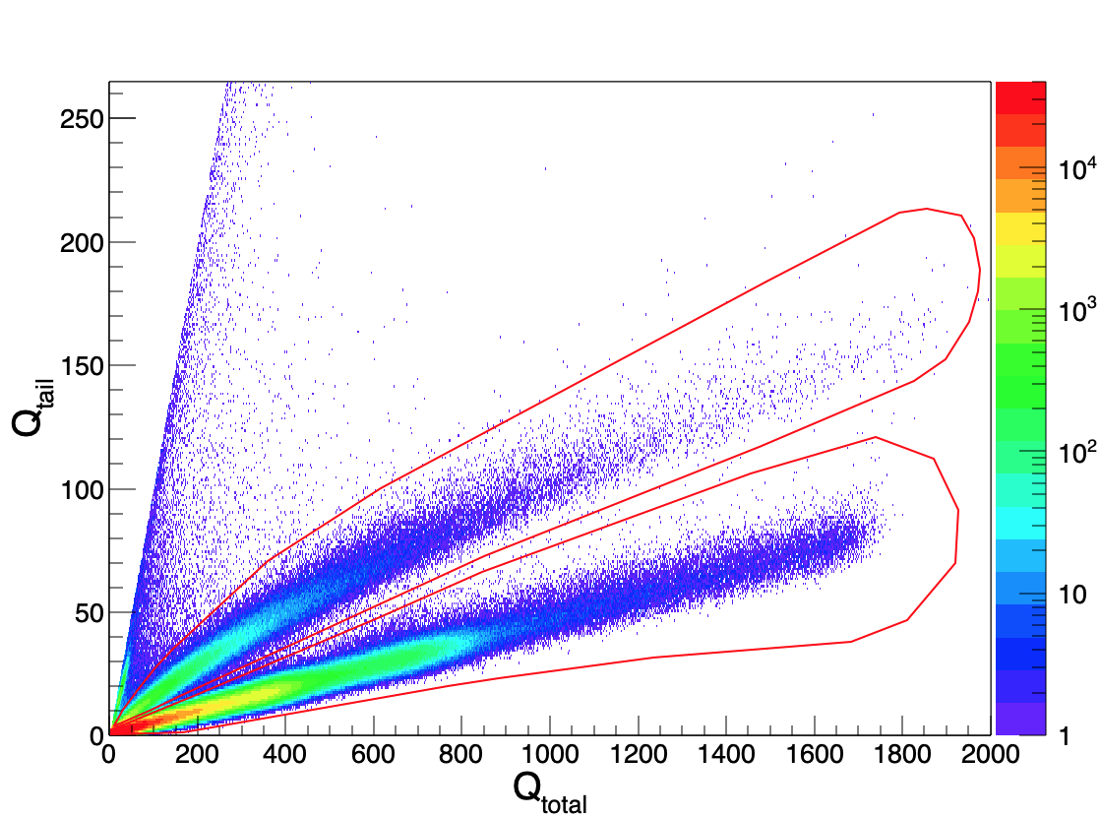
FIG. 2. Total (sum of all detectors) pulse-shape discrimination (PSD) plot showing the distribution of tail integrals (taken over the last 73% of the signals) vs the full integrals of the PMT signals. The vertical color scale is indicated on the right. Neutrons and gamma rays were selected by choosing events within the regions indicated by the red line (upper and lower region, respectively. The signals saturate at around 6.5 MeV_{ee}.
The spontaneous fission and spontaneous photons options were used to simulate prompt gamma rays and fast neutrons, with accurate neutron and gamma-ray multiplicities and correlations [13]. In the computational environment the scattering/absorption of photons and scattering of neutrons in different detectors were counted as valid fast coincidences when their interactions occurred within a pre-defined time window identical to that used in the experimental conditions and resulted in energy depositions above the experimental detection thresholds. The PTRAC card was used to follow the particles, track the scattering events, and the time between the emitted, correlated fast neutrons and gamma rays as well as their energy deposited in the detectors. A MATLAB™ [14] post processing code was created to filter the events and perform the calculations of correlation time and energy deposition. The script identifies scattering events for neutrons/photons generated in the same fission event that occurred in different detectors within a given coincidence time window. Energy range cuts were applied from 0.5 MeV to 6.6 MeV for neutrons and above 0.02 MeV for photons.
The ANSI N42.35-2016 standard [6] was used to establish the test conditions. Count rates for single gamma rays, single neutrons, neutron-neutron as well as gamma-neutron coincidences were calculated and compared for the standard ²⁵²Cf source. The effective detection zone was determined and sensitivity maps of relative counting rates for the different detection modes were constructed.

Geometrical model
The system geometry (see Fig. 1) was modelled taking into account the detailed detector specifications according to the manufacturer’s manual which has been validated in previous work [15]. The RPM prototype was placed in a 100 m² measurement room with a ceiling height of 4m, with walls consisting of concrete (density 2.250 g/cm³ [16]) as the foundation material.

Source Modelling
In order to investigate the ANSI N42.35-2016 standard [6] requirements related to neutron detection, computational simulations of the setup were done for the prescribed ²⁵²Cf neutron source in bare and moderated conditions. The modelled ²⁵²Cf source has a neutron emission rate of 2⋅10⁴ neutrons/s, and is encapsulated by 1cm of steel and 0.5 cm of lead in the “bare” condition and by a 4cm thick high-density polyethylene (HDPE) spherical container in the moderated condition. To validate the source modelling the calculated rate of single neutrons per detector area was compared with experimental and MCNP-PoliMi results presented in Ref. [17]. The source was considered isotropic and 10⁶ histories were run and normalized to the neutron emission rate of the source afterwards. Simulations were also performed for a PuO₂ sample in the setup for which the isotopic mass composition was: 0.064g of ²³⁸Pu, 4.140g of ²³⁹Pu, 1.679g of ²⁴⁰Pu, 0.099g of ²⁴¹Pu and 0.091g of ¹⁶O [18]. The modelling of this sample was validated in a previous study [8].

4. RESULTS

Background evaluation
The ANSI standard background conditions for performing radiological tests of RPMs are 5-10µR/h for gamma radiation and less or equal to 200 neutrons s⁻¹m⁻². Applying these to the present system would result in a neutron background count rate of around 21 neutrons s⁻¹. However, since organic-scintillator based detection systems, as for the present RPM prototype, are only sensitive to fast neutrons, the neutron background levels are significantly reduced compared with the dominant thermal neutron background, emanating to a large extent from downscattering of cosmic-ray induced neutrons. Standard neutron-sensitive RPMs containing ³He counters or similar thermal neutron detectors, however, detect both the cosmic ray neutron spectrum and the downscattered spectrum without preserving incident neutron energy information.
A detailed study of the fast neutron background in different environmental conditions was recently performed by Davis et al. [19] using similar liquid organic-scintillator detectors and a similar neutron-gamma discrimination technique as in the present work. Davis et al. reported a mean neutron count rate for neutron energies deposited in the detectors above 500 keV of around 2.2 s⁻¹ at near sea-level elevation and normal atmospheric pressure in a total active detection volume of approximately 25l. They also observed an increase in count rates with increasing altitude in the range of 0 – 1200 m, and a decrease in count rates with increasing atmospheric pressure in the range 970 – 1030 mbar. No significant influence from humidity (in the range, 2 – 16g/m³) or temperature (in the range, 5ºC – 37ºC) was observed. Miloshevsky et al. [20] studied the correlations between cosmic-ray-induced neutrons and gamma rays at sea level and reported singles fluxes of 0.0175 cm⁻²s⁻¹ and 0.0024 cm⁻²s⁻¹ for gamma rays and neutrons, respectively, at latitude 40°N. Cosmic-ray induced coincidence rates were reported to be up to five orders of magnitude lower than the singles rates. For example, neutron-neutron coincidences were reported at a rate of 0.12 s⁻¹ in an interval of 50µs within an area of 100m² with average time correlations of ~50-70µs. This already small cosmic-ray-induced background coincidence rate reduces dramatically on the coincidence time scales applied for fast-neutron and gamma detection with organic scintillators of up to around 200 ns. In organic-scintillator detectors employed in PSD mode the contribution from particle misidentification to the detected neutron background rate also needs to be taken into account. It is proportional to the average singles gamma rate in the scintillators with a factor typically around one to a few per mille [21] depending on the PSD cuts applied.
The background rates measured by the RPM prototype system inside the KTH Nuclear Physics detector laboratory are given in Table 1. The energy thresholds for gamma rays and neutrons are 20 keV and 500 keV_{ee}, respectively. Note that the system is unshielded in its present configuration and therefore sees a much higher gamma-ray background count rate than in standard commercial systems which typically have 10 mm or more of lead shielding installed on the outer sides of each pillar.

TABLE 1. MEASURED BACKGROUND COUNT RATES

 | Counts/s
Single neutrons | 3.0 ± 0.01
Single gamma rays | 6030 ± 0.5
Gamma-neutron coinc. | 0.0034 ±0.0003
Gamma-gamma coinc. | 227 ± 0.08
Neutron-neutron coinc. | 0.022 ±0.001

Taking into account the differences in active detection volume between the system used by Davis et al., (25l) and the KTH prototype system (13l) the present RPM system counts background neutrons at a rate which is roughly a factor 3 higher compared with the results of Davis et al. This difference is largely accounted for by the overall higher natural gamma-ray background levels (due to radon) in the Stockholm area. Another contribution to the higher background rates measured in the KTH RPM prototype system compared with those measured by Davis et al. is the complete lack of shielding of the KTH prototype in its present configuration, whereas in the latter case the detection system was mounted inside the RadMAP survey vehicle with significant shielding from surrounding materials [19].

False alarm rate tests
A “false alarm” is deﬁned as the declaration of an alarm due a measurement of counts during the relevant measurement period, in this case one second, in any of the measured parameters (neutrons, gamma-rays, gamma-neutron coincidences, neutron-neutron coincidences, etc) when no radiation source other than room background is present. The ANSI standard document [6] does not take into account systems which are able to measure fast coincidence events as in the present case even though the same principles apply. The document describes a false alarm test method and sets as an acceptable result if no more than 1 false alarm occurs in 1000 occupancies for systems with occupancy sensor, or no more than 1 alarm in 2 hours of observation in systems without occupancy sensor. The KTH RPM prototype system can be operated with or without occupancy sensor. To investigate the background rates and their variation a 60 h long background measurement was recorded with the sampling period set to 1s. The resulting single gamma, single neutron and gamma-neutron coincidence measurements are shown in Figs. 3-5. The >4σ alarm thresholds relevant for an interrogation time of 1 s with the background conditions in the KTH detector lab are given in Table 2. The alarm trigger limit corresponding to a >4σ threshold above the mean background level is exceeded in 17 cases for the gamma-ray measurements (i.e. 17 out of 216 000 measurements) and in 24 cases for the neutron measurement (i.e. 24 out of 216 000 measurements). The accidental neutron-neutron coincidence rate is higher than the background gamma-neutron coincidence rate due to the relatively large probability of neutron scattering between detectors. The probability to observe one gamma-neutron coincidence count in a one second interrogation period due to room background was measured to be 0.0034. In only one case was two gamma-neutron coincidence events observed during 216 000 consecutive measurements corresponding to a FAR of the order of 5⋅10⁻⁶.

TABLE 2. ALARM TRIGGER THRESHOLDS (>4σ above background)

 | counts/s
Single neutrons | 10
Single gamma rays | 6340
Gamma-neutron coinc. | 1
Neutron-neutron coinc. | 1

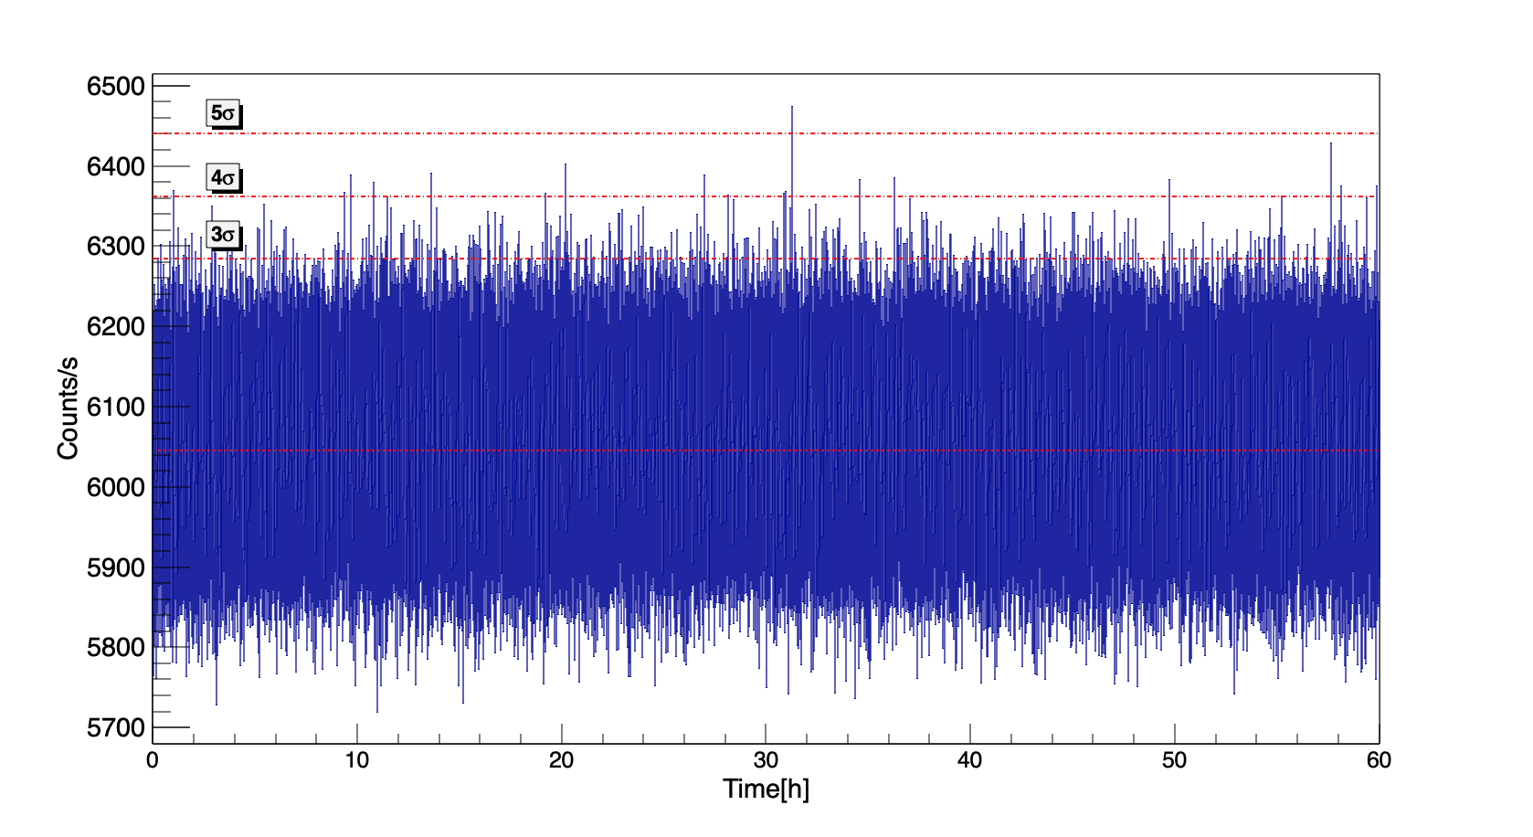
FIG. 3. Background test for single gamma rays taken during a 60 h data acquisition period. The data were taken without any source (except room background) present. Each bin corresponds to a 1s measurement. The dashed lines indicate the mean level of counts whereas the dash-dotted lines show the 3, 4, and 5 sigma limits (assuming Poisson statistics).

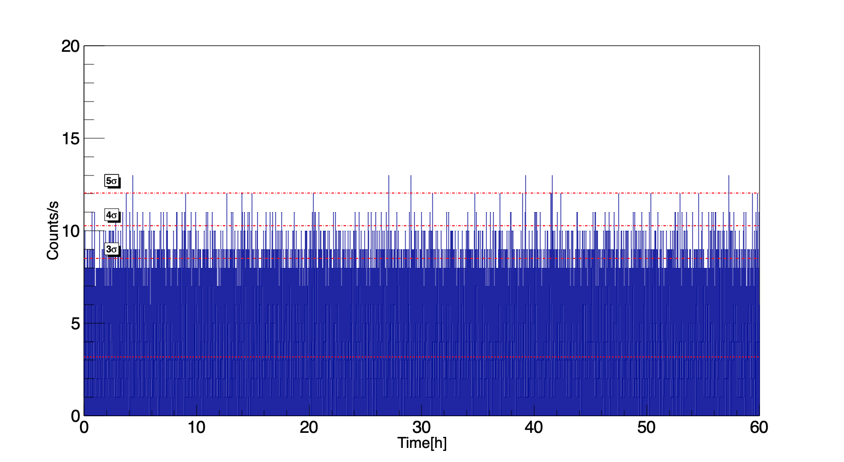
FIG. 4: Background test for single neutrons taken during 60 h. Each bin corresponds to a 1s measurement.
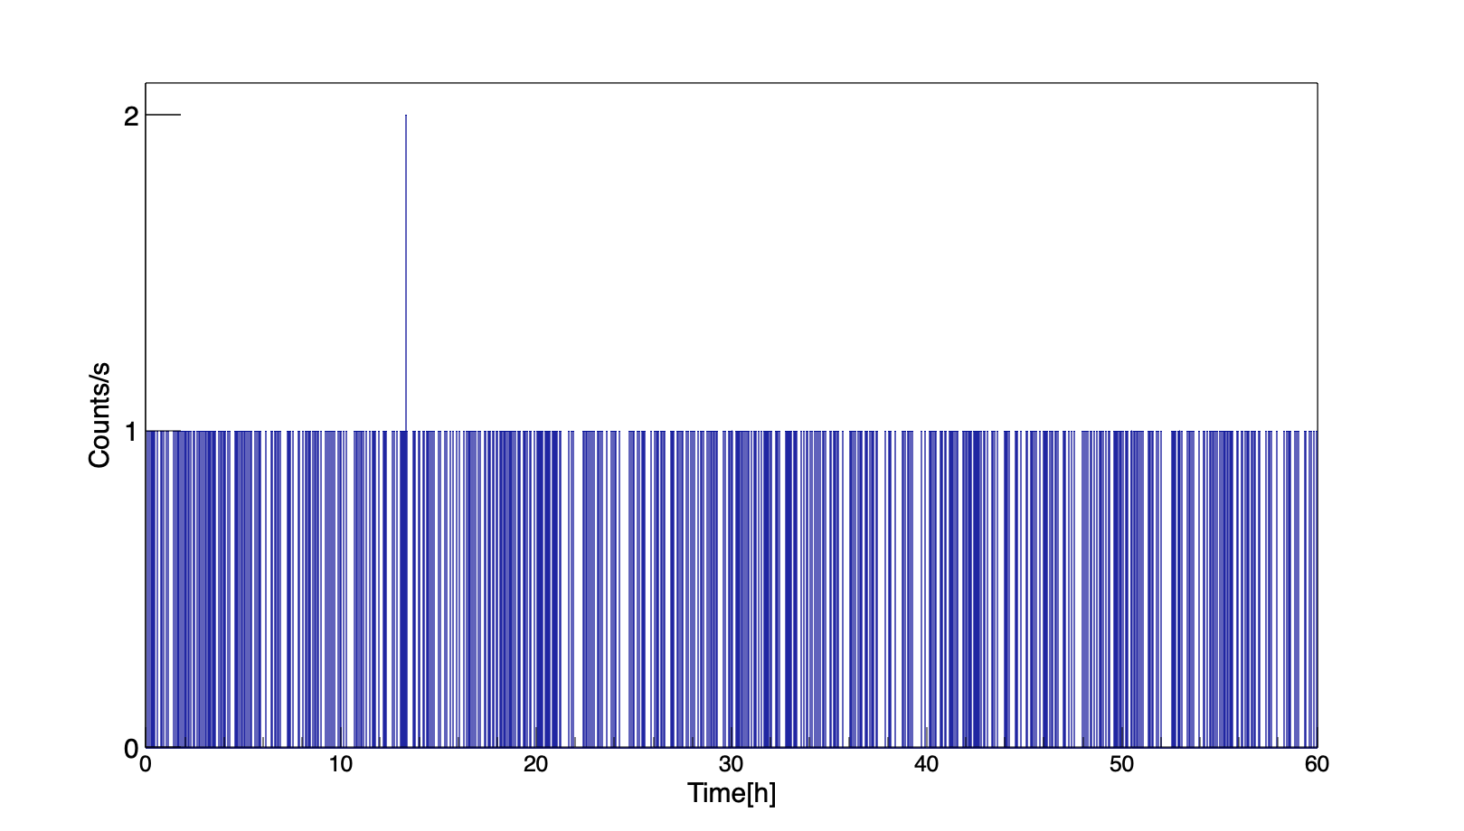
FIG.5: Background test for gamma-neutron coincidence events. Each bin corresponds to a 1s measurement. Only one out of 216 000 events was registered above the 1-count alarm threshold determined for the present pprototype configuration.

Simulated response to radiation sources
    - ²⁵²Cf

The RPM prototype system has been evaluated for its response to a standard ANSI ²⁵²Cf source (neutron emission 20 000 neutrons/s) based on the method described in the ANSI N42.35-2016 standard document [6]. It requires that an alarm shall be triggered when the measured count rate is greater than the alarm setting when a “bare” and a moderated ²⁵²Cf source moves horizontally through the portal at a velocity of 1.2m/s. We here report the results for source paths going through the centre of the RPM, at a vertical position of 1.0 m and 0.5 m from the front face of each detection assembly. According to the ANSI standard the RPM response is considered acceptable when a minimum of 59 neutron alarms occur in 60 trials, i.e. one false negative or less per 60 trials. The ANSI standard requires the performance to be evaluated for two source conditions. In the “bare” condition the source is surrounded by 1 cm of steel and 0.5 cm of Pb while in the moderated condition the source is shielded by 4 cm of HDPE. We also evaluate the results for “beyond ANSI” conditions with a source that has half the activity of the standard ANSI ²⁵²Cf source.
The results were used to calculate the sigma multiplier factor [22] in order to access the performance of the KTH RPM prototype in its limited-scale 8-module configuration. The sigma multiplier satisfies the condition that the sum of the background counts, C_{B}, and the product of its standard deviation sigma, σ_{B} and the sigma multiplier factor, N equals the mean counts measured during a given interrogation time (source + background): <C_{B}> + N ⋅ σ_{B} = <C_{S} + C_{B}>. Here, we evaluate the sigma multiplier factor for detection of single neutrons, gamma-neutron coincidences and neutron-neutron coincidences for a measurement time of one second while the source is moving through the RPM at 1.2 m/s (i.e covering the distance from -0.6 m to +0.6 m, where the origin is at the centre of the detection system, see Tables 3 and 4. Considering detection thresholds of > 4σ above the mean background (see Table 2) we also give the probabilities of a false negative result, p_{N} (i.e that the passage of the source was not detected) for the different detection modes in Tables 3 and 4.

TABLE 3. ALARM TESTS FOR ANSI STANDARD AND BEYOND - “BARE” ²⁵²Cf (1 cm STEEL, 0.5 cm LEAD SHIELDING).

SOURCE NEUTRON EMISSION RATE | SINGLE NEUTRONS  N / p_{N} | GAMMA-NEUTRON COINCIDENCES N / p_{N} | NEUTRON-NEUTRON COINCIDENCES  N / p_{N}
20 000 n/s | 150 / <10⁻¹² | 184 / 0.0015 | 46 / 0.013
10 000 n/s | 75 / <10⁻¹² | 92 / 0.030 | 23 / 0.096

TABLE 4. ALARM TESTS FOR ANSI STANDARD AND BEYOND - MODERATED ²⁵²Cf
(4 cm HDPE SHIELDING).

SOURCE NEUTRON EMISSION RATE | SINGLE NEUTRONS  N / p_{N} | GAMMA-NEUTRON COINCIDENCES N / p_{N} | NEUTRON-NEUTRON COINCIDENCES  N / p_{N}
20 000 n/s | 102 / <10⁻¹² | 185 / 0.0014 | 12 / 0.27
10 000 n/s | 51 / <10⁻¹² | 93 / 0.029 | 6 / 0.54

In all cases is the background sigma multiplier factor for gamma-neutron coincidence counting the highest and this counting mode also by far meets the ANSI requirement on a maximum false negative rate (1/60) for the standard ANSI ²⁵²Cf source. Neutron-neutron coincidence counting can be used in the bare conditions but is too inefficient to be useful when the source is shielded by a 4 cm layer of HDPE. Singles neutron counting is most efficient but has lower sigma multiplier factors than for gamma-neutron coincidence counting, a difference that increases with decreasing source activity.

Measured response to radiation sources
Before the measurements the individual detectors were gain matched using standard radioactive calibration sources; the electron conversion X-ray photopeak and Compton edge for ¹³⁷Cs (32 KeV and 478 keV, respectively) and the 59.5 keV photopeak of ²⁴¹Am.

²⁵²Cf
The measured response to the passage of a ²⁵²Cf source [23] with a neutron emission rate of approximately 8300 n/s is summarized in Table 5. This source has an activity of around 42% of the standard ANSI ²⁵²Cf source and the ²⁵²Cf material is embedded in a ceramic cylinder with dimensions 4.6 mm (diam.) × 6 mm and encapsulated in a double-welded stainless steel cylinder with outer dimensions 7.8 mm (diam.) × 10.0 mm (ANSI classification code C66544). The measurements show results that are qualitatively similar to the simulations: the highest sigma multiplier factor and a low FAR are achieved for the gamma-neutron coincidence mode.

TABLE 5. ALARM TESTS FOR ²⁵²Cf – MEASUREMENT.

SOURCE NEUTRON EMISSION RATE | SINGLE NEUTRONS  N / p_{N} | GAMMA-NEUTRON COINCIDENCES N / p_{N} | NEUTRON-NEUTRON COINCIDENCES  N / p_{N}
8 300 n/s | 68 / <10⁻¹² | 123 / 0.011 | 20 / 0.12

¹³⁷Cs and ¹³³Ba
The measured response to the passage of a ¹³⁷Cs and a ¹³³Ba gamma-ray source are summarized in Table 6. The sources are significantly weaker than required in the ANSI standard, 9.6% and 32% of the ANSI standard activities for ¹³³Ba and ¹³⁷Cs, respectively. The gamma-ray “surrogate” for weapons grade plutonium (WGPu) is ¹³³Ba with 120 kBq of ¹³³Ba corresponding to 1 g of WGPu. The results show excellent detection capabilities for these relatively weak sources. In the case of the ¹³³Ba source the activity only produces an increase of approximately 14% in the count rate over the normal background rate.

TABLE 6. ALARM TESTS FOR GAMMA SOURCES: ¹³⁷Cs and ¹³³Ba – MEASUREMENT.

SOURCE | ACTIVITY | SIGMA MULTIPLIER (N) | PROBABILITY OF FALSE NEG. (p_{N})
¹³³Ba | 50 kBq | 11 | <10⁻¹²
¹³⁷Cs | 191 kBq | 31 | <10⁻¹²

5. IMAGING CAPABILITIES
Due to its granularity, fast timing properties and energy resolution the system has excellent imaging capabilities and several new, proprietary, imaging techniques have been developed for this purpose. Due to space limitations the imaging capabilities of the system, which for SNM are based on detailed neutron-gamma energy and time correlations, are not discussed further in the present paper.

6. CONCLUSIONS
A pedestrian/package/luggage RPM system based upon organic liquid scintillation detectors was designed and tested in a limited-scaled prototype version at KTH Royal Institute of Technology. The system has been shown to be able to consistently alarm for standard gamma-ray sources and a ²⁵²Cf neutron source under conditions outlined in the ANSI N42.35-2016 standard document and beyond. For sources undergoing spontaneous fission the ability to apply the novel gamma-neutron coincidence mode in addition to standard single-neutron counting provides the lowest false alarm rate and low false negative rates in conjunction with new imaging capabilities [24]. The gamma-ray detection mode therefore provides a performance that goes well beyond the requirements of the ANSI standard.

ACKNOWLEDGEMENTS

This work was supported by the Swedish Radiation Safety Authority under contract No. SSM2016-3954, the Swedish Innovation Agency (Vinnova) under contract No. VFT-1 245, and Carl Tryggers Stiftelse för Vetenskaplig Forskning under contract No. CTS 14:89.
References
- IAEA INCIDENT AND TRAFFICKING DATABASE (ITDB) Incidents of nuclear and other radioactive material out of regulatory control 2019 Fact Sheet, https://www.iaea.org/sites/default/files/18/12/itdb-factsheet-2019.pdf
- Pickrell, M.M., et al., The IAEA workshop on requirements and potential technologies for replacement of 3He detectors in IAEA safeguards applications, J. Nucl. Mater. Manage. 41 (2) (2013).
- Lewis, J.M.; R. P. Kelley; D. Murer; K. A. Jordan, "Fission signal detection using helium-4 gas fast neutron scintillation detectors". Appl. Phys. Lett. 105 (2014) 014102.
- Trombetta, D.M.; Klintefjord, M.; Axell, K.; Cederwall, B., Fast neutron and γ-ray coincidence detection for nuclear security and safeguards applications, Nuclear Instrumentations and methods in physics research, A. 927 (2019) 119-124.
- Pozzi, S.A. et al., Comparative neutron detection efficiency in 3He proportional counters and liquid scintillators, Nucl. Instrum. Meth. Phys. Res. A 929 , (2019) 107.
- ANSI N42.35-2016, American National Standard for Evaluation and Performance of Radiation Detection Portal Monitors for Use in Homeland Security, DOI: 10.1109/IEEESTD.2016.7551097.
- Eljen Technology, Neutron/gamma PSD liquid Scintillator EJ-301, EJ-309, <https://eljentechnology.com/products/liquid-scintillators/ej-301-ej-309 > (accessed 20 November 2019).
- https://www.hamamatsu.com/eu/en/product/type/R1250/ (accessed 28 November 2019).
- https://www.caen.it/subfamilies/up-to-6-kv-dt55xxe/ (accessed 28 November 2019).
- https://www.caen.it/subfamilies/730-digitizer-family/ (accessed 28 November 2019).
- https://www.intel.com/content/dam/www/programmable/us/en/pdfs/literature/pt/cyclone-iv-product-table.pdf (accessed 28 November 2019).
- MCNP® USER’S MANUAL Code Version 6.2 Los Alamos National Laboratory report LA-UR-17-29981 (October 2017).
- Rising, M.E., et al., Using the MCNP6.2 correlated fission multiplicity models, CGMF and FREYA, Transactions of the American Nuclear Society, Vol.116 (2017)
- MATLAB R2017a, The MathWorks, Inc., Natick, Massachusetts, United States (2017).
- Trombetta, D. M.; Axell, K.; Cederwall, B., MCNP6 simulation validation of fast neutron coincidence detection system for nuclear security and safeguards applications, ESARDA Symposium 2018 (2018) 49-57.
- Compendium of Material Composition Data for Radiation Transport Modelling, PIET-43741-TM-963 PNNL-15870 Rev. 1 ( 2011).
- TROMBETTA, D. M., CEDERWALL, B., AXELL, K. “Investigation on an alternative RPM concept design for special nuclear material detection”, ESARDA Symposium 2019 Proceedings (2019) 105.
- Certificate of analysis, CBNM nuclear reference material 271, Tech. Rep. Commission of the Europe Communities, JRC, Central Bureau for Nuclear Measurements (1989).
- Davis, J.R., Brubaker, E., Vetter, K. Fast neutron background characterization with the Radiological Multisensor Analysis Platform (RadMAP), Nucl. Instrum. Meth. Phys. Res. A 858, (2017) 106.
- Miloshevsky, G., Hassanen, A., Time correlation of cosmic-ray-induced neutrons and gammas rays at sea level, Nuclear Inst. and Meth. in Phys. Research A 737 (2014) 33-41.
- Cederkäll, J., et al. Nucl. Inst. Meth. Phys Res. A 385 (1997) 166.
- IAEA, Nuclear Security Series No.1, Technical and Functional Specifications for Border Monitoring Equipment (2016).
- Sealed Radiation Sources, Product Information – Eckert & Ziegler Nuclitec GmbH, Rev. 07 /2009.
- Cederwall, B., Int. PCT Patent application No PCT/SE2019/050609.

