ACTIVITIES AND CHALLENGES OF NUCLEAR
SECURITY WITHIN THE FORUM FOR NUCLEAR
COOPERATION IN ASIA (FNCA)

M. SENZAKI
Project Leader of FNCA
Tokyo, Japan
Email: senzaki <senzaki.masao@tbz.t-com.ne.jp>

P. RODRIGUEZ
Japan Atomic Energy Agency (JAEA)
Tokai-mura, Ibaraki, Japan

M.SEKINE
Japan Atomic Energy Agency (JAEA)
Tokai-mura, Ibaraki, Japan

Y. KIMURA
Japan Atomic Energy Agency (JAEA)
Tokai-mura, Ibaraki, Japan

Abstract

In response to the diversification of energy resources, several Asian countries have currently considered nuclear power as an option. As a result, a dramatic increase in the use of nuclear material is foreseen; nuclear security and safeguards, as well as nuclear safety, will become more important in the promotion of the peaceful uses of nuclear energy. For these reasons, the Nuclear Security and Safeguards Project (NSSP) started in 2011 within the framework of the FNCA, aims to cooperate with FNCA member countries to strengthen their respective infrastructures. The FNCA is a framework led by Japan’s Cabinet Office and the Ministry of Education, Culture, Sports, Science, and Technology (MEXT) for international cooperation with neighboring Asian countries towards the peaceful uses of nuclear technology. The framework for FNCA cooperation consists of a Ministerial Level Meeting, Senior Officials Meeting, Coordinators Meeting, and a Study Panel. The participating 12 countries are Australia, Bangladesh, China, Indonesia, Japan, Kazakhstan, Republic of Korea, Malaysia, Mongolia, the Philippines, Thailand, and Vietnam. Currently, 7 topical projects are being conducted with collaborative activities under equal partnership in various nuclear fields. Each project promotes joint research, discussions on common challenges, and information exchange. A workshop is held annually. Conversely, the Integrated Support Center for Nuclear Nonproliferation and Nuclear Security (ISCN) of the Japan Atomic Energy Agency (JAEA) has been providing assistance, specifically to Asian countries. Therefore, the ISCN has closely collaborated with the NSSP. The objectives of the NSSP are to share experiences, knowledge, and information on nuclear security and safeguards implementation including human resource development (HRD) and research and development activities. In 2015, under the NSSP, a survey was conducted among FNCA member countries on future activities. At the 6th FNCA workshop in 2016, the results of the survey and the prospects for future activities were discussed. The following fields were selected for this project: 1) Nuclear Security: Nuclear forensics, cyber security, nuclear security culture, and security of radioactive sources; 2) Safeguards: Additional Protocol, others; 3) Common for security and safeguards: Capacity building under Centers of Excellence (COEs). The 19th FNCA Ministerial Level Meeting (MLM) was held in Japan, in December 2018. The MLM Joint Communique reiterated and emphasized the FNCA’s objectives toward the peaceful uses of nuclear technology. The accomplishments of the NSSP activities have shown the importance and beneficial effects of the collaborative efforts among the FNCA member countries. The paper describes a 3-year plan and the outcome, and also challenges of the NSSP activities.

INTRODUCTION

1.1 What is FNCA

The FNCA is a Japan-led cooperation framework for the peaceful use of nuclear technology in Asia. At present, FNCA’s 7 projects are being conducted in various nuclear energy fields. Each project promotes information exchanges, joint research, and debates on common challenges, and holds a workshop annually, including open seminars. Each project also reports information exchanges and research results and provides guidelines/manuals on which activities in Asian countries should be based. Under this framework, the 7 projects are as follows: 1) Mutation Breeding, 2) Radiation Processing and Polymer Modification, 3) Research on Climate Change using Nuclear and Isotopic Techniques, 4) Radiation Oncology, 5) Research Reactor Utilization, 6) Radiation Safety and Radioactive Waste Management, and 7) Nuclear Security and Safeguards.

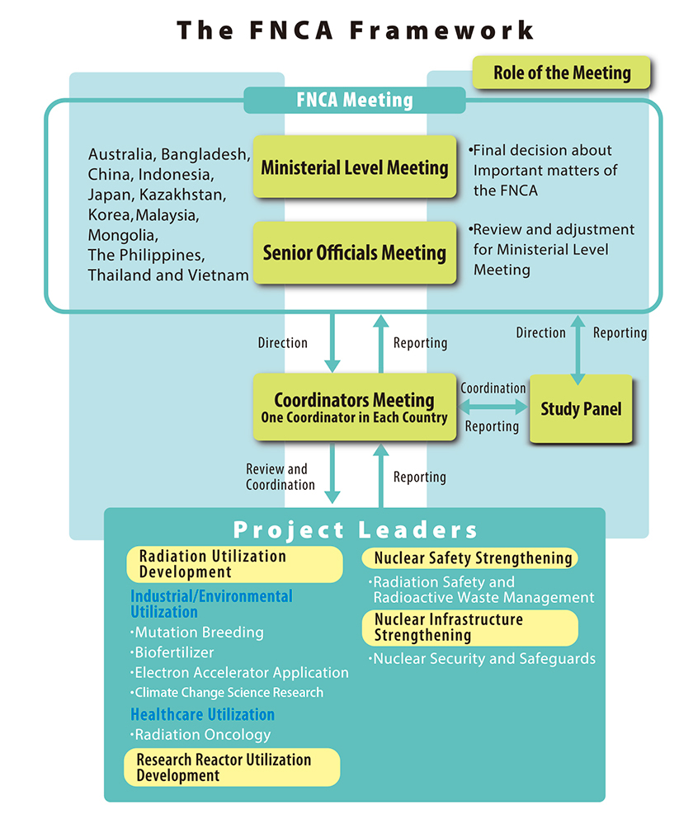
FIG. 1. FNCA Framework

1.2 Framework of FNCA
The basic framework [1] of cooperation, as shown in Fig. 1, consists of the following three systems and project activities:

(1）FNCA Ministerial Level Meeting (MLM)
The FNCA Meeting is composed of MLM and Senior Officials Meeting in which cooperation measures and nuclear energy policies are discussed. The MLM is a gathering of ministerial level representatives in science and technology who are in charge of activities that use nuclear energy and radiation. FNCA’s cooperation policies and participating countries’ nuclear energy policies are discussed. At the Senior Officials Meeting, the representatives from each participating country gather to hold a preliminary discussion on the preparation, theme and specific topics for MLM.
(2）Coordinators Meeting
The total review and coordination of the FNCA projects are implemented by an appointed coordinator from each member country. A coordinator is appointed for each participating country with the responsibility to oversee project activities in various nuclear fields. Coordinators gather to assess the progress of individual projects and to discuss their results, evaluations and future policies.

(3）Study Panel
The Study Panel holds a discussion on nuclear policy matters of both power and non-power areas of nuclear energy in the participating countries, supplemented by a technical discussion on nuclear development.

Establishment and Activities of Nuclear Security and Safeguards Project

2.1 Establishment
The NSSP was established in Japan’s Fiscal Year (JFY) 2011, addressing the Resolutions of the 11th (2010）& the 12th（2011）FNCA MLMs respectively [2]. The project is aimed at sharing experience in, knowledge of, and information on nuclear security and safeguards implementation, and exchanging views on policies, strategies, and frameworks for better performances in these areas. Alongside this background, the project is expected to:

- Raise awareness of the importance of nuclear security and safeguards,
- Facilitate information sharing in these areas,
- Promote capacity building efforts in these areas, and
- Enhance the regimes of nuclear security and safeguards by sharing information on technical tools and requirements of nuclear security and safeguards.

The FNCA member countries have been improving knowledge and awareness of the importance of nuclear security and safeguards through information exchange on the implementation of nuclear security and safeguards in each country in combination with workshops (WSs) and open seminars. Information on the implementation of nuclear security and safeguards, as well as the information on the regulatory authorities for nuclear 3Ss (Safety, Safeguards, and Security), has been shared through the FNCA website. Based on the Chair’s Statement on the 14th（2013）FNCA MLM, the FNCA member countries have been sharing information on initiatives and best practices for the development of nuclear security culture and safeguards implementation through the FNCA website with the aim of strengthening nuclear security and safeguards in the Asian region [3]. In addition to the participants from FNCA member countries, representatives from the IAEA have been invited to the workshop as observers. And also, ISCN/JAEA has fully supported the activities of the NSSP.

2.2 Activities
The 8 years’ activities of this project have produced excellent outcomes raising the awareness of the importance of nuclear security and safeguards, facilitating information sharing on nuclear security and safeguards, promoting capacity building for nuclear security and safeguards, and enhancing nuclear security and safeguards regimes. To date, the project has organized 8 WSs, and 36 sessions in Japan (2011), Vietnam (2012), China (2013), Republic of Korea (2014), Kazakhstan (2015), Indonesia (2016), Japan (2017), and China (2018) respectively, with a total of 370 participants. The workshops and open seminars were very useful for productive discussions and information exchanges. The WSs demonstrated that the NSSP has the potential to play an important role by serving as a platform for knowledge- and experience-sharing for the enhancement of nuclear security and safeguards regimes in FNCA member countries.

THREE-YEAR PLAN
The FNCA member countries need to contribute to the Post-Nuclear Security Summit (NSS) process to continue with their international leadership by promoting the implementation of their nuclear security commitments made during the NSS (i.e., four NSS Communiqués, the 2016 Action Plans, national commitments, others). The FNCA member countries have to promote the Ministerial Declaration of the IAEA International Conference on Nuclear Security (held on 5-9 December 2016). The FNCA member countries with nuclear material and nuclear activities need to obtain international trust by enhanced transparency. Thus, Safeguards/Additional Protocols (AP) is essential for global security.

The NSSP conducted a survey among FNCA member countries about Future Activities of the project. At the 6th WS (2016), FNCA member countries discussed the result of the survey and the prospect for future activities. The following areas of the project were selected for the next 3-Year Plan:

3.1 Nuclear Security
(1) Nuclear Forensics (NF)
- (FY2017)
- Sharing the information among the FNCA member countries by using questionnaires to identify the current NF status in each country addressing Technical capabilities (analysis, NF library), the status of the national response plan, and international collaboration.
- Overview and a basic understanding of the NF process.
- Awareness-raising information exchange. Developing an action plan.
- (FY2018)
- Discussing the development of the national response plan, sharing information on the development of the national nuclear NF library.
- Tabletop training exercise on evidence sample collection, initial investigation at nuclear forensics laboratory (including sub-sampling and distribution planning) and nuclear forensics interpretation including the introduction of nuclear forensics sponsored by ISCN/JAEA & MEXT of Japan.
- (FY2019)
- Hands-on training exercise on nuclear forensics analysis.
- Short tabletop exercise on the occasion of WS (Philippines)
- Discussing the promotion of multinational or bilateral collaboration in the region (covering infrastructure and equipment development, transferring nuclear materials for analysis, training, and developing the national nuclear forensics library - NNFL) as the Next Plan.

(2) Cyber security
Lectures from the experts (IAEA, others), and sharing experiences of FNCA member countries.

(3) Nuclear security culture
- Sharing good practices of nuclear security culture: policy and guidelines for establishment and implementation.
- Efforts to encourage the participation of all stakeholders in nuclear security.
- Training and education, self-assessment methods and its implementation
- Providing information to strengthen nuclear security culture through education and training opportunities, including activities of the regional COEs.

(4) Security of radioactive sources
- (FY2017): Lectures from Nuclear Regulation Authority (NRA) of Japan.
- (FY2018): Sharing the information regarding regulation and good practices of FNCA member countries to strengthen the security regime of radioactive sources and their associated facilities.
- (FY2019): Tabletop Exercise (TTX) on the Security of radioactive sources.
(Note: dependent on Japan’s budget for 2019 FY)
Lectures from Philippine Nuclear Research Institute (PNRI)

3.2 Safeguards (AP, others)
- (FY2017): Compile a generic set of good practices on AP implementation from members, experiences either based on actual experience or inferred. ISCN/JAEA will send a few examples, and the FNCA project member countries to provide their own good practices and examples before the end of 2017.
- (FY2018):
- ISCN/JAEA to compile input and prepare a report for the next FNCA Meeting.
- FNCA project members will discuss results and further actions.
- To prepare a consolidated document for publication in the FNCA webpage, and others, and further dissemination among FNCA member countries.
- (FY2019): As more information, on good practices supported by actual experiences, is received, a final report, a consolidated document for publication, will be prepared and shared with all FNCA members.

3.3 Capacity Building under COEs in the fields of Nuclear Security and Safeguards

- Discussing effective human capacity building and the need for a long-term Human Resource Development (HRD) plan or strategy for sustainable development (reaching out to a wide variety of stakeholders; increase opportunities for training/education; use of limited resources training opportunities: lecturers, course topics; effectively develop training tools/facilities; others).
- Exchanging information on each other’s training activities, and sharing good experiences on nuclear security and safeguards training among COEs.
- Facilitating cooperation and assistance activities, to optimize the use of available resources among FNCA member countries.

4. PAST 2-YEAR ACTIVITIES REGARDING NUCLEAR SECURITY

4.1 Topics at the 7th WS (2017)

The FNCA WS took place in Mito/Tokai, Japan on 19-21 September 2017. This WS was hosted by the Ministry of Education, Culture, Sports, Science, and Technology (MEXT) of Japan. The 7th WS had a total of twenty-six participants from ten countries: Bangladesh, China, Indonesia, Japan, Kazakhstan, Malaysia, Mongolia, Thailand, the Philippines, and Vietnam, as shown in Fig 2. The 3-year plan was proposed and agreed upon.

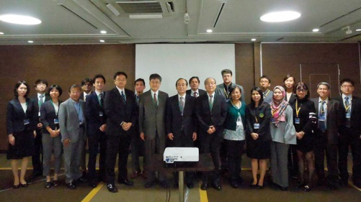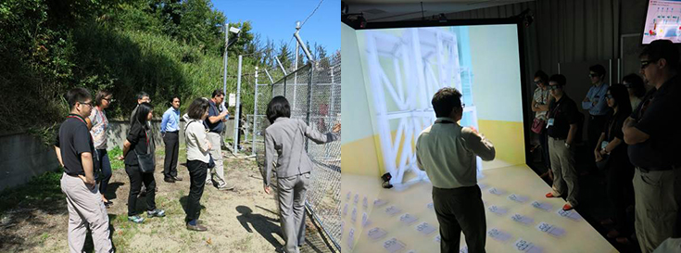
Fig. 2 7th WS participants Visit at ISCN PP field Visit at ISCN Virtual Reality

(1) Nuclear Forensics
- The questionnaire was sent in advance to the participants of the WS. This was aimed at sharing the information among FNCA member countries on the current status of nuclear forensics capability of each country and to identify the needs of the collaborative activities within the FNCA.
- The result shows that most of the FNCA member countries have the basic capability or at least have started to build nuclear forensics capability. Also, it illustrates the common challenges among the member countries, namely: the development of the national framework, the National Nuclear Forensics Library (NNFL), and forensics interpretation and findings capability.
- The participants discussed how to further enhance each country’s capability. One proposal is the use of already available resources for nuclear forensics. Rather than establish an entirely new nuclear forensics laboratory from scratch, it is more efficient to use the technology and equipment already developed for a different purpose.
- For the future activity of the Project for enhancing nuclear forensics capability, participants welcomed the proposal by Japan to organize, in 2018, a tabletop exercise addressing the technical issues on nuclear forensics. Thailand will also seek the possibility of hosting a hands-on training exercise on nuclear forensics analysis at their laboratory in 2019.

(2) Special Lectures on Security of Radioactive Sources
- Japan introduced its current efforts on enhancing the security of radioactive sources. Currently, there are over 8,000 users of radioactive sources in Japan, and that number is increasing in recent years. At the same time, in the past, though the numbers were small, there were some incidents involving leakage, loss and false disposal of radioactive sources. Japan received the IAEA Integrated Regulatory Review Service (IRRS) Mission in 2016 and accepted the Mission's recommendation to reconstruct its national regulation to include security measures.
- The reconstructed regulation will require licensees possessing radioactive sources beyond D-values (Dangerous Quantities of Radioactive Material) for tighter security measures. About 500 licensees are subject to this security regulation and will be required to have the elements of detection, delay, response, and access control, etc. to address security events at their facilities. The reconstructed regulation is expected to be implemented in 2019, before the 2020 Tokyo Olympics/Paralympics Games.

(3) The New 3-Year Plan
The past three-year achievements of the Project were reviewed, and the new direction of the Project was introduced.

4.2 Topics at the 8th WS (2018)

The FNCA WS took place in Beijing, China on 11-13 September 2018. The WS was hosted by China’s State Nuclear Security Technology Center (SNSTC) and MEXT of Japan. The Workshop had 23 participants from nine countries: Bangladesh, China, Indonesia, Japan, Malaysia, Mongolia, Thailand, the Philippines, and Vietnam, as shown in Fig. 3.

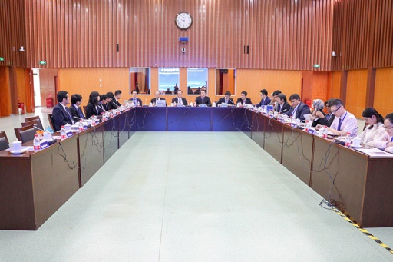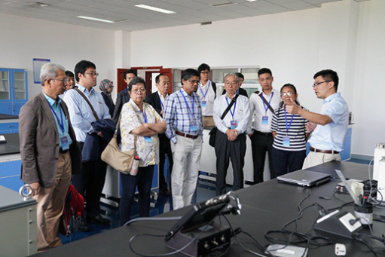
Fig. 3 8th FNCA Workshop Participants

(1) Nuclear Forensics
- ISCN/JAEA presented the background on the common challenges on NF capacity building among FNCA member countries based on the NF questionnaire covering the topics on National Framework, Chain of Custody, NF Laboratory, and Interpretation and Findings (NF Library) in order for FNCA member countries to be familiar with NF. Also, the ISCN/JAEA proposed FNCA members to enhance National Nuclear Forensics capacity building by its participation in the introduction of NF Tabletop Exercise (TTX) for regional participants which was held on 28-31 January 2019 at the ISCN/JAEA in Tokai, Japan. One of TTX objectives is to discuss regional cooperation regarding NF.
- The discussion regarding the following 3 proposals made by ISCN/JAEA on the Tabletop Exercises (TTX) on Nuclear Forensics are:
- Collaborative Research for NNFL Development
- TTX for NNFL Development and Data Analysis
- TTX for NNFL Query
- Regarding building confidence in NF evaluation, participants of the workshop suggested that collaboration with international organizations on NF should be made to conduct certification and calibration for NF capability to provide a standard for NF that can be used as reference by other FNCA member countries. This future program can help to create subject matter expert

(2) Cyber Security - Regulatory Framework and Capacity Building (2 Presentations)
- AELB (Malaysia) shared a cyber incident that occurred in Malaysia in 2017 in which all the government offices and relevant agencies received notification from the National Security Council about the cyber security attack. Capacity-building activities on 3S are being continuously done by the AELB through national/international training/workshop programs.
- ISCN/JAEA (Japan) presented the establishment of ISCN in 2010 which is focused on the development of Nuclear Security capabilities among the workforce in Japan and regional/international countries in collaboration with the IAEA. The ISCN offers training courses on Nuclear Security, and non-proliferation framework with a view to sharing knowledge, experience and providing support towards the development of legal framework related to Nuclear Security and Cyber Security. Effective Inter-section cooperation in JAEA between IT professionals, Nuclear Security Administration and ISCN exists and it has been very helpful towards ensuring Cyber Security in nuclear facilities and organizations.

5． CONCLUSION
The 19th FNCA MLM was held in Tokyo, Japan, on 6 December 2018. The MLM Joint Communique reiterated and emphasized the FNCA’s objectives toward the peaceful uses of nuclear technology. The Joint Communique also emphasized the urgent need to reinforce nuclear security, including nuclear forensics and cyber security in nuclear facilities, through adequate preparations that deal with such potential risks as terrorism threats and other critical security issues for the member countries.

The accomplishments of the NSSP activities have shown the importance and beneficial effects of the collaborative efforts among the FNCA member countries. The activities of the 3-year plan are aimed at reinforcing nuclear security and safeguards; furthering the activities prioritized by member countries. It also addresses human resource development which is a universal concern among member countries. There is a wide spectrum of interest in future research and development to support the sustainability of activities related to the application of nuclear science and technology, including nuclear forensics and cyber security.

Under the NSSP, there were various technical, cultural, and socio-economic differences as well as nuclear energy situations among FNCA member countries, but the Project has achieved a mutual understanding on the importance of strengthening nuclear security and safeguards in their respective countries, both during the workshops and at the open seminars. The expert network established through Project activities has the potential to promote and strengthen further cooperation among Asian countries in the field of nuclear security and safeguards. The Project activities need to be enhanced through collaboration with JAEA, the IAEA, the APSN, and other existing multilateral frameworks.

The 9th FNCA workshop is scheduled to take place in Manila, the Philippines, on 25-28 November 2019, aiming to discuss the future challenges as well as the sharing of the members’ experiences and insights on nuclear security and safeguards, specifically highlighting the outcome of the 3-year plan, short TTX on NF and the next activities.
References
[1] http://www.fnca.mext.go.jp/
[2] http://www.aec.go.jp/jicst/NC/sitemap/bunya15_fnca.htm
[3] M. Senzaki, “Current Activities and Future Challenges of FNCA’s Nuclear Security and Safeguards Project”, Proceedings of 56th INMM Annual Meeting, USA, July 2015

