CHALLENGES IN MPLEMETING NUCLEAR SECURITY SYSTEMS AND MEASURES IN MAJOR PUBLIC EVENTS IN UGANDA

NOAH DEOGRATIAS LUWALIRA
Atomic Energy Council
Kampala, Uganda
Email: noahdeo@yahoo.com

Abstract

The nuclear law for regulation of peaceful applications of radioactive sources in Uganda was enacted in 2008. The law established the Atomic Energy Council as the national regulatory body in the nuclear energy subsector. The Act also provided for radiation safety, radiation protection and nuclear security in the applications of radioactive sources in the country.
The increasing use of radioactive materials in the medical, industrial as well as research and education sectors, though, has numerous benefits, it is associated potential risks. The increasing importation of radioactive sources by the different operators in the various sectors of development in Uganda point to the increasing number of radioactive sources in the public domain. Although the Act provides that the responsibility for radiation safety and nuclear security is primarily on the authorised persons, there have been incidences in Uganda where radioactive sources get out of regulatory control. These radioactive sources if not managed safely and securely protected, pose high risk to human health and the environment. The risk posed by these materials is amplified when they end up in the hands of the unauthorised persons who could use them for malicious acts to satisfy their selfish interests.
The potential of the risk would even have worse consequences when used against people gathered in large numbers particularly on major public events. Uganda on annual basis and in some cases, on particular occasions holds such events. One of such events is when the Uganda government hosted the Pope in 2014 which attracted over two million people in one place. Other such events include Uganda Martyrs day, Independence anniversary celebrations, presidential swearing in of a re-elected president and some presidential election campaign events among others.
During major public events, the national security agencies draw up general security plans for such events. However, times and again, nuclear security had not been given the due consideration and on many occasions not incorporated in the general security plans. Nevertheless, during the preparations for the pope’s visit to Uganda, the Atomic Energy Council proposed the inclusion and implementation of nuclear security measures and systems in the general security plan for this major public event. This was adopted by the security agencies during the Pope’s visit and many other subsequent major public events.
The IAEA supported nuclear security preparations through training of security personnel (FLO, Bomb squad) and the personnel from the regulatory body (MEST) as well as loaning equipment to be used during the event and to be returned after the event.

Introduction
The Soccer world cup of 2010 in South Africa was the first of the tournaments to be held in Africa. Soccer being the most popular sport in Uganda, a lot of fans keenly followed and watched every game of the tournament with a lot of passion. At the climax of the tournament on July 11, 2010, soccer fans in Kampala gathered in big numbers different locations to watch the final match of the tournament which was between Spain and Netherlands. A big number of fans gathered at Kyadondo Rugby club in Kampala and several other places including restaurants and bars.
As the fans were enjoying the game, terrorists had been at work they took advantage of the huge gatherings to hit the country. There were several concurrent terrorist bombings at three places in Kampala including Kyadondo Rugby club where the biggest crown was, and two other restaurants which also had significant numbers of people. A total of eighty (80) people were killed and a big number sustained injuries. The Al-Shabaab terrorist group based in Somalia claimed responsibility for the attacks. These attacks and the prevailing threat assessments in the country and the region have confirmed the high impending threat of attacks at major public events in Uganda.
The July 2010 attacks did not involve use of any radioactive materials and did not attack any nuclear or radiological facility or installation but exhibited the possibility of such materials being used in malicious attacks at major public events if such terrorists get hold of the radioactive material. They gave lessons to the country to strengthen the physical protection systems in facilities, implement radiation detection measures at border points and to implement nuclear security systems and measures at major public events in the country.
In November 2015, the head of the roman Catholic Church in the world, Pope Francis made a three days visit to Uganda which included a series of mass gatherings bringing up to two millions of people in the same place at the same time. In the build-up to the event, the Atomic Energy Council initiated efforts to implement nuclear security systems for the visit of Pope Francis to Uganda and this turned out to be the first major public event in which nuclear security measures were implemented. After the Pope’s visit, nuclear security measures have been implemented at a few other major public events mainly the annual June 03, Uganda martyrs celebrations which bring in thousands of Christian pilgrims from Uganda and abroad to celebrate the martyrdom of the holy Uganda martyrs. In these AEC provides technical expert support to the Uganda Police in the operations.

Nuclear security measures for major public events in Uganda
2.1 Pre-event and Event activities
The implementation of nuclear security measures at major public events is not an event but a series of events with a series of activities. Activities included coordination meetings, trainings, resource mobilization and deployment of nuclear security systems during the event. In particular the implementation in Uganda involved the following activities among others:
2.1.1 Policy decision to include nuclear security as part of overall MPE security plan
Upon the advice of the Atomic Energy Council with the backing of the International Atomic Energy Agency, a high level policy decision was by the Ugandan security chiefs to include nuclear security measures among the security measures to be implemented for the event of the visit of the pope to Uganda. This is was further implemented by the official request to the Atomic Energy Council to spearhead the design and coordination of nuclear security systems and measures, and memos to other security agencies to cooperate and fully participate in the preparation and implementation of nuclear security measures for the major public event.
    - Engagement with IAEA for assistance
The national and regional threat assessments around the times of 2015 – 2015 had stressed the need for nuclear security measures at major public events however the preliminary evaluations of national capabilities had postulated that Uganda lacked enough trained personnel, radiation detection and identification equipment and any procedures or concepts of operations such activities. For the proper implementation of the national decision to implement nuclear security measures for the event of the visit of the pope to Uganda, it was imperative that the state engages international partners for assistance in terms of training of personnel, development of concepts of operations and equipment. The Atomic Energy Council thus engaged the IAEA and talks ensued a result of which Uganda received nuclear security support for the event.
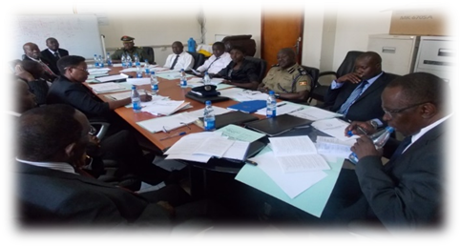
    - Identification of relevant organizations to participate
With the national decision, the first step was to identify the various key stakeholder agencies that were to actively participate in the implementation of the nuclear security measures. A list of the agencies was developed and they were invited to the first coordination meeting for engagement of key stakeholders to map out roles and responsibilities.

Figure 1: preparatory meeting on nuclear security measures for the visit of the pope
    - Analysis of capabilities and equipment needs (IAEA Mission)
The first of the results from the engagement with the IAEA was a mission that was held in Kampala hosted by AEC with the participation of all other identified stakeholders to analyze the existing capabilities and assess the need for assistance. The output of the mission was the capabilities report which clearly stated what was in place in relation to was required for successful implementation of nuclear security measures for the then upcoming major public event of the visit of the pope. It further analyzed the gap that was existing and solutions were sought to bridge it – consequently the IAEA loaned out a number of equipment pieces to Uganda or use in the event.
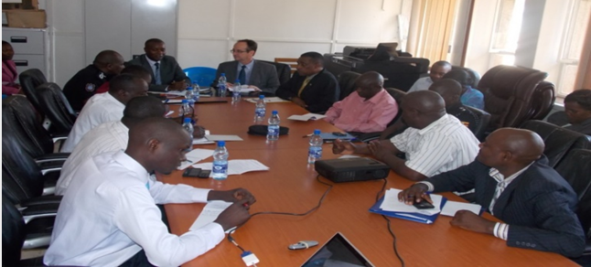
Figure 2: participants during a capabilities and needs assessment session

    - Training of participating officers from stakeholder agencies
As another very important result form of assistance obtained for the event, the IAEA assisted the AEC in the preparation and delivery of trainings on the implementation of nuclear security measures for major public events to the different identified officers of the participating agencies. The training was centered on basics of nuclear security, radiation detection and identification, use of detection and identification equipment, basic radiation protection and detection and response procedures for radioactive material out of regulatory control among others.
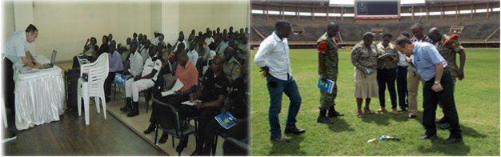Figure 3: Left: Participants during a training session, Right: Equipment use training
At the end of the trainings, Concepts of operations were developed and agreed to and specific roles were shared among the participants basing on the satisfaction that each at the time knew what to do. In addition to the training, the IAEA experts assisted Uganda in the development of concepts of operations and planning for the final implementation.
    - Sweep of the venue before the event
Using the knowledge obtained from the training, the event venues were identified and on acquisition of equipment, a sweep of the venues of the event was conducted to ascertain that they were all free of any radioactive material.
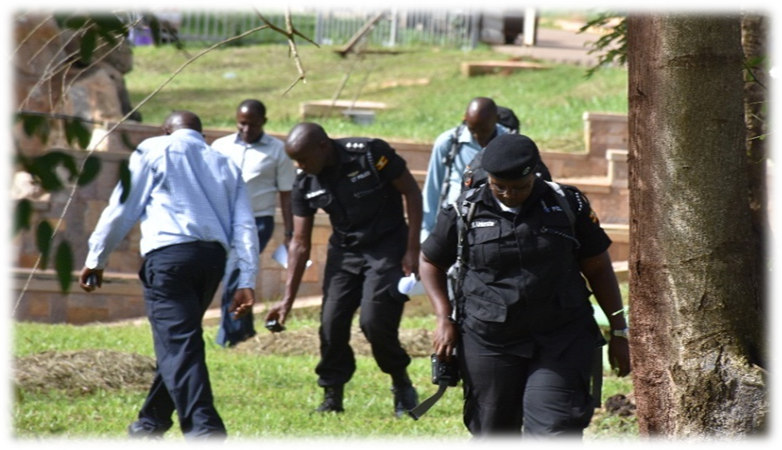
Figure 4: Regulators and security officers conducting a sweep at Namugongo martyrs shrine

  - Actual implementation of nuclear security measures in the event
In brief the actual implementation of the nuclear security systems and measures was implemented with the three nuclear security focus areas in mind:
Prevention: There is always strict control and screening of all entries including pedestrian and vehicles at all access points which were located at all designated entry points to the venues. Entry to the venues is only permitted through designated access points. The venues are normally split into different zones for easier control and efficient deployment of resources in terms equipment and man power.
Detection: A complete sweep of all the venues, the conference rooms, cathedrals, roadways, hotels and vehicles before the event was conducted, which was complemented with random venue surveys were jointly conducted by the bomb squad and MEST teams. There were detection equipment deployed at all venue access points and a number of officers had pagers on their belts.
Response: For preparedness for any incident or nuclear security event, A Mobile Expert Support Team (MEST) stayed on call 24/7, at the Joint Operations Centre (JOC) supported by a Radiological Assessment Team made up of technical radiation protection experts from the Atomic Energy Council which also stayed on call. The emergency medical services (ambulance service) had also been trained and put on notice and in the unlikely event that of the need for international Assistance, the Ministry of Foreign Affairs was in the loop and was ready to act.
3.0 CHALLENGES FACED IN THE IMPLEMENTATION OF NUCLEAR SECURITY SYSTEMS AND MEASURES FOR MAJOR PUBLIC EVENTS IN UGANDA
Although the past major public events covered have gone on well without any nuclear incidents or accidents, this was not without challenges that affected the proper implementation of nuclear security measures and systems. Many of the challenges stemmed from the relatively immature national nuclear security regime. The major challenges faced included:
  - Limited Nuclear Security awareness among stakeholders
Nuclear security is relatively new concept in the security systems mix in Uganda as the case is in most developing countries and as a result a large section of stakeholders including the general public are unaware about nuclear security, what it is, what it entails and why it is essential particularly in the context of major public events. This lack of or limited awareness in some ways hindered the easy and effective implementation of nuclear security systems and measures at major public events as it took much longer and a lot of explanations to get stakeholders to integrate nuclear security systems into the general security systems and to play their parts within the nuclear security system to ensure efficient measures for prevention, timely detection and efficacious response to any nuclear security events or incidents that might arise in the cycle of each major public event in the country.
  - Coordination challenges
Nuclear security unlike many other areas of state operations is a multi-disciplinary subject and thrives on input of several government and local actors many of whom come from organizations with different backgrounds, areas of focus and areas of expertise. For instance establishment of nuclear security laws involves legal experts and legislators, the detection of materials outside regulatory control involves customs agencies, law enforcement and radiological experts, the transportation and storage of seized illegal material is done by the regulator where extradition and prosecution of offenders involves legal and foreign affairs officers. Further responding to nuclear security events involves emergency services, police, law enforcement and at times armed forces; involvement of medical casualties calls for medical services, and request for international assistance is done by foreign affairs office among others.
These experts or players of different competences and responsibilities have to work smoothly and harmoniously in order for nuclear security to be successful. It is very challenging to smoothly coordinate the operations of all the several concerned agencies – it even gets harder in times of a nuclear security event to know how response is implemented. There are always challenges of resource mobilization, chains of command, and information sharing and information security, reporting lines among others.
  - Limited trained personnel
There is currently no formal training in nuclear security, nuclear engineering or nuclear physics in Uganda and as a result there is no consistent training and mentoring channel for nuclear security practitioners and experts. At present most training on radiation detection techniques is offered by the Atomic Energy Council – the national nuclear regulatory body amidst challenges of limited resources in terms of time, human resources and funds. This has resulted in a shortage of personnel with capabilities to perform the nuclear security functions that are required to implement nuclear security systems and measures for a major public event.
Through the efforts of the Atomic Energy Council, Uganda has been able to obtain some training assistance on a few occasions from the International Atomic Energy Agency and the United Stated Department of Energy however the gap remains to be completely addressed by a more permanent and local or locally implemented solution overtime.
The other aspect that makes this even a bigger challenge is the inconsistency in participation on the part of the trained personnel from the stakeholder agencies. In many cases trainings have been conducted to personnel from the different stakeholder agencies with the hope that those persons would be the group that undertakes nuclear security operations during the major public event and at the time of implementation the coordinators receive completely new faces who have no clue about radiation safety, radiation detection or nuclear security. This implies that there is also a weakness in the tracking and efficient utilization of the few trained manpower available.
  - Limited appropriate detection and identification equipment
To this day, we know not of any company manufacturing Radiation detection or identification equipment on the African continent. Such equipment for use in our countries has to be imported from Europe or America and the costs of procuring it is significantly high. Also nuclear security involving many different national agencies presents a bit of a puzzle on which of the agencies should provide equipment for use in the inter-agency activities. In some cases where some agencies possess some equipment, it has also been challenging to ascertain which agency has which equipment so as to map out the existing capabilities in terms of equipment.
Pursuant to the above, the implementation of nuclear security systems and measures for major public events in Uganda has always been faced by a challenge of limited radiation detection and identification equipment. In some cases this challenges has been addressed through borrowing some equipment from the International Atomic Energy Agency but this is clearly a temporary fix and cannot be relied on for the future. There is need for the country to devise a long term to ensure availability of radiation detection and identification for the implementation of nuclear security at major public events.

  - Limited resources in terms of funding
Nuclear security systems and measures for a major public event are implemented over a relatively longer period of time than just the duration of the event. There is also a lot of work that goes into the preparations, the training, the coordination meetings, the equipment procurements and maintenance, the human resources, transportation, communications and so much more. All of those and the unmentioned are important for the successful implementation of nuclear security systems and measures for a major public event and the reality is that none of it comes free. It all has to be paid for and it has to be maintained.
In Uganda, most of the coordination and thus funding has been done by the Atomic Energy Council whose core mandate is the execution of the core regulatory functions. Efforts have been made ad are underway by the regulator who is currently the driver of the national nuclear security regime to establish a more reliable and consistent source of funding for nuclear security activities with special attention to nuclear security systems and measures for major public events.
  - Non-incorporation of Nuclear Security in the general national security system design
Nuclear security being a relatively new concept in Uganda, it has not been well integrated in the overall security frameworks and systems of the country. It would be much better situation for basic nuclear security concepts to be part of what the security officers learn during the course of their continuous trainings especially those trainings for high level cadres and those being prepared for management and strategic positions such that they can be able to consider nuclear security as an important part of national security.
The challenge goes beyond just security – it exists in all nuclear security aspects. At present it has been observed that specific nuclear security aspects are only briefly addressed in the Atomic Energy Act, 2008 (Act 24 of 2008) and impliedly supported by the counter terrorism Act, 2002. As a result the current legal system and the legal personnel in the country lack an understanding of nuclear security despite the fact that they have crucial roles to play for nuclear security.
A need has been identified to make efforts in the country to make a nuclear security an integral part of legal and security frameworks so that stops being looked at as a thing of nuclear experts at the regulatory body but a national responsibility and an important factor for social and economic order and in turn development.
  - Difficulties in Information sharing
There is a lack of an established information sharing and information security structure that can be exploited by the participating agencies in the execution of collaborative activities and as a result, some of the agencies hesitate to share information with others.
4.0 LESSONS LEARNED
Despite the challenges discussed in 3.0 the implementation of nuclear security systems and measures for major public events in Uganda has been largely successful and continues to improve mainly because of the attention given to the lessons learned from the previous operations. It is on the basis of these lessons learned that improvements and solutions are to be implemented for better operations in the future. This section discusses the major lessons learned.
The lessons learned from organizing the nuclear and radiological security at the previous major public events in Uganda at which nuclear security systems and measures were implemented have been categorized into three major aspects - organizational aspects, technical aspects, and training.
4.1 Organizational Aspects
- Early initial engagement, Close coordination and cooperation between all partners is critical throughout the event cycle.
- Strong political commitment and that of leadership from a lead agency and other participating agencies is necessary to move the project forward.
- International and local expertise must be well mapped and combined in the design and implementation of such a project.
- The combined threat (radiological, chemical and/or biological) should be accounted for in the emergency planning and response, as well as in training.
- The existence of adequate, trained and well informed personnel with clear assignment of responsibilities is a prerequisite. Moreover, efforts should be made to keep well-trained personnel in place and assure the knowledge dissemination.
- Time is always a crucial factor that must be seriously taken into consideration for all activities (e.g., planning, contract negotiations, purchase of equipment, acceptance tests, installation, training, etc). • When introducing or implementing structural changes in the facilities or the procedures, the stakeholders and the personnel involved must be well informed and their opinion must be seriously taken into consideration.
- Even if the goal is a near-term event such as the Olympics, it is important to plan for long-term use and benefits of the systems. It is crucial to develop a plan for the sustainability of the system over time and the transition of full ownership and operation to the host country. Moreover, the use of the equipment after the event must be investigated (redistribution, leasing, etc).
- Intelligence information on illicit trafficking provided by the IAEA to the Ugandan authorities has proved to be a critical element in the evaluation of the overall terrorist threat to the major public events, particularly in conditions characterized by limited time available for decision-making.
- It is always important to Harmonize the command system: there should be only one command point (source of instructions) at a time and as the event evolves or escalates, it should be clear well in advance who takes over from who and when.
- At the end, always review and evaluate, take note of lessons and disseminate the lessons learned.
4.2 Technical Aspects
  - During major events, both the threat level and the consequences of threat activity are significantly higher than under normal situations. For that reason, the adequacy of the security systems, even if they meet current international recommendations, should be reassessed.
  - When installing physical protection systems in radiological installations like hospitals, special emphasis must be attributed, in order to assure the functionality of the system without disturbing the proper duties of the staff (e.g. the operation of both tough access control and alarm systems can become impractical).
  - Special provisions must be taken for the prevention and handling of false and innocent alarms and their possible consequences. In case of an alarm, the key point is to localize quickly the person at the check point, not in the crowd.
  - The radiation detection should ideally be integrated with standard security equipment. This in many cases has turned out difficult as a result of the late decision to include nuclear security measures after the general security systems have already been designed. Nuclear security should be considered right from the start of the planning.
  - The optimum positioning of the detectors in the entrance of the venues is: one pager at the belt of the security officer, and one pager under the tray, not ignoring the X-ray flashes and electromagnetic interferences. Overnight removal and re-deployment of pagers.
4.3 Training
- Training is crucial; it is impossible to overestimate the importance of the training. Equipment means nothing if people do not know how to use it effectively. Initial training as well as ongoing refresher training is necessary to ensure that the system works. The most important lessons concerning this issue include:
- Cooperative teamwork is essential since experts with different background contribute to the project. Training should be approached with a deliberate intention to build teams that will work together. It should somehow cover collective implementation of the concepts and it should involve all necessary stakeholders.
- Create a comprehensive, phased plan taking into account different stages, different categories of staff (specialty, tasks, etc) but at each stage or phase, train the participants from the different agencies together as long as they are going to perform the task together.
- Provide timely and convincing information to address concerns on chemical, biological, radiological and nuclear aspects of the possible scenarios. It is more effective to address them holistically than individually.
- Provide theoretical and practical training on radiation, instrument usage and procedures, scheduled well in advance and in these provide chance for the trainees to try out what they have been trained on. Aim at achieving confidence among the trainees with the equipment. Include instrument training materials into the purchase as you acquire equipment.
- Documentation should be made available in time. Adherence to established plans, in order to bring everything together at the right time: equipment, procedures, training facilities, materials, trainers and trainees.
- Exercises demonstrating the cooperation of different authorities, based on a national response plan and small-scale exercises for the personnel within a single authority are very important. The multi-agency actions should be rehearsed and the lines of cooperation clearly defined and marked or easy implementation.
5.0 Conclusion
Uganda has in the last few years demonstrated commitment to nuclear security in assigning the highest priority to security issues and in particular to nuclear and radiological security associated with major public events and to that effect has successfully implemented nuclear security systems and measures for major public events at four events including the pope’s visit of 2015 and three Uganda martyrs annual celebrations. The preparations and implementation has greatly contributed to the growth of the state’s nuclear security capabilities for detection of, and response to radioactive materials outside regulatory control. It has improved multi-agency collaboration in nuclear security and enhanced general national security. Uganda as a state is further proudly contributing to the growth of the global nuclear security regime through sharing of experience and participating in multinational technical discussions on the subject.

