IMPROVED SPECIFICATIONS, PERFORMANCE, AND UNDERSTANDING OF RADIATION DETECTION EQUIPMENT USED FOR NUCLEAR SECURITY – OUTCOMES OF PARTICIPATION IN IAEA COORDINATED RESEARCH ACTIVITIES

R. A. N. C. RANASINGHE*
Radiation Protection & Technical Services Division, Sri Lanka Atomic Energy Board, Colombo, Sri Lanka
Email: nirodha@aeb.gov.lk

P. D. MAHAKUMARA
Radiation Protection & Technical Services Division, Sri Lanka Atomic Energy Board, Colombo, Sri Lanka

P. N. G. RATHNAWEERA
Radiation Protection & Technical Services Division, Sri Lanka Atomic Energy Board, Colombo, Sri Lanka

K. K. B. KARIYAWASAM
Radiation Protection & Technical Services Division, Sri Lanka Atomic Energy Board, Colombo, Sri Lanka

C. MASSEY
Division of Nuclear Safety and Security, International Atomic Energy Agency

I. CHAIRAM
Division of Nuclear Safety and Security, International Atomic Energy Agency

Abstract
Sri Lanka’s major improvements and achievements on its NS regime through the CRP can be identified in both technical and managerial context. Sri Lanka Atomic Energy Board (SLAEB) has been a part of the CRP J02012 from 2017 and has received assistance for the development, improvement, and sustainment of NS detection. Apart from the technical and monetary assistance received from the International Atomic Energy Agency (IAEA), the CRP has nurtured a graceful platform to establish inter-state, inter-institute collaboration on nuclear security (NS). A set of surveys and experiments have been conducted to evaluate the detection equipment, methods and user requirements in the NS detection culture. Here, it has been practically identified that the effectiveness and efficiency of a detection is primarily affected by the user’s knowledge, instrument performances and selection of appropriate equipment. In order to evaluate the performance of radioisotope identifiers, a set of experiments have been conducted. A survey was conducted among the Front-line Officers (FLOs) involved in NS detection work to obtain their insight on existing field equipment such as Personal Radiation Detectors (PRDs). Their inputs can be utilized to further develop these equipment to match the field requirements of the FLOs ensuring the user-friendliness of the PRD. The results from the survey clearly depicts that the FLOs appreciate simpler field equipment where extensive training is not required. The paper discusses these improvements as fruits of the project and encourages other Member States to collaborate in CRPs.

Introduction
The Coordinated Research Projects (CRPs) have been a set of most influential activities related to nuclear security in global scale. Sri Lanka joined the CRP programs related to nuclear security in 2015 with the participation to the CRP J02005. The CRPs have supported Sri Lanka to improve the national nuclear security regime in various aspects. The second CRP; J02012 (Advancing Radiation Detection Equipment for Detecting Nuclear and Other Radioactive Material out of Regulatory Control) has been initiated in 2017 under the research theme of “Investigation and improvement of the detection capabilities of the available Radionuclide Identification Devices (RIDs)”. The CRP J02012 is focused on identifying the strong and weak points of the existing detections systems, especially Radio-isotope Identifiers that can be used for the further improvement of the detection capabilities and other features. The final goal of the project was to assure the sustainability of the nuclear security regime on a local and global scale. Sri Lanka, as one of the participating Member States in the CRP, has received tremendous benefits through it.
The managerial gain from CRP can be explained in either a) improvement of approach and b) sharing of knowledge and experience. This intangible development was primarily facilitated by sharing of experience and by inter-state, inter-organization collaborations. The approach to the NS has been expanded through the exposure to international and institutional NS cultures. Also, the CRP has developed a platform to establish links among the stakeholder member states. With this improved approach, the members have been strengthened up through sharing of the knowledge, experiences on best practices, ways of overcoming challenges and understanding limitations of detection instruments. In this scenario, Sri Lanka utilizes the inter-organization collaboration to obtain user requirements. A well-established coordination among the NS stakeholders (Sri Lanka Atomic energy Board, Sri Lanka Atomic Energy Regulatory Council, Sri Lanka Customs, Sri Lanka Ports Authority, Civil Aviation Authority and Sri Lankan Airlines) of the country has been observed after the adoption of CRP operations in the boarder monitoring and other NS related activities. This is a vital requirement to ensure the sustainability of the NS culture. These requirements can be used as a bottom-to approach to understand the user requirements based on their experience, knowledge and cultural background.
The needs of the NS stakeholders have been identified through a systematic need analysis performed using a sample of Front-line Officers (FLOs) working in NS as mentioned in above paragraph. This response can be considered as a critical input to understand the instrument characteristics valued by the field officers and the performance required by the competent authorities and its experts. Apart from that, tests for assessing the performance of the NS detection instruments are being conducted by the SLAEB’s instrument research team to fulfill the objectives of the CRP J02012. The results obtained through these descriptive studies are also presented by this document.
The technical gain from CRP can be expressed further using the significant improvements in a) instrument selection, and in b) detection capabilities. The understanding of the identification of suitable instruments and specifications has been enhanced with the assistance of the CRP. This can be further explained in the scopes mentioned in figure 01. The detection capabilities were tested and identified gaps have been reduced through networking & combination of instruments, improving the performance and developing the ways of assuring technical sustainability.
In order to evaluate the detection capabilities of the RDE, a set of RIDs were field tested. The actual brands and model numbers are kept confidential to protect the technical details of the vendors and to ensure the impartiality of the study. The approximate physical parameters of the RIDs are as mentioned in table 01.

Figure 1: Aspects improved regarding the instrument selection through the CRP
Improvement of instrument selection methods

Based on requirements
Based on specifications
Selection of instruments based on, requirement, environmental condition, socio-economic conditions and sustainability
Identifying specifications for suitable instrument models such as physical characteristics (weight, size, shape) performance (detection algorithm, library), QA/QC methods, data communication and additional features such as battery backup and GUI.

Table 1: Physical characteristics of tested RIDs
Instrument Ref. No. | Approximate dimensions (l × w × h) (cm) | Weight (kg) | Neutron Detection Capability | Special Features
I01 | 25 × 8.5 × 7.4 | 1.17 | No | Detect then identify (manual setup)
I02 | 28 × 12.8 × 12.5 | 2.90 | Yes | Detect then identify (manual setup)
I03 | 32 × 14.7 × 15.7 | 3.61 | Yes | Detect and identify in parallel
I04 | 30.5 × 14.2 × 21.7 | 2.97 | No | Detect and identify in parallel
I05 | 14 × 10 × 5.5 | 0.71 | No | Detect then identify (manual setup)
I06 | 25 × 11.6 × 15.5 | 2.80 | No | Detect then identify (manual setup)
I07 (PRD) | 10 × 6 × 3 | 0.18 | Yes | -

Methodology
The approach to the research work was taken in two pathways; technical pathway of the CRP to evaluate the radiation detection equipment (RDE) performance and the managerial pathway of the research to study the human resource factor of the detection culture.
The human resource factor is mainly the Front-line Officers (FLO) and technical experts involved in local support and mobile support work. Here, the inputs of the FLOs are extremely crucial as they represent the majority of the detection staff. Their technical requirements in the practical use of RDE are very important to evaluate the success of any RDE in the field environments where actual detections are being made. In order to identify the actual requirements of the FLO and other field officers, the SLAEB has distributed a simple questionnaire with several multiple choice questions including a PRD and its usage. The participants of the survey are the FLOs in field. Total number of participants is 41. The details of the PRD used, is mentioned in the table 01. The questions can be divided into categories as follows,
- Questions related to performance (detailed detections/algorithm) and physical characteristics (weight, size, shape) – Set 01
- In your opinion, what is the best way to detect radioactive material in field (in a public place)?
- Using only the PRD | - Using a portal monitor | - Using both
- Do you need the radionuclide identification capability in every PRD?
- Yes | - No
- What is your opinion on the weight of the equipment?
- satisfactory | - should be lighter | - no special attention

- Questions related to data display and communication – Set 02
  - What is your opinion on the overall user friendliness of the PRD?
- satisfactory | - should be simpler | - should give more info.
  - Do you need a numerical display for the dose rate view?
- Yes | - No
  - Is it sufficient to have visible (using LEDs), audible or other (vibration) notification as a detection alarm?
- Yes | - No
  - To notify the detection of artificial and natural radionuclides,
- separate signals are preferred | - No need of distinction
  - In your opinion, what is the best method to notify a detection to the supervising officer?
- using a call through a phone or a walkie-talkie | - automatic notification by the instrument itself | - both
  - In order to identify a dangerous radiation level, it is easier to,
- read the value on the screen | - using of a special notification sound/light is easier
- Questions related to use and QA/QC operations – Set 03
- As FLOs do you need the access to change “settings” of the PRD?
- Yes | - No
- Is it enough to give the above mentioned capability to the supervising officer?
- Yes | - No
- What kind of power supply is preferred?
- dry cells | - rechargeable batteries | - either (no preference)
- Do you need an on/off switch? (Is it better to keep it “switched on” all the time?)
- Yes | - No
The answers for each question can be depicted as in figure 02.
Another part of the CRP is to evaluate the performances of RIDs in different field environments. A set of RIDs have been tested for their performance by varying the flux, background radiation level and other field conditions. The fundamental variables for the experiment were sampling time and gamma radiation flux. Flux was varied by setting the distance from the radiation source to the instrument. The flux was calculated per 1 cm², closest to the detector. Here, it was assumed that the point sources emit gamma photons in uniform spherical geometry and the atmospheric attenuation is negligible.
The sources are reference gamma calibration sources (point sources) as mentioned in table 02. The sources were selected to represent wide range of gamma energies as the detection efficiency in each gamma energy is different.
Sampling times of 30 s, 60 s and 120 s were used to set the spectrum data collection time of each instrument. Two test fields with different background levels were used to evaluate the effect of background in the identification of a radionuclide. The higher background area is an area with higher concentrations of naturally occurring radioactive material (NORM) close to the city of Colombo, Sri Lanka. Each test (sample time and gamma flux) was repeated 20 times to replicate the result of each instrument. The accurate identification probability was then calculated out of 20. In some special cases, the confidence level of the detection was also noted down. The market price of each instrument (as in 2017) was also compared with its performance to test any correlation between the price of the instrument and the performance. A higher performance is generally expected for more expensive equipment. Since the gamma detector size (scintillator size) plays a major role in detection efficiency, the weight of each instrument is again compared with its identification performance. It is assumed that the detector size is proportional to the weight of each RID. These results will be presented by a separate paper.
Table 2: Details of the reference gamma sources
Radioisotope | Reference Activity (Bq) | Reference Date | Most Abundant Gamma Energy / Energies (keV)
Am-241 | 39800 | 01.05.2010 | 59.5
Cs-137 | 35800 | 01.05.2010 | 661.5
Co-60 | 44100 | 01.05.2010 | 1173, 1332

Observations
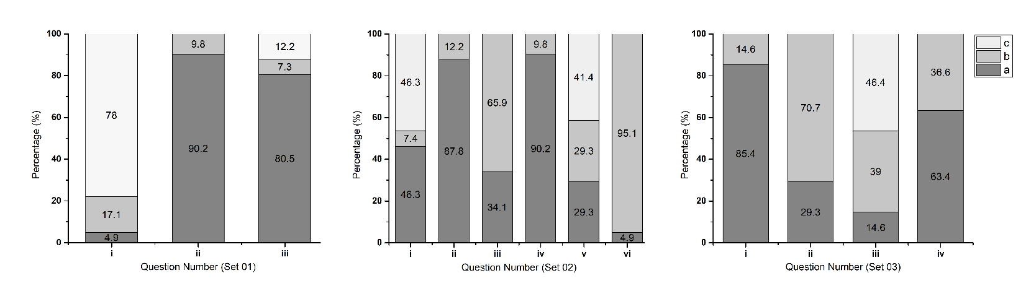
The responses of the FLOs for each question mentioned in the above list of questions are as follows.
Figure 2: Graphs of FLO preferences
RID responses for flux levels (0.5, 1, 5, 10 and 20 Bq) are presented in figure 03. Responses for Cs-137 for 120 s has been considered here as Cs-137 represents a median gamma energy. The spectrum collection time of 2 minutes (120 s) was considered as it is the practically high sampling time in field detection.
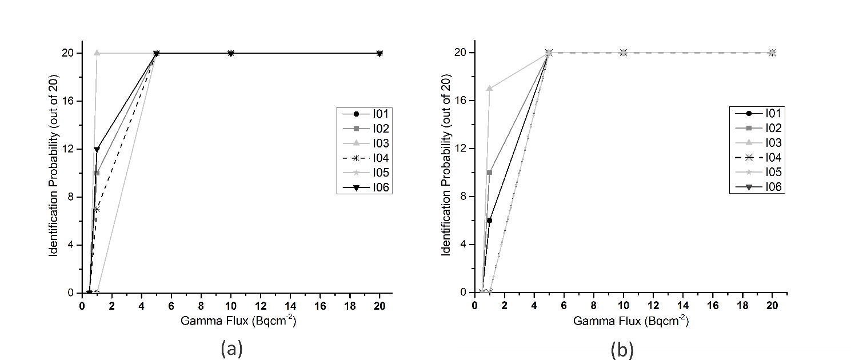
Figure 3: Identification probability for each equipment; a) in low background condition, b) in high background condition as mentioned in table 03
A summary of the test results in both background conditions is presented in table 03. Here, the probability of false identifications was calculated considering the total number of repeated tests. Every RID underwent 300 tests in 05 different flux levels for 03 different radioisotopes. Therefore, altogether 1800 tests have been performed for 06 RIDs per each isotope.
Table 3: Summery of the performed test results
Parameter |  | Low Background (108 – 115 µSv/h) | High Background  (250 – 290 µSv/h)
Physical Environment |  | Temp: 33.1 ºC, RH = 60.4% | Temp: 36.8 ºC, RH = 42.1%
Probability of false identifications (out of 1800) |  | 32 | 30
Probability of recalibration requirement out of 1800) |  | 07 | 10
Probability of Correct Identifications (in 120 s) out of 1800 | For Am-241 | 1069 | 778
 | For Cs-137 | 1148 | 1141
 | For Co-60 | 1106 | 1152
Minimum detection time for 5 Bq (Cs-137) (s) |  | 60 | 60
Here, a misidentification means the display of radioactive material instead of actual isotope used in the test.

Results and Discussion
The survey conducted for the FLOs clearly identifies that the interpretation of display data of the PRD needs to be simpler. They also identifies that, it is more practical to use both portal and PRD instruments for public screening (Q01.i). A simple audible or visible alarm has been selected by the majority of FLOs in Q02.iii for the alarm notification. However, there are certain conflicts within the answers as they also mention the need of radioisotope identification in each PRD. The FLOs also request the dose rate display of the instrument (Q02.ii). During the discussions, it has been identified that, this is emerging from the attention towards their own-safety. Also, regarding the communication of the equipment, majority of the FLOs believe it is more appropriate to adopt an automatic mechanism to notify the supervisor in a case of detection (Q02.v). Further evaluation is needed to identify other specific requirements of the FLOs regarding the field equipment. The collection of data is to be continued with the CRP. Also, it will be important to understand any modifications of the answers with the improvements in their experience. Therefore, a periodic surveys are recommended to identify these changes.
The upper test limit for the sampling time was selected to be 120 seconds as it is a considerably high value for a field detection. Practically, it is not expected to keep a person/conveyed baggage in a stationary detection point for a period more than 2 minutes. However it is observed that in mid energy ranges (Cs-137) the performance accuracy of the RIDs are satisfactory for 5 Bqcm⁻² flux level and 1 minute sampling time. It is well distinguished that the identification probability for Am-241 has been changed significantly with the background radiation level. This can be further explained by the low-energy Compton peaks and NORM energy peaks masking the low-energy gamma peak of Am-241. The results of misidentifications are inconclusive. The effects which cause the misidentifications are yet to be identified.

Conclusions
The benefits from participating to a CRP program can be explained in variety of fruits in different fields. One of the approach is to consider the managerial gain and the technical gain of a CRP program which is mostly provided by the IAEA in the objective of developing a Member State’s NS culture. Sri Lanka as an active member of the NS CRP programs has received tremendous benefits through it. The managerial gain of a CRP can be further explained by the improvements of approach and sharing knowledge and experience in inter and intra organization environment. This is mostly the technical expertise, human resource development activities and mutual collaborations among the organizations.
The technical gain on the other hand extends further from simple technical and material support. Since the socio-economic, geographic and other cultural factors are different from a Member State to another, it is vital to understand the most appropriate NS regime to be implemented in a certain State. This is very important to ensure the continuous operation and the sustainability of the NS culture. This approach is taken by evaluating the improvements in instrument selection and detection capabilities. In order to identify the appropriate instruments and the limitations of existing detection systems, a set of experiments had been conducted. The results from these studies and surveys can be directly utilized by the vendors, method developers, trainers and users to select the most suitable equipment for their specific requirements.

Acknowledgements
The authors convey their acknowledgements to the International Atomic Energy Agency (IAEA) and the expert assistance, financial and material support through the coordinated research projects (CRP J02012) & other activities related to nuclear security field. Also, to the Sri Lanka Atomic Energy Board, to facilitation and the encouragement.

