# A PROPOSED DESIGN FOR: SECURITY LIGHTING AND CAMERAS SURVEILLANCE SYSTEM FOR OPTIMUM SUPERVISION AT A PERIMETER AREA OF NUCLEAR FACILITY

A. A. WADOUD

Egypt’s Second Research Reactor Complex (ETRR-2), Egyptian Atomic Energy Authority (EAEA), 3 Ahmed El-Zomer St. El Zohoor Dist.,– Nasr City Cairo, Egypt . Children Village P.O, P Code 11787, Email: amirwadood@gmail.com

A. A. Saleh

Egypt’s Second Research Reactor Complex (ETRR-2), Egyptian Atomic Energy Authority (EAEA), 3 Ahmed El-Zomer St. El Zohoor Dist.,– Nasr City Cairo, Egypt . Children Village P.O, P Code 11787, Email: alaa91071@yahoo.com

**Abstract**

In this work a proposed design for security lighting and cameras surveillance system for optimum supervision at a perimeter area of a hypothetical nuclear facility will be presented. A perimeter area has an isolation zone between double fences which are surrounds a nuclear facility site. The illumination poles, lamps type, towers space distance and lighting level, required for camera surveillance system will be computed and determined. The work provides the requirements of cameras surveillance system at nuclear reactors isolation zone. Width of images sensitive area, lens focal length, lens format and angel of view will be determined by calculation method. The work determines cameras type, distributions, camera’s parameters and formulas according to the physical protection design process. The output results will be analyzed and tabulated.

***Keywords: Security lighting,* *Illumination, Perimeter Area, Cameras Surveillance System***

**1. INTRODUCTION**

Security lighting is an important part of the perimeter security plan. On most projects, however, little consideration is given to the security design and layout. Usually, lights are installed, and that is far as it goes. Then the owners, property managers, security directors, managers, etc., wonder why the images from the closed circuit television system (CCTV) along the perimeter of the property are not very good and usually are of poor quality. Security lighting is used to light up the perimeter and property at night to closely simulate daylight. Security lighting makes an intruder visible, unable to use the cover of darkness to breach the perimeter security. Security lighting also will enhance the effectiveness of any security force on site by providing a clear view of the property through the CCTV. To determine the security lighting requirements for the location, we need to know what we are trying to protect and from whom must be protected. Table (1) shows a quick reference to lighting requirements by foot-candle power. The table outlines the minimum amount of illumination needed and provides foot-candles based on the Department of the Army Field Manual 19.30 Physical Security, USA **[1].** The lighting also will aid the CCTV system by providing the necessary light for capturing useful images for security and investigations of unauthorized entries to the site as well as identifying any vandals. The lighting will enable the security force to observe activities around the site while minimizing the presence of the securityforce. To accomplish this task, The CCTV is essential to identify the cause of an alarm (intrusion process) and to determine if the alarm is true or false. Whereas (CCTV) previously required especially high illumination levels, current CCTV cameras can function under very low light levels

. **Table 1foot-candles permitted for security lighting (Michael and Arata, 2006) [1]**

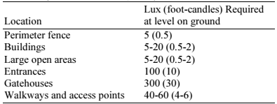

Kukula and Elliot found that the “failure to enroll” rate for an automatic face-identification system was only 6.3% under 10 lux, compared with 3.2% under 410 lux **[2].** Vermeulem found that a CCTV camera with a “good quality lens” required 26 lux for “excellent picture quality**” [3];** This value can be expected to have dropped very dramatically since 1992. Indeed, some modern infra-red CCTV cameras specifically require very low light levels for proper functioning. The following information needs to be provided to designers which will enable them to evaluate the Site Plan for proper exterior lighting:

**(1)** The lighting plan should include a key to the proposed lighting that provides the following information:

a- Type and number of luminaries fixtures, including the "cut off characteristics".

b- Lamp source type, lumens output, and wattage.

c- Mounting height with distance noted to the nearest property line for each luminaries.

d- Types of timing devices used to control the hours set for illumination,

e- Total Lumens for each fixture, and total square footage of areas to be illuminated.

f- For all plans of more than three fixtures: A Calculation Summary indicating foot-candle levels on the lighting plan, noting the maximum, average and minimum, as well as the uniformity ratio of maximum to minimum, and average to minimum levels.

**(2)** Lighting manufacturer-supplied specifications ("cut sheets") that include photographs of the fixtures.

**(3)** Foot-Candle distribution, plotting the light levels in foot-candles on the ground,

**(4)** An environmental impact statement may be required as to the impact of the exterior lighting proposed on flora, fauna, and the night sky. Location of species sensitive to light at night or the proximity to nature preserves or astronomical observatories or "Dark Sky Parks", needs to be indicated.

**(5)** On the Approved Plan it should be noted that no substitutions, additions, or changes may be made without prior approval by the governing authority **[4]. In this paper;** each of: Security lighting design, illumination requirements, calculations, and, Determination of cameras’ parameters of the surveillance system, at the external perimeter area of hypothetical research reactor facility (HRRF), will be provided.

**2. HYPOTHETICAL RESEARCH REACTOR FACILITY (HRRF)**

Hypothetical nuclear site is a simulation site for implementation the design process of the physical protection system (PPS). Hypothetical Research Reactor Facility (HRRF) is located in a hypothetical country and contains the following buildings: Main Entrance (ME), Reactor Research Building (R.R), and Nuclear Fuel Plant (NFP) **[5].** The nuclear complex surrounded by an external double peripheral fence which considers the first perimeter fenceand it contains an isolation zone. HRRF site have one main entrance access. It consists of two gates: personal portal gate and vehicle gate which are located in the middle of the left side of the fences. After you passing the gates, you are in the protected area. Figure (1) shows the Hypothetical Research Reactor Facility (HRRF)

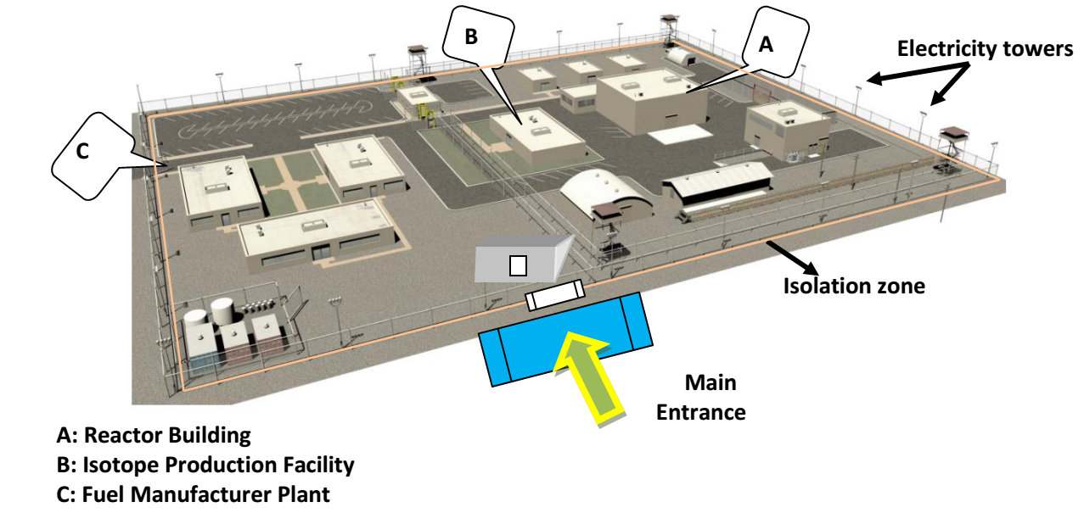

***Fig.1. Hypothetical Research Reactor Facility (HRRF) [5]***

**3. PERIPHERAL FENCE DESIGN**

Peripheral Fence is the first barrier for unauthorized access of people to atomic center. It forces its personnel to enter or exit at one point, the main guard, where personnel involved in security activities will be found**.** Peripheral fence has been designed to protect HRRF-site is2.5 m chain link double mesh fence with an isolation zone**.** Fences cover the total peripheral near to **1180m long (350m×240m)** length, 10 protected zones,surrounding the whole site, and with a separation of **10 meters wide of isolation zone** between two fences, (Except for main guard location), Designs consider that the fence plane-side overview shape is rectangular and no detection sensors installed on the outer and inner fences **[6]**.The peripheral fence is made up of a double concentric fence that covers the total peripheral (except for main guard location), and with a separation of 10 meters isolation zone between fences, and includes towers of illumination, located around HRRF site, these towers are 8meter tall, and erected 2meters away the interior fencer. A Closed circuit television system (CCTV); is essential to identify the cause of an alarm (intrusion process) and to determine if an alarm is true or false. Many of fixed and moving cameras should be installed at the isolation zone. Camera surveillance system needs sufficient illumination according to camera technical specifications. Using of Infrared and cameras with high technical specifications needs more costs. If the designer calculate appropriate illuminations and select the optimal lamps type taking into accounts the factors to consider in selecting a lighting type, suitable for cameras requirements such as lux over object, it will reduce the costs

**3.1 Fences Lighting Design**

It should be apparent from the discussions in the preceding pages that lighting requirements vary according to each security application (object illumination, physical deterrence, psychological deterrence). All of these applications have different requirements for intensity, distribution, quality, sources and reliability.In addition lighting design must consider,

* Where perimeter lighting is required, the lighting units for a perimeter fence should be located a sufficient distance within the protected area
* Perimeter lighting should be continuous and on both sides of the perimeter fence and should be sufficient to support CCTV and other surveillance equipment where required.
* The cone of illumination from lighting units should be directed downward and outward from the structure or area being protected. Cones of illumination should overlap to provide coverage in the event of bulb burnout. The lighting should be arranged so as to create minimal shadows and minimal glare in the eyes

**3.1.1 Lamp Type Selection**

In casual conversation, lighting terms are often used imprecisely. These are two terms which are often used interchangeably; however, in discussing technical lighting issues, their correct usage is important to avoid confusion. So we must take into consideration:

***Lamp:*** the actual bulb or tube which emits light when electrical energy is applied.

***Luminaries****:* the lamp, housing and all other hardware used in mounting and focusing illumination;

***A-Lamps Types:***  There are many different types of lamps used in modern protective lighting systems: Incandescent- Fluorescent- Mercury vapor- Metal halide- High pressure sodium (HPS)- Low pressure sodium (LPS). Some factors must be considered in selecting lamp type such as:The lumens per watt- Color rendering- Focusing capability- Warm-up time- Restrike time- Flicker rate **[7]**. Illumination quality is the combination of these entire individual factors. The advantages and disadvantages of various lighting sources are listed in **table (2).**

**Table (2) Comparison of lamps types properties (IEC 60598.2.3, 2002) [7]**

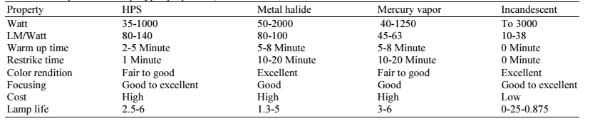

(1) HPS lighting is the most energy efficient source which has an acceptable color rendition.

(2) Metal halide lamps have a good color rendition, but luminous efficacy, lumen maintenance (lumen output diminishes more rapidly throughout life), length of life, and restrike time make them a less than desirable source for many applications.

(3) Incandescent lighting not desired because of the extremely low luminous efficacy and short lamp life.

(4) Mercury vapor lighting is also not desired because of lower luminous efficiencies, poor lumen maintenance, higher life cycle costs, and environmental considerations (mercury propagation and disposal).

(5) Unacceptable sources. Fluorescent lighting has not been included in table (2) due to its relatively low luminous efficacy and the limited control possible with the tubular shape. Low pressure sodium lighting is also not included, as the color is monochromatic and therefore is not considered suitable for general use **8}**

**3.2 Fixtures Locations and characteristics**

For a given scene to be visible to a camera the scene should be illuminated by light and a certain amount of this light must be reflected into the camera lens. For the CCTV system, the most important parameters in lighting system are its minimum intensity and its evenness of illumination. So, the function of the external lighting system is to illuminate the alarm location evenly with enough intensity for the chosen camera and lens system. The exterior lighting system is designed to have an average value of light level greater than 10 lux. The evenness of illumination is characterized by the light-to-dark ratio, which is the ratio of maximum intensity to minimum intensity. The system is designed to get a ratio of 6:1. The Exterior Lighting System consists of illumination poles covering the entire length of the peripheral fence, in the clear zone, a UPS system with sufficient capacity to provide year-round 24 hours operation, and all related connections and accessories. A number of poles will be determined to locate around the site. They are 8 meters height and installed 2 meters away from the interior fence. It is necessary to calculate the suitable distance between poles (poles span) where the distance between the two fence edges equal ten meters and the distance between the pole and the two fence edges equal 2, and 8 meters respectively. Figure (2) shows the double fences luminaries location and Dimensions,

* **A-Fixtures (Poles) Locations**

Sufficient illumination must be available to accomplish the observation. For CCTV, the camera specifications required the minimum illumination (Emin) = 0.16 as a percent of the maximum illumination

( **Emin / Emax = 1:6 , Emin /Eav = 1:3**). **So: Emin / Emax = 0.16** When,

H is the pole height = 8m and install with a distances equal to 2, and 8 meters from the two edges of the fences.

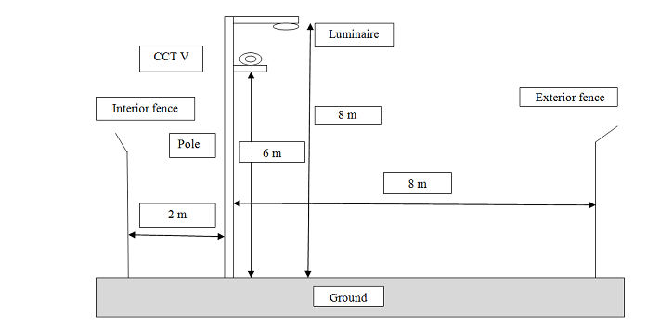

***Fig.2. Double Fences Luminaries Location and Dimensions***

Calculation of the distance between the line of the poles and the two edges of the fences as a function of **(H)** will be: The line (A-A) with a distance (2/8) *H, and

The line (B-B) with a distance of (8/8) * **H** as shown in the isolux diagram in **figure (3)**

Suppose we have 2 poles and the ratio Emin / Emax = 0.16 **So:**

**Emin (pole1) + Emin (pole2) = 16% E max and, for each pole Emin = 8 % Emax**.

The points a, b will be recorded at 8 % curve on the isolux diagram in **figure (3)**

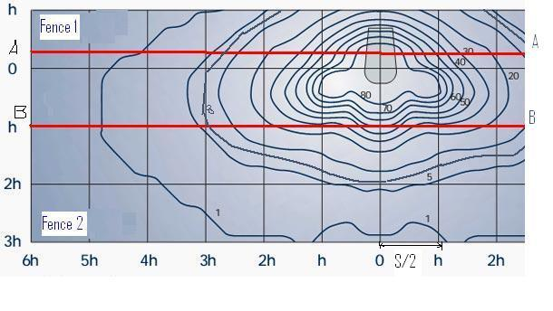

***Figure (3) Isolux diagram***

From the curve the distance between 2 poles (poles span) “S “will be calculated as:

S /2 = 2 (1.05H), S = 4 (1.05H) = 4 * 1.05*8 = 34 meters, and The total numbers of poles can be calculated as: Total number of poles = the length of the fence / poles span

No of poles = 1180meters /34 meters = 35 poles

* **B-Fixtures Characteristics**

Luminaries comprise a hexagonal structure of cast aluminum with a demountable connection box and a frame supports the reflector glass. It has two anodized aluminum demountable mirrors for better light reflection and performance. It contains a high pressure sodium vapor lamp that has power consumption of 250 Watts and luminous flux of 28000 lm. Of course, like any other electrical equipment, the luminary complies with safety requirements regarding electrical insulation and protection (IP65).

**Eav= (U.F * M.F * Lumen) / (D * W), Where:**

**Eav**: Lux (Average Lighting Level)

**D**: Distance between two poles (poles span) in meter

**W**: Area width in meter

**Lumen**: Flux per lamp (28000 from the selected lamp characteristics)

**U.F**: Utilization factor (= 0.35 from utilization curve)

**M.F**: Maintenance factor (= 0.8 from selected lamp characteristics)

From the previous equation the **Eav** can be calculated as follows:

**Eav** = (0.35*0.8*26000) / (34*10) = 21 Lux **Average Lighting Level (Eav ) = 21 Lux**

**Emin =** 21/3 = 7 Lux **Minimum Lighting Level (Emin ) = 7 Lux**

Table (3) listed the illumination calculations and final results



***Where:*** U1: (Min. / Average Lighting Level) ≥ 32%

U2: (Min. / Max. Lighting Level) ≥ 16%, Emin: Lux (Minimum Lighting Level), Diffuser: Polycarbonate, Lamp: 250w, High Pressure Sodium, Pole Arm: 30cm, From the previous calculations, the Illumination distribution and poles types at HRRF-site will be arranged as shown in figure (4).

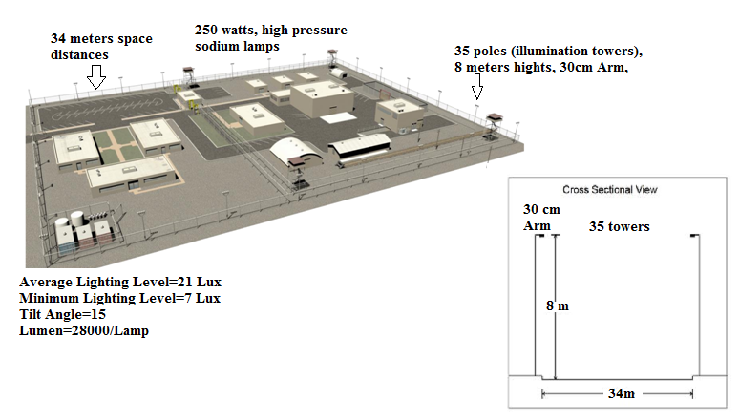

Main Entrance

***Fig.4. HRRF Illumination Distribution and Poles Types***

**4. SURVEILLANCE SYSTEM PARAMETERS CALCULATION**

A CCTV system is essential to identify the cause of an alarm and to determine if an alarm is true or false. The purposes of camera surveillance system are to determine the cause of a sensor alarm, and to provide information about an intrusion **[9].**

# **4.1 Cameras System at Fences Isolation Zone**

# According to determination of cameras requirements and illumination calculations as mentioned above, ***black and white or low lux colored fixed and moving cameras*** can be used and mounted in isolation zone. This means that there are ***low cost will be pushed***. External moving cameras, located at the plan view corner of the perimeter. The Exterior CCTV System consists of fixed cameras for a general inspection and Pan-Tilt and Zoom (PTZ) cameras for a detailed observation.

## 4.1.1 Cameras Type Determination

Monochrome Cameras (Black and white), 420 lines resolution, and Cameras of ***1/4-Inch format*** from VICON type or equivalent will be used. They have a high-sensitivity Charge-Coupled-Device (CCD) image sensor and solid-state circuitry that provide long life and high reliability. All cameras have auto iris lenses, low light capability, output level control and self identification generator. An incorporated automatic linear electronic shutter responds automatically to changes in light level by increasing or decreasing the integration period of the chip. The linear ***shutter range is 1/50 - 1/10000 second***. Lens size is chosen according to supervision area of each one of the cameras **[10].**

**4.1.2 Camera Parameter Calculations**

Many cameras' parameters, which consider important factors in designing CCTV system, should be computed and/ or determined, these parameters, are:

Lens Format, Lens focal length calculation, F-Number, Width of images sensitive area Angle of view calculation, and **[11]**

**4.1.2.1 Cameras Lens Format,**

The length format size defines the maximum usable image created by the lens, **1/4-Inch format**, (**3.6** Constant **W**idth, **2.7** Constant **H**eights), will be used, for the exterior cameras between the double fences, 10 meters width isolation zone, which are illuminated by34 Poles, 250watts high pressure sodium lamps (28000 lumen/pole) , and 7 lux minimum light level, these format are suitable, cheapest and low maintenance **[12]**

**4.1.2.2 Lens Focal Length and Subject Dimensions Calculation**

Focal length is the single most important factor in proper lens selection. It determines the relative magnification of the object. Since the format of a lens is known, the focal length will define the angular fields of view (horizontal and vertical angles covered by lens), thus defining the width and height to the field of view for the camera for any object distance **[13]. .** According to the external perimeter fence dimensions, the required ***wide image area (W)*** is 10 meters (distance between the two double fences), HRRF-Site fences covers the total peripheral near to **1180m long (350m×240m)** rectangular shape, 10 protected (supervision) zones,surrounding the whole site, and with a separation of 10 meters space of isolation zone between two fences, (Except for main guard location), and sides zone configuration as follows the **two Long sides:**  are 350m; each side has 3 supervision zones (116.6 meters /zone) ***So that;*** (L) is the Distance between subject and camera = 116.6 meters **=~** 120meters **two short sides:** are 240m; each side has 2 supervision zones (120 meters / zone), ***So that;*** (L) is the Distance between subject and camera = 120meters Lens focal length (mm) of the cameras can be obtained from the formulas:For **1/4'' inch** camera format type, the equation is:

W=3.6/f ×L (m); H=2.7/F× L (m) (4.1)

**W:** Width of subject **H:** Height of subject **L:** Distance between subject and camera **F:** Lens focal length (mm) **[14].** Figure (5) View field. As mentioned above a 1/4-Inch format camera is used. By substituting on (4.1) formula Lens focal length can be obtained as follows: 10 (meters) = 3.6/**f** ×120 (meters), f = 43.2 According to the manufactured focal lens types founded we choose the nearest values, **Lens focal length= 50mm**

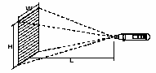

**4.1.2.3 F-Stop Number Calculation**

**F-Number** is **a**n important lens parameter is its aperture setting called an f-stop, which is the lens' measure of its ability to gather light. The smaller the f-stop, the light is admitted; therefore, a small f-stop (1.2 to 1.8) is desirable for exterior assessment applications. The number is the ratio of the lens focal length to the aperture opening in mm.

**F-stop** is ratio between lens focal length (50mm) and aperture opening

If aperture opening is 27.7 the f-stop number will be: **F-Stop Number = 1.8**

Height (H) of the subject can be computed by formula (4.1)

H = 2.7/F × L (m) H = (2.7/50) ×120, and **H** = 6.4 meters

The image area Dimensions (W×H) is = 10 width ×6.4 height as illustrated in Figure (5)

**4.1.2.4 Width of Images Sensitive Area Calculation**

The width of image sensitive area can be calculated from the equation: **D=W (f/*w*) (4.2)**

**D:** distance from the camera (m), **W:** is width of field of view (m)

**f :** is focal length of lens (mm), ***w***: is width of images sensitive area (mm)

Computation of the width of images sensitive area by substitute on (4.2) formula: 120 = 10 (50/*w*)

Width of Images Sensitive Area (*w)* = 4.1

**4.1.2.5 Angle of View Calculation**

The angular range covered by a camera is referred to as its “angle of view” and is determined by the focal length of the lens and the size of the imager (CCD) on which the picture is formed.The angle of view is expressed by the following formula:



**(4.3)**

**θ:** Angle of view, **I:** effective dimension of CCD (mm)

**f:** Lens focal length **[15].** By substituting in formula (4.3) by lens focal length **50mm** and effective dimension of CCD **4.6mm** (selected technical specification of model VC2130-24 from VICON) the angle of view becomes is: **Angle of view (θ) = 5.26 degree,** The calculation results are illustrates in table (4).

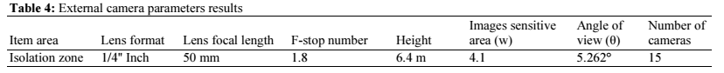

**4.2 Determination of Cameras Numbers and Locations**

A total of Ten (10) Fixed cameras are placed and distributed as shown in figure (6), on the isolation zones of the double fences and installed on 6 meters iron steel columns and their view is in the opposite direction to make interference on image viewer area and they will protect themselves **[16]**. The fixed cameras should be distributed as follows:

Four (4) Fixed Cameras/ two short sides, Six (6) Fixed Cameras/ two long sides**,** and

The fixed cameras should be aided by:

* Four (4) Moving Cameras (Pan-Tilt Zoom) / perimeter fence corners, and
* One (1) Moving Cameras (Pan-Tilt Zoom) located on the top of Guard building

Cameras e image sensitive area (W×H) is = 10m width ×6.4m height**.** Cameras columns height (6m) is lower than the illumination towers height (8m), which stand at the isolation zone, 2m far from the internal fence. Moving Cameras are used for identification and recognitions. Pan-tilt and zoom units will have 350°panoramic movements and full ±90° up-down movement capacities, all cameras are linked to a central CCTV programmable digital matrix, 16 cameras inputs/6 output monitors **[17]**

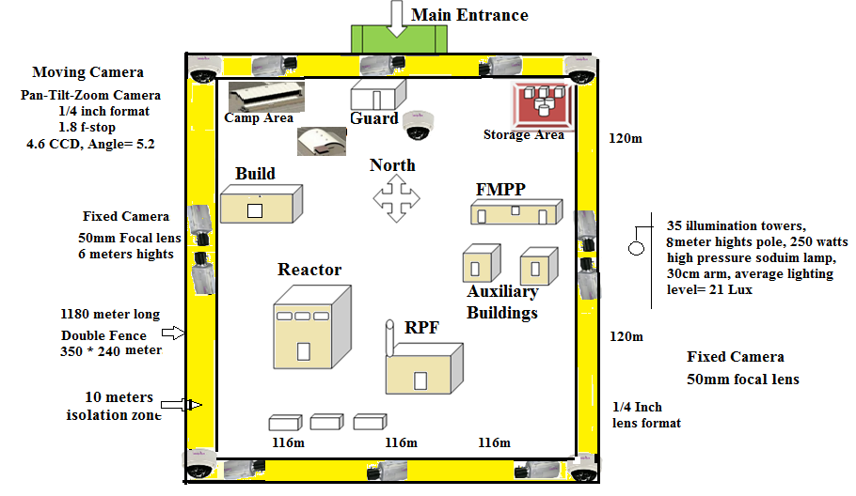

**Figure (6) Peripheral Fence Camera's Distributions**

Isolation zone or cameras supervising area will be illuminated by 35 electric towers, (30cm Arm, 15 Degree Tilt Angle) with, (250 Watts) high-pressure sodium lamps (28000 Lumen/Lamp), to produce 7lux minimum light level.

**5. CONCLUSION**

Security lighting is an important part of the perimeter security plan. On most projects, however, little consideration is given to the security design and layout. Usually, lights are installed, and that is far as it goes. Then the images from the closed circuit television system (CCTV) along the perimeter of the property are not very good and usually are of poor quality. In this work a proposed design for Illumination and Cameras Surveillance System For optimum supervision at a perimeter area of nuclear facility are presented. A perimeter area has an isolation zone between double fences which are surrounds the nuclear facility site. The illumination poles, lamps type, towers space distance and lighting level, required for camera surveillance system are computed and determined. The work provides the requirements of cameras surveillance system at nuclear reactors isolation zone. A calculation of camera's parameters and its technical specifications is presented for a nuclear research reactor facility. A distribution of the cameras locations inside the isolation zone of the nuclear site is explained and worked depending on the calculated camera's parameters and specifications. The results shows that the nuclear facility site isolation zone needs fifteen cameras, (10 fixed and 5 moving), with 50mm focal lens, ¼ inch format, with 5.2 angle of view. Cameras supervising area should illuminated by 35 electric towers, (30cm Arm, 15 Degree Tilt Angle) with, (250 Watts) high-pressure sodium lamps (28000 Lumen/Lamp), to produce 7lux minimum light level,

**REFERENCES**

[1] Michael J. Arata, Jr.,”Perimeter Security”, Book, McGraw-Hill, New York, USA, 2006.

[2] Kukula, E.P. and Elliott S.J., The Effects of Varying Illumination Levels on FRS Algorithm Performance, Department of Industrial Technology, School of Technology, Purdue University, West Lafayette, IN 47907. 2004.

[3] Vermeulen, J. 1992. Light Sources and Closed-Circuit Television Lighting Research and Technology, 24(2), PP. 63-67.

[4] www.darkskysociety.org ‘’Guidelines for Good Exterior Lighting Plans”’ the dark sky society, 2009

[5] Hypothetical Facility Data Book “’the Shapash Nuclear Research Institute

(SNRI)”’ international Atomic Energy Authority (IAEA) 10 September 2013

[6] Safety Analysis Report (SAR) of Egyptian Second Research Reactor (ETRR-2) "Security System Basic Design'', 1999.

[7] IEC 60598.2.3 Edition 3 (2002) Luminaries for Road and street

[8] IEC 60662 High Pressure Sodium vapor lamps.

[9] 18th International Training Course, ''Physical Protection of Nuclear Facilities and Materials'', Sandia National Laboratories, Albuquerque, New-Mexico, USA, 2004.

[10] Fixed Camera, Data/Specification Sheet/ Part Number: 8009-7259-00-00, series, VICON Industries Inc, 2012

[11]A. A. Wadoud, “Determination of Television Surveillance Cameras’ Parameters Of Hypothetical Nuclear Facility “Arab Journal of Nuclear Science and Applications, 48(3), (129-142), 2015.

[12] Closed Circuit Television Systems Fundamentals Course", TOA Electronics, Inc., USA, 2005.

[13] Stanislav, Utochkin, CCTV-Cad.Com "The principles of CCTV Design in Video-CAD" issue 36 – 2006.

[14] Joe Cieszynski, IEng MIEE (elec) Cert. Ed. CGI,” Closed Circuit Television” second edition, Elsevier, 2004.

[15]Intelligent Transportation Systems (ITS)"Closed-circuit television (CC.TV) cameras design manual" December, 2000.

[16] Military handbook 1013/1A, ''Design Guidelines for Physical Security of Facilities", USA, 9 October, 1987

[17] Marry Lynn Garcia," The Design and Evaluation of Physical Protection System", Butterworth-Heinemann, Elsevier Science, USA, 2001.