PNRA Technical Support Capabilities for Detection Technologies and Associated Challenges

ANAYAT ULLAH
Pakistan Nuclear Regulatory Authority (PNRA)
Islamabad, Pakistan
Email: anayat.malik@pnra.org

MAJID ALI SALEEMI
Pakistan Nuclear Regulatory Authority (PNRA)
Islamabad, Pakistan

MUHAMMAD RIZWAN
Pakistan Nuclear Regulatory Authority (PNRA)
Islamabad, Pakistan

SAJJAD AHMAD
Pakistan Nuclear Regulatory Authority (PNRA)
Islamabad, Pakistan

Abstract
The International instruments including United Nation Security Council Resolution-1540, IAEA Convention on Physical Protection of Nuclear Material (CPPNM) and its amendment-2005 and IAEA Code of Conduct on Safety and Security of Radioactive Sources require the state to have a system in place for detecting the illicit trafficking of nuclear and other radioactive materials. The national laws and regulations are also in place for the effective control of radioactive sources based on the concept of “Cradle to Grave”. The national legislative and regulatory framework empowers the regulatory authority for regulating and supervising all matters related to safety and security of radioactive materials.
Pakistan has established a detection mechanism coupled with fixed installed radiation portal monitors and hand held detection equipment at various borders and sea ports. Further, to ensure the sustainability and long term operation of detection mechanism, PNRA has established a Technical Support Unit (TSU) having capabilities in preparation of equipment specifications as per end user requirements, acceptance and periodic testing to ensure the operation of equipment, protection and energy calibrations for optimization of equipment response. The TSU is also capable for identification of the fault in hardware and software of detection equipment and trouble-shooting. At the national level, TSU is capable to provide technical assistance to the relevant stakeholders.

BACKGROUND
The availability of legislative and regulatory framework, organizations with defined roles and responsibilities, systems and measures for the prevention, detection and response are key attributes for controlling and regulating nuclear and other radioactive material. The state system and measures for the detection of, planning, preparedness and response to a nuclear security event is composed of detection technologies, assessment of the nuclear security event within the country and at borders, relevant national competent authorities and authorized persons with defined chain of command and authority to detect, assess and respond to nuclear security events involving nuclear and other radioactive materials out of regulatory control.
The state mechanism for the detection of and response to nuclear security event also requires availability of coordination mechanism and relevant measures for the detection of nuclear and other radioactive materials out of regulatory control, performing initial alarm assessment and other secondary inspection for localization, identification, categorization and characterization of nuclear and other radioactive material. The mechanism is also complemented with the provision of technical support for detailed assessment of an alarm.
Besides the deployment of detection mechanism and availability of expert support network, research and development with international collaboration is a vital element for improvement in existing detection technologies and to find out suitable alternatives. Research in detection technology may be carried out on the technical attributes such as probability of detection, identification capability, detection range and mobility etc. These improvements may be sought out through the development of improved instruments, and integration detector hardware and software modules.
The objective of the paper is to describe the national mechanism for the detection of radioactive material out of regulatory control, search and survey programs of various locations and challenges in the sustainable operation of detection technologies.

Legal Basis for the Detection and Controlling of Radioactive Materials
In Pakistan, the national legislative and regulatory framework to control and regulate the nuclear and radioactive material in an effective way consists of;
- Pakistan Nuclear Regulatory Authority (PNRA) Ordinance -2001
- Pakistan Customs Act-1969
- National Command Authority (NCA) Act-2010
- National Import and Export Policy Orders-2018
- Strategic Export Control Act-2004
- PNRA regulations such as on authorization (PAK/908), radiation protection (PAK/904), security of radioactive sources (PAK/926) and physical protection of nuclear materials and nuclear installation (PAK/925).
The national framework is also supported by the international instruments and is being implemented through national law and regulations with aim to strengthen nuclear security and physical protection globally. These instruments are;
- IAEA Convention on Physical Protection of Nuclear Material (CPPNM) and its amendment-2005
- United Nation Security Council Resolution-1540
- IAEA Code of Conduct on Safety and Security of Radioactive Sources
At national level, PNRA regulatory framework addresses the cognizant requirements related to the authorized import and export of radioactive materials and also for the availability of detection mechanism at entry/exit point to prevent the unauthorized movement of any commodities or metallic objects having radiation level above background. The regulations clearly depict that:
- The import and export of edible goods with radionuclide level above the level prescribed by the regulatory body is prohibited. Furthermore, import and export of scrap metal, recycled metal product or other commodities having radiation level above background is prohibited.
- The person importing scrap metal and recycled metal products is required to furnish a certificate issued by the relevant authority of the country of origin specifying the radiation levels in the scrap. An undertaking is required; if any imported consignment is found to have radiation levels higher than natural background levels, and is to be returned back to the country of origin by the importer at own risk. The consignment, shipments and containers also requires verification by the local authorities.
The regulatory framework also establishes a mechanism for the licensee to report PNRA the events involving loss, theft, unauthorized removal, unauthorized movement etc. of nuclear materials and radioactive sources. Further, the framework also requires the licensee to take remedial actions in coordination with the national authorities to bring the materials under regulatory control.

National Measures for the Detection and Controlling of Radioactive Materials and their Sustainability
PNRA regulatory requirements related to authorize shipment of nuclear and other radioactive materials have been included in the national import and export policy orders under which any shipment of dangerous goods under class-7 (radioactive materials) will be subject to prior approval of Pakistan Nuclear Regulatory Authority. This mechanism is being practiced in mutual cooperation of PNRA, Pakistan Customs and Ministry of Commerce at national level. The interface has also been established among national organizations for any new inclusion of radioactive materials or goods in import/export policy orders to ensure effective control of radioactive material and prevent their unauthorized movement.
The national measures for the prevention of, detection of and response to unauthorized shipment of nuclear and radioactive materials are in place at entry/exit points. These measures are complemented with Radiation Portal Monitors (RPMs), handheld radiation detection equipment, high energy accelerators for x-ray scanning, procedures for the inspection and verification of shipments and communication mechanism with regulatory authority for technical support in decision making actions.
The sustainability of the detection technology is a challenging task and requires the availability of technical and financial resources. At national level, the port authorities as a licensee of PNRA; are responsible for the continuous operation and maintenance of the systems and implementation of directives related to operational mechanism, maintenance of the system and necessary upgrades. For sustainable operation of the scanning and fixed installed monitoring systems, the port authorities have negotiated the maintenance contract with the manufacturer, since the installation of the systems.

Survey of Strategic Locations in Pakistan
It is evident from the day to day event reports of IAEA ITDB that presence of the radioactive materials in scrap cannot be ignored. Hence, there is a strong need to have mechanism in place for the monitoring of various strategic locations including scrap yard, steel mills, dry ports, sea ports, cargo terminals and metal recycling foundries. PNRA as a national regulatory authority with function to control and regulate all matters related to radioactive material performs the periodic survey of scrap yard, steel mills, dry ports, sea ports, cargo terminals and metal recycling foundries by using various detection equipments.
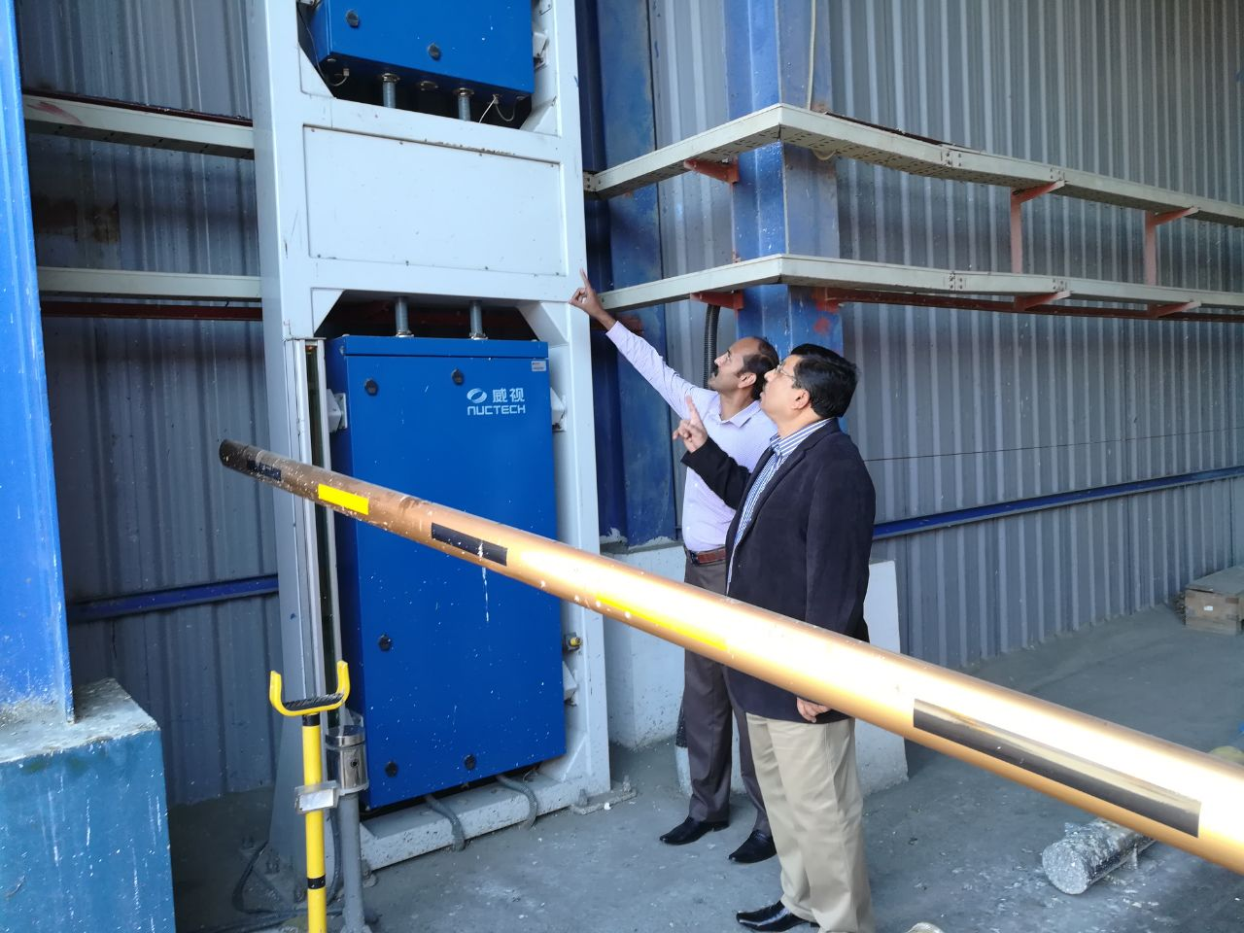
Fig. Detection Mechanism at Sea Ports

Technical Support Unit for Nuclear Security
PNRA with the assistance of IAEA has established a Technical Support Unit (TSU) to provide technical and scientific support services at national level to ensure operation of the detection at all time. The TSU is equipped with necessary tools, equipment, and experienced manpower for technical support.
In the area of technical support, TSU provides services to national organizations in the testing, calibration, maintenance and troubleshooting of radiation detection equipment (RDEs). TSU have technical capabilities and provides support to national stakeholders in the preparation of specifications, selection of intended purpose equipment, procurement, installation criteria, and operational mechanism related to radiation detection equipment. For the sustainable and long term operation of the radiation detection equipment, TSU provides expert services to national organizations having role in the detection architecture. These services includes routine testing of radiation detection equipment to maintain the availability of equipment, fault finding in hardware of handheld equipment and perform necessary repairs, identification of deficiencies in the operations of RPMs and issue directives from time-to-time for up-gradation of RPMs or rectification of deficiencies. It also assists in identification of potential upgrades in equipment through the IAEA.
In the area of scientific support, TSU provides expert advice and support to national authorities to regulate and control unauthorized movement of nuclear or radioactive material and radioactively contaminated goods. The imperative procedures are also established for the correct use of equipment in case of nuclear security events, communication with authorities and decision making.
TSU provides support services for remote monitoring and resolution of alarms from RDEs. It also offers assistance for response activities in case of an unauthorized act involving nuclear/radioactive material like radiological assessment, safe and secure transportation of contaminated material to temporary/permanent storage. PNRA also provides in-situ support for dose measurements, radiation spectra, categorization of detained radioactive material, and specific long term measurement to resolve identification problems.
The radiation detection equipment available with TSU are Personal Radiation Detectors, Radionuclide Identification Devices, Contamination Monitors, Neutron Search Detectors, Radiation Survey Meters, High purity Germanium Detectors, analytical software's for quantification and isotopic composition of radioactive materials. The procedures available with TSU describe the sequential process of use, analysis of radioactive materials, acceptance and periodic testing, calibration and maintenance of equipment. However, it is difficult for TSU to perform full scope of repair, maintenance and calibration of software and hardware of equipment due to the challenges of compact design of the equipment.

On-Site Support Network and Capacity Building
PNRA has established a lab network for expert support at six regional offices, fully capable for analysis of more complex spectra with advance equipment and expert reach back to national organization responsible for initial detection of radioactive materials. These labs also provides support to national authorities in the analysis and conclusion of bare and shielded radioactive materials used in nuclear, medical and industrial sectors using advance equipment and tools.
PNRA have an extensive capacity building program for the training of PNRA officials and other stakeholders including Front line officers, law enforcing authorities, rescuers and security agencies. PNRA has conducted number of training courses in detection of and response to unauthorized acts involving nuclear and other radioactive materials and trained officials from various organizations.

Challenges in the Operation AND MAINTENANCE of Detection Technology
The international community is now moving towards the need of a detection infrastructure with updated detection equipment and user friendly interface. The fixed RPM installed in Pakistan for nuclear security purposes are operational since two decades. It has been observed that new operational and integration features are missing in the RPMs and software, which are needed for the assessment and decision making. PNRA recommended the licensees to upgrade the RPMs by making software’s integration, data traceability for evidence and generation of daily files with complete information of x-ray scan images, background counts, gamma/neutron count profile, container, commodities, speed of vehicle and occupancy.
Also the TSU is operating various kinds of handheld equipment in Pakistan for support to national organizations, since 2006. These equipments have caused some faults and problems in hardware and software modules which need to be rectified at end user site. The TSU has challenges in the long term sustainability of handheld equipment, due to high complications and compact design in the hardware and software of the handheld equipment. Hence, there is a strong need to sort out the solution at IAEA, by designing suitable and flexible specifications in view of technical challenges; by preventing compact design equipment; support for upgrading the existing handheld equipment into easily repairable technologies, and availability of spares and training from the vendors for the repair and maintenance of the equipment at their technical support units.

Conclusion
Necessary regulatory framework for the authorization and detection of the movement of nuclear and other radioactive materials has been established for controlling, regulating the movement of nuclear and radioactive material in the country. Moreover, appropriate radiation detection systems are in place at various entry/exit points, capable to detect technologies nuclear and radioactive materials. TSU equipped with requisite tools and skilled manpower is available for expert support to national organizations for ensuring availability of systems, resolution of alarm and identification of radioactive materials.
The TSU recommends the licensees to upgrade the RPMs by making software’s integration, data traceability for evidence and generation of daily files with complete information of x-ray scan images, background counts, gamma/neutron count profile, container, commodities, speed of vehicle and occupancy.
The challenges for TSU is the sustainability of handheld radiation detection equipment and hence, the solution at IAEA need to be sorted out, by designing suitable and flexible specifications; by preventing compact design equipment; by providing support for up-gradation of the existing handheld equipment into easily repairable technologies, and availability of spares and training from the vendors for the repair and maintenance of the equipment at their technical support units.
REFERENCES
[1] PNRA Ordinance-2001
[2] PNRA Regulations on Radiation Protection-PAK/904 (amendment)
[3] PNRA Regulations on Licensing of Radiation Facilities other than Nuclear Installations PAK/908
[4] PNRA Regulations on Security of Radioactive Sources-PAK/926
[5] Pakistan Import and Export Policy Orders-2016
[6] IAEA Nuclear Security Series No.15

