- Background and Goal
The increasing of global nuclear security issues encourages the need to improve the competence of human resources in the field of nuclear security in Indonesia, especially for security officers. The Republic of Indonesia as an archipelago country which has around 17,000 islands connected by the sea. This condition makes the complexity of nuclear security surveillance. The Nuclear Engineering Program of Universitas Gadjah Mada (UGM) as a member of INSEN has a moral responsibility to improve Indonesian human resources capability in the field of nuclear security. According to this need, the Nuclear Engineering Program has been conducted a three days training for members of the police and UGM’s security officer to improve their capabilities in dealing with nuclear security issues. The training was supported by the Nuclear Energy Regulatory Agency of Indonesia (BAPETEN) and Yogyakarta Special Province’s Police (POLDA DIY).

- The Training
Twenty security officers were trained by UGM and BAPETEN staff who delivered the materials in various methods (class, table top, case study, and exercise) in 12 sessions.

Session | Time (minutes) | Trainer
Introduction to Radiation | 90 | UGM
Risks and Benefits of Radiation | 90 | UGM
Introduction to Radiation Detection and Measurement and Detector for Nuclear Security | 60 | UGM
Detector Exercise | 75 | UGM
Nuclear Security Principle and Global Cases | 60 | UGM
Nuclear Emergency Procedures | 60 | BAPETEN
Psychology for Nuclear Security | 75 | UGM
Introduction to Nuclear Installations and Radiation Facilities | 60 | UGM
Introduction to Physical Protection System | 60 | UGM
Table Top Exercise | 120 | UGM
Nuclear Security in Transportation | 75 | UGM
Nuclear Material Transportation Case Study | 60 | UGM

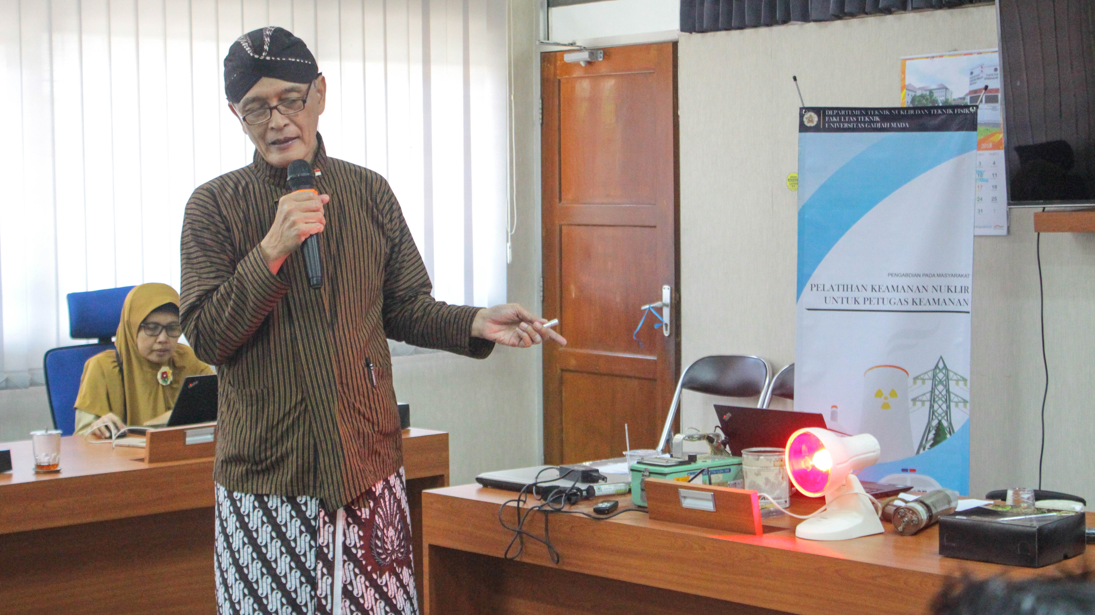
UGM’s staffs introduced principle of radiation detection and measurement in class
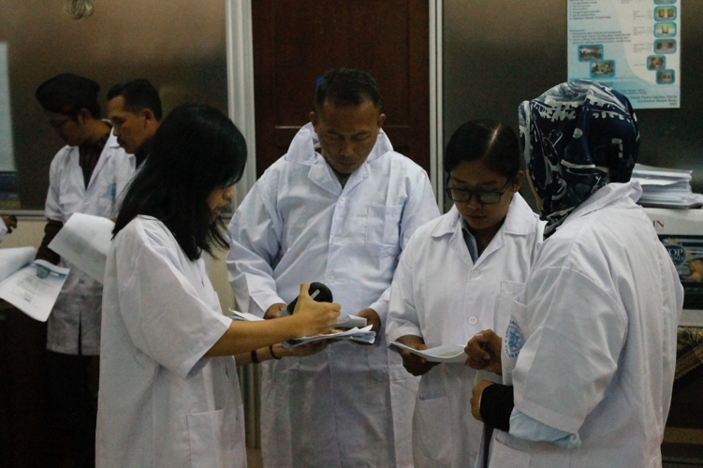 | 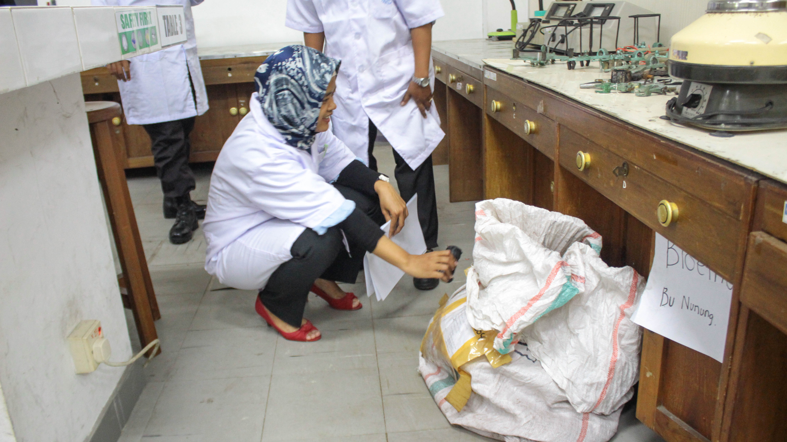
Radiation detection and measurement exercise

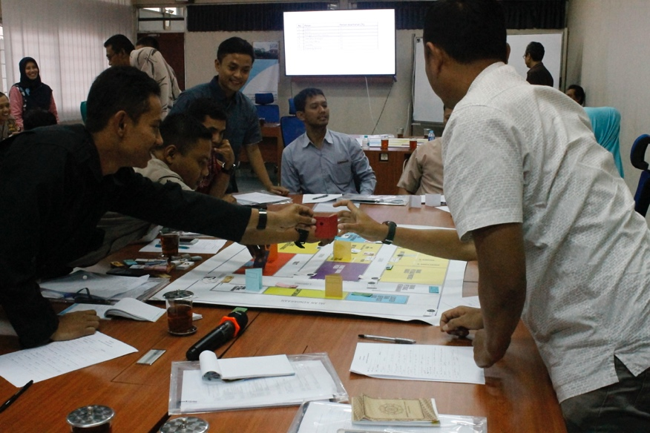 | Table top exercise

Pretest-posttest was done to measure the benefits felt by participants.
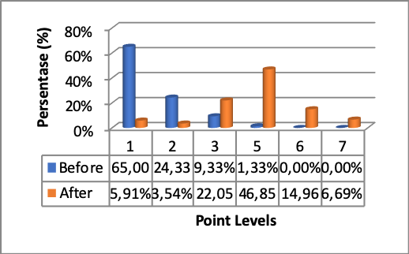
The different understanding of participants between before and after training

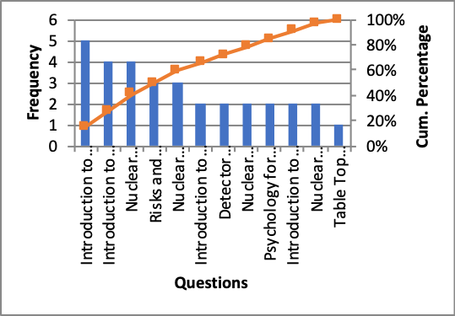
Pareto diagram of materials that were considered less useful by participants.

- Conclusions and Acknowledgements
Based on the before and after training questioners, we could conclude that the understanding of participants on nuclear security could be improved. This understanding arises due to the material fit to the need, varied delivery methods, and the participant’s awareness.
The excellent collaboration of BAPETEN, POLDA DIY, and Faculty of Engineering UGM were acknowledged. Hopefully, we could improve our relationship in the next training.
Locally Rooted, Globally Respected
ugm.ac.id

