international shipments of sensitive nuclear materials
Experience of International Nuclear Services in safe and secure transport of sensitive nuclear materials across international borders

Mark Crowther
International Nuclear Services
United Kingdom
Email: mark.crowther@innuserv.com

Abstract

This paper explains the key activities that International Nuclear Services undertakes to consistently deliver high quality and reliable international marine transports of Category I to III nuclear materials.

INTRODUCTION
International Nuclear Services (INS) and its majority-owned subsidiary Pacific Nuclear Transport Ltd. (PNTL) have been carrying out transports of different categories of nuclear materials for well over forty years, travelling over five million miles without any nuclear or security incident.
This record has been achieved through significant and sustained investment in the capability of assets, people and systems by INS and its international partners and stakeholders. INS has applied its unique experience in this field to ensure a rigorous and uncompromising approach to regulatory compliance, safety, security, capability and communication.

INS and PNTL
INS is a subsidiary of the Nuclear Decommissioning Authority (NDA), a UK public body responsible for the safe and efficient clean-up of the UK’s nuclear legacy. INS’s role is to support delivery of the NDA strategy by providing specialist nuclear transport, design and licensing services. A significant part of INS’s work involves the transportation of spent fuels, highly active waste and special nuclear material. INS is the only organisation in the world that offers a high-security Category I nuclear shipping capability and therefore plays a key role in delivery of UK and global security and non-proliferation goals. Since becoming an NDA subsidiary in 2008, after the restructuring of the UK civil nuclear industry, INS has undertaken many complex nuclear transport projects for various countries including Japan, USA, Sweden, Italy, Belgium, France, Switzerland and Germany. INS has provided end-to-end solutions for transport of such materials as plutonium, highly enriched uranium, MOX fuel, vitrified high-level waste and spent fuel.
INS is the majority owner of PNTL, the world’s most experienced marine shipper of sensitive nuclear materials, and is responsible for its management and operations. PNTL was formed in 1975 to provide a strategic transport solution for transports from Japan to Europe and back. The experienced PNTL crew are highly trained in the specialised skills needed to transport nuclear materials.
INS and PNTL’s people are experts in engineering, package design and licensing, nuclear transport operations, project management, international nuclear law, shipping, stakeholder relations, security and resilience, health and safety, emergency response, contract management and commercial services.
Of the four vessels operated by INS, NDA owns one vessel and PNTL three vessels, all INF3 class ships are specifically designed to transport up to Category I material safely and securely. All the ships are crewed by PNTL.

regulatory framework
Regulation of safe and secure nuclear transport is comprehensive and had been developed since the 1960’s through the leadership of IAEA and its member states. There is a robust framework of international legal and regulatory requirements and standards that apply to safety and security in the multi-modal approaches to transport of nuclear materials. International regulations include (not exhaustive):

- IAEA Regulations for the Safe Transport of Radioactive Material (SSR-6)
- UN Recommendations on the Transport of Dangerous Goods
- IMO International Maritime Dangerous Goods Code (IMDG Code)
- International Code for the Safe Carriage of Packaged Nuclear Fuel, Plutonium and High-level Radioactive Wastes on Board Ships (INF Code)
- European Agreement concerning the International Carriage of Dangerous Goods by Road (ADR)
- IMO International Convention for the Safety of Life at Sea (SOLAS)
- IAEA Planning and Preparing for Emergency Response to Transport Accidents Involving Radioactive Material Safety Guide
- IMO International Convention for the Prevention of Pollution from Ships (MARPOL)
- IMO International Safety Management Code (ISM Code)
- United Nations Convention on the Law of the Sea (UNCLOS)
- ICAO Technical Instructions for the Safer Transport of Dangerous Goods by Air
- IATA Dangerous Goods Regulations
- OTIF Regulations Concerning the International Carriage of Dangerous Goods by Rail (RID)
- UN Convention on the Physical Protection of Nuclear Material (CPPNM)
- IAEA Nuclear Security Recommendations on Physical Protection of Nuclear Material and Nuclear Facilities (INFCIRC/225/Revision 5)
- IAEA Security in the Transport of radioactive Material (Nuclear Security Series No. 9)
- IAEA Security of Nuclear Material in Transport (Nuclear Security Series No 26-G)
- IMO International Ship and Port Facility Security Code (ISPS Code)

INS and PNTL are required to follow these regulations and, as UK companies operating from within the UK, all of the UK regulatory requirements. For transport across and into other countries, INS and PNTL must also meet all of the legal and regulatory requirements of those countries.
An effective regulatory framework is central to not only maintaining the safety and security of nuclear transports but also gaining the understanding and support of the many national and international stakeholders who maintain an interest in INS’s activities.
INS is one of the founder members of the World Nuclear Transport Institute (WNTI) and is active in supporting WNTI in its work with key intergovernmental organisations in promoting an efficient, harmonised international transport safety regime. WNTI is a non-governmental organisation that has consultative status with the IMO and observer status with the IAEA. In addition, WNTI has consultative status with the United Nations Committee of Experts on the Transport of Dangerous Goods, Category B Liaison Membership with the International Organization for Standardization (ISO), and information status with the American National Standards Institute (ANSI) N14 Committee.

elements of effective nuclear materials transport
Through working closely with partner organisations, INS offers complete solutions for transport of nuclear materials from door-to-door across the world. INS transports over the past forty years have covered over five million miles by sea, as well as rail and road. The company has carried out movements of over 2,000 transport flasks, 20 shipments of high-level vitrified waste residue, 12 shipments of MOX fuel and various other significant shipments in support of governments’ efforts to reduce the global threat associated with certain nuclear materials. Whilst INS has maintained a flawless radiological safety record throughout that period, it has continued to develop and improve its approach in order to adapt to changing circumstances and the resulting regulatory and, best practice landscape.

The key to INS’s success has been to develop with its partners an uncompromising approach that focusses on key areas including planning, safety, security, reliability, compliance and expertise.

Safety in depth

Design and Licensing
Shipping assets, the vessels and transport packaging or flasks, are specifically designed for the purpose in hand.

Package Design and Licensing
IAEA Regulations for the Safe Transport of Radioactive Material set the basic requirement that safety is vested in the package in order to provide all the levels of protection needed for the transport. The package must be appropriately shielded to provide protection from radiation to workers and the public; protect from the effects of an accident or fire; prevent potential dispersion of contents.
Regulations cover five classifications of package (Excepted, Industrial, Type A, Type B, Type C), each providing standards based on levels of radioactive activity and the form of the material. Test requirements are set for each package depending on risks that may arise during the transport.
Type B packages are needed to transport material with higher levels of radioactive activity and are used frequently by INS in transports around the world. In addition to standard design requirements for all packages, Type B are required to withstand:
- Drop test from 9 metres
- Puncture test
- Fire (at least 800ºC for 30 minutes)
- Immersion (up to 200m for 1 hour)

The INS flask design and licensing team are experienced in finite element analysis, shielding, criticality assessments and mechanical design, allowing them to design and license new packages, as well as applying their expertise to existing packages for transport of varying materials. INS can self-certify packages up to Type A classification. The team can design complete end-to-end transport solutions, including engineering, bespoke transport packages and bring the benefits of its expert ongoing contribution to IAEA regulations to ensure efficient and compliant transports.

Vessel Design and Licensing
In 1993, the International Maritime Organisation (IMO) established the International Code for the Safe Carriage of Packaged Irradiated Nuclear Fuel, Plutonium and High-Level Radioactive Waste on Board Ships (INF Code). The INF Code became mandatory in 2001 and sets stringent standards for the three classes of INF ships, described in Table 1.

TABLE 1. CLASSES OF INF SHIPS

INF Class 1 Ship | INF Class 2 Ship | INF Class 3 Ship
Ships which are  certified to carry  materials with an  aggregate radioactivity  less than 4,000 TBq | Ships which are certified to carry irradiated nuclear fuel or high-level radioactive wastes with an aggregate radioactivity less than 2 x10⁶ TBq and ships which are certified to carry plutonium with an aggregate radioactivity less than 2 x 10⁵ TBq | Ships which are certified to carry irradiated nuclear fuel or high-level radioactive wastes, and ships which are certified to carry plutonium with no restriction on the aggregate radioactivity of the materials
Source: WNTI

The four vessels that INS operates, Oceanic Pintail MV, Pacific Heron MV, Pacific Egret, and Pacific Grebe were designed to meet the requirements for INF3 vessels. The INF code was based upon the first generation of PNTL ship design and INS was operating vessels to INF3 standards twenty years before IMO made INF Code mandatory.
INS’s design of the three PNTL vessels is an evolution of the first generation of INF3 class ships and exceeds the requirements of the INF3 code. The cargo compartments are protected by a double hull and all essential systems on the ships are duplicated and separated to provide high reliability and accident survivability. If any important system fails during a voyage, either owing to mechanical or system failure or as a result of an accident, there is always a second system ready to be brought into operation. In addition, no tanks or spaces containing oils or other pollutants are positioned directly adjacent to the outer hull to minimise the chances of pollution should the outer hull be ruptured during an incident. In summary the key features are:

- double hull throughout, with additional strengthening surrounding the holds
- independent engines, machinery and steering gear
- auxiliary generators
- duplicated and multiple systems
- hold cooling plant located outside holds for easier maintenance
- integrated bridge system
- no oil tanks adjacent to outer hull
- security features incorporated into design
- enhanced security features
- improved environmental and safety performance
- advanced fire detection and firefighting systems
Code
Some of these features are illustrated in the image of the Pacific Heron in Fig 1 below.
11
FIG 1. CUTAWAY IMAGE OF PACIFIC HERON
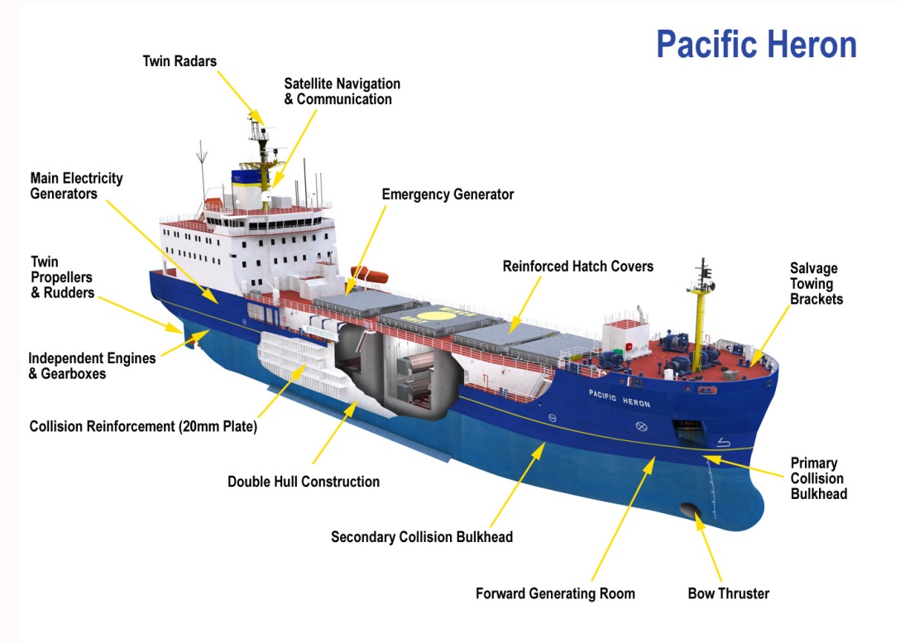

Assurance - Planning, Preparation and Implementation
INS plans each of its shipments meticulously. For more complicated transports, planning may need 12 months and sometimes longer. Ahead of shipment planning, INS will also undertake feasibility studies as necessary to ensure that licensing and all the options for delivery are fully understood and developed.
For each individual transport, INS assures itself that all applicable requirements of the transport regulations and all additional assurance requirements are met. INS has a robust Transport of Nuclear Cargoes process (extract shown below in Fig 2) that supports the operations and approval teams in ensuring these requirements. To verify that all requirements are in place, INS also implements a decision matrix under its Nuclear Transport Safety Committee Review process to reviewing key nuclear safety aspects of transports, including all transport modes and multi-modal transfer points.

FIG 2. EXAMPLE OF NUCLEAR CARGOES TRANSPORT PROCESS
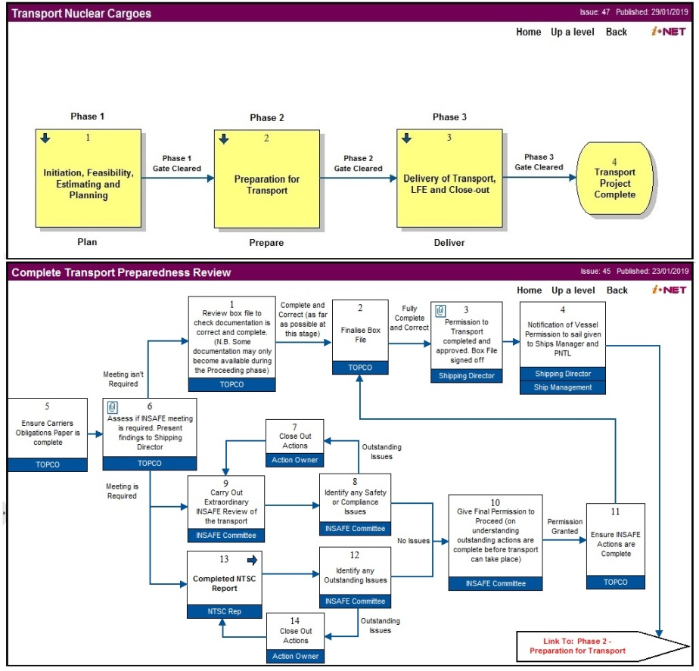

The summary of both reviews are then presented and discussed at a Readiness Review Meeting, convened to confirm that all requirements are in place and the transport can proceed. The Readiness Review Meeting also ensures that any learning taken from previous shipments has been implemented for the upcoming shipment.
This whole process is subject to external audit and regular self-verifications to ensure that the process remains fit-for-purpose.

Security
INS and its shipping subsidiary PNTL are subject to UK security regulations. CPPNM and IAEA security requirements flow through to the UK in the Nuclear Industries Security Regulations 2003 (NISR2003) and the Security Assessment Principles for the Civil Nuclear Industry (SyAPs), regulated by the Office of Nuclear Regulation. INS is the dutyholder for provision of security for nuclear transports in line with UK regulations. It is responsible for providing a Transport Security Statement laying out INS’s overall approach to meeting all required security regulations, as well as a Transport Security Plan for each individual shipments.
INS vessels have enhanced security features and for higher category shipments are armed to protect the vessels against potential security threats. The UK Civil Nuclear Constabulary (CNC) is responsible in the UK for the physical protection of civil nuclear sites and facilities from potential threats. INS partners with CNC and their specialised Strategic Escort Group to provide security services for transports. Requirements will vary depending on the nature of the shipment.
INS implements a comprehensive security programme to ensure that everyone involved in transport of nuclear materials is an active participant in a strong security culture. INS approach includes:

- Leadership and management: ensuring clear governance, leadership by example, policies and roles & responsibilities
- Security culture: a programme to educate, enable, encourage, evaluate and continually improve security culture
- Competence: a programme to ensure appropriate training and qualifications of responsible personnel
- Supply chain management: setting expectations of supply chain in managing sensitive information and assets
- Cyber and information security: protection of systems and Sensitive Nuclear Information
- Reliability, resilience, sustainability: accreditation, examination, maintenance, testing, sustainability
- Physical protection systems: protecting against theft, sabotage, design, vulnerable assets
- Emergency response: exercising and testing arrangements
- Policing/guarding: ensuring an effective relationship with CNC, local police and security guards
- Vetting: ensuring a reliable and trustworthy workforce through national vetting, aftercare and a programme of insider threat measures

Emergency Response and Transport Control
INS has a proven and well exercised 24 hour emergency response and transport monitoring capability. Any issues that arise during transports are managed through this capability.
In support, INS has established a network of global response partners; including marine salvage, air transport and health physics. It has put in place dedicated tactical and strategic UK command centres for transports and has highly trained and experienced personnel in command, control and communication. INS has worldwide access to emergency response equipment including pre-determined grab-bags positioned globally.
The response capability, systems and procedures are tested regularly including desktop, simulated and real-time multi-disciplinary exercises.

Information and Communication
During transport operations INS follows a general principle of transparency, at least to the extent permitted by security considerations. An open and honest approach to information disclosure helps to establish credibility and confidence. INS also proactively engages with the public and communities in advance of transport operations. It works closely with its partners to explain its transport activities, in particular with its local stakeholders in its home port of Barrow-in-Furness, and with the countries and organisations along the routes travelled by INS vessels. These relationships are key to maintaining confidence in INS’s ability to transport materials safely and securely.

conclusion
Transport of nuclear materials is an essential part of civil nuclear industry operations, allowing for movement of fresh fuel, spent fuel, waste and other products. The basis for the safe and secure transport of sensitive nuclear materials is the sound international regulatory framework, stretching across a wide range of disciplines, such as safety, security, maritime, rail, road, air. In addition to the key standards set by regulation, INS has developed systems and capability to set the bar for delivery of nuclear transports to a high level, resulting in no nuclear incidents over more than forty years of operation. Key to delivering these high standards is the integrity of transport assets, integrity of management systems, competence of staff in planning, delivery and security, constant challenge to prevent complacency and ensuring effective relationships with national and international stakeholders.
References
- World Nuclear Transport Institute, Fact Sheet on the INF Code and Purpose-built Vessels.
- World Nuclear Transport Institute, Fact Sheet on Safety Regulations Governing Radioactive Materials Transport.

