EUROPEAN COMMISSION'S JOINT RESEARCH CENTRE RESEARCH ON THE SAFETY OF SPENT FUEL AND HIGH LEVEL RADIOACTIVE WASTE MANAGEMENT

M. MARTÍN RAMOS
European Commission's Joint Research Centre
Brussels, Belgium
Email: Manuel.MARTIN-RAMOS@ec.europa.eu

V.V. Rondinella, T. Wiss, D. Papaioannou, R. Nasyrow
European Commission's Joint Research Centre
Karlsruhe, Germany

Abstract

The management of the spent fuel in the EU is addressed in alignment with Council Directive 2011/70/Euratom, which aims at the safe and responsible management of radioactive waste and spent fuel in order to avoid imposing undue burdens to the future generations; at ensuring the highest levels of safety; and at ensuring transparency and the involvement of the public in the decision-making process. Twenty one EU Member States manage about 59 000 tHM of spent fuel generated in past and current nuclear power generation and nuclear research activities. Each year, about 3 200 tHM of additional spent fuel are generated. Some Member States reprocess spent fuel and some others have decided to keep this option open. The majority of the EU Member States have opted for direct disposal of their spent fuel. Right now the EU does not have in its territory any facility for the disposal of spent fuel, high level and long-lived radioactive waste. Finland, Sweden and France expect to start the operation of their deep geological disposal facilities within the next two decades, while the rest of the MS with nuclear programmes have planned operating disposal facilities in the time interval 2040-2130, with a peak in the decade of 2060-2070. Long-term or extended interim storage is thus instrumental in the national strategies for the management of spent fuel prior to reprocessing or disposal. The Euratom Research and Training Programme contributes, within its portfolio of activities, to the safe management of spent fuel and radioactive waste. This is done through indirect research and innovation activities to which the European Union provides financial support and which are undertaken by EU Member States research entities, and through direct research and innovation activities undertaken by the Commission through its Joint Research Centre (the ‘JRC’: the European Commission's science and knowledge service). This paper provides an overview of the JRC areas of research relevant for safety of spent fuel (and high level radioactive waste), which cover all stages of spent fuel management since it is removed from the reactor: cooling in the spent fuel pool; handling, transport, storage (with particular emphasis on long-term storage); retrieval, handling and transportation after storage; disposal in a deep geological formation, and long term safety aspects thereafter. The paper highlights the main achievements, and the main challenges, stressing the relevance of the experimental work carried out on "real" spent fuel in JRC's research infrastructure, which include hot cells and other shielded facilities that are relatively rare or even unique.

INTRODUCTION
It is up to each European Union (EU) Member State to choose whether or not to use nuclear power in its energy mix. Fourteen Member States have nuclear power plants currently operating, which generate around one fourth of the electricity in the European Union. Overall, twenty one EU Member States manage about 59000 tHM of spent fuel generated in past and current nuclear power generation and nuclear research activities, and about 3 200 tHM of additional spent fuel are generated each year. Pursuant to Council Directive 2011/70/EURATOM of 19 July 2011 establishing a Community framework for the responsible and safe management of spent fuel and radioactive waste [1], EU Member States shall, among other obligations, establish and maintain national policies on spent fuel and radioactive waste management ensuring a high level of safety to protect workers and the general public against the dangers arising from ionising radiation.
The management strategy for spent fuel from nuclear power plants and research reactors in the few EU Member States that consider the spent fuel as a valuable resource consists of reprocessing and reusing the fissile and fertile material recovered, and disposing of the high level radioactive waste resulting from the process. Most Member States consider spent fuel as radioactive waste, and thus have opted for its direct disposal. A few of the Member States that have adopted and follow the direct disposal policy keep open the option of reprocessing of spent fuel, and plan to take the final decision in the future.
Regarding spent fuel from research reactors, a few Member States opt for returning it back to the countries in which it was manufactured, and a small number of Member States with training and demonstration reactors have not yet defined the strategy for the long term management of their spent fuel.
There is a general consensus at technical level that the safest and most sustainable option for the management of high-level radioactive waste and spent fuel (when considered as waste) is its disposal in a deep, stable, geological formation. There is not yet any deep geological facility in operation for the disposal of high level radioactive waste or spent fuel in the European Union, nor in the rest of the world. Finland, Sweden and France expect to start the operation of their deep geological disposal facilities within the next two decades, while the rest of the Member States with nuclear programmes have planned starting and operating disposal facilities in the period 2040-2130, with a peak in the decade of 2060-2070. Taking into account the very long timeframes until disposal facilities are ready to receive high level waste or spent fuel, long-term interim storage becomes instrumental in the national strategies for the management of spent fuel prior to reprocessing or disposal.
In effect, to bridge the time gap up to the availability of disposal options, a majority of EU Member States that has or has had nuclear power plants in operation has made or is making available increased storage capacity for spent fuel and high level radioactive waste. Under the current situation, spent fuel will need to be stored under the highest levels of safety for periods of time many decades longer than initially foreseen (and licensed) when the first interim storage facilities were commissioned, spanning up to more than 100 years. It is then crucial to identify and understand mechanisms that may affect the evolution of the spent fuel "system" (including spent fuel rods and assemblies, structural materials and containers) during long-term storage, and to ensure that it will still retain sufficient properties and conditions to stand handling and transportation to the disposal facility, or otherwise take the appropriate measures.
The present paper provides an overview of the EU research, in particular the direct research and innovation activities undertaken by the European Commission through its Joint Research Centre (the European Commission's science and knowledge service) in the area of spent fuel and high level waste safety related to long-term storage and disposal in deep geological formations.

The EURATOM RESEARCH AND TRAINING PROGRAMME
The Euratom Treaty establishes that the Commission is responsible for promoting and facilitating nuclear research in the Member States and for complementing it by carrying out a Community research and training programme. These programmes are proposed by the European Commission, and are discussed and adopted by unanimous vote in the Council. The programmes are funded by the budget of the Community.
The Euratom Research and Training Programme 2014-2018 [2] and its extension 2019-2020 [3] (the Euratom Programme) is implemented through so called Indirect and Direct Actions. Indirect Actions are research activities carried out by consortia of research institutions from EU Member States and associated countries partially funded by the research budget of the European Union. Direct Actions are research activities carried out by the Commission's Joint Research Centre (JRC). The overall objective of the current Programme is "to pursue nuclear research and training activities with an emphasis on the continuous improvement of nuclear safety, security and radiation protection, in particular to potentially contribute to the long-term decarbonisation of the energy system in a safe, efficient and secure way."
The Programme also sets specific objectives for both Indirect and Direct actions. Specific objectives of the Indirect Actions encompass supporting the safety of nuclear systems; contributing to the development of safe, longer-term solutions for the management of ultimate nuclear waste, including final geological disposal as well as partitioning and transmutation; supporting the development and sustainability of nuclear expertise and excellence in the Union; supporting radiation protection and the development of medical applications of radiation, including, inter alia, the secure and safe supply and use of radioisotopes; moving towards demonstrating the feasibility of fusion as a power source by exploiting existing and future fusion facilities; laying the foundations for future fusion power plants by developing materials, technologies and conceptual design; and promoting innovation and industrial competitiveness; (h) ensuring the availability and use of research infrastructures of pan-European relevance.
Direct Actions constitute an important part of the Euratom Programme and pursue specific objectives: improving nuclear safety, (including nuclear reactor and fuel safety), waste management (including final geological disposal as well as partitioning and transmutation); decommissioning, and emergency preparedness; improving nuclear security, including: nuclear safeguards, non-proliferation, combating illicit trafficking, and nuclear forensics; increasing excellence in the nuclear science base for standardisation; fostering knowledge management, education and training; and supporting the policy of the Union on nuclear safety and security.
The Programme is an integral part of Horizon 2020, the EU Framework Programme for Research and Innovation.
The Commission's proposal for the next Euratom Research and Training Programme 2021-2025 [4], which is currently being discussed at the Council aims at focusing in the same key research areas as the current programme, i.e. nuclear safety, security, radioactive waste and spent fuel management, radiation protection and fusion energy. At the same time, the programme intends to expand research into non-power applications of ionising radiation, and make improvements in the areas of education, training and access to research infrastructure.
With the aim of exploiting synergies and better streamlining both the Indirect and Direct Actions, the new programme aims at a single set of common objectives. Two general ones: to pursue nuclear research and training activities to support continuous improvement of nuclear safety, security and radiation protection; and to potentially contribute to the long-term decarbonisation of the energy system in a safe, efficient and secure way.
And four specific objectives: improve the safe and secure use of nuclear energy and non-power applications of ionizing radiation, including nuclear safety, security, safeguards, radiation protection, safe spent fuel and radioactive waste management and decommissioning; maintain and further develop expertise and competence in the Community; foster the development of fusion energy and contribute to the implementation of the fusion roadmap; and support the policy of the Community on nuclear safety, safeguards and security.
The Programme will be an integral part of Horizon Europe, the next EU Framework Programme for Research and Innovation.

EUROPEAN COMMISSION'S JOINT RESEARCH CENTRE.
The JRC is the European Commission's science and knowledge service. It employs scientists to carry out research in order to provide independent scientific advice and support to EU policy in areas such as agriculture, food security, environment, climate change, innovation, growth, as well as in nuclear safety and security.
The JRC creates, manages and makes sense of knowledge and anticipates emerging issues that need to be addressed at EU level. It develops innovative tools and makes them available to policy-makers. It explores new and emerging areas of science and hosts specialist laboratories and unique research facilities. Its scientific results are highly ranked by international peer systems.
Established as a Joint Nuclear Research Centre by Article 8 of the Euratom Treaty, the JRC draws on 60 years of scientific experience and continually builds its expertise, sharing know-how with EU countries, the scientific community and international partners. With time, the JRC has broadened its field of research to non-nuclear disciplines, which now cover around 75 % of its entire activities. It works together with over a thousand organisations worldwide in more than 150 networks whose scientists have access to JRC facilities through various collaboration agreements.
The JRC is funded by the EU's framework programme for research and innovation: Horizon 2020, and by the EURATOM Research and Training Programme for its work in the nuclear field.
The JRC is organised in two Directorates with corporate responsibilities for strategy, work programme coordination and resources, and eight scientific Directorates: six of them deal with Growth and Innovation; Energy, Transport and Climate; Sustainable Resources; Space, Security and Migration; Health, Consumers and Reference Materials; and Nuclear Safety and Security; two are cross-JRC directorates, for Knowledge Management and Competences. The JRC Directorates are spread across six sites in five different countries within the EU: Brussels and Geel in Belgium, Petten in The Netherlands, Karlsruhe in Germany, Ispra in Italy, and Seville in Spain.
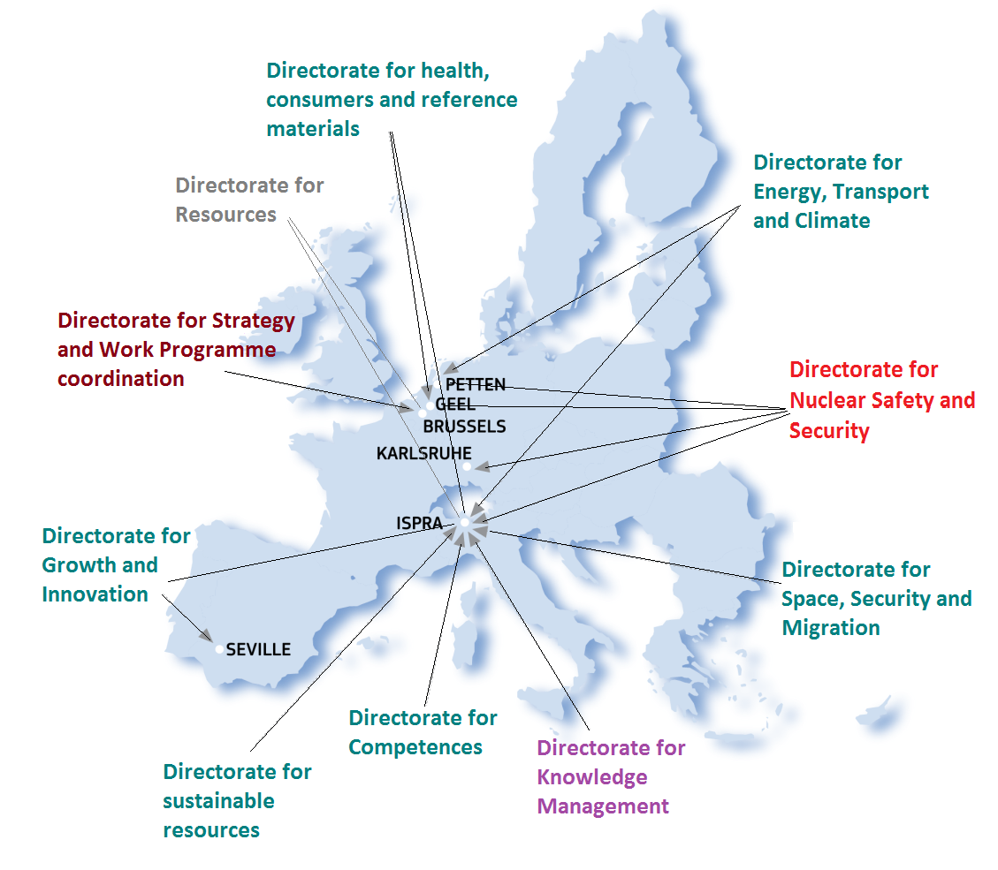
Figure 1. European Commission's Joint Research Centre sites

    - JRC research and training in nuclear safety and security.
The Directorate for Nuclear Safety and Security employs about 460 scientists, technicians and administrative staff in Petten, Karlsruhe, Geel and Ispra.
The JRC work programme for nuclear activities is structured in about 20 projects on nuclear safety, waste management, decommissioning and emergency preparedness, nuclear security, safeguards and non-proliferation, reference standards, nuclear science and non-energy applications; and education, training and knowledge management. To align with and complement the research and training needs of the Member States, JRC is continuously interacting with the main research and scientific institutions in the EU, and actively participating in technological platforms and associations. JRC also participates as member of the consortium in several Indirect Actions; this allows JRC scientists to engage in top level scientific research together with relevant actors from the Member States, maintaining and further developing scientific excellence. At the same time, the members of the consortia can have access to unique research infrastructure.
JRC's most relevant activities in the nuclear reactor safety research domain encompass, without being exhaustive: advanced mechanical testing methods to address creep fatigue or stress corrosion cracking at high temperatures in corrosive environments (e.g. supercritical water and liquid metals); severe accident modelling and analysis using computer codes (e.g. the European software system ASTEC). The JRC operates the EU Clearinghouse on Operating Experience Feedback, a regional network constituted by nuclear safety regulatory authorities and their technical support organisations that aims at enhancing nuclear safety through further use of lessons learned from Operating Experience. Another key activity is the development, operation and maintenance of EURDEP, EU systems for almost real-time monitoring of radioactivity in the environment, and support to ECURIE, the EU early notification and information exchange system for radiological emergencies.
JRC also carries out research on safety of the nuclear fuel cycle: the scope of these research activities encompasses in-core irradiation behaviour, spent fuel handling, transportation, storage and disposal, and covers normal, off-normal and (severe) accident conditions. JRC developed and further improves and maintains the TRANSURANUS computer code, which is an independent computer code for fuel performance analysis employed by an extensive network of users in the EU and in third countries. JRC research is not limited to current light water reactor (LWR) nuclear fuels, but includes also advanced and innovative designs for evolutionary or next generation systems. In particular, JRC investigates safety and safeguards aspects of Generation IV reactors and fuels, and is the Euratom implementing agent of the Generation IV International Forum.
In the area of radioactive waste management, JRC R&D activities cover spent fuel and high level waste safety aspects (see chapter 4), and also management of waste from decommissioning and site remediation applications. The projects covering the latter focus on: non-destructive analysis for the characterisation of waste packages; standardisation of free release measurements; development of novel techniques for detection and mapping of contamination; damaged fuel and debris characterization and removal from high activity environments; remediation applications, e.g. tools to analyse in-situ "hard to measure" nuclides, etc.
JRC activities in the field of nuclear security and safeguards focus on four main areas: effective and efficient safeguards (through research on nuclear material detection, characterization, containment and surveillance, and through process monitoring including on-site laboratories); verification of absence of undeclared activities (e.g. through trace and particle analysis, and development of in-field deployable tools); nuclear non-proliferation (e.g. through export control and trade analysis studies); combating illicit trafficking (e.g. through nuclear forensics, equipment development, testing and validation, preparedness plans).
In the standardisation domain, the JRC is a reference entity for reference measurements and data, basic and pre-normative research, and inter-laboratory comparisons. The JRC develops and manufactures standards and reference materials. It is a major European provider of nuclear data and standards for nuclear energy applications, due also to its unique scientific infrastructure. The main repositories for these data are the databases of Nuclear Data bank of the NEA-OECD and the IAEA, which provide open access to the data.
JRC has relevant research activities in the field of nuclear science applications, such as accelerator-based nuclear measurements, basic properties of actinides, and radionuclides for special applications, including nuclear medicine and space applications.
JRC activities in knowledge management, education and training include organisation and active participation in expert and scientific conferences, and the organization and implementation of education and training initiatives such as the European Nuclear Security Training Centre (EUSECTRA), European Safeguards Research and Development Association (ESARDA), education and training of Euratom and IAEA nuclear inspectors, European Learning Initiatives in Nuclear Decommissioning and Environmental Remediation (ELINDER), international schools and courses on radioactive waste management and decommissioning, nuclear safety, security, nuclear data, etc. Students and young researchers can access JRC nuclear research facilities through several programmes enabling them to perform research projects as part of their academic or post-academic curricula. Access to JRC nuclear research infrastructure is an area that will be further expanded and enriched during the next Framework Programme.
    - JRC nuclear research infrastructure.
The nuclear research experimental facilities of the JRC are distributed among the sites of Geel (Belgium), Petten (the Netherlands), Karlsruhe (Germany) and Ispra (Italy).
JRC-Geel research infrastructure mainly focuses on nuclear data, radioactivity metrology, and nuclear reference materials:
- The neutron time-of-flight linear accelerator (GELINA) is a pulse white spectrum neutron source with the best time resolution in the world. GELINA combines four specially designed and distinct units: a high-power pulsed linear electron accelerator, a post-accelerating beam compression magnet system, a mercury-cooled uranium target, and very long (up to 400 m) flight paths.
- The Tandem accelerator based monoenergetic fast neutron source (MONNET) is a vertical 3.5 MV Van de Graaff accelerator that produces continuous or pulsed ion beams, providing a stable neutron field for more than a week. The combination of both facilities GELINA and MONNET makes JRC-Geel one of the few laboratories in the world capable of producing the required accuracy for neutron data needed for the safety assessments of present-day and innovative nuclear energy systems.
- The radionuclide metrology laboratories consist of a cluster of instruments for high precision radioactivity measurements (RADMET laboratories) and the high activity disposal experimental site (HADES): a laboratory for ultra-sensitive radioactivity measurements 225 m deep underground.
- Nuclear reference materials laboratories for the preparation and provision of certified nuclear reference materials and reference measurements (METRO), and well-defined and well-characterised samples for nuclear data measurements (TARGET). These laboratories encompass equipment for mass spectrometry, chemical sample preparation in glove boxes, substitution weighing in glove boxes, robot systems, and production of reference particles and UF6 reference measurements.

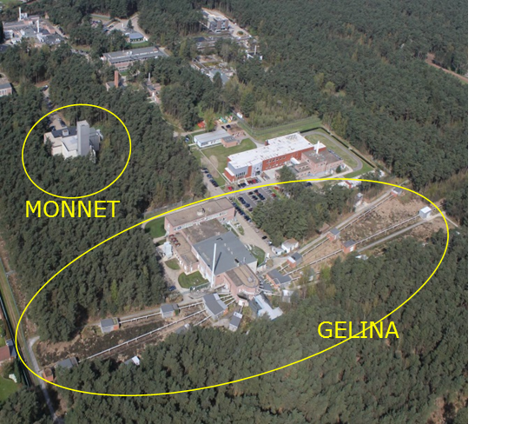
Figure 2. Accelerators for nuclear data measurements in JRC-Geel.

JRC-Petten hosts and operates laboratories for the assessment of materials and components performance under thermo-mechanical loading, corrosion, and neutron irradiation:
- The high flux reactor (HFR, owned by the EC-JRC but operated by the Dutch NRG) is one of the most powerful (45 MW) multi-purpose materials testing research reactors in the world. The tank in pool type light water-cooled and moderated reactor provides irradiation facilities and possibilities in the reactor core, reflector region and in the poolside facility, as well as neutron beams.
- The laboratory for the ageing of materials in LWR environments (AMALIA) is a laboratory for aqueous corrosion and stress corrosion cracking investigations, a unique facility encompassing four recirculating water loops with 6 autoclave systems, all featuring full water chemistry control. The autoclaves (Tmax = 650°C, Pmax = 360 bar) are equipped with environmental mechanical testing facilities (slow strain-rate tensile tests, crack initiation and crack growth rate tests, fracture mechanics, cone-mandrel tests, small-punch tests), electrochemistry, electric impedance, DC potential drop, and acoustic emission monitoring, to assess coolant compatibility and materials degradation issues in light water reactor environments.
- The Structural Materials Performance Assessment laboratories (SMPA) are used for the mechanical performance characterisation, life assessment and qualification of structural materials for present and next generation nuclear systems. The test installations include 3 servo-hydraulic and 3 electro-mechanical universal test machines for (thermo-)mechanical tests, low-cycle fatigue, and fracture mechanics tests, 11 uniaxial creep rigs, 5 small-punch creep rigs, 2 Charpy test rigs, a dedicated test rig for thermal fatigue tests of tubular components, and a nano-indentation hardness tester (–150°C to + 700°C). Depending on the application, temperature control ranges from cryogenic (liquid nitrogen) to high temperatures (induction heaters, radiation heaters and resistance furnaces).
- The Microstructural Analysis Infrastructure Sharing laboratory (MAIS) is a user lab for microstructural characterisation and materials degradation studies. The facilities include scanning electron microscopy, transmission electron microscopy and atomic force microscopy (AFM), optical microscopy, metallography, 3D X-ray computed tomography with comprehensive image analysis and defect visualization capabilities for cracks, creep damage, grain boundary decohesion, dimensional analysis etc., X-ray diffraction, 3D profilometer, thermo-electric power and Barkhausen noise measurements.

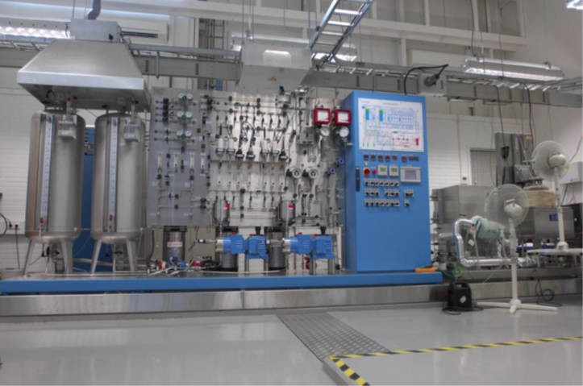
Figure 3. AMALIA laboratory.

JRC-Karlsruhe mainly focuses on properties of irradiated and non-irradiated nuclear fuel and materials, performing research on fuel, fuel cycle, radioactive waste, security and safeguards. A new laboratory building, known as wing M, is currently being constructed on site. Activities currently distributed among several hot laboratories of JRC Karlsruhe will be transferred into the new state of the art facility, which will contain laboratories involving the handling of highly radioactive samples of fuels and materials.

- Fuels and materials synthesis and characterisation facility (FMSC): The facility comprises 3 shielded glovebox chains for U/Th-, Pu- and Am- bearing samples, respectively. Conventional and advanced methods are available for the synthesis and characterisation of actinide compounds, including nuclear fuel samples.
- Hot cells (HC): 24 hot cells with different capabilities for the investigation of irradiated fuels, cladding and nuclear materials. The scientific studies cover safety-relevant properties and behaviour of nuclear fuels during irradiation and of spent fuel under normal and accident conditions. The available methods encompass non-destructive and destructive physical and chemical analyses. For the characterization of: structure and microstructure, morphology, fission products and phase distribution and properties; high temperature behaviour during severe accidents; mechanical characterization; dissolution; inventory/burnup determination; applications for closed cycle studies; leaching and corrosion behaviour for waste management/disposal studies.
- Materials research laboratories (MRL): series of unique, mostly home-built experimental installations dedicated to the study of thermodynamic and thermo-physical properties of actinide compounds and nuclear materials.
- Nuclear trace and analyses facility (NTA): set of installations for the chemical, physical and spectroscopic analysis of actinide and nuclear materials. It encompasses glove boxes equipped with mass spectrometers, titration chain, elemental analysis, chemical separations, gamma spectrometers, alpha spectrometers, calorimeter, neutron counters and Hybrid K-edge detectors.
- Fundamental properties of actinide materials under extreme conditions (PAMEC): state-of-the-art installations designed for basic research on behaviour and properties of actinide materials. Modular surface science laboratory with a spectroscopy station allowing photoemission, atomic force microscopy, and electron scattering measurements for the characterisation of model nuclear materials. Devices for measurements of crystallographic, magnetic, electrical transport, and thermodynamic properties as well as facilities for Np-237 Mössbauer spectroscopy, and a Nuclear Magnetic Resonance configured for studies on solid radioactive compounds.
- EUSECTRA offers a unique combination of scientific expertise, specific technical infrastructure and availability of a wide range of nuclear materials, to enable training opportunities in the field of nuclear security and safeguards. Training areas for EUSECTRA include border detection, train-the-trainers, mobile emergency response, reach-back, creation of national response plans, nuclear forensics, radiological crime scene management, nuclear security awareness and sustainability of a national nuclear security posture. It is based on the JRC facilities at the Ipsra and Karlsruhe sites.
- The large geometry secondary ion mass spectrometry laboratory (LG-SIMS) laboratory is equipped with a highly sensitive mass spectrometer to detect trace quantities of uranium/plutonium in micron-sized particles collected for safeguards purposes.

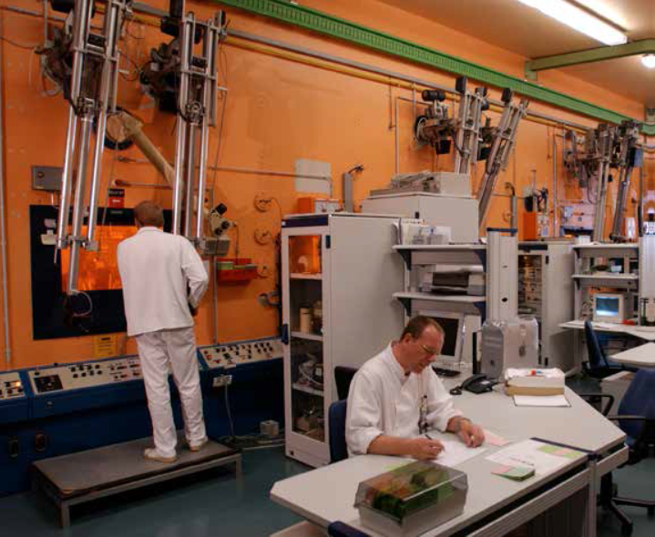
Figure 4. JRC hot-cells.

JRC-Ispra carries out research in safeguards, security and decommissioning:
- Laser laboratory for nuclear safeguards and security: Laser based systems to carry out containment and surveillance techniques for nuclear safeguards, including fingerprinting of nuclear containers, change detection, design information verification systems and outdoor verification systems.
- Advanced safeguards, measurement, monitoring and modelling laboratory: Laboratory to measure nuclear material, to monitor the operation of facilities through an extensive collection of data from multiple types of sensors, and to model the plant operations in order to be able to analyse the data collected by the monitoring system. This laboratory is thus used for testing and developing innovative integrated solutions for the implementation of safeguards in nuclear installations.
- Performance laboratory / Pulse neutron interrogation test assembly (PERLA / PUNITA): Laboratory for the assessment and evaluation of performances for all non-destructive assay (NDA) techniques applied in the safeguards of nuclear materials. PUNITA incorporates a pulsed (D-T) neutron generator.
- Tank measurement laboratory / Solution monitoring laboratory (TAME / SML): Bulk handling facilities, which proposes challenges to the performances of inventory quantification and density characterisation.
- Sealing and identification laboratory (SILab): Laboratory for the development, testing and commissioning of security systems used for nuclear and commercial applications.
- Illicit Trafficking Radiation Assessment Programme (ITRAP). The facility is dedicated to perform tests on radiological performances of radiation detection equipment used in nuclear security. It is composed by two laboratories: the static test lab for handheld equipment and the dynamic test lab for portals.
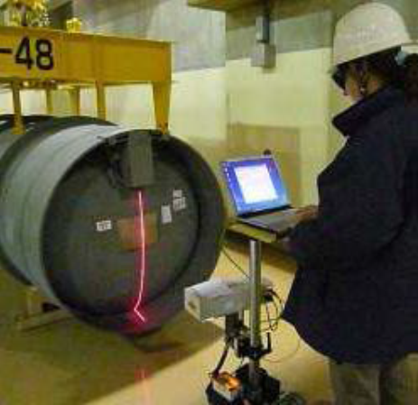

Figure 5. Nuclear facilities verification laboratory

jrc research activities in spent fuel and high level radioactive waste management. achievements and challenges.
The long timeframes until disposal of spent fuel and high level waste in deep geological formations is implemented require that countries with spent fuel enable extended interim storage installations that comply with the highest levels of safety. These interim facilities, based on wet or dry storage will be needed during periods of time significantly longer than originally expected. This requires that adequate research efforts are implemented to better understand the behaviour of spent fuel and high level radioactive waste forms, both under the conditions of extended storage, and during disposal, with the ultimate goal of providing scientific and technical evidence in support of the best suited options in terms of safety and efficiency of future spent fuel management procedures. The JRC has more than 20 years of experience in research aspects of spent fuel and high level radioactive waste management.
Understanding the impact of long term storage on properties and behaviour of spent fuel and high level radioactive waste forms to be expected during the later stages of management prior to disposal, such as for example handling, recondition (repackaging), and transport is key in terms of safety. Understanding its behaviour after disposal will also help reducing uncertainties in the assessment of the deep disposal facilities.
The safety assessment of extended storage requires defining/extrapolating the behaviour of the fuel assemblies and the package systems over a correspondingly long timescale, to ensure that the mechanical integrity and the required level of functionality of all components of the containment system are retained. Investigations on packages stored for relatively short term revealed no alterations negatively affecting the integrity of the dry storage system including spent fuel and containers [5, 6]. Since no direct measurement of "old" fuel and/or packages can cover the ageing time of interest, such measurements must be complemented by studies aimed at targeting specific aspects and processes expected to affect properties and behaviour of spent fuel during extended dry storage. For instance, tests conducted under accelerated conditions or other relevant simulations can be useful to define the boundary conditions for the safe implementation of extended storage concepts.
During storage, radioactive decay events determine the overall conditions of the fuel and generate heat that must be dissipated. Alpha-decay damage and He accumulation are the key process affecting the evolution of properties and behaviour of spent fuel. The dose rates and the temperatures experienced during storage are lower than during in-pile operation: however, the duration of the storage is much longer (if spent fuel disposal in the repository is considered, the time interval in which radiation damage accumulates ultimately is open-ended).
The effects of alpha-decay damage and helium build-up during spent nuclear fuel storage are the object of a multi-year programme of studies carried out at JRC-Karlsruhe, which covers in particular the evolution of physical-chemical and mechanical properties [7-9] as a function of accumulated radiation/decay damage and He. The experimental characterization covers microstructure alterations, lattice swelling, thermal diffusivity, calorimetry, hardness and mechanical fracture behaviour. Irradiated LWR fuels (UO₂ and MOX) and tailor-made materials are studied. The superimposition of alpha-decay effects occurring during storage at relatively low temperature on the fuel configuration as determined by in-pile irradiation is evaluated. The investigations address processes and mechanisms from the microstructural level (lattice defects, He bubbles) up to the macroscopic properties (swelling, impact load resistance), which determine the safety performance of the spent fuel rod during long-term storage. The final goal of these studies is to contribute to assessing the mechanical integrity of spent nuclear fuel rods during and after extended dry storage.
The approach combines different experimental techniques, encompassing a multiscale range from the microstructure up to the macroscopic property level. The studies are performed using irradiated fuel and tailor made materials which allow studying alpha-decay and helium accumulation effects under accelerated ageing conditions. The trends over time/cumulative decay damage of several properties could be validated by comparing spent fuel and accelerated ageing analogues. For instance, comparative studies between spent fuel and analogues show an almost complete similarity of the basic recovery mechanisms associated with thermal annealing of alpha-decay induced defects and with He release from the fuel. Similar validation of the accelerated ageing approach could be obtained for thermal conductivity and hardening, which show satisfactory similarity between accelerated ageing analogue and spent fuel. These results indicate that these properties should not be cause for concern in case of extended spent fuel storage. The validation of the swelling trend is still under study. The radiation damage and helium generation range relevant for UO₂ up to medium-high burnup stored for 100 years may induce a lattice swelling within tolerable levels. However, analogue samples results indicate that saturation may occur at higher swelling level (up to ~0.4% for accumulated damage levels > 1 dpa). If verified in spent fuel, such swelling levels may be relevant for very high burnup UO₂ or for MOX fuel during extended storage of the order of a century. The application of these findings to spent fuel requires factoring in specific characteristics of irradiated fuel, namely its heterogeneity, which may play an overall benign role in maintaining a satisfactory degree of mechanical integrity for spent fuel.
The basic property studies are complemented by integral macroscopic spent fuel rod characterization aimed at determining safety relevant aspect which would affect the behaviour during accident conditions. Both fuel and cladding are subject of these investigations.
The fracture and fuel dispersion of LWR spent fuel rod segments subjected to simulated impact loading has been characterized experimentally at JRC-Karlsruhe in the frame of a collaboration with GNS (Germany) and AREVA (now Framatome) [10, 11] and in subsequent campaigns [12]. In this first set of tests a falling hammer device was used to test UO₂ fuel rodlets with a burnup ranging between 19 and ~74 GWd/tHM. Figure 7 shows photogram from the test performed on the ~67 GWd/tHM PWR rodlet recorded by a high speed camera placed outside the hot cell [12].
Remarkable similarities were observed among all rodlets tested, in spite of the burnup range affecting the samples tested; in particular, the amount of fuel released per fracture is similar among the samples. In all the tests the released fuel collected at the bottom of the device corresponded to ≤ 2g per fracture. Neither extensive fuel release nor special fuel release effects associated with the presence of the high burnup structure [13] were observed for the high burnup samples.

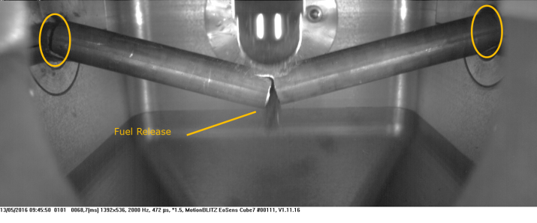
Figure 7. High speed camera photogram illustrating the impact fracture of a ~67 GWD/tHM PWR fuel rodlet [12].

The testing campaigns are continuing, and include also bending tests and other methods to determine the resistance of aged spent fuel rods against mechanical loads and the overall mechanical integrity of the spent fuel during and after extended storage. Key factors that may influence the mechanical stability, and which are specifically investigated include (high) burnup, irradiation and post-irradiation history, type of fuel (e.g. MOX), and hydride distribution/orientation in the zircaloy cladding.
The long term corrosion behaviour of spent fuel exposed to groundwater in a geologic repository is also object of multi-year study campaigns in JRC Karlsruhe hot cells. Although the combination of natural and engineered barriers will provide full sequestration of the spent fuel/high level waste from groundwater and other environmental agents, it is expected that in the remote future there will be contact between spent fuel and groundwater. Specific research topics include research and assessment of spent fuel stability and radionuclides mobilization when in contact with aqueous media. In particular, the aim of the current research projects is to investigate specific aspects of the so-called Instant Release Fraction (the fraction of radionuclides inventory available for relatively fast release upon "first contact" between spent fuel and groundwater) for different compositions of spent fuel such as UO₂, MOX, and fuel with additives, as well as for different irradiation histories (different burnups). JRC research also cover basic processes and mechanisms, such as the factors and mechanisms determining the corrosion of the UO₂ matrix in groundwater, e.g. effects associated with expected fuel properties at the time of groundwater interaction, and effects associated with the local environment, e.g. the presence of hydrogen overpressure. The very long term fuel structure stability as a function of self-irradiation damage, in dry and wet conditions and the investigation of individual processes (e.g. affecting dissolution and re-precipitation) at the surface of the spent fuel or high level waste form are also investigated [14].

conclusions and way forward
A few Member States in the European Union consider the spent fuel as a valuable resource and opt for a management policy of reprocessing and reusing the fissile and fertile material recovered, and disposing of the high level radioactive waste resulting from the process. The spent fuel management policy of the majority of the Member States is direct disposal, although a few of these keep the option of reprocessing open and plan to take the final decision in the future.
One of the important topics of the Euratom Research and Training Programmes continues to be spent fuel management. Complementary to the research in this topic carried out by EU Member States the JRC follows and adapts to the evolution of the scenario: hence, it focuses its research on extended storage, and on reducing uncertainties of the behaviour of spent fuel under disposal conditions. To this end, JRC makes use of its research infrastructure (which can be accessed by students and researchers through several programmes to be further expanded), know-how and competences.
Regarding storage, the results so far indicate that the main mechanism that may affect properties of spent fuel is alpha-decay and He accumulation. The ongoing research on the expected evolution of some of these properties, as well as the influence of the heterogeneities of the fuel will further address processes and mechanisms from the microstructural level up to the macroscopic properties, which determine the safety performance of the spent fuel rod during long-term storage. Accident condition testing (impact, bending tests) so far indicate that there is no extensive fuel release in case of spent fuel rod failure, being rather independent of the burnup. More tests will extend the database and will combine conditioning to try and reproduce properties after extended storage.
On disposal, the results so far contribute to the determination of the "instant release fraction" for different types of fuel, different burnup, and different irradiation history; additionally, different fuel regions have been and are tested to take account of the different conditions.
JRC research work will continue in partnership with our EU and international partners with the aim of completing the work of finding the evolution in the long-term of the properties of the spent fuel important for safety. It will follow, and try to anticipate the evolution of the scenarios and the priorities, and will further exploit the synergies among its different nuclear research lines, specifically (but not exclusively), with the ones on the fuel cycle, radioactive waste, nuclear data, and partitioning and transmutation.

References
- Council Directive 2011/70/Euratom of 19 July 2011 establishing a Community framework for the responsible and safe management of spent fuel and radioactive waste. OJL 199, 2.8.2011, p. 48–56
http://data.europa.eu/eli/dir/2011/70/oj
- Council Regulation (Euratom) No 1314/2013 of 16 December 2013 on the Research and Training Programme of the European Atomic Energy Community (2014-2018) complementing the Horizon 2020 Framework Programme for Research and Innovation. OJ L 347, 20.12.2013, p. 948–964
http://data.europa.eu/eli/reg/2013/1314/oj
- Council Regulation (Euratom) 2018/1563 of 15 October 2018 on the Research and Training Programme of the European Atomic Energy Community (2019–2020) complementing the Horizon 2020 Framework Programme for Research and Innovation, and repealing Regulation (Euratom) No 1314/2013. OJ L 262, 19.10.2018, p. 1–19
http://data.europa.eu/eli/reg/2018/1563/oj
- Proposal for a COUNCIL REGULATION establishing the Research and Training Programme of the European Atomic Energy Community for the period 2021-2025 complementing Horizon Europe – the Framework Programme for Research and Innovation. COM/2018/437 final - 2018/0226
https://eur-lex.europa.eu/legal-content/EN/ALL/?uri=COM%3A2018%3A0437%3AFIN
- Electric Power Research Institute (EPRI),”Dry Cask Storage Characterization Project,” Technical Report 1002882, 2002.
- A. Sasahara and T. Matsumura, “Post-irradiation Examinations Focused on Fuel Integrity of Spent BWR-MOX and PWR-UO₂ Fuels Stored for 20 Years,” Nuclear Engineering and Design, 238 (2008) pp 1250-1259.
- T. Wiss, J.-P. Hiernaut, D. Roudil, J.-Y. Colle, E. Maugeri, Z. Talip, A. Janssen, V. Rondinella, R.J.M. Konings, Hj. Matzke, W.J. Weber, "Evolution of spent nuclear fuel in dry storage conditions for millennia and beyond", J. Nucl. Mater., 451 (2014) 198-206.
- D. Staicu, T. Wiss, V.V. Rondinella, J.-P. Hiernaut, R.J.M. Konings, C. Ronchi, Impact of auto-irradiation on the thermophysical properties of oxide nuclear reactor fuels, J. Nucl. Mater., 397 (1-3) (2010) 8-18.
- V.V. Rondinella, T. Wiss, D. Papaioannou, R. Nasyrow, "Studies on nuclear fuel evolution during storage and testing of used fuel response to impact loadings", Proc. PSAM11 ESREL 2012, paper 16BS-We2-4, Helsinki June 25-29, 2012. Vol. 1 p. 3171-3179, IAPSAM & ESRA 2012.
- D. Papaioannou, R. Nasyrow and V.V. Rondinella, W. Goll, H.-P. Winkler, R. Liedtke, D. Hoffmann, "Fuel release experiments on irradiated fuel rodlets under transient impact conditions", Proc. KTG 2009, May 12-14, 2009, Dresden, Germany.
- Final Report CRP SPAR III, IAEA-Tecdoc-1771, IAEA 2015.
- V.V. Rondinella, R. Nasyrow, D. Papaioannou, E. Vlassopoulos, F. Cappia, O. Dieste-Blanco, T.A.G. Wiss, "Mechanical integrity studies on spent nuclear fuel rods", Proc. 16th International High-Level Radioactive Waste Management Conference (IHLRWMC 2017), Charlotte, April 9 – 13, 2017, ANS, Paper 19921 (2017) p. 734-740.
- V.V. Rondinella, T. Wiss, "The high burnup structure in nuclear fuel", Materials Today, 13 (2010) 24-32.
- T. Fanghänel, V.V. Rondinella, J.-P. Glatz, T. Wiss, D.H. Wegen, T. Gouder, P. Carbol, D. Serrano-Purroy, D. Papaioannou, "Reducing uncertainties affecting the assessment of the long-term corrosion behaviour of spent nuclear fuel", Inorg. Chem. 52 (2013) 3491-3509

