**Partitioning of High Level Liquid Waste for value recovery – a step toward advance fuel cycle**

Dr. C. P. Kaushik

Nuclear Recycle Group,

Bhabha Atomic Research Centre

Email: [cpk@barc.gov.in](mailto:cpk@barc.gov.in)

Mr. Kailash Agarwal

Mumbai, INDIA

Email: [kailashagarwal@yahoo.com](mailto:kailashagarwal@yahoo.com)

## ABSTRACT

India has adopted a ‘closed fuel cycle’ considering spent fuel a material of resource. This has enabled not only optimally utilising the scarce resource of Uranium but also helped in efficient management of radioactive-waste and opening the possibilities for tapping the energy of various useful radio-isotopes present in waste for societal benefits which otherwise are not available in nature. Reprocessing of spent fuel enables in recovering of fuel and recycling them to future reactor for utilising as fuel. Such recovery and recycling of fuel material in reactor to generate power not only helps in ensuring the energy security of the country but also helps in reducing the rad-waste volume meant for geological disposal to a great extent. Spent fuel reprocessing results in recovery of more than 95% of material and hence generates a very small amount of high level liquid waste (HLLW) which is significantly lower than the direct disposal of spent fuel in case of ‘open fuel cycle’.The HLLW, characterised by high concentration of radioactivity in combination with presence of long lived minor actinides, poses the challenge for its safe management. The HLLW is vitrified in suitable glass matrix and interim stored for removal of decay heat. The advantage of vitrification of HLLW into vitreous matrix is to immobilise the radioactivity in chemically durable form ascertaining containment and isolation of radioactivity from the human environment for extended period of time.

HLLW contains many valuable radio-nuclides such as Cs-137, Sr-90, Ru-106 etc which have various societal applications in the field of industry and healthcare. India has put a step forward in implementation of advance fuel cycle by recovering the valuable radionuclides from HLW and deploying them for various societal applications. Separation science has played a key role in selective recovery of these radio-nuclides in pure form from HLLW. Recovery of Cs from HLLW using solvent extraction based system enabled use of Cs in non-dispersible glass form for irradiation purpose. Recovery of Sr-90 from HLLW was also demonstrated to milk out the radio-pharmaceutical grade Y-90 for radiopharmaceutical applications. Recently, Ru-106 has been recovered from HLLW to produce Ru plaque for eye cancer treatment.

Reprocessing of spent fuel for recovery of heavy metals followed by extraction of useful radioisotopes reduces the waste volume immensely prior to isolation and their eventual disposal. The paper outline, the practices being adopted in India for management of high level radioactive waste. A brief description covering the important aspects of waste management like the sources of HLW, composition details along with management strategy is given below:

## Introduction

India’s adoption of closed nuclear fuel cycle considering spent fuel as a material of resource enables optimal utilisation of fuel resources for sustainable nuclear power program of country. In view of the importance of fuel reprocessing pertaining to optimal resource utilisation, the challenges associated with management of high level liquid waste are well recognized. Accordingly, R&D activities on management of high level waste are directed to develop and characterise suitable glass matrices for immobilisation of High Level Liquid Waste on the one hand and also develop and deploy vitrification technologies on other hand. The emphasis is to develop and deploy technologies on the concept of waste volume minimisation, concentrate & contain of radioactivity, recycle and reuse with near zero discharge of activity to the environment. The technologies are also being developed for reducing / minimising the long term impact of these wastes on future generations and the human environment. The efficacy and adaptability of nuclear power ultimately has a bearing on efficient management of waste streams due to the inherent challenges associated with them.

## Source of High Level Waste (HLW):

Spent fuel mainly contains the valuable material like Plutonium and un-utilised Uranium, fission products and minor actinides. At reprocessing plant, valuable material like Pu and U are extracted out from spent fuel using solvent 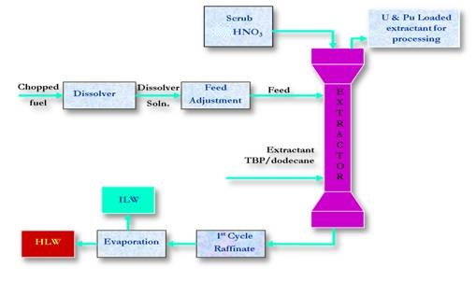extraction based Purex process (Fig. 1). The Pu and U are recycled back for fuel fabrication for Breeder reactor.

After extracting Pu and U, remaining materials including fission products, minor actinides etc. come out as first cycle raffinate of solvent extraction system of Purex process. The first cycle raffinate is concentrated further to reduce the volume and is termed as High Level Waste (HLW). It contains bulk of fission products and minor actinide generated at a nuclear power reactor and contains about 99% of the radioactivity generated in the entire nuclear fuel cycle.

*Fig. 1: Reprocessing of spent fuel by PUREX process*

## Components of HLW:

HLW is characterized by the presence of additives during reprocessing like nitric acid, nitrate salts of Na, Al,corrosion products (Ni, Cr, Fe), dissolved organics and their degradation products. In addition to these, the radioactivity is contributed due to presence of fission products and minor actinides. These actinides are either them-selves long lived or their decay products are long lived. Presence of actinides thus poses a challenge in the management of HLW in respect of long term durability of the product to ascertain the containment of radio-nuclides and their isolation from human environment for extended period of life. The radioactivity content varies depending upon the type of fuel, fuel burn-up and off-reactor cooling. These liquid wastes are stored in under-ground high integrity stainless steel tanks with required cooling , monitoring and control instrumentation.

## Three stEP HLW management strategy:

In line with the international practice, a three-stage programme for the management of high-level has been evolved and practiced in India.

*Step- 1 Immobilisation of HLW in sutiable matrix – Vitrification :*

Conditioning of the highly radioactive liquid wastes wherein radio-nuclides present in the aqueous stream are immobilised in a suitable glass matrices that are inert, highly durable (resistant to chemical/aqueous attack), having good thermal and radiation stability etc. and housed in high integrity storage canisters which are subsequently over packed in suitable and contamination free material. The prime reasons of glass, to be chosen as suitable conditioning matrix for HLW, are chemically inert nature and long term durability of glass matrix. Glass matrix offers very high degree of resistance to leaching of the HLW constituents out of the matrix to environment. Borosilicate glass has been selected for industrial scale immobilisation in India. Vitrified Waste has desired characteristics like high radiation resistance; excellent thermal stability and low leachability. [1,2,3] After successful development and establishment of vitrification technology has been deployed on industrial scale in Waste Immobilisation Plant (WIP) at Trombay using induction heated metallic melter (Fig. 2) [4,5] . The high throughput vitrification facilities, based on Joule Heated Ceramic Melter (JHCM) (Fig. 3), has also been developed and deployed successfully for vitrification of HLW at Tarapur and Kalapakkam.

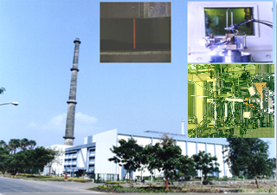

*Fig. 3: Joule Heated Ceramic Melter at*

*Advance Vitrification Plant, Tarapur*

*Fig. 2: Induction Heated Metallic Melter at*

*Waste Immobilisation Plant, Trombay*

*Step- 2 Interim storage of conditioning product:*

Interim storage under surveillance and cooling of over packs containing conditioned wastes for periods ranging up to 30 - 40 years to facilitate the dissipation of heat generated on account of decay of fission products to a level acceptable for geological disposal on the one hand and to ensure integrity of the waste form and its packaging on the other before their final disposal. (Fig. 4)

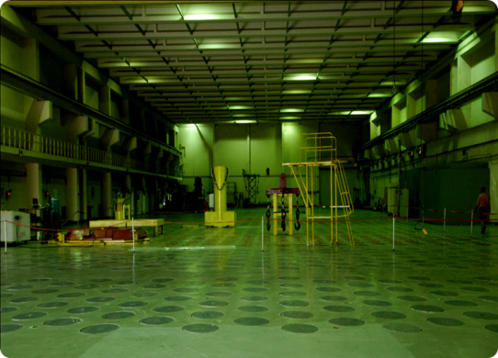*Step- 3 Final Disposal:*

*Fig.4: Solid Storage Surveillance Facility, Tarapur*

Final emplacement for Disposal of vitrified waste canisters would be carried out in a Geological Disposal Facility (GDF) such that at no stage potentially hazardous radioactive materials are recycled back into human environment. As on date waste volume are too small and hence a number of research and development initiatives are in process to understand the site selection as well behaviour of radioactive canisters in the GDF environment.

## Partitioning of Minor Actinides from HLW:

Presence of long lived Minor Actinides (MA) in HLW necessitates the requirement of GDF for safe storage of canisters for extended periods of time. Removal of long lived MA prior to immobilization will considerably reduce the volume of waste product to be disposed in GDF. Hence, it becomes imperative to consider and adopt cross cutting technologies that would not only lead to a substantial reduction in repository capacity both in terms of volumes and thermal loads but also lead to a reduction in radio- toxicity of the waste forms. Partitioning of HLW (Fig. 5) is the first step towards achieving the above objectives. Transmutation or burning of MA in Fast Breeder Reactor/ ADSS will substantially reduce radio-toxicity associated with vitrified waste and obviate the long term concern of HLW under disposal environment.

The Actinide Separation Demonstration Facility (ASDF) (Fig. 6) has been set up at BARC, Tarapur with an objective of testing the partitioning processes with actual HLW on an industrial scale. The facility has been designed based on a structured R&D being pursued on laboratory scale followed by comprehensive testing on bench and engineering scale. This facility involves a three step solvent extraction process i.e. U removal cycle (first cycle), bulk An-Ln separation cycle (second cycle) and cycle for separation of An from Ln (third cycle).

Ac/Ln Group Separation Cycle

Ac-Ln Bulk Separation Cycle

U Removal Cycle

U Lean HLW

D2EHPA

Ac/Ln

Product

MA Lean HLW

HLW

TBP

TEHDGA

*Fig. 6: Actinide Separation Demonstration Facility*

*Fig. 5: Process Schematic for partitioning of Actinides*

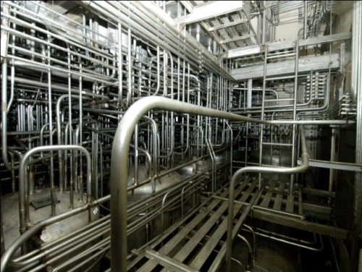

The choice of the contactors had to account for the limited head room available and relatively larger number of stage requirement for the separation process. Suitably designed Air Lift based mixer settler contactor has been therefore deployed in the facility. The three independent cycles have been engineered for simultaneous operation of extractor and stripper with the solvent in recycle mode. The observed separation efficiencies during hot commissioning were found to be quite high with respect to removal of MA.

Ac. Rich product stream

Vitrification

U Product

## Wealth from Waste:

High Level Liquid Waste (HLLW) contains many useful radio isotopes like Cs-137, Sr-90, Ru-106, Am-241 etc. which have many industrial as well as medical applications. Thus radioactive waste is not a waste but a material of resource. Separation and recovery of useful isotopes from radioactive waste and their deployment for societal application makes it as a wealth. Additionally it helps in improving waste loading per canister by multi-fold enabling significant saving of GDF space during their eventual disposal.

## *Cesium as an irradiation source*

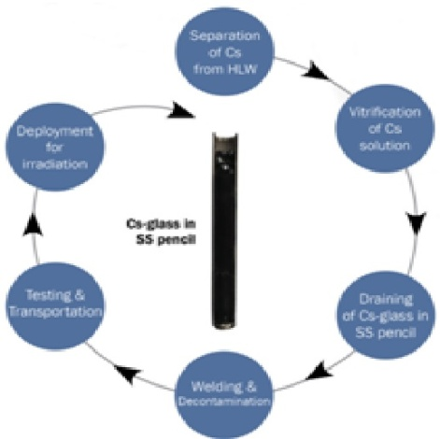Radioisotope of cesium, Cs-137, is one of the beta, gamma emitting radio nuclides which has immense potential for use as a sealed gamma source in radiation technology applications such as irradiation of blood and foodstuffs, sterilization of medical supplies and radiation processing of sewage sludge.

Currently, most of the irradiators are deploying Co-60 and only very few are based on Cs-137. The use of Cs-137 in place of Co-60 is exceptionally advantageous with respect to the source life which thereby minimizes source replacement frequency and reduces the total man rem expenditure. In addition to this, it also requires lesser shielding and is available in large quantity in nuclear waste. In fact, Cs-137 is an ideal isotope for use in gamma chambers (GCs) and blood irradiators (BIs) where source strength requirement is not very high and source replacement will not be required during the useful life of the unit.

Conventionally Cs-137 in the form of CsCl powder encapsulated in stainless steel capsule is used as an irradiation source, but issues related to high corrosion and high solubility of CsCl in water restricted its safe use for irradiation purpose. India has taken a conscious decision of deploying Cesium in vitrified form as an irradiation source (Fig. 7).

*Fig. 7: Cs glass pencil making process*

The preparation of the Cs-137 based radiation sources therefore involves processes like separation of the radioactive element from nuclear waste, immobilization of the recovered Cs in vitreous matrix and encapsulation of the glass in source pencils.A solvent extraction based Plant, for recovery of Cs-137 from legacy (HLLW) has been operated in the hot cells of WIP, Trombay (Fig. 8). Large quantity of Cs has been recovered successfully with an overall decontamination factor of 2000.

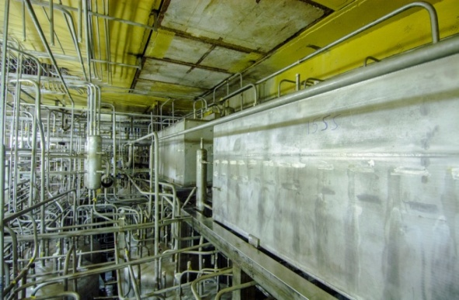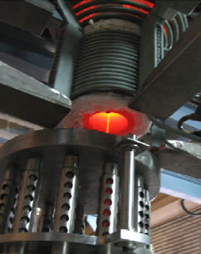Immobilization of radio Cesium (Fig. 9) in the vitreous matrix based on Sodium Borosilicate (NaBS) formulation has been established. Tailor made composition for matrix has been optionally identified for increasing Cs loading in glass and minimising Cs volatility losses during vitrification. Cesium glass is doubly encapsulated in stainless steel pencils of desired dimension for blood irradiators as per qualifying regulatory norms for its usage for societal applications.

## *Recovery of STRONTIUM-90 for societal application:*

*Fig. 9: Pouring of Vitrified Cs Product to form Cs pencil*

*Fig. 8: Solvent extraction plant for Separation of Cs from HLW*

Sr-90 is another prominent fission product present in HLLW. The Yettrium-90 (Y-90), daughter product of Sr-90 is β emitter with shorter half life (T1/2 = 64 hrs) and has potential use for radio-therapatic application. For the radio-therapatic application, carrier free Y-90 should be extracted without contamination of other radio-nuclides. The process to recover pure Sr-90 (free from radio-chemical contaminants) from HLLW using solvent extraction system followed by milking of carrier free Y-90 from Sr-90 solution using Supported Liquid Membrane (SLM Generator) (Fig. 10) system has been developed and demonstrated at Trombay.

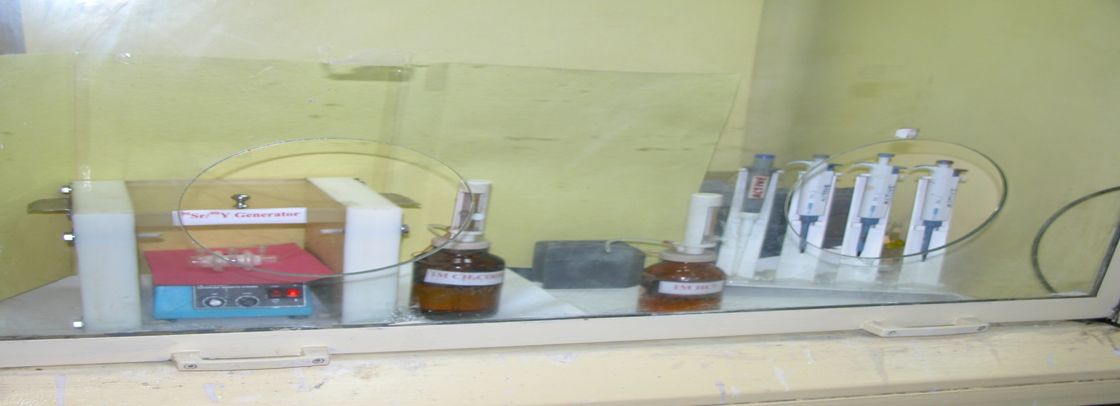

*Fig. 10: SLM Generator*

## *Ruthenium plaque for eye cancer treatment:*

Extension of partitioning process has led to an opportunity to recover Ru-106 from HLW and use it for eye cancer treatment applications. Process developed for the recovery of Ru-106 in radiochemically pure form envisaged separation of trace Cs-137, followed by conversion of Ru to RuO4, extraction of RuO4 following stripping of Ru as Ru(III). The demonstration of process has resulted in recovery of Ru-106 of the required purity and suitable for intended applications. The recovered solution is further processed and subjected to electrodeposition on silver substrate. The electrodeposited substrate is sealed in between the two silver disc to form a plaque of desire size and shape. A file photograph of a Ru plaque is presented in Figure below. The active Ru plaque ( Fig. 11) has qualified all the tests as per regulatory requirements and presently under clinical trials at hospitals.

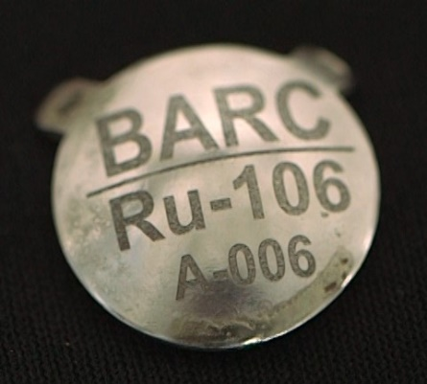

*Fig. 11: File photograph of Ru-106 plaque (Top view)*

## FUTURE ideal nuclear fuel cycle:

The ideal nuclear fuel cycle is conceptualised with objectives of waste volume minimisation and reducing the long term hazard concerns. These objectives are achievable by adopting recycle and reuse of valuable radio-nuclides, partitioning and transmutation of Minor Actinides and conditioning of other radio-nuclides with minimal generation of waste volume. This requires recovery of different radio-nuclides at different stages of fuel cycle and management of each of them with dedicated techniques. The reference diagram for ideal nuclear fuel cycle is given in Fig.12 Our efforts of reprocessing of spent nuclear fuel and further partitioning of High Level Liquid Waste (HLLW) is the first step towards the Advanced nuclear fuel cycle.

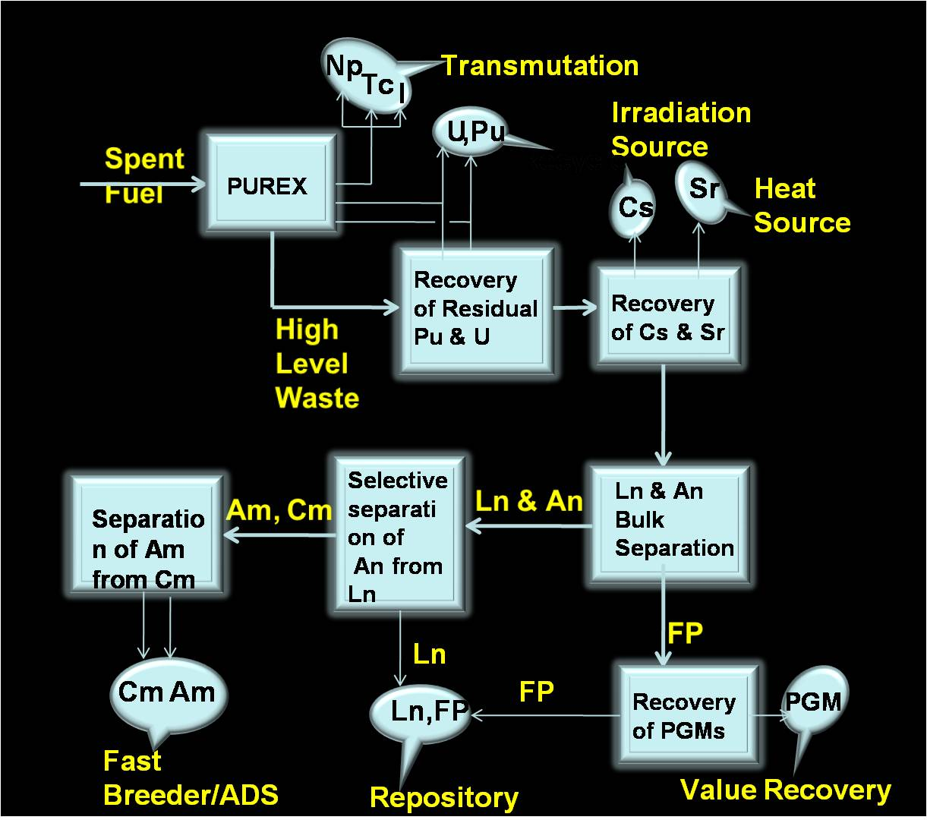

*Fig. 12: Ideal Nuclear Fuel Cycle*

Acknowledgement:

Author acknowledges the operations, research and maintenance staff of HLW management facilities for their untiring and dedicated efforts and contribution for successfully developing, demonstrating and implementing the radioactive waste management techniques and practices.

Reference:

[1] K. Raj, K. K. Prasad, N. K. Bansal, “Radioactive waste management practices in India” Nuclear Engineering and Design 236(2006)914-930

[2] C. P. Kaushik et al., Proc. Of 14th Annual Conference of Indian Nuclear Society (INSAC 2003), IGCAR, Kalpakkam, 2003.

[3] C. P. Kaushik, “Development of glass matrix for vitrification of sulfate bearing High level radioactive liquid waste generated at Trombay”, Indian Nuclear Society News, Vol. 5, No. 4, Oct-Dec2008.

[4] Darshit Mehta, Anand Gangadharan, Tejas Morzaria, Neelima Singh Tomar and B. B. Verma, “Industrial scale vitrification of High level Radioactive liquid Waste – Experience at Waste Immobilisation Plant, Trombay”, Indian Nuclear Society News, Vol.5, No.3, July-Sept.2008.

[5] T. Morzaria, D. Mehta, Anirudhha D., B. B. Verma, P. D. Ozarde and Kanwar Raj, Proc. 14th Annual Conference of Indian Nuclear Society (INSAC2003), IGCAR, Kalpakkam, 2003.