# Lessons learned from Fukushima Daiichi

# Nuclear Accident for spent fuel storage

KAMINISHI SHUJI

Tokyo Electric Power Company Holdings, Inc.

Tokyo, Japan

Email: kaminishi.shuuji@tepco.co.jp

TOKUMORI RITSURO

Tokyo Electric Power Company Holdings, Inc.

Tokyo, Japan

FUTATSUGI TAKATOSHI

Tokyo Electric Power Company Holdings, Inc.

Tokyo, Japan

**Abstract**

On March 11, 2011, a tremendous earthquake of a 9.0 magnitude occurred in Japan. In the Fukushima Daiichi Nuclear Power Station, fuel assemblies were stored for the Units 1 to 6 Spent Fuel Pool, common pool and dry casks. The paper reports the lessons learned from Fukushima Daiichi Nuclear Accident for spent fuel storage.

## INTRODUCTION

At 14:46 on March 11, 2011, a tremendous earthquake of a 9.0 magnitude occurred undersea off the coast of the Sanriku region of Japan, triggering a massive tsunami on an unprecedented scale that hit the north-eastern coast 50 minutes later. The earthquake caused the lose of all off-site power supplies of the Fukushima Daiichi Nuclear Power Station (Fukushima Daiichi NPS), but all Units succeeded in cooling the reactors by using emergency power. Units 1 to 3, which were in operation when the earthquake struck, shut down safely as designed.

However, this emergency power was also lost due to flooding from the tsunami, causing the cooling equipment to become inoperable, thereby resulting in the water in the reactor pressure vessels of Units 1 to 3 evaporating into steam. It is supposed that hydrogen, produced by the chemical reaction between fuel rods sticking out of the water and steam, accumulated in the upper part of the reactor buildings and triggered explosions in Units 1 and 3. For Unit 4, it is supposed that hydrogen that flowed in through the joint part of the exhaust stack accumulated when the air in the primary containment vessel of Unit 3 was vented to the outside, leading to the explosion.

Units 5 and 6 were undergoing outage when the earthquake occurred. Cooling via seawater system pump was flooded by tsunami, making it unusable. However, Unit 6 Emergency Diesel Generator (EDG) which was air-cooled and the electricity station distribution system power cable (tie-lines) between Units 5 and 6 had been ensured, temporary seawater system pump etc. were restored and cooling function was ensured. Cold shutdown was achieved for Units 5 and 6 while event progression was controlled.

At the accident, spent fuel assemblies were stored for the Units 1 to 6 Spent Fuel Pool (SFP), common pool and dry casks (see Table 1 and Fig. 1). The paper shows the impacts of the accident and progress status after the accident for spent fuel storage on the Fukushima Daiichi NPS [1].

TABLE 1. NUMBER OF STORED FUEL ASSEMBLIES (copyright: TEPCO, [2])

|  |  |  |  |  |
| --- | --- | --- | --- | --- |
| Storage location | As of March 11, 2011 | | As of January 31, 2019 | |
| Spent fuel | Fresh fuel | Spent fuel | Fresh fuel |
| Unit 1 | 292 | 100 | 292 | 100 |
| Unit 2 | 587 | 28 | 587 | 28 |
| Unit 3 | 514 | 52 | 514 | 52 |
| Unit 4 | 1,331 | 204 | 0 | 0 |
| Unit 5 | 946 | 48 | 1,374 | 168 |
| Unit 6 | 876 | 64 | 1,456 | 428 |
| Common Pool | 6,375 | 0 | 6,081 | 24 |
| Dry Cask (Dry Storage Cask Building) | 408 | 0 | 0 | 0 |
| Dry Cask (Temporary Cask Custody Area) | - | - | 2,033 | 0 |

Note: The number of Units 1 to 3 exclude core loading fuels. The number of Units 5 and 6 include core loading fuels and Unit 6 include transferred fresh fuels from Unit 4 as of January 31, 2019.

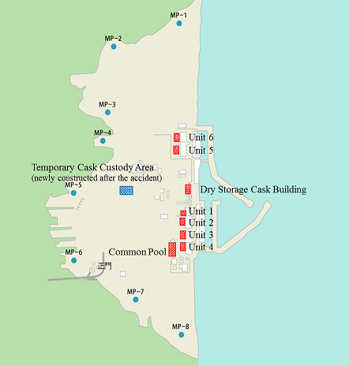

*FIG. 1. Fukushima NPS site layout (copyright: TEPCO, [2])*

## the impacts of the accident

The tsunami resulted in a total loss of AC power to Units 1 to 5 and common pool, which in turn caused the SFP to lose cooling and supplementary feed function. Furthermore, whereas the D/G for Unit 6 maintained function, seawater pump function was lost so SFP cooling function was lost. The Dry Storage Cask Building also experienced Station Black Out, but the dry storage casks are designed to be air cooled through natural convection.

### Spent fuel pools

Restoring cooling water injection and cooling of the SFP for Units 1 to 6 and the common pool was necessary. In particular, the amount of heat being generated by the SFP for Unit 4 in which all fuel was being stored since the Unit had undergone outage was huge. Because of hydrogen explosions occurred in the reactor buildings of Units 1, 3 and 4, therefore, factors such as access and the ensuing environment made it extremely difficult to achieve cooling water injection and cooling of the SFPs.

Cooling water injection of Unit 4 using concrete pump trucks that extending the boom to inject coolant from right next to the reactor building, began on March 22 and similar operations began at Unit 3 (March 27) and Unit 1 (March 31). Furthermore, since the Unit 2 reactor building did not experience an explosion, so an injection measure that consisted of using a fire engine to inject coolant via pipes inside the building was examined and put into implementation on March 20. Radionuclide analysis of the SFP water provided no data that indicates fuel damage.

As explained above, cold shutdown of reactor Unit 5 and Unit 6 was successful, as was pool cooling on March 19.

### Common pool

Several thousand spent fuel assemblies were stored in the common pool for which it was necessary to restore cooling. The amount of heat generated by each individual spent fuel assembly in the common pool is small, but the vast quantity required a large amount of cooling water injection, therefore, restoration of the cooling equipment installed in the common pool building was required. Off-site power was supplied to the site, enabling the restoration of common pool cooling on March 24.

### Dry casks

At the accident, 9 dry casks had been stored in Dry Storage Cask Building (see Fig. 2 and 3). The tsunami flooded the Building with a large amount of sea water, sand, and rubbles, and the louvers and doors were damaged, but the airflow required for natural air cooling was not inhibited, and there were no cooling problems. The outer appearance of the casks showed no signs of abnormalities concerning soundness. There were no abnormality with result of measuring the dose rate and the temperature as well.

All casks were transported to the common pool, inspected and then necessary parts were replaced. Additionally, the cask which is maximum amount of heat generation was opened for inspection and 3 fuel assemblies were unloaded for external appearance observation at common pool.

The cask was inspected the leakage rate of the primary and secondary lids, the pressure between lids, the monitoring Krypton gas, and the observation of flange surface, metal gaskets for primary and secondary lids, and basket. It was confirmed that there was no problem to the sub-criticality function, the containment function and spent fuel integrity (see Fig. 4). Then all 9 casks were stored in the newly constructed Temporary Cask Custody Area.

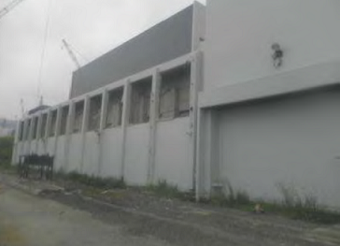

*FIG. 2. Dry Storage Cask Building; photographed August 24, 2011  
(copyright: TEPCO, [3])*

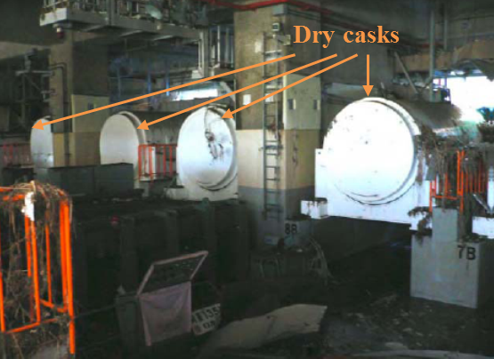

*FIG. 3. Dry Casks; photographed March 17, 2011 (copyright: TEPCO, [3])*

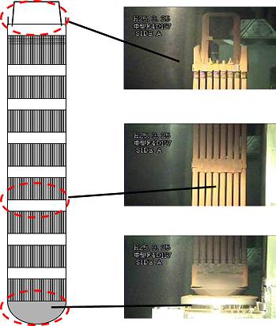

*FIG. 4. Result of external appearance observation of spent fuel assemblies (copyright: TEPCO, [4])*

## PROGRESS STATUS AFTER the accident

About 6,000 fuel assemblies, that are stored in Units 1 to 6, are to be removed to the common pool and stored there. However, over 6,000 fuel assemblies had already been stored in the common pool prior to the accident. Therefore, the Temporary Cask Custody Area was newly built to store fuel assemblies that were in the common pool in order to ensure capacity (see Fig. 5). This facility monitors area radiation, pressure between dry cask lids and temperature of dry cask. Current storable capacity of casks is 50 units and prospective expansion of this capacity is under consideration. The issues of dry cask storage are that it needs to be secured in a area and to be satisfied with the criteria of radiation dose taking effect of the skyshine include stored the contaminated water and the rubbles at site boundary into consideration.

Loading of spent fuel stored in the common pool to dry casks commenced since June, 2013. Unit 4 fuel assemblies were removed to the common pool starting on November 18, 2013 and the removal work was completed on December 22, 2014. Work continues toward fuel removal from Units 1 to 3.

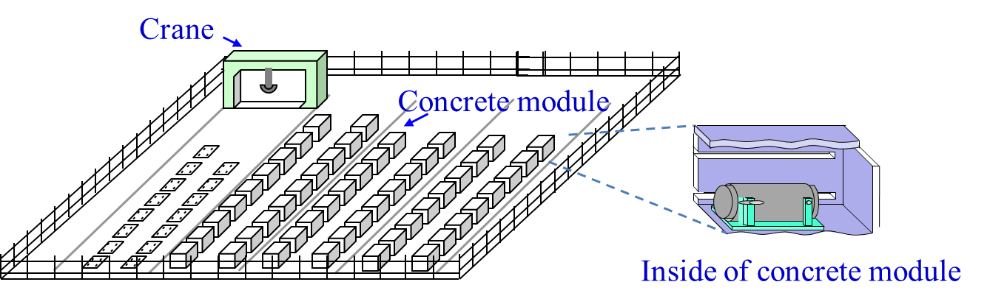

*FIG. 5. Temporary Cask Custody Area (copyright: TEPCO, [4])*

## CONCLUTIONS

Although Units 1 to 3 SFP were affected by tsunami and hydrogen explosion, the stored fuel assemblies were not found with fuel damage. And the dry casks were submerged by tsunami, as the result of inspections, no abnormality was found with safety functions and spent fuel integrity.

Fuel removal from Unit 4 SFP was completed in December 2014. TEPCO will proceed with fuel removal from Units 1 to 3 SFP using common pool and dry casks and with decommissioning work steadily in a stable manner.

References

1. Tokyo Electric Power Company Holdings, Inc., Fukushima Daiichi Decommissioning Project (2019),

<https://www7.tepco.co.jp/responsibility/decommissioning/index-e.html>

1. Tokyo Electric Power Company Holdings, Inc., Storage States of Spent Fuel and Fresh Fuel at Fukushima Daiichi NPS (Written in Japanese) (2019),

<http://www.meti.go.jp/earthquake/nuclear/decommissioning/committee/osensuitaisakuteam/2019/3-2-8.pdf>

1. Tokyo Electric Power Company, Inspection for the Dry Storage Cask at Fukushima Daiichi NPS (Written in Japanese) (2013),

<http://www.tepco.co.jp/nu/fukushima-np/roadmap/images/t130131_01-j.pdf>

1. Tokyo Electric Power Company, Report of Inspection Results of the First Dry Storage Cask at Fukushima Daiichi Nuclear Power Station (2013),

<http://www.tepco.co.jp/en/nu/fukushima-np/handouts/2013/images/handouts_130327_04-e.pdf>