EVOLUTION OF AN EXECUTION STRATEGY ANALYSIS
CAPABILITY AND TOOL FOR THE DISPOSITION OF
SPENT NUCLEAR FUEL AND HIGH LEVEL WASTE

R.H. STOLL
Predicus LLC
Issaquah, WA, USA
Email: rstoll@predicusconsulting.com

N.V. SARAEVA ¹, S.J. MAHERAS ², W.M. NUTT ², A.E. KEIZUR ³
¹Argonne National Laboratory, Washington, DC, USA; ²Pacific Northwest National Laboratory, Richland, WA, USA; ³Golder Associates Inc., Redmond, WA, USA

Abstract

Since 2013 the U.S. Department of Energy’s Office of Nuclear Energy began developing the Execution Strategy Analysis (ESA) tool that is both a subject matter expert elicitation process and a dynamic simulation modelling capability for use in the analysis of alternative implementation strategies and plans associated with an integrated nuclear waste management program. Early ESA models were used to evaluate potential alternatives for deploying consolidated interim storage for commercial Spent Nuclear Fuel (SNF). There have been several iterations of the ESA tool since 2013. In 2017 the ESA model was further enhanced by developing a stand-alone ESA Origin Sites Readiness Model. This model represents all the activities and milestones necessary to establish at-reactor and near-reactor site transportation infrastructure. By complementing the main ESA model and other Integrated Waste Management logistics tools, this new stand-alone model provides a structured, systematic methodology for evaluating potential SNF transportation campaigns associated with comprehensive disposition strategy alternatives.

INTRODUCTION
This is a technical paper that does not take into account the contractual limitations under the Standard Contract for Disposal of Spent Nuclear Fuel and/or High-Level Radioactive Waste (Standard Contract) (10 CFR Part 961). For example, under the provisions of the Standard Contract, DOE does not consider spent nuclear fuel in multi-assembly canisters to be an acceptable waste form, absent a mutually agreed to contract amendment. To the extent discussions or recommendations in this paper conflict with the provisions of the Standard Contract, the Standard Contract provisions prevail.
The Nuclear Waste Policy Act of 1982, as amended (NWPA), established the federal government’s responsibility to accept SNF and high-level radioactive waste (HLW) from waste owners and generators for ultimate disposition. The DOE’s Office of Nuclear Energy (DOE-NE), Integrated Waste Management (IWM) program is applying a variety of system analysis tools for the identification and evaluation of options for the future deployment of a comprehensive nuclear waste management system. Systems analysis and systems engineering principles are being applied to evaluate an integrated approach to transportation, disposal, and interim storage of SNF within the waste management system with an emphasis on providing flexibility to respond to evolving national policy/direction. These analyses support the establishment of functional and operational requirements for the SNF and HLW management system, provide the framework for future planning activities (e.g., transportation hardware procurements), and provide information to inform future decisions regarding the management of SNF and HLW from U.S. shutdown and operating commercial nuclear reactors and DOE facilities.
The system analysis tools include the Used Nuclear Fuel Storage, Transportation, & Disposal Analysis Resource and Data System (UNF-ST&DARDS) designed to perform technical analyses using data on SNF characteristics; the Next Generation System Analysis Model (NGSAM) for evaluation of alternative system configurations and concepts of operations; the Execution Strategy Analysis (ESA) tool for analysis of implementing strategies, and the Stakeholder Tool for Assessing Radioactive Transportation (START).
The IWM ESA tool has been in use since late 2013. It has been applied to provide useful insights into meeting the IWM program’s objectives and to improve understanding of the range of potential future implementation scenarios. The tool provides performance assessment of the evolving project plan/strategy that considers significant assumptions, uncertainties, and risks throughout the project lifecycle. It has evolved through multiple iterations to reflect evolving program needs.
Early versions of the ESA model only broadly reflected the uncertainty associated with commercial origin sites readiness to transport SNF and did not include specific sites or cask types into consideration. In 2017 a stand-alone ESA Origin Sites Readiness Model was developed to represent all of the major activities and milestones necessary to establish on-site and near-site transportation infrastructure at individual commercial reactor sites. The initial model focused on shutdown reactor sites.
The Origin Sites Readiness Model was integrated into the most recent version of the main ESA model in 2018. This paper provides overview of the stand-alone model development and describes some insights gained from the analysis.

ENHANCEMENTS TO THE ESA TOOL SINCE 2015
The ESA model has completed several iterations since the initial development efforts were described in the 2015 paper [1].
The ESA capability provides information regarding how alternative implementation strategies perform in meeting program objectives. The ESA tool helps to answer the types of questions that are typically asked related to the implementation of an integrated waste management system, including:

- What are the implementation approaches to meet the program goals?
- What are the critical path milestones and activities?
- What are the interdependencies across program elements?
- What are the key program risks and potential mitigation strategies?
- What are the impacts of various policies and potential legislation?
- What are the long lead-time activities that must be started now?
- What near-term activities could be started to provide schedule benefits and reduce risks?

The ESA process and tool are being used to:

- Characterize the sequence of activities and milestones that must be accomplished in order to arrive at the intended end states characterized by analyses of infrastructure and logistics requirements;
- Quantify the uncertainty in achieving milestones and thus the uncertainty in achieving system end states;
- Quantify the cost and schedule impacts of these uncertainties;
- Evaluate risks to the successful implementation of plans;
- Identify potential strategies to mitigate identified risks.

There are likely to be multiple possible approaches for meeting the goals of an integrated nuclear waste management system. ESA, in conjunction with other IWM tools (e.g., NGSAM), is being used to evaluate a range of potential future approaches. The scenarios and assumptions described in this report should not be viewed as defining DOE policy or a path-forward for implementation, but rather as potential approaches whose performance attributes are being evaluated to inform future decisions regarding implementation. Results produced by the ESA model for particular scenarios are also assumption-dependent and thus may vary should the set of inputs be altered by another user.
The first version of the model (2014) was a proof of concept that used a limited number of subject matter experts (SMEs) focused on questions related to how a consolidated interim storage facility (CISF) strategy might unfold. In 2015 a larger group of SMEs, including representatives from the nuclear industry, was involved to improve the fidelity of the model’s data inputs and risks. In 2016 the ESA team focused on risk mitigation strategies that could improve overall project performance while also taking into account the potential for constrained funding scenarios.
In 2017, the ESA team worked with transportation SMEs to improve the model’s fidelity and examine alternatives for accelerating the development of the transportation system. This effort demonstrated that it is necessary to better understand what is needed to be done to prepare for transportation of SNF and HLW from commercial origin sites, and to compare different options. This led to the successful development of a stand-alone Origin Sites Readiness Model in 2017. In 2018, the main ESA model was streamlined to include an abstraction of the Origin Sites Readiness Model as well as generic repository options.

DEVELOPMENT OF THE ORIGIN SITES READINESS MODEL
Initial versions of the ESA model supported analysis of strategies for initiating operations at one or more CISFs over multiple expansion phases. These early versions of the model included only high-level activities and risks and specific characteristics of individual origin sites and transportation cask types were not considered. While analyzing possible strategies to accelerate the development of the transportation system and acquiring transportation hardware, it became clear that activities related to origin site readiness for transportation could potentially constitute the critical path.
Because of these limitations, a stand-alone Origin Sites Readiness Model was created to enhance the capabilities of the ESA model. This new model was developed to represent all of the activities and milestones necessary to establish at-reactor and near-reactor transportation infrastructure needed to support the initial shipment of SNF to an IWM facility such as a repository or a CISF. The original model focused on the shutdown sites. The team used information on multiple shutdown reactor sites that was available to the program through the sites visits [2] to review the characteristics of these sites and identified a suite of potential transport methods (modes). It was determined that the model would need to include multiple transportation mode options as well as the potential for changes in transport mode (“transloads”) while the SNF was en route to an IWM facility.
A group of SMEs followed the ESA process [1] in a series of four workshops. Generic success precedence diagrams were created to reflect the logic for the milestones and activities needed to achieve the “success.” In this case, success was defined as readiness to commence transportation from a generic origin site, with all on-site infrastructure and all near-site infrastructure in place and all necessary approvals are received. A certified transportation cask would also need to be fabricated and transported to the site ready to be loaded. A modular approach in the model’s structure was developed to accommodate site-specific inputs. This was done to allow the 2017 version of the model to be expanded to include operating sites, and acknowledge the potential that the first shipment could occur from a currently-operating site.
Spreadsheet templates were developed for data inputs and included separate data sheets for each origin site. There was an additional need to model the use of transportation casks to reflect an assumption that the same cask might be used at multiple sites. Initial modelling efforts focused on developing activity inputs (durations and costs) for two selected shutdown origin sites (Maine Yankee and Trojan). These sites were selected because their detailed information was available in the DOE-developed shutdown sites report [2] and de-inventory reports [3, 4].
Initially the model for a single generic origin site was created and demonstrated for a larger group of SMEs. Ultimately, 14 shutdown origin sites and 9 different transportation cask types were included in the model to allow for analysis of broader sets of scenarios. During initial analysis, several key issues were identified including potential ways to accelerate the procurement of transportation casks, the importance of consultations with States and Tribes, and the need for traceability of costs between ESA models and other IWM tools for extended analysis.

DEVELOPMENT OF THE ORIGIN SITES READINESS MODEL SCENARIOS
The model’s logic was specifically developed to represent activities for on-site and near-site readiness of the origin sites. Potential modes of transportation across the boundary of these sites included:

- Direct rail;
- Barge;
- Heavy-haul truck (HHT).

Two transload options were created for each origin site to accommodate the potential for a change of mode during transportation. The near-origin transload combinations included:

- HHT to rail;
- Barge to rail;
- Barge to HHT;
- HHT to barge.

- Intermediate location transload options (such as a port) included:
- Barge to rail;
- Barge to HHT.

Transportation cask acquisition was simulated for the licensing and fabrication activities associated with the overpacks and associated hardware, and then the casks were matched to the origin sites. For modelling purposes it was assumed that at least one transportation cask of the required type must be manufactured and present on-site before an origin site can be ready to transport.
The user can configure each selected origin site to evaluate a wide variety of start dates, transportation modes, and cask types. Configuration options include:

- Date to begin on-site work;
- Date to begin offsite work;
- Primary transportation model on-site;
- Transload required near the origin site;
- Transload required at an intermediate location;
- Date to begin transportation cask acquisition activities;
- Primary transportation cask for the origin site.

At the conclusion of the ESA process, 45 risks were identified and documented in a risk register; 24 of them were individually quantified and included in the model for their potential to impact program costs and/or schedule and their associated probability of occurring. Ten risks were considered adequately addressed in the base uncertainty ranges or other risks, and the remaining risks were excluded from or outside the scope of this model.

ORIGIN SITES READINESS MODEL SCENARIO ANALYSIS
The ESA tool produces probability distributions of selected performance metrics, which can be used to identify critical uncertainties and risks that could impact key objectives.
Table 1 sums up two primary scenarios that were selected for the analysis [5]. A number of enabling assumptions were made for the purpose of modelling, including the following:

- The start dates for work to begin at origin sites are based upon generic assumptions;
- Work at all origin sites included in the model (14 total) begins simultaneously;
- A CISF is constructed and ready to receive SNF when the first origin site is ready to transport;
- Risks associated with legislative authorization or funding delays are not included;
- Risks associated with transportation operations during movements are not included.

TABLE 1. SUMMARY OF SCENARIOS ANALYZED IN ORIGIN SITES READINESS MODEL

Site | Transport Mode Option
 | Scenario 1 | Scenario 2
Big Rock Point | HHT to Rail | Barge to Rail
Crystal River | Direct Rail | Barge to Rail
Connecticut Yankee | Barge to Rail | HHT to Rail
Fort Calhoun | Direct Rail | Barge to Rail
Humboldt Bay | HHT to Rail | HHT to Barge to Rail
Kewaunee | HHT to Rail | HHT to Barge to Rail
La Crosse | Direct Rail | Barge to Rail
Maine Yankee | Direct Rail | Barge to Rail
Rancho Seco | Direct Rail | Direct Rail
San Onofre | Direct Rail | HHT to Barge to Rail
Trojan | Direct Rail | Barge to Rail
Vermont Yankee | HHT to Rail | HHT to Rail
Yankee Rowe | HHT to Rail | HHT to Rail
Zion | Direct Rail | Barge to Rail

Fig. 1 depicts the probability of completing an initial transportation milestone for a single site for the two transport mode scenarios. As the figure shows, the on-site readiness milestone will be achieved earlier with the assumed transportation mode options in Scenario 1 compared with different transportation mode options in Scenario 2.

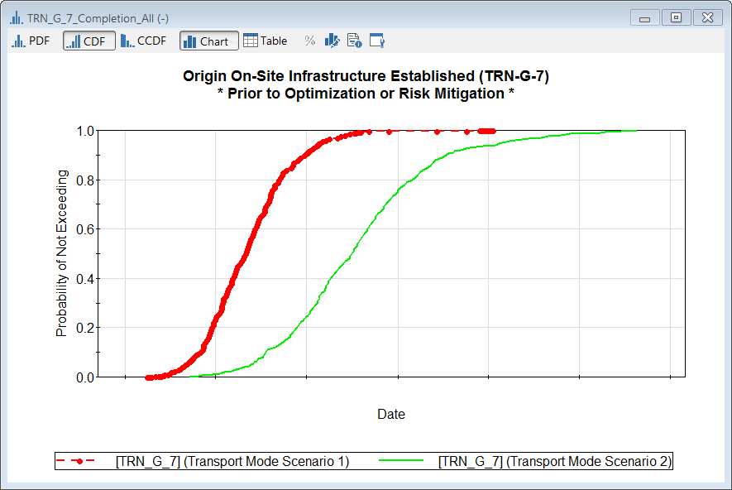Fig. 1. Comparison of Timing for On-Site Infrastructure Readiness Milestone Completion for Scenario 1-2

The model has the capability to compare milestones for a given scenario across origin sites. Fig. 2 is a summary of the milestone when transportation is initiated for each of the 14 shutdown sites in Scenario 1 (assuming preparations begin simultaneously at all sites). There are significant differences among the shutdown sites in regards to when they might be ready for transportation to begin. Factors such as casks manufacturing processes, transportation readiness, and work needed to be done to prepare the sites for transportation contribute to these differences.

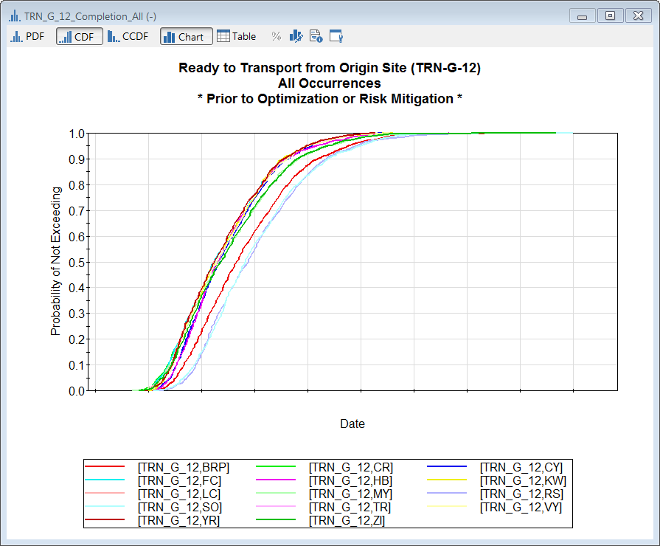 Fig. 2. Comparison of Timing for Initial Transport across Origin Sites, Scenario 1

The Origin Sites Readiness Model was recently used to focus on analysis of on-site and near-site transportation infrastructure costs. The first step in this evaluation involved examining the activities in the model to determine those that contributed to on-site and near-site transportation infrastructure costs. The second step involved evaluating all activities and risks in the model to determine if any updates were necessary to reflect current conditions at the sites. These data consist of activity durations and costs. Some cost data are identified as per unit (e.g., a cost per cask) while others occur on annual basis. To incorporate uncertainty, the most likely value, 10th and 90th percentiles of the activity durations and costs are used as input. Risks are parameterized by developing data on the probability of occurrence of the risk, along with the most likely, 10th and 90th percentile conditional schedule impacts and cost impacts. In the third step in the evaluation, the Origin Sites Readiness Model was run for the 14 shutdown sites. To capture the uncertainty of the output data, key statistics including the 20th, 50th, and 80th percentiles of the cumulative on-site costs, the cumulative near-site transportation infrastructure costs, and the on-site and near-site transportation infrastructure readiness dates were recorded for use in future planning efforts.
Fig. 3 provides a summary of the implementation schedule for a single site. The mode of transport for this site is assumed to be via barge to a transload location, then via rail transport to the destination location. The figure illustrates the most significant site-specific milestones necessary to achieve readiness for transport, along with a depiction of the associated schedule uncertainties. The milestone diamonds represent the 50th percentile dates, while the uncertainty bars depict the 90% confidence range for each milestone (5th to 95th percentiles). The most probable critical path is also highlighted on the diagram.

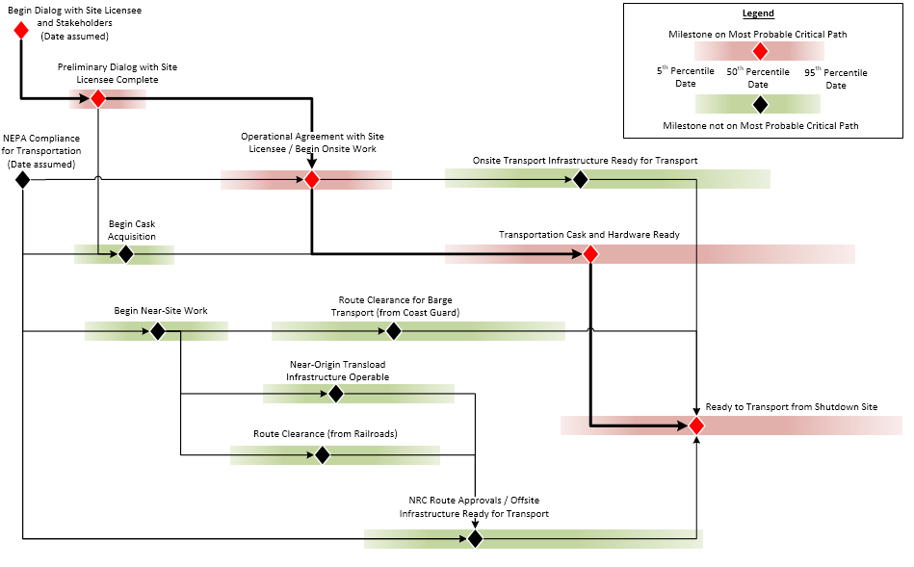
Fig. 3. Summary Schedule for Transportation Readiness at a Single Site
Critical path and sensitivity analyses identified that subsequent to the assumed initial milestones taking place the following activities are most likely to be on the critical path for the both scenarios: preliminary dialogue with site licensee, completing an operational agreement with the licensee, and acquisition of transportation casks. Establishing the infrastructure readiness both on-site and off-site has a low probability (<5-8%) of being on the critical path for the initial shipment from the first site under the assumptions used in this analysis; however, these activities may have a higher likelihood of being critical under different planning assumptions.
Risks were identified which, if the event occurred, could have a significant impact on schedule for the scenarios and included:
- Changes to U.S. Nuclear Regulatory Commission (US NRC) transportation regulations which could affect the transportation cask Certificate of Compliance;
- Unanticipated discovery of radioactive material contamination at an origin site;
- Transportation cask procurement delays;
- Delayed initiation of near-site transportation due to state or local government or other stakeholder intervention;
- Delays associated with channel hydrographic surveys where barge transportation is an option.

In late 2018 the stand-alone Origin Sites Readiness Model was combined with a new streamlined ESA model that had been enhanced by the addition of options for the acquisition of generic disposal capabilities. Monte Carlo simulation results from the Origin Sites Readiness Model scenarios were imported as inputs to the ESA model and incorporated into the analysis of the IWM program. Exported results from the Origin Sites Readiness Model included cumulative costs and durations for on-site and near-site transportation readiness activities at each site for the two primary mode scenarios, along with associated correlations. The integrated analysis in the ESA model accounts for uncertainties associated with predecessor activities, such as National Environmental Policy Act (NEPA) compliance, along with elements of the national transportation program such as determination of hardware asset requirements, Atlas Railcar development and emergency responder training along affected routes. The integrated ESA analysis also accounts for readiness to receive shipments at the destination facility, either a repository or consolidated interim storage facility.

CONCLUSION
The DOE-NE IWM program is developing and applying a variety of systems analysis tools to evaluate various architectures and approaches that could inform future decisions. As a part of the IWM effort, a stand-alone ESA Origin Sites Readiness Model was developed to analyze what actions will be required to achieve readiness of on-site and near-site infrastructure at commercial reactor sites to support SNF campaign alternatives. It was subsequently added into the main ESA model to support other analyses.
While the initial focus in the development of the stand-alone Origin Sites Readiness Model was on the 14 shutdown reactor sites and 9 transportation cask types used in the United States, it was important to recognize that when an actual campaign to move SNF and HLW is initiated the possibility exists that the first SNF shipment could be from a currently-operating reactor site. The next planned enhancement for the model will include the logic, activities, and risks for a generic operating site where the on-site transportation infrastructure would more likely be in a higher state of readiness than at a site that had been shut down for an extended period of time.
On-going collection of site-specific data continues to be necessary to be able to understand the current conditions at the sites. The SNF and HLW inventory of materials must be characterized as well as a clear description of the on-site infrastructure at all shutdown sites. Off-site transportation infrastructure status should be kept updated and allowance made for the loss of experience at the shutdown sites as time advances. As more sites shut down, the importance of integrating on-site and near-site infrastructure activities increases. It is especially important not to preclude transportation options at the data collection stage to be able to properly assess the activities, uncertainties, and risks for all options. Additionally, unique risks are associated with each mode option and an understanding of those risks may help to inform future mode selection decisions.
It is planned to update the Origin Sites Readiness Model as new reactor sites are shut down in order to be able to conduct analysis of SNF transportation campaign options in an integrated waste management system.
ACKNOWLEDGEMENTS
This work is supported by the U.S. Department of Energy, Office of Nuclear Energy, Office of Spent Fuel and Waste Disposition under contract #DE-AC02-06CH11357.
This manuscript has been created by UChicago Argonne, LLC, Operator of Argonne National Laboratory (“Argonne”). Argonne, a U.S. Department of Energy Office of Science laboratory, is operated under Contract No. #DE-AC02-06CH11357. The U.S. Government retains for itself, and others acting on its behalf, a paid-up nonexclusive, irrevocable worldwide license in said article to reproduce, prepare derivative works, distribute copies to the public, and perform publicly and display publicly, by or on behalf of the Government.
REFERENCES
- STOLL, R., GREEVES, J., VOSS, J., KEIZUR, A., NEIR, A., SARAEVA, N., and NUTT, W., “Development of an Execution Strategy Analysis (ESA) Capability and Tool for the Storage of Used Nuclear Fuel”, International Conference on Management of Spent Fuel from Nuclear Power Reactors – An Integrated Approach to the Back-End of the Fuel Cycle (2015).
- MAHERAS, S., BEST, R., ROSS, S., BUXTON, K., ENGLAND, J., MCCONNELL, P., MASSARO, L., JENSEN, P., “Preliminary Evaluation of Removing Used Nuclear Fuel from Shutdown Sites Report, Report”, Report No. SFWD-IWM-2017-000024, U.S. Department of Energy, Washington, DC (2017)
- Areva Federal Services LLC, “Initial Site-Specific De-Inventory Report for Maine Yankee”, Report No. RPT-3016127-002 (2017)
- Areva Federal Services LLC, “Initial Site-Specific De-Inventory Report for Trojan”, Report No. RPT-3016128 (2017)
- SARAEVA, N., STOLL, R., GREEVES, J., VOSS, J., MILLER, I., MOZINGO, W., KEIZUR, A., SEAL, A., FELDMAN, M., NUTT, W., MAHERAS, S., “Execution Strategy Analysis (ESA) Origin Sites Readiness Model – 19073”, Proceedings of the WM2019 Conference (2019)

Origin sites are the sites from which SNF, GTCC, or HLW could be shipped to a CISF or a repository.
Different dry cask storage systems are used across commercial origin sites in the US.

