International Multimodal Transport

of Spent Nuclear Fuel Through the Example

of Research Reactor Spent Fuel

Return Programs

S.V. KOMAROV
Sosny R&D Company
Dimitrovgrad, Russian Federation
E-mail: office@sosny.ru

A.A. IVASHCHENKO
Sosny R&D Company
Dimitrovgrad, Russian Federation

Abstract

The paper describes key engineering and logistical solutions for organization of international shipments of nuclear materials from research reactors. The evolution of transport equipment and routes is generalized, and the issues requiring harmonization of national requirements and procedures for the safe transport of the spent nuclear fuel are identified.

INTRODUCTION
The International Program on Russian Research Reactor Fuel Return (RRRFR) is coming to its completion giving an opportunity to summarize the lessons learned.
The Program has completed nuclear material shipments from 15 countries to Russia; this required solving a wide range of various tasks associated with preparation and transportation of nuclear fuels of different health with poor infrastructure available involving all transport modes to minimize transiting through third countries. The unique engineering solutions developed for these conditions are of interest to future nuclear fuel shipment projects.
The experience gained by Russian companies from the RRRFR Program is demanded in the current international MNSR HEU Take-Back Program. In 2017 and 2018, international SNF shipments from Ghana and Nigeria by air took place.

Technical solutions for RR SNF shipments
The choice of equipment and techniques for preparation of the spent nuclear fuel of any type of reactors for transportation is dictated, firstly, by the fuel type and health and, secondly, by the method of its storage. Preparation of the spent fuel for transportation is aimed at making it loadable and transportable to the consignee's site. As a rule, this is done through repackaging, i.e. placing the spent fuel in special canisters, which in their turn are loaded into baskets and, then, into casks.
In 2006–2010, a large IAEA project on Russian-origin research reactor SNF removal from Vinca Institute, Serbia was completed. The big quantity of fast-degrading spent fuel required that the fuel be removed as a single run and in the shortest possible time. What made that campaign the most complicated RRRFR project is the transit through Hungary and Slovenia, a long route over the Mediterranean sea and the Atlantic ocean, a variety of transport modes (road, rail and sea), two types of shipping casks (TUK-19 and SKODA VPVR/M), new European regulations, and a lot of other nuances [1].
In preparing for the SNF removal, Sosny engineers developed and justified safety of the damaged SNF removal from the packages, in which they had been stored for a long period of time, as well as repackaging for interim storage and transport. A set of tools and accessories (more than 150 types) – from relatively simple long-length grapples of different design to sophisticated equipment for opening the primary SNF package – was developed and fabricated for handling the SFAs and canisters. In addition, a new large-capacity packaging was developed and fabricated for the transport of the spent fuel in the TUK-19 and SKODA VPVR/M casks (Fig.1). Sosny engineers and other Russian experts analyzed and justified all safety aspects of handling the new canisters. To prevent explosive hydrogen and oxygen concentrations, the choice fell on an untight design for the canisters that allowed a regular blow-down of the spent fuel in the cask [2].

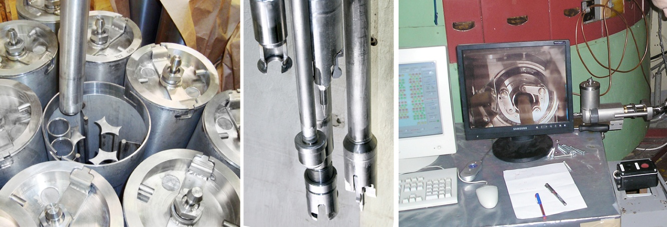

FIG. 1. Untight canisters and equipment for repackaging of the damaged Vinca SNF.

The Serbian removal project became one of the most complicated in terms of the SNF shipment licensing. Analysis of various routes for their feasibility, safety, and cost-effectiveness revealed the most acceptable one, i.e. transit through Hungary and Slovenia to a Slovenian port in the Adriatic sea, a sea section to the Russian port of Murmansk, and then a rail shipment to the reprocessing plant. The selected route was supported by all necessary authorizations, i.e. Russian certificates for the package design and transportation endorsed in Serbia, Hungary and Slovenia and licenses for transit through Hungary and Slovenia. In December 2010, almost 2.5 tons of the Serbian spent fuel were delivered to Mayak PA.
The TUK-19 and SKODA VPVR/M casks used in the RRRFR program fit well for handling on the most of the RR sites. However, some projects required development of additional equipment to enhance safety of the SNF reloading operations. For instance, the Romanian research reactor VVR-S did not allow the existing SNF loading technologies, i.e. underwater or "air" reloading of the spent fuel into TUK-19 casks. So, it was decided to develop a special transfer cask with an automatic grapple for handling the SFA-containing basket [3]. The dry run and subsequent SFA reloading operations proved safety of that technology both under normal and accident conditions. Similar technologies were developed for the follow-up projects involving SKODA VPVR/M casks when the standard "bottom" loading seemed impossible (Fig.2).

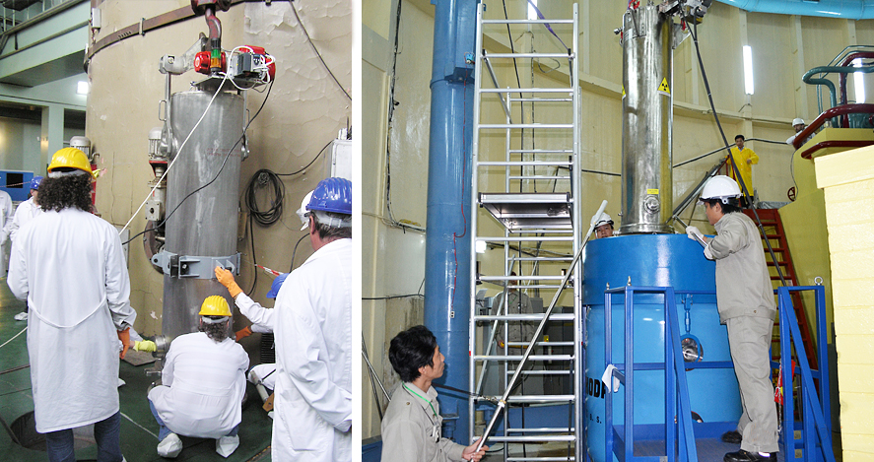

FIG. 2. Loading canisters with liquid SNF into SKODA VPVR/M through the transfer cask.

Another example of development of a specific technical solution was preparation for removal of the liquid irradiated high-enriched nuclear fuel (LSNF) from the INN-3M research reactor, Uzbekistan [4]. In spite of the fact that Russia has reactors consuming the liquid nuclear fuel, no technology for the LSNF transport had ever been developed. In addition, uranyl-sulphate water solution was not on the list of the fuels reprocessed at Mayak PA.
Preparation for the removal included development of special equipment for the discharge of the liquid spent fuel from the reactor into temporary storage canisters and, then, into transport canisters and a SKODA VPVR/M cask (Fig.3) For the LSNF delivery to the reprocessing plant, a transport plan and a fuel receipt, temporary storage and reprocessing procedure were developed, equipment for the LSNF discharge from the transport canister into the reprocessing line was fabricated, and calculations of design, fire and explosion risk, nuclear and radiation safety during receipt, temporary storage and reprocessing were performed.

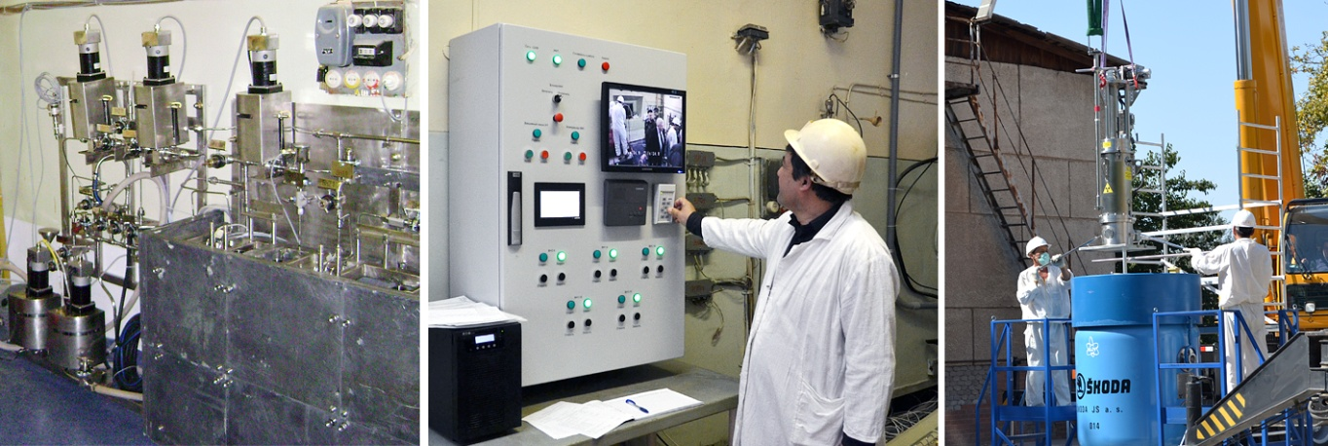

FIG. 3. Equipment for preparation of IIN-3M LSNF removal.

Evolution of RRRFR multimodal shipments
The first RRRFR shipment of the spent fuel took place in 2006. The VVR-SM SFAs were transported from Uzbekistan to the Radiochemical Plant in the TUK-19 casks by rail in the TK-5 container railcars, and from the Institute to the rail terminal – by road. The road section of the route required developing special equipment that could not be used in other projects.
Later, financed by the U.S. DOE, 16 SKODA VPVR/M casks were fabricated. The Czech-made SKODA VPVR/M cask fit better for multimodal shipments, since a 20-ft freight ISO container could easily accommodate it, and the ISO container handling procedure is standard for nearly all modes of transport. Using the SKODA VPVR/M cask for the SNF shipments in the Russian Federation required getting a certificate for the package design and shipment and adapting the Mayak PA's container receipt procedure. Successful certification of the package and preparation of the reprocessing plant's infrastructure were followed by a number of shipments of the spent fuel in the SKODA VPVR/M casks by road, rail and water [5].
When implementing the Romanian VVR-S SFA removal project, there emerged a necessity to use air transport due to the problems encountered with land transit through third countries. Russian experts had to apply efforts to, first, justify safety of air shipment, and, then, to arrange it. Since the activity of all 70 S-36 SFAs as of the date of the shipment did not exceed the value of 3000A₂ specified in the NP-053-04 and TS-R-1 regulations, the air shipment of the SFAs in a B(U) type package was possible; so, the choice fell on the TUK-19 cask. A transport overpack based on a large-capacity 20-ft ISO container (Fig.4) accommodating three TUK-19 casks tied down with turnbuckles and capable of withstanding accelerations and vibrations typical of all transport means [5] was developed to ensure multimodality of the shipment.
The dynamic deformation and strength analysis performed by Russian experts for the TUK-19 cask under impacts simulating normal and accident transport conditions including an aircraft crash, as well as nuclear risk analysis for the worst cases of impact onto a solid target demonstrated that the air shipment of the VVR-S SFAs in the overpack satisfied safety requirements of the NP-053-04 and TS-R-1 regulations. The flight over the Black sea to avoid transit countries minimized air transport risks [6].
Successful air shipments of B(U) type packages by An-124-100 aircraft from Romania and Libya in 2009 demonstrated a possibility in principle to transport the SNF RR by air. The next step forward in this direction was development of a Type C package for air transportation of various radioactive materials of infinite activity.

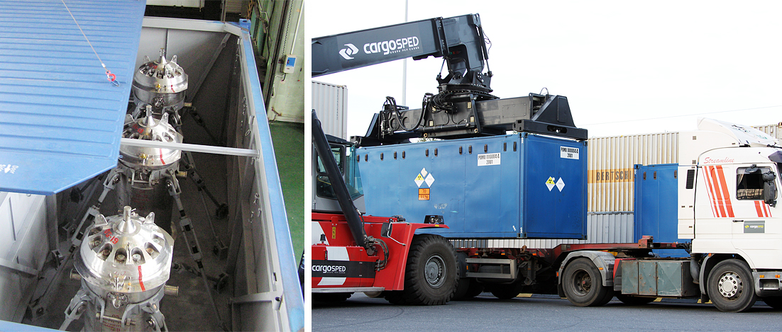

FIG. 4. Overpack for multimodal transportation of TUK-19 casks.

In 2009, US DOE/NNSA addressed Sosny R&D Company to analyze a possibility to develop a Type C package based on the SKODA VPVR/M cask. During the pre-conceptual study it was decided to develop an impact absorber to take in a part of the energy during an impact of the cask onto a target. The analysis of various impact absorbers revealed the most promising option, i.e. a two-piece cylinder with a flange joint in the middle and hollow titanium balls as absorbing elements arranged inside. The overpack was assigned identification number TUK-145/C.
The Russian and international regulatory requirements for Type C packages do not impose additional restrictions on the content radioactivity, but require maintaining the integrity after an impact at a velocity of not less than 90 m/s and exposure to fire for a period of one hour. Compliance with these requirements was verified by model analysis of possible air crashes and physical tests of a 1:2.5-scale mockup TUK-145/C package.
The Russian certificate of approval for the TUK-145/C package design granted in 2012 allowed air shipments of the RR spent fuel from Vietnam and Hungary (2013), and the liquid fuel from Uzbekistan (2015) [7].
The development of the Type C package made the air transport the main mode for international shipments of the RR spent fuel (Fig.5). It allows optimizing physical protection and emergency response, avoiding transit issues, shortening the time of the shipment and ensuring the highest safety level required for the packages of radioactive materials by the IAEA safety standards.

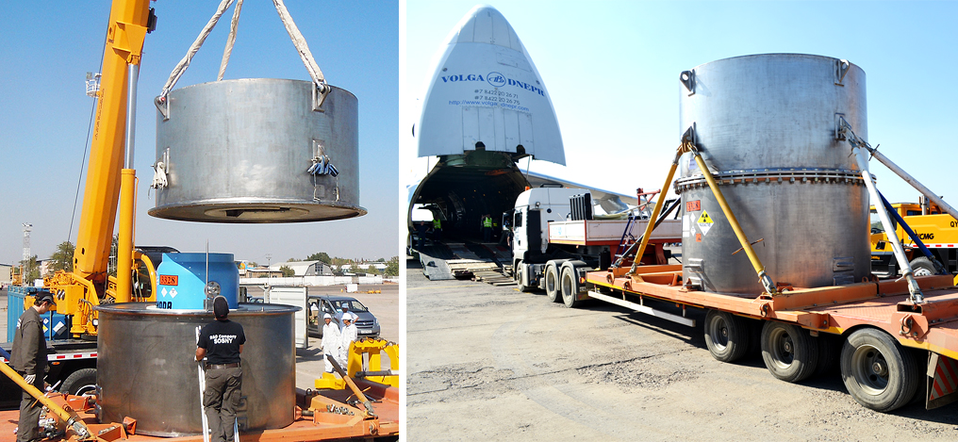

FIG.5. TUK-145/C for air transport of the spent fuel.

Application of shipment organization experience in MNSR Conversion Program
The Chinese-design 27 kW miniature neutron source reactors (MNSR) are research reactors used, mainly, for neutron activation analysis, education and training. The reactor core contains about 1 kg of 90%-enriched HEU. In 2006, the IAEA initiated a coordination research project (CRP) to support conversion of such reactors to LEU fuel. At the 2016 Nuclear Security Summit, the USA and PRC committed themselves to joint effort with support from the IAEA to complete conversion of the MNSR facilities in Ghana and Nigeria to the LEU fuel within the shortest possible time. The PRC marked itself ready to convert all other Chinese-origin MNSR facilities to the LEU fuel [8].
In 2017, the GHARR-1 research reactor in Ghana was converted to the LEU fuel, while the HEU fuel was subject to return to China. TUK-145/C fitted with a new basket and certified as TUK-145/C-MNSR was used for the shipment of the core and several non-irradiated fuel pins. An automatic remotely-controlled transfer cask for the core reloading from the reactor into the shipping cask and auxiliary equipment were developed for the safe SNF handling on the reactor site (Fig. 6).

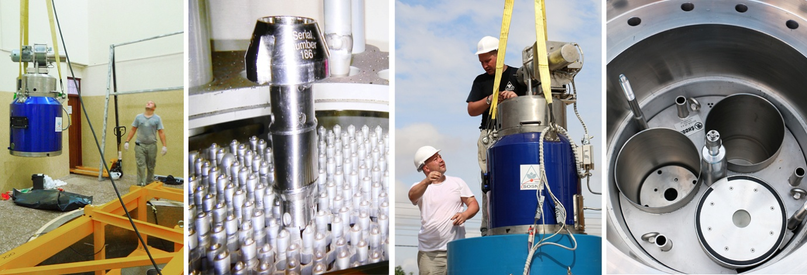

FIG. 6. Preparation for removal of the MNSR SNF from Ghana to China.

In December 2018, the second MNSR campaign, i.e. removal of the spent HEU fuel from Nigeria, took place. Specific NIRR-1 infrastructure, administrative and security requirements for the removal required developing and implementing relevant engineering solutions to modify the technology and equipment for reloading of the fuel from the reactor core into a shipping container, personnel training, and the removal management in Nigeria.

Harmonization of international approach to shipment arrangements
The following aspects should be noted in analyzing experience in arrangement of international RR SNF shipments:
- In general, the worldwide trend to unify package design and transport conditions requirements on the basis of the IAEA recommendations has a positive effect on development of international shipments from the viewpoint of broadening options and simplifying licensing procedures.
- In addition to the IAEA recommendations, many countries impose national requirements adding complexity to administrative approval procedures, for instance:
      - Russia: ban on NM shipments by passenger aircraft, a mandatory specific regulator's authorization (license) for NM shipment by air transport, approval of the design of the Type A package with non-fissile material;
      - France: an additional regulator's authorization for certain air shipments over the territory of France;
      - Vietnam: one and the same authorization procedure (in particular, the prime minister's written authorization) for any radioactive material shipments including empty packagings (ООН2908);
      - China: design approval for some cases, when the IAEA recommendations do not require multilateral approval, for instance, for Type B(U) package containing fissile-excepted radioactive materials (ООН2916).
- The multilateral approvals of package design and shipment certificates imposed by the IAEA regulations were obtained in each country in a variety of ways.
- The unified certificates for package design and shipment issued in Russia are never endorsed in the countries involved. Most of the countries endorse the Russian certificate as "multilateral approval" of the certificate for the package design and issue a separate certificate for the package shipment in compliance with national administrative procedures. The certificate of shipment approval goes under different names and formats in different countries.
- National administrative procedures for getting an OVF permit for a chartered plane carrying a radioactive cargo can differ significantly in different countries. In addition to a regular set of documents (air carrier's documents, a certificate of package design, liability insurance, etc.), additional documents may often be required, for instance: endorsed certificate of the package design in the countries of departure and landing, import and export licenses, OVF permits from all countries of transit, departure and landing.

Conclusions
High Enriched Uranium Take-Back Programs have really boosted the development of the SNF safe handling technologies and the SNF transport equipment.
Experience in multimodal shipment arrangements and the engineering solutions developed by Sosny R&D Company are universal and can be applied (and have already been applied) in any projects involving handling the spent nuclear fuel from the research, power and propulsion reactors.

REFERENCES
- Massive Operation Safely Secures Serbian Nuclear Fuel in Russia (2010), www.iaea.org/newscenter/news/massive-operation-safely-secures-serbian-nuclear-fuel-russia.
- Samsonov, A., Amosov, S., Ivashchenko, A., Defective spent fuel management at the Vinca Institute, J. Nuclear & Enviromental Safety, No. 1, 2011, pp. 84-88.
- Kanashov, B., “First experience in international air transportation of RR SNF in russian-made TUK-19 casks”, presented at RRFM 2010 International Conference, March 21–25, 2010, Marrakech, Morocco.
- Derganov, D., Budu, M., Ivashchenko, A., Komarov, S., Samsonov, А., Salikhbaev. U., Maksumov, N., Kirilova, T., Tyacke, M., “First Experience in Developing the Technology for Liquid Spent Fuel Transport and Reprocessing”, presented at 18th International Symposium on the Packaging and Transportation of Radioactive Materials PATRAM 2016, September 18–23, 2016, Kobe, Japan.
- Dorofeyev, A., Ivaschenko, A., Kanashov, B., Baryshnikov, M., Multimodal transports – an incentive to improve, J. Nuclear & Enviromental Safety, No. 1, 2011, pp. 27-31.
- Barinkov, O., Kanashov, B., Komarov, S., Buchelnikov, A., Shapovalov, V., Morenko, A., Preparation of the first air transport of spent fuel certified to new requirements, J. Nuclear & Enviromental Safety, No. 1, 2011, pp. 67-71.
- Budu, M., Komarov, S., Moses, S., Safety assessment, questions and lessons learned from licensing TUK-145/C as type B(U) and C packages in different countries, presented at Technical Meeting on Lessons Learned from High Enriched Uranium Take-back Programmes, June 19–22, 2017, Tbilisi, Georgia.
- Budu, M., Ivaschenko, A., International and National Requirements in the Framework of the MNSR HEU Return Project from Ghana to China, presented at Technical Meeting on Lessons Learned from High Enriched Uranium Take-Back Programmes, June 11–14, 2018, Beijing, China.

