# Enusa activities regarding Spent Fuel Management

M. LLORET

Enusa Industrias Avanzadas SME

Madrid, Spain

Email: mll@enusa.es

M. MALPICA

Enusa Industrias Avanzadas SME

Madrid, Spain

Email: mmalpica@enusa.es

**Abstract**

Spent Fuel management in Spain is open cycle. Nowadays the Spanish NPP (7 PWR and 2 BWR) have constructed or designed ISFSIs (Independent Spent Fuel Storage Installation), however a Centralized Storage Installation will be operating in the future. The first Spanish ISFSI was installed in Jose Cabrera NPP (14x14 PWR Fuel) due to the definitively cease of the NPP operation in 2006. At that time Enusa Industrias Avanzadas developed, and made available to its customers, its resources and capabilities applicable to all the phases of the management of the irradiated fuel. These capabilities and resources are especially focused on two major areas: engineering and on site fuel services. These paper will be focused on engineering developments in regard to Spent Fuel Management.

In engineering area, a Methodology for the classification (damage/ no damage) of fuel assemblies has been developed, considering characteristics as internal pressure, hoop stress, hydride lens in spalled oxide positions, stress corrosion cracking in the top nozzle-skeleton sleeves, etc. A detailed data base for each NPP has been designed and developed taking into account the most important fuel assembly characteristics. Different type of inspections (visual for integrity, In- can sipping and UT for fuel rod leaks detection, visual for oxide spalling…) are performed to complete every fuel assembly characterization before classification.

With the objective of decrease the number of fuel assemblies classified as damaged, some developments have been performed: (1) design, licensing, manufacturing and installation of a device named ESPIGA to solve the handling problems for oldest fuel assemblies affected by intergranular stress corrosion cracking on top nozzle sleeves; (2) specific analysis to detect fuel assembly leaks; (3) methodology to assure the fuel rod integrity during transport considering hydride lens deep up to 40% of cladding width ; (4) methodology to calculate cladding hoop stress to assure the fulfilment of the regulation limit (90 MPa in Spain for low burnup fuel assemblies if storage temperature is above 400ºC).

## INTRODUCTION

The strategy followed in Spain for the Spent Fuel Management is the open cycle. It is stated in the 6th revision of the Radioactive Waste General Plan approved in 2006 by the Spanish Government. Currently the Spent Nuclear Fuel (SNF) is on-site stored in Spent Fuel Pool (SFP) and when the pool capacity is over, the fuel is transferred to the Independent Spent Fuel Storage Installation (ISFSI). In the future, there will be a Centralized Storage Installation.

In Spain there are 7 PWR NPP with 17x17 (5), 14x14 (1) and 16x16 (1) fuel assemblies; and 2 BWR NPP. Jose Cabrera NPP (14x14 PWR) and Santa Maria de Garoña NPP (BWR) have ceased their operation in year 2006 and 2012 respectively. Nowadays, due to the Spent Fuel Pool situation, all the NPP in Spain have an ISFSI, in operation or under construction. The first ISFSI was constructed due to the Jose Cabrera NPP cessation, and from these days, Enusa Industrias Avanzadas is working in Spent Fuel Management, developing different capacities not only in engineering area, but also in equipment for fuel assembly inspection and repair, however the paper will be focussed on engineering developments.

## INTEGRAL SUPPORT TO PWR NPP

ENUSA support NPP in all the phases of the management of the irradiated fuel. The integral support include the necessary engineering analysis and the on- site inspections, based on the regulation, to SNF dry storage and transportation.

The regulation applicable in Spain for SNF storage and transport is a combination of Spanish, European and NRC regulation [1, 2, 3, 4 and 5 as examples]. It should be highlighted that 10CFR 71 [4], applicable for transportation of SNF states that for *Normal conditions of transport (1) The contents would be subcritical; and (2) The geometric form of the package contents would not be substantially altered.* Additionally, the10CFR 72 [5] applicable for storage of SNF states that *the spent fuel cladding must be protected during storage against degradation that leads to gross ruptures.*

Considering all the requirements indicated in the standards, the working flow developed by Enusa, that provides an integral support regarding Spent Fuel Management is outlined in Figure 1

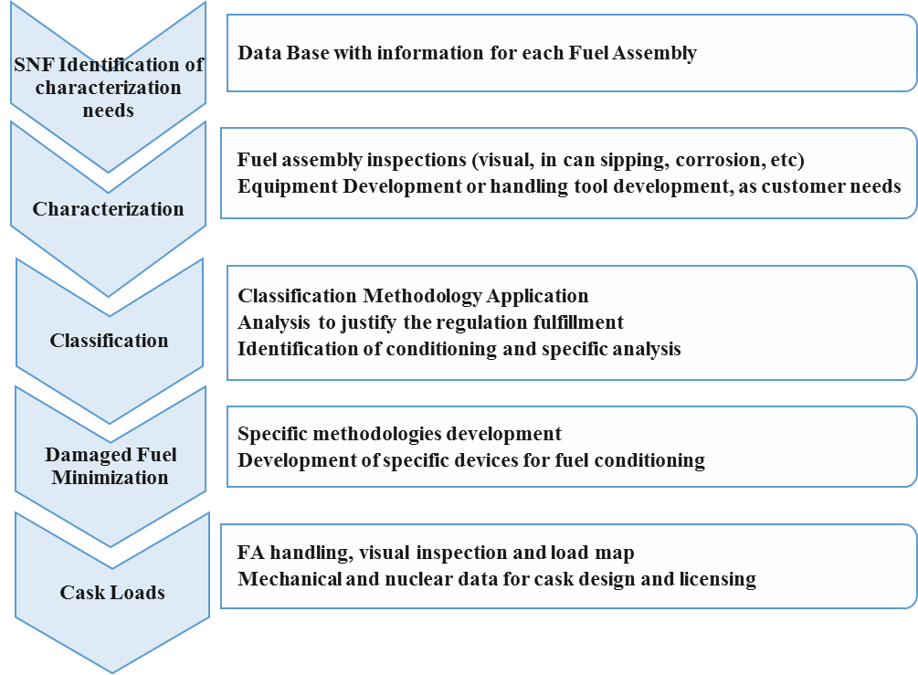

*FIG. 1.Activities for Integral Spent Fuel Management Support*

A detailed data base for each NPP has been designed and developed taking into account the most important fuel assembly characteristics. The Data Base includes individual records for every SNF. All the characteristic considered necessary for any kind of analysis to be performed regarding the second part of the cycle are included: dimensions and materials for every piece; irradiation cycles; core position; power, average temperature and other irradiation data as needed. The Data Base allows to identify the characterization needs.

For SNF characterization, ENUSA had developed a complete set of inspection equipment´s as In- can sipping [11].

## Fuel Assembly Classification

The classification performed in Spain is based on NRC Interim Staff Guidance NRC ISG-1 Rev. 2[6] and NRC ISG-11 Rev. 3 [7], where the following definitions are included:

* Damaged SNF: Any fuel rod or fuel assembly that cannot fulfil its fuel-specific or system-related

Functions.

* Undamaged SNF - SNF that can meet all fuel-specific and system-related functions. Undamaged fuel may be breached. Fuel assembly classified as undamaged SNF may have “assembly defects"

Based on that, Enusa has developed a flow chart for the classification of the SNF, considering the steps indicated in Figure 2:

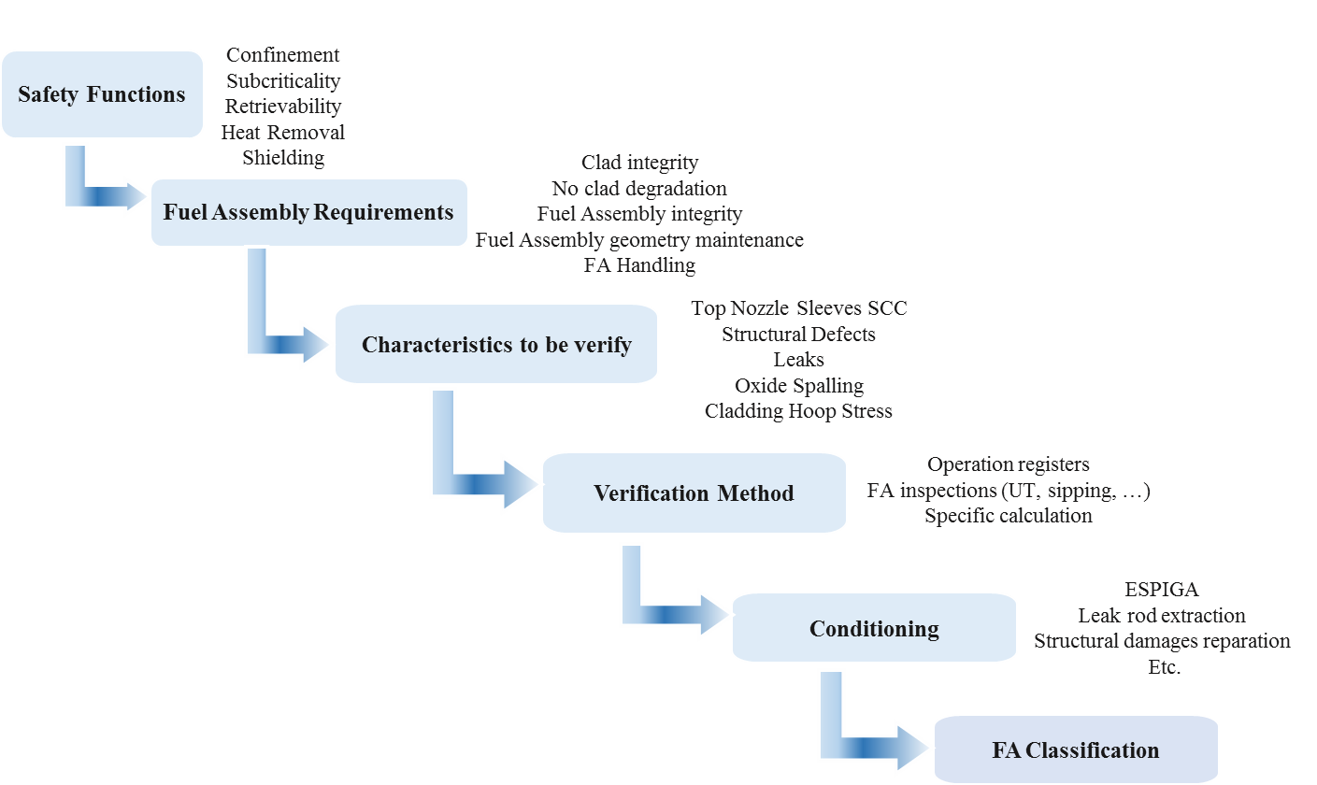

*FIG. 2. Fuel Assembly Classification Methodology*

## DAMAGE SNF MINIMIZATION

Some of the most interesting developments that allows Enusa minimize the number of damaged fuels are indicated below:

### 4.1. ESPIGA Device

ESPIGA is a device developed to conditioning the 17x17 PWR fuel assemblies that could be affected by Stress Corrosion Cracking on the sleeves that attach the skeleton to the top nozzle. It could happen in old design fuel assemblies where the top nozzle/skeleton joint is performed by stainless steel sleeves (Fig 3) that could be sensitized during the grid manufacturing process. As Top Nozzle Separation is feasible, this kind of SNF cannot be moved by normal means. The ESPIGA device provides a secure attachment between top and bottom nozzle that allows the handling by normal means. The ESPIGA device has been designed, licenced in Spain, manufactured and installed by Enusa in Spanish NPP (Fig 4) [8]. The installation tools have been also designed by Enusa, manufactured and used during the different installation campaigns.

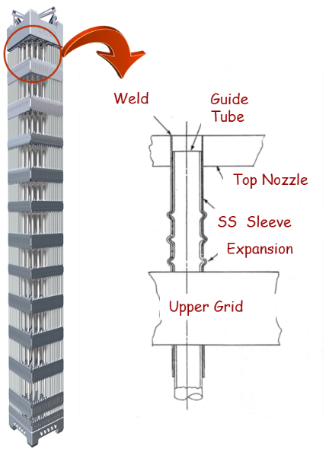

*FIG. 3. Fuel Assembly with welded sleeves FIG. 4. ESPIGA Device*

In the future, the device could be adapted to different types of fuel assemblies. Additionally, the knowhow and experience obtained during this project will be very useful for any new spent fuel conditioning developments for fuel assemblies without top-nozzle, or repaired fuel assemblies that have no attachment between skeleton and top nozzle.

### 4.2. Analysis to detect Fuel Assembly (FA) Leaks

The ISG-1 [6] states that the undamaged fuel may be breached if the defect permits the release of gas from the interior of the fuel rod but not permits release of particles during fuel handling and retrieval operations. In any case, the objective is always to detect the breaches and to avoid fission gas releases during spent fuel loading operations [9]. This could be an ambitious objective for the oldest cores, where the radiochemical data and the reliability of the inspection equipment's were not so good as nowadays. Due to that, Enusa developed a work flow for fuel classification regarding leak: the RQ data and the leak inspection results for all the assemblies irradiated every cycle have to be analysed together, and the coherence between the predicted failed fuel assemblies based on RQ analysis and the leaks detected during the inspection should be assured. If there is no coherence between these numbers, the fuel assemblies should be inspected again. This work flow has been a very useful way to avoid fission gas releases during cask load drying operations. Nowadays, as the accuracy of the reactor core chemistry records has increased and the limitations of the inspection techniques have decreased, the probability of having an issue regarding this subject has diminished.

Enusa has developed an in-can sipping equipment, more accurate that the UT equipment for leaks detection. This equipment has a high efficiency. During the verification tests a minimum of 175 counts per second-cps/μci Kr-85 has been measured. The gas extracted is continuously analysed. The detection unit will measure β-activity and the software permits discerning if there has been external ionized agents not present inside the fuel rod.

### 4.3. Oxide Spalling

As it has been indicated above, 10CFR72 states that *the spent fuel cladding must be protected during storage against degradation that leads to gross rupture;* additionally Spanish regulation requires retrievability after storage accidents [1] and due to the current process defined in Spain for future spent fuel storage, it is also a requirement after transport. Based on that, Enusa has analysed the behaviour of rods with spalled oxide. When the spalling of the oxide cladding is produced, a cold spot is generated in the cladding; due to the temperature gradient and considering that the hydrogen migrates to the cold temperature zones (Fig 5), a hydride lens could be produced in the spalled oxide position. Due to the different mechanical properties of the hydrides vs the Zirconium alloy, to assure that the rod maintains its integrity during storage and transport, Enusa has analysed the behaviour of the clad in these situations. As the most limiting situation is the transport accident, a finite element model has been developed to obtain the stresses that the rod should support during transportation accident (9 m cask vertical drop and cask side drop [4]). Based on that and considering the characterization of the possible defect, a fracture analysis provides curves that indicate if a certain blister size may cause failure under postulated accidents conditions, Figure 6 [10]. The use of these curves in addition to the SNF inspections allow the classification of spalled spent fuel as undamaged or damaged.

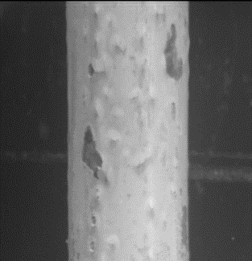

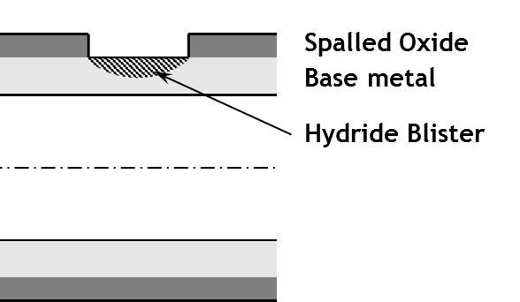

*FIG. 5. Oxide spalling*

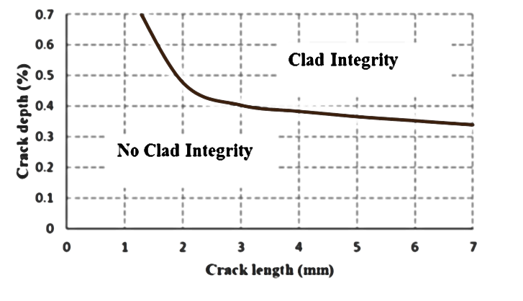

*FIG. 6. Result for horizontal drop analysis*

This methodology has been applied for one type of container. Enusa is now performing new applications for different types of fuels and containers; some key parameters as temperature profile during storage, temperature profile during transport, loads transmitted to the fuel rods, characteristics of the irradiated fuel assemblies, etc have an important effect on the results.

### 4.4. Cladding Hoop Stress

ISG-11 Rev. 3 [2] states that for low burnup fuel (FA average burnup less than 45 GWd/MTU, a higher than 400ºC short-term temperature limit may be used if the applicant can show by calculation that the best estimate cladding hoop stress is equal to or less than 90 MPa. This could be easy for current fuel rod designs, however it could be no so easy for older designs with high internal rod backfill pressures and low plenum lengths. Based on that, Enusa has developed a methodology for cladding hoop stresses calculation, using a fuel rod thermomechanical code, considering the axial temperature profile during storage and the thin tube formulae for hoop stress calculation (Fig 7). Nominal values for fuel rod characteristics and best estimated models are used, as it is required in ISG-11 [2]. The analysis is performed considering FA groups with the same characteristics (rod backfill pressure, pellet type, pellet densification model, …) and similar irradiation conditions. Based on the temperature axial profile and considering the fissile column divided in "n" equal segments, the average temperature for each segment and for the plenum is obtained. The void volume is calculated considering not only the pellet-cladding gap, but also other pellet parameters as chamfer, dish, porosity, … The total void volume for this temperature profile is calculated as

V_void= Vs1(T1)+ Vs2(T2)+Vs3(T3)+Vs4(T4)+Vs5(T5)+…+Vsn(Tn)+Vp(TP)

The fuel rod thermomechanical code provides de number of moles of gas inside the rod. The internal rod pressure is calculated using the perfect gas low. The fuel rod thermomechanical code provides de number of mols of gas inside the rod. The internal rod pressure is calculated using the perfect gas law. The fine tube formulae is used for hoop stress calculation.

The post code calculations are performed using MATLAB, therefore the execution is made on a quick and efficiente way.

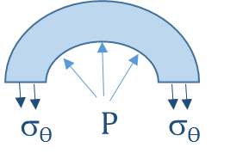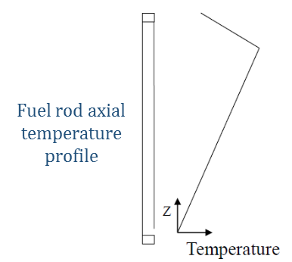

*FIG. 7. Cladding hoop stress Calculation*

### 4.5. Structural Damages Reparation

ISG-1 Rev. 2 [6] states that *SNF classified as undamaged may have “assembly defects”.* Considering Assembly Defect as *Any change in the physical as-built condition of the assembly with the exception of normal in-reactor changes such as elongation from irradiation growth or assembly bow. Examples of assembly defects: (a) missing rods; (b) broken or missing grids or grid straps (spacers); and (c) missing or broken grid springs, etc. An assembly with a defect is damaged only if it can't meet its fuel-specific and system-related functions required by the applicable regulations.*

Oldest fuel assembly's design could have higher assembly bow than the new ones, therefore there is a higher probability of having difficulties during handling. For these old designs some defects as broken grid straps or grid springs could appear, and they should be evaluated or repaired before fuel classification. Enusa is developing some tool to repair these elements. Once they were repaired no evaluation would be needed, and the fuels could be classified as undamaged.

### 4.5. Support to Cask Vendors

Besides these activities related with the SNF management, ENUSA could support cask vendors with additional developments related with axial and radial cladding temperature distribution during storage, canister mechanical design, criticality and shielding analysis using COBRA SFS, ANSYS, LS-DYNE, and SCALE codes.

## SUMMARY

Enusa provides an integral support to the NPP regarding Spent Fuel Management from the spent fuel pools to the dry storage and transport.

A detailed data base for each NPP has been designed and developed taking into account the most important fuel assembly characteristics. Different type of inspections (visual for integrity, In- can sipping and UT for fuel rod leaks detection, visual for oxide spalling…) are performed to complete every fuel assembly characterization before classification. For the SNF classification, ENUSA has developed a methodology (damaged/undamaged) based on the regulation. With the objective of minimize the number of damaged fuel assemblies, new methodologies, inspections and conditioning devices have been developed. New applications of these methodologies considering different casks designs are been developed nowadays and will be performed on the future.

References

1. IS-20, "“Safety requirements for spent fuel storage casks”, 2009.
2. IS-29, “Safety criteria at spent fuel and high-level radioactive waste storage facilities”, 2010.
3. IAEA Specific Safety Guide No. SSG-26 Advisory Material for the IAEA Regulations for the Safe Transport of Radioactive Material (2012 Edition).
4. 10 CFR part 71, "Packaging and Transportation of Radioactive Material".
5. 10 CFR Part 72, "Licensing Requirements for the Independent Storage of Spent Nuclear Fuel, High-Level Radioactive Waste, and Reactor-Related Greater than Class C Waste.
6. Spent Fuel Project Office Interim Staff Guidance - 1, Revision 2, Classifying the Condition of Spent Nuclear Fuel for Interim Storage and Transportation Based on Function, 2007.
7. Spent Fuel Project Office Interim Staff Guidance - 11, Revision 3 Cladding Considerations for the Transportation and Storage of Spent Fuel, 2003.
8. GARCÍA DE LA INFANTA , J. "Enusa Integral Solution for Intergranular Stress Corrosion Cracking on early 17x17 PWR Designs" 2018 Water Reactor Fuel Performance Meeting, Prague.
9. NRC INFORMATION NOTICE 2018-01: Noble Fission Gas Releases during Spent Fuel Cask Loading Operations (2018).
10. MUÑOZ J. "Assessment of the Integrity of the Fuel Rod with Spalled Oxide under Hypothetical Transportation Accidents" 2017 Water Reactor Fuel Performance Meeting, Korea.
11. TENA P. et al "Advanced Vacuum Sipping for Spent Fuel Classification", 2018 Water Reactor Fuel Performance Meeting, Prague.