robotically-deployed nde inspection development for dry storage systems for used nuclear fuel

J.B. RENSHAW
Electric Power Research Institute
Charlotte, NC, USA
Email: jrenshaw@epri.com

J. BEARD
Robotic Technologies of Tennessee
Cookeville, TN, USA

J.J. STADLER
Baker Hughes, A GE Company
Shorewood, IL, USA

S.M. CHU
Electric Power Research Institute
Palo Alto, CA, USA

N. MUTHU
Electric Power Research Institute
Charlotte, NC, USA

M. ORIHUELA
Electric Power Research Institute
Charlotte, NC, USA

Abstract

Dry Storage Systems are used as an onsite storage method for used nuclear fuel. Since no country currently has an operable repository, it will be essential for many countries around the world to extend the period of operation for these systems. Nondestructive evaluation (NDE) inspections are needed to verify continued safe operation of these dry storage systems; however, elevated temperatures, dose rates, and confined entry/exit all pose unique challenges for deployment of NDE techniques as a part of aging management requirements for these dry storage systems. Therefore, robotically-deployed in situ NDE systems and techniques have been developed to address these challenges. Field trials have been conducted to evaluate the feasibility and improve the functionality of the NDE and delivery systems in real-world environments. This paper describes development of the NDE systems, presents laboratory tests on flawed mockup specimens, and highlights field trial efforts to refine the NDE and delivery systems for deployment with dry storage system inspections.

INTRODUCTION
Due to the need to extend the lifetime of dry storage systems, the nuclear industry has begun to develop aging management plans for dry storage systems that store used nuclear fuel discharged from reactors following the pattern that has been implemented for other structures, systems, and components (SSCs) for other important to safety (ITS) plant systems. An important aspect of these aging management plans will be to perform high-quality non-destructive evaluation (NDE) inspections of the canister surfaces to verify the presence or absence of degradation mechanisms that may threaten structural or confinement integrity. The scope and frequency of these inspections is established with the goal of ensuring safe operation for the duration of the extended storage period.
While multiple NDE techniques and systems have been developed for critical examinations in many industries, including the nuclear industry, such techniques require adaptation to be applied in a dry storage canister environment [1]. Dry storage canisters present numerous challenges for inspections, including high radiation doses (on the order of 1000 R/hr or higher), elevated temperatures (as high as 120 C have been measured), narrow annulus spaces (50-100 mm), and tortuous entry/exit pathways [2].
Plants face operational challenges related to moving a canister once it is in place, not only due to high temperatures and radiation levels, but also due to the sheer weight of a canister, which can be 45-140 metric tons. Thus, in situ inspection offers a low risk and lower cost option for performing inspections. Additionally, decommissioned plants that no longer have a spent fuel pool would benefit greatly from in situ inspection options.

background
The Electric Power Research Institute (EPRI) established the Extended Storage Collaboration Program (ESCP) in 2009 [3] to address issues related to extended storage of used fuel at reactor sites around the world. ESCP is a working group meeting where representatives from over 20 different countries come together to collaborate and leverage resources related to management of used fuel. The ESCP group has multiple subcommittees, currently including groups for chloride-induced stress corrosion cracking (CISCC), NDE, and Mitigation and Repair. Representatives from these groups work collaboratively to produce technologies, techniques, guidance, and reports that are typically published by EPRI.
In 2015, EPRI published a report detailing a process for ranking the susceptibility of different sites to chloride-induced stress corrosion cracking (CISCC) [4]. Factors related to humidity, presence of atmospheric chlorides, and so forth were used to rank the relative susceptibility of different sites and guidance was provided on criteria to rank the susceptibility of specific canisters by factoring in alloy material, heat load, and storage duration. Additional reports focused on providing guidance for aging management practices [5], NDE inspections [2,6-7], and options for mitigation and repair [8]. The output from these and other reports [9-16] are being utilized in the American Society of Mechanical Engineers (ASME) Code Case N-860 related to examination requirements and acceptance standards for spent nuclear fuel storage and transportation containment systems [17]. The ASME code case is intended to provide industry with guidance related to inspection and evaluation criteria for observed flaws as well as a graded inspection approach. The results from completed inspections will be entered into the Aging Management INPO Database (AMID) [18].
Many NDE technologies have been proposed for inspection of dry storage canisters [2,10], including visual [2,10], ultrasonic [2,6,9,10,19,20], eddy current [2,9,10,21], acoustic emission [2,9,10,22], thermography [23], muon imaging [24,25], and others [26]. These technologies will be discussed in further detail in the next section.

Inspection and delivery system development
Prior to robotic and NDE system development efforts, several early field trials were performed [27-28]. These tests were instrumental in identifying challenges related to performing in situ inspections and key areas needing development to perform inspections, such as the benefits from robotic delivery systems. Four key aspects were identified and have been incorporated into the development of NDE systems: collaboration, mockups, robotic development, and NDE technique development. Each aspect is addressed below. Collaboration was used to bring together the right set of skills, tools, and equipment to perform the needed inspections. Mockups were a key need for NDE technique development and evaluation but could not adequately simulate all of the conditions to be encountered in the field (such as elevated radiation levels, as-built conditions, etc.). Some conditions were simulated in laboratory testing, such as entry/exit pathways, annulus spaces, and temperatures. The actual canister surface temperature was an item of significant uncertainty and this temperature varies significantly across the canister surface. Limited surface temperature measurements showed surface temperatures in the range of 40-80°C for most conditions with the highest readings on a freshly-loaded canister near 120°C [27-28], however, some estimates were as high as 175-180°C [29]. Temperatures below 50°C are typically suitable for nearly all NDE techniques and <80°C for most techniques. Temperatures above 80°C start to become problematic for many NDE technologies due to thermal degradation of cables, etc. As such, an accurate understanding of canister surface temperatures is critical for designing the most effective NDE tools and techniques to perform inspections. It is anticipated that after cooling for 20+ years that surface temperatures for most areas on the majority of canisters will be at or below 80°C, significantly simplifying aging management inspections.

3.1. Collaboration
Collaboration is a key aspect of the ESCP group. This project was organized under the ESCP NDE Subcommittee. The ESCP Subcommittee has over 75 participating members, representing about 40 companies. Key activities of this group include identifying complementary tools, techniques, and platforms for performing field inspections as well as identifying and organizing field trials for developing technologies.

3.2. Mockup Development
EPRI has a library of test mockups available for industry use [2] that include a range of conditions useful for developing NDE techniques. Over 20 mockups have been manufactured and are presently available for NDE technique development. Other organizations have also collaborated with EPRI via the ESCP group to provide access to additional mockups. The EPRI and industry mockups include variations in the following properties:
- Material geometries (flat/curved plates and pipes)
- Thicknesses (primarily 12.7 and 15.9 mm)
- Flaws in and around welds, or in base metal
- Flaw sizes (lengths and depths)
- Flaw shapes and morphologies (via different flaw manufacturing processes)
- Flaw orientations
- Flaw types (CISCC, stress corrosion cracking (SCC), compressed electrical discharge machining (EDM) notches, and thermal fatigue flaws)

3.3. Robotic System Development
Multiple organizations have developed and/or collaborated on robotic system development for dry storage canister inspections [6], including inspection rings [6], multi-stage cars [29], and 3D printed robotic platforms [7,30]. Each of these systems provided unique platforms for delivering NDE systems into a dry storage canister environment and resulted in differing levels of complexity to operate. This paper will focus on the simplest platform to deploy, the 3D printed robotic platform.
The 3D printed robotic platform has been demonstrated in ten field trials and/or inspections. These demonstrations have progressed from fit, form, and function testing on mockup canisters at utility or vendor sites to field inspections of loaded canisters storing greater-than-class-C (GTCC) waste [7, 18] and used nuclear fuel [18].
The robots have been subjected to all of the environmental challenges mentioned previously (high temperature, high radiation, narrow annulus, and confined/tortuous entry and exit pathways). In all cases, the robots were successfully able to enter and exit the canisters and perform their intended function of providing a visual or other examination of the canister.
The various dry storage canister vendor designs represent unique conditions that vary in geometry (annulus gap, annulus shape), internal obstructions (standoffs, shelfs, rings, channels, etc.), and available entry and exit pathways. Fig. 1-3 below show the different robotic designs developed to date that have been adapted for these variations.

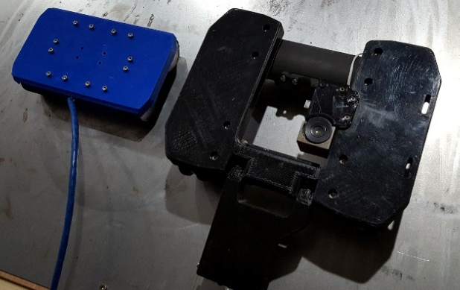

FIG. 1. 3D printed robotic inspection platforms tailored to different canister designs and annulus spaces. These robots include attachments for various NDE tools to be mounted onto the body of the robot.

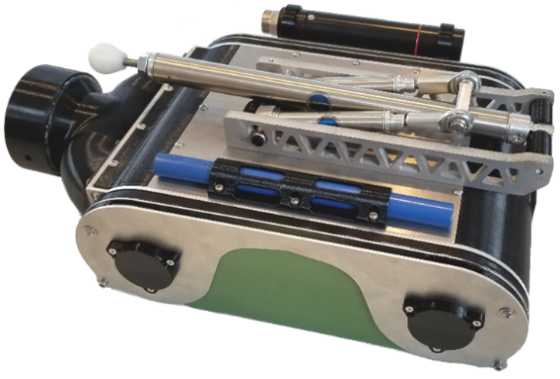
FIG. 2. Partially-3D printed robotic inspection platform tailored to a horizontal canister design, utilizing vacuum suction to adhere to the canister surface. The blue tube on the bottom secures the visual inspection system, the black tube on the top is a radiation detector, and the black cylinder on the left side is the vacuum hose connection. The arm in the center of the image is utilized for assisting with transitioning over 90-degree corners on a dry storage canister.
These designs continue to undergo minor iterations based on lessons learned from field trials and inspections.

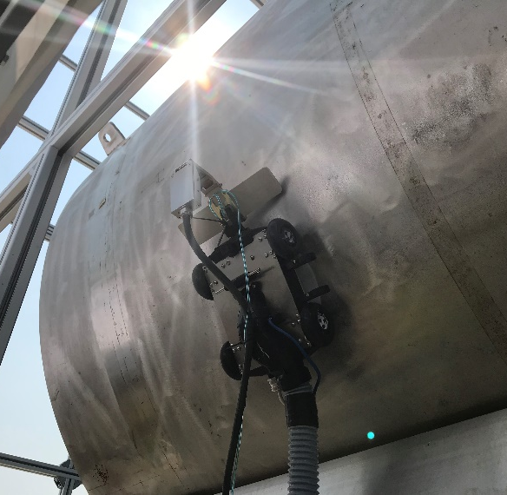

FIG. 3. Upper stage of a multi-stage (marsupial) robot where a “mother” robot deploys a “daughter” robot. The deployed robot contains an eddy current array inspection system for inspection of the stainless steel dry storage canister mockup. The bottom section of the robot is not shown in this image.

3.4. NDE System Development
Commercially-available NDE technologies were evaluated for inspecting a dry storage canister to guide development efforts [2]. Each technique offers unique advantages, limitations, and applicability as shown in the high-level assessment in Fig. 4. Development efforts focused on preparing these techniques for deployment [6,7].

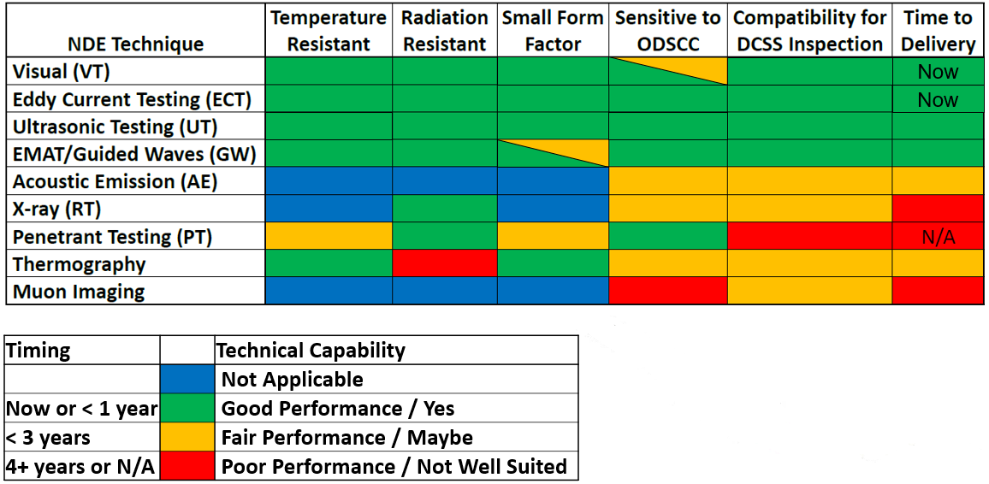

FIG. 4. Current (updated) status of the NDE Matrix presented in [2] showing that several techniques are capable of being deployed today or within 1 year that meet most or all of the identified criteria for dry storage canister inspections.

3.4.1. Visual Testing (VT) development
VT is one of the most common NDE techniques that is utilized in industry. As such, a number of systems and techniques have been developed and are at a late stage of technical readiness level (TRL). Several vendors have commercially-available systems that meet the key limitations of a dry storage canister environment, including small size and high temperature and radiation resistance. The desire is for a minimum of VT-3 level inspections to be performed on and near welded areas with the capability to perform VT-1 inspections if indications are observed.

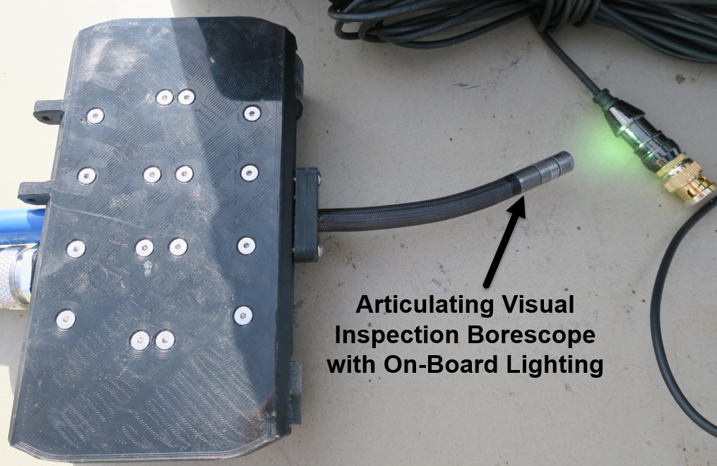
FIG. 5. 3D printed magnetic wheel robot with an articulating visual inspection probe

3.4.2. Eddy Current Testing (ECT) development
If visual inspection identifies indications of cracking or other degradation, eddy current array (ECA) inspection provides a rapid inspection option that can provide increased resolution and differentiation of defects. Eddy current devices detect the presence of surface and near surface defects through electromagnetic interaction between the eddy current probe and electrical eddy currents generated within conductive materials [21]. An ECA device was designed and tested that provided excellent resolution of defects in a range of mockup samples [21]. The ECA consisted of a 32X3 coil arrangement (96 total coils) with multiple channel arrangements that allowed for qualitative differentiation of shallow and deep flaws and was demonstrated to be capable of being field deployed [7]. The ECA incorporates design features to improve remote operation such as a low-profile design, curved array designed to be less than 10 mm thick, flexible printed circuit board and a foam backing that aids the probe to conform to surfaces, and specialized low-profile mounting brackets to minimize the height. All of the probe materials are designed to be tolerant of both high temperatures and high radiation doses.

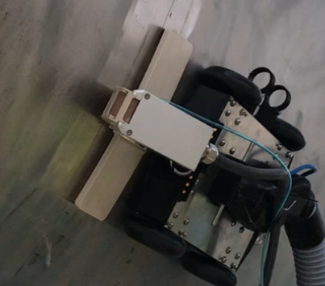
FIG. 6. 3D printed vacuum suction robot performing an inspection with an eddy current array probe (white)

3.4.3. Ultrasonic (UT) development
Ultrasonic testing (UT) is the industry standard technique for length and depth sizing of flaw indications. Ultrasonic inspection operates on the principle of the generation of sound vibrations that propagate within a structure and reflect off of material interfaces (such as cracks, porosity, delaminations, and geometrical reflections in the material). The desire to avoid the use of couplants on a canister surface limits the use of UT in a dry storage canister environment. Water is typically used as a couplant, but its use could impact radiation protection (i.e. injected water could potentially wash contamination off of the canister and out of the overpack) and potentially negative long-term effects of salt redistribution due to adding water on the surface, such as facilitating degradation.

3.4.4. Guided Wave development
Guided waves are long range ultrasonic waves that use the material boundaries as a wave guide. Similar to traditional ultrasonic inspection, guided waves indicate the presence of defects via the transmission and reflection of sound waves in the inspected material. Contrary to traditional UT, guided waves are capable of traveling great distances to perform inspections of components such as rails, tanks, plates, etc. Past work on guided waves shows significant promise [2], but implementation of guided wave technologies in a dry storage canister environment presents challenges due to the presence of carbon steel liners in the concrete overpacks surrounding the canisters, which can attract the strong magnets used in electromagnetic acoustic transducers (EMATs) that have been used to generate guided waves to inspect dry storage canister mockups and prevent the device from successfully entering the dry storage system.

3.4.5. Acoustic Emission (AE) development
Acoustic Emission (AE) relies on the transmission of vibrations associated with degradation – such as crack growth – within a structure [22,31]. A field trial was conducted to assess the feasibility of acoustic emission for the inspection of dry storage canisters at McGuire Nuclear Station [2]. A key activity of this field trial was to simulate degradation events using acoustic events such as pencil lead break tests and miniature impactor hits. This field trial demonstrated that acoustic emission signatures from acoustic events could be detected throughout an actual dry storage canister with minimal attenuation. In fact, the AE transmission within a dry storage canister was sufficient that sensors attached to the base of an overpack had sufficient sensitivity to monitor the entire canister. Additional, detailed studies are ongoing to assess the capabilities of detecting active stress corrosion cracking in laboratory samples [22].

3.4.6. Thermography development
Thermography is a useful tool for inspecting a wide range of large, complex structures such as dams [32], pipes, tanks, liners [33], aircraft engine components [34], and other complicated structures. Thermographic inspection relies on active or passive methods of detecting defects through differences in observed temperature profiles and evolution. Vibrothermography, where vibration induces heat generation at cracks and other defects [23], has been proposed as a potential inspection technique for dry storage canister inspection. However, dry storage systems present additional challenges for thermography and especially for vibrothermography. Dry storage canisters typically have bright, shiny surfaces which results in a low surface emissivity and high surface reflectivity, adding to the challenges of confined spaces, high temperatures, and high radiation. Many of the sensitive IR cameras required for vibrothermographic inspection are either too large to fit into a dry storage canister environment, are not radiation resistant, or both. Additionally, during field trials at McGuire Nuclear Station, an interaction between the magnetic wheels and infrared camera was observed that degraded the performance of the camera. It was possible to magnetically shield the miniature infrared camera from the wheels, but this would be increasingly complex with a large, sensitive infrared camera. It may be possible to utilize alternative means to achieve high quality thermographic inspection, but with several high-quality inspection alternatives readily available, minimal follow up efforts have been attempted.

3.4.7. Muon imaging development
Muon imaging has been proposed as a potential inspection technique for evaluation of dry storage canisters. Muons are subatomic particles that are generated through cosmic ray interactions with the Earth’s atmosphere and have been used for inspection of the Fukushima reactor [24] due to their ability to penetrate deeply into materials. However, due to the low flux of muons, such inspections are limited in resolution and may be able to detect the presence of a missing fuel assembly in a dry storage canister, but presently are not able to detect the presence of a missing pellet or pellet surface in a fuel rod, cracks in fuel rods, or cracks in dry storage canisters [25].

3.4.8. Other NDE techniques
Many other NDE techniques exist, including X-ray, penetrant, magnetic particle, resonance [35] and other inspection methods, however, due to the success of several traditional inspection methods and the difficulty with deploying some of the aforementioned techniques in a dry storage canister environment (see Fig. 4), no additional tests were performed using these techniques.

4. experimental studies and field trials

4.1. Laboratory Studies
Laboratory studies were carried out under increasingly realistic and challenging field conditions to identify potential weaknesses of the inspection and delivery systems, both in terms of accessing the dry storage canister through stepped entry pathways and narrow annuli as well as evaluating various techniques in a simulated environment to gain experience and make adjustments before going to the field. Fig. 7 shows early laboratory testing on dry storage mockups while Fig. 8 shows data collected using robotically-scanned eddy current arrays on mockups containing intentional flaws [2]. These flaws are easily observed with a high signal-to-noise ratio.

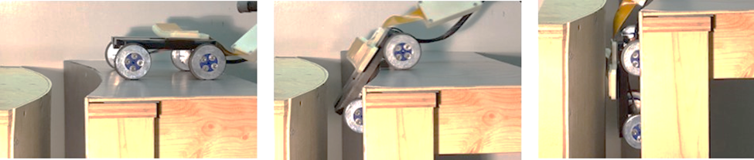
FIG. 7. Robot traversing over a 90 degree corner into a narrow annulus space in a simulated dry storage canister mockup

FIG. 8. Robotically-scanned NDE data obtained on laboratory flaw mockups. Note that flaws (denoted by blue arrows) are observed with a high signal-to-noise ratio.

4.2. Field Trials and Inspections
To date, 10 field trials or inspections have occurred using the tools developed. The first three field trials were a key aspect of identifying improvements to and potential weaknesses in the developed tools for both the inspection devices and the robotic deployment systems. Through lessons learned from the following field trials and inspection deployments, the tools and systems have been further honed for simplified and more effective field use. These field trials and inspections are discussed in more detail in the references [2, 6, 7, 18]. These field trials and inspections include the following:

- Orano Dry Storage Facility Field Trial (Aiken, South Carolina)
- Palo Verde Nuclear Station Field Trial (Tonopah, Arizona)
- McGuire Nuclear Station Field Trial (Huntersville, North Carolina)
- Maine Yankee Independent Spent Fuel Storage Installation (ISFSI) – Greater-than-class-C Waste Canister Pre-Application Inspection (Wiscasset, Maine)
- Hatch Nuclear Power Plant Field Trial (Baxley, Georgia)
- Maine Yankee ISFSI – 2nd Deployment, Fuel-Loaded Canister Pre-Application Inspection (Wiscasset, Maine)
- Pacific Northwest National Lab Dry Storage Test Mockups Field Trial (Richland, Washington)
- Trojan Independent Spent Fuel Storage Installation Inspection (Columbia County, Oregon)
- Vermont Yankee Inspection (Vernon, Vermont)
- San Onofre Nuclear Generating Station Inspection (Pendleton, California)

5. Results and discussion
The field trials and inspections to date have typically identified surfaces that are in very good condition, nearly identical to the as-loaded conditions. The industry AMID database [18] is the central repository for data and information related to the inspections that have been performed. Temperature and radiation data have also been collected and are being used to continue to improve the quality of the inspection systems and robotic deployment tools. The temperature and radiation data are being used for a blind benchmarking study, so no results will be reported until after those studies have been completed. Some of the key findings of this study are:

- Corner transitions – early field trials identified that 90-degree corner transitions were not an issue for the magnetic wheel robot, but that the vacuum suction system needed some additional work to effectively transition around corners. This resulted in the development of an arm mechanism to help push the robot around 90-degree corners. While the magnetic wheel robot did not have issues transitioning around corners, the tools that it carried could be damaged during this process and modifications were made to protect sensitive and/or exposed electronics from damage.
- Internal obstacles – internal obstacles, such as standoffs, channels, and so forth in dry storage systems can present challenges for catch points. In one early field trial, a wheel became stuck at the bottom of a standoff, so the robotic design was modified to add protection around the wheels to prevent them from getting stuck or caught. Additionally, while no issues have been observed to date, cable management is a key concern. Thus, inspection paths have been simplified and cables have been carefully inserted and retracted during field trials and inspections to avoid cable management issues.
- Trailing camera – through experience from the various tests in the field, the addition of a trailing camera behind the robot has provided significant benefits during inspections. This provides a wide-field view of the robot that has helped improve the quality and efficiency of the inspection and avoid issues related to internal obstacles and potential cable management issues.
- Suction system – the vacuum suction system has been improved to balance the needs for both the pressure differential (to provide suction force) as well as the airflow through the vacuum. A perfect seal provides the maximum force but can cause significant issues related to corner transitions and overheating of the vacuum system. The suction method and materials have been modified for each suction robot design to balance suction force, air flow, vacuum system heating, and corner transitions.
- Surface cleaning – there is some desire to clean surfaces before inspection to provide maximum resolution with the visual inspection systems. For reasons previously discussed, water or chemical cleaning is undesirable. For this reason, dry cleaning methods have been evaluated, such as using the air flow from a vacuum suction robot and/or a rough material to sweep away loose deposits and break up more adherent layers of dust, pollen, and other debris. While vacuum suction systems provide an easy pathway to clean surfaces during or before an inspection, there is a potential issue related to expulsion of debris from inside of an overpack to the external environment. Vacuum suction systems have, therefore, been equipped with HEPA filters. While some systems may require cleaning to adequately perform inspections [27], none of the demonstrations to date have included a cleaning step.

6. conclusions
Inspection and delivery systems have been developed, tested, and delivered to the field to perform examinations of dry storage canister systems. A few issues have been identified and addressed with modifications to the robotic or inspection systems and these upgraded systems have been deployed to perform inspections of several operating dry storage canister systems. Additional tests and field trials are planned with the purpose of continued development of the NDE and delivery systems and to support license renewal for dry storage systems.
ACKNOWLEDGEMENTS
The authors gratefully acknowledge the contributions of the ESCP NDE Subcommittee in addition to Spencer Toone, Brian Hansen, and Jack Cadogen (Arizona Public Service), Matt Keene (Duke Energy), Gabriel Grant (Southern Company), Paul Plant and Neil Fales (3 Yankees), Bernie Buteau and Steven Naeck (Vermont Yankee), Randall Granaas and Allen Williams (SONGS), among many others who helped to provide key comments, field trial opportunities, and significantly accelerate the progress of this collaboration.
References
- RENSHAW, J. et al., “Inspection and monitoring of dry canister storage systems,” Intl. High-Level Rad. Waste Mgmt. Conf. 2015, American Nuclear Society, Charleston, SC, USA (2015).
- Dry Canister Storage System Inspection and Robotic Delivery System Development. EPRI, Palo Alto, CA: 2016. 3002008234.
- AKKURT, H., “Extended Storage Collaboration Program for Addressing Long-Term Dry Storage Issues,” Proc. Of 2017 Water Reactor Fuel Perf. Mtg., S. Korea (2017).
- Susceptibility Assessment Criteria for Chloride-Induced Stress Corrosion Cracking (CISCC) of Welded Stainless Steel Canisters for Dry Cask Storage Systems. EPRI, Palo Alto, CA: 2015. 3002005371.
- Aging Management Guidance to Address Potential Chloride-Induced Stress Corrosion Cracking of Welded Stainless Steel Canisters. EPRI, Palo Alto, CA: 2017. 3002008193.
- Extended Storage Collaboration Program (ESCP) Nondestructive Evaluation Subcommittee – Industry Progress Report. EPRI, Palo Alto, CA: 2017. 30020010617.
- Inspection and Delivery System Development and Field Trials for Dry Canister Storage System Evaluation. EPRI, Palo Alto, CA: 2017. 3002010621.
- Welding and Repair Technology Center: Extended Storage Collaboration Program Canister Mitigation and Repair Subcommittee – Industry Progress Report. EPRI, Palo Alto, CA: 2018. 3002013130.
- Meyer, R.M. et al., NDE to Manage Atmospheric SCC in Canisters for Dry Storage of Spent Fuel: An Assessment. PNNL-22495, Pacific Northwest National Laboratories, 2013.
- Meyer R.M. et al., Review of NDE Methods for Detection and Monitoring of Atmospheric SCC in Welded Canisters for the Storage of Used Nuclear Fuel, PNNL-22158, Pacific Northwest National Laboratories, 2013.
- ENOS, D et al., “Data Report on Corrosion Testing of Stainless Steel SNF Storage Canisters,” FCRD-UFD-2013-000324, Sandia National Laboratories, Albuquerque, NM, USA, 2013.
- BRYAN, C. and ENOS, D. “Analysis of Dust Samples Collected from Spent Nuclear Fuel Interim Storage Containers at Hope Creek, Delaware, and Diablo Canyon, California,” SAND2014-16383, Sandia National Laboratories, Albuquerque, NM, USA, 2014.
- BRYAN, C. and ENOS, D., “Analysis of Dust Samples Collected from an Unused Spent Nuclear Fuel Interim Storage Container at Hope Creek, Delaware,” SAND2015-1746, Sandia National Laboratories, Albuquerque, NM, USA, 2015.
- BRYAN, C. and ENOS, D., “Analysis of Dust Samples Collected from an In-Service Interim Storage System at the Maine Yankee Nuclear Site,” SAND2016-10266, Sandia National Laboratories, Albuquerque, NM, USA, 2016.
- BRYAN, C. and SCHINDELHOLZ, E., “Analysis of Samples Collected from the Surface of Interim Storage Canisters at Calvert Cliffs in June, 2017,” SAND2017-10555, Sandia National Laboratories, Albuquerque, NM, USA, 2017.
- BRYAN, C. and SCHINDELHOLZ, E., “FY18 Status Report: SNL Research into Stress Corrosion Cracking of SNF Interim Storage Canisters,” SAND2018-12595 R, Sandia National Laboratories, Albuquerque, NM, USA, 2018.
- Examination Requirements and Acceptance Standards for Spent Nuclear Fuel Storage and Transportation Containment Systems, American Society of Mechanical Engineers Code Case N-860, (draft O1a) 2019.
- Nuclear Energy Institute, ISFSI Aging Management INPO Database (AMID) User’s Guide, NEI 16-10, Revision 0, July 2016.
- REHMAN, H. et al., “Sizing stress corrosion cracks using laser ultrasonics,” Proc. of the 8th Intl. Pipeline Conf., Calgary, Canada, 2010.
- RENSHAW, J. et al., “MRP-227/228 component inspections supporting nuclear power plant license renewal,” Energy Conversion and Management, Vol. 74, pgs. 569-573, Pergamon, 2013.
- Eddy Current Array Study: Early Research to Support Surface Inspections, EPRI, Palo Alto, CA: 2016. 3002007801.
- Nondestructive Evaluation: Investigation of Acoustic Emission Technologies for Monitoring Inaccessible Regions of Dry Fuel Storage Systems, EPRI, Palo Alto, CA: 2016. 3002007816.
- RENSHAW, J. et al., “The sources of heat generation in vibrothermography,” NDT&E International, Vol. 44:8, pgs. 736-739, 2011.
- JONKMANS, G et al., “Nuclear waste imaging and spent fuel verification by muon tomography,” Annals of Nuclear Energy, Vol. 53, pgs. 267-273, 2013.
- DURHAM, J.M. et al., “Tests of cosmic ray radiography for power industry applications,” AIP Advances, Vol. 5:6, 2015.
- ZOUGHI, R. et al., “Microwave and Millimeter Wave High-Resolution Imaging of Voids in a Rubber Composite Sheet,” Materials Evaluation, Vol. 75:2, pgs. 185-194, 2017.
- Calvert Cliffs Stainless Steel Dry Storage Canister Inspection, EPRI, Palo Alto, CA: 2014. 1025209.
- Diablo Canyon Stainless Steel Dry Storage Canister Inspection, EPRI, Palo Alto, CA: 2016. 3002002822.
- LISSENDEN, C.J. et al., “Robotic Inspection of Dry Storage Casks for Spent Nuclear Fuel,” Proc. Of the ASME 2016 Pressure Vessels and Piping Conf., Vancouver, Canada, 2016.
- CANFIELD, S.L. et al., “Development of Remote Operated Vehicle Prototype for Dry Stainless Steel Storage Canister for Used Nuclear Fuel,” Proceedings of the ANS D&RS (Decommissioning and Robotic Systems), Pittsburgh, PA, 2016.
- HILL, J.W., “Acoustic Emission Detection In 304H Stainless Steel Due to Intergranular Stress Corrosion Cracking,” Masters Thesis, Univ. of S. Carolina, 2018.
- RENSHAW, J. et al., “Thermographic inspection of massive structures,” Rev. of Progress in Quant. Nondestructive Evaluation, Vol 1581, pgs. 978-984, 2014.
- RENSHAW, J. et al., “Thermographic inspection of pipes, tanks, and containment liners,” Rev. of Progress in Quant. Nondestructive Evaluation, Vol 1650, pgs. 290-297, 2015.
- MORBIDINI, M. and CAWLEY, P., “Prediction of the thermosonic signal from fatigue cracks in metals using vibration damping measurements,” Journal of Applied Physics, Vol. 100, 2006.
- GLASS, S.W., et al., “Ultrasound and Nonlinear Resonant Testing of Nuclear Reactor Internals Bolts,” Proc. of the 2011 ASME Pressure Vessels and Piping Conf., pgs. 185-189, 2011.

