# THORP – COMMERCIAL REPROCESSING AT SELLAFIELD

Phil Hallington

Sellafield Ltd

Seascale, Cumbria CA20 1PG

Email: phil.j.hallington@sellafield sites.com

**Abstract**

45 years since it was first conceived and after reprocessing over 9,300 tonnes of fuel, THORP sheared its last fuel assembly on 9th November 2018. Providing a vital service to UK, European and international reactor operations, the facility will continue to store fuel for at least the next 50 years. This presentation will look back at some of the history, the economics and lessons learnt more than 24 years of successful operation and forward to a new future for the staff and facility.

## INTRODUCTION

When British Nuclear Fuels Ltd announced plans to expand operations on the Sellafield site in 1975, one of the facilities mentioned was a new reprocessing plant to recycle thermal oxide fuel – Thorp. The UK needed to build a plant to reprocess fuel from the British fleet of advanced gas cooled reactors, so BNFL developed with the ambitious plan to build a plant with more capacity than the UK needed and secure contracts with overseas customers. The economic case was a simple one: secure overseas contracts where the money was paid up front to build Thorp (therefore reducing the burden on the UK Treasury), and build a larger plant than the UK needed (therefore spreading the operating cost of a plant which the UK needed to build). This would put UK in a strong commercial position to support the Global Nuclear Industry.

## Origins

When the plan for Thorp was announced in 1975, it was not envisaged that it would be a further 19 years before the first fuel would be introduced into the shear cave. From the outset, there was tension. BNFL entered into a planning arena which was hostile to the project, involving the national press and international anti-nuclear groups which escalated into a public inquiry and debates in UK parliament. The 100 day Windscale inquiry heard evidence from all sides and at the end presiding inspector Mr Justice Parker recommended that the UK should reprocess thermal oxide fuel and that once built, Thorp should be allowed to reprocess fuels from overseas. Objectors appealed to the Secretary of State for another parliamentary debate, ahead of the final decision. After this second debate permission was given to construct Thorp – with conditions attached relating to safety and environmental considerations.

In the latter stages of commissioning, further legal challenges were mounted to prevent the plant being operated. These were successfully overcome, and Thorp began operation with the first fuel, from Heysham station, being sheared in March 1994.

## research, development and design

Thorp was the third reprocessing facility to be built at Sellafield. The intended feedstock of oxide fuel required extensive flowsheet research and development programmes to provide the necessary technical information to support plant design activities.

Fundamental differences in the physical make-up of fuels to be reprocessed, required development of the highly reliable mechanical shearing equipment, batch dissolution in boiling nitric acid, and removal of fine particles from the active feed to the solvent extraction facilities.

The solvent extraction flowsheet was based on a PUREX-type process, modified however to provide for an early split between Uranium and Plutonium in the interests of improved utilisation of solvent, and reduced environmental impact downstream.

Two factors required these changes:-

* The Plutonium content of the higher burn-up oxide fuels
* The need to process fuels of higher specific activity whilst reducing quantities of liquid effluent arisings.

The first factor led to development of pulsed columns for stages of the process where significant quantities of plutonium were present. The second factor resulted in the adoption of a ‘salt-free’ flowsheet.

Designing such an integrated facility brought many new challenges. The scale of the project, encompassing fuel receipt and storage and the main reprocessing facilities was 0.5km long. To meet programme requirements, detailed design, construction and commissioning activities were carried out in parallel. Phased programmes continued from 1983 with the start of fuel receipt construction, until completion of main Thorp construction in 1992.

Extensive use was made of the then latest computer aided design tools to produce integrated information on piping, vessels and cabling, which was linked to installation data to maximise productivity at the workface. This information was also used to support safety case development and commissioning testing, to bring the plant into operation.

## the process

Thorp provided an integrated approach to reprocessing and recycling spent irradiated oxide fuels. Within the building envelope (Fig 1) were facilities to receive and store spent fuels, mechanically shear fuel assemblies, produce fuel solution and separate uranium, plutonium and fission product wastes. In addition, uranium was purified into stable powder form ready for re-enrichment, and the plutonium was converted into oxide powder, safely packaged and stored ready for re-use.

The plant comprised:-

* Receipt and Storage
  + Flask unloading
  + Fuel storage
  + Transfer for reprocessing
* Head End
  + Fuel element verification
  + Whole assembly shearing into large scale batch dissolvers with off-gas treatment
  + Dissolver liquor clarification in solid bowl centrifuges
  + Accountancy and buffer tanks
* Chemical Separation
  + Solvent extraction in pulsed columns for plutonium baring streams
  + Solvent extraction in mixer-settler equipment for all other duties
  + Transfer of highly active fission products for treatment on-site
* Effluent Treatment
  + Pre-treatment to remove oxide compounds
  + Evaporation and nitric acid recovery
  + Process off-gas treatment
  + Low active effluent transfer systems
* Conversion of Products
  + Production of uranium trioxide powder in secure packaging and storage
  + Production of plutonium oxide powder in secure packaging and storage
* Central Services
  + Chemical reagent preparation and supply
  + Filtration and ventilation of process cells and facilities
  + Centralised decontamination and maintenance
  + Solid radioactive waste handling and transfer
  + Highly active analysis laboratories

Figure 1 – Facility schematic

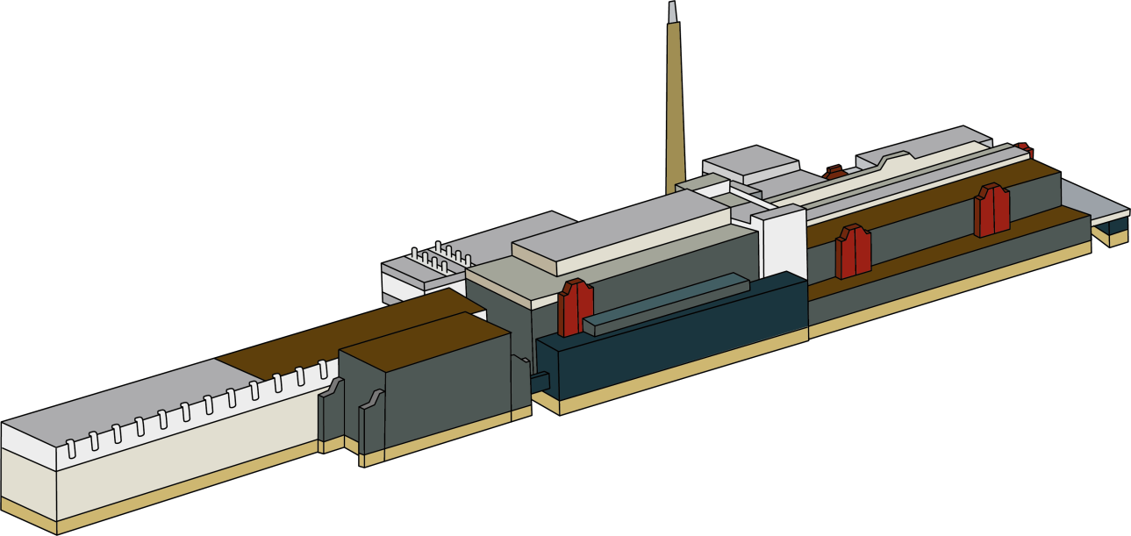

Chemical Plants

Head End

Receipt and storage

Figure 2 – Thorp 2018

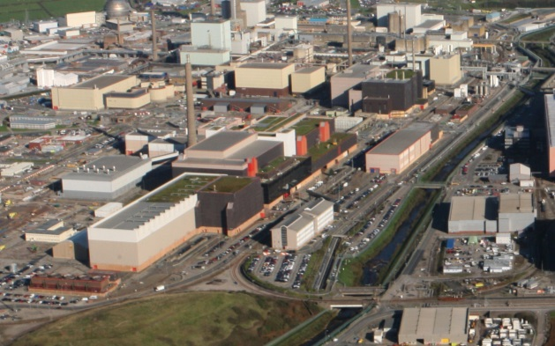

From the outset Thorp was designed to operate to modern safety and environmental standards. This was achieved by incorporating many advanced features, to provide high reliability in operation and low maintenance. Extensive use was made of stainless steel within containment cells to provide for ease of future clean out and subsequent decommissioning.

Movement of liquids was carried out using power fluidic technology to avoid pumps and moving parts subject to wear and needing maintenance. A distributed control system, essentially a network of over 50 local processing stations linked to a central supervisory control computer system provided highly reliable process control, with high levels of redundancy built in.

## safety and environmental aspects

Thorp was built to modern safety standards including seismic design criteria, and low levels of worker and public exposure to ionising radiation.

All reprocessing operations were conducted behind massive shielding, generally incorporating facilities for remote repair and maintenance. Secondary containment was provided in the form of in-cell stainless steel cladding, which also facilitates future decommissioning.

The original workforce radiation exposure design target was an individual exposure not exceeding 15mSv per year. In practice, average exposure of the workforce has been around 0.18mSv per year in 2018.

In terms of environmental impact, a range of modern effluent treatment facilities were commissioned at Sellafield in the 1980’s. They were therefore available to support Thorp operations from the beginning. The ‘salt-free’ flowsheet and the collection of Carbon 14 from the dissolution stage have further reduced the environmental impact of Thorp throughout its operational life.

## operational experience

Over a period of almost 25 years of operation, over 9000te(U) of oxide fuel has been successfully reprocessed. The initial operating period saw a steady increase in annual throughput towards ~900te(U).

As was foreseen during the design stage, a range of operational issues have arisen. The conservatism and redundancy built into the plant allowed these challenges to be overcome and operations to continue – albeit in some cases at a lower throughput than design. Solutions to restore capacity were developed and tested, however due to changes in demand schedules for future processing they were never implemented.

Perhaps the most notable event occurred in 2005 when a significant quantity of dissolver product solution leaked into the stainless steel cladding in-cell. The cause was later identified as weld failure in piping subject to different stress cycles resulting from a changed operating regime. No release of radioactivity occurred, all the material was recovered back into the process using the designed in provisions, and the plant was subsequently brought back into service. The solvent extraction plant has been very reliable throughout, with better than predicted flowsheet performance.

Experience with supporting downstream plants such as the facility encapsulating solid waste in cement grout have generally proven to be reliable – given their innate simplicity this is unsurprising.

During design, provision was made to capture and store products of solvent degradation that were anticipated to arise in operations. Experience has shown that the amounts arising are much lower than expected. Tank capacity will now be used to support post-operations clean-out.

Some plant items were expected to be replaced within an operating cycle. Items such as the shearing machine blades were remotely replaceable. Other equipment such as effluent evaporators were replaced at scheduled outages. Design provision to support this approach has been very successful.

Figure 3 – Summary timeline to start of operations

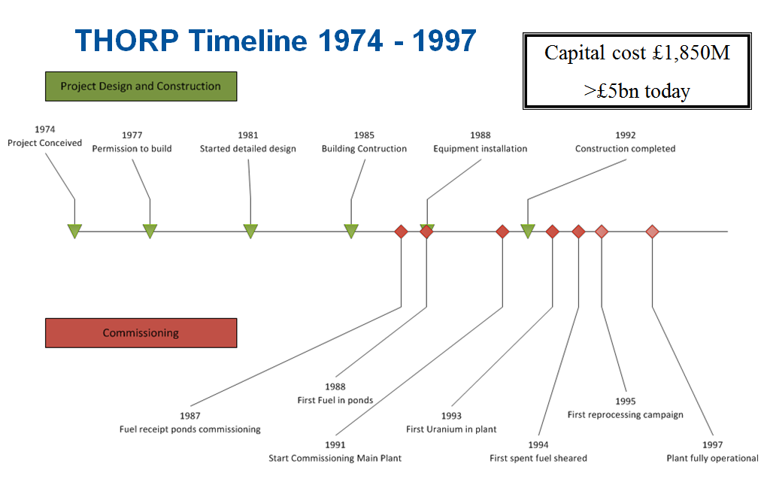

## safeguards

The need to meet the highest international standards of nuclear material accountancy and control were designed into Thorp from the very beginning. Close liaison with Safeguards Authorities during design, construction and commissioning, has continued throughout the following ~25 years of operations. Thorp deployed a very advanced (for the time) system of Near Real Time Material Accountancy (NRTMA) which was derived from the IAEA programme LASCAR. Independent data gathering from Key Measurement Points, incorporated throughout the whole process is a cornerstone of safeguards compliance. Equipment was installed to verify fuel element feed into the shearing equipment, based on advanced radiometric techniques. This has proven to be very reliable in-service. The automated system for transferring plutonium into secure and safeguarded storage has similarly met international expectations.

## closure

The last batch of fuel was sheared into the Thorp dissolver on 9th November 2018, almost 25 years since the start of operations. This brought an end to commercial reprocessing at Sellafield, and the Thorp facility has moved promptly into post-operational clean-out, making extensive use of the designed in provisions to support decommissioning which are a key feature of modern facilities at Sellafield.

## Thorp – into the future

Some facilities in the building will still be used to support the next stages of decommissioning of the site. These are expected to take until at least 2032 to complete. In April 2019, enhanced cleanout procedures will begin. Using a systematic approach, different wash solutions will remove activity out of the plant making it more efficient to decommission when that stage arrives. This will also allow much of the equipment installed in Thorp to go to low level waste routing for disposal, rather than medium or high level routes. This is in line with the site strategic ambition to significantly reduce the overall cost of managing the nuclear liability and hence bringing overall benefit to the UK.

During the final Thorp Chemical Plants rundown the vast majority of fissile material and chemicals will be removed from vessels and pipework. Residual radioactivity and chemicals will then be flushed out and the plant washed out. Further reduction of the radioactive and chemical inventory will follow, enabling the vessels and pipework to be removed and disposed of. As noted above, Thorp is also home to the medium active evaporator which supports the rest of the Site and is destined to do so until around 2032. The storage pond attached to the Thorp reprocessing plant will continue in service for the coming decades for the long term storage of Advanced Gas-cooled Reactor (AGR) fuel. The fuel will be consolidated in other site facilities and transferred for long-term storage prior to final disposal around ~2085.

To achieve this, the pond in Thorp will be re-equipped with new fuel storage racks to allow it to store all of the UK’s un- reprocessed AGR fuel in safe long term storage pending final conditioning and ultimate disposal in a deep geological facility.

## conclusion

In the 1970’s the UK sought to establish a new modern world-scale oxide fuel reprocessing plant, built to deliver safe secure reliable processing with a very small environmental impact

The Thorp plant has operated safely and securely for almost 25 years, completing commercial reprocessing business and treating over 9,300te(U), with very low environmental impact, in addition, the delivery of internationally significant nuclear material safeguards has been consistently achieved at industrial scales.

In all aspects, a very successful commercial project.

**Appendix 1 - Key dates in Thorp ‘lifetime’**

| Date | Event | |
| --- | --- | --- |
| 1969 | Oxide fuel reprocessing starts at Windscale in an early generation Magnox reprocessing facility which has been converted into a Head End facility capable of reprocessing oxide fuel.  First ‘modest’ contracts signed to reprocess oxide fuel on a commercial basis. | |
| 1973 | Original Head End plant which reprocessed oxide fuel is put out of action following a safety incident. | |
| 1975 | BNFL announce plans for expansion of site operations – including Thorp  BNFL contracts have been negotiated, to reprocess 1,500 tonnes fuel for Japanese, German, Swiss, and Spanish utilities companies | |
| 1976 | Government agrees to BNFL taking on reprocessing contracts from overseas, subject to return of wastes  First parliamentary debate on Thorp  Planning permission submitted for Thorp  New international legislation on the exchange of nuclear materials between countries is introduced which requires the return of waste generated in reprocessing to the country where the spent fuel originated from. | |
| 1977 | Secretary of State for the Environment “calls in” planning application.  June - Public Inquiry launched.  November - Public Inquiry closed | |
| 1978 | Public Inquiry report published, allowing Thorp to be built | |
| 1981 | Site clearance begins |
| 1984 | Major civil works start |
| 1986 | BNFL announces Thorp’s order book is full after signing £1.6bn contracts with overseas customers and the English and Scottish electricity boards | |
| 1987 | An analysis shows that Thorp will be capable of reprocessing 7,000 tonnes of fuel in its first 10 years of operation – meaning there is an extra 1,000 tonnes of capacity available to sell to foreign customers. They all take up the option. |
| 1988 | Thorp receipt and storage opens and receives first fuel |
| 1989 | Completion of main buildings and civil engineering contract  Electrical and instrumentation installation started |
| 1991 | Completion of electrical and instrumentation installation |
| 1992 | All shear cave equipment installed and tested  Timetable for revised Sellafield site discharge authorisation agreed with Regulators and Government. |
| 1993 | Third Parliamentary debate – covering the need for Thorp  Summer - Second discharge authorisation consultation opened and “Trust Us” campaign launched  October - Second discharge authorisation consultation closed  December - Greenpeace attempt to gain judicial review and Secretary of State for the Environment announces the decision to go ahead with Thorp operations  Government review of the viability of reprocessing allows Thorp to open | |
| 1994 | First active shear of fuel – AGR from Heysham power station |
| 1995 | Official inauguration |
| 1997 | Plant fully operational |
| 2012 | Government announces Thorp reprocessing will cease in 2018 | |
| 2018 | The last fuel to be sheared in the plant took place in 2018 bringing to an end almost 25 years of operation. | |