# Funding Strategies

# for Spent Fuel Liabilities

D. SUBBOTNITSKIY

IAEA

Vienna, Austria

Email: d.subbotnitskiy@iaea.org

P. WARREN

IAEA

Vienna, Austria

S. DARDOUR

IAEA

Vienna, Austria

**Abstract**

The paper analyzes different strategies for funding the disposal of Spent Nuclear Fuel (SNF). The approach is based on the idea that back-end liabilities should be funded entirely from the cash flow generated during the operation of the nuclear power plant (NPP); future generations should not be burdened with paying the costs of managing spent fuel that was used to benefit earlier generations. The framework underlying this paper is a simple one, assuming a ‘fixed-price’ world with no inflation or cost escalation over the period of NPP operation and Spent Nuclear Fuel (SNF) disposal implementation. Two key concepts used in the model are (i) the target value for the fund at the end of the NPP operation and (ii) contribution schedule - a profile of deposits into fund over the NPP operational stage. Failing to estimate these parameters correctly would lead to the mismatch of fund against liability. An important way to reduce this risk is constant recalibration, i.e. regular revisiting of expected target value of the fund and the amount accumulated over the previous periods. One of the possible strategies respecting the inter-generational equity is a contribution schedule based on constant and ongoing contributions during a station’s operating life (such a contribution schedule may be derived using a Sinking Fund Factor). The paper provides illustrative examples of one-off and ongoing contributions as well as reviewing the evolution of the fund over the duration of the NPP operation and waste management programme implementation phases. Finally, the conceptual overview of the funding strategy in a fixed-price world is introduced.

## INTRODUCTION

The spent fuel produced over the course of a nuclear power plant’s (NPP) operating life will give rise to an associated financial liability – the cost of safely disposing of it – which will accumulate over time. This liability must be met if a nuclear power project is to be successfully wrapped up in a safe and environmentally sound fashion.

The Joint Convention on the Safety of Spent Fuel Management and on the Safety of Radioactive Waste Management [1] states that “[E]ach Contracting Party shall take the appropriate steps to…aim to avoid imposing undue burdens on future generations” (Chapter 2, Article 4, §(vii)). In the context of funding strategies for spent fuel liabilities this principle of *intergenerational equity* may be implemented by designing strategies which fund such liabilities from the revenues earned over a station’s operating life, effectively ensuring that the costs of Spent Nuclear Fuel (SNF) disposal are met by the same consumers who benefited from the electricity generation that gave rise to it.

Practically, such strategies will involve setting up a fund into which the NPP operator will make contributions from its revenues. Over time these funds will grow, with growth driven by both ongoing contributions from station revenues (whose required magnitude can be determined using the so-called Sinking Fund Factor) and returns on the portfolio of assets (bonds, shares etc.) of which it will be composed. In this way the operator will provide arrangements for covering long-term costs associated with the ultimate management of SNF. Clearly the duration of the various phases of the overall NPP project lifecycle will be crucial in determining the amount of funds accumulated; key phases and associated considerations are shown in Fig. 1.

Ensuring that funds’ growth over stations’ operating lives will be sufficient to meet the eventual cost of disposing of SNF can be challenging. In particular any funding strategy must be designed to be robust in the context of significant uncertainties, including the eventual cost of disposing of SNF, the return which funds will earn, the NPP’s operating life (and the possibility of premature shutdown), the choice which will be made regarding when to commence SNF disposal, etc. Repeated re-estimation is key to ensuring this robustness; a funding strategy should be revisited regularly during a station’s operating life, with crucial bases for planning contributions to the fund(s) – such as the estimated SNF disposal cost – re-estimated, and plans revised accordingly.

The remainder of this paper is organised as follows: Section 2 discusses the intergenerational equity principle briefly, stresses the key components of any funding strategy, and introduces an example (Canada’s Adaptive Phased Management approach to SNF) which will be used in the examples in this paper. Section 3 sets out the way in which the notion of discounting can be used to map a profile of SNF disposal programme expenditures into a single number: the amount of money which must be available at the outset of programme implementation (the Present Value or PV of the programme expenditures). Section 4 discusses two key ideas: the application of the PV concept to arrive at a simple ‘lump sum’ solution to funding SNF disposal (avoiding the risk of premature shutdown and the consequent loss of revenues and contributions), and the use of the Sinking Fund Factor (SFF) to derive a constant contribution schedule of uniform payments into the fund(s) over the life of the NPP. Section 5 illustrates the anticipated evolution of the fund in the context of the APM example discussed, and provides a schematic overview of a process for re-visiting and revising a funding strategy, to keep it “on target” for meeting eventual SNF disposal costs. Section 6 contains some conclusions.

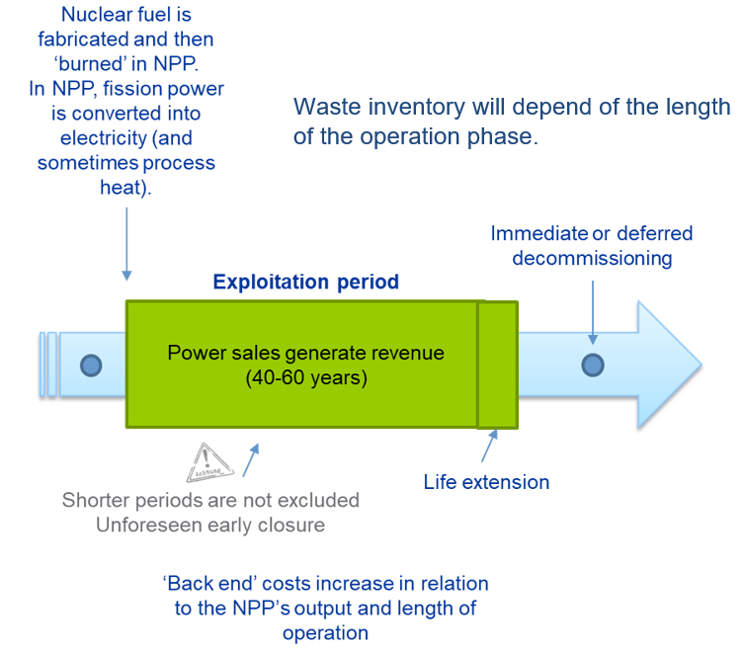

*FIG. 1. Phases and associated considerations in an NPP project lifecycle*

## inter-generational equity, TIMING AND A CANADIAN EXAMPLE

The approach used in this paper to funding of the spent fuel liabilities is based on the assumption that all necessary funds will be accumulated over the operational stage of the NPP life-cycle. This assumption reflects the inter-generational equity principle discussed above: in situation when necessary funds will not be accumulated, or fund provision will be inadequate, unnecessary burden will be put on future generations. Specifically, they would have to pay for managing the spent fuel accumulated during the operation of the NPP that provided energy to previous generations. Inter-generational equity concept considers the arrangement when future generations must pay for the actions of previous generations as fundamentally unjust. The discussion in this paper is practically the systematic analysis of possible ways to avoid such situation.

A key assumption that runs through the examples in this paper is that the operating life of the NPP is 60 years (for the NPP of Generation III or III+), which is also the contribution period for funding the SNF liabilities. The SNF disposal programme is assumed here to start immediately after station shutdown. As regards the timing of that programme, the specific assumptions used in this paper for illustrative purposes draw on a particular SNF (quasi-) disposal concept developed in Canada: the Adaptive Phased Management (APM) approach. APM is based on the idea of “keeping options open” with regard to SNF; retrievability is assumed to be maintained for a period after the spent fuel has been placed in the repository, with the SNF disposal and monitoring being assumed to last 150 years. Therefore, the overall programme lasts 210 years.

Clearly, very long-run planning is necessary for funding the spent fuel liabilities over such a time period within the framework of inter-generational equity approach.

There are two key components of any plan to ensure that SNF disposal liabilities are funded:

1. A target value for the fund at power plant End Of Life (EOL). This target value is an amount of money to be available at power plant EOL to meet SNF disposal costs;
2. A plan for fund deposits until power plant EOL. In practice, this plan is a profile of deposits into fund over the NPP operational stage – a ‘contribution schedule’.

The major challenge is to make right choices on both components, as, given the exceptionally long-term period of planning, underlying assumptions are subject to considerable risk and uncertainty. One way of reducing risk of fund against liability mismatch is constant recalibration, i.e. regular revisiting of expected target value of the fund (that may change over the decades of the NPP operation) and the amount accumulated over the previous periods (in case if the rent of return varies). This approach is called Adaptive Phased Management (APM).

Fig. 2 illustrates the spending profile for the SNF programme envisaged under APM (left axis) and total accumulated cost (right axis) spanning over the period of 150 years (see [2] for further details of the APM programme and a related cost estimate).



*FIG. 2. Annual and Cumulative Costs of the SNF programme under APM.*

## FUNDING IN A WORLD OF CERTAINTY AND FIXED-PRICES

In this Section the most simplified case with no uncertainty in ‘fixed-price’ world will be discussed. ‘Fixed-price’ world means that there is no inflation and cost escalation over the period of NPP operation and SNF disposal programme implementation. This assumption allows getting precise estimate of the target value for the fund: and the cost of the SNF disposal programme will remain the same in 60 years after the start of the NPP operation. ‘No uncertainty’ means that the discounting factor is known and is expected to remain constant over the whole period of NPP operation and the cost of the SNF disposal programme is known with certainty. Note that in this context a funding strategy could be established at the outset of an NPP’s operating life, and never revised.

The example illustrated by Fig. 2 shows the cumulative cost at the level of $18B for the whole duration of the programme. However, it will not be necessary for the owner of the NPP to make contributions totalling $18B; to understand why not we introduce the notion of discounting.

Discounting is a method for estimating amount that needs to be saved in present to fund expenses in future. The method is based on the idea that interest of ***r\**** could be earned per year on current amount of investment. Specifically, if ***$100*** is deposited in the bank today, then ***$100 × (1+r*)*** will be received in 1 year. The “Present Value” (PV) of ***$1*** to be received in 1 year is the answer to the question: What is the $ amount that – if multiplied by ***1 + r\**** – would give $1? PV concept is key in SNF disposal funding planning in two distinct ways:

1. Calculating a target value. PV back-end expenditures back to the date of the first expenditure.
2. Calculating a lump sum funding contribution. PV the target value back to the date at which the lump sum is deposited in the fund (see Section 4).

The value of ***r\**** – rate of return assumption in the formula is necessary for the adequate calculation of a target value of the fund. In case if assumption about ***r\**** valueis incorrect the funds accumulated by the end of the NPP operation will be inadequate to fund the Decommissioning and SNF programme. Again, the forecasting here is used for the period over two centuries, which puts any assumptions about the rate of return at risk. Clearly, it is impossible to eliminate the risk completely, however, it can be mitigated by the use of conservative assumptions on the rate of return, similarly to other organizations and entities that need to do long-term projections, e.g. public pension fund actuaries. Again, regular recalibration within the framework of APM approach is another part of the risk-mitigation strategy. When certain (probably very conservative) assumption about the rate of return is accepted, it is possible to calculate the target value for the fund. For the example provided in this paper the assumption ***r*= 2.6%*** is used.

Target value for the fund at the period T can be derived by:

1. Estimating ‘overnight’ cost profile of ‘back end’ expenditures, e.g. SNF disposal.
2. Discounting cost profile back to first expenditure period (i.e., back to T+1) using discount rate.

Fig. 3 illustrates this approach: the total amount of spending over 150 years of SNF management programme is not a simple addition of expenditure as the funds being spent for the SNF management programme are being used over 150 years, i.e. not a cumulative value of $18B from Fig. 2. The actual amount of funds needed to fund the programme will be the addition of the value of expenditure by years discounted to the moment of the power plant EOL, i.e. year 60. Discounting normalizes the spending and makes expenditure that will be made in different years comparable. Taking out the time component allows obtaining the total amount of funds that will be needed by the NPP EOL. This amount (in example provided in Fig. 3 – $6.8B) should be enough to fund the SNF management programme given the assumptions that:

1. Fund returns will remain not lower than discounting rate used to obtain the target value of the fund, which is the sum of PVs of expenditures over the whole period of programme implementation at the power plant EOL.
2. Expenditure will follow the spending profile for the programme.

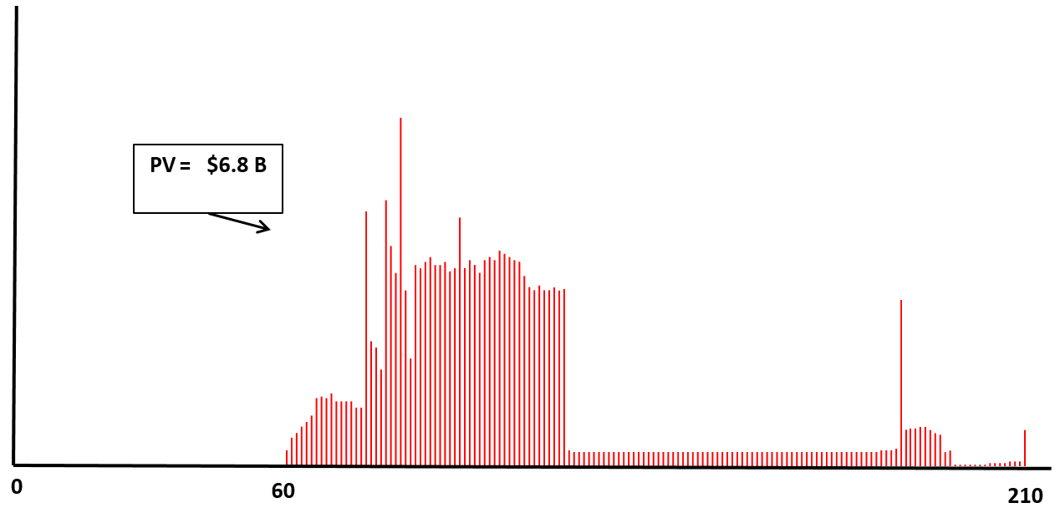

*FIG. 3. Calculating Present Value of Adaptive Phased Management (APM) spending for Decommissioning and SNF management programme.*

## ONE-OFF AND ONGOING CONTRIBUTIONS TO FUND

If an expenditure is to take place in T periods (e.g., SNF disposal programme) then discounting it (taking its PV) at ***r\**** yields the one-off lump sum amount to be deposited in a (segregated) fund today to ensure the availability of funds to meet that expenditure when it falls due. The assumption here again is that ***r\**** will be met over the period of NPP operation and implementation of the SNF disposal programme. Specifically, to accumulate $6.8B by the NPP EOL (60 years in future) that will be enough to fund cumulative spending of $18B over 150 years (i.e., till the year 210 in future) with assumption that ***r*= 2.6%*** over the whole period, it is enough to put in the fund $1.497B in the beginning of NPP operation (see Fig. 4). With the constant rate of return this amount will increase to $4.513B in year 44 since the NPP commissioning, $5.402B in year 51 and will reach required $6.8B in year 60.

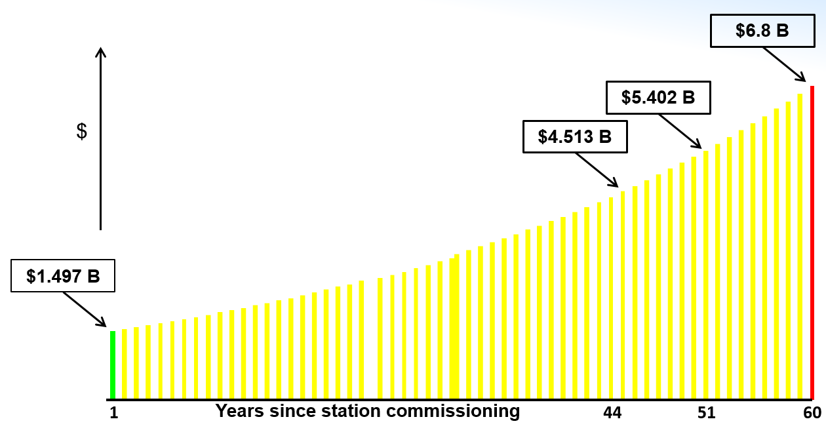

*FIG. 4 Discounting for a lump sum contribution*

However, this “one-off funding” is not typical as it requires investment before the NPP is commissioned and starts generating revenue. A more typical arrangement is one of “ongoing funding” *via* a stream of contributions from station generation revenues over 60 years. For this strategy there are two drivers of fund accumulation, both being subject to risk:

1. Contributions.
2. Fixed amount or $/MWh-based contribution scheme;
3. Risks: (1) premature shutdown and/or operator bankruptcy; (2) lower than expected output. Number (2) can be corrected during plan revisions.
4. Returns.
5. Risks: inadequate fund returns;
6. Risks can be corrected during plan revisions; asset composition of fund holdings can often lead to increased returns - at cost of more risk exposure.

One approach for “ongoing funding” is to design a contribution schedule based on uniform (and ongoing) contributions. To calculate these contributions the concept of the Sinking Fund Factor (SFF) is employed. The SFF is a factor which can be multiplied by a ‘target’ fund value to compute the *uniform* stream of periodic contributions needed to fund that target in ***n*** periods if contributions earn a periodic return of ***r\****. The SFF is calculated using the following formula:

$$\text{SFF=}\frac{\text{1}}{\left(\frac{{\left(\text{1+}{\text{r}}^{\text{*}}\right)}^{\text{n}}\text{-1}}{{\text{r}}^{\text{*}}}\right)}$$

where:

* ***r\**** is the return on contributions.
* ***n*** is the number of periods over which contributions will be made.

In the example of the SNF management programme spanning for 150 years after the NPP operation for 60 years the inputs for the SFF formula are:

* ***r*= 2.6%*** - return on contributions.
* ***n=60*** - funds will accumulate over 60 years.

Using these inputs SFF could be calculated:

$$\text{SFF=}\left(\frac{\text{1}}{\left(\frac{{\left(\text{1.026}\right)}^{\text{60}}-\text{1}}{.\text{026}}\right)}\right) = 0.007094342$$

The periodic (annual) contribution will therefore be $0.007094342 × \$6,800M = \$48.24M$. This means that to accumulate the $6.8B by the NPP EOL it will be necessary to contribute $48.24M annually over the period of 60 years.

Fig. 5 below illustrates this contribution schedule with the elements in green showing contributions over the 60 years of NPP operation accumulating in the fund that will be able to fund expenditures (in red) over the period of 150 years in future.

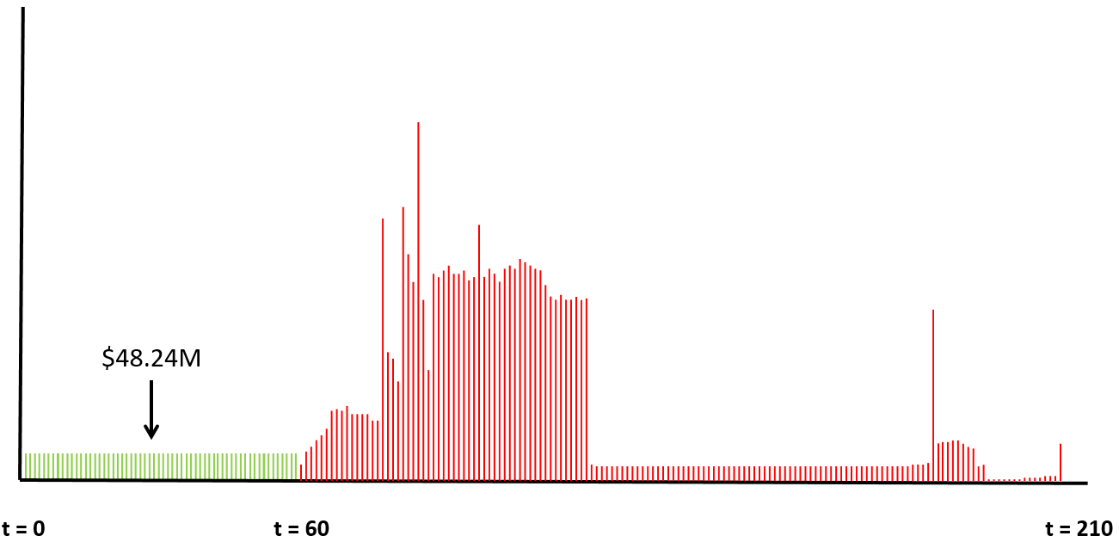

*FIG. 5. Contributions and disbursements over 210 years to fund APM*

## EVOLUTION OF THE FUND AND CONCEPTUAL OVERVIEW OF THE STRATEGY IN A WORLD OF UNCERTAINTY AND FIXED PRICES

The fund will exist for the whole period of NPP operation and implementation of decommissioning and waste management programme. Over the first 60 years (period of NPP operation) there will be no expenditures and the fund will be expanding up to the level of $6.8B in the year 60. Expenditures will start after this (year 61), however, the fund will continue expanding for some time as the revenue on the accumulated funds will continue adding up. At its maximal expansion the fund will be nearly $10B a few decades after the end of the NPP operation, afterwards it will start declining being completely exhausted by the end of the Decommissioning and SNF management programme implementation. Illustration of this evolution over the period 210 years is shown in Fig. 6.

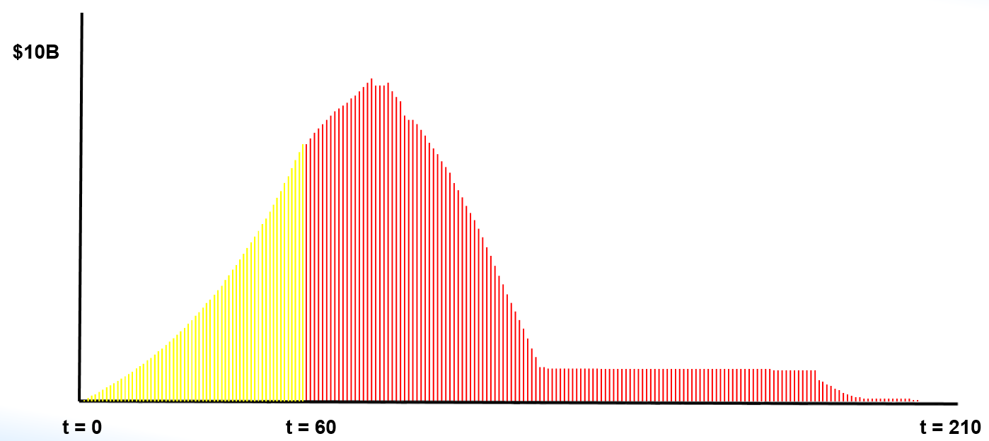

*FIG. 6. Fund evolution over 210 years*

If we now allow for uncertainty, a key component of ensuring that the fund achieves its target value by the NPP EOL is the regular revision of the target value of the fund and the contributions based on amount already accumulated in the fund. The conceptual representation of this iterative revision is shown in Fig. 7. The assumption is that revisions will be done regularly (e.g., every five years) and scheme on Fig. 7 shows the revision done in the cycle k. Different types of inputs used for the analysis are shown in the boxes of different colours.

‘Green’ boxes include the inputs used for the revision of the target value of the fund, specifically, the overnight cost estimate of the Decommissioning and SNF management programme made in the cycle ***k*** and the discounting factor (which could potentially change over time as well). These inputs allow calculating the PV of the necessary funds by the NPP EOL, i.e. target value of the fund ***Ck***. ‘Yellow’ box represents the amount ***Vk*** already accumulated in the fund by the time of revision in the cycle ***k***. ‘Red’ boxes show the inputs necessary to recalculate the SFF in the revision cycle ***k***, specifically, the projected return on funds ***r\****, and the strategy for the implementation of the Decommissioning and SNF management programme, i.e. over how many periods the contributions will be made.

These inputs provide, within the framework of the model in fixed-price world and no uncertainty, enough information to recalculate the amount of periodic (annual) contribution. This amount is the difference between the estimated target value of the fund and amount that has already been accumulated (this amount should also be normalized to the moment of the NPP EOL given the estimate of the projected return on funds ***r\****) and multiplied by the SFF.

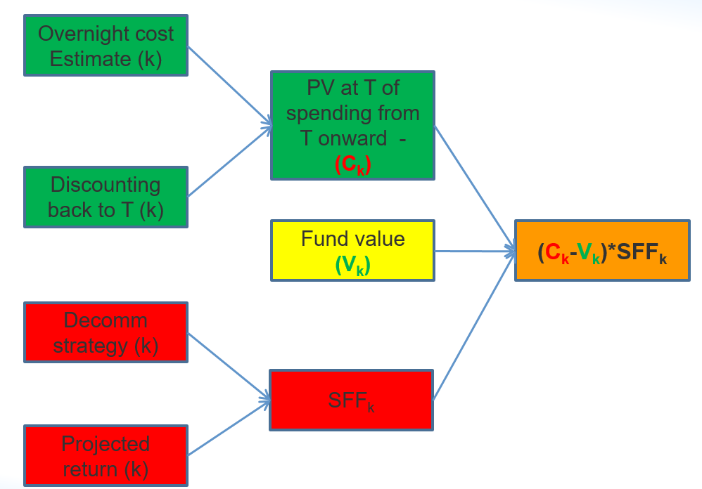

*FIG. 7. Inputs to the kth revision of a contribution schedule*

## CONCLUSIONS

Funding strategies designed to meet liabilities arising from the need to dispose SNF are an integral part of ensuring that nuclear power generation is carried out in an environmentally conscientious and sustainable manner. In this paper we have emphasized the role of the intergenerational equity principle in shaping such strategies, demonstrated the role of discounting in identifying a target for funds to attain by an NPP’s EOL, demonstrated the use of the SFF in deriving a uniform contribution schedule, and stressed the importance of periodic re-estimation and plan revision (as shown in Fig. 7) in order to address uncertainty. Two examples of ‘contribution schedules’ have been presented: the ‘lump sum’ case and the ‘continuous uniform contributions’ case. These may be thought of as polar cases, with the former removing all funding risk arising from the possibility of premature shutdown. It is straightforward to derive an intermediate case in which funding is front-end loaded – i.e. weighted so that larger contributions are made earlier in an NPP’s operating life. It is also relatively straightforward to relax the ‘fixed price’ assumption – made here for simplicity; in the real world this will necessitate the forecasting of price escalation and the incorporation of this forecast into the revision process shown in Fig. 7, but this modification is also relatively straightforward.

# REFERENCES

|  |  |
| --- | --- |
| [1] | IAEA, "Joint Convention on the Safety of Spent Fuel Management and on the Safety of Radioactive Waste Management, INFCIRC/546," IAEA, Vienna, 1997. |
| [2] | Nuclear Waste Management Organisation, "APM Conceptual Design and Cost Estimate for a Deep Geological Repository in Crystalline Rock Summary Report, APM-REP-00440-0011," Toronto, October, 2011. |