French “Cycle Impact” approach

Integrated approaches to the back end of the fuel cycle

F. GAUTHIER
IRSN
Fontenay-aux-Roses, France
Email: florence.gauthier@irsn.fr

J-P. DAUBARD
IRSN
Fontenay-aux-Roses, France

Abstract

The fabrication of EDF's nuclear fuels and their management once used, as well as associated waste, require many industrial operations, qualified as "fuel cycle".
As requested by the French nuclear safety authority (ASN) since 2000, EDF in collaboration with its industrial French partners (Orano Cycle, Framatome, Andra) elaborates periodically a so-called "Impact Cycle" file. This document provides elements to demonstrate for the next ten years the compatibility, in terms of safety and radioprotection, between changes in fuel characteristics and fuel management in NPP and developments in fuel cycle facilities and the corresponding transports.
In June 2016, EDF submitted the file called "Impact cycle 2016" covering the 2016-2030 period.
The IRSN examination focused on:
• the adaptation to needs and evolutions, that may occur in the short or medium term (change of fuel, evolution of facilities, etc.), of the means involved in the fuel cycle (production or storage facilities, logistical means, etc.);
• the study of different scenarios of nuclear-sourced electricity production, including scenarios considering its reduction to 50 % of electricity production by 2025, in accordance with the Energy Transition Law for Green Growth (TECV Law);
• the study of postulated dysfunctions for every stage of the cycle, with identification of associated parades;
• the analysis of major inflections and "cliff effects" that may appear by 2040.
IRSN transmitted to ASN the conclusions of its assessment in May 2018, which were presented to permanent group of experts for laboratories and plants (GPU), including experts from waste, nuclear reactors and transports committees at its meeting on 25 May 2018.
In conclusion, IRSN considers that assessment of the impact on the facilities and the transport activities participating to the French fuel cycle, of the current managements of EDF nuclear fuels and those envisaged until 2030, does not reveal major technical difficulty for this period. The study of prospective scenarios considering a reduction of nuclear-sourced electricity in application of the TECV Law shows that the shutdown of reactors loaded with MOX fuels can induce a short-term saturation of spent nuclear fuel storage facilities. However, a scenario including only the shutdown of reactors loaded with only UOX fuels could delay or even prevent the saturation of these storage facilities. IRSN also underlines the importance of examining the impact on the overall fuel cycle, of reactors shutdown, which will be carried out in application of the TECV Law.

INTRODUCTION
EDF operates a fleet of 58 pressurized water nuclear reactors (PWRs), 34 reactors of 900 megawatts (MWe), 20 reactors of 1300 MWe, while the last four deliver 1450 MWe. A 59th reactor is currently under construction in Flamanville. The fuels currently loaded in the reactors are manufactured with enriched natural uranium oxide (UNE), 22 reactors of 900 MWe also use mixed oxide uranium and plutonium (MOX) fuels.
The fabrication of fuels for EDF nuclear power plants and the management of these fuels once used, as well as associated waste, require many industrial operations. All these operations are included in the fuel cycle.
In this context, the fuel cycle in France includes the following operations described on the diagram:
- Manufacture of fuels with enriched natural uranium oxide (UNE).
- Burning of the fuels in NPPs.
- Reprocessing of UNE fuels once used.
- Manufacture of MOX fuels from the plutonium produced by reprocessing of used UNE fuels.
- Storage of unreprocessed fuels (in particular MOX fuels).
- Associated waste treatment and storage facilities.
- Radioactive material transportation required for these different operations.

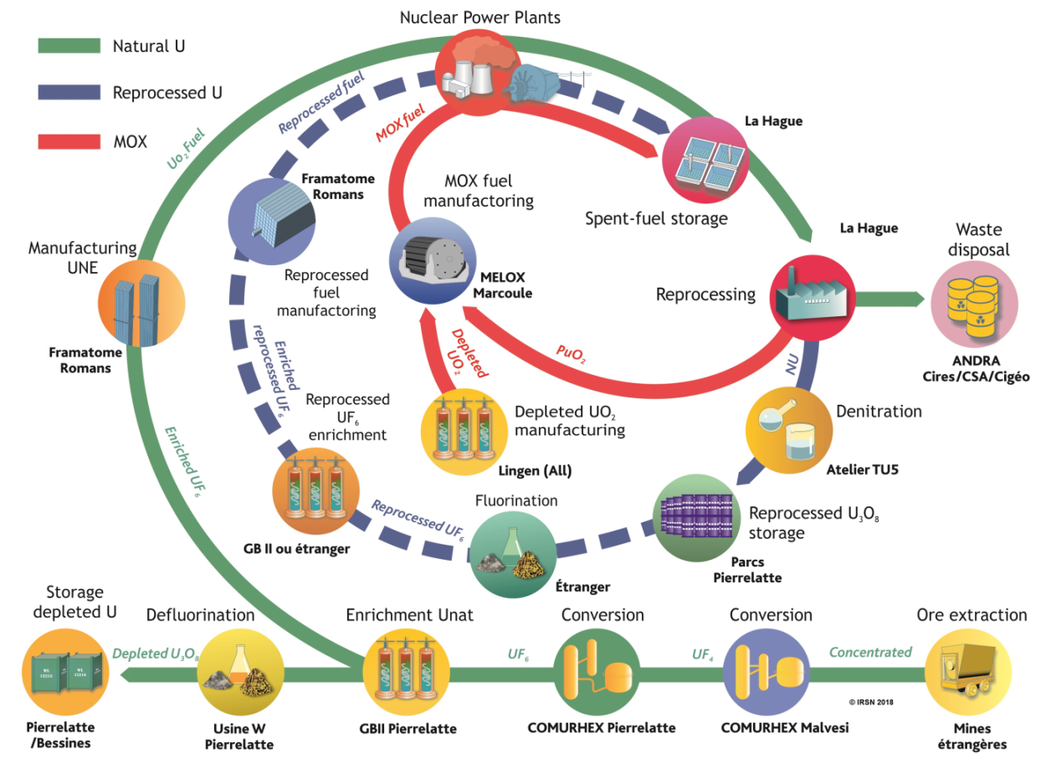

The periodic review of the overall coherency of this cycle (i.e. the adequacy, in terms of safety and radiation protection, of the plants, the facilities and means of transport associated with fuel management planned in the reactors) is essential to anticipate changes to be made, such as the modification or creation of facilities. Considering the kinetics of these evolutions, it is necessary to anticipate them by about ten years.
As requested by the French nuclear safety authority (ASN) since 2000, EDF in collaboration with its industrial French partners (Orano Cycle, Framatome, Andra) elaborate periodically a so-called "Impact Cycle" file. This file presents the consequences, at each stage of the cycle, of EDF's strategy concerning the use of different types of fuel in its reactors for the next ten years. It provides elements to demonstrate the compatibility between changes in fuel characteristics and fuel management and developments in fuel cycle facilities and the corresponding transports with regard to safety and radiation protection.
The first version in 2000 and its update in 2007 were the subject of IRSN assessments. The conclusions of these assessments were presented to the advisory committee in 2002 and 2010 respectively. At the end of the last instruction, ASN sent a list of requests to EDF, in particular the transmission by EDF of an update of the “Impact Cycle” file.
In June 2016, EDF submitted the file called "Impact cycle 2016" covering the 2016-2030 period. In addition to the items requested in the two previous files, this file includes:
- The study of prospective scenarios to reduce the level of nuclear power generation to 50% by 2025, in line with the goal of the Energy Transition Act for Green Growth (TECV). ASN has defined the scenarios to be studied by EDF; these define the timing, from 2017 to 2025, of reactor shutdown to achieve the 50% target mentioned above.
- A study of operational dysfunctionings for each stage of the fuel cycle.
- An analysis of major inflections and “cliff edge effects” that may appear by 2040.
IRSN transmitted to ASN the conclusions of its assessment in May 2018 [1]. These conclusions were presented to the advisory committee for laboratories and plants, including experts from waste, nuclear reactors and transports committees at its meeting on 25 May 2018. IRSN published in October 2018 the synthesis of the expertise and the report [2] presented to the advisory committee.

Main changes concerning nuclear fuel management
The “Impact Cycle 2016” file presents the main changes concerning nuclear fuel management envisaged by EDF for its reactors. IRSN in particular notes that:
- EDF will soon recycle reprocessed uranium (URT) for the production of enriched reprocessed uranium fuels (URE fuels). These URE fuels will be loaded in four reactors.
- Used MOX and used URE fuels will not be reprocessed during the period considered in the "Impact Cycle 2016" file. They are intended to be stored in the storage pools of La Hague site. Reprocessing is however envisaged after 2050 in order to use the materials recovered for the manufacture of fuels to be loaded in the so-called fourth generation reactors.
IRSN observes that the orientations adopted by EDF in terms of fuel management do not introduce any significant change compared to the current situation. In addition, EDF maintains the management principle of balancing the amount of plutonium coming from reprocessing to the amount necessary to manufacture MOX fuels loaded in reactors.

Impact of envisaged fuel management on French fuel cycle facilities
The "Impact Cycle 2016" file presents an analysis of the impact, on the facilities of the cycle, of the EDF scenarios taking into account the evolutions envisaged concerning the fuel management as well as the provisions foreseen to remedy the identified difficulties.
IRSN notes that the main issues concern:
- Storage capacities of depleted uranium and reprocessed uranium. EDF in cooperation Orano has planned actions to increase the capacity of these storages.
- Adaptations in facilities that will manufacture URE fuels. EDF is committed to presenting the safety and radiation protection provisions to be implemented in the plants concerned.
- Spent fuel storage capacities in the reactor cooling pools and in La Hague storage pools. EDF concludes that there is a risk of saturation by 2030. IRSN's assessments are consistent with this estimation. In this respect, EDF is planning to commission a centralized storage pool by 2030, particularly for MOX and URE used fuels. The safety options file for this facility, submitted in 2017 by EDF, has been assessed by IRSN. In addition, EDF and Orano Cycle plan to continue actions to increase the storage capacities in the reactors cooling pools and La Hague storage pools. For IRSN, the deadline for commissioning the centralized storage pool has little margin to avoid saturation of the pools and could be insufficient in the event of a short-term shutdown of reactors loaded with MOX fuels. Also IRSN estimates that EDF, with Orano Cycle, will have to present annually a detailed analysis of the available storage capacities of used fuels until 2030, extended prospectively until 2035. This was the subject of a commitment by EDF.
- Waste storage. The analysis of the impact, over the period from 2016 to 2030, of changes of fuel management on waste (quantity, type, etc.) that will be generated by the cycle facilities shows that the storage capacities of certain waste in La Hague plant (vitrified waste packages, compacted waste packages, etc.) could not be sufficient, depending on the retained hypotheses. This subject was examined by IRSN. Orano Cycle made several commitments, notably to ensure that its waste management strategy will enable to have sufficient waste storage capacity, under adequate safety conditions.

Impact of envisaged fuel management on the material and waste transportation
The “Impact Cycle 2016” file presents an evaluation of the availability rate of the different transport packages required for the operation of the fuel cycle facilities. This does not lead to the identification of any particular difficulty over the period studied. IRSN has no comment on the elements presented concerning off-site transport.
However, with regard to internal transport on the La Hague site, IRSN considers that one transport system constitutes a critical equipment for the management of waste on this site; the unavailability of one of these systems could lead to a significant reduction of the transport capacities of certain waste. IRSN made a recommendation on this subject.

Study of dysfunctionings
EDF, with Orano Cycle and Andra, studied the consequences on the operation of the fuel cycle, of dysfunctionings (unavailability of facility or mean of transport, loss or absence of approval for a transport package...) likely to affect the operation of facilities involved in the fuel cycle or the schedule for the deployment of new fuel management. Operators indicate that the duration of the dysfunctionings selected in this study is based on experience feedback. The study concludes that the dysfunctionings selected are not likely to lead to significant consequences on the functioning of the cycle.
For IRSN, this study, which takes into account operational dysfunctionings, is a first step which is globally satisfactory. Nevertheless this study needs to be completed for La Hague plant and the reprocessed uranium conversion facility (TU5) in order to better take into account all operational dysfunctionings that may lead to a prolonged unavailability of these facilities. In fact, concerning La Hague plant, the study only examined the consequences of the unavailability of one of the two treatment plants for a period of six months. However IRSN considers that some events may lead to a prolonged shutdown of the two plants. For IRSN, the studies carried out for La Hague treatment plants and TU5 facility must be completed. In this respect, Orano Cycle has undertaken, in liaison with EDF, to complete its study.
In addition, for IRSN, events leading to the shutdown of certain facilities in the cycle, for a duration longer than that retained in the “Impact Cycle 2016” file, cannot be excluded, particularly in the event of an accidental situation. Also IRSN recommended that the operators continue this study by an evaluation of the duration of unavailability of facilities participating in the fuel cycle that could lead to its blockage and, on this basis, identify possible parries to face it.

Technical watch and anticipation process
The "Impact Cycle 2016" file presents the main orientations envisaged for the fuel cycle operation beyond the period of study considered, that is from 2030. In particular, it is planned to extend the lifespan of reactors beyond 40 years and to continue the treatment of spent fuels in order to use plutonium and uranium for the production of MOX and URE fuels. In particular, EDF indicates to study the implementation of MOX fuels in 1300 MWe reactors, replacing the use of this type of fuel in the CPY reactors. The main modification envisaged concerning the management of fuels is the implementation of a new MOX fuel (different spectrum). In addition, apart from the commissioning of the centralized storage pool, the file does not present major changes concerning fuel cycle facilities, waste storage facilities and transport. In any case, the submitted file does not identify a cliff edge effect related to the planned changes in fuel management for these facilities and means of transport.
IRSN has not identified, at this stage, any blocking problem due to the envisaged evolutions. However, IRSN pointed out that the loading of MOX fuels in the 1,300 MWe reactors, which will require in-depth studies, would entail major adaptations of the facilities concerned and the implementation of a new transport package. For IRSN, feasibility of the modifications to be carried out, remains to be confirmed.
In addition, while most facilities of the front end of the cycle have recently been upgraded or replaced, the submitted file does not contain the measures for ensuring the renovation or renewal of the back end facilities: MELOX and La Hague plants, which have been in operation for more than twenty five years.
In this regard, recent periodic safety reviews of these facilities have led operators to make modifications for ageing management of equipment (evaporators of fission products of La Hague plant in particular). Also, as part of the "watch and anticipation" process, the operators concerned must anticipate the measures to be taken for ageing management of these facilities. IRSN recommended that operators submit, in the next "Impact Cycle" file, the provisions envisaged for the refurbishing or renewal of cycle facilities according to their predictable lifespan and planned changes in energy policy.

Mix energy scenarios
EDF has studied the reactor shutdown scenarios, defined by ASN, aimed at taking into account a 50% limitation on the share of nuclear power in electricity generation by the end of 2025. The scenarios studied by EDF show that the impact of the shutdown of reactors on the fuel cycle facilities depends strongly on the type of fuel loaded in the shutdown reactors. Indeed the scenarios studied leading to the shutdown of several reactors loaded with MOX fuels would quickly lead, all things being equal, to the saturation of La Hague storage pools, followed by the saturation of the reactor cooling pools and the shutdown of the reactors. This saturation is related to the application of the management principle aimed at balancing the plutonium flux resulting from the treatment of used fuels and that used for the manufacture of MOX fuels. On the other hand, the shutdown of reactors loaded with UNE fuels would not have a so strong impact on the fuel cycle facilities.
Calculations carried out by IRSN confirm the conclusions of the studies carried out by EDF. In particular, IRSN underlines that a scenario, "mix energy" including the shutdown of reactors loaded with UNE fuels could delay or even prevent, according to the number of reactors shutdown, the saturation of spent fuel storage pools. For IRSN, these studies show, in particular, that the impact on the overall operation of the cycle must be taken into consideration in the choice of reactors to be shut down in order to respect the objective set in the TECV law. IRSN considers, in particular, that EDF, with other operators, will have to examine this impact in the case of the shutdown of MOX fueled reactors. This point was the subject of an EDF commitment.

Conclusion
In conclusion, IRSN considers that, from the safety and radiation protection point of view, assessment of the impact on the facilities and the transport activities participating to the French fuel cycle, of the current managements of nuclear fuels and those envisaged until 2030, does not reveal major technical difficulty for this period. This is due to the absence of any significant change in the management of fuels. However the provisions planned by the operators to cope with the expected saturation of certain storage facilities (depleted uranium, spent fuel assemblies, etc.) must be deployed according to the planned schedule.
The study of prospective scenarios considering a reduction of nuclear-sourced electricity in application of the TECV law shows that the shutdown of reactors loaded with MOX fuels can induce a short-term saturation of spent fuel storage facilities. Evaluations carried out by IRSN confirm the conclusions of EDF. However a scenario including the shutdown of reactors loaded only with UOX fuels could delay or even prevent the saturation of spent fuel storage facilities. IRSN also underlines the importance of examining the impact on the fuel cycle of the shutdown of reactors. This exam has to be carried out considering the Multi annual energy plan Decree to be released in summer in application of the TECV law.
The study of operational dysfunctionings for each stage of the fuel cycle constitutes a first exercise that is globally satisfactory. Nevertheless the study needs to be pursued in order to reinforce the robustness of the French fuel cycle. IRSN considers that the operators will have to evaluate the duration of unavailability of each workshop of the facilities of the fuel cycle which would lead to block the operation of the fuel cycle and, on this base, to identify the possible parries to put in place.
Finally, from the analysis of the major evolutions on the fuel cycle facilities envisaged in the longer term, IRSN notes in particular that the loading of MOX fuels in the 1,300 MWe reactors will require in-depth studies and important adaptations of the facilities and of transport packaging; the feasibility of these adaptations remains to be confirmed. In addition the refurbishing or renewal of fuel cycle facilities according to their foreseeable lifetime and the energy policy constitute a major challenge for the control of the fuel cycle beyond 2030.
In November 2018, based on IRSN expertise ([1] and [2]), ASN issued its decision ([3] and [4]) in which it made requests for EDF and the other operators.
References
- Avis IRSN/2018-00126 du 4 mai 2018
- Rapport IRSN n°2018-00007 – Cycle du combustible nucléaire en France – Dossier “Impact Cycle 2016”
- Lettre ASN CODEP-DRC-2018-041575 du 25 octobre 2018
- Avis n° 2018-AV-0316 de l’Autorité de sûreté nucléaire du 18 octobre 2018 relatif à la cohérence du cycle du combustible nucléaire en France

