# LA HAGUE REPROCESSING PLANT: A MATURE TECHNOLOGY CONTINUOUSLY ENHANCING ITS PERFORMANCES THROUGH INDUSTRIALIZATION OF R&D PROGRAMS

BERTRAND MOREL

Orano

Paris, France

Email: bertrand.morel@orano.group

ANDREAS SALVATORES

CEA

Saclay, France

**Abstract**

Over 35,000 tons of used fuel have been processed in La Hague so far, and more than 8,000 MOX and 7,200 ERU Fuel Assemblies have been produced from recycled material. These experiences together with fairly stable yearly production levels for 40 years clearly demonstrate the industrial maturity of those technologies.

In France, used fuel reprocessing and recycling facilities continue their operation while enhancing the range of LWR and RR used fuels to be treated and performing investments to both increase competitiveness and secure long-term operations. This leads to continuously develop and implement new technologies, those resulting from constant interactions between R&D teams, mainly from the CEA, engineering department and operating facility teams.

These improvements include since 2010 the implementation of a Cold Crucible Induction Melter (CCIM) in an existing and very highly active facility (R7) at La Hague. In comparison with the Hot Melter, the Cold Crucible Induction Melter allows to operate with a higher throughput and a higher elaboration temperature. This technology makes possible the conditioning of two different types of effluents (from rinsing operation and with corrosive solution) with different glass formulations. Additional recent examples range from the first silicide fuel reprocessing campaign completed in 2017 at La Hague thanks to R&D developments enabling the process qualification, the deployment of a prototype innovative technology in order to provide a 360 degree weld with no physical nor visual access, and the completion of the dismantling of one of the former fission products’ evaporator using laser technology.

R&D developments are continuously being performed to enlarge the range of used fuel capabilities to meet customer/market needs as well as to improve operating standards and secure long term operation.

## INTRODUCTION

Over thirty thousand tons of used fuel have been processed in La Hague plants so far, and more than two thousand tons of each LWR MOX fuel and ERU fuel have been produced from recycled material. These experiences together with fairly stable yearly production levels for almost thirty years clearly demonstrate the industrial maturity of those technologies.

However, after so many years of production for UP2-800 and UP3 several ageing issues, such as clogging and corrosion, are observed. Also new technologies are needed due to obsolete electronics, rising maintenance cost of remote operations.

R&D programs are therefore necessary to deal with new problems arising. In this paper we present several example of R&D work performed between Orano and CEA and how the implementation led to process improvement. Two themes are discussed: clogging and corrosion with a focus on dissolution, separation, concentration and vitrification (Fig. 1).

In many cases the R&D projects expand for many years and sometimes several decades occur between starting time of R&D and industrial application. However for some projects the implementation is much faster, only a few years. The key factors favoring efficient R&D in the field of U, Pu reprocessing are discussed.

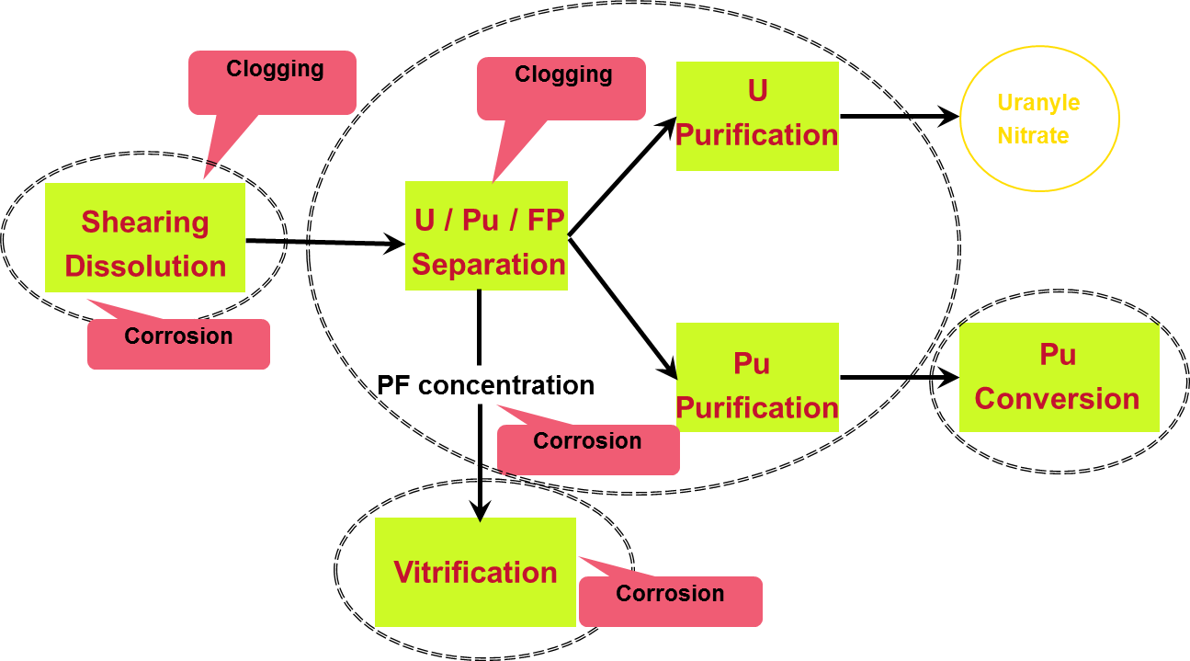

*FIG. 1. Type and location of ageing issues discussed in the paper*

## R&D PERFORMED REGARDING CLOGGING, FOULING ISSUES

### Dissolution

During the nitric dissolution process, Zirconium molybdate precipitation occurs and the crystalline precipitate sticks to the internal walls [1]. Accumulation in the dissolver wheel and vessels is a problem for several reasons: the precipitate incorporates Plutonium as a substitution to a small fraction of zirconium IV and its accumulation creates criticality issues [2]. Also the accumulation on the walls hinders the heat exchange.

Indeed, in 1994, after 4 years of industrial operations of UP3, a decrease of heating performances of the wheel was first observed and this led to the discovery of deposits on the buckets and on the bottom of the dissolver. Composition was then investigated and found to be (Zr(MoO4)2) with typical few percent of Pu[3].

Scheduled dissolution of such precipitates is now therefore considered an important action to maintain optimum heating performance and avoid accumulation of nuclear material.

After launching a R&D program in 1995 regarding the conditions of precipitation, a rinsing protocol with NaOH solution was designed. However the use of sodium was found not very advantageous:

* regarding vitrification, the incorporation of the added Na would contribute to glass volume increase;
* the rinsing time was found very long, which means a loss of production;
* the protocol required alternate acid and basic rinsing therefore increasing the effluent volume going to treatment.

In 1999 a new R&D program was launched to study a carbonate rinsing and in 2000 a patent was filed. In 2010 through 2013, a progressive qualification in the R1 workshop was performed.

The process is now fully industrialized since 2016 with a gain of 50% on both effluent volume and production time loss. The project is rightly considered an industrial success. However one may note that from the initial discovery of the precipitates in 1994 and the full industrial implementation, 22 years have passed.

### Separation

In a similar manner to dissolution, after several years of operation, several columns of extraction in UP3-T4 plant had to be changed in 2012 because of clogging. Analyses revealed that TPH degradation products could be responsible for precipitating a palladium complex [4]. The dissolution of the precipitate was studied in 1M NaOH which proved the most efficient reagent to dissolve the precipitate after one day. Since 2016, several columns are now washed on a regular basis in La Hague and only 4 years occurred between discovery and implementation.

## R&D PERFORMED REGARDING CORROSION ISSUES

In a reprocessing plant using high concentration of nitric acid, boiling processes and high oxidation potential fission products, corrosion is always an issue. The most severe environment is the concentration of fission products. It operates at boiling nitric acid conditions, with corrosive elements such as Neptunium.

Two classes of materials are used: highly resistant materials such as zirconium (with a strong passive layer of ZrO2, except in the presence of fluorine ions) and stainless steels alloys such as Uranus S1N containing 4 wt % Si. The silicon present in the alloy accumulates in the passivation layer (35 at %) and an absence of intergranular corrosion is observed.

### Evaporators

Uranus S1N presents a uniform corrosion mechanism around 200 µm/year in oxidizing conditions (such as boiling 5M HNO3+1g/L Cr6+) [5]. In such case, a higher corrosion rate compared to other materials such as 304L but it is preferred because the corrosion is uniform [6]. The life time of the equipments is more predictable because it is governed by the excess thickness by design.

After 30 years of operation, some evaporators need now to be replaced and the industrial implementation is on-going in 2019. R&D has been performed before 2000 but was intensified after 2010 to better understand the corrosion mechanisms during the cycle of evaporation. Although there is still some debates regarding some exact mechanisms, the work which is followed by the safety authority, contributed to enhance the life time of the equipments.

To perform some repair operations, such as welding, a remote operation performed by robotic arm is absolutely necessary due to the extreme level of irradiation. In 2012, a decision was made to launch an R&D program to improve the lifetime of telemanipulator mechanical systems and in 2016 the qualification of the slave robotic arm TERMAN by CEA was made. The deployment at La Hague was launched.

In 2016, during a routine inspection a leak was detected on a heating pipe of an evaporator located in zone 4 without neither physical nor visual access. Seven months later, after 3D modeling of the cell, the TERMAN robotic arm was successfully used to 360° weld the pipe during 124 hours of teleoperation.

### Vitrification

Vitrification of high activity liquid waste is one the most challenging activity in a reprocessing plant but with the 30 years feedback from AVM, R7 and T7, CEA and Orano have an excellent track record for the hot wall induction melter, more than 21,000 glass canisters produced since 1989. To reach such a level of performance, specific metal was chosen for the melter to resist the corrosion at these temperatures and another one was used for the stirrers to present high mechanical properties and high resistance to corrosion under temperature. However, this technology is not able reach temperature beyond 1100°C. Hence, the cold crucible induction melter (CCIM) was developed to vitrify a wide range of high activity liquid waste.

In fact, the CCIM is expected to provide superior performance due to a thin solidified layer of glass which coats the surface of the crucible in contact with the glass. It protects the crucible from the corrosive melt and its corrosive gases, and it allows the temperature to be increased [7].

The first CCIM was tested in CEA in 1981. After several years of scaling up, a specific CCIM prototype was designed and built in 2000 for the vitrification of highly corrosive UMo fission product solutions resulting from the recycling of old GCR fuels. In 2008 a nuclearized industrialized CCIM prototype was built and implemented in ORANO’s Beaumont Testing and Development Laboratory and was used to qualify the equipment. Finally in 2013, the production of UMo vitrified wastes started in R7 [8]. More than 550 canisters with UMo fission product solutions have been produced so far. A total of 30 years was needed from the start of the R&D project to the industrial implementation.

With a few years of industrial experience with vitrification of solutions with high molybdenum content, next step for Orano is to immobilize in the near future fission products and fines solutions using the CCIM technology. Although the R&D is still on-going, the expected time between the between initial R&D and potential implantation is expected to be much shorter than the initial 30 years project.

## Conclusions

Due to large constraints and safety issues, the time between initial R&D and industrial application can be very long in a reprocessing plant. It can be 20 to 30 years in some cases. However when the project can benefit from previous experience or when an anticipation was done (like the qualification of Terman), the implementation time can be drastically reduced.

Key factors for successful projects are:

* Mix teams: Scientist who know the industrial plant and Engineers who understand Science. This is achieved with the Orano-CEA collaboration and it helps to maintain competencies on the long run;
* Integrate safety experts as soon as possible in the R&D project;
* Develop pilots and in parallel computation;
* Anticipate when possible.

R&D developments are continuously being performed to enhance used fuel capabilities to meet customer/market needs as well as improve operating standards and secure long term operation.

References

1. A Magnaldo, M Masson, R Chamion, Nucleation and growth of zirconium molybdate hydrate in nitric acid, Chem. Eng. Science 62 (2007) 766-774.
2. F Doucet, The formation of hydrated zirconium molybdate in simulated spent nuclear fuel reprocessing solutions, Phys. Chem. and Chem. Phys. 4 (2002) 3491-3499.
3. T Usami, T Tsukada,T Inoue, N Moriya,T Hamada, D Serrano, R Malmbeck, JP Glatz, Formation of zirconium molybdate sludge from an irradiated fuel and its dissolution into mixture of nitric acid and hydrogen peroxide, J Nucl. Materials 402 (2010) 130-135.
4. S de Sio, I Klur, E Tison, C Bouyer, D Lebeau, F Goutelard, L Séjourné, CEysseric, N Vigier, Palladium behaviour in the presence of irradiated diluent in the PUREX process, Proceedings of Atalante 2016.
5. P Fauvet, F Balbaud, R Robin, QT Tan, A Mugnier, D Espinoux, Corrosion mechanisms of austenitic stainless steels in nitric media used in reprocessing plants, J. Nuclear Materials 375 (2008) 52-64.
6. R Robin, F Miserque, V Spanol, Correlation between composition of passive layer and corrosion behaviour of high Si-containing austenitic stainless steels , J. Nucl. Materials 375 (2008) 65-71.
7. S Robert, B Carpentier, S Naline, F Gouyaud, C Girod, A milestone in vitrification, the replacement of a hot metallic crucible with a cold crucible melter in a hot cell at the La Hague plant, Proceedings of the 13th international Conference on Environmental remediation and radioactive waste management ICEM 2010 Tsukuba Japan.
8. E Chauvin, F Leprovost, B Carpentier, E Prudhon, S Naline, J Lacombe, A milestone in vitrification : the replacement of a hot metallic crucible with a cold crucible in a hot cell in record time at the La Hague plant, WM2011 conference, Phoenix.