new challenges in the dry storage and transportation of spent nuclear fuel from spanish nuclear power plants

ALEJANDRO PALACIO
Equipos Nucleares S.A., S.M.E.
Maliaño (Cantabria), Spain
Email: palacio.alejandro@ensa.es

Abstract

Spain, with 7 operating nuclear power reactors (NPPs) of different technologies and 3 NPPs already shut down, has adopted an open cycle strategy for the back-end of the nuclear fuel cycle. All the spent fuel generated is either wet stored in the spent fuel pools or dry stored in casks from different technologies at the reactor sites. After interim storage, all the spent fuel is expected to be transported to a centralized storage facility that is currently in licensing process but undergoing political controversy. ENSA has specifically developed different technologies of bare fuel type casks for all the Spanish NPPs. Once the initial licensing round of these package designs has been completed and the first casks units are being loaded at some of the NPPs, the next goal is to modify the transportation Certificates of Compliance (CoC) to remove current limitations that restrict the loading of high burnup fuel. Different approaches have been developed and agreed with the nuclear authority depending on the type of fuel rod cladding, the utilisation of the cask and the requirements of the new regulatory standards. Loading of damaged fuel is been approached from two different perspectives. For those power plants with a significant amount of fuel assemblies categorized as ‘damaged’, the ENUN casks will include dedicated basket positions where the entire fuel assembly will be loaded in specific cans. On the opposite, for those NPPs where damaged fuel can be limited to a certain number of fuel rods, ENSA is currently working to adapt specific sealed bundle systems to be loaded in the casks. ENSA’s Engineering area is facing new technical challenges to increase the capabilities of the ENUN cask series to load spent fuel with more demanding requirements, and allow its transportation to the future centralised storage facility.

INTRODUCTION
In Spain, in 2018 the electricity generated by the nuclear power plants contributed to more than the 20% of the total electricity generation [1]. There are seven nuclear generators currently operating at five different sites. Two reactors are under decommissioning and a third one has recently been shut down and is expected to start decommissioning soon. The last reactor was commissioned in 1988. However, since 1984 a nuclear moratorium cancelled several new build projects and banned the development of new nuclear reactors. At the beginning of 2018, the Spanish government has reached a preliminary agreement with the utilities to shut down all operating reactors between 2025 and 2035, when most of the reactors will have exceeded the 40 years of operation.
The 6th General Radioactive Waste Plan approved by the Spanish Ministry Council in 2006 [2] confirmed an open cycle strategy for the back-end of the nuclear fuel cycle. The first step in that plan was to set up, as a priority, the construction of an interim centralized storage facility (called the ‘ATC’) where all the spent fuel generated from all Spanish reactors would be dry stored in a vault type system facility. After no more than 100 years of dry storage all spent fuel would be transported to a future deep geological repository for its final disposal. Before that, all the spent fuel is currently wet stored in the spent fuel pools of the NPPs or dry stored in casks in interim storage facilities at the reactor sites. Some more spent fuel has been reprocessed in France and related high level waste are stored, waiting to be finally returned to Spain.
Regarding the interim storage facilities in operation in Spain exist different technologies of casks from two different vendors, including bare fuel type casks and canister systems. ENSA, a state owned company dedicated to the supply of large equipment and services for the civil nuclear sector, has specifically developed different technologies of bare fuel type casks for all the Spanish NPPs. For Trillo NPP (Guadalajara, Spain) a PWR German design reactor, ENSA has supplied 32 units of the ENSA-DPT (see Fig. 1), a dual-purpose cask with a gamma shielding body made of stainless steel and lead. The first unit of this cask was loaded in 2002. In 2018, the ENSA-DPT design was substituted by a new cask technology, a more competitive solution with improved capabilities named the ENUN 32P. The first two units of this cask were loaded at Trillo NPP in December 2018 (see Fig. 1), marking a new milestone for ENSA and concluding a complex licensing process with the Spanish nuclear regulator (the Nuclear Safety Council, ‘CSN’) that started in 2011. At the same time, in Almaraz NPP (Cáceres, Spain) a PWR U.S. design reactor, another unit of the ENUN 32P cask was also loaded at the same time, inaugurating the single interim storage facility constructed for storing the spent fuel from the two reactors of Almaraz NPP (see Fig. 1). Finally, ENSA has already supplied five units of its customized small BWR ENUN 52B cask for storing and transporting the spent fuel from Santa María de Garoña NPP (Burgos, Spain) a BWR U.S. design reactor. The NPP was officially shut down in 2017 and is currently waiting for the removal of the entire inventory from the spent fuel pool and beginning of the decommissioning activities.

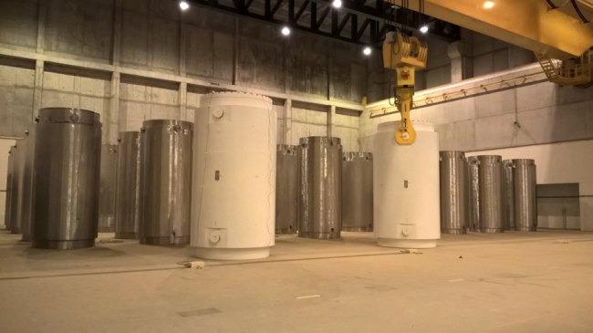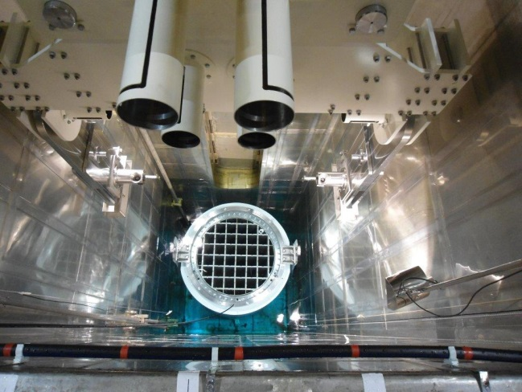
FIG. 1. 32 units of the ENSA-DPT cask and 2 units of the ENUN 32P cask loaded at the interim storage facility of Trillo NPP (left). 1 unit of the ENUN 32P cask at the loading pit of Almaraz NPP, during the loading procedure before being transferred to the interim storage facility at the reactor site (right).

In Fig. 2 are shown the locations of the nuclear reactors and the interim storage facilities on the Spanish territory (green colour for those facilities with casks already loaded, yellow colour for a facility already constructed but without cask loaded yet and purple for the projected centralized storage facility ‘ATC’).

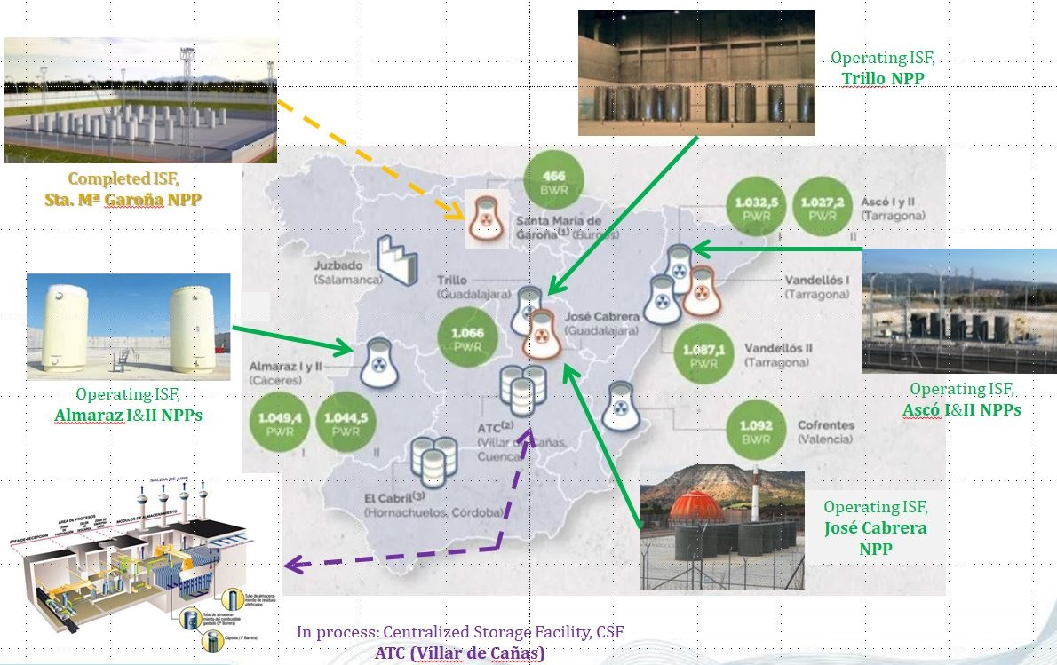
FIG. 2. Locations of Nuclear Power Reactors and Interim Storage Facilities in Spain [3]

These two casks have specifically being designed to fulfil the requirements of all PWR and BWR Spanish NPPs. The first licensing processes established some limitations on the Certificates of Compliance (CoC) for the type of contents that can be loaded in the casks and the environmental conditions. The first limitation is the maximum burnup of the spent fuel allowed to be loaded, that has been limited to 45 GWd/MTU. The CSN recommended ENSA to follow the requirements indicated by the U.S. NRC in the Interim Staff Guidance 11 [4], where the transportation of High Burnup Fuel (HBU) in commercial spent fuel casks would be handled on a case-by-case basis until further guidance is developed. The second limitation is in the condition of the fuel, since by nowadays both the ENUN 32P and the ENUN 52B cask can only store and transport ‘undamaged’ spent fuel, according to the classification established by the U.S. NRC in the Interim Staff Guidance 1 [5].

A resume on how ENSA is facing these technical challenges to improve the capabilities of its ENUN cask designs is introduced in this paper.

storage and transportation of high burnup fuel
According to Interim Staff Guidance 11 [4] HBU is that fuel with average burnups generally exceeding 45 GWd/MTU. In that document, a threshold is established in order to differentiate the mechanical performance of the fuel rods of the fuel assemblies that have been irradiated in the reactors for long time and have reached high power values.
After the irradiation in the reactor, the fuel rods that reached high burnup values present specific conditions and phenomenology at the beginning of the storage period, characterized by different parameters like the corrosion thickness of the fuel rod cladding, the hydrogen content absorbed by the cladding material and the amount of fission gasses that increase the inner pressure in the fuel rods. During the dry storage period inside the casks within an inert atmosphere (i.e. helium) the corrosion thickness and the absorbed hydrogen content do not tend to increase. However, it is necessary to take into account that the fuel rod temperature drops progressively and can lead to new associated phenomena, like the susceptibility to brittle behaviour in the mechanical performance of the fuel rod cladding, the reduction of the gap between the cladding and the fuel pellets and the increase of the pressure inside the fuel rods. All these different phenomena are related but differ from the phenomena produced in fuel rods that have reached lower burnup values. In order to take into account this particular situation, in 2003 the U.S. NRC established a criteria that applications of design approvals of commercial spent fuel cask for transporting HBU shall be handled on a case-by-case basis until further guidance is developed. The CSN have followed this requirement since then for all applicants of commercial spent fuel cask for transporting HBU in Spain.
Currently, the only two casks licensed in Spain by the CSN that can transport spent fuel with average burnups above 45 GWd/MTU are the ENSA-DPT and the ENUN 32P dual-purpose casks. In both cases, authorized HBU content is the KWU 16x16-20 fuel from Trillo NPP. Both situations have been handled specifically by the regulator and have required ENRESA (the applicant of the ENSA-DPT license) and ENSA (the applicant of the ENUN 32P license) to provide detailed and specific information about the performance of the fuel and its cladding in the Trillo NPP reactor and spent fuel pool. This type of fuel has been designed with a cladding alloy called DUPLEX (DX), constituted by two different layers. The inner one is made by Zircaloy-4 while the outer one (the liner) is made by a different Zirconium alloy with less Tin (Sn) content, that improves the overall performance of the entire cladding against corrosion mechanisms. Two main activities have been developed by the utility of Trillo NPP to provide ENRESA and ENSA with detailed information about the HBU fuel stored in the spent fuel pool:

- Establishment of several inspection campaigns in Trillo NPP and in Göesgen NPP (a sister reactor of Trillo located in Switzerland) to measure the maximum corrosion thickness of the fuel rod cladding;

- Perform a series of calculations to estimate the maximum hydrogen content absorbed by the cladding of the HBU fuel, during its irradiation in the reactor.

The result of these complex and detailed evaluations led to identify different sets of fuel assemblies with low hydrogen absorption contents that will not impair the ductile behaviour of the cladding, during the postulated normal and hypothetical accident conditions established by the Transport regulation IAEA SSR-6 [6]. These refers mainly to the postulated Accident Conditions like the 9 m drops (see Fig. 3) and 1 m puncture drop, the events that produce higher accelerations in the fuel rod and can compromise its structural integrity. With this amount of data, the Spanish regulator established a maximum burnup of the authorized content of both casks in 49 GWd/MTU for the ENSA-DPT and 58 GWd/MTU for the new ENUN 32P, allowing the utility to empty fuel and create free positions in the reduced spent fuel pool from Trillo NPP without interfering in the reactor operation, in the short term.

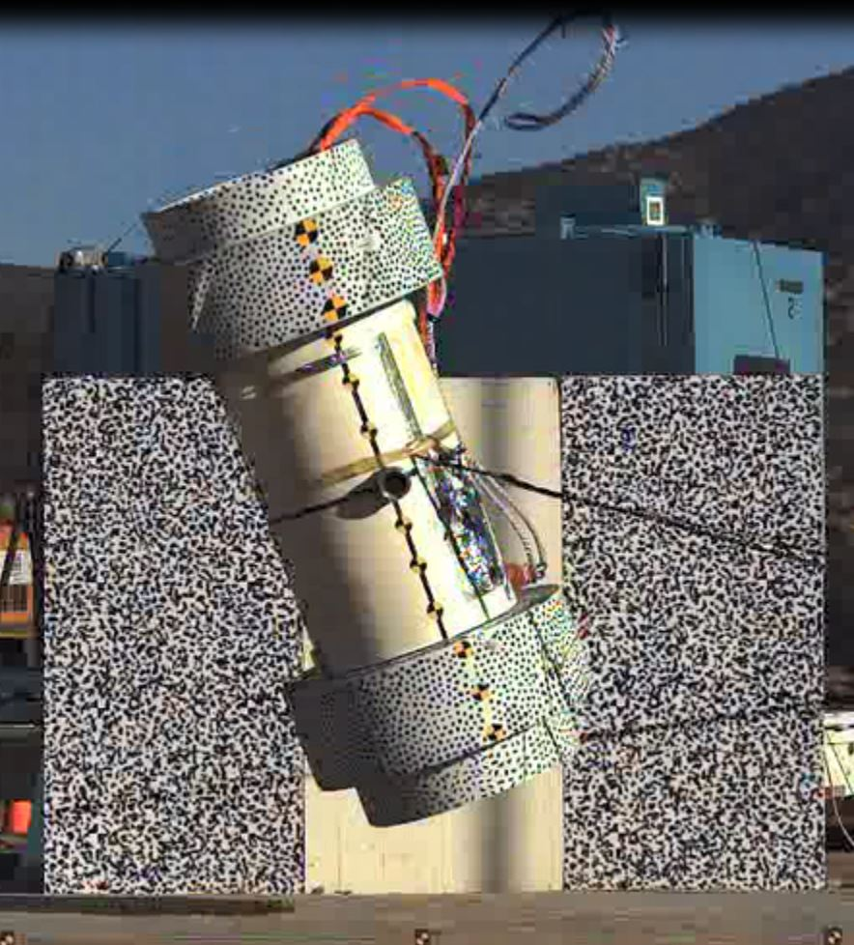
FIG. 3. Example of a 9 m drop test performed in a mock-up of the ENUN 32P cask, to validate its performance against the Accident Conditions required by IAEA SSR-6 [6] regulation

In 2016, ENSA was thoroughly working in a specific methodology to analyse and justify the structural integrity of the HBU fuel rod cladding that could be applied to the other type of content that can be also stored and transported in the ENUN 32P cask: the PWR W17x17 spent fuel, with Zircaloy-4, Zirlo and Optimized Zirlo fuel rod claddings. The idea was to develop a methodology that define the assumptions, fuel rod cladding source data for the mechanical properties and acceptance criteria to perform all safety evaluations that will be included in the Safety Analysis Report (SAR) of the cask, without the need to depend on specific data from the spent fuel inventory intended to be loaded. Furthermore, by that time the U.S. NRC had published a draft Regulatory Issue Summary (RIS) about the analysis of the HBU in spent fuel casks. That document was called ‘Considerations in Licensing High Burnup Spent Fuel in Dry Storage and Transportation’ [7] and provided proposed licensing approaches based on the fuel rod cladding maximum temperature, to demonstrate the ductile performance of the HBU fuel rod cladding during Storage and Transportation events. However, that document did not reach a general consensus and was not officially published. As a consequence, the CSN communicated ENSA that its proposed methodology implied several hypotheses and assumptions, but a lack of specific fuel data from applicable bibliography or experiments, and could not accept it. Furthermore, the CSN recommended ENSA to perform additional conservative safety evaluations assuming the failure of the fuel rods for ‘non-damaged’ HBU fuel, like reconfiguration analyses.
By that time, ENSA initiated a process to analyse more in detail the performance of the HBU in the ENUN 32P and the ENUN 52B casks. Several technical meetings were held with the CSN, with the utilities of the NPPs and different suppliers and experts in nuclear spent fuel performance. A first approach was done with a new cask that was then being designed, the ENUN 24P that had been specifically designed for transporting spent fuel across China. In that case, it also involved the transportation of PWR 17x17 spent fuel. However, there was a specific condition established by the customer that the cask was intended to transport only spent fuel immediately from pool to pool, to a different NPP or a centralized wet storage facility. Therefore, it did not imply interim dry storage that led to fuel rod temperature drops and consequently, to increase the risk of brittle performance in the fuel rod cladding and possibility of fuel rod failure during transportation. In that particular scenario, ENSA was able to justify that the minimum temperature of the fuel after transportation was going to be always above the Ductile-to-Brittle Transition Temperature (DBTT) of the fuel rod cladding material, and therefore there was no risk of cladding failure. ENSA was able to obtain the CoC of the Cask from the CSN in 2017. And in 2018 validated the CoC with the Chinese regulator, the Nation Nuclear Safety Administration (NNSA), to allow for the use of ENUN 24P as a Type B(U) cask for the transportation of HBU in China.
The process concluded in the second half of 2018. ENSA started the development of a new licensing approach to analyse the performance of the HBU spent fuel in the ENUN 32P and the ENUN 52B casks, for PWR KWU 16x16-20, PWR W17x17 and BWR GE spent fuel types. A vast amount of knowledge was acquired from the previous licensing processes, and a deep understanding of the cladding performance thanks to the participation of ENSA in different research projects, like the International Multi-Modal Surrogate Spent Nuclear Fuel Transportation Test project (also called the “2017 rail cask world tour triathlon”, see Fig. 4) [8] led by Sandia National Laboratories and Pacific Northwest National Laboratories, and the Extended Storage Collaboration Project (ESCP) led by the EPRI. Furthermore, by August 2018 the NRC issued a draft document with guidance on the HBU issue that had been working for several years, and had suffered different delays. The draft report for comments, named NUREG-2224 “Dry Storage and Transportation of High Burnup Spent Fuel” [9], includes a comprehensive explanation on the phenomena associated with the HBU fuel allocated inside Storage and Transportation casks, a description of the different tests developed by several U.S. laboratories to investigate the performance of the fuel rods and several licensing approaches, both for Storage and Transportation, that will be considered valid by the U.S. NRC once the document incorporates the comments received by the different stakeholders involved and is officially released.

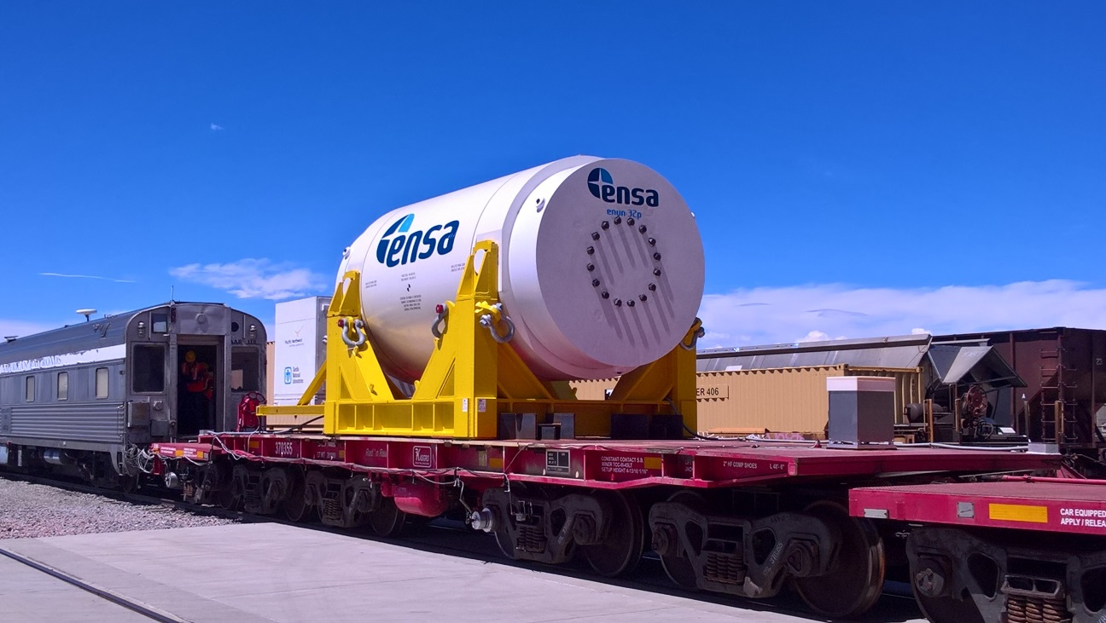
FIG. 4. ENUN 32P cask during the tests performed for the International Multi-Modal Surrogate Spent Nuclear Fuel Transportation Test project in 2017.

Following draft NUREG-2224 recommendations, ENSA has submitted for approval of the CSN an analysis methodology document and based on it,.is developing all safety evaluations to apply for revised CoCs for its dual-purpose casks, the ENUN 32P and the ENUN 52B casks, to update its allowed content for the maximum burnup expected to be achieved in the fuel irradiated in Trillo (PWR, KWU 16x16), Almaraz (PWR, W17x17) and Santa María de Garoña (BWR, GE) NPPs. In this case, the approach includes several structural and dynamic evaluations to assure the integrity of the fuel rods during all the events postulated in the Storage and the Transport configurations, assuming a maximum 20 year dry storage period. In order to consider the uncertainties in the ageing effects and the performance of the fuel rods after 20 years of dry storage, even for extended storage or off-site transportation, the licensing documentation will be completed by additional safety evaluations of all safety functions of the cask assuming the failure of the fuel rods and the reconfiguration of the HBU fuel. In all cases, the results of all the safety analyses comply with the acceptance criteria established by the Storage and Transport regulations.

components for handling ‘damaged spent fuel’ inside the dual-purpose casks
Current CoCs of the ENSA-DPT, the ENUN 32P and the ENUN 52B only allow the loading of ‘undamaged spent fuel’. According to Interim Staff Guidance 1 [5] this type of fuel can meet all fuel-specific and system-related functions, unless it may be breached and may have assembly defects. This definition differentiates from ‘intact spent fuel’, which is defined as any fuel that can fulfil all fuel-specific and system-related functions, and is not breached. According to these definitions, all intact spent fuel is undamaged but not all undamaged fuel is intact, since under most situations breached spent fuel rods that are not grossly breached will be considered undamaged.
With the scope of increasing the capabilities of ENUN 32P and ENUN 52B casks to provide a unique solution for the future emptying of the spent fuel pools of the Spanish NPPs, where several assemblies with different types of defects are stored, ENSA is currently working in two different solution to handle ‘damaged spent fuel’, defined as fuel rods of fuel assemblies that cannot fulfil its fuel-specific or system-related functions within its list of allowed contents.

Cans to store and transport damaged fuel assemblies
For those power plants with a significant amount of fuel assemblies categorised as ‘damaged’, ENSA has designed a specific can to load the damaged fuel assemblies inside, and place it inside dedicated basket positions of the ENUN casks. The idea is to load the damaged fuel assembly in an overpack and handle it as a non-damaged content inside its designated position in the cask. The main defects are suffered by the W17x17 fuel assemblies with Zircaloy-4 rod cladding, and include:

- Pinhole leaks or hairline cracks, that are defined [5] as minor cladding defects that will not permit significant release of particle matter from the spent fuel rod, and therefore present a minimal concern during fuel handling and retrieval operations.

- Breached and grossly breached spent fuel that may have cladding defects sufficient to permit the release of fuel particles.

- High degree of spalling that cannot justify the fuel rod integrity under the accident events in Storage and Transport configurations (like that shown in Fig. 3).

In order to assess the damaged fuel cans for the postulated worst scenarios required by the applicable regulations and not to impose additional limitation to its contents, ENSA is performing the safety evaluations of the cask without considering any structural integrity of the damaged fuel rods cladding and establishing different levels of fuel reconfigurations inside the cans. To set it up, different hypothetical fuel scenarios have been selected as initial assumptions for performing conservative safety evaluations of the cask from those identified in NUREG-7203 [10] guidance. The outcome of the analysis are specific loading curves for the basket configuration that include undamaged fuel assemblies together with a certain number of cans containing damaged fuel assemblies. Next target in these analyses procedure is to identify in more detail the different defects and phenomenology affected by the damaged fuel assemblies, to perform less conservative but more realistic safety assumptions, and allow the loading of a bigger number of damaged fuel cans imposing less restrictions in the CoCs of the casks.
The design of the cans are made of very thin shells of stainless steel material, welded to create a prism with very narrow gaps to introduce the damaged fuel assemblies inside, and later introduce the cans inside its designated basket position in the cask, by the fuel operators in the loading pit of the spent fuel pool. They include meshes to allow the drainage and drying of the can and its contents during the loading process of the cask, but avoiding the release of radioactive fuel pellets out of the can. They include a closure system that safely confines the gross particles of the damaged fuel assembly and can be remotely operated.

Specific sealed bundle systems to store and transport damaged fuel rods
For those NPPs where damaged fuel can be limited to a certain number of leaking fuel rods in the entire inventory of the spent fuel pool, ENSA is currently working to adapt a specific bundle system structure to be loaded in the ENUN casks. In this case, the magnitude of the problem within the spent fuel inventory is lower. This bundle allows loading single leaking fuel rods and can be handled as ‘undamaged spent fuel’ until its final disposal.
The design of this bundle structure is more complex and shall be customized to the type and quantity of fuel rods intended to be loaded. Furthermore, it shall be adapted to the geometry of the cell positions in the basket of the cask. The bundle structure has been conceived as leak-tight containment container with a sealing gasket, to avoid the release of any fission gas outside. In order to allow it and maintain an inner atmosphere inside, similar to the atmosphere of the inner cavity of the cask, the bundle structure shall be drained and dried inside the spent fuel pool before loading into the designated basket position in the spent fuel cask.
The sealed bundle structure shall be included as a new authorized content within the CoC of the ENUN casks, but with less loading restrictions than an ‘undamaged’ spent fuel. Before loading the leaking fuel rods inside the bundle, they shall be disassembled from the original fuel assembly inside the spent fuel pool or another dedicated facility

coNCLUSIONS
ENSA’s Engineering Department has been working during last years to update the allowed contents of the ENUN 32P and ENUN 52B dual-purpose casks, in order to load spent fuel with more different and complex phenomena. The final goal is to provide a unique solution to empty the complete inventory of the spent fuel pools, and facilitate the beginning of the decommissioning activities when the Spanish NPPs are finally shut down. The first issue has been the evaluation of the high burnup fuel performance stored and transported in ENSA’s bare fuel type cask designs. A lack of consensus within the NRC staff has delayed the issuance of a definitive guide on how to evaluate this type of fuel. ENSA has maintained several discussions with the Spanish regulator and performed different safety evaluations and design modifications. Finally, a generic approach has been developed and submitted for approval of the Spanish regulator, to validate it before including the new safety evaluations in the application for renewal the CoCs from both ENUN casks, for storage and transportation of high burnup fuel. Furthermore, ENSA is dealing with the handling of the ‘damaged’ spent fuel inside the casks basket positions with two different equipment, one for handling damaged fuel assemblies, one for handling individual leaking fuel rods. An agreement has been reached with another company to include its specific systems within the ENUN casks. Most of the safety evaluations have been completed and submitted to the Spanish regulator for the renewal of the CoC from the ENUN 32P and ENUN 52B casks, for both storage and transportation.

ACKNOWLEDGEMENTS
The author would like to thank all members of ENSA’s Engineering team who are responsible of the design and licensing of the ENUN casks and are currently completing the safety evaluations and dealing with all licensing issues. In alphabetic order they are: Alejandro Lanza, Ana María Calzada, David Castrillón, David Pondal, Emma Merino, Enrique Gómez, Jesús Fernández, Jesús Saiz de Omeñaca, Luis Moreno, Raúl Muñoz, Roberto Miguel, Roberto Ruiz, Víctor Gómez, Virginia Madrazo. It is very important to mention the contribution of Antonio Igareda Manager of the Engineering Department, and Guillermo Calleja from the Marketing Department.
Special thanks also to David Garrido, former ENSA’s Licensing Manager who developed the ENUN dual-purpose cask series concept design.
Finally, thanks to ENUSA (Spain) and ENERCON (U.S.A.) for providing excellent engineering support in some of the safety evaluations of the ENUN casks analysing the spent fuel performance. To ENRESA (Spain) the owner of all the ENUN 32P and ENUN 52B fabricated cask units and reviewer of the design and licensing documentation. To CNAT (Spain) and NUCLENOR (Spain) the utilities of the NPPs where the ENUN 32P and ENUN 52B cask respectively, are being loaded and stored. And to the Spanish Nuclear Safety Council (CSN) for reviewing and approving the licensing documentation of all Ensa spent fuel casks.
References
- Red Eléctrica de España (“Spanish Electric Network”), December 2018 bulletin.
www.ree.es/es/estadisticas-del-sistema-electrico-espanol/boletines-mensuales/boletin-mensual-diciembre-2018
- Spanish Ministry of Industry, Tourism and Commerce. Sixth General Plan of Radioactive Waste (6º P.G.R.R.), June, 2006.
- Data from the Spanish Ministry of Industry, Energy and Tourism. Image developed by Foro Nuclear and completed by ENSA.
- Interim Staff Guidance 11, Rev. 3, Cladding Considerations for the Transportation and Storage of Spent Fuel, U.S. Nuclear Regulatory Commission, Washington, U.S.A. (2003).
- Interim Staff Guidance 1, Rev. 2, Classifying the Condition of Spent Nuclear Fuel for Interim Storage and Transportation Based on Function, U.S. Nuclear Regulatory Commission, Washington, U.S.A. (2007).
- Regulations for the Safe Transport of Radioactive Material, Specific Safety Requirements No. SSR-6, IAEA, Vienna (2012).
- NRC Draft Regulatory Issue Summary 2015-XX, Considerations in Licensing High Burnup Spent Fuel in Dry Storage and Transportation, U.S. Nuclear Regulatory Commission, Washington, U.S.A. (2015).
- KALININA, E.A., WRIGHT, C., LUJAN, L., GORDON, N., SALTZSTEIN, S.J., NORMAN, K.N., Data Analysis of ENSA/DOE Rail Cask Tests, prepared for U.S. Department of Energy Spent Fuel and Waste Science and Technology, 2018.
- NUREG-2224, Dry Storage and Transportation of High Burnup Spent Fuel, Draft Report for Comment, U.S. Nuclear Regulatory Commission, Washington, U.S.A. (2018).
- NUREG/CR-7203, A Quantitative Impact Assessment of Hypothetical Spent Fuel Storage Casks and Transportation Packages, U.S. Nuclear Regulatory Commission, Washington, U.S.A. (2015).

