An Integrated Approach to Aging
Management of Spent Fuel Dry Storage
Systems in the United States

J. Wise, R. Torres, K. Banovac, D. Dunn, M. Davis
U.S. Nuclear Regulatory Commission
Washington, D.C., USA
Email: john.wise@nrc.gov

Abstract

In the United States, an approach to manage the aging of spent fuel dry storage systems was created by contributions from the regulatory body, storage facility owners, cask vendors, and the engineering community. The U.S. regulations for storing spent fuel beyond the first approved storage term require aging management activities to ensure that materials degradation will not adversely affect the safe storage of the spent fuel. Several guidance documents provide recommendations for complying with this regulation. The U.S. Nuclear Regulatory Commission (NRC) and the Nuclear Energy Institute (NEI) developed NUREG-1927 and NEI 14-03, respectively, to describe methods to identify the components that support a safety function, to evaluate the aging mechanisms could affect safety, and to establish aging management activities. The NEI guidance also introduces a new system to share operating experience through an Institute of Nuclear Power Operations database. The NRC also developed NUREG-2214 to identify the credible materials aging mechanisms for several cask designs used in the United States. NUREG-2214 also provides example aging management programs that may be used to effectively manage aging. Those programs rely, in part, on consensus codes and standards for monitoring and inspection guidelines, such as American Concrete Institute codes and the American Society of Mechanical Engineers (ASME) Boiler and Pressure Vessel Code. Finally, to provide oversight of aging management activities, the NRC is developing internal procedures to evaluate, through inspection, the storage facilities’ performance of their aging management programs. Lessons learned from NRC Temporary Instruction TI 2690/011 will inform the development of a new NRC inspection procedure.

1. INTRODUCTION
In the United States, most spent nuclear fuel is stored in pools at nuclear power plants or in approximately 3000 dry storage casks. The dry storage casks are typically located outdoors at over 70 operating and decommissioned power plant sites. Two basic cask designs are in wide use. Canister-based designs are the most common. They feature an inner welded steel canister that is placed either vertically or horizontally within a concrete or steel overpack. Bolted cask designs have thick steel shells and are similar to the dual-purpose storage and transportation casks commonly used in Europe.
The U.S. Nuclear Regulatory Commission (NRC) approves the dry storage of spent fuel in one of two ways, via:

- a specific license for a storage facility. This license is granted to the facility owner, and it is based on the cask design, other facility structures and components, site-specific parameters (e.g., design basis accidents), an environmental assessment, and owner qualifications, or
- a certificate of compliance for a cask design. This certificate is granted to a cask vendor. A nuclear power plant owner may store its spent fuel in a certified cask design without first requesting NRC approval, if the cask design addresses the range of conditions and events that may exist at the nuclear power plant facility.

To date, the NRC has approved the storage of spent fuel for an initial term of 20 years. The NRC may extend the allowable time in storage for additional 40-year terms. This extension is referred to as the “renewal” of a storage term, and it requires the renewal applicant to address potential aging-related degradation issues [1]. The U.S. regulations require that a renewal application include:
- aging management programs (AMPs) – programs for addressing aging effects that may include monitoring or inspection activities to verify the condition or performance of components, and
- time-limited aging analyses (TLAAs) – calculations that demonstrate that time-dependent degradation mechanisms will not adversely affect a component’s function.

In the NRC’s reviews of the first renewal applications, it became clear that more guidance was needed to describe acceptable approaches to meet the regulations. Because few cask inspections were performed in the first 20-year storage terms, it was sometimes difficult to define potential aging mechanisms and thus develop acceptable approaches to manage aging.
To address this need for additional guidance, the NRC, storage facility owners, cask vendors, and others in the nuclear community contributed to an integrated approach to guide all aspects of aging management. Figure 1 summarizes the roles of each of the components of the approach for (1) establishing a methodology to develop aging management activities, (2) providing technical support for decision making, and (3) responding to operating experience and ensuring that aging management activities continue to be effective.

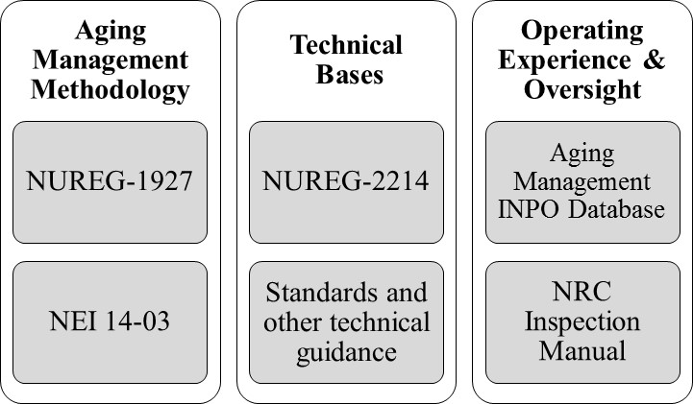

FIG. 1. Summary of guidance framework to address aging management.

2. Aging Management Methodology
The NRC and the Nuclear Energy Institute (NEI) created separate, but complementary, guidance to recommend a methodology to manage the aging of storage casks and storage facilities.
In NUREG-1927, “Standard Review Plan for Renewal of Specific Licenses and Certificates of Compliance for Dry Storage of Spent Nuclear Fuel,” Revision 1, the NRC provides a framework to systematically review cask and storage facility components and develop programs and analyses to address aging issues [2]. As shown in Figure 2, the process begins by selecting the components that support a safety function (scoping). Then, by considering the materials of construction and exposure environments, aging effects that could potentially impact a safety function are identified (aging management review). Potential aging issues are addressed by either an AMP or a TLAA. AMPs include preventive actions, monitoring, and inspection activities to ensure safety functions are maintained. Alternatively, TLAAs address aging effects that were evaluated with an analysis in the original cask or facility design, such as fatigue and corrosion rate calculations. The calculations are re-evaluated to ensure that components can perform their intended functions for the extended storage term.
NUREG-1927 recommends that AMPs change over time, as necessary, as more is learned about how cask components age. This is addressed in greater detail in NEI 14-03, “Format, Content and Implementation Guidance for Dry Cask Storage Operations-Based Aging Management,” Revision 2[3]. NEI 14-03 is guidance to assist storage facility owners and cask vendors in preparing renewal applications. This document expands on many of the same recommendations in NUREG-1927, but from the perspective of the applicant. NEI 14-03 also introduces the concept of “tollgates” to ensure that AMPs are continuously enhanced to incorporate new knowledge.

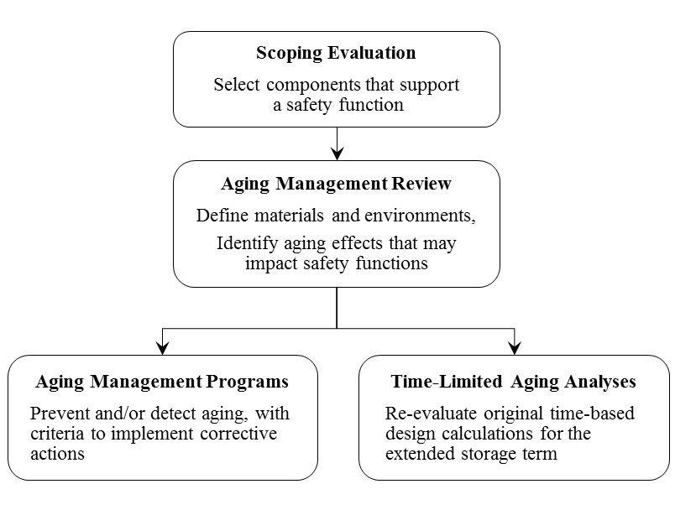
FIG. 2. Framework to address issues associated with aging
(introduced in NUREG-1927).

As shown in Figure 3, tollgates are periodic assessments of the current state of knowledge to confirm that aging management activities will continue to be capable of ensuring safe storage. The tollgate assessments consider prior monitoring and inspection results at the storage facility, operating experience from other facilities, findings from research programs, and any other relevant sources of materials aging information. If this review of new knowledge identifies potential deficiencies in the aging management approach, corrective actions are taken to revise AMPs or TLAAs. Similarly, if the review identifies potential deficiencies in the performance of a component, repair or replacement activities may be performed.

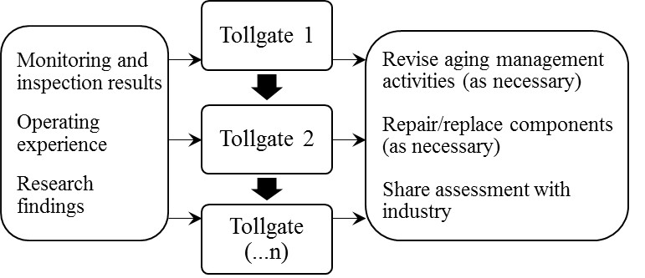

FIG. 3. Periodic tollgates to assess available data and the effectiveness
of aging management activities (introduced in NEI 14-03).

3. Technical Bases
Although NUREG-1927 and NEI 14-03 recommend a general methodology to aging management, these documents do not provide guidance for technical issues. To address the need for a technical basis for safety reviews of renewal applications, the NRC created NUREG-2214, “Managing Aging Processes in Storage (MAPS) Report.” [4] NUREG-2214 includes a technical evaluation of all aging mechanisms (e.g., corrosion, stress corrosion cracking) for the materials of construction and exposure environments present in common U.S. cask designs to identify the aging mechanisms that have the potential to adversely affect safety functions. NUREG-2214 also provides example AMPs that may be used to address the credible aging mechanisms. NUREG-2214 is intended to make the renewal process more efficient by providing an acceptable approach to identify and manage aging effects. Renewal applicants can reference their application against the NUREG-2214 guidance, allowing the NRC staff to focus its review on areas where the applicant proposes an alternative approach to the guidance.
The technical bases in NUREG-2214 rely on hundreds of research studies, examples of operating experience, consensus codes and standards, and other guidelines for addressing materials aging. For example, NUREG-2214 references, to the extent practical, the inservice inspection requirements of the American Society of Mechanical Engineers Boiler and Pressure Vessel Code for nuclear power components [5] and American Concrete Institute inspection standards for nuclear and non-nuclear structures. [6, 7]. Also, U.S. national laboratories and other research organizations have devoted considerable effort to assist storage facility owners and cask vendors in developing effective aging management programs. Examples include the Electric Power Research Institute reports on assessing the susceptibility of storage canisters to cracking, guidance on inspections and flaw evaluation, and the development of remote inspection tools [8-11]. In addition, Argonne National Laboratory developed guidance similar to that in NUREG-2214 for aging management of dry storage casks and facilities [12].

4. Operating Experience and Oversight
As discussed above, an important recommendation in NUREG-1927 and NEI 14-03 is the need to continually assess the effectiveness of aging management activities. This requires a system for sharing operating experience among the storage facility owners and cask vendors. To fill this need, the nuclear industry recently created the Independent Spent Fuel Storage Installation (ISFSI) Aging Management INPO Database (AMID). The Institute of Nuclear Power Operations (INPO) has historically gathered, reviewed, and communicated nuclear power plant operating experience. With the ISFSI AMID, these activities are now performed specifically for aging issues associated with storage casks and facilities. Following the tollgate process summarized in Figure 3, storage facility owners and cask vendors periodically gather the latest industry-wide operating experience from the database and also add site-specific monitoring and inspection results to the database for the benefit of others.
The NRC provides oversight of storage facilities’ aging management activities to ensure that the facility owners are following the approved AMPs and that aging management activities are being enhanced, as necessary, to consider lessons learned from operating experience. Recently, the NRC revised its inspection manual to include a new temporary instruction, TI 2690/011, to gather information on storage facilities’ AMP processes and procedures [13]. Based on the insights gained from this short-term information-gathering effort, the NRC will develop a new inspection procedure to conduct inspections of licensees’ performance of their aging management activities.

5. Implementation of the New Framework
In the U.S., many storage facility licenses and cask certificates have recently reached, or are nearly reaching, the end of their first 20-year term. The integrated approach outlined Figure 1 will assist the applicants in preparing, and the NRC in reviewing, storage renewal applications. The guidance documents were developed in collaboration with the counterparts of the authoring organizations (i.e., the NRC documents were reviewed by the nuclear industry and vice versa). As a result, the NRC and the nuclear industry generally have a shared understanding of steps that should be taken to effectively manage aging degradation. Whereas the NRC review of early renewal applications took several years in some cases, the new guidance is expected to reduce the time and effort to evaluate applicants’ renewal applications. The integrated approach will also allow the storage facility owners to share and assess future operating experience and data and respond, if necessary, with changes to AMPs. The NRC, in its oversight role, will inspect storage facility owners’ implementation of AMPs in the extended storage term to ensure continued safe storage of spent fuel.

References
- U.S. Code of Federal Regulations, Title 10, “Energy,” Part 72, “Licensing Requirements for the Independent Storage of Spent Nuclear Fuel, High-Level Radioactive Waste, and Reactor-Related Greater Than Class C Waste,” Washington, D.C. (2019).
- U.S. NUCLEAR REGULATORY COMMISSION, NUREG-1927, Revision 1, “Standard Review Plan for Renewal of Specific Licenses and Certificates of Compliance for Dry Storage of Spent Nuclear Fuel,” Washington, D.C. (2016).
- NUCLEAR ENERGY INSTITUTE, NEI 14-03, Revision 2, “Format, Content and Implementation Guidance for Dry Cask Storage Operations-Based Aging Management,” Washington, D.C. (2016).
- U.S. NUCLEAR REGULATORY COMMISSION, NUREG-2214, “Managing Aging Processes in Storage (MAPS) Report,” Washington, D.C. Draft Report for Comment (2017), Final (2019).
- AMERICAN SOCIETY OF MECHANICAL ENGINEERS, Section XI, “Rules for Inservice Inspection of Nuclear Power Plant Components,” New York, New York (2007).
- AMERICAN CONCRETE INSTITUTE, ACI 349.3R-18, “Report on Evaluation and Repair of Existing Nuclear Safety-Related Structures,” Farmington Hills, Michigan (2018).
- AMERICAN CONCRETE INSTITUTE, ACI 201.1R-08, “Guide for Conducting a Visual Inspection of Concrete in Service,” Farmington Hills, Michigan (2008).
- Fuhr, K., Broussard, J., White, G., “Susceptibility Assessment Criteria for Chloride-Induced Stress Corrosion Cracking (CISCC) of Welded Stainless Steel Canisters for Dry Cask Storage Systems.” EPRI-3002005371. Electric Power Research Institute. Palo Alto, California (2015).
- Chu, S., “Flaw Growth and Flaw Tolerance Assessment for Dry Cask Storage Canisters,” EPRI-3002002785, Technical Update, Electric Power Research Institute. Palo Alto, California (2014).
- Fuhr, K., Broussard, J., White, G., “Aging Management Guidance to Address Potential Chloride-Induced Stress Corrosion Cracking of Welded Stainless Steel Canisters,” EPRI-3002008193. Electric Power Research Institute. Palo Alto, California (2017).
- Chu, S., Renshaw, J., “Dry Canister Storage System Inspection and Robotic Delivery System Development,” EPRI-3002008234, Technical Update, Electric Power Research Institute. Palo Alto, California (2016).
- Chopra, O., Diercks, D., Fabian, R., Han, Z., Liu, Y., “Managing Aging Effects on Dry Cask Storage Systems for Extended Long-Term Storage and Transportation of Used Fuel – Revision 2,” FCRD-UFD-2014-000476, ANL-13/15, U.S. Department of Energy, Washington, D.C. (2014).
- U.S. NUCLEAR REGULATORY COMMISSION, Temporary Instruction 2690/011, “Review of Aging Management Programs at Independent Spent Fuel Storage Installations,” NRC Inspection Manual, Washington, D.C. (2018).

As of February 2019. UxC StoreFUEL Newsletter, Ux Consulting Co., Vol. 21, No. 246, February 2019.

