AUTHORITY EXPERIENCE DURING DESIGN
APPROVAL PROCEDURE FOR PACKAGES LOADED
WITH SPECIAL ENCAPSULATIONS FOR DAMAGED
SPENT NUCLEAR FUEL

K. Linnemann, L. Mueller, T. Schoenfelder, S. Komann, F. Wille
Bundesanstalt für Materialforschung und -prüfung (BAM)
Berlin, Germany
Email: konrad.linnemann@bam.de

Abstract

The first German package design approval certificates for a dual purpose casks intended for loading with damaged spent nuclear fuel were issued recently. BAM as part of the competent authority system in Germany carried out comprehensive assessment procedures with respect to the mechanical and thermal design, the release of radioactive material and the quality assurance aspects of manufacturing and operation. Packages for the transport and storage of radioactive material have been assessed by BAM for many years, thus the common assessment procedure is well-known and good practice. Up to now only SNF without defects or HLW with well-defined properties were designated for long-term interim storage and transports afterwards. Due to Germany’s nuclear phase out all other kinds of spent nuclear fuel in particular damaged spent nuclear fuel shall be packed now. Damaged spent nuclear fuel needs a tight closure with special encapsulations and clearly defined properties in Germany. In addition, these encapsulations shall be long-term durable, because they are not accessible after loading in a packaging within periodical inspections. The main difference to standard package components is that encapsulations with a permanent closure achieve their specified conditions not after manufacturing but only during operation, after loading and closing. To ensure compliance with the specific conditions, special measures for quality assurance are necessary during operation of each encapsulation, e.g. drying and sealing, which were assessed by BAM. The present paper gives an overview of the conducted assessment from BAM and point out the findings concerning to the special closure lid of the approved encapsulation, which is screwed and welded. A wide verification concept was necessary to show the specific tightness under transport conditions. Together with quality assurance measures during first operation steps these encapsulations with damaged spent nuclear fuel can then be handled like standard fuel assemblies in approved package designs.

INTRODUCTION
In accordance with German guideline R003 [1] the approval procedure and the associated package design assessment are carried out by the Federal Office for the Safety of Nuclear Waste Management (BfE) and the Federal Institute for Materials Research and Testing (BAM) as the competent authorities in Germany. BAM is responsible for the assessment of the mechanical and thermal design, the release of radioactive material and the quality assurance aspects of manufacturing and operation. BAM also operates test facilities and performs drop tests as well as thermal tests during package licensing procedures. The assessment of shielding and criticality safety is in the responsibility of BfE. The properties of the package regarding its mechanical and thermal behaviour are the basis for the boundary conditions of the shielding and criticality assessment and shall be confirmed by BAM. The assessment is based on the package design safety report (PDSR), which should be structured according to the European PDSR Guide [2] and demonstrates compliance with all applicable requirements according to IAEA SSR-6 [3].
To avoid additional handling of spent fuel and to reduce radiation exposure as well as the risk of radioactive release or contamination the use of dual purpose casks (DPC) for the transport and interim storage of spent nuclear fuel (SNF) or high level waste (HLW) is preferred in Germany. These DPC shall fulfil both - the transport regulations based on IAEA SSR-6 [3] and the requirements of the storage facilities based on the recommendations of the German Nuclear Waste Management Commission [4]. The main requirement for long-term interim storage is the dry storage of spent fuel and heat-generating waste. This is caused by the consideration of the long term behaviour of the materials and components in the safety case of a DPC and shall be taken into account for the design approval procedure.
The shutdown and following decommissioning of nuclear power plants (NPP) creates new challenges on packages for the transport of radioactive materials due to an expansion of the permitted radioactive inventory. In addition to standard SNF assemblies all other types of high level waste, e.g., control rods or non-standard-assemblies as well as defect or damaged fuel rods must be transported and stored now. These kinds of fuel rods are called damaged spent nuclear fuel (DSNF) and need dry conditions and tight closure with special encapsulations inside the packaging to ensure safety.
For loading of these special encapsulations in existing package designs the applicants shall show in the corresponding PDSR that all applicable requirements mentioned above are fulfilled. Thus the influences of encapsulations on the package and their long-time behaviour shall be analysed and evaluated in the PDSR.
The paper describes the BAM experience during design approval procedures for packages loaded with special encapsulations for DSNF. Thereby information about the definition of DSNF and about different types of encapsulation systems is given. By means of the recently conducted assessment procedure for the encapsulation system of the German company GNS (Gesellschaft für Nuklear-Service mbH) the main aspects in view of mechanical and thermal design, the containment system and the quality assurance during manufacturing and operation are described. This paper points out the main findings from the assessment of the special closure lid of the approved encapsulation, which is screwed and welded. A wide verification concept was necessary to show the specific tightness under transport conditions.

Encapsulation SystemS for Damaged Spent Nuclear Fuel
Up to now only SNF without defects are licensed for DPCs. But during reactor operation defects or damages on SNF can occur due to reactivity events, debris or handling. With Germany’s nuclear phase out DSNF need to be packed now.
More than 1000 non-standard fuel rods have been detected yet for non-standard handling based on information of different German nuclear power plant operators. According to IAEA technical report NF-T-2.1 [5] different mechanisms lead to fuel rod failures, e.g. fretting, crud corrosion, pellet cladding interactions, stress corrosion cracking, debris, mishandling, fabrication failure or baffle jetting (Fig. 1). Fuel rods with these kinds of damages are grouped as damaged spent nuclear fuel (DSNF).

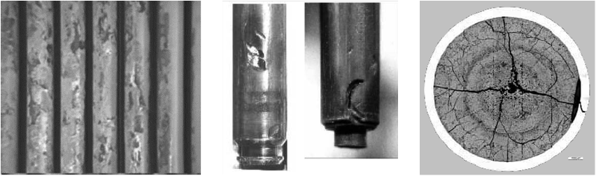
FIG. 1. Failures examples - crud caused corrosion, debris fretting, PCI with SCC from [5].
The IAEA technical report NF-T-3.6 [6] presents an overview of the management procedures of DSNF from over 20 countries. To ensure safety and to protect human health, property and the environment from the effects of radiation the tight encapsulation of DSNF is a regulatory requirement [4] in Germany. New encapsulation concepts were necessary for transport and storage of DSNF rods.
Because of the limited amount of DSNF usually existing package designs are used for transport and interim storage. Therefor the dimensions (e.g. geometry, mass) of the special encapsulations for DSNF conform to standard fuel assemblies. The containment system of these special encapsulations for DSNF is an important issue for the design. Further design aspects result from criticality safety as well as from handling. The types of special encapsulations for DSNF range between single rod systems with one capsule for each DSNF rod and multi rod systems with a specific amount of DSNF rods capsuled together (Fig. 2).

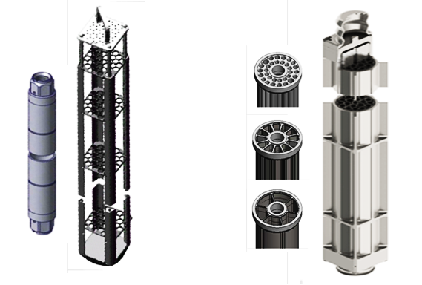
FIG. 2. Examples: Single rod system from AREVA [7] and multi rod system from GNS [8]
The single rod system from AREVA (now Framatome) [7] consists of capsules with single DSNF rods and a capsule canister for the handling like standard fuel assemblies. The loading procedure of this encapsulation involves typical steps of loading, drying at high temperature, welding and tightness testing. Thereafter the capsules are collected into the capsule canister and are ready for loading in a packaging.
The multi rod system from GNS [8] consists of an inner basket for DSNF and an outer capsule made of forged stainless steel. This system is named quiver. It can capsule up to 66 DSNF in dry and tight condition. The quiver system is designed to be loaded in the approved CASTOR®-packages, which are commonly used in Germany. There are two different designs, one with the dimensions of PWR fuel assemblies for the CASTOR® V/19 packages and a second one with the dimensions of BWR fuel assemblies for the CASTOR® V/52 packages.
Due to the fact that these special encapsulations are exclusively manufactured for the assimilation of damaged spent nuclear fuel, they cannot be considered as content; they are components of the package. Therefore the applicants have to prepare the complete set of documents for the corresponding PDSR which are assessed by BAM and BfE.

ASSESSMENT experienceS ON THe approved ENCAPSULATION SYSTEM
Specific matters of the assessment for encapsulation systems as component of a transport package are discussed in this section. The aspects presented take into account the transport conditions according to IAEA regulations SSR-6 [3]. The regulations distinguish between routine, normal and accident conditions of transport (RCT, NCT and ACT). RCT include mechanical loads resulting from accelerations, decelerations and vibrations of the incident free transport of the package. NCT relate to minor incidents. The test sequences prescribed for ACT cover mechanical and thermal loadings of severe hypothetical accidents. All test conditions are assessed in the transport configuration of the package.
As mentioned before special encapsulations for DSNF are designed for the use in approved packages for (undamaged) spent nuclear fuel assemblies. The corresponding PDSR has to show that these packages loaded with special encapsulations for DSNF still fulfil the applicable requirements for transport according to [3]. The paper is focused on the assessment issues from the design of the quiver systems [8] from GNS (Fig. 2) and give additional information about special manufacturing and operation processes which were developed and qualified for these encapsulations for instance for drying and welding. The specific findings from the assessment of the GNS quivers are relevant for other encapsulations of this kind.

Boundary conditions for criticality safety and shielding
The geometrical and material properties of a package are used as boundary conditions for criticality safety and shielding verification. They depend on the results of the mechanical and thermal design. For the loading case of encapsulations with DSNF the properties of an encapsulation itself as well as the influences on the package shall be specified in the PDSR and shall be confirmed by BAM. In comparison to a loading with SNF assemblies a loading with a DSNF-encapsulation has usually a lower amount of radioactive material. Consequently, the compliance with limits for criticality safety and shielding is generally feasible. Nevertheless two aspects shall be taken into account for DSNF-encapsulations: The first issue is the maximum possible sphere-size of fissile material assumed to be released into the cavity of an encapsulation. The second aspect is the position of the radioactive content.
An encapsulation system shall be designed to resist the specified transport conditions (see [3]) also for transports after interim storage. So each encapsulation can be considered as a confinement for the loaded DSNF. With respect to a multi-rod encapsulation system (like the quiver from GNS) the size of the inner cavity is important for the assessment. E.g. the quiver designed for PWR packages has a rather big cavity which makes the shape of the quiver inner basket relevant for criticality safety analyses. For encapsulations with smaller cavities like single rod systems only the encapsulation itself is decisive. This leads to different classifications of the encapsulation components regarding the quality assurance.
For shielding analyses the movement of the radioactive content is restricted and any deformations shall be taken into account. Especially the 20 % limit of dose rate increase under NCT is a demanding requirement. If encapsulations are designed with shock absorber units, the deformations under accident conditions of these components shall be considered in the shielding analysis as well.

Mechanical interactions of encapsulations with the package design
Usually the lid system of a packaging is designed to ensure a save containment of the radioactive content under all specified transport conditions (RCT, NCT, ACT). In this context the secondary impact of the content onto the lid system shall be considered. Thereby the mass and stiffness of the spent fuel assemblies are significant properties regarding the possible mechanical interaction between the radioactive content and the lid system. The design of special encapsulations shall take into account that the loads encountered by the lid due the encapsulation are comparable. Although the mass is generally equal, the stiffness of an encapsulation is usually higher than of a spent fuel assembly. Therefore the influence of an encapsulation on basket, lid system and body of the package shall be analysed and evaluated appropriately.
An appropriate maximum axial gap between encapsulations and the package lid has to be assumed to evaluate the internal impact of the content. A multi-degrees-of-freedom system is used in [9] to describe these content interactions and determine the resulting loads during different transport conditions. The most severe loads on the lid system occur during the 9 m vertical drop test. For encapsulations with a stiffness higher than the one of SNF assemblies, shock absorbing components shall be designed to reduce the impact on the lid system. The GNS quiver has specific head and foot components which were designed as shock absorber.
Experiences have shown that numerical calculations are often not sufficient to determine the complex damping behaviour of shock-absorbing components. From BAM point of view experimental drop tests are required to analyse the complete load-deformation-performance of a shock-absorbing component (Fig. 3). The corresponding drop test height can be calculated analytically (see [9]) to perform drop tests which reproducing the internal impact in a package. The equations are based on the conservation of energy and consider further influences like the deformation time of the components itself as well as energy losses during the drop test e.g. due to friction within the test equipment.
During the tests the corresponding limit force of the lid system must not be exceeded during the complete impact process of the encapsulation. Possible load peaks during the deformation process of the shock-absorbing components shall be considered in the assessment, see [10].

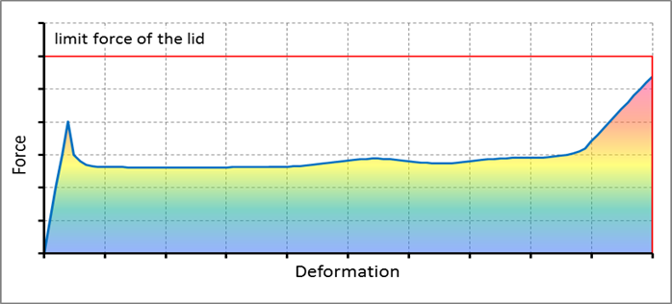
FIG. 3. Typical load-deformation-performance of a shock-absorbing unit
BAM operates a qualified testing facility to carry out such drop tests in the framework of approval procedures. For the quiver of GNS another testing facility was used. To ensure the applicability of the test results for the safety analyses the facility performance was qualified and validated by BAM with a specific qualification program in advance. The quiver drop tests were performed according to a test program provided by the applicant and assessed by BAM.

Effects of thermal induced bending
Concerning thermal aspects of the assessment it is generally known that the analysis of temperature gradients is very important for the package design to avoid major loads from thermal induced deformations. During manufacturing and also during first operation steps under water the packaging components have nearly equal temperatures with only small temperature gradients. But after loading and drying of the cask the temperatures increases strongly due to the heat generation of the radioactive content. Substantial temperature gradients occur depending on package and environment properties. These temperature gradients lead directly to deformations and if deformation is restricted to significant stresses.
The quiver system has a relatively high bending stiffness. Therefore the thermal induced bending was addressed in the package assessment. Because of the length of such encapsulations also small temperature gradients lead to substantial deformations and high contact forces if the deformation is restricted. A simplified calculation as an example for a PWR encapsulation with 4.5 m length and a temperature gradient of 50 K over the cross-section results in a deflection of 9 mm only due to thermal induced bending (Fig. 4).
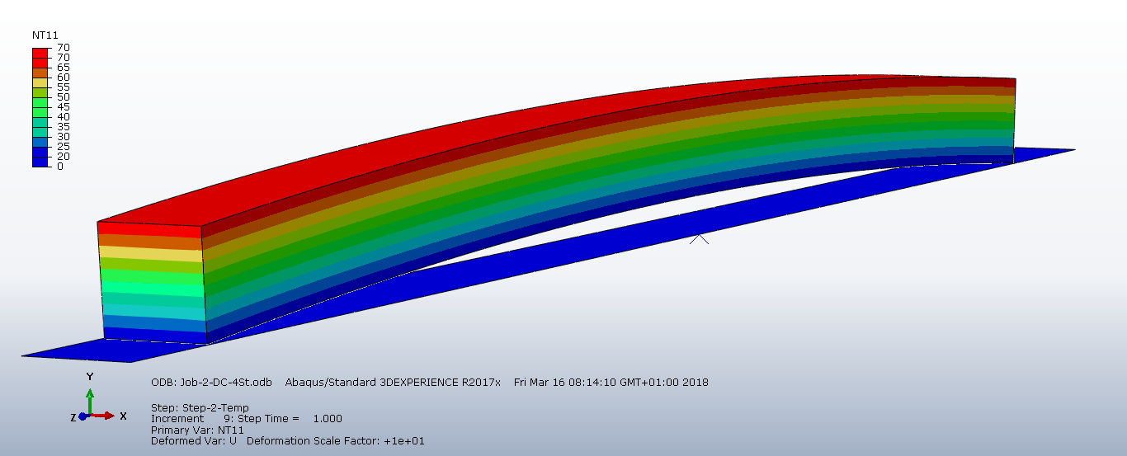
FIG. 4. Sample calculation with thermal induced bending of 9 mm for a 50 K gradient (scaled)
The dimension of the quiver system is designed appropriately to avoid relevant contact forces due to thermal deformations. Furthermore the loading concept of the quivers in one package is specified with a balanced heat flux that higher temperature gradients do not occur. Therefore, a combined loading of spent fuel assemblies with comparable high thermal power and quiver-like encapsulations with much less thermal power into the same package is currently not recommended by BAM.

Mechanical assessment of the closure system
Generally, the leak tightness requirements for a package depend on the particular transport condition as well as on the assumptions for the criticality safety and the containment analysis. In this context the containment system of an encapsulation serves as an additional barrier to the package containment and has also be assessed for the different transport conditions. The leak tightness specification for an encapsulation affects the criticality safety and the containment analysis of the whole package. In general a fuel rod failure rate of 100 % shall be considered for DSNF under all transport conditions. In the specific case for the quiver system with a welded sealing, it is assumed, that gas tightness shall be met for RCT and NCT. According to the content of the quiver and together with the containment system of the package particle tightness of the quiver sealing is sufficient under ACT to prevent accumulation of fissile material in the cask cavity. The characteristics of a welding seam shall be assessed also with respect to aging effects, e.g. to consider a transport after long term interim storage.
The special closure system of the quiver consists of a screw-on lid which is welded with an external sealing seam (Fig. 5). The lid and the quiver body are manufactured from stainless steel as mentioned before and screwed with low pretension without a gasket. Therefore the external sealing seam must ensure the leak tightness requirements for the closure system. The shock absorber of the quiver covers the lid system of the quiver against external loads and the contact with the lid of the cask.

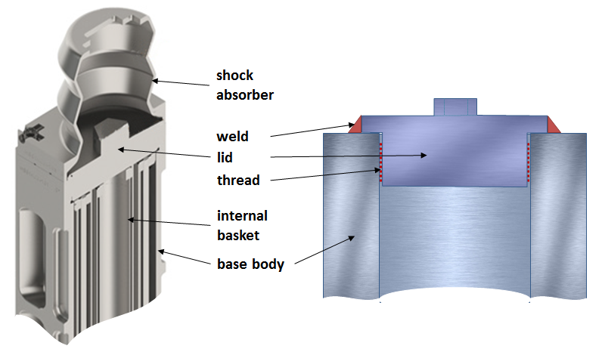
FIG. 5. Closure system components of the quiver from [8] and as schematic drawing
The mechanical assessment of the closure system is performed under the assumption that the welding seam and the screw-on lid form a compound connection system. Depending on the load case and direction the welding seam or the screw connection or both components are involved in the mechanical verification of the closure system.
Finite element analyses (FEA) using solid elements are applied for the assessment of the closure system. The finite element model includes the relevant components of the quiver like body, the screw-on lid, and the welding seam as well as an appropriate representation of the cask basket. The threads of the screw connection are not modeled. Instead, a combination of contact definitions and node coupling is used to approximate the mechanical behavior of the screw connection in a conservative manner for the particular load case. The assessment of the welding seam is based on the German Guideline KTA3201.2 [11]. The loads are obtained circumferentially by calculating the internal forces and moments at the interfaces between welding seam and quiver as well as welding seam and lid. The required thickness of the welding seam is determined in an iterative process for each load case. For each iteration step the nominal stresses in the welding seam are calculated by using the results of the updated FEA with an alternated fictive thickness of the welding seam. The iteration process is stopped as soon as the nominal stress equals the allowable limit according to [11].
The screw connection is verified according to German Guideline VDI 2230 [12]. The verification is performed for the assembly condition and for the transport conditions which implies an axial load on the screw connection. The following subsection gives an overview about the assessment of the welded screw-on lid for the different conditions of transport. The loads applied for the different transport conditions are gathered from the PDSR of the related package design.
The decisive load onto the quiver from RCT is determined by an axial acceleration of 2 g see [13]. The transversal loads are covered by NCT. For axial loads the impact of the content of the quiver onto the lid system of the quiver shall be considered. Additionally, loads from the internal pressure are applied. It is assumed that the loads are bore by the screw connection and the welding seam together. The distribution of the loads between the two components is obtained analytically by a mechanical replacement model with springs. The spring stiffnesses are determined by using beam representations for the welding seam and the screw threads. As result the majority of the axial loads are bore by the screw connection and a smaller share by the welded seam. The assessment of the welding as sealing seam is performed according to the above mentioned procedure with respect to [10]. The general bearing capacity of the screw connection is covered by axial ACT loads.
The transversal acceleration is the decisive load case for NCT resulting from a 0.3 m lateral drop of the package. Other drop positions are not considered in the German licensing process for this kind of packages, because it is assumed that the packages are only handled in the transport orientation. The FEA for NCT include a modeling of a basket compartment in which a quiver is transported in to ensure appropriate and adverse boundary conditions. Due to the transversal loading different contact conditions are used in the thread area of the screw connection instead of a spring model to analyze the influence of the screw connection resilience on load of the welding seam and to find the most severe calculation case. The assessment of the welding as sealing seam is performed according to the above mentioned procedure with respect to [11]. A verification for the screw connection is not needed due to the transversal direction of the NCT loads.
In contrast to RCT and NCT particle tightness is only accepted by BAM for the quiver system under ACT. This means that the integrity of the welding seam is not required to achieve this objective. Instead, the verification of the integrity of the screw connection under ACT loads was shown to ensure particle tightness. The most severe ACT load case for the screw connection of the quiver is the 9 m axial lid side drop onto an unyielding target. The assessment of the screw-on lid is based on [12]. The connection is assessed with respect to the ultimate strength limit and the yield strength. Additionally an experimental shear off test for the screw connection without the welding seam was performed to check the plausibility of the calculation.

quality SURVEILLANCE for encapsulations
BAM is responsible for the assessment of the management systems for design, construction, manufacturing, operation and maintenance of packagings for transport of radioactive materials. Because encapsulations for DSNF are a component of the packaging, all components of an encapsulation shall be classified according to the guideline BAM-GGR 011 “Quality Assurance Measures of Packagings for Competent Authority Approved Package Designs for the Transport of Radioactive Material” [14]. Therefor the documents of the PDSR shall provide all relevant information of an encapsulation system for its manufacturing with drawings, parts lists, material specifications and manufacturing instructions and for its operation with corresponding instructions for handling, testing and maintenance. These documents are assessed by BAM during approval procedure and are the basis for the quality surveillance during manufacturing and operation of encapsulations.
The quality surveillance during manufacturing is done by BAM for packagings or grade 1 and 2 components according to [14]. The manufacturer has to show documents about qualification, sufficient human resources and adequate infrastructure to guarantee the product quality before manufacturing. The quality surveillance during manufacturing is structured in the three parts, pre-assessment, manufacturing control and inspection before commissioning. The pre-assessment includes verification and approval of documents which are needed to guarantee the accordance with the approval certificate of the packaging.
The manufacturing control is defined for each component in specific fabrication and test plans and depends from the classification according to [14]. Deviations must be reported to BAM and need to be assessed. According to the design approval, the result of the inspection before commissioning is confirmed by BAM. This certificate guarantees the compliance of the manufactured packaging with the specified design in the design approval certificate.
For encapsulations with a permanent closure after loading (like the quiver from GNS) the certificate before commissioning only guarantees the specified conditions after manufacturing. The final certificate of such encapsulations is issued during operation, in fact after loading and closing.
In general the quality surveillance during operation of transport packages is done by BAM with the acceptance of documents for the handling and testing instructions and plans for periodic inspections, which ensure to remain the specified conditions of the packaging during operation. Additionally the result of every periodic inspection is confirmed by BAM.
During the operation of the encapsulations for DSFN special measures are necessary for the quality surveillance especially for encapsulations with permanent closing concepts like welding (e.g. the quiver of GNS). The manufacturing of the quivers is not finished until the final and permanent closure which cannot be tested before operation or before loading. Therefor the welding process is considered as an operational step which finalizes the manufacturing of these quivers. For the closing of the quivers new welding procedures and specific welding equipment were necessary which also needed a corresponding qualification process during the approval process. This was done in compliance with ISO 15613:2004 [15]. During operation only non-destructive testing in kind of visual and leak tightness tests are possible. Theses test are surveilled by independent experts authorised by BAM and sufficient for the issuing of the certificate about the final closing of the quiver. Together with the previous confirmations and approved protocols from operation the BAM authorised expert is able to issue the final certificate for each quiver. Only then a quiver is eligible for loading in a CASTOR®.

CONCLUSION
Due to Germany’s nuclear phase out all kinds of SNF in particular special or damaged fuel shall be packed in transport and storage casks now. Therefore specific requirements shall be considered in accordance with international experiences from IAEA technical reports [5] and [6]. According to German demands, damaged spent nuclear fuel (DSNF) needs a leak tight encapsulation and clearly defined properties. Only then the fulfilment of the IAEA recommendations [3] can be ensured.
The quiver system [8] of GNS for DPC package designs was evaluated recently. Therefor specific assessment procedures for mechanical and thermal design, containment and quality assurance were performed at BAM. The main findings from the assessments are:
- Special encapsulations for DSNF are components of the package and need a detailed design for the PDSR of the used package;
- Influences of special encapsulations on baskets and lid systems of existing packagings shall be determined in detail and should be covered by the existing design of the package;
- Encapsulations must be leak tight under the normal transport conditions with an appropriate verification concept according to the state of the art;
- Specific handling and testing instructions for the operation of special encapsulations for DSNF are different to standard packages especially for encapsulations with permanent closing concepts like welding.
Every special encapsulation for DSNF with permanent closing needs a specific final certificate after loading and closing to enable the final loading in a package. This certificate finishes the manufacturing and confirms the end condition in accordance with the licensed specification. To enable the issuing of the final certificate it has to be considered that BAM can survey the final manufacturing steps during operation.
References
- Federal Ministry of Transport and Digital Infrastructure, Guideline for the design approval procedure of packages for the transport of radioactive material, of special form radioactive material and low dispersible radioactive material (R003), VkBl. No. 12, 2016 June 9, p. 430.
- Federal Office for Radiation Protection, Technical Guide - Package Design Safety Reports for the Transport of Radioactive Material, European PDSR Guide ISSUE 3, December 2014.
- International Atomic Energy Agency (IAEA), Regulations for the Safe Transport of Radioactive Material, 2018 Edition, Specific Safety Requirements No. SSR-6 (Rev. 1), Vienna, 2018.
- Entsorgungskommission (ESK), Leitlinien für die trockene Zwischenlagerung bestrahlter Brennelemente und Wärme entwickelnder radioaktiver Abfälle in Behältern, Revidierte Fassung vom 10. June 2013.
- IAEA-TECDOC, Review of Fuel Failures in Water Cooled Reactors, IAEA NUCLEAR ENERGY SERIES NF-T-2.1, IAEA, Vienna, Austria, 2010.
- IAEA-TECDOC, Management of Damaged Spent Nuclear Fuel, IAEA NUCLEAR ENERGY SERIES NF-T-3.6, IAEA, Vienna, Austria, 2009.
- Framatome (AREVA), Defective Fuel Rod Treatment for Interim and Long-Term Dry Storage, http://www.framatome.com/EN/customer-1750/defective-fuel-rod-treatment-for-interim-and-longterm-dry-storage.html, reviewed on 12.04.2019.
- GNS IQ Integrated Quiver System, available online: http://www.gns.de/language=en/29870/quiver-iq, reviewed on 12.04.2019.
- Wille, F.; Ballheimer, V.; Quercetti, T.; Sterthaus, J.: Consideration of Gaps between Content and Lid within Package Design Assessment, Proceedings of RAMTRANS 2015; Oxford, UK.
- Müller, L., Schönfelder, T., Komann, S., Wille, F., Ballheimer V., Assessment Experience on Packages Loaded with Damaged Spent Nuclear Fuel for Transport after Storage, 11th International Conference on the Transport, Storage and Disposal of Radioactive Materials, London, UK, May 15-17, 2018
- Sicherheitstechnische Regel des KTA, KTA 3201.2 Komponenten des Primärkreises von Leichtwasserreaktoren Teil 2: Auslegung, Konstruktion und Berechnung, Fassung 2017-11.
- Verein Deutscher Ingenieure VDI, VDI 2230 Blatt 1, Systematische Berechnung hochbeanspruchter Schraubenverbindungen - Zylindrische Einschraubenverbindungen, November 2015
- International Atomic Energy Agency (IAEA), Advisory Material for the IAEA Regulations for the Safe Transport of Radioactive Material (2012 Edition) Specific Safety Guide No. SSG-26, Vienna, 2014
- BAM-GGR 011, Maßnahmen zur Qualitätssicherung von Verpackungen zulassungspflichtiger Bauarten für Versandstücke zur Beförderung radioaktiver Stoffe, Rev.1 vom 01.10.2018, veröffentlicht im Amts- und Mitteilungsblatt der BAM Band 48, 3/2018, S. 109-121
- ISO 15613:2004, Specification and qualification of welding procedures for metallic materials - Qualification based on pre-production welding test, Publication date: 2004-06

