**Industrywide Global Efforts Toward Long-Term Monitoring of Neutron Absorber Materials in Spent Fuel Pools**

H. AKKURT

Electric Power Research Institute (EPRI)

1300 West W.T. Harris Blvd., Charlotte, NC 28262 USA

E-mail: [hakkurt@epri.com](mailto:hakkurt@epri.com)

E. WONG

Electric Power Research Institute (EPRI)

1325 G St. NW Suite 530, Washington, D.C., 20005, USA

Email: [ewong@epri.com](mailto:ewong@epri.com)

**Abstract**

Neutron absorber materials (NAMs) are used in spent fuel pools (SFPs) to maintain criticality safety margins while increasing fuel storage space. SFP lifetimes are increasing, and operating experience has documented that there are a number of pools without a coupon monitoring program or with a limited number of coupon samples remaining. To address the long-term monitoring needs globally across the industry, EPRI has initiated the development of the industrywide learning aging management program (i-LAMP) for NAM monitoring in SFPs. This program is initially focused on BORAL®, the most widely used material in SFPs—especially in the United States—and will later be extended to other metallic neutron absorber materials. In addition to participation by all U.S. utilities, several other countries (for example, Mexico, South Korea, and Taiwan) are participating in the program; the aim is to increase global participation to achieve a globally-applicable program. As part of the program, SFP water chemistries and coupon analysis results to date are being collected. From these data, analysis is performed to determine additional data needs as well as analysis for the development of the sister pool criteria and learning aging management program. The program will also allow trending, timely identification of outliers and any potential concerns, and development of an improved technical basis for guidelines and future monitoring. The paper presents the proposed i-LAMP, the components of the i-LAMP, data collected to date, and a roadmap for the development and implementation of the i-LAMP.

## INTRODUCTION

Neutron absorber materials (NAMs) are used in spent fuel pools (SFPs) to maintain criticality safety margins while increasing fuel storage space [1]. With increasing plant lifetimes, there is a need to maintain NAM monitoring in SFPs. The primary question posed in this study is: Can an industrywide aging management program be implemented to:

1. Bound the pools that do not have a coupon monitoring program?
2. Allow earlier identification of trends and any potential issues to facilitate the control and mitigation of aging effects?

To address long-term monitoring needs across industry, EPRI proposed to develop an industrywide learning aging management program (i-LAMP) for NAM monitoring in SFPs [2, 3]. This program will initially focus on BORAL®, the most widely used material in the United States, and later be extended to other metallic neutron absorber materials. In this paper, the proposed industrywide learning aging management program (i-LAMP), the components of the i-LAMP, and roadmap and schedule for the development and implementation of the i-LAMP are presented.

## Overview of i-LAMP

There are a number of SFPs that use BORAL® as a neutron absorber material and do not have a coupon monitoring program or have a limited number of coupon samples remaining. Given the fact that many of the SFPs have similar properties and exposure, EPRI proposed to initiate an i-LAMP as a coordinated alternative monitoring approach for NAMs in SFPs.

The general overview of the proposed i-LAMP is illustrated in Fig. 1. As shown in the figure, i-LAMP has four components:

* **Component 1:** SFP Water Chemistry Database
* **Component 2:** SFP Coupon Database
* **Component 3:** NAM data for SFPs with no coupons
* **Component 4:** Additional data and analysis needs

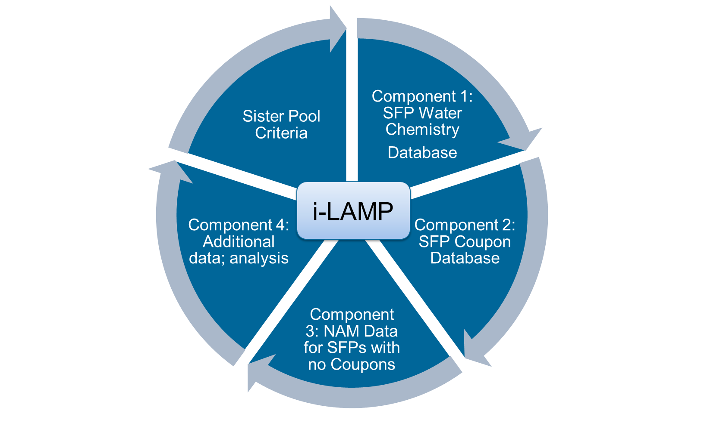

*FIG. 1. Overview of i-LAMP with all the components leading to a learning aging management program to monitor neutron absorber materials in SFPs*

Based on these four components, sister pool criteria (SPC) will be developed. As shown in Fig. 1, as part of a learning aging management program, each component communicates with one another and will be revisited at regular intervals. The i-LAMP will be beneficial across the industry because it will allow monitoring of trends, identification of outliers, and development of an improved technical basis for guidelines and future monitoring. Currently, all U.S. utilities and several international utilities (for example, South Korea, Taiwan, and Mexico) are participating in the i-LAMP development. Each component of the i-LAMP is described briefly in the following sections.

### Component 1: SFP Water Chemistry Database

SFP water chemistry is monitored at regular intervals at all the SFPs in the United States and in many countries around the world. SFP water chemistry measurement serves two purposes:

* It ensures compliance with water chemistry guidelines for corrosion. The EPRI Boiling Water Reactor (BWR) and Pressurized Water Reactor (PWR) water chemistry guidelines [4, 5] recommend chloride (Cl), fluoride (F), and sulfate (SO4) levels below 150 ppb to reduce corrosion potential. The guidelines were developed primarily to reduce corrosion of fuel.
* It is a monitoring tool. When there are anomalies, the chemistry levels will be an early indicator. For example, Boraflex degradation was first identified when SFP silica levels were elevated.

In other programs, water chemistry is used as part of an industrywide monitoring program for the same purpose.

SFP water chemistry data collection for this Component started in late October 2017. To date, SFP water chemistry data from over 30 pools have been collected, corresponding to over 70,000 data points, and are currently being populated into the database. The collected data include all the measured parameters for each pool. The parameters that are measured and recorded at every SFP include pH, conductivity, chloride (Cl) concentration, fluoride (F) concentration, and sulfate (SO4) concentration. In addition, for PWRs, boron (B) concentration and sodium (Na) concentration are measured. For pools that still have Boraflex, silica levels are also measured. Very few pools still measure aluminum (Al) since most utilities discontinued this practice because Al levels were usually below detectable limits.

At this point, no additional measurement parameters are required. Historic SFP water chemistry data from all U.S. utilities (~100 SFPs) and other participating countries (for example, Mexico, Taiwan, and South Korea) will be collected and populated into the database by the end of 2019.

Once the collection of historic data is complete, it is anticipated that the database will be updated with the new data approximately every six months.

#### Examples of SFP Water Chemistry Data

For illustration, several examples from the SFP water chemistry data that have been collected to date are presented in the following figures. For some of the SFPs, the time interval of measurements spans over two decades. For the initial analysis, the measured SFP water chemistry data from all the SFPs (including PWRs and BWRs) are merged.

The Cl levels for over 30 pools (over 10,000 measurement points) are presented in Fig. 2. As is evident from the figure, all the measured Cl levels are within recommended levels, and the maximum measured level is 150 ppb.

The measured sulfate levels, for the same SFPs, are presented in Fig. 2. As shown in the figure, several measurements are above the recommended level of 150 ppb. A closer inspection and preliminary analysis of the sulfate data showed the following:

* The maximum measured sulfate level in the data collected to date for these SFPs is 446 ppb (~3x higher than the recommended value).
* Out of 10,500 measurement points, 126 data points are above the recommended level of 150 ppb. It should be noted that all the points above the recommended value do not belong to the same SFP. Furthermore, when excursions occur, plants monitor and record the sulfate levels more frequently—which tends to bias the results on the high side.
* For any single SFP, the maximum number of consecutive days on which the sulfate levels were above 150 ppb was 12.

The recommended levels are shown with a dark red solid line in Fig. 2.

|  |  |
| --- | --- |
|  |  |

*FIG. 2. The measured Cl (left) and sulfate (right) levels for over 30 SFPs*

### Component 2: SFP Coupon Database

The SFP coupon database is being developed to collect the data and analyze them to determine bounding conditions (for example, changes in areal density or maximum observed blisters/pit sizes to date), trends (as a function of time in service), and any potential relationship between potential degradation and SFP water chemistry and other parameters.

#### SFP Coupon Data Collection

Unlike SFP water chemistry, development of the coupon database poses more challenges. First, there are multiple vendors performing coupon analysis. Second, some of the utilities are performing their own in-house analysis. Subsequently, there are variations in the analyses performed and in the documentation of results. Furthermore, because some of the historic coupon analysis reports are not available electronically, these reports are being scanned and converted to electronic form.

The data being extracted from coupon reports currently include pool name, rack installation year, rack type (egg crate versus flux trap), stainless steel encapsulation or not, coupon unique ID number, coupon analysis year(s), whether the same coupon is analyzed multiple times, dimensional data (pre-characterization and post-irradiation), height, width, thickness, weight, areal density values (pre-characterization and post-irradiation), pit and blister data, and pictures. The current plan is to link the coupon data in the database (including pictures) to the original coupon report from which the data were extracted. This would also allow easier cross-checking with the original reports and documentation.

#### Examples of SFP Coupon Data

In this section, some of the features from the SFP coupon data to date are presented. The measured pit depth and area as a function of frequency are presented in Fig. 3. These figures include over 100 coupon data points representing over 20 SFPs, including both PWR and BWR, with service time varying from 1 to 18 years. Based on the actual coupon data from these SFPs:

* Maximum observed pit depth is ~0.1016 cm (0.04 in.)
* Maximum observed pit area is ~0.3 cm2 (0.046 in2)

It should be noted that the maximum pit depth and area include Al cladding, which is usually 0.025 cm (~10-12 mil) thick [1]. The analysis performed to determine the impacts of pitting on SFP reactivity showed that the pitting, observed to date based on operating experience, has a negligible impact on reactivity [6].

|  |  |
| --- | --- |
|  |  |

*FIG. 3. Pit depth (left) and pit area (right) as a function of frequency for SFP coupons*

The measured blister height and area as a function of frequency intervals are presented in Fig. 4. These figures include over 100 coupon data points representing 20 SFPs with service time varying from 1 to 18 years. It should be noted that the majority of the coupons (80%) did not show any blisters. For the remaining coupons, the majority showed only a few blisters while several of the coupons showed a larger number of blisters. Based on the actual coupon data from SFPs:

* Maximum blister height is ~0.4 cm (~0.16 in.)
* Maximum blister area is ~21.4 cm2 (~3.32 in2)

The analysis performed to determine the impact of blisters on SFP reactivity showed that blisters of these sizes have negligible impact on reactivity [6].

|  |  |
| --- | --- |
|  |  |

*FIG. 4. Blister height (left) and blister area (right) as a function of frequency for SFP coupons*

Currently, a few pools perform visual inspection at regular intervals and re-insert the coupon into the SFP. For these pools, the analysis includes visual inspection and dimensional measurements. These inspections also include the measurement of the blister height, which allows trending over time.

As an example, the blister growth data for a coupon over a long period of time are presented in this section. The coupon was placed in the SFP in 1983 and belongs to one of the currently operating SFPs. The neutron absorber panels in this SFP are encapsulated in stainless steel. The coupon itself was also initially encapsulated; however, in 1991, the stainless steel encapsulation was removed—since then, the coupon resides in the SFP without any encapsulation. The coupon size is 15.24x15.24 cm (6x6 in.).

The pictures of the coupon showing blisters on the front and back side of the coupon are available from 2010 and 2017. The pictures for the front side of the coupon from 2010 (left) and 2017 (right) are shown in Fig. 5. As shown in the figure, the front side of the coupon has four blisters with varying sizes. The back side of the coupon has two blisters with varying sizes. As is evident from the pictures, there is no significant change in blister size between 2010 and 2017.

|  |  |
| --- | --- |
|  |  |

*FIG. 5. Front side of the coupon from 2010 (left) and 2017 (right)*

Between 1991 and 2017, the blister height measurements were taken at certain intervals. For this coupon, the blister height and area as a function of measurement year are presented in Fig. 6. In these figures, *F-1* to *F-4* represent the blisters on the front side of the coupon, and *B-1* to *B-2* represent the blisters on the back of the coupon. As is evident from the figure, between 1991 and 2017, there is no large variations in blister growth. The variation in sizes is mainly due to the measurement uncertainty, which includes changes in measurement equipment, human performance, selection of measurement points, and potential other factors that are not fully confirmed. These figures demonstrate that even for older vintages of BORAL®, which are most susceptible to blister growth, blisters stabilize and do not continue to grow after initial formation. Although only one coupon with the largest blister sizes is included in this report as an example, similar behaviour was observed in other coupons in the same pool.

|  |  |
| --- | --- |
|  |  |

*FIG. 6. Blister height (left) and blister area (right) as a function of measurement year*

### Component 3: Basic Information Needed for SFPs with No Coupons

To develop an industrywide monitoring program and SPC for the entire fleet of SFPs, basic information on neutron absorber materials from all the participating SFPs will need to be gathered. This data collection and analysis will allow for the development of sister pool criteria.

Therefore, for SFPs without a coupon program, some of the basic information related to NAMs also needs to be collected and analyzed. The basic information needed for SFPs without coupons includes the following:

* NAM areal density values
* NAM thickness
* Manufacturing and installation year
* Manufacturer and vendor information may also be needed

The coupon database (Component 2) will already include information on the rack geometries—which is important because there are many variations in rack geometry. If a correlation between coupons and racks is determined, the information on rack geometries for SFPs without a coupon program will also be collected.

In addition, if it is determined that the NAM properties in this Component are not bounded by the NAM properties in Component 2, additional analysis will be needed. The scope of the additional analysis will be determined after the completion of the data collection and analysis of the range of variations.

### Component 4: Evaluation of Potential Needs for Additional Data and Analysis

For a given NAM, aging effects in SFPs are a function of the following:

* Time in the SFP
* Cumulative neutron dose
* Cumulative gamma dose
* Temperature
* Water chemistry
* Type and vintage of the material

Table 1 summarizes the ongoing EPRI research on NAMs and the corresponding parameters it addresses. For the SFP coupon database, dose information is not collected; however, given the variations in time for coupons residing in SFPs, the coupon analysis results will indirectly provide the impact of the radiation on NAM performance. A brief overview of these research projects is presented in Section 2 of Reference [2], and further description is available in References [6–14]. As shown in the table, the ongoing research projects provide additional information on long-term performance of NAMs and the impact of certain parameters. For example, for the accelerated corrosion project, the coupons were placed in test baths representing PWR and BWR water chemistry at elevated temperatures. During the first year, sulfate levels were unintentionally significantly higher (1500 ppb) than the EPRI-recommended levels (150 ppb). None of the coupons in the PWR test bath showed significantly more degradation, which can demonstrate that even at higher sulfate levels, the material is still robust [7–9].

TABLE 1. Summary of ongoing EPRI research on neutron absorber materials

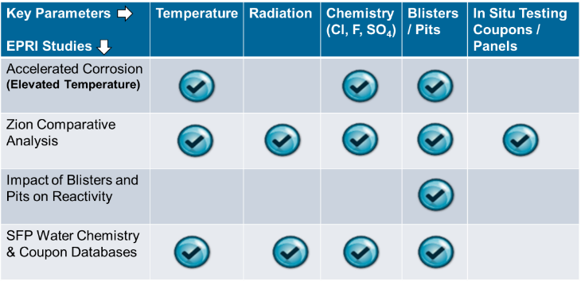

However, when the historical SFP water chemistry and coupon data collection is completed, any variations will be evaluated to determine whether additional research projects are required to close the information gaps and improve the understanding of the long-term impacts on the material’s intended function.

## Development of Sister Pool Criteria for Spent Fuel Pools

The development of the SPC is highly dependent on the quality of data collected in the databases (Components 1–3) and additional analysis, if deemed necessary.

The following are the generalized steps of the SPC process:

1. **Collection of the data.** For the initial determination of the SPC, it is very important to have completed the collection of the historical data for Components 1–3. After the initial collection, having updated data will help to inform whether the criteria would need to be revised.
2. **Analysis of the data.** Each of the Components will be analyzed and, when appropriate, synergized (for example, evaluation of SFP water chemistry and coupon results to determine whether there is a correlation between elevated chemistry levels and observed degradation).
3. **Development of the SPC.** Once all the Components have been analyzed and the synergistic effects determined, the SPC can be developed. As a starting point, for simplicity, initially only two bins are proposed. The first bin contains all SFPs with coupons; the second bin will contain the SFPs that do not have coupons.
4. **Re-evaluation of Components 1–4 for updates.** Analysis of the data will continue to determine whether refinement of the SPC is needed. Sub-bins may be created and analyzed as needed.

## i-LAMP Development

After the SPC have been defined, the i-LAMP guidelines will be developed with input from the industry. These guidelines will be published by EPRI as recommendations and will be reviewed at EPRI’s Neutron Absorber User Group (NAUG) annual meeting for any changes that may be necessary. EPRI will perform an initial detailed evaluation of these guidelines three years after publication and then every five years. This proposed interval will be adjusted as needed.

Once the i-LAMP has been established, it will be important to maintain the sample size to maintain its effectiveness. For this reason, EPRI’s recommendation is for SFPs participating in the program and planning to be decommissioned to communicate with their sister pools and move the coupon tree to a sister pool. This will be further defined upon completion of the analysis of the initial data set.

EPRI will host the SFP water chemistry and coupon databases, and access will be limited to EPRI members.

## Summary

In this paper, the proposed industrywide learning aging management program (i-LAMP) and its components are presented. At this preliminary stage, it is proposed to have two bins for SPC: one bin will include SFPs with a coupon monitoring program; the other bin will include SFPs without a coupon monitoring program. Once the data collection and analysis are complete, SPC will be revised as needed.

Based on the initial proposed schedule, it is anticipated that by the end of 2019, data collection and analysis will be completed; it will then be determined whether finer binning is needed. Once the data collection and analysis are complete, guidelines for SPC development will be developed in 2020 and discussed at NAUG meetings. Then, regulatory endorsement for i-LAMP, as an alternative monitoring approach, will be pursued. Depending on the analysis results, it will be determined whether guideline development for water chemistry and coupon analysis is needed. If it is deemed necessary, EPRI will develop the guidelines and communicate to the industry and regulators.

ACKNOWLEDGEMENTS

The authors would like to thank all the U.S. and global utility representatives for their participation in the i-LAMP. The members have been providing water chemistry and coupon data and actively participating in discussions for an improved aging management program.

REFERENCES

1. *Handbook of Neutron Absorber Materials for Spent Nuclear Fuel Transportation and Storage Applications*. EPRI, Palo Alto, CA: 2009. 1019110.
2. *Roadmap for Industrywide Learning Aging Monitoring Program (i-LAMP) for Neutron Absorber Materials in Spent Fuel Pools*. EPRI, Palo Alto, CA: 2018. 3002013122.
3. H. AKKURT and E. WONG, “Industrywide Learning Aging Management Program (i-LAMP) for Neutron Absorber Material Monitoring in Spent Fuel Pool,” *Trans. Am. Nuc. Soc.*, **119**, 305–308 (2018).
4. *BWRVIP-190 Revision 1: BWR Vessel and Internals Project, Volume 1: BWR Water Chemistry Guidelines – Mandatory, Needed, and Good Practice Guidance*. EPRI, Palo Alto, CA: 2014. 3002002623.
5. *Pressurized Water Reactor Primary Water Chemistry Guidelines: Volume 1, Revision 7*. EPRI, Palo Alto, CA: 2014. 3002000505.
6. *Evaluation of the Impact of Neutron Absorber Material Blistering and Pitting on Spent Fuel Pool Reactivity*. EPRI, Palo Alto, CA: 2018. 3002013119.
7. H. AKKURT, A. QUIGLEY, and M. HARRIS, “Accelerated Corrosion Tests to Evaluate Long-Term Performance of BORAL® in Spent Fuel Pools,” *Trans. Am. Nuc. Soc.*, 115, 306–309 (2016).
8. H. AKKURT, A. QUIGLEY, and M. HARRIS, “Update on Accelerated Corrosion Tests for the Evaluation of Long-Term Performance of BORAL® in Spent Fuel Pools,” *Trans. Am. Nuc. Soc.*, **117**, 319–322 (2017).
9. H. AKKURT, A. QUIGLEY, and M. HARRIS, “Accelerated Corrosion Tests for the Evaluation of Long-Term Performance of BORAL® in Spent Fuel Pools,” *Radwaste Solutions*, **25**, No 1, 41–43, Spring 2018.
10. *Evaluation of BORAL® Coupons from Zion Spent Fuel Pool*. EPRI, Palo Alto, CA: 2016. 3002008195.
11. *Evaluation of BORAL® Panels from Zion Spent Fuel Pool and Comparison to Zion Coupons*. EPRI, Palo Alto, CA: 2016. 3002008196.
12. H. AKKURT, S. FEUERSTEIN, M. HARRIS, and A. QUIGLEY, “Analysis of BORAL® Coupons from Zion Spent Fuel Pool,” *Trans. Am. Nuc. Soc.*, **113**, 372–375 (2015).
13. H. AKKURT, A. QUIGLEY, and M. HARRIS, “Evaluation of Neutron Absorber Panels from Zion Spent Fuel Pool,” *Trans. Am. Nuc. Soc.*, **115**, 645–647 (2016).
14. H. AKKURT, “Comparison of Neutron Absorber Panels and Monitoring Coupons from Zion Spent Fuel Pool,” *Proc. of International High-Level Radioactive Waste Management (IHLRWM 2017)*, April 2017, Charlotte, NC.