AGING MANAGEMENT OF DRY STORAGE SYSTEMS

CENTRALIZED INTERIM STORAGE FACILITIES

P. NARAYANAN
ORANO TN
Columbia, MD USA
Email: Prakash.narayanan@orano.group
Abstract
In the United States, used fuel assemblies discharged from nuclear power plants (NPPs) have historically been stored on-site using licensed dry storage systems. The duration of storage at the NPP sites was intended to be short term (20 to 40 years) with subsequent transportation to a geological repository. Due to shutdown/decommissioning of several NPPs and delays in the implementation of the geological repository, there is a need to develop solutions to manage the storage of dry storage systems in interim storage facilities.
The centralized interim storage facility (CISF) functions as an intermediate repository/staging area for dry storage systems for an extended duration of time prior to eventual transportation to a geological repository. The operation of a CISF will lead to a significant reduction in the number of independent spent fuel storage installations (ISFSIs) nationally and enable release of space in those decommissioned reactor sites that currently only maintain their respective ISFSIs.
The licensed dry storage systems are categorized as 1) metal cask systems with fuel assemblies directly loaded into the cask which is then stored on site or 2) canister systems where the fuel is housed within a thin-walled canister which is then stored in an overpack. Regardless of type, these systems need to be designed and licensed to ensure that the necessary safety functions are maintained during long term periods of storage and subsequent transportation after storage. In addition, consideration needs to be given to potential aging deterioration of component materials that may occur during operation of the storage system at the ISFSI or in a CISF.
Managing the effects of aging of the structures, systems, and components associated with dry storage is therefore, an important aspect of the extended interim storage of used fuel. Effective aging management programs require a technical understanding of the aging degradation mechanism, inspection and assessment techniques, prevention and mitigation measures (to retard the effects of aging) and, as needed, guidance on repairs or replacements for each component. Significant research is being carried to develop expertise on the various aspects of aging management including material behavior, inspection methods, criteria and long term durability.
The CISF approach to dry storage offers a significant advantage wherein an aging management program can be effectively and uniformly implemented for a wide variety of currently licensed dry storage systems. For example, the appropriate siting of the CISF location can be made to significantly minimize the potential for environmental degradation or natural phenomena.
The paper provides additional insights into design and operation of CISF with an objective to managing effects on dry storage systems for long-term interim storage. The paper also discusses innovative solutions being developed for comprehensive aging management within interim storage facilities.

INTRODUCTION
The management of used nuclear fuel (UNF) from commercial nuclear power plants in several countries, including the United States is being effected using on-site storage in dry storage systems. In the absence of a solution for sustainable UNF management including final disposition, this current method of on-site storage in the ISFSI has become more widespread and several countries have recently embarked on dry storage or have plans to transition to dry storage. Storage of UNF on-site is also partially necessitated in order to support continued plant operations.
Dry storage systems were originally designed and licensed for shorter storage periods, generally 20-40 years [1]. However, several ISFSIs in the United States have been operating for 20 or more years and the storage duration on-site continues to increase. For this purpose, effective licensing evaluations including aging management programs are required to allow for longer term storage. With the shutdown/decommissioning of several NPPs, there is a need to further consolidate the storage of UNF in one or more CISFs resulting in a reduction in the number of ISFSIs.

Dry Storage Systems
The dry storage systems are designed and licensed to provide for important-to-safety functions such as physical protection, radiological protection, criticality control, material confinement, and thermal performance. In addition, the dry storage systems must be designed to withstand a variety of off-normal and accident conditions.
Typical dry storage systems consist of a cylindrical container housing the spent nuclear fuel assemblies in fuel compartments. Prior to storage and after the fuel assemblies are loaded into container from the spent fuel pool, the container is dried, filled with an inert gas and sealed. Depending on the type of storage system, the container, usually made of steel, is either welded or bolted. This results in a leak-tight or near leak-tight confinement barrier and also physical protection to the fuel assemblies. In addition, depending on the type of storage system, the container is stored in the ISFSI directly on in a secondary housing that provides additional shielding and physical protection.

ORANO TN dry storage systems
ORANO TN has developed several dry storage systems [2] for the storage of UNF which are in operation in various countries around the world.

Canister systems with overpack
The NUHOMS® system, the reference system for dry storage of UNF in canisters, was initially developed by ORANO TN in the United States for interim storage more than 20 years ago and has been in operation at several NPP sites. In a canister based system, the UNF is placed in a thin-walled canister, called the dry shielded canister (DSC), back-filled with helium gas, welded and verified to be leak-tight. The DSC is housed in a massive concrete overpack called the horizontal storage module (HSM) during storage at the ISFSI. The DSCs are transferred to the HSM from the NPP using a transfer cask. Following licensed storage at the ISFSI, the DSCs are designed to be transported to an interim storage facility or a UNF processing facility using a certified transportation cask. The NUHOMS® system comprises of several different types of DSCs that are designed and licensed to store BWR and PWR fuel in the United States. In addition, the NUHOMS® system is also licensed to store VVER fuel assemblies.
The most recent innovation in dry storage is the NUHOMS® EOS [3] system with the MATRIX [4] concrete storage module that is capable of high-density storage with a high heat load performance of 50 kW per DSC. In the TN NOVATM system, the DSC is designed for storage within a specially designed metallic overpack. The DSCs designed by ORANO TN are also intended for transportation. Several DSC designs are licensed for both storage and transportation in the United States.
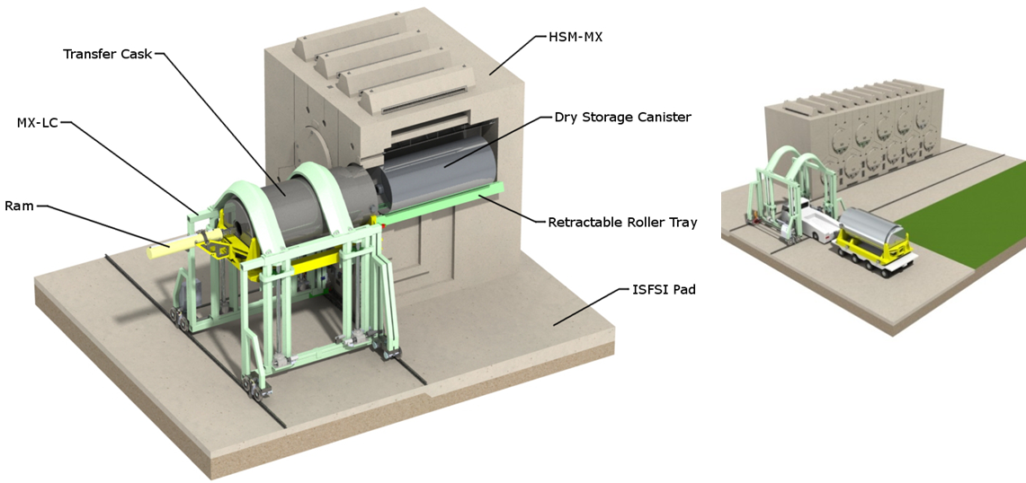
FIG. 1. NUHOMS® MATRIX HSM.

Metal casks
The TN 24 family [5] is an example of a versatile, metal cask system designed and licensed for dry storage and transportation in several countries. Thick-walled metallic casks, also known as dual purpose casks are designed for both storage and transportation and do not require an additional overpack. Because the metal casks are sealed using bolted closure system, the cask confinement can be monitored during storage. ORANO TN has also developed several models of metal casks in the United States and Europe. These models are specifically adapted for the various ISFSI locations and content-specific requirements.

Centralized Interim Storage Facility
The centralized interim storage facility (CISF) is an intermediate staging area for housing UNF dry storage systems. The use of a CISF provides a location where fuel assemblies are allowed to age prior to subsequent or final processing. An example of a CISF is the ZWILAG facility in Switzerland [6] where the spent fuel assemblies discharged from its nuclear power plants are stored in metal casks. The NPPs in Switzerland are not licensed to store UNF in dry storage systems on-site storage, so they are transported to Zwilag after loading and placed inside the storage building. This interim storage facility is intended to operate for a duration of 30 to 40 years until the commissioning of a deep geological repository.
In the United States, with a widespread distribution of NPPs around a much larger geographical area, combined with a large number of NPPs, the on-site storage of UNF evolved as a necessity. While the earlier storage systems were licensed on a site-specific basis, the newer systems were certified such that they are implemented under the provisions of the general license. This widespread distribution of operating ISFSIs also makes it more imperative to consider the development of regional facilities that function as the CISF. Since UNF is stored in more than 2,000 dry storage systems on-site in several ISFSIs, they will need to be transported to the CISF location prior to intermediate or extended intermediate storage. Storage of the UNF in dry storage systems at an appropriately sited and constructed CISF offers significant advantages over traditional on-site ISFSIs. Storage at a CISF will require the following considerations:
- Dry-storage system type–metal cask or canister to be stored;
- Number of years of prior storage at the NPP ISFSI;
- Applicable aging management program, if any, at the NPP ISFSI;
- Design of the storage overpack at the CISF;
- Additional licensing requirements, if applicable, at the CISF;
- Storage duration at the CISF prior to subsequent transportation/processing.

Aging Effects considerations for Dry Storage Systems
The effects of aging may have a potential impact on the performance of the UNF and dry storage system components under extended storage. The dry storage systems are typically licensed for initial storage duration of 20 years. In the United States, a robust regulatory framework has been developed for the renewal of the storage duration by an additional 40 years [7]. The behaviour of the UNF and dry storage system components under extended thermal, radiation and environmental degradation mechanisms has been the subject of several national and international research efforts [8] to develop the technical and licensing basis for extended storage.
Several ISFSIs with dry storage systems, a majority being ORANO TN systems, have started operating under the period of extended operation with license/certificate renewal. The primary objective of the aging effect evaluation analyses/studies is to ensure that the dry storage system maintains its confinement design function under all conditions. The dry storage systems are designed and licensed considering multiple confinement barriers such as the fuel cladding and welded closure lids for canisters (multiple bolted lid for metal casks). The integrity of the cladding is a function of the fuel assembly burnup, hydride concentration/orientation, clad thermal cycling/heat up during loading operations, operating temperature and pressure during storage operations. Extensive research has been conducted [9] [10] and is being conducted on the topic of cladding integrity. As a result, several limiting performance parameters have been established to ensure its integrity for dry storage in an inert environment. The effect of radiation on the dry storage system components, including cladding has also been studied in support of reactor operations which can be applied to dry storage. The half-life of the thermal, neutron and gamma source terms for commercial spent nuclear fuel is approximately 20 years—indicating that their impact reduces with aging.
Therefore, the effect of environmental exposure during the storage duration and its potential impact on confinement is the most important consideration for dry storage systems. Management of the effects of aging is accomplished by an aging management program (AMP). The administration of the AMP is much more effective in a CISF compared to an ISFSI.

Aging Management Program
The objective of the AMP is to ensure that there are no aging effects that result in the loss of the intended design functions of the dry storage system and its components during the period of extended storage. Extensive regulatory and industry guidance is available for the development and implementation of an AMP at a conceptual level. Additional insights will be gained as DSC inspections and subsequent analyses are performed to determine and quantify these aging effects and potential degradation. In general, the AMP can be structured as follows:
- Scope, identification of components, and aging effects and prevention;
- Inspection, detection and analysis;
- Monitoring, trending and acceptance criteria;
- Corrective actions, administration, and learning via operational experience.
Several aging effects associated with radiation and thermal sources for components such as neutron absorber materials, basket plates, canister/cask shells, and concrete overpacks can be shown to be significantly below the well-established threshold limits for more than a hundred years of exposure. AMPs are developed primarily for environmental degradation considerations for confinement. Depending on the storage system type, the AMPs are established for the following:
- Canister/cask external surface inspection program;
- Canister–chloride-induced stress corrosion cracking (CISCC) program;
- Concrete module/HSM internal and external surface inspection program;
- Cask confinement monitoring program;
- Concrete module thermal monitoring program;
- Fuel cladding integrity program.
The above list is a compilation of the ORANO TN experience with several ISFSI license/Storage certificate renewals in the United States. Except for the fuel cladding integrity program, all the other programs are associated with the protection/maintenance of the DSC/cask confinement integrity. A separate research program for high burnup cladding integrity [11] is being conducted in the United States and ORANO TN has supplied the TN-32 high burnup metal cask for this purpose. The objective of the program is to develop the technical basis to evaluate the effectiveness of cladding integrity during dry storage. It is expected that the results will serve to confirm the current understanding of the technical and licensing basis [12] for cladding integrity are applicable and conservative.

Aging Management at THE CISF
The design and operation of the CISF can play an important role in the administration of the AMP for dry storage systems and significantly extend the storage duration of UNF.

CISF Location and Siting
Appropriate siting of the CISF can be performed to minimize the potential for accidents and environmental effects on the dry storage systems. For example, minimizing the potential for and consequences of bounding environmental phenomena such as floods, earthquakes, and tornadoes can be achieved by siting the CISF appropriately. The most consequential aging degradation mechanism for dry storage systems is CISCC–which could impact canister integrity over duration of 50 to 300 years, depending on the susceptibility criteria. As a result, there is a requirement to administer a separate AMP to manage the effects of CISCC for dry storage system operations during period of extended storage. CISCC can occur when there is a susceptible material, corrosive environment and residual stress in the material. Prevention is possible by minimizing or eliminating one of more elements that cause CISCC. For NPPs with ISFSIs that are located near a marine environment, the likelihood of CISCC is higher due to the higher environmental chloride concentration. The CISF when located in an environmentally “benign” region will provide for a non-corrosive environment. For systems that were previously stored in ISFSIs located in more susceptible regions, their subsequent storage in the CISF will result in significantly minimized risk of continued degradation.

Innovative Overpack Designs for the CISF
Innovation in the overpack design at the CISF could result in a very effective implementation of the AMP for canister based systems. The NUHOMS® MATRIX is an example of an overpack design that was specifically designed for extended storage and facilitating CISF operations including enhancement of the AMP. It features an innovative two-tiered, modular horizontal loading and storage of DSCs within a cavity that provides for a maximum heat rejection capacity of 50 kW and enhanced self-shielding. It is also sized to accept DSCs with the largest diameter currently licensed in the United States, providing the capability to house all licensed canister designs. The use of a horizontal method of DSC transfer into the MATRIX module significantly reduces the risk of handling, particularly following storage at the ISFSI. DSCs are transported in a horizontal orientation in the transportation casks, so horizontal storage will eliminate several high risk handling operations. The DSCs are loaded into the MATRIX module using the new retractable roller tray (RRT) deployed through the specially designed RRT openings near the door. The RRT opening and the RRT system is designed to be configured to perform 100% DSC surface inspections within the module. The ability to perform inspections and potential repairs without removing the DSC from the MATRIX results in a significant reduction in risk and exposures.

Innovation in Canister Designs for the CISF
The susceptibility to CISCC could also be minimized by the use of materials such as duplex stainless steel for the confinement boundary. The NUHOMS® EOS is an example of a system where the DSC is licensed employing duplex stainless steel for the confinement boundary. In addition, the potential for CISCC could also be addressed by improvements in manufacturing that result in reduction of residual tensile stresses. Several methods have been studied and can be implemented during DSC fabrication which result in minimized residual tensile stresses at the weld seams (or even net compressive stresses) thereby minimizing or eliminating the susceptibility to CISCC. In order to facilitate extended storage, the HSM can be equipped with a liner or a secondary canister built using duplex stainless steel at the CISF. The DSC containing the UNF is then inserted into the secondary DSC, and the annulus between the two canisters is filled with an inert gas and sealed. This annulus can be monitored as part of a long term AMP. This method has been patented in France (FR2969362).
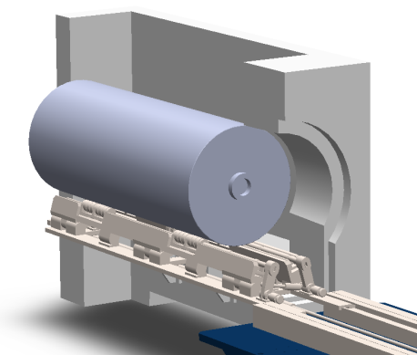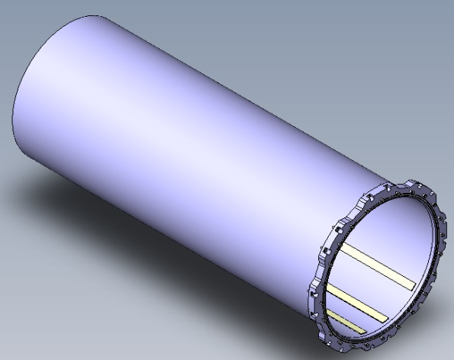
Liner Body & Lid
DSC Surface Inspection Feature
Fig. 2. Aging management enhancement features.

Enhanced Operational Experience at the CISF
The CISF will offer the opportunity to administer a uniform AMP including inspections, monitoring, and analysis for a variety of DSC designs, fuel assembly designs, and prior operating environments. Inspection of the DSC external surface and analysis of the inspection data will provide for a comprehensive understanding of the potential degradation mechanisms associated with DSC confinement as a function of temperature, heat load, prior environmental exposure, and storage duration at the CISF. Mathematical models associated with initiation and propagation of defects could be developed rapidly and can be employed to fine tune the AMPs at ISFSIs located in susceptible environments. Emerging technologies for prevention, inspection, mitigation, and repair/remediation can be deployed at the CISF as they are developed due to the adaptability of the innovative system components such as the MATRIX HSM.

Conclusion
Centralized interim storage facilities offer significant advantage over traditional ISFSIs located within NPPs particularly considering extended storage of UNF in dry storage systems. Safety and continued robustness of the dry storage and transportation systems will require innovative solutions to monitor and mitigate any potential deterioration of the systems. AMPs associated with the management of the potential degradation of the effectiveness of the dry storage system design functions can be enhanced at the CISF due to a combination of site selection, innovation in system designs, and adaptability of future technological advances. International exchanges on operational experience associated with prevention, inspection, mitigation, analysis, and repair/remediation will lead to the next evolution of aging management.
NOMENCLATURE
NUHOMS® is a trademark of TN Americas LLC registered in the United States and other countries.
AMP–aging management program
CISCC–chloride-induced stress corrosion cracking
CISF–centralized interim storage facility
DSC–dry shielded container
HSM–horizontal storage module
ISFSI–independent spent fuel storage installation
NPP–nuclear power plant
UNF–used nuclear fuel (spent nuclear fuel)

REFERENCES
- GARCIA, J., NARAYANAN P., Leading the way with Aging Management, PATRAM 2016, Kobe, Japan (2016)
- GARCIA J., ISSARD, H., Aging Management of Dry Storage System for Long Term Storage, ICONE22, Prague, Czech Republic (2014).
- NARAYANAN, P., NUHOMS® EOS: Innovations to Ensure Safe Extended Optimized Storage, INMM Spent Fuel Seminar, Arlington, USA (2015).
- BONDRE, J., NUHOMS® MATRIX (MX) HSM, NEI Used Fuel Management Conference, Savannah, USA (2017)
- ISSARD, H., Dry Storage Reliable Solutions for the Management of Spent Nuclear Fuel in the Long Term, TOPFUEL 2012, Manchester, UK, 2012.
- WILLIAMS, T., Management and Transportation of Spent Nuclear Fuel in Switzerland, US NWTRB Summer Board Meeting, Denver, USA (2015)
- U.S. Nuclear Regulatory Commission, NUREG-1927, Standard Review Plan for Renewal of Specific Licenses and Certificates of Compliance for Dry Storage of Spent Nuclear Fuel, Revision 1, 2016 (ML16053A199)
- LARSON, N., DOE R&D in Support of High Burnup Spent Fuel Dry Storage and Transportation, NEI Used Fuel Management Conference, Orlando, USA (2016)
- IAEA TECDOC-1680, Spent fuel performance assessment and research: final report of a coordinated research project (SPAR-II), (2012).
- ZEACHANDIRIN, A., DALLONGEVILLE, M., PURCELL, P., CORY, A., Description of fuel integrity project methodology principles, PATRAM 2010, London, UK (2010)
- EPRI, High Burnup Dry Storage Cask Research and Development Project: Final Test Plan, contract No. DE-NE-000593, 27 February 2014.
- BARE, W.C., TORGERSON, L.D., Dry Cask Storage Characterization Project-Phase l: CASTOR V/21 Cask Opening and Examination, INEEL/EXT-01-00183 Rev.1, Idaho National Laboratory, Idaho (2001).

