# PReliminary evaluation for independent confirmation of source term and criticality of the dual purpose cask in korea

DAESIK YOOK, KANG GYEONGUK, HAIYONG JUNG

Korea Institute of Nuclear Safety

Daejeon, Republic of Korea

Email: dsyook@kins.re.kr

**Abstract**

Spent fuel information are essential to make a national policy for spent fuel management, to evaluate the safety of transportation, storage facility and disposal facility. For that reason, The AMORES program (Automatic Multi-batch ORIGEN Runner for Evaluation of Spent fuel) was developed and used to evaluate inventory, radioactivity, and thermal power of transport cask or storage cask. This code is very useful to evaluate the present and future spent fuel characteristic to provide fundamental data for informed decision-making at various stages of SNF management (storage, transportation, and disposal) by using the whole spent fuel data from 1978 to 2015 in Korea. The aim of the study is to expand the function of AMORES code for evaluating the safety of transport cask or storage cask. For this purpose, AMORES code can contain the cask specification and material information as a database in advance. This data can be modified as an input file of MCNP code or KENO VI for calculating radiation shielding and criticality automatically by AMORES code, respectively. Therefore, it can call the MCNP code or KENO VI, execute these code, and extract the results from output file form.

In the study, in order to AMORES code validation ,criticality evaluation of KORAD 21 dual purpose cask was performed using the cask specification and material information of this cask that was developed to KORAD (KOrea RADioactive waste agency).

According to the nuclear safety act of Korea, the effective neutron multiplication factor, keff including all biases and uncertainties at a 95 percent confidence level, should not exceed 0.95 under all credible normal, off-normal, and accident-level conditions. keff of KORAD 21 was evaluated as 0.3280 and 0.94132 under the normal condition and accident condition, respectively.

## INTRODUCTION

### The basic concept and function of AMORES program [1]

The AMORES program was developed using C++ and C# to generate the source terms of SNFs, making it possible to automatically generate ORIGEN-S input files and process their output files for a large number of SNF assemblies. Figure 1 conceptually shows the AMORES computer code. Figure 2 shows the initial screen of the AMORES program. AMORES consists of four primary functions: (1) SNF database (DB) validation, (2) Using projection model, (3) Source term evaluation, and (4) Output processing. Using the "SNF DB validation" function, the user can set the normal range of the initial enrichment, the discharge burnup of the last cycle, and the discharge date, as well as filter out data beyond the set range. The "Using projection model" function generates future SNF data from the latest discharge date in the normal SNF DB to the date designated by the user (e.g., interim storage facility operation date). The future SNF data is generated to reflect the distribution of burnup and initial enrichment derived from the statistical analysis of the normal SNF DB. The "Source term evaluation" function automatically generates ORIGEN-S input files using the normal SNF DB and future SNF data and calculates concentration, radioactivity, thermal power, and isotopic composition by assembly using the batch mode of ORIGEN-S. In addition, this function can extract the nuclides selected by the user and calculate inventory. There are 183 nuclides considered important for mass, activity, decay heat, and accident consequence. The "Output processing" function can provide users with the results of total, assembly, and nuclides inventory, and can export them to a spreadsheet. Additionally, it can create input files for transportation risk assessment code, SNF disposal facility safety assessment code, etc.

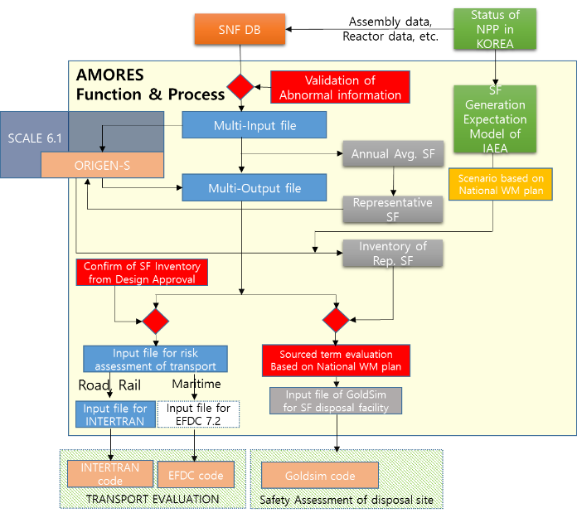

*FIG. 1. The concept of AMORES computer code*

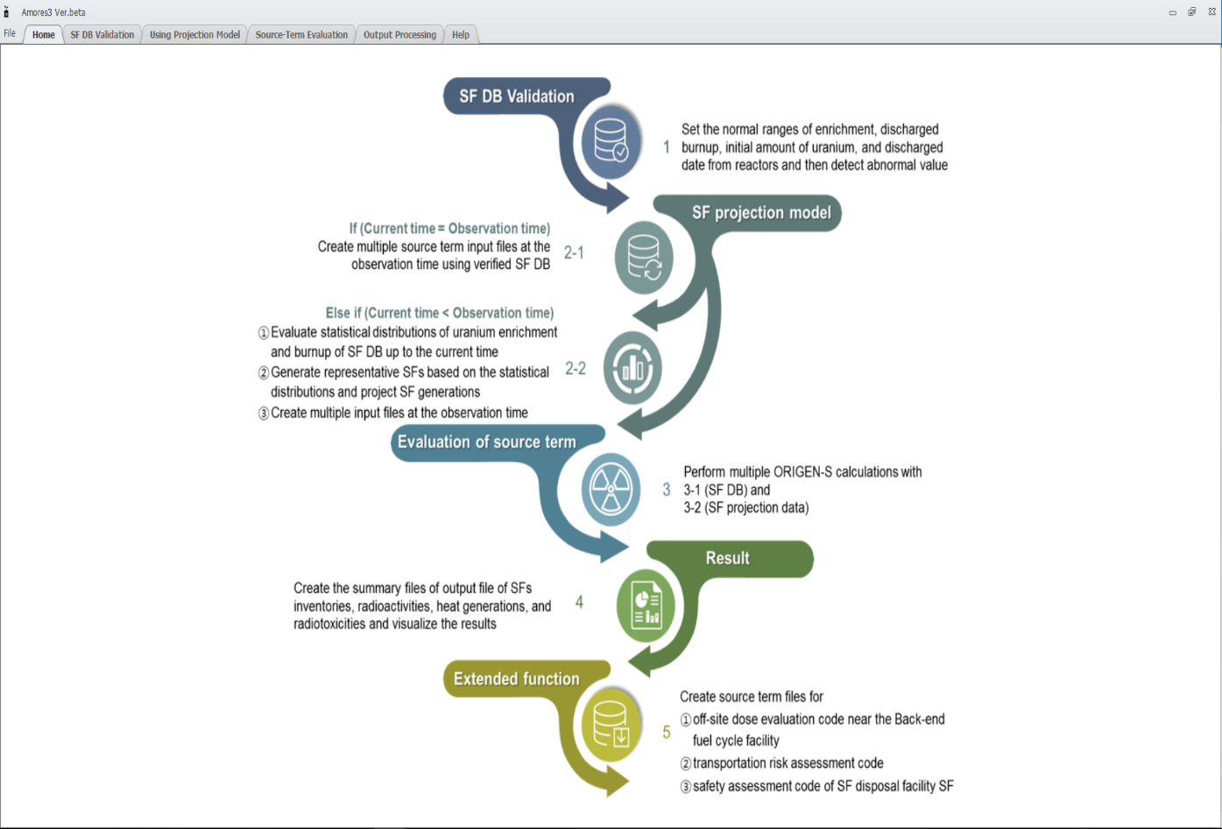

*FIG. 2. Initial screen of AMORES program*

### The direction of extension of the AMORES code capability

Whereas the current AMORES computer code focuses on the evaluation of the source term of spent fuel, the Used Nuclear Fuel-Storage, Transportation & Disposal Analysis Resource and Data System (UNF-ST&DARDS) which is a comprehensive integrated data and analysis tool being developed for the US Department of Energy (DOE) can provides cask-specific as-loaded safety analysis, including criticality, thermal and dose evaluations. [2].

In compliance with the nuclear safety act and the notice of NSSC (Nuclear Safety and Security Commission), transport cask or storage cask for spent fuel shall be evaluated the criticality, shielding, heat removal function, etc. Furthermore, KINS (Korea Institute of Nuclear Safety) has in charge of the safety review and inspection of this transport cask or storage cask. There are 5 transport casks which were approved by the regulatory body in Korea as shown in table 1. And KORAD-21 dual purpose cask is under review for the design approval by the KINS. The owner of spent fuel transport cask who has intention to use it continuously shall be inspected periodically in every 5 years by the KINS. Spent fuel transport cask has to be confirmed on each safety like as criticality, radiation shielding, containment, heat removal ability, etc. in both review process and periodic inspection.

TABLE 1 . The status of transport casks of spent fuel in Korea

|  |  |  |  |  |  |  |  |  |
| --- | --- | --- | --- | --- | --- | --- | --- | --- |
| Holder | Model | Capacity  (assembly) | Burnup  (MWD/MTU) | Enrichment  (w/o) | Cooling time  (year) | Weight  (ton) | Quantity  (EA) | Developing  time |
| KAERI | SC-1 | PWR  1 | 40,000 | 3.5 | 1 | 28 | 1 | ’82-’85 |
| KAERI | KSC-4 | PWR  4 | 38,000 | 3.5 | 3 | 37 | 2 | ’87-’91 |
| KHNP | KN-12 | PWR  12 | 50,000 | 5.0 | 7 | 75 | 5 | ’99-’02 |
| KHNP | KN-18 | PWR  18 | 55,000  60,000 | 5.0 | 7  9 | 104 | 4 | ’06-’09 |
| KHNP | HI-STAR63 | PHWR  120 | 7,800 | 0.711 | 6 | 25 | 2 | ’07-’09 |

For this reason, the capability of AMORES computer code shall be extended as shown in figure 3. First of all, the approved spent fuel transport cask characteristic information will be stored in AMORES code as database. These data can be converted the input file of KENO VI for criticality, the input file of STARBUCS for burnup credit, the input file of MAVRIC for radiation shielding, respectively. For the evaluation of burnup credit and radiation shielding, neutron spectra and gamma spectra from specific spent fuel assemblies are necessary. These spectra can be obtained from AMORES code as shown in figure 3, then AMORES code merge neutron, gamma spectra and transport cask configuration data into the input file of STARBUCS or MAVRIC.

Finally, these computer codes for each purpose in SCALE 6.1 can be executed by AMORES automatically. The assumption that fresh fuel will be loaded in the transport cask is applied for the criticality evaluation so that it is not necessary additional information from spent fuel database of AMORES. In case of thermal evaluation of transport cask, both KINS and the applicant for the design approval of spent fuel transport cask use the FLUENT code or CFX code. AMORES code can evaluate the decay heat of specific spent fuel and provide this data to these computer codes as the thermal source input parameter. However AMORES can’t make input file of FLUET or CFX code directly and it can provide some parameter merely. In the study, in order to AMORES code validation, criticality evaluation of KORAD 21 dual purpose cask was performed using the cask specification and material information of this cask that was developed to KORAD as parts of the development of the expansion of AMORES code function.

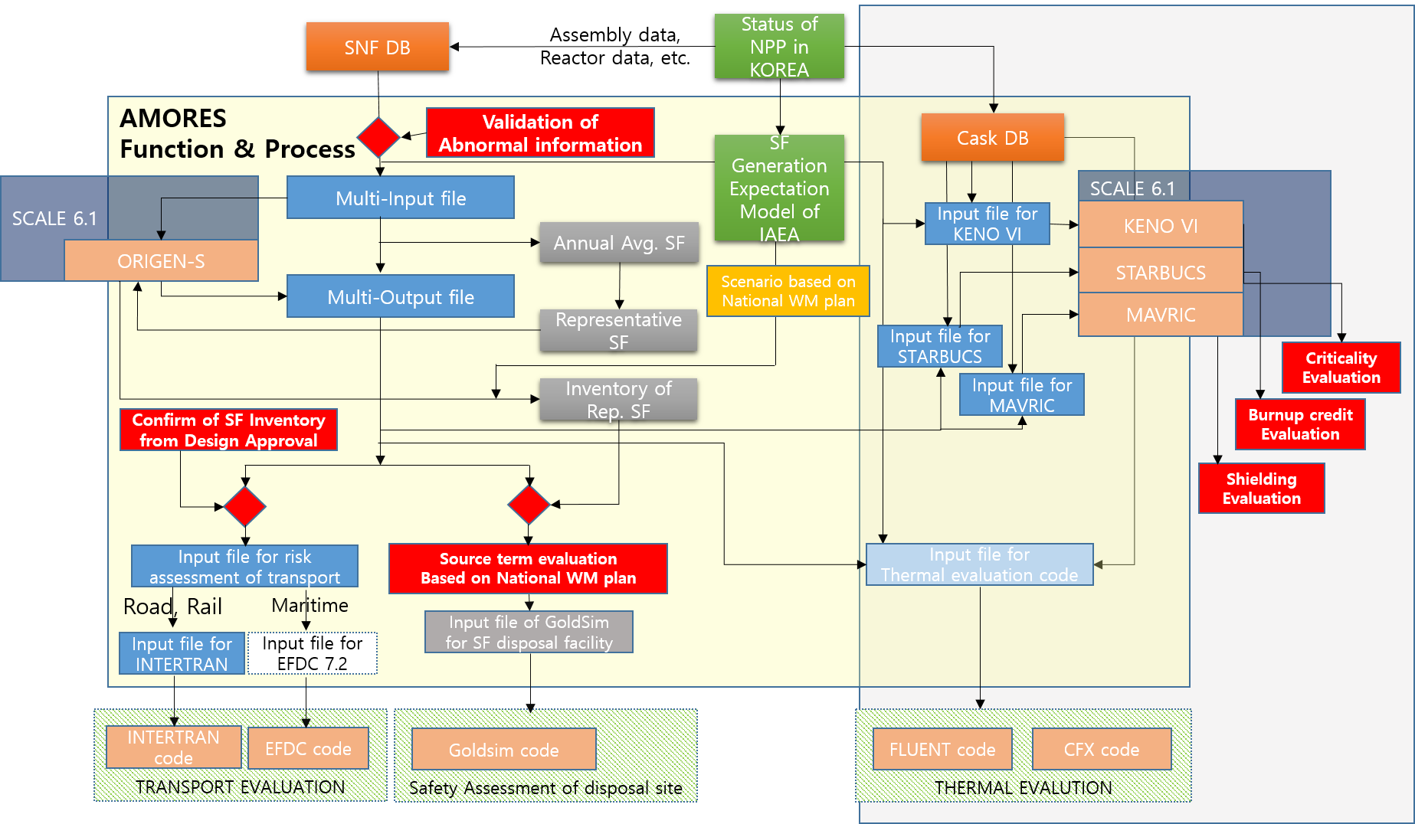

*FIG. 3. The direction of extension of the AMORES code capability*

## Evaluation results of source term of spent fuel and criticality of transport cask

### Preliminary evaluation results of source term of spent fuel in Korea

AMORES code has PWR spent fuel assembly data like as assembly identifier, initial enrichment, initial uranium mass, discharge burnup, fuel type, last irradiation cycle number, discharge date, discharge NPP unit, and storage NPP unit. By using this data, AMORES can calculate the total radioactivity inventory and thermal power at the present time, and it can project the future inventory through various scenarios, as well. Since 1978, the first commercial nuclear power plant Kori 1 started in commercial operation, total amounts of PWR spent fuel in Korea were about 7.07E3 MTU from 20 nuclear power plants as of the end of 2015. Total radioactivity and thermal power of these spent fuels can be evaluated as 2.00E20 Bq, and 1.92E07 Watt by using AMORES, respectively [1]. Offsite spent fuel storage facility will be constructed until 2035 and deep geological disposal facility will be constructed and operated in 2050s, according to the national high-level radioactive waste plan which was announced in 2016 officially. Total inventory of spent fuel stored in the off-site storage facility which are operated from 2035 to 2050s are evaluated 1.457E+3 MTU through the AMORES code. This evaluation is based on the scenario that the oldest spent fuels are moved to the off-site storage facility from each NPPs. Additionally, this evaluation results were based on the assumption that all the fuel assemblies for PWRs have undergone a single specific power (40MW/MTU) over a depletion period estimated with the discharge burnup. In order to use the STARBUCS sequence of SCALE6.1, the spent fuel characteristics with realistic irradiation and cooling histories are necessary. GyeongMi Kim et al.[3] studied the comparison results between the simple AMORES calculation and the considering calculation of irradiation and cooling histories of spent fuel. The analysis of the spent fuel characteristics for the distinct six patterns of irradiation and cooling showed that some cases which has long cooling times between the irradiation cycles give higher radioactivities and gamma powers but smaller thermal power and radiotoxicities for 40MW/MTU than the ones for the realistic irradiation histories. From the additional nuclide-wise analysis for these special cases, it was shown that the discrepancy in thermal power and radiotoxicities mainly come from the large discrepancy in 238Pu inventories [3]. This effect affects the criticality analysis with burnup credit and the quantitative evaluation was studied by GyeongMi Kims et al.[4], as well. It will be developed that the improved AMORES calculation module in capable of applying irradiation and cooling histories of spent fuel.

### Preliminary evaluation results of criticality of transport cask

Whereas the source term information of spent fuel is necessary for the burnup credit, radiation shielding, and thermal evaluation, in case of the criticality, it is not necessary because the assumption that fresh fuel will be loaded in the transport cask is applied. As shown in figure 3, AMORES code can contain the cask specification and material information as a database in advance. This data can be modified as an input file of MCNP code or KENO VI for calculating radiation shielding and criticality automatically by AMORES code, respectively. In the study, in order to AMORES code validation, criticality evaluation of KORAD 21 dual purpose cask was performed using the cask specification and material information of this cask that was developed to KORAD. Figure 4 shows the configuration of KORAD 21. According to the nuclear safety act of Korea, the effective neutron multiplication factor, keff including all biases and uncertainties at a 95 percent confidence level, should not exceed 0.95 under all credible normal, off-normal, and accident-level conditions. The article 32 to 34 of the NSSC notice which is called Regulations for the Packing and Transport of Radioactive Materials, etc. describe the technical requirements of sub-critical evaluation of an individual package, assessment of package arrays under normal conditions of transport, and assessment of package arrays under accident conditions of transport, respectively [5]. According to the article 32(sub-critical evaluation of an individual package) of the NSSC notice, it shall be assumed that water can leak into or out of all void spaces of the package, including those within the containment system and it shall be assumed that the confinement system is closely reflected by at least 20 cm of water or such greater reflection as may additionally be provided by the surrounding material of the packaging. According to the article 33(assessment of package arrays under normal conditions of transport) of the NSSC notice, there shall not be anything between the packages, and the package arrangement shall be reflected on all sides by at least 20 cm of water. According to the article 34(assessment of package arrays under accident conditions of transport) of the NSSC notice, hydrogenous moderation between the packages and the package arrangement reflected on all sides by at least 20 cm of water. These three technical requirements on the criticality evaluation are the same that of IAEA safety requirements [6]. The main objective to develop the AMORES code is to evaluate the applicant’s design of transport or storage cask independently. In the study, input file of KENO VI are generated by AMORES code and the criticality of transport cask are calculated and compared the results of the safety analysis report under the three condition as followings:

(1) Dry storage status under the normal condition, (2) 100% water ingress into all void spaces of KORAD-21 dual purpose cask under the normal condition and (3) 100% water ingress under the accident condition.

Cross section library was used the ENDF-B VII of SCALE 6.1 and it was assumed that the transport cask was arrayed at intervals of 60cm infinitely and surrounded by water in case of (2) and (3). Table 2 shows the comparison results on the criticality between the applicant calculation and the KINS calculation by using AMORES code in conjunction with the KENO VI. The effective neutron multiplication factor, keff including all biases and uncertainties at a 95 percent confidence level, should not exceed 0.95 under all credible normal, off-normal, and accident-level conditions. keff of KORAD 21 was evaluated as 0.32803 and 0.94132 under the normal condition and accident condition, respectively.

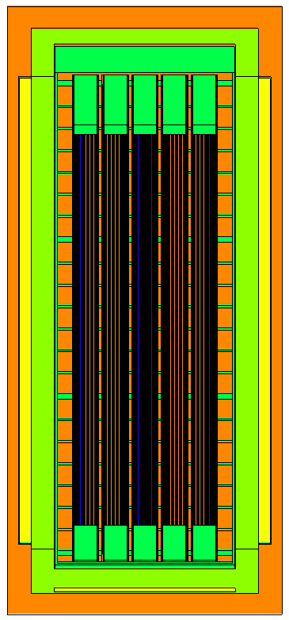

*Fig. 4. The configuration of KORAD 21*

Table 2. The comparison results on the criticality of KORAD-21

|  |  |  |  |  |
| --- | --- | --- | --- | --- |
|  | | Maximum neutron multiplication factor (Max. Keff) | | |
| KORAD | KINS | Difference |
| Normal condition | Dry storage | 0.34265 | 0.32803 | 4.27% |
| 100% water | 0.92624 | 0.92771 | 0.16% |
| Accident condition | 100% water after 9m drop | 0.94112 | 0.94132 | 0.02% |

## CONCLUSION

The AMORES was very useful to evaluate inventory, radioactivity, and thermal power from real spent fuel data in Korea. However it is limited the applicability for the evaluation of the safety of transport or storage cask. In order to overcome this limitation, various functions of AMORES code will be developed and will be added to it. First of all, the approved spent fuel transport cask characteristic information will be stored in AMORES code as database. This data can be converted the input file of KENO VI for criticality, the input file of STARBUCS for burnup credit, the input file of MAVRIC for radiation shielding, respectively. For the evaluation of burnup credit and radiation shielding, neutron spectra and gamma spectra from specific spent fuel assemblies are necessary. These spectra can be obtained from AMORES code and it will be used to make the input file for STARBUCS or MAVRIC. Finally, these computer codes for each purpose in SCALE 6.1 can be executed by AMORES automatically. As the first step to confirm the validation of this code, the criticality evaluation of KORAD 21 was performed and compared to the applicant’s calculation result. As a result, the difference range between the two calculations is from 0.02% to 4.27% in the case of normal and accident condition. Additionally, the function of source term evaluation of AMORES will be improved to consider the irradiation and cooling histories of spent fuel.

## ACKNOWLEDGEMENTS

This work was supported by the Nuclear Safety Research Program through the Korea Foundation of Nuclear Safety (KOFONS), granted financial resource from the Nuclear Safety and Security Commission (NSSC), South Korea (No. 1803015)

## REFERENCES

|  |  |
| --- | --- |
| [1] | Ara Go, Daesik Yook, etc al. “Analysis of Korea’s PWR Spent Nuclear Fuel  (SNF) Characteristics Evaluated from Existing SNF Inventories (1979–2015) and Projected SNF Inventories (2016–2089)”, Nuclear Technology, August, 2018, online : <https://doi.org/10.1080/00295450.2018.1500795> |
| [2] | Josh Peterson, Bret van den Akker, et al. “UNF-ST&DARDS Unified Database and the Automatic Document Generator”, NUCLEAR TECHNOLOGY · VOLUME 199 · 310–319 · SEPTEMBER 2017. |
| [3] | GyeongMi Kim, Geon Hee Jung, Dae Sik Yook, et al., “ Analysis of Detailed Operational History Effects on the Spent Fuel Characteristics for Hanbit Unit 3”, ANUP 2014, 9-12 November 201, Republic of Korea’, Transactions of the Korean Nuclear Society Autumn Meeting, Yeosu, Korea, October 25-26, 2018. |
| [4] | GyeongMi Kim, Geon Hee Jung, Dae Sik Yook, et al., “Spent Fuel Characteristic Analysis with Realistic Irradiation History”, ANUP 2014, 9-12 November 201, Republic of Korea’, Transactions of the Korean Nuclear Society Autumn Meeting, Yeosu, Korea, October 25-26, 2018. |
| [5] | The Notice of NSSC, “Regulations for the Packing and Transport of Radioactive Materials, etc.”, 2018. |
| [6] | IAEA, “Regulations for the Safe Transport of Radioactive Material 2012 Edition”, SSR-6, 2012. |