An oxidizing digestion process applied to SFR MOX fuel recycling to recover plutonium and reduce solid residue volumes

E. BURAVAND

CEA, DEN, DMRC, SPDS, LED

BP 17171, 30207 Bagnols sur Cèze, France

Email: emilie.buravand@cea.fr

N. REYNIER-TRONCHE

CEA, DEN, DMRC, SPDS, LED

BP 17171, 30207 Bagnols sur Cèze, France

**Abstract**

In the scope of Sodium Fast Reactor (SFR) spent fuels recycling, the chemical composition and irradiation conditions require a specially-adapted head-end treatment process to quantitatively dissolve the plutonium. Dissolution studies are therefore being performed at the CEA ATALANTE facility in Marcoule research center. The R&D is based on the use of experimental irradiated Phenix fuels. The dissolution studies include a primary dissolution step in nitric acid medium. Solid residues are then separated by filtration and dissolved applying an oxidizing digestion process which is more efficient for dissolving high Pu-content particles and metallic elements. The composition of SFR spent fuel residues and their masses are presented and linked to the initial fuel compositions and irradiation conditions. Plutonium recovery rates along with the dissolution process, including primary dissolution and oxidizing digestion, are presented. The efficiency of the oxidizing digestion of dissolution residues is also discussed, illustrating the advantages of this chemical step not only for plutonium recovery but also for metallic element dissolution.

## INTRODUCTION

Fast Reactors (FR) are considered in the future to fully exploit the uranium resource and enlarge the solutions to decrease the volume and impact of the final wastes. Initial Pu (recycled from LWR spent fuels) is needed to produce the fuel for the first FR (e.g. mixed uranium and plutonium oxide MOX). Sustainability is then ensured by progressively deploying a FR reactor fleet and repeatedly recycling plutonium together with uranium (multi-recycling) [1], [2].

In France, the treatment process of spent fuel is carried out using the Purex process. The first chemical step of this process is a dissolution of the spent fuel in aqueous concentrated nitric acid. The chemical composition and irradiation conditions of FR MOX fuel require a specially-adapted head-end treatment process to quantitatively dissolve the plutonium.

Probably due to its manufacturing process, (U,Pu)O2 Mixed Oxide (MOX) fuel contains locally high Pu concentrations of plutonium dioxide particles that are particularly difficult to dissolve in nitric medium because the oxidation potential is insufficient to oxidize Pu(IV) into Pu(VI). High burnups and temperatures reached at the core also lead to the formation of refractory intermetallic phases that may include plutonium. Therefore a complementary Pu recovery step from the solid residues left after the primary fuel dissolution step is studied.

Dissolution studies are being performed at the CEA ATALANTE facility in Marcoule research center. Innovative dissolution studies are carried out on perfectly known separate sections of FR MOX PHENIX fissile pins to better understand their dissolution behaviour and learn more about the residue characteristics specific to the initial fuel. After a primary dissolution step in nitric acid medium, solid residues are then separated by filtration and dissolved by an oxidizing digestion process involving Ag(II) [3]. This digestion process is a key to quantitatively recover plutonium from solid residues left after the primary fuel dissolution process and enhance the multi-recycling.

## Experimental

### Spent Fuel characteristics

Phenix assemblies were fabricated in the ATPu plant at CEA Cadarache with the SFR fuel manufacturing process. Initial composition and irradiation conditions are presented in Table 1.

TABLE 1. EXPERIMENTAL IRRADIATED PHENIX FUELS

|  |  |  |  |  |
| --- | --- | --- | --- | --- |
|  | Fuel Pu content :  Pu/(U+Pu) molar ratio (%) | Dissolved Zone | Maximum burn-up of the pin  (GWd/t IHM) | End of irradiation campaign |
| NESTOR-3 fuel | 22.4 | Full-flux | 124 | 07/1987 |
|  |  | Upper |  |  |
| MOX A SFR Fuel | 20.8 | Full-flux | 156 | 11/1998 |
|  |  | Upper |  |  |
| MOX B SFR Fuel | 28.2 | Upper | 143 | 11/1998 |

Each dissolution test involved pieces of irradiated materials obtained after shearing equal length sections of MOX fissile pins (Fig. 1). Small portions (120 mm) or large portions (300 mm) were investigated.



*FIG. 1. SFR MOX fuel piece.*

Dissolution tests were carried out on the middle zone, i.e., full-flux zone, the most irradiated part of the pin, and the burnup profile upper zone (Fig. 2).



*FIG. 2. SFR MOX Burnup profile (simplified).*

### Test descriptions

### Dissolution experiments were carried out in the C11/C12 shielded cells of the ATALANTE facility [4], [5]. Non-destructive analysis of residues, i.e. SEM pictures and EDS analyses, were performed by the Fuel Characterization laboratory in ATALANTE facility [6]. Destructive analyses, i.e. of uranium, plutonium, and fission product concentrations in solution, were determined by the Atalante analysis laboratories. Concentrations of uranium and plutonium in solution were measured by K-EDGE or X-ray Fluorescence densitometer [7], [8]. The concentrations of fission products (FP) were determined using ICP-AES spectrometry.

#### Fuel dissolution and separation of residues

1. Dissolutions were conducted in concentrated nitric acid for 6 hours, producing a feed solution concentrated to about 180 g/L of U+Pu. At the end of the dissolution, the dissolver solution was cooled to room temperature. The solid particles dispersed in the dissolver solution were collected by suction filtration on a Millipore® filter with 0.3 µm pore diameter, and rinsed with diluted nitric acid (Fig. 3).

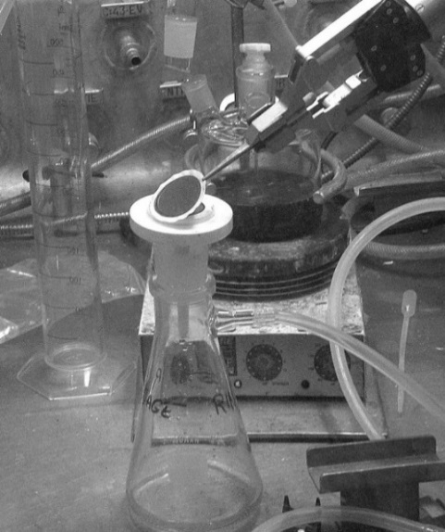

*FIG. 3. Dissolution residues on a Millipore® filter.*

1. Filters containing the solid particles were calcined for 8 hours at 400°C and the dissolution residues were weighed. For non-destructive analysis, a very small amount of solid particles was placed in diluted nitric solution and few milliliters of this aqueous suspension were filtered by a 0.1 micron filter.

#### Oxidizing digestion of primary dissolution residues

Dissolution residues were dissolved by an oxidizing digestion process involving Ag(II) generated in concentrated nitric acid. The digestion was carried out under stirring. A few hundred milligrams of residues were tested per run. The test durations depended on the plutonium dissolution steady state. Volatile compounds were trapped in soda media (Fig. 4).

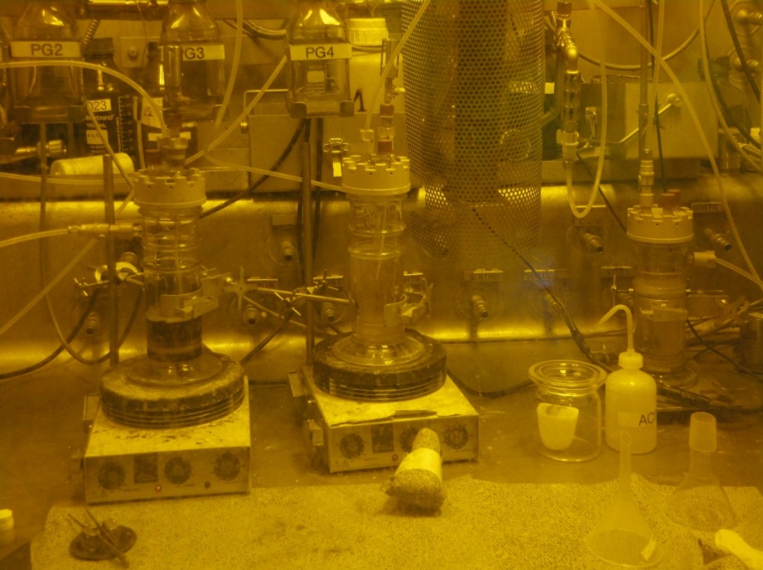

**Gaseous trapping**

**Digester**

1. *FIG. 4. Oxidizing digestion setup.*

After the oxidizing digestion step the remaining residues, so-called “secondary residues”, were separated from the solution by a 0.3 micron filter, followed by rinsing with diluted nitric acid, drying at room temperature, and weighing.

#### Complementary dissolutions of secondary residues

Additional dissolutions were carried out to quantify the plutonium remaining in these residues, and determine their elemental composition.

The residues were fused in sodium peroxide salt at 500°C. The melt was then dissolved in water and the aqueous solution produced was filtered on a 0.3 micron filter. Remaining solid residues were recovered in boiling concentrated acid and the resulting solution was filtered on a 0.3 micron filter. The residues were fused in potassium pyrosulfate at 750°C. The melt was dissolved in water and the resulting aqueous solution was filtered on a 0.3 micron filter. Fig. 5 shows the dissolution processes performed in this study.

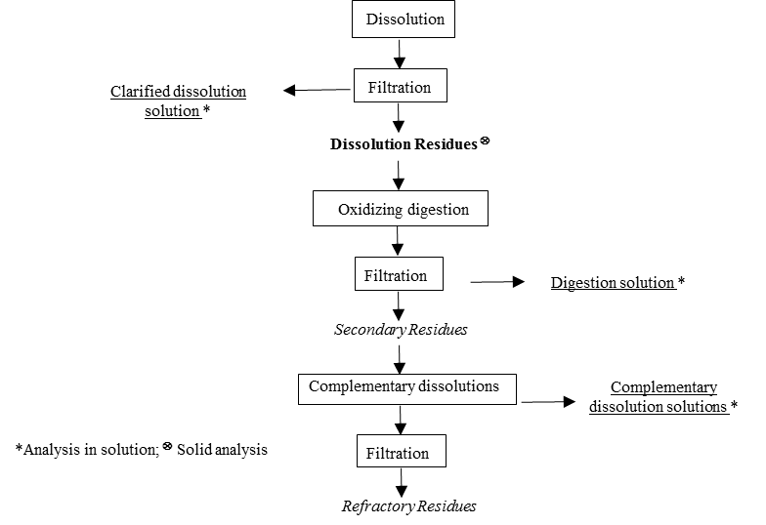

*FIG. 5. Overall dissolution process flow diagram (simplified).*

## results and discussion

### Amount of dissolution residues

1. For each dissolution test, the initial mass of fuel and the resulting dissolution residues were weighed. The residue mass ratios were determined (Table 2).

TABLE 2. GENERATED RATIO OF DISSOLUTION RESIDUES

|  |  |  |  |  |  |  |
| --- | --- | --- | --- | --- | --- | --- |
| Run No. | Fuel Pu content: Pu/(U+Pu) molar ratio (%) | Dissolved Zone | Burn-up range (GWd/t IHM) | Mass of oxide (g) | Mass of dissolution residues (g) | Residue mass ratio (%) |
| 1 | 22.4 | Full-flux | 124-115 | 25.3 | 0.638 | 2.5 |
| 1’ | 22.4 | Upper | 86-58 | 25.8 | 0.398 | 1.5 |
| 2 | 20.8 | Full-flux | 150-135 | 69.3 | 1.615 | 2.4 |
| 2’ | 20.8 | Upper | 135-70 | 67.6 | 1.111 | 1.6 |
| 3 | 28.2 | Upper | 125-65 | 64.1 | 1.203 | 1.9 |

The dissolution residue mass ratios are between 1.5% and 2.5%. Depending on the dissolved zone of a given fuel, the residue mass ratio was different: the full-flux zone residue masses were higher than the upper zone. These results are consistent because the higher the burnup, the greater the amount of fission products (FP). A higher initial fuel Pu content lead to higher residue mass.

### Characterization of dissolution residues

The elemental compositions of dissolution residues were determined by measuring the U, Pu, cladding components, and FP in each dissolution solution, except for run No.2’ (only uranium and plutonium determination); see Table 3.

TABLE 3. COMPOSITION OF DISSOLUTION RESIDUES

|  |  |  |  |  |  |  |  |  |  |  |
| --- | --- | --- | --- | --- | --- | --- | --- | --- | --- | --- |
|  | Compositions (wt %) | | | | | | | | | |
|  | Fission products | | | | | | Structural material | | Actinides | |
| Run No. | Ru | Rh | Mo | Pd | Tc | Zr | Fe | Cr | Pu | U |
| 1 | 20.1 | 9.3 | 10.7 | 7.4 | 6.6 |  | 1.4 | 1.4 | 0.7 | 2.4 |
| 1' | - | - | - | - | - | - | - | - | 2.5 | 5.3 |
| 2 | 9.8 | 10.2 | 11.6 | 7.2 | 8.3 | 0.1 | 2.4 | 0.1 | 0.9 | 2.9 |
| 2’ | 7.9 | 7.4 | 9.8 | 4.0 | 3.1 | 0.1 | 1.4 | 3.4 | 2.1 | 5.0 |
| 3 | 13.8 | 5.9 | 10.7 | 4.8 | 4.1 | 0.1 | 2.8 |  | 2.0 | 5.3 |

The SFR dissolution residues are mainly composed of platinum group metals, i.e. Ru, Rh, Mo, Pd, and Tc, known to be the constituents of metallic precipitates which are the so-called “ white inclusions” in the irradiated oxide fuel [9], [10]. Dissolution residues also include small cladding component contents and undissolved-based oxides. The residues contain up to 2.5% of plutonium and 5.3% of uranium by weight. The lowest plutonium (and uranium) contents are for the most irradiated parts of a given fissile pin. The erasing of initial fuel plutonium heterogeneities with an upper linear power density during irradiation could be an explanation for this. A higher initial plutonium content for a similar burnup range (Run No.3 *vs* run No.2’) does not lead to higher plutonium residue content.

More local investigations were performed by Scanning Electronic Microscope and X-ray mapping in ATALANTE facility (Fig. 6 and Fig. 7).

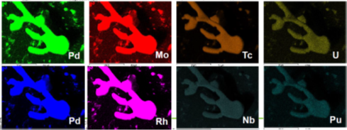

1. *FIG. 6. SEM image, EDS spectrum and X-Ray maps of dissolution residues (Run No.1).*

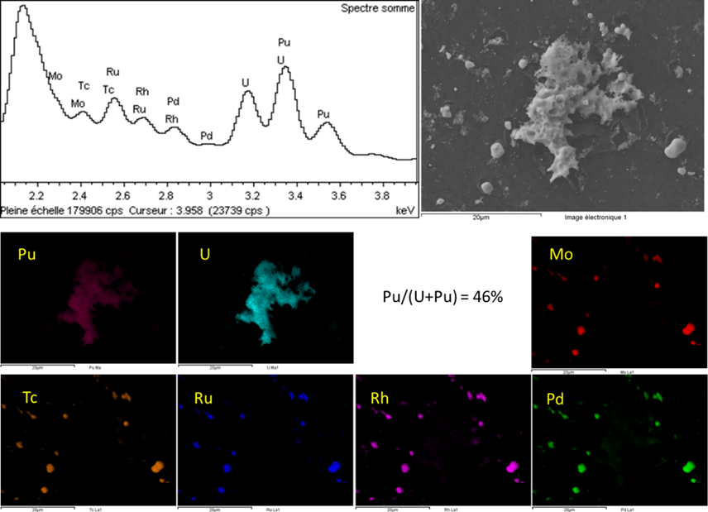

1. *FIG. 7. SEM image, EDS spectrum and X-Ray maps of dissolution residues (Run No.3).*

Dissolution residue examinations confirmed their chemical contents and potential sources of plutonium in these residues. Platinum group metals form insoluble intermetallic phases, and plutonium can be combined with these precipitates (Fig. 6). However the residues shown in Fig. 7 illustrate locally high Pu contents (Pu/(U+Pu) = 46%) in an atypical particle (different size and morphology compared to the others), probably because of the (U,Pu)O2 MOX fuel manufacturing process. Sub-micron size particles are predominant, with some particles reaching several tens of microns, mainly linked to intermetallic phases.

### Pu digestion step efficiency

The plutonium digestion step efficiency (Table 4) was calculated using the following formula:

$$Pu recovery rate (\%) = \frac{Pu quantified in digestion solution }{Pu quantified in dissolution residues}$$

TABLE 4. PU DIGESTION YIELD

|  |  |  |  |  |  |
| --- | --- | --- | --- | --- | --- |
| Run No. | Fuel Pu content: Pu/(U+Pu) molar ratio (%) | Dissolved Zone | Residues Pu content (wt (%)) | Pu/(U+Pu) residues (%) | Pu digestion yield (%) |
| 1 | 22.4 | Full-flux | 0.7 | 24.1 | 95.4 |
| 1' | 22.4 | Upper | 2.5 | 32.1 | 99.8 |
| 2 | 20.8 | Full-flux | 0.9 | 32.8 | 96.5 |
| 2' | 20.8 | Upper | 2.1 | 45.8 | 95.3 |
| 3 | 28.2 | Upper | 2.0 | 39.1 | 97.7 |

Plutonium accessibility did not seem to be limited in the dissolution residues: from 95.3% up to 99.8% of plutonium was dissolved. For local portions of a given fuel, the lowest plutonium dissolution yield was from the most irradiated part, i.e. the full flux part, with the lowest Pu content. Its high fission product content could be the main factor influencing digestion efficiency. This result is not so significant for larger dissolved portions (runs No.2 and 2’), probably due to averaged irradiation effects. An initial higher Pu content of the fuel (run No.3) did not impact the plutonium digestion efficiency.

### Global Pu dissolution yield

The plutonium recovery rates along with the dissolution process, including primary dissolution and oxidizing digestion, are presented in Table 5. The overall recovery of plutonium in solution increased by more than one order of magnitude compared to Pu recovery after a single dissolution step in nitric acid.

TABLE 5. GLOBAL PU DISSOLUTION YIELD

|  |  |  |  |  |
| --- | --- | --- | --- | --- |
| Run No. | Dissolution yield (%) | Digestion yield (%) | Global yield (%) | |
| 1 | 99.909 | 0.087 | | 99.996 | |
| 1' | 99.784 | 0.205 | | 99.989 | |
| 2 | 99.861 | 0.135 | | 99.996 | |
| 2’ | 99.758 | 0.232 | | 99.990 | |
| 3 | 99.814 | 0.181 | | 99.995 | |

### Mass of insoluble residues after oxidizing digestion

Oxidizing Ag(II) digestion is a non-selective chemical reaction oxidizing redox potential elements less than the Ag(I)/Ag(II) couple. The mass of residues after oxidizing digestion, the so called “secondary residues”, and the mass of dissolved residues by the digestion step are thus illustrated in Fig. 8 (results of Run No.3 non-usable). The dissolved mass ratio was calculated using the following formula:



$$Dissolved mass ratio(\%) = \frac{Mass of dissolved residus by the digestion step }{Mass of residues}$$

2. *FIG. 8. Mass of residues and dissolved mass ratio during the digestion step.*

There is a considerable difference between Run No.1 and 1’, corresponding to the smaller dissolved portion and narrower burn-up range. 92% of the dissolution residues were dissolved by the oxidizing digestion compared to 57% for the full-flux zone (wt in %). As previously seen for plutonium, the high FP content could be the main factor influencing the residue digestion. The results are nearly the same when larger portions are dissolved (Runs No.2 and 2’): approximately 50% of the residues were dissolved by the oxidizing digestion regardless of the dissolved zone.

Digestion step recovery rates for metallic residue elements are indicated below:

* Ru: 16 to 58%
* Mo: 46 to 59%
* Rh: 28 to 59%
* Pd: 53 to 77%
* Tc: 32 to 66%

These results could be useful, as there is an increase in the quantities of solid residues with higher burn-up fuels, especially in the platinum group elements. It is already known that insoluble phases including these elements are formed in the borosilicate glass matrix used for waste conditioning [11]. These phases can lead to some melting process modifications.

## Conclusion

The higher plutonium contents in SFR MOX fuels require specific treatment steps to prevent plutonium retention in residues at the front end of the reprocessing cycle. It has been demonstrated that the nature and the composition (U, Pu) of the dissolution residues are heavily dependent on the initial fuel material and on the irradiation conditions in the reactor. The more irradiated the fuel, the more soluble Pu there is, but also the higher the remaining residue mass, because of insoluble fission products.

1. The oxidizing digestion of dissolution residues permits the recovery of up to 99% of residual plutonium, with some slight differences depending on the position of the pin part from which the dissolution residue was obtained. The global recovery of plutonium in solution from dissolution plus digestion steps can be increased by more than one order of magnitude compared to the Pu recovery after a single dissolution step in nitric acid.
2. The efficiency of oxidizing digestion was seen not only for plutonium recovery but also for metallic element dissolution. The quantity of residues after digestion was significantly reduced by 46% and up to 92%, thus reducing the potential impact on the need for industrial waste conditioning downstream in the process.

ACKNOWLEDGEMENTS

The authors wish to thank ORANO and EDF for their financial support. The authors also wish to thank the analysis laboratories and the fuel characterization laboratory of the Atalante facility.

References

1. GRANDJEAN, S., et al., “French R&D program for multirecycling of plutonium”, Proceedings of the GLOBAL 2015 conference, Paris, France (2015).
2. POINSSOT, C., et al, “From the historical PUREX process to innovative recycling processes for irradiated MOX fuels. Trends for the future of fuel recycling processes”, Proceedings of GLOBAL 2017- September 24-29, Korea (2017).
3. French patent 95 10428.
4. REYNIER-TRONCHE, N., et al, « A comprehensive study of the dissolution of spent SFR MOX fuel in boiling nitric acid (the PHENIX NESTOR-3 case)”, Proceedings of the FR’17 Conference, International conference on Fast reactors and Related Fuel Cycles: Next generation Nuclear Systems for Sustainable Development, IAEA-CN-245-519, Yekaterinburg, Russian Federation (2017).
5. GRANDJEAN, S., et al., “New insights into the Head-end Treatment process of spent Fast neutron reactor MOX Fuels for Improved Plutonium Dissolution”, Proceedings of the GLOBAL 2017 conference, September 24-29, Seoul, Korea (2017).
6. JOUAN, G., et al, “SEM analyses of powdered actinide compounds: implementation in a hot laboratory” Annual meeting hot laboratories and remote handling, HOTLAB 2016, Karlsruhe, Germany (2016).
7. ESBELIN, E., et al, High concentration measurements of U and Pu with nondestructive and standardless K‐edge densitometer device, X-RAY Spectrometry 47 (2018) 22-23.
8. ESBELIN, E., et al, Graphite monochromator for actinide L-line EDXRF analysis in liquid sample E. Esbelin, X-RAY Spectrometry (2014) 43, 198-208.
9. KLEYKAMP, H., The chemical state of the fission products in oxide fuels, J.Nucl.Mater, 131 (1985), 221-246.
10. DUMAS, C., et al, « Fuel chemistry of irradiated FBR mixed oxide fuel – Comparison between thermodynamic calculations and post-irradiation experimental results”, NuFuel & MMSNF 2015, Karlsruhe, Germany (2015).
11. KRAUSE, Ch., LUCKSCHEITER, B., Properties and behaviour of the platinum group metals in the glass resulting from the vitrification of simulated nuclear fuel reprocessing waste,J. Mater. Res, 6 (1991), 2535-2546