PWR Spent nuclear fuel integrity evaluation results in korea

D. Kook
Korea Atomic Energy Research Institute
Daejeon, Korea
Email: syskook@kaeri.re.kr

Y. Koo
Korea Atomic Energy Research Institute
Daejeon, Korea
Email: yhkoo@kaeri.re.kr

Abstract

Accumulation of spent nuclear fuel in PWR power reactor pools is facing saturation limit within 5 years in South Korea. Though the national policy will be discussed again through public hearing process, it seems very clear to imply dry storage technique for the first management step out of reactor pools like other countries. Spent nuclear fuel (SNF) integrity evaluation R&D work has been performed for lower burnup (less than 45 GWd/tU) range for 5 years in order to produce initial SNF characteristic properties and anticipate aging effect during dry condition for several decades. This project produced non-destructive examination data which are essential prior to the destructive testing. The former data set includes visual exam, defect scan, dimension measurement and gamma scan. The later data set includes creep testing, hydride reorientation testing, delayed hydride cracking, ring compression testing, optical microscope analysis, hydrogen contents analysis and mechanical properties testing. This project also tried to evaluate fuel assembly hardware integrity including spacer grid, welding points between components, and bulge joint for real SNF components and for unirradiated components by charging hydrogen to simulate SNF. In order to anticipate SNF degradation for several decades, modeling of each single effect like creep and hydride reorientation have been done and comprehensively merged into a newly developed SNF performance platform which deals with thermal profile among SNF rods. Based on achievement for lower burnup range, SNF R&D infra could be expanded to high burnup range successively.

spent nuclear fuel management
Spent nuclear fuel (SNF) has been accumulated after the first commercial nuclear power plant operation since 1978 in Korea. There were several efforts to expand storage capacity in order to manage more SNF in reactor building because the final SNF management solutions like repository or recycling has not been realized. Those efforts are the rerack by reducing SNF rack size and the transhipment by moving SNF from the urgent plant building to the relatively relaxed plant.

Current Amount of SNF
20 PWR units and 4 PHWR (CANDU) units of nuclear power plants make Korea a unique country in the world which operates these two types mixture. Though CANDU reactor number is a fourth of PWR’s, the amount of CANDU SNF occupies 70% of total national SNF amount by mass. This becomes one of the reasons why Korea does not have further construction plan of CANDU. SNF saturation values are 74% for PWR and 87% for PHWR (CANDU) as of 2017.

National Strategy of SNF Management
In order to solve the eventual SNF management problem, the government has tried to find an appropriate disposal site for last 30 years. However it was the heavily challenging work because of severe objection by the local people and environmentalist. Most important reason of those objection is the lack of communication between the government and the public. This background urges the first public hearing process, PECOS (Public Engagement Commission on Spent Nuclear Fuel Management), launched in 2014. The commission recommended a national SNF management direction to the government after 2 years activities and the government announced a basic plan of national high-level radioactive waste management strategy according to the commission’s opinion. The major direction of it consists of 3 steps; (1) SNF dry storage at reactor site by the nuclear power utility until an appropriate site is ready for the central storage and the disposal, (2) central storage by the government owned organization on the surface of the appropriate site until underground research laboratory’s work is done, and (3) final disposal at the appropriate site. Fig. 1 summarized the basic national plan of SNF management plan as of 2016.

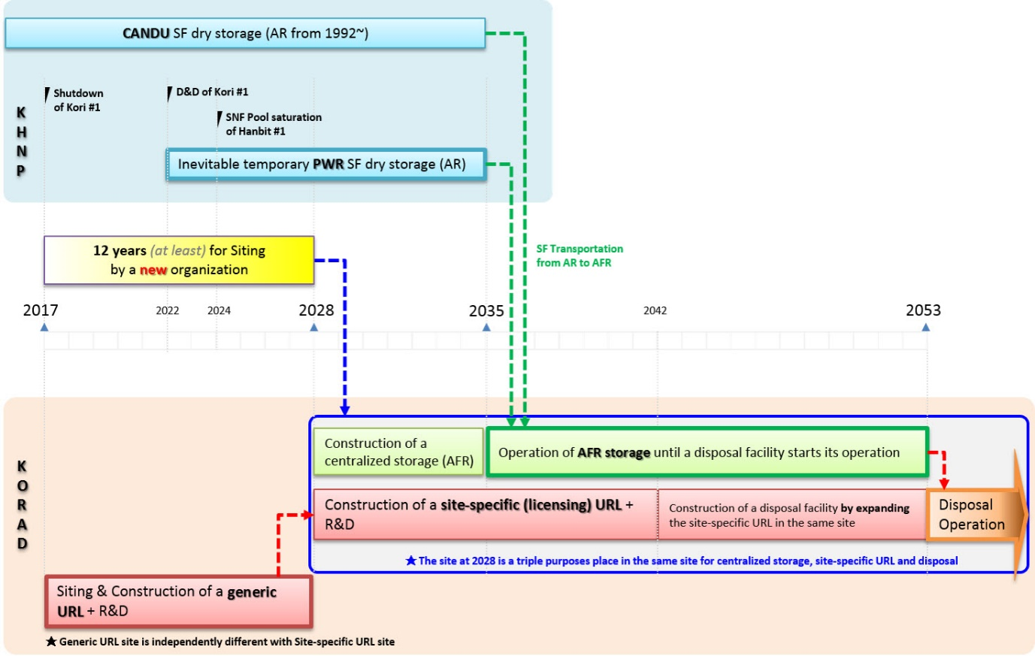
FIG. 1. National basic plan of SNF management in Korea as of 2016
Currently Korean society is waiting for the second public hearing process to receive more local voices including economical compensation and update the disposal site capacity demand again according to recently changed national energy supply plan. However, the major direction of SNF dry storage implementation for the upcoming several decades does not seem to change because wet storage capacity is closing to its maximum saturation, SNF transhipment between plants has difficulty of administrative districts, the first dismantlement & decommission of Kori-1 unit urges the utility to prepare an immediate SNF management solution before wet storage pool disappearance, and the other ultimate solutions like recycling and disposal needs several decades of time to be realized.

SNF INTEGRITY EVALUATION WORK
SNF dry storage is prevalent all around the world and its safety is already proved by thousands of dry storage system for over 30 years. However, there are several reasons to look into SNF integrity before Korea starts PWR SNF dry storage implementation in near future.
First, most of available SNF testing data from other countries are very limited and they are very old data for low burnup ranges.
Secondly, testing condition of them is not clear or very limited to answer for the current experimental question.
Thirdly, already existing data does not concern the extended dry storage period because the dry storage itself was born as a temporary solution for 20 years from 1986. Hydride effect, for example, was not concerned which could be a most effective degradation mechanism during extended dry storage beyond initial 20 years as cladding temperature decreases extremely slowly.
Fourthly, most of already existing data focus on static situation because SNF only stands for several decades inside of cask/canister except the moving from reactor building to storage pad in the initial dry storage campaign. However, more dynamic situation for earthquake, tsunami, cask tip-over, air plane attack, fuel handling when repacking is necessary after long term storage, and transportation for long distance are getting high concerns for extended dry storage era. Therefore, single effect test items on cladding are evolving continuously according to the changing safety demand.
Fifthly, SNF fuel assembly hardware also has to be analysed very well because this hardware is a key part when retrievability becomes a real situation after long dry storage. SNF cladding integrity is very important in the confinement security point of view, but SNF fuel assembly hardware is very important in the retrievability point of view. However, this importance has been usually ignored because this retrievable situation does not happen yet and the initial SNF dry storage implementer at site who is mostly nuclear power plant operator does not need to concern the next retrievability step which belongs to the government responsibility regarding to nuclear waste fund. It should be remembered that most countries who has the direct disposal of SNF as a national strategy have no choice but to encounter the retrievability or repacking situation because of huge SNF assembly capacity gap between the current massive dry storage system and the almost fixed final disposal system decided by environmental conditions
Sixthly, the real temperature which the cladding experiences during dry storage is very important for SNF integrity evaluation because temperature is a main factor controlling SNF material condition and it influences most SNF degradation mechanisms.
Finally, a precise engineering modelling is necessary to anticipate the future SNF condition for repacking, retrievability, license extension, and SNF title transfer between organizations. This modelling is an comprehensive work by merging experimental data and analysis methodologies and by integrating fuel performance code, thermal evaluation code, material degradation code, and mechanical analysis code.

Cladding
Fuel cladding testing usually consists of non-destructive testing and destructive testing. The former includes visual inspection, scanning on the cladding surface for to find defect, gamma scanning for burnups and pellet missing and measuring clad growth, distortion and oxide thickness. The later includes measuring rod internal pressure, observing optical microscope of hydride & oxide layer and analysing hydrogen content of cladding.
These non-destructive and destructive testing were performed successfully for 14x14 and 17x17 improved Zircaloy-4 SNF. Most of testing results show similar tendency with previous literatures. For example, Fig. 2 shows SNF rod internal pressure comparison of Korean data with US DOE reports at room temperature. Left data group shows mixture of EPRI data (available US utility data plus Spanish ENSA data) and recent High Burnup DEMO sister rods data. Right data group shows Korean publicly available data. Yellow-coloured band helps the readers to compare rod internal pressure results more easily and find out that there is nothing special to point out. Difference between two groups are the presence of 15x15 fuel array type and available data around 70 GWd/MtU. For 14x14 Korean data, it should be described that the initial rod internal pressure by helium before reactor operation was almost 3 MPa, that is, higher than other fuel array types and this causes similar rod internal pressure level at the end-of-life even though 14x14 fuel array type's burnup range were so lower than other fuel array types.

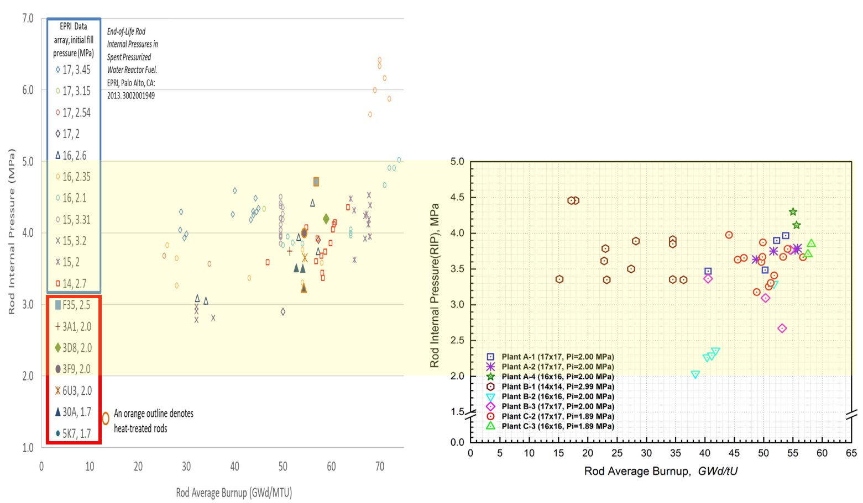
FIG. 2. SNF Rod Internal Pressure Comparison

Single effect tests like creep, and hydride reorientation, and delayed hydride cracking were also performed to evaluate SNF integrity during long term dry storage condition because they could be major cladding degradation mechanism.

Creep
Creep was believed the main factor of SNF degradation during dry storage in early 1980. However as cladding is ballooned by creep, the internal pressure decreases because of increased internal volume. Furthermore, cladding axial growth could relieve the radial stress by creep and creep-downed cladding diameter during reactor operation which is less than the factory manufacturing original diameter gives additional burden for cladding creep-out to be a concerned factor during dry storage. Therefore, this self-limiting phenomenon could not be concerned any more currently.
Nonetheless, creep is still remaining as an important factor of cladding degradation because creep is the only one phenomenon which could be observed by visual inspection from the outside of cladding without following destructive test. On the other hand, hydride effect like hydride reorientation must be performed just after destructive test of cladding. According to US NRC regulation [1], creep limit could be allowed under 1% which is the only fixed quantitative value to meet in the real SNF management while hoop stress limit under 90 MPa for hydride reorientation is very intangible value because a lot of following analyses have to be performed to evaluate this value exactly.
Creep test for Korean SNF were performed twice for a same cladding of which burnup was 51.8 GWd/tU, but its specimen axial locations are different with 800 mm & 2112 mm from the bottom. Its length was 250 mm and testing duration time was 1200 hours. Additionally, unirradiated but hydrogen charged cladding to mimic SNF cladding material & mechanical characteristics were used for a lot of creep testing to support various SNF creep testing condition. Fig. 3 shows unirradiated Zry-4 cladding creep data for various testing conditions [2]. According to the literature [3], unirradiated cladding creep limit could be estimated as 10 % of its original diameter while irradiated cladding creep limit is 1 %. This difference is caused by irradiation hardening effect on cladding. Though most unirradiated cladding creep strain data is depicted around 1% value, those are very low against 10% value. The secondary creep rate is the most important factor in creep analysis and its anticipated values for extremely long term are calculated as lower than 10 % value. Two test cases for SNF also shows that creep does not seem to be a concerned degradation mechanism.

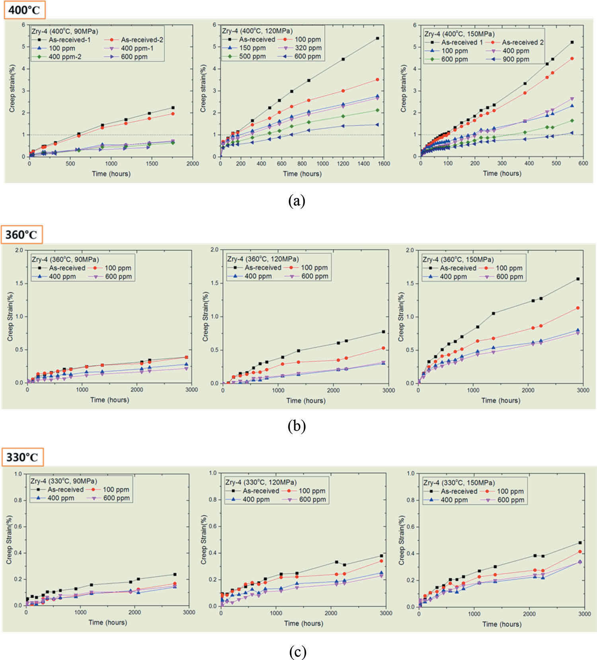
FIG. 3. Unirradiated Zry-4 Creep Testing Results

Hydride Reorientation
Hydride reorientation is one of the main issues in high burnup SNF dry storage and transportation because the radial hydride can lead to a significant thorough wall crack when the SNF faces severe impact or vibration during handling after several decade storage [4]. The offset strain method proposed by ANL [5] to understand the cladding brittle behavior with the ring compression test (RCT) is quite a reasonable approach to judge the cladding embrittlement very quickly. The main concept of offset strain is to simply divide the cladding situation into brittle (less than 2%) and ductile (more than 2%)
Fig. 4 shows the RCT results comparison between the as-irradiated cases and irradiated & HRT cases. The data group shows that cladding embrittlement caused by hydride reorientation of Zircaloy-4 in the 150 ℃ RCT temperature does not seem to be clear and serious.
However, it is necessary to integrate other circumstances below;
- these data were gained for static testing rather than more real dynamic situation
- transportation temperatures are various in real situations depending on cask type, loaded SNF numbers, fuel cladding material, burnup level, cooled time in dry storage
- the room temperature RCT group presents a very obvious contrast with and without HRT, some of the room temperature data are located under the 2% limit. It is essential to remember that 2 % limit is not a clear safety judgement value, but a convenient indicator of material brittleness. In addition, the room temperature is not a real condition which the SNF cladding never meets within a dry storage lifetime

Recently, the slow cooling rate effect which means that the real dry storage temperature decreases extremely slowly has become an issue [6][7] as the SNF dry storage operation is extended longer than 20 or 40 years.
Usually laboratory experiments for hydride reorientation chooses Δ 3~5℃/hour cooling rate because of very limited R&D resources, but this rate is extremely faster than the real temperature decreasing rate. In order to check the cooling rate effect, three cases for 3, 6, and 12 month cooling rate test have been prepared with unirradiated Zircaloy-4 cladding. Each of them has 0.109, 0.054, and 0.027 ℃/hour cooling rates respectively. Each canister contained 8 tube specimens with a 300 mm length. The hydrogen charging target of 4 tubes was set to 200 ppm, and the other 4 tubes were set to 400 ppm. The hoop stresses were controlled to 70, 80, 90, and 110 MPa. RCT results under a room temperature of the 3 months cooled HRT specimen shows a meaningful embrittlement tendency. It is necessary to recall that room temperature does not represent the real situation in dry storage & transportation and this is not irradiated cladding. However, this long term experiment could suggest a new point of view for cladding degradation. If hydrogen or hydride has a stronger kinetic effect than known so far, the cooling rate effect should not be underestimated for several decades of dry storage. Further analysis of 6 month & 12 month cases are highly encouraged for this reason.

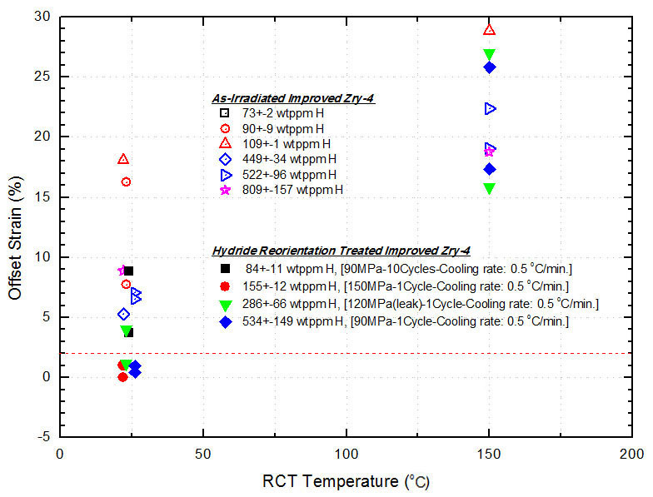
FIG. 4. RCT test comparison between before HRT and after HRT

Delayed Hydride Cracking
Delayed hydride cracking (DHC) has been treated as a negligible degradation mechanism because the circumstances of DHC occurrence was not possible in the early dry storage in 1980's. However, the probability of DHC occurrence seems to be changed because the number of initial crack presence could be increased in high burnup range and low temperature region is getting important for extended long term dry storage.
Previous studies [8] usually focused on evaluating DHC threshold (K_{IH}) because their analysis showed an extremely high threshold value. This means that there is no reason to consider DHC as a dangerous degradation mechanism in dry storage. However, K_{I} value needs to be revised by considering K_{IH} value which could be reproduced according to the above mentioned circumstances.
DHC experiments were performed at several temperature points from 150 to 300 ℃ for unirradiated specimens and are underway from 150 to 325 ℃ for irradiated specimens. Fig. 5 shows the calculated and measured K_{IH} value for Zircaloy-4 cladding according to various hydride thickness compared with IAEA CRP data [9]. Tough there are some deviation over 200 ℃, overall temperature dependency of K_{IH} could be observed. In order to better understand DHC mechanism, further experiments and deep modelling work are necessary.

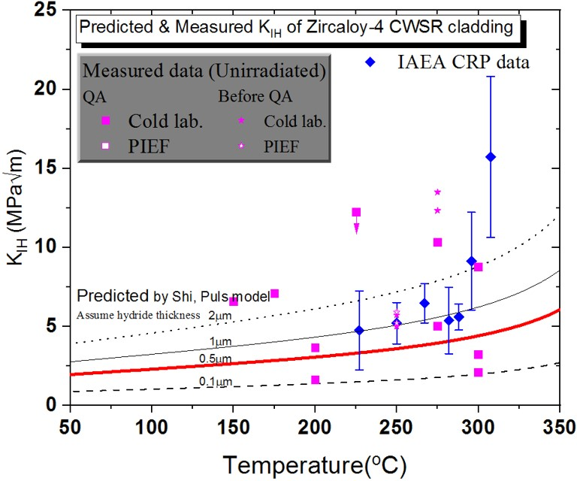
FIG. 5. K_{IH} value comparison with IAEA CRP data

Fuel Assembly Hardware
Fuel assembly hardware is very important when repacking and retrievability become a real situation in the future. However, this hardware integrity evaluation work has been also underestimated because current dry storage operation is getting extended and those 're-' activities timeline are still unknown. The major fuel assembly hardware consists of spacer grid, guide tubes, bulge joint of below top nozzle, and top & bottom nozzle. Those topics R&D are currently underway, and this paper briefly presents some progress of spacer grid topic.
A thin-plate structure pendulum type impact tester (Fig. 6) was developed to evaluate the mechanical integrity of simulated spent nuclear fuel spacer grid. By using this tester, it is possible to perform the normal and cell setting non-irradiated spacer grid [10]. The simulated cell size was enlarged about ø0.05 mm than the normal cell size to mimic irradiation effect on SNF. This process is called as 'cell setting' [11]. The pendulum type impact tester was equipped and confirmed reliability using solid bar specimen. The measuring items of this tester are impact forces, initial impact angle, acceleration, temperatures, and strains. The pendulum type impact test of the normal and cell setting unirradiated spacer grid was executed under the room temperature condition.
As a result, the critical buckling strength of the cell setting unirradiated spacer grid was about 78 to 90% smaller than those of the normal spacer grid case. This means that SNF spacer grid is weaker than normal grid to the impact although there is a loose contact between cladding and spacer grid. This could be interpreted as the residual frictional forces between the cladding and the spacer grid had significant influence on the impact strength of spacer grid.

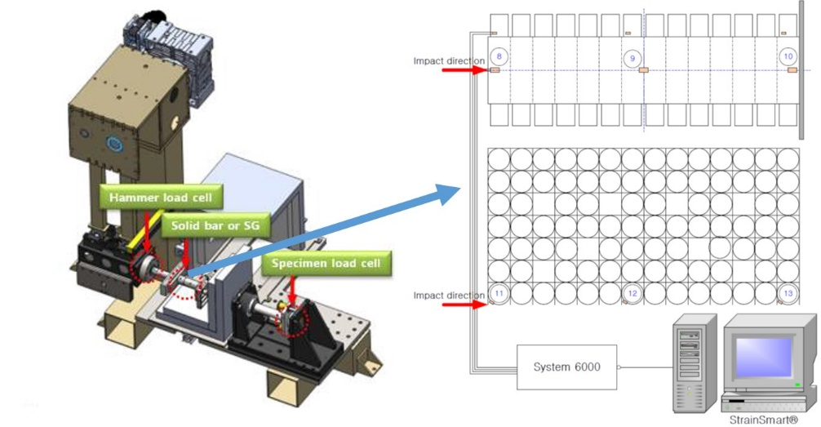
FIG. 6. Pendulum type impact tester for spacer grid

Fuel Temperature Evaluation
A temperature experimental facility with a PWR spent fuel assembly was designed and constructed. Its name is STEP (Single fuel assembly Temperature ExPerimental facility) [12] and its purpose is to investigate the heat transfer characteristics of a SNF under simulated dry storage conditions by using COBRA-SFS and to determine the priority of the model development and experiment variables [13].
STEP consists of the assembly storage cask, the 14xl4 electrically heated model fuel assembly, the transition piece, fuel tube, the cask lid, and chamber as shown in Fig. 7. The cask is fabricated from pipe with a 5 mm thick, 545.8 mm diameter inner wall, and 4,400 mm long of stainless steel. An insulating blanket of 50 mm thick of ceramic wool covered the cask to minimize the heat loss. The transition piece and fuel assembly tube serves the functions of basket within the cask. The fuel assembly is designed and built to be structurally and thermally characteristic of a typical 14x14 commercial PWR spent fuel assembly.
This assembly consists of 17 unheated 12.7 mm diameter pins for simulating control rod guide tubes and
179 independently heated 9.5 mm diameter pins for simulating SNF cladding. Resistance element tubular heater pin has a 3,800 mm heated length. The fuel assembly power can be supplied by 5 independent electric power groups for 0.5 ~ 3 kW level. A total of 190 independent thermocouples are mounted on the STEP to measure the surface temperature of fuel rods, a fuel tube, and a cask as well as the temperate in exit sub-channels at the steady state condition under uniform and non-uniform radial power distribution. Fig. 8 shows the examples of non-uniform power distribution which are useful to mimic the various temperature situation in a fuel assembly.
A heat transfer coefficient from the measured data of temperature difference between on the surface of rods and in the middle of a sub-channel was recently obtained. The heat transfer coefficient for a hottest fuel rod was 3.48 W/(m²℃) and is close to the recommended user input value of 3.66 in the COBRA-SFS code. The fuel cladding temperatures will be measured as functions of cask backfill gases in the next process.

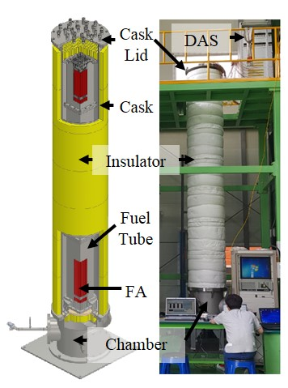
FIG. 7. Overview of STEP system

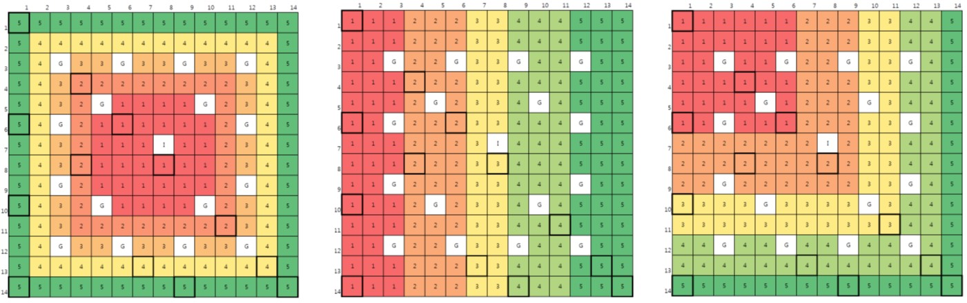
FIG. 8. Non-uniform power distribution by 179 independent power heaters

A Platform for Spent fuel’s Integrity Evaluation during Dry Storage
During a dry storage, the spent fuel cladding is exposed to the high temperature and the tensile stress condition due to its high decay heat and cumulative fission gas pressure in fuel rod. In these environment, the cladding degradations are evitable phenomena such as the creep, hydride reorientation and DHC. All these degradation mechanisms are greatly influenced by cladding temperature and which is decided by the heat transfer design of dry storage and the heating rate of spent fuel.
A new platform (Fig. 9) was developed to evaluate spent fuel’s temperature and degradation simultaneously and is composed of several code systems such as SCALE, FRAPCON, COBRA-SFS including newly developed cladding degradation models of creep, HR and DHC. Based on detailed power history during irradiation, the pin-by-pin heating rate was calculated by SCALE and spent fuel’s conditions are determined by fuel performance code, FRAPCON for each fuel rods. Loading patterns of spent fuel in dry storage and design characteristics of canister and cask can be modelled by COBRA-SFS. After temperature distribution calculation, 3-dimensional cladding temperatures for pins and axial nodes are transferred to cladding degradation modules and then the various spent fuel integrity analysis can be performed. These calculation flows can be continuous until the end of dry storage life and final status of spent fuel can be predicted [14].
.

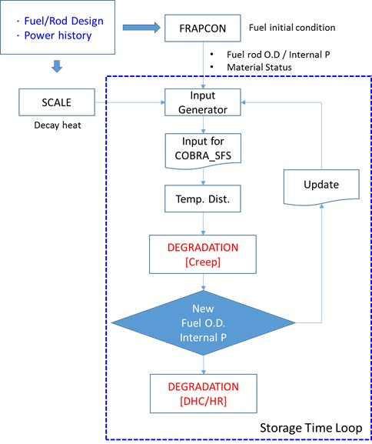
FIG. 9. Flow diagram of the integrated platform

Closing
PWR SNF accumulation is very urgent situation to Korea, and most possible solution of it could be dry storage like other countries. Prior to this implementation, SNF integrity evaluation work for cladding & fuel assembly hardware, thermal analysis in detail for rod to rod, integrated evaluation platform development were performed to produce basic safety prediction data. Based on low burnup range R&D experience, further research up to high burnup level could be successfully fulfilled.

ACKNOWLEDGEMENTS
This work was supported by the Radioactive Waste Management Technology Program of the Korea Institute of Energy Technology Evaluation and Planning (KETEP), granted financial resource from the Ministry of Trade, Industry & Energy, Republic of Korea. (No. 2014171020166A)
References
- T. HIROSE, M. OZAWA, H. MIURA, T. BABA, and K. KAMIMURA, "Research on Integrity of High Burnup Spent Fuel under Long Term Dry Storage and Transport", OECD/NEA International Workshop on Safety of Long Term Interim Storage Facilities, OECD/NEA, Munich, Germany (2013)
- US NRC, NUREG-1536 "Standard Review Plan (SRP) For Dry Cask Storage Systems. Revision 1" (2010)
- J. D. Hong, E. Kim, Y. S. Yang, and D. H. Kook, Mechanical Property Degradation of Unirradiated Zircaloy-4 Cladding After Creep Deformation, Nuclear Technology, 203, 282-292 (2018)
- K. Yoon, J. Kim, H. Oh, S. Lee, and D. Kook, "Correlation between Strain and Buckling of Spacer Grid by Side Impact", Transactions of the American Nuclear Society, Vol. 118, p.173, Philadelphia, June 17-21 (2018)
- D. S. Oh, S. J. Byun, C. H. Shin and D. H. Kook, Single Fuel Assembly Temperature Experimental Facility (STEP), Transactions of the Korean Radioactive Waste Society 2018 Autumn Meeting, p.151, Jeju, October (2018)
- J. LEE, H. KIM, D. KOOK and Y. KIM, "A study on the effects of hydrogen content and peak temperature on threshold stress for hydride reorientation in Zircaloy-4 cladding", Journal of Nuclear Materials 509, 285 (2018)
- M.C. BILLONE and T.A. BURTSEVA, Effects of Lower Drying-Storage Temperature on the Ductility of High-Burnup PWR Cladding, ANL-16/16 (2016)
- P. KAUFHOLZ, M. STUKE, F. BOLDT, and M. PERIDIS, "Influence of kinetic effects on terminal solid solubility of hydrogen in zirconium alloys", Journal of Nuclear Materials, 510, 277 (2018)
- W. GONG, L. DUARTE, R. ZUBLER, and J. BERTSCH, "Hydrides and Zr-Cladding Mechanics", GRS 2nd Workshop on Safety of Extended Dry Storage of Spent Nuclear Fuel, Garching, Germnay, June (2018)
- M. P. Puls, "Review of the thermodynamic basis for models of delayed hydride cracking rate in zirconium alloys", Journal of Nuclear Materials, 393, 350 (2009)
- IAEA CRP, Delayed hydride cracking of zirconium alloy fuel cladding, IAEA-TECDOC-1649 (2010)
- K. H. Yoon, H. R. Oh, J. Y. Kim, S. U. Lee and D. H. Kook, "Dynamic Buckling Behavior of Cell Setting & Normal Non-irradiated Spacer Grid using Pendulum Type Impact Test, Transactions of the Korean Nuclear Society Autumn Meeting, Yeosu, Korea, October 25-26 (2018)
- C. H. Shin, K. W. Seo, D. H. Kook, “Sensitivity Analysis of COBRA-SFS for Dry Storage of Spent Fuel.” Proc. of the KRS 2017 Spring Conference, 15(1), Busan, Korea, May 24-26 (2017)
- C. H. Shin, K. W. Seo, Y. S. Yang, J. D. Hong, S. U. Lee, D. H. Kook, " Design of Integrated Analysis Tool for Degradation Evaluation of Spent Nuclear Fuel in Dry Storage System", Transactions of the Korean Radioactive Waste Society 2018 Autumn Meeting, p.173, Jeju, October (2018)

