Transmutation of minor actinides in AP1000 reactor

ABBAS BASHIR AHMED.
Ministry of Water Resources, Irrigation and Electricity- Nuclear Power General Directorate
Khartoum, Sudan
Email: abbasbashir@live.com

BIN LIU
School of Nuclear Science & Engineering, North China Electric Power University
Beijing, China

Abstract

Clean energy is most desirable in the world without any problem; nuclear energy can fill the thirst of energy with lower problems. Waste disposal and radiotoxicity is the most challenge issue in nuclear power generation. It is suggested to transmute spent nuclear fuel and especially minor actinide due to it is high contribution of radiotoxicity. We transmute the Np-237 in the LWR AP1000 reactor. We simulate the reactor and the minor actinide materials using mcnp5 code. We got promised and good results to recommend realizing this issue.

INTRODUCTION
In recent years, there have been rising expectancy for nuclear energy all over the world to meet the rapid increasing in the energy demand due to the shortage of fossil fuels supply in order to limit greenhouse gas emissions and this will greatly speed up the nuclear power industry development. [1] As of April 2017, 30 countries worldwide are operating 449 nuclear reactors for electricity generation and 60 new reactor plants are under construction in 15 countries. Nuclear power plants provided 11 % of the world electricity production in 2014. [2]
Nuclear power reactors work based on neutron induced fission process to burn nuclear fuel to get heat energy to use it in making steam in order to drive steam turbine to generate electricity. Burning nuclear Fuel inevitably lead to generation of new actinide isotopes and after a certain period of operation nuclear power reactor need to be refuelled by fresh fuel due to the irradiation of the fuel and it will be discharged as spent fuel and called nuclear waste. [3] About 98.5% of this spent fuel weight is composed of uranium and short-lived fission products, about 1% is plutonium and minor actinide and about 0.4% is long-lived fission products such as caesium, strontium, technetium and iodine. The spent fuel disposal considers as an important issue in the nuclear power industry. [4]
As the spent fuel is irradiated materials and has radiotoxicity hazards to the environment so this is an important issue and consider as the one of the most demerits of the nuclear power reactor industry. Roughly there is 8000 tons of spent fuel are discharged annually in the world in order to overcome this obstacle it was suggested to minimize the spent fuel amount or converting them into other useful materials or less in radiotoxicity hazard materials researchers conducting a lot of researches, studies and experiments to deal with this. [5]
Nuclear transmutation is an artificial method considered as an efficient approach that can convert chemical element\isotope into another one by either nuclear reaction or radioactive decay. [6]
Actinides are a family of 15 elements that range in atomic numbers from 89 to 103. The 15 elements include: Actinium (Ac), Thorium (Th), Protactinium (Pa), Uranium (U), Neptunium (Np), Plutonium (Pu), Americium (Am), Curium (Cm), Berkelium (Bk), Californium (Cf), Einsteinium (Es), Fermium (Fm), Mendelevium (Md), Nobelium (No), and Lawrencium (Lr). [7]
Neptunium (Np), Americium (Am) and Curium (Cm) considered as Minor actinides (MA) in the spent fuel (NSF) and despite their small fractions are long-term radiotoxicity and decay heat contributors in the spent fuel and featuring both alpha decays and high-energy gamma emissions. So, they are the major contributors to the radiotoxicity, neutron output and decay heat in the spent nuclear fuel and if it is reprocessed conventionally it consider as vitrified high-level waste (VHLW) Therefore, transmutation of neptunium, americium and curium supposed to assist in solving the disposal problem of the spent fuel. [8]
Application studies aim to have possibility of getting nuclear energy free of the discharge of any of these radiotoxic elements are conducted and still work on in this. The interest in partitioning and transmutation of the minor actinide in the nuclear reactors is sustaining in growing up internationally to alleviate the burden of geologic disposal. France, Germany and japan see the MA transmutation as very important target and they have made very huge Research and Design (R&D) commitments to it. [9] Light water reactor LWR fuel typically contains about 600g/tHM of neptunium, 850g/tHM of americium and about 50g/tHM of curium these quantities depend on cooling time and discharge burn up. Table1 shows annual arising of transmutation elements worldwide. [10]
TABLE 1. EXAMPLE TABLE THE ANNUAL INCREASING OF MA ELEMENTS

Element | Production rate (kg per year)
Np | 3400
Pu | 68000
Am | 2750

Neptunium, which predominantly represented by the single isotope Np-237 with half-life T1/2 =2.14*10^6 years is a significant contributor to long-term radiotoxicity due to it is long half-life but it does not contribute to decay heat output. Americium consider as prime candidate for transmutation because it is present in relatively large amount and it is a major contribution in gamma activity and radiotoxicity especially after about 500 years cooling time and have reasonably large nuclear cross-section. Am considerable being produced in thermal reactors with half-life T1/2 =4.32*10^2 years. Curium Cm is Long-lived isotope produced in considerable amounts in thermal reactors makes a significant contribution to gamma activity and radiotoxicity major contributor to neutron emissions. [12]

Transmutation in PWR approaches

Homogenous Transmutation
Homogenous transmutation fuel technically is simplest option due to fuel assembly mechanical design is unaffected and the fuel material properties only are slightly affected. In this approach minor actinides are incorporating minor as a minority component of the nuclear fuel and subject to the same neutron flux as nuclear fuel. Np-237 is considered particularly well suited for homogenous approach. However, Am and Cm are less suited for this approach.

Heterogeneous Transmutation
Heterogeneous approach includes concentrating the minor actinide to be into targeted assemblies, which are distinct from the normal fuel assemblies. Heterogeneous targets complicate the core design because there are different fuel types in the core. It is difficult to fabricate the heterogeneous non-uranium targets and reprocess. [9]
There are many researches about utilization of soft neutron spectrum to transmute MA. Fast reactors needed to transmute MA because fast neutron cross sections are generally more effective in the splitting processes. Studies also demonstrated that MA transmutation is also achievable in the thermal reactors.
In US 2007 studies on preliminary multi-cycle transuranic actinide portioning and transmutation was conducted and it is outcome is thermal reactor light water reactors (LWR) are more efficient in burning Minor actinide (Np-Am-Cm) than Actinide Burner Reactors (ABR). [3]
C.W. Forsberg, E.D, Collins, J.P. Renier, C.W. Alexander in 2004 studied the ability of thermal reactor to eliminate the need of multiple repositories they burn MA in LWR this recycling increased yucca mountain repository 5 times. [3]
Since minor actinides are fissionable materials in fission threshold in several hundred of kv range and their capture cross section rapidly decrease with neutron energy higher than this energy it was proposed to transmute them in Actinide Burner Reactor (ABR) but this adopt maybe not economically feasible. [11]
S. Leray discussed transmutation of MA by using accelerator driven systems (ADS). In ADS, in subcritical system driven by the neutrons created by spallation. [13] In 2002 Investigation on transmutation of MA in thermal neutron field done by Tomohiko Iwaskai. [14] In 1994, Salvatores et. L, Iwasaki and Hirakawa in 1995 used soft spectrum to transmute MA in thermal reactors. [15] M.Szieberth, M.Halasz, T. Reiss, S. Feher assessed the transmutational capabilities of the 2400 MWth Gas cooled fast reactor (GFR) and consider the homogeneous recycling of minor actinides into the GFR and he got results that MA can be transmuted in GFRA. [16]
The irradiation of Thorium Th {Th-232} breeds fewer of the problematic minor actinides (Np, Am, Cm) than the irradiation of U {sup 238}. This characteristic makes thorium an attractive potential matrix for the transmutation of these minor actinide. [17] Professor Liu Bin from north china electric power university has studied the transmutation of MA in the high flux reactor. He used mcnp code to design the high flux reactor. His simulations results that is introduction of MA to the reactor core will highly affect the effective multiplication factor of the reactor core. [18] Two researchers from South Carolina University studied the feasibility of transmutation of MA in LWR by adding the MA to MOX fuel and they calculated the separation rate the conclusion that the separation rate is nearly 40% for uniform mixing and in heterogeneous can reach 68%. [19]
Researchers from north china electric power studied the transmutation of MA in the pressurized water reactor in two different manner one is to mix MA with fuel rod homogenously second one is to introduce the MA into uneven distribution their results hat homogeneously addition of MA nuclides to UO2 fuel significantly affects the effective multiplication factor of pressurized water reactor. Even adding 1% of MA nuclides to the nuclear fuel would drastically reduce the effective multiplication factor of the light water reactor. [20]
Liu et al, studied minor actinide transmutation characteristics in the high flux thermal reactors in 2013 and in the pressurized water reactor in 2014, They calculated the multiplication factor Keff after loading the minor actinide materials to PWR core in uniform distribution with fuel their results showed that Keff was changed. [20]
Yang et al. suggest transmuting MA and long-lived fission products (LLFP) in the film coating on the fuel rods or annular transmutation. In addition, their approach reduces the self-shielding effects and improve the transmutation rate. [20]

Transmutation of minor actinide Np-237 in AP 1000 PWR reactors
In this paper, we will study the transmutation of MA in the AP1000 reactor aiming to investigate the effect of loading minor Actinide mainly Np-237 in the criticality of the reactor. We load the MA materials inside the burnable absorber rods in three different approaches. We establish the Ap1000 reactor core using mcnp5 code because mcnp5 has the criticality calculations feature. Our concern is to see the characteristics of MA transmutation when it will be introduced to the core including the reactor core design, the effect to the reactor Keff after loading MA materials to the reactor. [21]

PWR AP1000 reactor
Ap1000 is most advanced pressurized water reactor evolutionary design in the global markets, which introduced by Westinghouse electric company U.S derived from AP600. It is greatly simplified plant with increased margins of operation and of course safety. The safety systems are depending on the passive phenomena and processes only such as gravity and natural circulation which is more reliable than the active processes. Ap1000 met all requirements for advanced light water reactor (ALWR) established by the national regulatory commission (NRC) and electric power research institute (EPRI).
Ap1000 reactor core contains fuel assemblies, structural parts and control elements. The fuel assemblies have a three different enrichments level, the structural parts functions are to provide mechanical support and directing the coolant when it is passing through the fuel assemblies to extract the generated heat due to the fission process. The fuel pellets, which is the key components in the reactor operation are made of UO2 and their enrichments are 2.35%w/o, 3.5%w/o and 4.45%w/o, these pellets stacked in a cladding material (Zirlo) to make fuel rod (FR). Fuel rods arranged with bottom nozzles, top nozzles and spacer in a form of typical square array and every fuel assembly has 264 fuel rods, 24 control rods and 1 instrument guide tube. The below table 2 shows of the structural data of AP1000

TABLE.2 AP1000 REACTOR PARAMETERS SPECIFICATIONS

Parameter | Dimension
Fuel Pellets
Length | 0.98 cm
Mass of UO2 | 6.54 kg/m
Fuel Rods
Length | 0.98 cm
Mass of UO2 | 6.54 kg/m
Number | 41448
Gap diameter | 0.0161 cm
Outside diameter | 0.95 cm
Cladding thickness | 0.057 cm
Fuel Assemblies
Number | 157
Rod array | 17*17
Rod pitch | 1.26 cm
Overall transverse | 21.40*21.40 cm

The reactor core geometry and fuel assembly’s different configurations explained below. The fuel assemblies have different enrichment levels with different number of control rods, shutdown rods (Black and grey types), instrumentation guide tube, plug cells and burnable poisons rods (BP). Some fuel assemblies have 12BP and some have 24BP in the beginning of cycle (BOC).

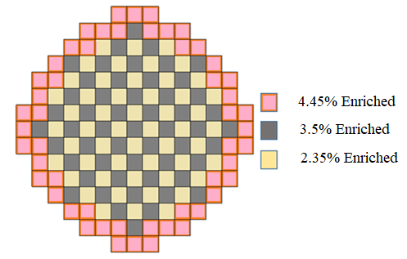
FIG .1. The arrangement of reactor core and fuel enrichments.

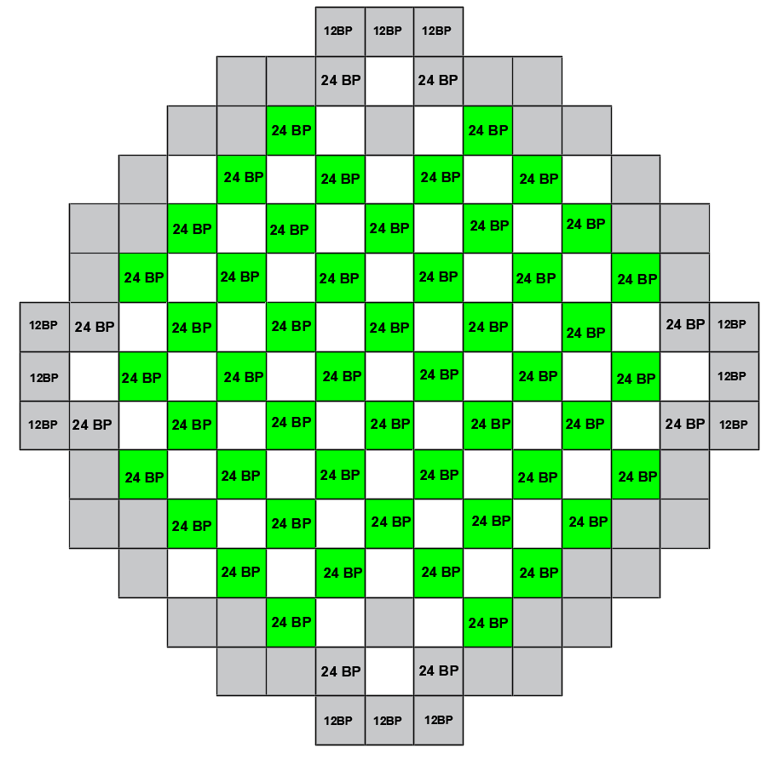

FIG. 2. BP numbers and positions.

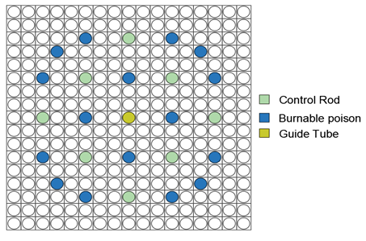
FIG. 3. fuel assembly with 24 BP.
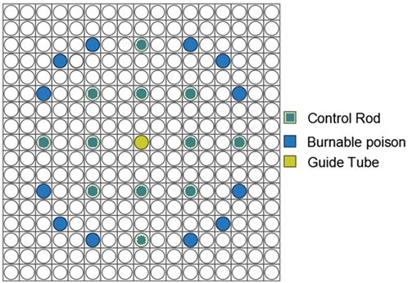

FIG. 4. fuel assembly with 12 BP.

Burnable Poison BP
Burnable Poison (BP) or burnable absorber (BA) are materials that have a high neutron absorption cross-section that are converted into materials of relatively low absorption cross section as the result of radiative capture. Therefore, it loaded into the reactor core to control large amounts of excess fuel reactivity. This material has negative moderator temperature coefficient of reactivity. Borosilicate Glass used as a burnable poison in pressurized water reactor. Burnable poison rod is cladded with stainless steel. The configuration of burnable poison rod shown below:

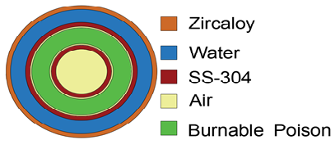

FIG. 5. BP cutaway.

Loading MA materials NpO2 into the core
Based on the in the above parameters and configurations that represented above we used mcnp5 code to simulate the AP1000 core in order to study the transmutation characteristics of MA in the AP1000 such as AP1000 reactor multiplication factor (Keff) and the loading capacity of MA in the core. We wrote Mcnp5 inputs files for all approaches and simulated. The minor actinide MA introduced as NpO2 and it loaded in three different approaches as figures below shows. First, we performed mcnp5 input file before loading the NpO2 the Keff the result is 1.04375 and the standard deviation is 0.00052.

4.1. Firstly, Coating a thin layer of minor actinide NpO2 with burnable absorber
We design Coating a thin layer of NpO2 in the burnable poison region in the BP rods. The coated layer is with different thickness in order to identify the transmutation characteristics. In this approach, just we modified the structure of burnable poison. Figure below shows this approach.

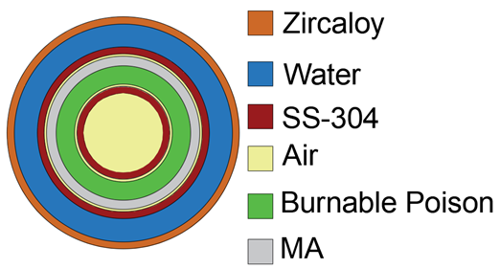

FIG. 6. a thin layer of MA coated in BP region.

The results of applying this approach after performing the input files and simulating all of them using mcnp5 arranged in the next table.

TABLE 3. FIRST APPROACH RESULTS

Thickness(cm) | Keff | SD | Mass(kg)
0.0 | 1.04375 | 0.00052 | 0.0
0.01 | 1.0367 | 0.00053 | 196.367
0.02 | 1.02684 | 0.00050 | 386.7082
0.03 | 1.02246 | 0.00049 | 573.021
0.04 | 1.01785 | 0.00048 | 754.8559
0.05 | 1.01295 | 0.00054 | 931.9695
0.06 | 1.00917 | 0.00047 | 1104.443
0.07 | 1.00732 | 0.00049 | 1272.276
0.08 | 1.0034 | 0.0005 | 1435.47
0.09 | 1.001 | 0.0005 | 1594.023
0.10 | 0.99996 | 0.00048 | 1747.936
0.11 | 0.99736 | 0.00048 | 1897.209
0.12 | 0.99467 | 0.00054 | 2041.841
0.13 | 0.99363 | 0.00055 | 2181.834
0.14 | 0.99195 | 0.00051 | 2317.187
0.15 | 0.99054 | 0.00051 | 2447.899
0.11 | 0.99736 | 0.00048 | 1897.209

4.2. Secondly, Coating a thin layer of minor actinide NpO2 in the water gap in BP
The second approach is introducing the minor actinide materials to the reactor core by coating thing layer with different thickness in the water gap of the burnable poison rods. There is figure to explain this approach. The results arranged in a table as below.
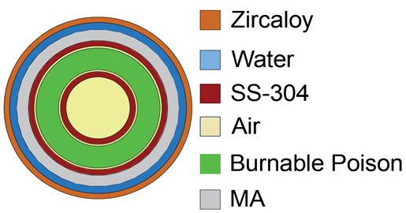

FIG. 7. coating a thin layer in the water gap.
TABLE 4. SECOND APPROACH RESULTS

Thickness(cm) | Keff | SD | Mass(kg)
0.00 | 1.04375 | 0.00052 | 0.00000
0.01 | 1.02629 | 0.00051 | 226.8326
0.02 | 1.01566 | 0.00054 | 458.3053
0.03 | 1.00631 | 0.00049 | 694.4182
0.04 | 0.99911 | 0.00054 | 935.1712
0.05 | 0.99113 | 0.00048 | 1180.564
0.06 | 0.98682 | 0.00050 | 1430.598
0.07 | 0.98088 | 0.00054 | 1685.271

4.3. Thirdly, homogenous mixing of MA (NpO2) with the Burnable poison materials
The third approach of loading the MA materials NpO2 is the homogeneous mixing of NP-237 in the burnable poison rod in this technique, the NpO2 mixed uniformly with burnable poison rod materials, which is made of Borosilicate glass. The concentration of The NpO2 in the poison materials is varied from 1%-5% to observe their effect on the reactor reactivity. Below the table, explain the calculated results:

TABLE 5. THIRD APPROACH RESULTS

Percentage | Keff | SD | Mass(kg)
1% | 1.04375 | 0.00052 | 0
2% | 1.0415 | 0.00054 | 2.955372
3% | 1.03832 | 0.00049 | 6.136854
4% | 1.03475 | 0.00054 | 9.544447
5% | 1.03484 | 0.00051 | 13.17815

Discusion and CONCLUSION
In the paper we have tried three approaches to transmute Minor Actinides (NpO2) in AP1000 reactor all these approaches proved possibilities to be used in transmuting of MA but they are different in the amount that can be transmuted, the first approach which is to coat a thin layer of MA which it is NpO2 with the burnable poison in the burnable poison rods showed that the largest amount that can be transmuted is 1897.209 Kg when the thickness of MA the layer is 0.11 cm, In the Second approach which is to coat a thin layer in the water gap in the BP rods and this is limited by the space that available which can not exceed 0.07 cm of the layer thickness and at this value the largest amount that can be transmuted is 1685.271 kg. The third approach is homogenously mixing the MA materials with the BP materials and the largest percentage is 5% and the mass is 13.17815 kg.
When we introduce the MA in the reactor it effects in the reactor criticality but the it can be maintained through some techniques like additive of boric acid.
I conclude that the first approach can be more effective in the matter of the MA amount as the results showed.

References
- EA-TECDOC-1613, 2009 edition nuclear fuel cycle information system, a directory of nuclear fuel cycle facilities 2009 edition
- https://www.nei.org/Knowledge-Center/Nuclear-Statistics/World-Statistics
- NEA No- 6997 OECD, Nuclear Energy Agency Minor Actinide burning in thermal reactors.
- Madic, C., Boullis, B., Baron, P., 2007 Futuristic back-end of the nuclear fuel. cycle with the partitioning of minor actinides . J.Alloy compd 444,23-27
- Terry A. Todd, April 22-2015, Warsaw-Poland, The US DOE R&D program on MA separations, National Technical Director Idaho national lab First SACSESS Int.
- www.iaea.org/inis/collection/.../_Public/27/.../27071162
- https://study.com/academy/lesson/actinides-definition-properties-uses.html
- Liu, B., Wang, K., Tu, J., Liu, F., Huang, L., Hu, W., 2014. Transmutation of minor actinides in the pressurized water reactors. Ann. Nucl. Energy 64, 86-92
- Position Paper, National Nuclear Laboratory-uk, Minor Actinide Transmutation
- C.H.M. Broeders, E. Kiefhaber , H.W. Wiese Forschungszentrum Karlsruhe, 1999, Burning trans-uranium isotopes in thermal and fast reactors and fast reactor
- T.mukaiyama, Y.Giunji, Japan atomic energy research institute, Characteristics of minor actinide transmutation in minor actinide burner reactor
- Production of minor actinides in thermal nuclear reactors and nonprofileration
- S. Leray, France, National laboratory, Nuclear waste transmutation
- Iwasaki, T., 2002. A study of transmutation of minor-actinide in a thermal neutron ﬁeld of the advanced neutron source. Prog. Nucl. Energy 40, 481–488
- Iwasaki, T and Hirakawa, H, 1995, Transmutation of minor actinide in well-thermalized neutron field and application of advanced neutron source.
- M.Szieberth, M.Halasz, T. Reiss, S. Feher, Institute of nuclear techniques, Budapest, Fuel cycle studies on minor actinide burning in Gas cooled fast reactor
- Bahatii, Zaki, Hyland, B, Edward, G.W.R, Minor actinide transmutation in thorium and uranium matrices in heavy water moderated reactors.
- Liu, B., Hu, W., Wang, K., Huang, L., Ouyang, X., Tu, J., Zhu, Y., 2013. Transmutation of MA in the High Flux Thermal Reactor. J. Nucl. Mater. 437, 95–10.
- Carey M. Read Jr., Travis W. Knight, Kenneth S.Allen, Development of a multi-tiered recycling strategy with a sodium-cooled Heterogeneous Innovative Burner Reactor.
- Bin Liu, Kai Wang, Jing Tu, Fang Liu, Liming Huang, Wenchao Hu, transmutation of minor actinide in pressurized water reactor.

