# Water Temperature Distribution in Spent Fuel Storage Pool of Nuclear Research Reactor in Indonesia

TITIK SUNDARI*

Center for Radioactive Waste Technology, National Nuclear Energy Agency of Indonesia (BATAN), Kawasan Puspiptek Serpong, Tangerang Selatan 15314, Indonesia.

*Email: titiks@batan.go.id

SRI ISMARWANTI

Center for Nuclear Fuel Technology, National Nuclear Energy Agency of Indonesia (BATAN), Kawasan Puspiptek Serpong, Tangerang Selatan 15314, Indonesia.

PARJONO

Center for Radioactive Waste Technology, National Nuclear Energy Agency of Indonesia (BATAN), Kawasan Puspiptek Serpong, Tangerang Selatan 15314, Indonesia.

IRWAN SANTOSO

Center for Radioactive Waste Technology, National Nuclear Energy Agency of Indonesia (BATAN), Kawasan Puspiptek Serpong, Tangerang Selatan 15314, Indonesia.

MUKHSINUN HADI KUSUMA

Center for Nuclear Reactor Technology and Safety, National Nuclear Energy Agency of Indonesia (BATAN), Kawasan Puspiptek Serpong, Tangerang Selatan 15314, Indonesia.

**Abstract**

Severe accidents at the Fukushima Dai-ichi nuclear power station became an important lesson learned to know the water temperature distribution at spent fuel storage pool (SFSP) of G. A Siwabbessy nuclear research reactor in Indonesia. When the active cooling system was not functioning properly, the knowledge of the cooling water temperature in the SFSP became an important parameter related to SFSP safety. The research objectives to determine the cooling water temperature distribution in G. A. Siwabessy SFSP when the active cooling system was failure in function. The experimental method is used to know the temperature distribution in the pool water when the active cooling system is turned off for 87.18 hours. The experiment results show that the highest temperature of pool water when the active cooling system failure was 26.89°C. With the present spent fuel, the results obtained show that the temperature of the water in SFSP does not exceed the temperature value which can cause high evaporation of water and does not cause danger to the overall spent fuel integrity.

## INTRODUCTION

In the case of spent fuel storage pool (SFSP) accident in Fukushima Daiichi NPP, the accident was caused by station blackout (SBO) following unprecedented earthquake and tsunami and has resulted in the presence of residual heat accumulation when no cooling system available to remove that residual heat in the SFSP. Severe accident of Fukushima Dai-ichi nuclear power station became an important lesson lerned to know the water temperature distribution at spent fuel storage pool (SFSP)[1, 2, 3].

Regarding the incident, more in-depth attention needs to be noticed for the SFSP in the Indonesian RSG-GAS. RSG-GAS has spent fuel storage pool used to store the spent fuel from its operation with maximum capacity of 1458 spent fuel and total heat flux of 4000 Q/cm². The SFSP level of surface water minimal is 3.6 m from the surface of spent fuel [4, 5].

Previous research on the characteristics of SFSP has been carried out by several researchers. Wang et al. [6] studied the design characteristic of SFSP and its decay heat load, and provided model to estimate SFSP evaporation rate based on the temperature. The result shows that predicted SFP level and temperatures are in good agreement with measured data and are consistent with safety requirement of Tokyo Electric Power Company evaluation results. Mochizuki [7] evaluate the spent fuel pool temperature and water level during SBO. Calculation model used RELAP5-3D code verified using the data measured during Fukushima-I accident and hand calculation. The evaluation results showed that the whole pool temperature is almost uniform under transient conditions without heat removal. Chen et al. [8] evaluate the cooling capacity with more fuel stored in the spent fuel pool of the Kuosheng plant used GOTHIC code with full capacity. The results conclude that the Cooling capability of the SFP still meets the safety requirement with storing more assemblies. Oertel et al. [9] studied temperature distribution in a spent fuel pool involving partially uncovered fuel storage rack using Computer Fluid Dynamic (CFD) analysis. Their results recommend best arrange the fuel assemblies in a spent fuel pool for optimal heat exchange in case of an accident involving loss of cooling water. Ye et al. [10] studied temperature distribution in a SFP using CFD to evaluate a new passive cooling system. Their results indicate that the water in the SFP will never boil, even in a severe accident with a lack of emergency power and outside aid. Chen et al [11] simulate the thermal–hydraulic characteristics include temperature distribution in a spent fuel pool (SFP) using CFD model, after the loss of external cooling system, there are about 44 h for the operator to provide the alternative water source to avoid the occurrence of the local boiling in the SFP.

From previous researches, it is known that the distribution of SFSP must be known for safety reasons. On the other hand, there has been no research to measure experimentally the temperature distribution in SFSP RSG GA Siwabessy. This study is important due to safety factor of SFSP. The research objectives to determine the cooling water temperature distribution in G. A. Siwabessy SFSP when the active cooling system was failure in function. The results will be used as knowledge to determine the water temperature in SFSP during SBO condition.

## METHODOLOGY

Experimental setup of SFSP temperature measurement can be seen in Figure 1. There are 245 spent fuels that divided into 6 racks stored in storage pool containing de-mineral water with a depth of 6.34 m, pH around 6.03 and conductivity 1.38 µS/cm. Each fresh fuel element contains 250 grams of enriched uranium and an average burn-up of 57%. Temperature sensor used type K thermocouples with error ± 0,36%. The measurement point is focused on 2 spent fuel racks and temperature sensor are located on 7 place: above the water surface (1), at the water surface (2), at level -3 m from the water surface (3), above the peak of spent fuel (4), at the middle of spent fuel (5), at water empty space (7), in the SFSP building (8). National instrument data acquisition system (NI-DAQ) and LabVIEW software are used to record data of measurement. Measurements were made on the VAC condition on for 8 hours and the VAC condition was off for 87.18 hours. Measurements taken when the VAC condition is off to simulate SBO conditions.

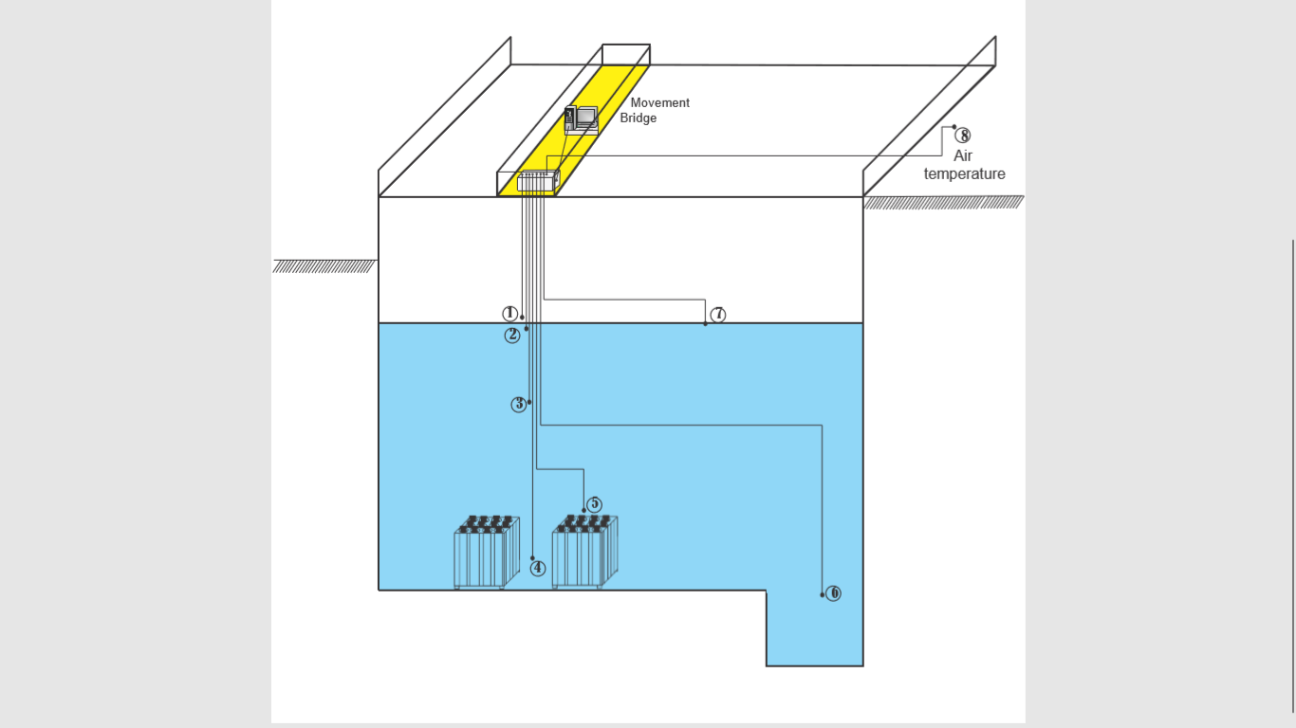

FIG. 1. *Experiment setup* of SFS*P temperature measurement*

## results and discussion

### Measurement of SFSP water temperature is carried out in 2 conditions, in the normal condition of VAC operation and SBO condition. Under normal operating condition, the VAC system is activated on working days (Monday to Friday) during office hours, 08.00 to 16.00 (8 hours). One of the operating parameters of VAC is the room air temperature of the SFSP is maintained at a value of normal operating condition limit, ≤ 25°C. Temperature measurement in normal condition is carried out when VAC operation reached the 8 hours operation time. Temperature measurements are carried out during 2 hours operation of VAC and when the VAC reached the 8 hours operation time. The results of measuring the SFSP water temperature under normal conditions are shown in Fig. 2.



FIG.2. *Water temperature distribution in SFSP during operation of VAC*

During the VAC operating condition, the room air (T8) has a temperature of 23.46°C. The temperature of the air above the water surface (T1) is measured at 23.62°C. The temperature of water surface (T2) is 25.84°C. The water temperature at the level of -3m (T3) is 25.74 °C. The temperature of the water at the top of the SNF in the middle of the rack (T4) is 25.96°C. The water temperature at the half level of SNF (T5) is 26.14°C. The water temperature in the empty pool area (T7) is 25.81°C.

To compare the temperature distribution of SFSP when VAC ON condition with SBO condition, in Fig. 3 is showed the temperature distribution of SFSP under SBO condition. Station blackout condition was simulated by turning off all SFSP operation support systems. The pool cooling system was turned off so there was no cooling process of the pool water. The VAC system was turned off so that there was no blowing of cold air and suction in the room air. The purification system was turned off so that there was no circulation of water which causes movement of water. The lighting was turned off so that there is no other heat sources except from SNF in the SFSP.

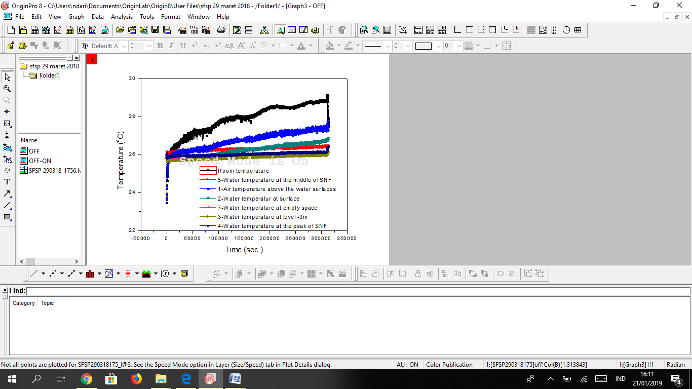

FIG. 3. *Temperature distribution in SFSP under SBO condition.*

Fig. 3 shows the measurement result of temperature in SFSP for 87 hours (313841 seconds) of SBO condition. The temperature of the room air that was originally 23.46°C, increase to 27.63°C. The temperature of the air above the water surface (T1) which was initially 23.62°C increase to 27.42°C. The temperature of water at the surface of the water (T2) which was initially 25.84°C increase to 26.89°C. The temperature of the water at the level of -3m (T3) initially 25.74°C increase to 26.14°C. The temperature of the water at the SNF peak in the middle of the rack (T4) was initially 25.96°C increase to 26.42°C. The water temperature at the half height of the SNF (T5) was initially 26.14°C, increase to 26.48°C. The water temperature in the pond area that is empty pool area (far from the SNF) (T7) was originally 25.81°C, increase to 26.18°C.

Temperature increases in all measurement points. A significant increase was in the room air temperature, which rose around 4.2°C. The increase of air temperature above the water level (T1) was 3.8°C. The temperature increase because there is no supply of cold air from the VAC system. The increase in air temperature above the water surface is smaller than the room air. Since the air above the water surface contact with water, which has a lower temperature so that heat transfer occurred. The heat transfer occurred from air at 27.42°C to surface water at 26.89°C.

The greatest temperature increase was in surface water (T2) was 1.05°C. At other points an increase in water temperature ranged from 0.34 - 0.46°C. Measurements at lower levels, at the -3 m (T3) water level, have a smaller increase of 0.41°C. This is because surface water receives heat from the air greater than water at -3m depth.

At the peak of the SNF and in the middle of the rack (T4), the increase of temperature was 0.46°C. Whereas at the half height of SNF (T5) has the smallest temperature increase, 0.34°C. However, the temperature of T5 (26.48°C) is higher than T4 (26.42°C). This is because T5 is closer to meat of SNF (closer to the heat source). But T5 does not rise significantly because it is far from the heat source.

Water temperature in the pool without SNF(T7) increases by 0.37°C. However, the temperature (26.18°C) is lower than the surface of the water in a location that has SNF (T2) (26.89°C). This shows that the increase in water temperature is not only influenced by the hot air temperature, but also the presence of SNF in the SFSP.

From the data obtained, the highest temperature for water on the condition of SBO (87.18 hours) is on the water surface close to SNF, which is 26.89°C. When compared with the boundary condition requirements for normal operations (less than 35°C), this value still meet the safety requirement.

## CONCLUSIONS

The measurement of SFSP water temperature was carried out on normal conditions (VAC operation) and SBO condition for 87.18 hours. Measurements on SBO conditions are carried out by turning off the SFSP cooling system, VAC system, purification circulation system, all other support systems and by turning off the lighting so that no heat affects the experimental results. From the results of temperature measurements in SBO conditions, there is an increase in temperature at all measurement points. This increase in water temperature is because water received heat from the air and the decay heat of SNF stored in the SFSP. The highest water temperature reached in 87.18 hours SBO was 26.89°C at SFSP surface water. This measurement has an error value of ±0.36%. This temperature when compared with the normal operating conditions limit (maximum 35°C) is still in accordance with the safety requirements of the SFSP operation. If there is an SBO in the SFSP RSG GAS for 87.18 hours, the SFSP water temperature will not evaporate excessively and endanger the SNF integrity.

ACKNOWLEDGEMENTS

The authors would like to thank the Center for Radioactive Waste Technology for funding this research.

References

[1] P. P. Povinec, L. Liong Wee Kwong, J. Kaizer, M. Molnár, H. Nies, and L. Palcsu, “Impact of the Fukushima Accident on Tritium, Radiocarbon and Radiocesium Levels in Seawater of the Western North Pacific Ocean: a comparison with pre-Fukushima situation, Radioact 166,” *J Env.*, vol. (Part 1), p. 56–66., 2017.

[2] V. Yoschenko, T. Takase, A. Konoplev, K. Nanba, Y. Onda, and S. Kivva, “Radiocesium Distribution and Fluxes in the Typical Cryptomeria Japonica Forest at the Late Stage After the Accident at Fukushima Dai-Ichi Nuclear Power Plant,” *J Env. Radioact 166*, vol. (Part 1), p. 45–55.

[3] M. H. Kusuma, N. Putra, A. R. Antariksawan, and R. A. Koestoer, “Passive Cooling System in a Nuclear Spent Fuel Pool Using a Vertical Straight Wickless-Heat Pipe,” *Int. J. Therm. Sci.*, vol. 126, no. December 2017, pp. 162–171, 2018.

[4] M. H. Kusuma, “Sistem Pendingin Pasif di Kolam Penyimpanan Bahan Bakar Bekas Nuklir dengan Menggunakan Pipa Kalor,” UNIVERSITAS INDONESIA, 2017.

[5] PTLR-BATAN, “Laporan Analisis Keselamatan Kanal Hubung-Instalasi Penyimpanan Sementara Bahan Bakar Bekas,” Tangerang Selatan, 2018.

[6] D. Wang, “Study of Fukushima Daiichi Nuclear Power Station Unit 4 Management and Disposal,” *Nucl. Technol.*, no. November, 2012.

[7] H. Mochizuki, “Annals of Nuclear Energy Evaluation of spent fuel pool temperature and water level during SBO,” *Ann. Nucl. Energy*, vol. 109, pp. 548–556, 2017.

[8] Y. Chen and Y. Yuann, “Annals of Nuclear Energy Evaluation of cooling capacity with more fuel stored in the spent fuel pool of the Kuosheng plant,” *Ann. Nucl. Energy*, vol. 109, pp. 120–134, 2017.

[9] R. Oertel, T. Hanisch, E. Krepper, D. Lucas, F. Rüdiger, and J. Fröhlich, “Two-scale CFD analysis of a spent fuel pool involving partially uncovered fuel storage racks,” *Nucl. Eng. Des.*, vol. 341, no. May 2018, pp. 432–450, 2019.

[10] C. Ye, M. G. Zheng, M. L. Wang, R. H. Zhang, and Z. Q. Xiong, “Annals of Nuclear Energy The design and simulation of a new spent fuel pool passive cooling system,” vol. 58, pp. 124–131, 2013.

[11] S. R. Chen, W. C. Lin, Y. M. Ferng, C. C. Chieng, and B. S. Pei, “Annals of Nuclear Energy CFD simulating the transient thermal – hydraulic characteristics in a 17 Â 17 bundle for a spent fuel pool under the loss of external cooling system accident,” *Ann. Nucl. Energy*, vol. 73, pp. 241–249, 2014.