Fast reactor SNF reprocessing for closed nuclear fuel cycle

A.YU. SHADRIN,

Innovation and Technology Center of the Project “PRORYV”

Moscow, Russian Federation

Email: shau@proryv2020.ru

K.N. DVOEGLAZOV, V.L. VIDANOV, O.V., YU.S. MOCHALOV

Innovation and Technology Center of the Project “PRORYV”

Moscow, Russian Federation

V.I. VOLK, V.A. KASHCHEEV, O.A. USTINOV

BOCHVAR INSTITUTE

Moscow, Russian Federation

**ABSTRACT**

Closed nuclear fuel cycle (CNFC) with inherent safety fast reactors (FR) is a new integrated product in the branch of atomic energy. A pilot demonstration power complex with reactor unit (BREST-OD-300) with lead coolant is under constriction at the Siberian Chemical Combine in frame of the “PRORYV” project. This pilot demonstration power complex includes not only fast reactor but also facility for fuel fabrication/refabrication and facility for mixed uranium-plutonium nitride (MNIT) spent nuclear fuel (SNF) reprocessing and radwaste management. Integrated system of models and codes for the coordinated simulation of different processes and phenomena for CNFC technologies are also under development.

## INTRODUCTION

CNFC with FR is a new integrated product in atomic energy. CNFC allows:

* to reduce an amount of accumulated used nuclear fuel;
* to manage a radwastes on the principles of radiation equivalency;
* to realized technological support for the non-proliferation;
* to provide the cost efficiency an compare with other energy sources.

Industrial scale CNFC should be realized at the experimental demonstration power complex (EDEC) including reactor unit BREST-OD-300, mixed uranium and plutonium fuel fabrication unit and FR SNF reprocessing unit. EDEC is and development and constriction under project “PRORYV”.

Two versions (combined (pyro + hydro) and hydrometallurgical) of FR mixed uranium-plutonium nitride and oxide SNF reprocessing technology are under developing within “Proryv” project. Up to day the R&D program on hydrometallurgical technology is close to complete. The study of pyroelectrochemical and plasma separation technologies are at the different R&D stages.

The following results were achieved for FR SNF hydrometallurgical reprocessing:

* a pilot set-up of extraction and crystallization affinage of U+Pu+Np mixture with the full-scale crystallizer was created;
* main technological equipment for hydrometallurgical reprocessing of MNIT and MOX SNF FR were developed;
* a realized tests of processes and equipment for extraction and crystallization affinage of U+Pu+Np mixture confirmed a total decontamination factor 5*106;
* deep recovery (> 99,9 %) of actinides was demonstrated;
* full-scale set-up for microwave denitration of U+Pu+Np, U-Am, U-Cm were developed and tested;
* partitioning technology for group separation of rare earth elements and transplutonium elements and for Am/Cm separation were tested using irradiated fuel;
* full-scale prototypes of industrial equipment (dissolution, clarification, off-gas cleaning, crystallization, microwave denitration, Am/Cm separation) were developed and tested;
* dry separation of SNF and fuel cladding, removal of more than 99.9 % tritium and more than 98 % 14C were demonstrated for the MNIT SNF voloxidation process;
* off-gas cleaning technologies provided recovery > 99.99 % I, 99 % 3H and 14C, were tested.

In terms of radwaste management for hydrometallurgy and the combine technologies for MNIT and MOX SNF were developed and verified including cold crucible for vitrification HLW and combination of alkali precipitation and tangential filtration for decontamination of U-Pu-Am-containing solutions.

The integrated system of models and codes is under development for simulation of heterogeneous processes and phenomena that are required to consider under calculating maintaining and reasoning the safety of CNFC technologies.

## COMBINED (HYRO + HYDRO) TECHNOLOGY FOR FR SNF REPROCESSING

### Head-end and pyrochemical operations

The EDEC aims include the demonstration and development of CNFC technologies with lead cooled reactor and MNIT fuel. The unit for MNIT fuel fabrication/refabrication is under construction now. The technologies of MNIT SNF reprocessing is under development now. The combine (pyro + hydro) technology (PH-process) is chosen for as a basic for EDEC. PH-process includes high temperature head-end operations, pyrochemical recovery of actinides and hydrometallurgical operations including deep purification of recycled actinides and recovery and separation americium and curium (FIG. 1). The most detailed description is given in [1]. Progress and results of 2017-2018 are given in [2].

The voloxidation of MNIT is a first chemical operation after decladding and mechanical fragmentation. This operation allows to remove 3H, iodine and 14C almost totally. The experiments on oxidation used MNIT were made in RIAR in 2017-2018. It was shown that MNIT can be fully oxidized and removal of 99.8 % and more of 3H, and 98.4 % and more of  14С were achieved (FIG. 2).

The description of off-gas decontamination operation is given in [3, 4]. The recovery of 98.2 – 99.9 % 14С is necessary for environment safety [5]. The developed technology allows to achieve the necessary level. The recovery of 99.99 % all iodine forms can be achived. The optimal sorption temperature is 160-170 oC.

The demonstration of pyrochemical operations with real (irradiated) MNIT was performed in air hot cells in 2013. However the passivation of MNIT SNF pellets due to formation of low soluble in electrolyte UNCl surface layer, and, probably, UN/U2N3 formation also insoluble in electrolyte, could lead to losses of uranium. Due to these and some other reasons these experiments were not fully successful. The oxidation MNIT to actinides oxide powder and reduction of oxides to metal actinides was proposed. The reason of this approach was experimentally confirmed with simulated products, U and Pu, and with irradiated SNF.

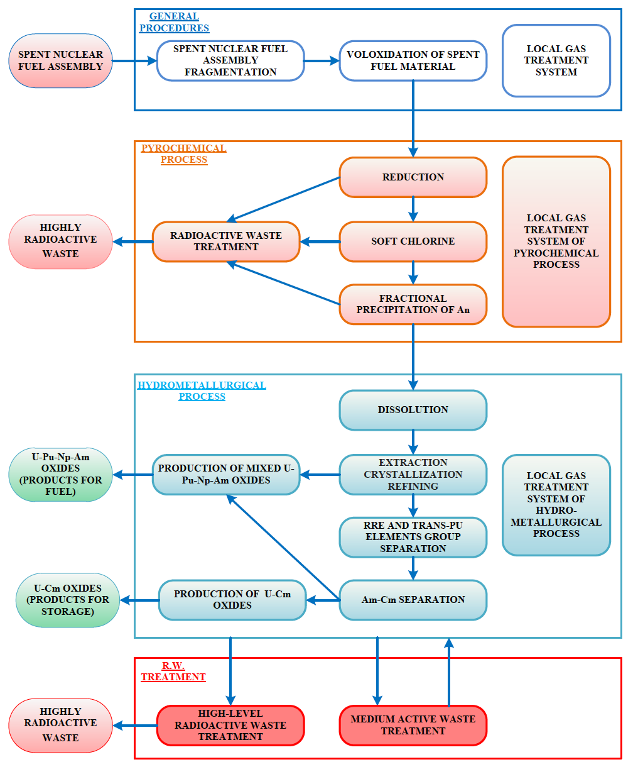

*FIG. 1 PH-process principal flow-sheet*



*FIG 2. Oxidized MNIT SNF*

### Hydrometallurgical operations

The recovery and purification of U-Pu-Np product by extraction and crystallisation was checked at Siberian Chemical Combine set-up. This set-up contains from 6 blocks of centrifugal contactors, two separators and crystallizer. The recovery of U, Pu and Np was more than 99,97 %. The Pu decontamination factors for Cs – 106, Sr – 103, Zr, Mo – 103 and rare earth elements `(104) were achieved. The crystallisation gives an additional decontamination factor 100-200. The direct denitration of U and Pu nitrates allows to prepare the needed products without additional amount of secondary waste. Mixed oxides of U and Pu were prepared using laboratory set-up for microwave denitration for MNIT fuel fabrication. Apart from mixed U and Ce oxides (several kilogram) were prepared using experimental set-up for microwave denitration (FIG. 3). U-Ce oxides (FIG. 4) were used for mixed nitride synthesis and for MNIT pellets fabrication. The prepared pellets are satisfied to technical requirements for MNIT fuel.



*FIG. 3 – Experimental set-up for microwave denitration*

|  |  |
| --- | --- |
|  |  |

*FIG. 4 – Microstructure of UN and U(Се)N pellets*

Results of studies on partitioning performed at 2016-2018 are given bellow. 99.99 % of Am were recovered from high level waste (HLW) simulated solution by dynamic test using solution of TODGA in metanitrobenzotrifluoride. 99.9 % of Am and Cm were recovered from real HLW using some extraction system. The technology of americium and curium separation was demonstrated in 2016 at the trial and industrial unit of PO “MAYAK” . Around 14 g of 244Сm were recovered of which 9 g was the fraction of enriched curium with the americium content of less than 6% by activity. The mixed americium-curium fraction contained around 4.6 g of 244Сm and around 40 g of 241,243Аm. The enriched americium fraction the curium share was less than 0.8 % by mass, and the content of 154,155Eu was less than 0.1% by activity

## MANAGEMENT WITH RADIOACTIVE WASTE

The full-scale prototype of industrial “cold” crucible for HLW vitrification was made and tested in Bochvar Institute (FIG. 5). This set-up with “cold” crucible not only has a remote control but this crucible can be distantly removed and changed for a new one. The test was performed for 300 hours including 200 hours of continuous operation. No deviations from technical requirements were obtained.

|  |  |
| --- | --- |
|  |  |
| a) | b) |
| *FIG. 5 – Full-scale prototype of set-up with “cold” crucible for HLW vitrification (a) and the drain of glass (b)* | |

## INTEGRATED SYSTEM OF CNFC MODELS AND CODES

The development of SNF reprocessing technologies is accompanied by the development of a system of models and codes for the mathematical simulation of technologies, namely:

* Code VIZART for the calculation of the material flows of the technological scheme and its sections in the stationary and dynamic modes, taking into account the evolution of the isotopic composition;
* Mathematical models of technological processes;
* Code COD TP for simulation of the operation of technological schemes in real time (model of automated process control system), including modeling of emergency situations;
* Simulation (kinematic) model of technological operations;

The state of development of the system of models and codes is described in [6].

REFERENCES

1. SHADRIN А., DVOEGLAZOV K., KASCHEEV V. РH process as a technology for reprocessing mixed uranium–plutonium fuel from BREST-OD-300 reactor. Radiochemistry, **58,** 3, (2016), 234-241.
2. SHADRIN A., MOCHALOV Yu., DVOEGLAZOV K., KASCHEEV V. Reprocessing of Fast Reactors Mixed U-Pu Used Nuclear Fuel in Russian Federation: Studies and Industrial Test. Fast Reactors and Related Fuel Cycles: Next Generation Nuclear Systems for Sustainable Development (FR17), (Proc. Int. Conf. Ekaterinburg, Russia, 2017), International Atomic Energy Agency, Vienna (2018). Paper IAEA-CN245-76.
3. VOSKRESENSKAYA Yu., USTINOV O., YAKUNIN S. Ruthenium trapping from the gas phase in the processing regeneration of spent nitride fuel of fast reactor. Atomic Energy, **115**,3,(2014), 187-190.
4. KULYUKHIN S., KAMENSKAYA A., MIKHEEV N., et. al. Basic and applied aspects of the chemistry of radioactive iodine in a gas medium. Radiochemistry, **50**, 1, (2008), 1-20.
5. ALEKSAKHIN R., SPIRIN E., SOLOMATIN V., SPIRIDONOV S.I. Environmental aspects of a pilot power complex in project breakthrough. Atomic Energy, **120**, 6, (2016), 380-387.
6. MAKEYEVA I., SHMIDT O. Modeling technologies of fuel cycles. / International Conference on Fast Reactors and Related Fuel Cycles: Next Generation Nuclear Systems for Sustainable Development (FR17), (Proc. Int. Conf. Ekaterinburg, Russia, 2017), International Atomic Energy Agency, Vienna (2018). Paper IAEA-CN245-147.