# iMPLEMENTING AGEING MANAGEMENT PROGRAM IN INTERIM WET STORAGE

M. NYSTRÖM

Swedish Nuclear Fuel and Waste Management Co

Oskarshamn, Sweden

Email: mattias.nystrom@skb.se

**Abstract**

Clab is a facility, own by Swedish Nuclear Fuel and Waste Management Co (SKB), for wet intermediate storage of spent nuclear fuel pending deposit in final repository. At Clab 6700 tonnes of nuclear fuel are currently stored with a residual power of about 8.3 MW. Requirements regarding ageing management programs at nuclear facilities were introduced in 2006. Two attempts to introduce ageing management programs were made between 2006 and 2013, but failed. In 2013, SKB received an injunction to implement an ageing management program for Clab.

A project group was appointed to produce an appropriate ageing management program for the facility. The program was developed with guidance from the IAEA safety guide No NS-G-2.12.

The strategy was to involve the line organization early in the project so that the people who would manage the program were involved in the development of management systems, analyses and proposals for measures. This made the handover of the project to the line organization quite simple and straight forward.

The facility consists of approximately 160 systems, of which about 96 are included in the ageing program. Only systems that are important for radiation safety are currently included in the program.

After all systems were analysed from an ageing perspective, 546 new measures, were identified that needed to be implemented to have control over the facility’s ageing. During the execution of the measures, several unexpected discoveries have been made.

The result of the work in the program has shown that the plant's status with regard to physical ageing is good. Technological ageing (obsolescence) is a bigger challenge.

Several lessons were learned in the development of the ageing program, for example the importance of good communication with the supervisory authority. Another lesson is the importance to set the right level of analysis that otherwise risks becoming ineffective.

## INTRODUCTION

Clab (Central Interim Storage Facility for Spent Nuclear Fuel) is a facility owned and operated by Swedish Nuclear Fuel and Waste Management Co (SKB). Clab is a facility for wet intermediate storage of spent nuclear fuel pending deposit in final repository. Clab was commissioned in 1985 and consists of an on-ground part with unloading equipment and auxiliary systems and an underground part with storage pools. At Clab, approximately 6700 tonnes of nuclear fuel (≈ 35 000 fuel elements) are currently stored with a residual power of about 8.3 MW. At the plant, all spent nuclear fuel is stored from Sweden's nuclear power program. The plant also stores other components from the nuclear power plant's primary system, such as control rods and neutron detectors. The facility is planned to be in operation until the middle of the 2060s when the last fuel elements, according to the planning, will be deposited in the upcoming final repository.

Requirements regarding ageing programs at nuclear facilities were introduced in Sweden through authority regulations in 2006 [1]. Two attempts to introduce ageing management programs were made between 2006 and 2013. In 2013, the supervisory authority carried out monitoring with regard to the ageing management at Clab. The authority then assessed the program as substandard and instructed SKB to develop an appropriate ageing program through an injunction.

Contributing factor to the failure was related to a lack of competence about what an ageing management program consists of. There was also a lack of prioritization which meant that sufficient resources were not assigned. The lack of knowledge meant that the organization did not understand how an ageing management program should be built and what activities should be included. As a result, there was a program on the paper, but there was no one within the organization that could distinguish the maintenance program from the ageing management program. There was also no appointed person to be in charge of the ageing program.

In a first attempt to develop a program, in 2006, a consultant was assigned with the task to go through the existing maintenance program and make a gap analysis. The gap analysis should show which additional measures that were required to handle ageing equipment with significance to radiation safety. The result was a list that showed a few gaps. The list became Clab's first "ageing management program". No management or development of the work was done at this time, the list was just archived in the document management system.

As the organization could not distinguish the maintenance program from the ageing program, or explain what the program was, a new attempt was made in 2010. At this time, a free interpretation of an authority document [2] was made, the result was that the ageing program would only cover the plant parts that were intended to keep the entire plant's lifetime. This means that the ageing program would cover the control program for structures (rock and concrete structures). The ageing program was thus more limited than before. In practice, the approach did not differ from the ordinary preventive maintenance program for structures.

In 2013, the supervisory authority carried out monitoring with focus on the ageing program at Clab. Clab then received sharp criticism for the methodology and working methods regarding ageing programs. SKB was given an injunction to produce an appropriate ageing management program for Clab. This was the start for SKB to handle the issue seriously.

## Implementing of the ageing program at Clab

When Clab was given an injunction to produce an appropriate ageing program in 2013, the maintenance manager was given a clear responsibility to rectify the injunction. It was found early that the effort would be substantial. When the responsible manager analysed the whole picture and what measures were required to rectify the injunction, a number of conditions emerged which were considered important for coping with the challenge. The most important conditions were considered to be:

* The work must be carried out as a project.
* The project must have a management group.
* The project must be staffed with in-house staff.
* The resources must work full time in the project.
* The resources should be hand-picked by the project manager.
* It must be stated that the company management prioritize the project.

The conditions were discussed with the management, which accepted them. The maintenance manager at Clab was appointed project manager.

### Project implementation when developing the ageing program

#### Manning the project

At the start of the project the project crew consisted of:

* 1 project manager.
* 1 senior operations engineer.
* 1 senior shift leader.
* 1 senior maintenance engineer.
* 1 maintenance engineer who was designated to manage the ageing program in the line organisation.

All 4 project participants were handpicked by the project manager with the aim of getting a functional and creative project group. Participants were selected because of their good technical know-how, their skills and ability to deliver, as well as their different personal qualities.

The project group was placed at the facility in new offices in order to release their regular work for the benefit of the project.

All participants in the project's core group worked full time in the project. In cases where replacements were required for their regular services, this was added. For example, an acting maintenance manager took over responsibility for the maintenance at the facility during the time the project continued.

As the project progressed, additional staff was involved, including full time project participants and line staff for specific tasks. The strategy was to involve the line staff who would perform the tasks when the ageing program was handed over to the regular organization.

Examples of competencies involved in the project were maintenance personnel, operating staff, chemistry personnel and fuel and material specialists.

#### The start-up phase of the project

The start-up phase of the project focused on analyzing and understanding the problem, an important prerequisite for success was to increase the project group's competence in the task.

The start-up phase can be roughly described with the following stages:

* Skills development
* Analysis of injunction
* Action plan

Skills development was conducted as a separate study of the available documentation relating to ageing management, with subsequent workshops where documents were interpreted and discussed. The documents used came from IAEA, Wano, and the authority. The next step was to go through routines, instructions and activities that already were developed for the existing ageing program.

A definition of "ageing management program" was stated. This activity required a lot of discussions and time, but it was well-invested hours that provided good support during the rest of the project.

After the analysis of the injunction and the subdocument it became clear why it had been issued. The facility's ageing program lacked, in principle, all the criteria required to be systematic, traceable and effective.

An action plane with time frame was drawn up and it was clear that it would be impossible to produce a ready-made ageing program in the time required by authority. SKB requested more time, but this was denied.

#### Development of management system for the ageing program

It was decided early on that available models should be used. It was decided that Clab's ageing program should be based on the IAEA's safety guide No NS-G-2.12, Ageing Management for Nuclear Power Plants [3].

This stage of the project largely involved drawing process schedules and flow charts of the various activities. Initially, a lot of time was spent drawing the overall process for the entire ageing program. Based on this, flow charts were then made for the various activities within the program. By using the flow chart, it was found that five governing documents were required for the ageing program. The flow charts were worked out and establish in the organization before the governing documents were produced.

### Handing over the project to the line organization

Handover to line organization were undramatic because the line was already committed in the project and had been involved in developing the method and analyses. The handover consisted mainly of the fact that the project group was dissolved. The personnel responsible for completing and managing the program were already familiar with the tasks as they had participated in the project.

The strategy for staffing the project with in-house staff and performing the work internally proved to work as intended. Since the staff responsible for carrying out the practical measures themselves had been included in the analyses, there was an understanding and acceptance of the task.

An education package was developed in order to create understanding and knowledge of the ageing program and the method. The target group was broad. The approach was that all personnel related to the facility would carry out the training, which was also carried out prior to the project's handover. The education, for example, discussed up the history of the ageing program, the requirements, basic documents such as SAR and Technical Specifications, and the process of ageing. It included practice examples that are adapted to suit all professions groups, for example, a scoping and screening exercise is done on a car and the ageing management analysis of the car's tires.

For the engineers and staff with practical performance within the ageing program, further training was carried out at a more detailed level, for example in the areas of material knowledge and inspection technology.

### The process of ageing management at Clab

The ageing process (FIG.1) at Clab consists of four main parts:

* Scoping and screening
* Ageing management analysis
* System analysis (System health review)
* Reporting and follow-up

The ageing program also has a strong connection to other activities and documents such as maintenance documentations, maintenance activities, operation and modernization projects.



*FIG. 1. Process for ageing management program at Clab*

The scoping and screening process is a comprehensive work aimed at selecting systems and its components that should be included in the ageing management program. The criterion for a system to be included in the ageing program is that it is important for radiation safety. This has been defined at Clab as a system that is of importance for the deep defence, or systems that can cause problems for the deep defence. The work is made more difficult by the fact that classification lists cannot be used. Clab has equipment without safety significance and some with safety signification with the same security classification. The basic data for scoping and screening is taken from the safety report that relates to the plant's requirements, the plant's description and the plant's design event analysis. Even other requirement documents are taken into consideration for scoping and screening, particularly regarding the systems associated to the physical protection. The screening and scooping is carried out in two stages, at a system level and at a component/functional level.

Systems and components that have been included in the program then undergo ageing management analysis. The ageing management analysis shows which measures are to be taken to control, minimize and manage the ageing impact, so that actions can be taken to ensure that age-related impairments cannot have any impact on radiation safety. The process follows nine attributes written in NS-G-2.12 [3]: (Scope, Preventive actions, Detection, Monitoring, Mitigating, Acceptance criteria, Corrective actions, Operating experience, Quality management). To get a similarity in the management of generic components, component AMP´s have been written to describe suitable measures, eg for electric motors, power electronics and solenoid valves. These measures are used in ageing management analyses for each system. The ageing management analysis concludes with a gap analysis in which the proposed measures are compared with existing measures. When a gap arises, a unit is appointed responsible to correct the gap within a certain time. As the gap is corrected, the analysis is updated, the analysis is completed when no gaps remain.

The system analysis determines the status with regard to ageing (technologically and physically). The input data for the analysis are experiences from operation, maintenance and radiation protection activities and the outcome of the measures indicated by the ageing management analysis. A check is made to see if there is a need to update the system's ageing management analysis. Input for this is new experience, technology development, or if the measures have not been effective enough. How effective the preventive measures have been assessed through a review of the last five years' fault reports. Are there fault reports that show ageing that has not been detected in measures within the ageing program, the program is updated with these improvements. An important part of the system analysis is the investigation of the system's technological ageing, eg availability of spare parts and competence (obsolescence). System analysis is carried out every five years.

A yearly report describes and follows up the previous year's activities of the ageing program. All recommendations from the system analysis are compiled and prepared for decision. Meetings are held with the first line managers to see what action proposals are accepted and can be addressed. Proposals that could not be decided upon or addressed at the first line's management level are lifted up to the plant's management level for decisions. In decision-making, a time is also set when the proposal is to be completed and a responsible person is appointed. When proposals are unaccepted, the reason must be motivated.

### Results from the introduction of the ageing program

The facility consists of approximately 160 systems and about 96 of these are covered by the ageing program. It is important to point out that only those parts of the systems that are of importance to radiation safety are covered. Examples of these systems are various buildings, underground structures, cooling systems, lifting systems, storage pools, storage cassettes and the spent nuclear fuel. The nuclear fuel is included because the facility credits the fuel enclosure as a barrier.

The result of ageing management analysis of all systems in the program was that 546 gaps were identified where measures were needed to manage ageing. Mostly this was condition checks that were addressed by maintenance, several gaps were also handled by other professionals groups, for example chemists and operational staff. The gaps involve different types of measures, for example:

* Control of cleanliness in the facility.
* FME program.
* Camera inspections of pipes and pools.
* Extended controls on electric motors.
* Installations of dehumidifiers in underground structures.
* Inspections of nuclear fuel.
* Control of functions.
* Control of chemical parameters, eg process water and diesel fuel.

Several unexpected observations were made in connection with the actions being carried out. For example incorrectly repaired pipes in safety systems (origin from time of construction), foreign objects in storage pools and on fuel that has the potential to cause corrosion problems in the long term, unexpectedly large amounts of microbes in storage pools and leaking bushing in transformers.

Several modernizing projects have been initiated, since the system analysis stated that the systems are exposed to technological ageing (obsolescence). This means that we could have availability problems in the near future due to lack of supplier support or access to spare parts.

The result of the work in the ageing program has shown that the plant's status with regard to physical ageing is good. Technological ageing is a bigger challenge. An important aspect in this context is that new modern components, primarily within I/C, which become obsolete faster than the older technology.

### Practical examples of measure in the ageing management program

#### FME

Routines and procedures how to work with FME has been implemented. An FME-coordinator has been employed to assist both staff and project to work properly in practical FME-questions. In the picture you can see an FME-covering the unloading pool. This was done prior to reconstruction of the fuel handling machine.

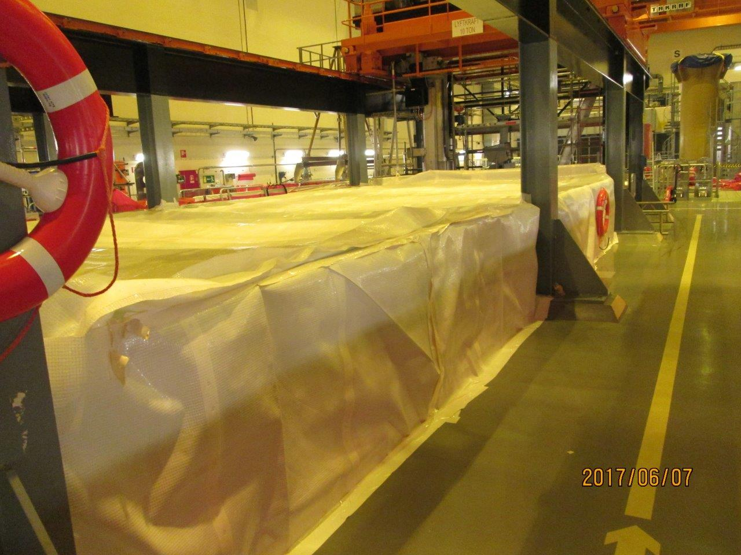

*FIG. 2. FME-covering of the unloading pool*

#### Internal inspection of pipes

One measure in the program is the internal inspection of selected pipes. One damaged pipe was found during an inspection. The damage was found in a safety system, in a pipe that can supply the storage pools with make up feed water in case of loss of cooling system. The damage was in an earthquake proof concrete structure which made it problematic to expose the damage for repair. An enlarged control program has been established for camera inspection of the damage, within the ageing program. No sign of ageing impact has been observed. As long as the damage is stable it will not be repaired.

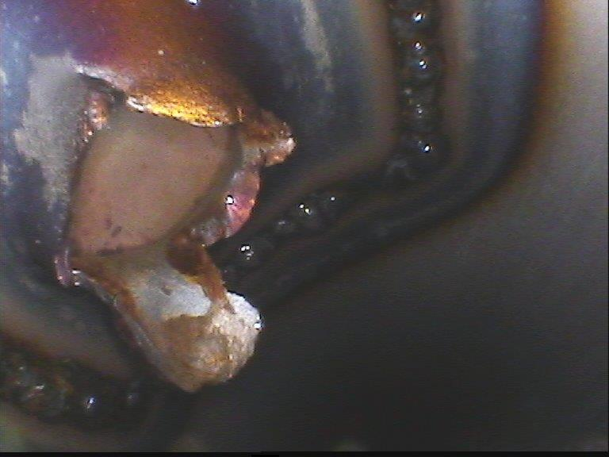

*FIG. 3. Damaged make up feed water pipe*

#### Inspections of fuel

Fuel inspections are made with underwater cameras. Fuel elements of different types and ages are selected for inspection and recording periodically with the intention to find changes depending on ageing.

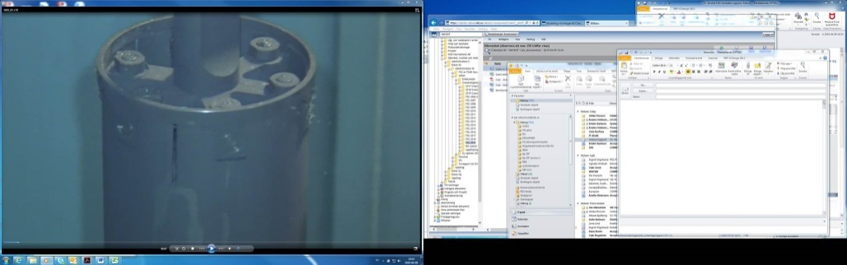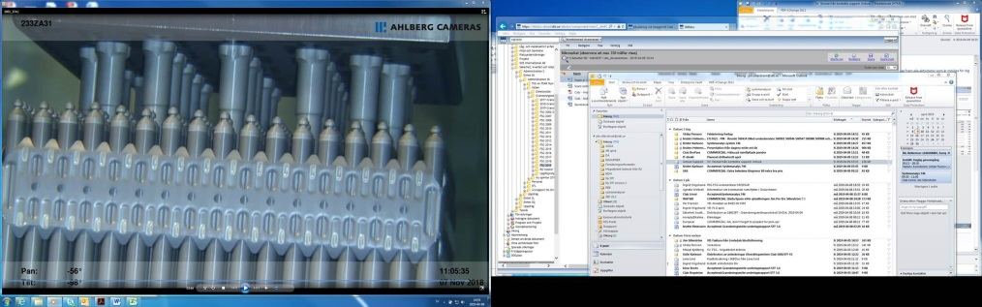

*FIG. 4. Fuel inspection pictures*

#### Measurement of capacitance in capacitors

Capacitor is one of the components that ages in electronic devices, like power supplies and rectifiers. The measure program has been expanded after implementing of the ageing management program.



*FIG. 5. Measurement of capacitor*

#### Measure of concrete structure

To determine the ageing influence of the concrete structure of the cooling water intake a comprehensive measure program was performed. There were some thoughts that it could be corrosion in the reinforcing bars. Core drilling was done to analyse the depth of the carbonation process, compressive strength, chloride content and other facts with importance for ageing. In some places reinforcing bars were uncovered to make visual inspections. The measurements showed that the ageing influence of the structure was less than expected, the concrete was in good condition.



*FIG. 6. Concrete structure testing*

### Lessons learned

#### 2.6.1. The importance of having clear communication with the supervisory authority

One of the main experiences in connection to the injunction of the ageing program is the importance of clear communication between the supervisory authority and SKB.

In connection with the remediation of the injunction, a lack of communication resulted in that the authority and SKB had different objectives regarding the extent of what was to be remedied. The cause of the misunderstanding was a poor word selection in SKB's action report. SKB interpreted that a working method was implemented and that the work of analyzing the plant's system had begun with a plan for progress. The supervisory authority intended that analysis of all of the plant's systems should be completed. One contributing factor to the misunderstanding was that SKB interpreted an ambiguity and error writing in the authority's letter to our own advantage.

The differences in the goals were not discovered until SKB sent in the final report of the remediation of the injunction and reported measures taken. The authority responded by issuing an additional injunction regarding the implementation of an ageing program.

An HFE investigation was carried out that showed several reasons, but the main reason is considered to be unclear communication from SKB to authority. Several measures were taken to strengthen SKB's way of working with injunctions, for example clearer role of responsibility between the security department and the line organization and better support for the line organisation when handling injunctions.

The experience is to have clear communication with the authority and to clarify any uncertainty.

#### 2.6.2. Level of analysis

When the ageing program was developed and the first analyses were carried out, considerable time was spent in discussing about the level of work. It is considered important to establish a reasonable level of analysis and measures. If the program becomes too deep and detailed, it will cost large sums of money and resources. If the program becomes too general, important aspects of ageing will not be found.

#### 2.6.3. Implementation with in-house staff

The main reason for the success of the work on the ageing management program is that it was decided that the program would be prepared by in-house staff. A number of specialists started to work together with the person who should manage the program in the line organization. As the analysis started, the organization became more involved in the project. This meant that the handover from project to line organization became undramatic. Many of the involved persons didn’t notice that work went over to the ordinary organization. Since maintenance and operation personnel had been involved in the analysis from the beginning, no resistance was encountered to perform the measures to reality. Another advantage by doing the work with in-house staff is that the knowledge about the ageing program is gradually being built up within the organization.

In summary, to do the work with internal resources has given understanding and acceptance to the ageing management program.

#### 2.6.4. Information to decision-makers

System analyses reports are solid information from employees to management in issues related to the plant's status. Problems and malfunctions that were previously discussed in coffee rooms and corridors are now formalized in the system analysis and result in a recommendation on action. Decision on action of the recommendation is then taken by decision makers at different levels depending on the competency of the recommendation.

#### 2.6.5. Documentation

The ageing program has resulted in a large amount of documentation. For examples, scoping and screening reports, ageing management analysis reports, system analysis reports and assessments on the impact on the ageing program in connection with modernizing projects. A good document structure and functional tools are required to have good control of the documents and their dependencies. In our case, a person was responsible for the document management. We found that our document management system did not provide required support for the tasks, we were forced to create independent lists and cross-reference tables to be able to manage all the documents.

#### Development work in the ageing program

A task on how to deal with spare parts in the ageing program has just begun. The purpose is to have control of spare parts so that they can be installed in the plant without delay. Ageing of spare parts should be postponed or prevented by correct storing and proper maintenance.

After the introduction of the ageing program it was noticed that manage of equipment with importance for radiation safety is good. Equipment that is important for operational availability is not currently handled within the ageing program. There is a difference in the quality of how these different systems and components are handled. In the future, the aim is to manage equipment important for the operational availability in the ageing management program. A first step to introduce a routine for classification of systems based on priority class has been developed. This takes into account how important the equipment is for both radiation safety and operational availability. The classification is supposed to replace today's screening for the ageing management program. This enables components of importance for both radiation safety and operational availability to be managed equally. In addition, an opportunity is given to differentiate the significance of a component in different stages. This makes it possible to further increase the focus on important components, while the less important ones can be handled more lightly.

The ageing program is based on the IAEA Safety standard NS-G-2.12 [3]. The Safety standard was replaced in 2018 by IAEA Safety standard SSG-48 [4]. In 2019, a gap analysis will be carried out to see development needs in the ageing program due to the updated IAEA document.

#### Authority inspection of the new ageing program

In 2017, the authorities carried out a renewed inspection of the ageing program. The authority stated that all systems of significance for radiation safety were covered by a functional ageing management program. The authority also stated that there was a commitment among the employees for the work on the program. Some areas of improvement were noted, but the assessment was that the facility met the regulatory requirements very well regarding ageing programs.

## ConCLuSion

After some failed attempts and some years of hard work we have a working ageing management program. The work has just started, the program will be managed and improved until the day when the facility is closed. Even though the facility have experienced employs that have worked many years with improvement of maintenance and operational procedures to keep the facility in god condition, the work with the ageing management program had given us a lot more knowledge about the ageing status and how to deal with it. As a result of the program, the communication and cooperation between different units and levels has increased which has led to an increased efficiency. The program also gives support to long-term planning of both maintenance activities and modifications.

References

[1] SKIFS 2004:1, Statens Kärnkraftsinspektion (Swedish)

[2] Gott K, Åldringshanteringsprogram – Behov och innehåll, Statens Kärnkraftsinspektion (2006) (Swedish)

[3] [IAEA Safety Standards Series](https://www.iaea.org/publications/search/type/safety-standards-series) No. NS-G-2.12, Ageing management for nuclear power plants, IAEA (2009)

[4] [IAEA Safety Standards Series](https://www.iaea.org/publications/search/type/safety-standards-series) No. SSG-48, Ageing Management and Development of a Programme for Long Term Operation of Nuclear Power Plants, IAEA (2018)