Storage capacity enhancement of SFISF at Paks in Hungary

BALÁZS FICKER
SOM System Ltd.
Budaörs, Hungary
Email: balazs.ficker@somsystem.hu

BÁLINT GÉHER
SOM System Ltd.
Budaörs, Hungary

Abstract

Spent fuels (SF) assemblies from Paks Nuclear Power Plant (Paks NPP, Hungary) are placed in Spent Fuel Interim Storage Facility (SFISF) since 1997. The SFISF is a modular vault dry storage (MVDS) type design accommodating SF after a minimum of a few years of cooling time in the reactor decay pool. The SFs are stored individually and separately in the vault modules (VM) in airtight sealed fuel storage tubes (FST) filled with inert gas. Decay heat rejection is achieved by buoyancy driven air flow through the vault, passing over the exterior of the array of storage tubes.
The capacity of the SFISF was planned on the total amount of the SFs arising from the planned 30-year lifetime of Paks NPP. To store these SFs a 33-vault facility was designed with 450 FST in each vault. Until now all together 24 vaults have been constructed.
Sixteen vaults were built with 450 FST in each vault. To make the storage economically more efficient the number of FSTs was increased from 450 to 527 in the last eight vaults. This was provided by use of the built-in reserves of the design and the development of analyses techniques making it possible to reduce the conservatism in calculations. According to this modification the total capacity of the SFISF was increased by around 9%.
At the millennium a decision was made to extend the lifetime of the Paks NPP with addition 20 years, resulting a significant growth in the amount of the SFs. In order to adjust the storage capacity a review of the design was carried out. The structural analysis showed that a number of 703 FSTs could be installed into the same geometry by modifying the charge face structure (CFS). Based on this number the total capacity could be increased by almost 20% compared to the original design.
Considering the initial few years of cooling period and applying it for the whole storage facility the heat load could be higher than the design criteria. However, with the rearrangement of the SFs cooled for many years in the FSTs it is possible to solve this issue. The decay heat production of SFs stored for many years decreased to a level at which it is possible for them to be placed in a higher density redesigned vault with the new CFS design. By transferring the older SFs to the higher density vaults there will be enough free positions to place the newer SFs arriving from the NPP. Construction license with the newly increased storage arrangement was issued by the nuclear authority in 2017.
The paper describes the design, modelling and licensing process of this capacity enhancement.

INTRODUCTION

Selection of the storage facility
According to the fuel strategy that was effective at the time of construction of the Paks NPP the Soviet Union undertook to take back the SF for reprocessing without returning any product or waste from it. The first transport of SF took place in 1989, but altogether 2331 SFs were returned.
As a result of a selection process the Modular Vault Dry Storage system was selected from a group of equally safe and reliable storage technologies in the beginning of the 1990s. The main factor of this decision was the fact that the MVDS technology has provided the lowest SF cladding temperature during storage. Having only limited experience at that time on the behaviour of the VVER-440 type SF under dry conditions it was judged to be an important issue. It was the reason that the operator of the Paks NPP signed a contract with a British-French company GEC Alsthom Engineering Systems Ltd. to build a dry storage facility of MVDS type. By 1997, the first VM – containing three vaults - and the service building has been built.
The possibility of the use of Russian reprocessing services still exists, but since commissioning of the Paks storage facility all SF assemblies taken out from the decay pools of the reactors are stored at SFISF adjacent to the NPP.

Facility design
The Paks storage facility functionally can be divided into three major structural units (see FIG. 1.).
The first major unit is the service building in which the reception, preparation, unloading and loading of the transfer cask takes place. The fuel assemblies are transported to the MVDS from the at-reactor pool using the C-30 transfer cask (with a maximum capacity of 30 FAs) and its railway wagon. The fuel handling system and other auxiliary systems are installed in this building.
The second major structural unit is known as the charge hall where the fuel handling machine travels during the fuel handling operations. The charge hall is bordered by the reinforced concrete wall of the ventilation stack on the one side and by a steel structure with steel plate sheeting on the other side.
The third one is the VM where the SF assemblies are stored in the vertical tubes (see FIG. 2.). These VMs include a minimum of three or maximum five vaults depending on the geometrical arrangement.
The VM structures form a rigid enclosing "box" with substantial thicknesses of radiological shielding concrete, which also provide adequate structural strength and weather protection. The box cell structure (i.e. the vault module) is supported by an integral foundation raft bearing directly onto the replacement fill.
The outlet ducts form stiff vertical cantilevers from the cellular structure, with thicknesses determined largely by shielding requirements. The rigid concrete structure provides firm anchorage points for the steelwork forming the charge hall enclosure. The steelwork is adequately braced in the plane of the walls and roof to ensure the elimination of sway and to bring the reactions directly on to the concrete structures.
Cooling air enters the vault through a louvred opening which is provided with a mesh covering to prevent the ingress of birds or large debris. The individual inlet openings are connected to a common plenum to aid the vault airflow distribution and to maintain the flow if an opening becomes blocked with snow or other debris. The air passes through a concrete labyrinth, which provides radiological shielding of the fuel assemblies then into the vault tube array section via precast concrete collimators, which are cast into the main cell structure walls. The collimators provide further radiological shielding of the fuel assemblies, whilst improving the cooling air distribution through the vault.
The air leaves the vault through a second set of collimators and is exhausted to the atmosphere through a concrete outlet duct which does not come in contact with the fuel in their storage tubes. Thus, the internal surfaces of the vault will remain clean and will not require decontaminable finishes.
The vault floor provides support to the FSTs via grouted-in support plates. A grouted gap provided in the top of the vault walls supports the CFS. Each CFS consists of four pre-fabricated steel boxes filled with concrete at site for shielding purposes. The CFS forms the roof of the vault and provides horizontal support for the FST array. The vertical loads are transmitted to the civil structure in direct bearing [1].

Capacity needs
Due to its modular nature the MVDS facility has been constructed according to the operational needs of the of the NPP. Initially the operator of the Paks NPP specified two requirements regarding its SF storage capacity needs. One of them was to accommodate the SF amount generated by the four reactors of the NPP in 10 years operation. The other one was to make it possible to extend the facility to receive the additional remaining SFs generated through its originally designed 30-year service life. The latter requirement has particular importance since parameters which depend on the number of SFs had to be taken into account for the full deployment of the facility. As a consequence, parameters which concern for example radiation protection had to be justified for the case of storing all SFs. According to the first construction licence an 11-vault facility was erected as it is shown in FIG. 1. with each vault including 450 FSTs. This 4950-arrangement capacity was based upon the amount of the SF arising from the Paks reactors over an operating period of 10 years.
Considering the additional amount of the SF arising from the 30-year service life of the NPP reactors the overall capacity of the facility was expected to be 14 850 FSTs in 33 vaults.

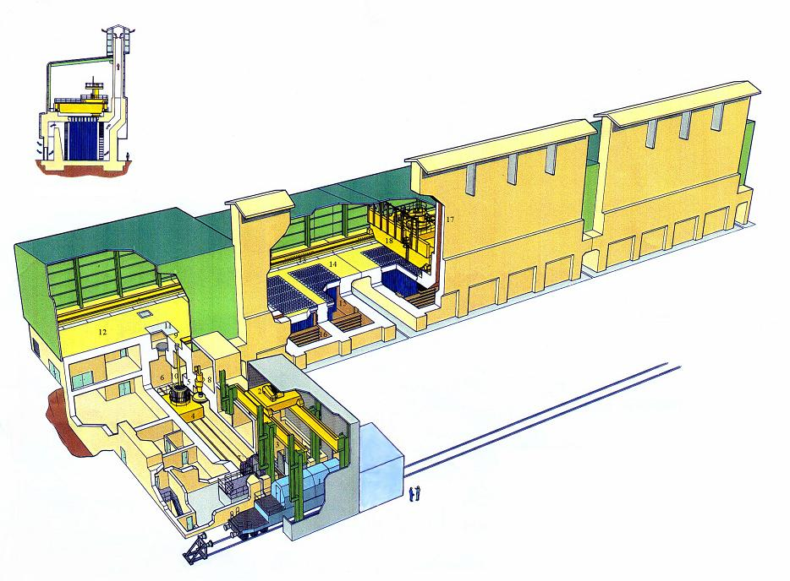

FIG. 1. Paks MVDS. [1]
1 Rail Wagon 10 Fuel drying tube
2 Cask Handling Crane 11 Maintenance Hatch
3 Cask Preparation Area 12 Charge Hall
4 Cask Transfer Trolley 13 Fuel Handling Machine Rail
5 Transfer Cask (C-30) 14 Vault Modules
6 Fuel Drying And Unloading Cave 15 Storage Tubes
7 Roller Shutter Door 16 Collimators
8 Lid Lifting Station 17 Stack
9 Load/Unload Port 18 Fuel Handling Machine

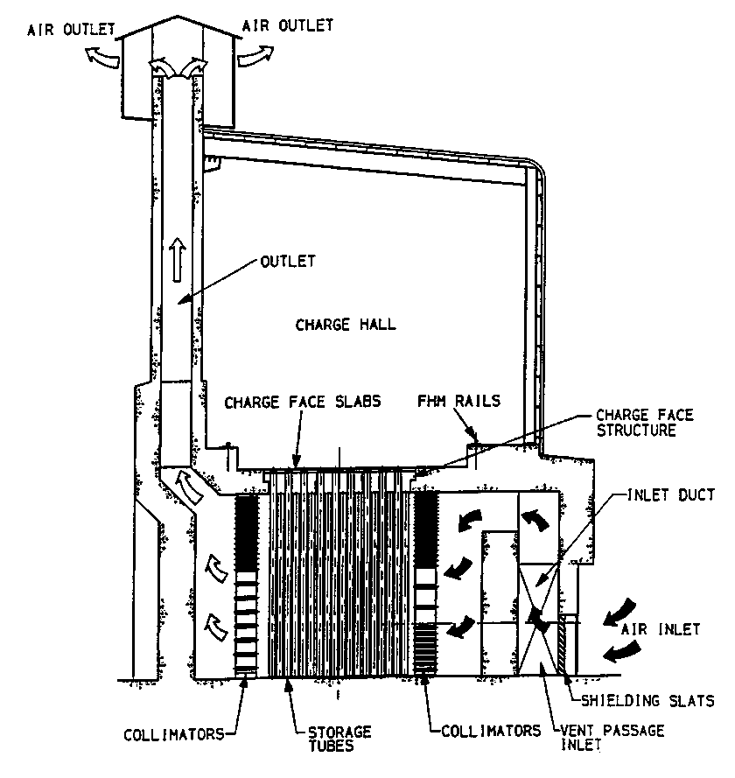
FIG. 2. Vault module schematic arrangement. [1]
As the first construction licence expired further enlargement of the Paks MVDS needed to renew its licence at the beginning of the 2000s. As the selection of the storage technology was carried out back in the early 1990’s this time a two-step re-selection process was initiated when the aim was to make sure that the adopted technology is not just safe but economical too. In 2003 a decision was made to continue the extension of the existing storage facility using the MVDS technology.
Based on the lessons learned from the operational experience and the above-mentioned re-selection process some important modification were licensed for further enlargement phases. One of them was to increase the total storage capacity which played an important role in the life extension for the Paks NPP.
As a result of the modifications starting from the 17th vault the number of FST per vault was increased from 450 to 527. This was provided by use of the built-in reserves of the design and the development of analyses techniques which contributed to reduce the conservatism in calculations.
The constraints of this modification were the CFS structural strength and the loading machine’s seismic system modification requirements. By taking into account all these conditions/criteria the overall capacity of the facility had become 16 159 (16x450+17x527) SFs storage capacity that has been commissioned up until now is not much more than half of what is required if the 20 years lifetime extension of the Paks NPP is also considered. Therefore, it was of paramount importance to investigate further capacity enhancement possibilities.

The rationale behiNd the capacity enhancement of the SFISF

Alternatives of storage capacity enhancement
To cover the required additional capacity only two possible solutions could be envisaged in terms of dry storage technology. One of the possible solutions was the deployment of dry cask storage as new technology and the other one was to further increase the capacity of the existing SFISF.
The cost analysis of the SFISF capacity enhancement made clear that reducing costs is possible by diminishing the space needed per storage tube.
According to the original design an approx. 3-year minimum of cooling is applied for the SFs arriving into the SFISF.
A proposal was made to take the advantage of the fact that the SFs stored for a long period of time in the storage facility do not need the room necessary for those SFs with the initial 3 years cooling period prior to transporting them from the at-rector decay pool.

As more than half of the storage facility has been constructed and has been storing SFs for a long period of time already so additional modules could be designed for SFs with much longer cooling period than 3 years. With the rearrangement of the SFs within the SFISF the old modules could be freed up for the SFs arriving form the NPP. This rearrangement would be possible if the old SFs could be transferred to new VMs with a further increased number of FSTs.
The preliminary static analysis showed that approx. 700 FSTs could be installed into the same geometry by modifying the CFS. The proposed solution was analysed according to the principles of interim storage relevant areas such as critical safety, decay heat rejection and radiation protection.

Critical safety
Based on preliminary model calculations with various assemblies and vault configurations it was anticipated that the justification of subcriticality would be possible.
Justifying critical safety of a denser arrangement on the other hand could benefit from the burnup credit. By taking into account the isotopic composition of the SFs significant reduction of the calculated vault multiplication factor can be achieved. Until this point critical safety calculations were carried on the basis of fresh fuel only. The denser grid arrangement proposal was explicit regarding to receive previously loaded SFs therefore fresh fuel assemblies were excluded by precondition. Thus, it was anticipated that critical safety requirements were not going to become limiting factor for the number of FSTs.

Decay heat rejection
Analysis of decay heat rejection was carried out on the basis 23 years of cooling time of SFs. According to the SFISF final safety analysis report the average heat production of a fresh SFs (approx. 3 years of cooling time) are decreased from 477 W to less than 135 W after 23 years of cooling time. Prior to the current enhancement under consideration vaults containing 527 assemblies resulted 527 x 477 ~ 250 kW of thermal power. Assuming for example 750 pieces of SF with 23 years of cooling time the thermal power reduces to 750 x 135 ~ 100 kW. As such this significant increase in the number of assemblies in one vault would result in less than half of the actual thermal load.

Radiation protection
In terms of radiation protection both operator doses and individual doses of the public had to be considered. Operator doses are made up of two effects. One of them is caused by the assemblies stored in the vaults the other is coming from the manipulation activities. The latter was considered as the decisive factor. The operational experiences regarding doses caused by manipulation activities of fresh assemblies were well below safety limits therefore no increase from the manipulations of 23 years of cooling time SFs could be expected. However, if assemblies stored in the vaults would cause an increased dose then shielding capability enhancement of the CFS could be a viable solution.

Result of the preliminary analysis
The technical feasibility analysis of the SFISF capacity enhancement was able to prove that storing all the SFs from Paks NPP of its lifetime in 33-vault could be a realizable solution. This meant that the vaults from 25 and the facility had to be redesigned in such a way that each vault would have had to be able to receive more than 700 SFs. As opposed to this solution there was no dry cask storage technology available on the market which would have been able to match the gain projected by the SFISF enhancement considering both costs and uncertainties coming from the application of a new technology. One of the additional defining circumstance was the fact that the significant cost of soil stabilization works needed for the construction of the vault modules was previously completed to the total of 33 vault configuration.

DETAILED Design and safety analysis
The detailed design of the facility started with the determination of the exact number of SFs needed to be stored in context with the remaining lifetime also tagging onto account the new 15-month operating cycle of Paks NPP. After an iterative decision-making process, the number of FST per vault was recorded to 703 and keeping the 33-vault configuration. That means a total storage capacity of 17 743 SFs. The concept was that SFs stored in the 1-15 vaults will be rearranged to the 24-33 vaults while the fresh SFs form the NPP will be stored in the places which thus become vacant. In order to accomplish that, 500 SFs rearrange and loading operations need to be done in the future annually.
Civil and mechanical technical plans were made with increased number of FSTs based on the previous VM design. On the bases of the technical plans detailed safety analyses were made to prove to meet the criteria defined by the facility design and legal regulations.
There are three main requirements on the design of the MVDS that had to be analysed in common with capacity enhancement for the proof of safety [2]:
- The effective neutron multiplication factor (K_{effective}) shall not exceed the value of 0,95.
- The maximum fuel clad temperature shall not exceed the value of 410 °C.
- The maximum temperature of concrete structures shall not exceed the value of 100 °C.
The decisive legal regulation for the operation of the facility are the follows:
- An annual risk of death to the individual of 10⁻⁶/years from all radiological accidents.
- Individual operator annual dose limit (normal operation): 20 mSv.
- Offsite annual dose limit (normal operation): 10 µSv.

For the demonstration of safety critical, thermal, radiation protection analysis and probability safety assessments were required to elaborate. These safety cases are the bases of the pre-construction safety report that required for the licencing processes. The main findings of the safety cases are disclosed below.

Critical safety
The array of FSTs within the 450 FST vault of the MVDS are arranged on a triangular lattice, while in the 527 FST vault in square pitch. The square pitch was defined such that the unit cell cross-sectional area containing a single FST, was equivalent to that of the FST on the triangular pitch (325,7 mm). The array of FSTs within the 703 FST vault are arranged on a triangular lattice but with a reducing on the cell dimension to 295 mm that means a determinative parameter to critical safety.
The assessment of critical safety was based on a hypothesized flooding with potential moderators such as non-borated water aerosols in the FST and outside of it (internal and external flooding). The calculations were made with MCNPX KENO-VI. In the modelling of external flooding the interstitial water density was subsequently increased from 0,0 g/cm³ to 1,0 g/cm³ in the model. The maximum value obtained for K_{effective} in the external flooding occurred with an interstitial water density of 0,16 g/cm³ giving a resultant maximum value of 0,8778±0,0003 (see FIG. 3.). It is interesting to note from the results of FIG. 3. that the array is in fact almost as reactive when the vault is flooded with full density water than is the case when dry.
FIG. 3. K_{effective} in function of water density on external flooding. [3]
On the calculation of the internal flooding the density of the water increased from 0,08 g/cm³ to 0,3 g/cm³. (Note that although the calculations assume internal flooding of all FSTs this is not considered to be a credible situation. The results are only to be used to assess the effect of external flooding of the vault.) The value of K_{effective} was calculated to be 0,8797±0,0003 illustrating no significant change to the external model and has a substantial margin on the stated design criteria value of 0,95 (see FIG. 4.).
FIG. 4. K_{effective} in function of water density on internal flooding. [3]

Thermal analysis
The FSTs are cooled by a naturally-induced crossflow of atmospheric air in the MVDS. No external agent, medium or power source other than atmospheric air and gravity are required to maintain the cooling regime. The open-loop thermosyphon is achieved by means of an outlet duct extending approximately 18 m above the ceiling of the vault. The cooling air is warmed by the fuel assembly decay heat as it passes through the FST array and hence enters the outlet duct at a higher temperature than ambient. The warmed air within the outlet duct produces a buoyancy force which draws more ambient air through the vault, which in turn picks up the fuel assembly decay heat as it passes through the tube array, before exhausting through the outlet duct. The flow is self-sustaining and self-regulating in as much as the flow rate is dependent upon the total fuel assembly decay heat generation within the vault.
The thermal analysis for the new vaults was completed by using of computational fluid dynamics code (Ansys CFX 14.5). The MVDS performance for all normal and fault operating conditions has been evaluated using the maximum (1 in 100 000 year maximum) value of temperature (47,8 °C). The calculation model took into consideration the case that two or more maximum irradiation fuel assembly are in each other’s neighbourhood. In the worst arrangement of maximum irradiation SFs, the results showed that the FST temperature maximum does not reach 90 °C even in fault situations (see FIG. 5.). Compared to this, in 527 FST vault the calculated maximum FST temperature was 327 °C in which case the fuel clad temperature does not reach the limit of 410 °C.
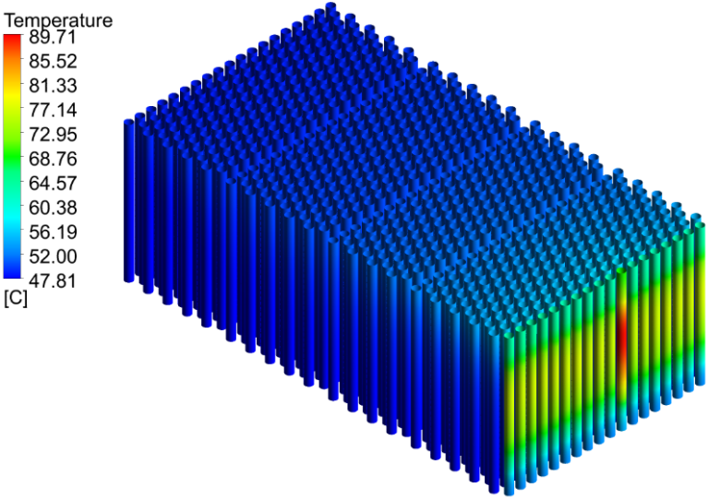
FIG. 5. FSTs temperature distribution. [4]
The maximum calculated temperature of concrete structures was 72,5 °C that also a lower value than in the 527 FST vault and is below the limit of 100 °C.

Probability safety assessment
Probability safety assessment is an established technique to numerically quantify risk measures usually in nuclear power plants. Although SFISF is not a nuclear power plant the PSA method is well useable to rate the risk of radiological accidents. In the facility particularly SF damage accident could lead to unacceptable consequences. The final safety case report of SFISF declares that the frequency of such an event shall not exceed 10⁻⁷/year. (It’s a stricter requirement than the Hungarian legal regulation.)
The revision of the current probability safety assessment was induced not directly by the capacity enhancement of the VM but the rearranging process of the SFs. The initiating events were totally revised and one new initiating event was defined which describes unintentional loading/rearranging fresh SF to the enhanced capacity VM. In this case the above-mentioned temperature limits could be reached that would cause damages to the SF. To exclude this from the design basis events new interlocks were defined to the operability of fuel handling machine which prevent unintentional SF loading/rearranging. Taking into account the changes of fuel handling machine the results of the PSA satisfied that requirements of the safety case and regulations.

Radiation protection
The goal of the radiation protection assessments was to prove the compliance with the operator and offsite dose limits. The increase of the operator dose is caused by the enhancement of the VMs capacity, while the offside dose changes comes from the rearranging process of SFs. The acceptance criteria for the operators was the dose rate calculated at the walking surface of the CFS in the case of the 527 FST vault (approx. 10 µSv/h) [5].
The CFS is a load bearing element providing lateral support for the FST array and also a radiological shielding fabric. The CFS was an on-site concrete filled welded steel structure on the pervious VMs. The on-site concrete filling and the welding processes would not have been evolvable due to the denser FST arrangement. These problems induced the redesigning of the CFS to a completely steel framework with reduced thickness to ensure the transportability and lifting requirements. The initial radiation protection calculations showed that the neutron dose would be higher at walking surface of the CFS because of the missing concrete filling. To solve this problem the CFS was divided into two sections. The upper load bearing section was designed to a completely steel framework while the lower section became an off-side concrete filled steel structure (see FIG. 6.). Additional changes had to be made in the FST plug that was redesigned to a concrete filled steel element. Changes of the structures reduced the dose rates to an acceptable level at the walking surface of the CFS.
In case of the offsite doses the detailed calculations proved that the dose rates added by the rearranging process of SFs doesn’t make significant changes and the limits will be respected later on.
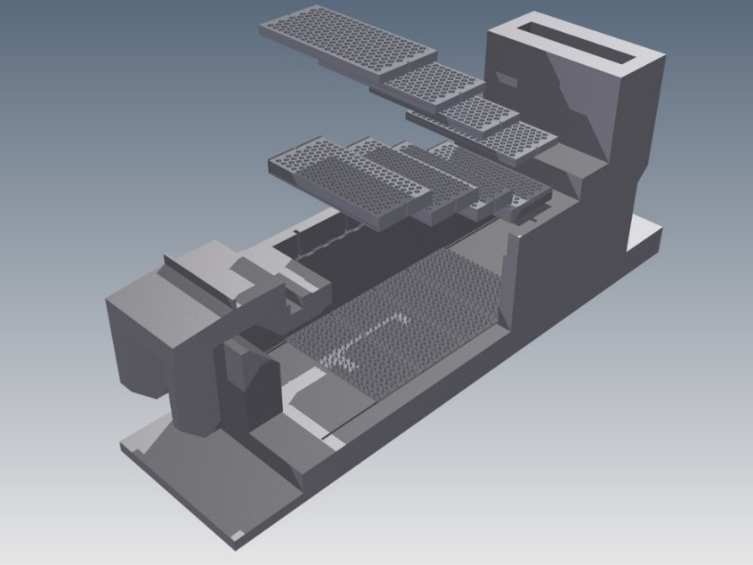
FIG. 6. Redesigned charge face structures. [6]
Upper CFSs
Lower CFSs

Licensing and construction
Review of the facility-level licences became necessary caused by planned modifications in the capacity enhancement program. According to the Hungarian legislative framework the licensing processes had to start with the renewal of the environmental licence in 2015. In this process the licensee demonstrated the compliance with the limits of radioactive discharges. Next step was to prove the fulfilment of requirements set out in the Nuclear Safety Code concerning construction licensing procedure.
The authority granted construction license for the facility at beginning of 2017. Construction licensing process for the building closed successful in the end of 2017 in an individual application. In possession of the necessary licenses the project stepped further into its implementation phase.
The complete construction documentation including a 3D building information model for the next VM was completed in 2018. The Licensee intends to start the tendering processes for the construction in 2019. The construction should finish till 2024, so the commissioning and operation licensing processes could be completed in 2025.

SUMMARY
The 20-year lifetime extension of Paks NPP made it necessary to review the technology used for interim storage of SFs in Hungary, as the facility originally was designed for the amount of spent fuel arising from the 30 years of operation of the four Paks NPP reactors. The preliminary analysis showed that the actually applied MVDS technology with some modifications could economically provide a reliable solution to accommodate all the spent fuel by increasing the number of FST per vault, but leaving the footprint of the facility according to its original size. Thus, all of the additional SFs produced by the lifetime extension could be stored in the formerly planned 33-vault configuration of SFISF.
From the safety cases of the facility it was known that the limit for the denser arrangement of FSTs comes from the relatively high decay heat production of the fresh SFs. It was recognised that the previously loaded thousands of SFs with more than 20 years of cooling time have a heat production that is much lower than the heat production of the SF newly arriving to the SFISF for storage. The idea was to rearrange the older SFs to the following modules with enhanced capacity while the fresh SFs will be loaded to the places which thus become vacant. The preliminary calculations demonstrated that a denser arrangement of FSTs is feasible in the aspects of safety and technology. The Licensee decided to execute a detailed design and analysis work to enhance the capacity of storage facility.
The most important challenge during the process was to redesign the CFS by fulfilling the structural, building technology and radiation protection requirements. A new CFS construction was created that can meet all criteria. Based on the technical plans and the revised safety cases the authorities gave permission to the construction. The development solved the storage issues of the SFs in the SFISF produced by Paks NPP after lifetime extension in the most economical way. Beyond the economic aspects it’s a notable success that the capacity enhancement program was fully designed by domestic institutions from idea to realization.
References
- ALSTEC Ltd., Pre-Construction Safety Report (PCSR) for the Paks Modular Vault Dry Store incorporating the Stage II and III Enlargement, AL/R(2004)003, September 2004
- PURAM, Final Safety Report for SFISF, Revision 7./d
- SOM System Ltd., Critical safety analysis report for capacity enhancement of SFISF, SOM(R)3/758 Rev. 1, 08.04.2014.
- PURAM, Pre-Construction Safety Report for SFISF, Revision 4./a
- SOM System Ltd., Radiological analysis for capacity enhancement of SFISF, SOM(R)3/761 Rev. 1, 08.04.2014.
- SOM System Ltd., Charge face structure for capacity enhancement of SFISF, Technical plan, SOM(R)3/1724 Rev. 2, 17.10.2014.

