# GENIORS, a EU project on MOX fuel reprocessing in GEN IV systems

**Stéphane BOURG*a, Andreas GEISTb, Jean-Marc ADNETa, Chris RHODESc, Bruce HANSONd**

*(a) Research Department On Mining And Fuel Recycling Processes, French Alternative Energies And Atomic Energy Commission, Bagnols Sur Cèze, France; (b) INE, KIT, Karlsruhe, Germany; (c) Central Lab, NNL, Sellafield, United Kingdom; (d) -, University Of Leeds, Leeds, United Kingdom  
Stephane.bourg@cea.fr*

Abstract

The current open nuclear fuel cycle uses only a few percent of the energy contained in uranium. This efficiency can be greatly improved through the recycling of spent fuel (as done today in France for instance), including, in the longer term, multi-recycling strategies to be deployed in fast reactors. In this context, and in the continuity of the FP7 EURATOM SACSESS project, GENIORS addresses research and innovation in fuel cycle chemistry and physics for the optimization of fuel design in line with the strategic research and innovation agenda and deployment strategy of SNETP, notably of its ESNII component. GENIORS focuses on reprocessing and fuel manufacture of MOX fuel potentially containing minor actinides, which would be reference fuel for the ASTRID and ALFREDO demonstrators. More specifically, GENIORS carries out research and innovation for developing compatible techniques for dissolution, reprocessing and manufacturing of innovative oxide fuels, potentially containing minor actinides, in a “fuel to fuel” approach taking into account safety issues under normal and mal-operation. The different promising options developed in SACSESS are currently further developed to address the specific challenges of GEN IV. For delivering a full picture of a MOX fuel cycle, GENIORS works in close collaboration with the INSPYRE project on oxide fuels performance. By implementing a three step approach (reinforcement of the scientific knowledge => process development and testing => system studies, safety and integration), GENIORS will lead to the provision of more science-based strategies for nuclear fuel management in the EU. It will allow nuclear energy to contribute significantly to EU energy independence. This paper presents the strategy and current results of GENIORS.

Nowadays, about 450 nuclear reactors are in operation in more than 50 countries all around the world (1). Most of these reactors are thermal reactors operated within an open fuel cycle, meaning that after about four years in core, the used fuel is considered as the ultimate waste to be managed on the long term. It also means that less than 0,7% of the total natural uranium mined were “burned” to produce energy, and that the remaining 99,3% will never be valorized (2).

In a few countries, including France, UK, Russia, Japan, a mono recycling of the use fuel has been implemented in order to recover the uranium and the plutonium and reused them as mixed uranium/plutonium fuel, like MOX fuel for instance in France. Reprocessed uranium can also be re-enriched and used manufacture fresh UOX fuel. Such a re-use of the uranium allow the saving of about 20% of natural uranium and increased the use of the uranium resource to about 1% (2). It also allows a significant reduction of the amount and radiotoxicity of the ultimate waste to be disposed off and an increased long term behaviour performance with the conditioning as nuclear glass. The heat load being also highly decreased, the glass canisters can be packed with a higher density than the spent fuel, reducing even more the waste disposal volume in the deep geological repository (3).

However, still 99% of the initial natural uranium resource is not valorized in this twice-through fuel cycle. Only the transition to a fast nuclear reactor fuel cycle would allow a quantitative use of this resource, with a multi-recycling strategy of the uranium and the plutonium (4). And only the recovery and the transmutation of the americium would decrease the burden of the remaining ultimate nuclear waste.

The multi-recycling of the fast reactor fuel is a challenge. The H2020 Geniors project contribute to the development of this advance fuel cycle by addressing the multi-recycling of MOX fuel, reference fuel of the GEN IV Sodium Fast Reactor (SFR) and Lead Fast Reactor (LFR), and also of the MYRRHA Accelerator Driven System (ADS).

The H2020 GENIORS project started in June 2017 with 24 partners, a total budget of 7.5 M€ and an EU grant of 5M€. It aims at providing sound sciences based options for the advanced partitioning of MOX fuel, based on the results of previous EU projects such as ACSEPT and SACSESS, with a “from fuel to fuel” approach (Fig 1). Process development and system integration will contribute to give advice to end users and policy makers.



Fig 1. Organisation of GENIORS

It means that dissolution and conversion are also considered through their common feature: understanding the mechanisms at a solid/liquid interface. Geniors also addresses the behaviour of fission products in separation process chemical systems. In the past, most of the work focuses on the data acquisition on actinides and lanthanides, but very little effort was made on the other fission products that will have to be managed in the industrial process. The work initiated in SACSESS on the behaviour of the chemical systems under irradiation continues, in particular to assess the organic species degradation impacts on the performances of the processes, but also to check how far gaseous degradation products could impact the safety of the processes.

More data are also acquired on the separation step: speciation, distribution coefficient, loading capacity, kinetics… all these data aiming at feeding the process simulation tools.

All this work is driven by two factors: simplification and safety, each piece of information contributing to keep a process option open as still promising or, on the contrary, to down-select it (Fig 2).

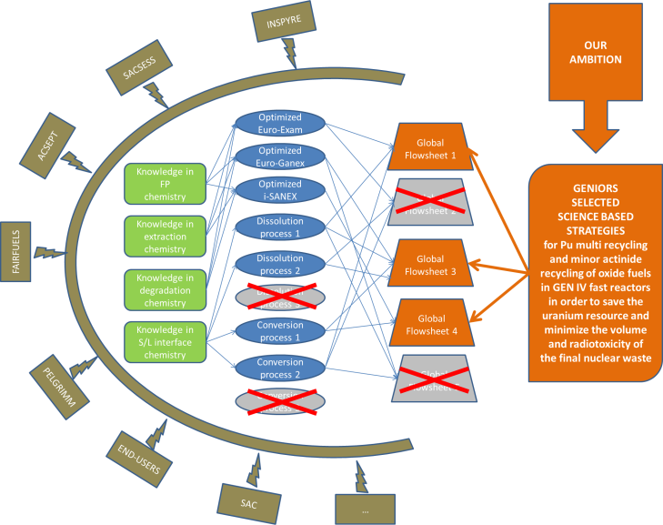

Fig 2. The ambition of GENIORS

An illustration of the work done is given based on the EURO-GANEX flowsheet developed in ACSEPT/SACSESS. Indeed, some key have been identified on this flowsheet, in particular, a low plutonium loading and third phase formation risk. It has been partially fixed in the initial flowsheet by mixing the TODGA with DMDOHEMA but it makes the system complex. Therefore an optimisation study was launched on the TODGA. It has allowed the selection of a promising modified diglycolamide with which the use of DMDOHEMA is not needed anymore. Tu Pu capacity has been increased up to more than 30g/L without third phase formation. The full assessment of this new molecule is undergoing.

When looking at the interface between separation and conversion, it was shown that sulphur atoms of the sulfonated BTP could be an issue. A new molecule (pitridiol, PTD) following the CHON principle, was selected and is under study.

These new achievements could also be beneficial to the initial i-SANEX flowsheet. Therefore, it has been decided to reconsider it for simplification. The same approach is also carried out on the EURO-EXAM flowsheet.

By the end of the projects, all these new data will allow us to propose the vision of emerging processes towards industrialisation, with a concept design of a plant and its safety review. The methodology is based on interactive brainstorming workshops. The first one was organised in October 2018 in Antwerp as part of the training and education activities of GENIORS.

In conclusion, at the end of GENIORS, we should be able to propose three simplified process flowsheets, with a reinforced operational safety.

# Bibliographie

1. http://www.world-nuclear.org/information-library/current-and-future-generation/nuclear-power-in-the-world-today.aspx.

2. Ch. Poinssot et al., Energy 2014, 6, 199–211.

3. Ch. Poinssot, S. Bourg, B. Boullis., PiNE 2016, 92, 234–241.

4. J.Serp, Ch Poinssot, S. Bourg, Energies 2017, 10, 1445.