ENVIRONMENTAL LOAD REDUCTION OF GEOLOGICAL REPOSITORY BY MINOR ACTINIDE SEPARATION: UTILIZATION OF MOX FUEL IN FUTURE FUEL CYCLE SYSTEM

ERIKO MINARI
Laboratory for Advanced Nuclear Energy, Institute of Innovative Research, Tokyo Institute of Technology
2-12-1 Ookayama, Meguro-ku, Tokyo, 152-8550, Japan
Email: minari.e.aa@m.titech.ac.jp

TOMOHIRO OKAMURA¹, MASAHIKO NAKASE¹, HIDEKAZU ASANO^{1,2}, and KENJI TAKESHITA¹
- Laboratory for Advanced Nuclear Energy, Institute of Innovative Research,
Tokyo Institute of Technology
2-12-1 Ookayama, Meguro-ku, Tokyo, 152-8550, Japan
- Radioactive Waste Management Funding and Research Center
Nichirei Akashicho Bldg. 12F, 6-4, Akashicho,Chuo-ku, Tokyo, 104-0044, Japan

Abstract

The current direction of energy politics adopted by the Japanese government is the utilization of nuclear energy, therefore, the argument of radioactive waste management is becoming increasingly important. To promise a safe, and less environmental load disposal repository for the high-level radioactive waste (HLW), it is necessary to look ahead of future fuel cycle system which intends to use plutonium by the introduction of mixed oxide (MOX) fuel together with the extended cooling period of UO₂ spent nuclear fuel (SF), which are not much considered until now. If such fuels are reprocessed and vitrified in near future, it will have much impact on the heat generation of the vitrified waste arisen from 4-year-cooled UO₂ spent fuel from discharge and will lead to an increase in the footprint of the geological repository.
To reduce the volume of HLW and the footprint of the geological repository, partitioning technology is considered as an option to help to solve the issue. By undertaking partitioning, separation of the heat generating and radiologically harmful nuclides such as minor actinide (MA: Np, Am, Cm) from HLW is expected and the related development of technology is promoting for the advanced nuclear fuel recycling. Then, it leads to higher waste loading ratio of vitrified waste and consequently the less space needed for final disposal due to the less amount of heat generation from vitrified wastes. In this study, the evaluation of effects of MA separation on spent MOX fuels and spent UO₂ fuels with prolonged cooling period were performed since one of the major factors hindering the higher loading is ²⁴¹Am and its decay heat affects adversely to the geological repository. Therefore, heat transfer calculation was carried out to evaluate the temperature of buffer material in a geological repository. For the UO₂ SF which cooling period is longer than 50 years, the reduction of the maximum temperature of the surface of the buffer material due to the MA separation was large, and it was lower than the upper limit of buffer material temperature of the surface, 100$℃$, by 70% separation of MA. This indicates that when the cooling period of SF is prolonged, MA separation impacts more on the reduction of the surface temperature of buffer material. However, the introduction of MA separation was not sufficiently effective in terms of the thermal property of a repository for spent MOX fuels because the amount of ²⁴¹Am was increased by beta decay of ²⁴¹Pu. Through this study, the relation among fuel type, cooling period of SF, waste loading, MA separation, and the disposal repository was revealed.

INTRODUCTION
In Japan, the SFs currently stored in Rokkasho reprocessing plant is waiting to be reprocessed, and hence the amount of the SFs are increasing, but also the amount of the SF with prolonged cooling period are increasing. Because of the lengthening of the cooling period between discharge and reprocessing, characteristics of the SFs are changing. Also, looking ahead of future fuel cycle system, the introduction of MOX fuels has concern for their changes in characteristics from the viewpoint of disposal as well. To promise a safe, and less environmental load disposal repository for the HLW, reprocessing and vitrification of these fuels needs to be comprehensively studied with considering multiple factors that will lead to increase the footprint of the geological repository. Therefore, it is necessary to evaluate the impact of characteristics of SFs on the storage and feasibility of geological disposal for assuring safety and less environmental burden. As one of the solutions, the introduction of separation of the heat generating and radiologically harmful nuclides from high-level liquid waste (HLLW) are effective. This separation step can realize an appreciable reduction in burden of waste management and the potential radiotoxicity [1,2].
Y. INAGAKI et al. [3]., studied the number of vitrified wastes with respect to current vitrification technology and they concluded that MA has a significant influence on heat generation rate but also MoO₃ and platinum group metals (PGM: Ru, Rh, and Pd), which have adverse impact on glass vitrification process, have restricted the number of glass units rather than the heat generation rate. The higher heat generation from MA, especially ²⁴¹Am, in spent MOX fuel was one of the most important nuclei in waste management. This indicates that the waste occupied area of geological disposal is quite sensitive to ²⁴¹Am, and the effects of ²⁴¹Am on spent MOX fuels and spent UO₂ fuels with a prolonged cooling period should be systematically evaluated.
In this study, effects of MA separation on disposal of spent MOX fuel and spent UO₂ fuels with prolonged cooling period were comprehensively evaluated not only from the aspects of geological disposal but also from the operation of a nuclear power plant, reprocessing of SFs and vitrification of HLLW.

Calculation methods and conditions
Table 1 shows the calculation conditions of this study. Most of the conditions were set based on the current Japanese geological disposal concept, shown as reference case [4]. And factors, such as a cooling period of SFs, MA separation ratio, and waste loading were varied to evaluate those effects. Firstly, calculations for the nuclide constituents and decay heat generated from both fuels were done using Origen2.2-upj [5]. Secondly, heat transfer calculation was carried out to evaluate the temperature of the buffer material surface in a geological repository using COMSOL Multiphysics code [6]. Finally, CAERA index was introduced to quantitatively evaluate the impact of the waste occupied area of the geological disposal.

TABLE 1 PARAMETER VALUES USED IN THE CALCULATION

Event | Factor | unit | Reference case | Study case
 |  |  |  | UO₂ | MOX
Reactor operation | Fuel pin assembly | - | 17$×$17 typical PWR
 | Burn-up | GWd/THM | 45
 | Cooling period of SF | year | 4 | 50, 100 | 4, 50, 100
Reprocessing | Carry-over fraction of U | % | 0.442
 | Carry-over fraction of Pu | % | 0.548
 | H, C, I, Cl, Noble gas | % | 0
 | MA separation ratio | % | 0 | 0 - 90
Vitrification | Waste loading | wt% | UO₂: 20.8 | 30, 35 | 16, 25, 35
 | Heat generation rate | kW/unit | $≦$2.3
 | MoO₃ content | wt% | $≦$1.50
 | PGM content | wt% | $≦$1.25
 | Na₂O content | wt%/unit | 10 (for viscosity)
 | Glass type | - | Japanese model glass
 | Glass volume | liter/unit | 150
 | Glass weight | kg/unit | 400
Geological disposal | Emplacement config. | - | Vertical

Fuel burn-up, decay, reprocessing/separation, and vitrification conditions
The nuclide constituents, the generation rate of decay heat, and reprocessing/separation were calculated based on the operation of a typical 17 x 17 PWR fuel assembly power plant. JENDL-4.0 was used for cross-section libraries and burn-up conditions for both fuel types were chosen to be 45 GWd/THM. Table 2 shows the initial fuel composition of MOX fuel for 45GWd/THM [7].

TABLE 2 INITIAL FUEL COMPOSITION OF MOX (wt.%)

U-235 | U-238 | Pu-238 | Pu-239 | Pu-240 | Pu-241 | Pu-242 | Am-241
0.166 | 87.834 | 0.25 | 6.54 | 3.00 | 1.116 | 0.768 | 0.324

As the aforementioned condition Table 1, in this study, multiple cases were studied under different conditions; fuel types, SF cooling period, introductions of the MA separation process, and waste loading of vitrified waste. The first focus of attention is how much MA will be separated. Therefore, 0-90% separation of MA from HLLW has assumed together with MoO₃ and PGM separation since such nuclei have an adverse effect as mentioned before. In addition, the following conditions were assumed for the vitrification process. Detailed numerical values and rationalization were already reported elsewhere [8].
- The weight of one single vitrified waste form is 400 kg;
- The sodium oxide (Na₂O) content was compensated in order to meet the criteria to warrant the quality of the glass (mainly to lower the viscosity of the glass for the flow-out-performance of glass melter), 10wt% (40 kg) of Na₂O content per glass unit. Amounts of compensated Na₂O was treated as waste constituents.;
- Upper limitation of waste loading ratio of vitrified waste was assumed with heat generation rate, 2.3kW/h, and the content of MoO₃ and that of PGM, 70%.

Thermal Analysis of Geological Disposal
To evaluate the effect of reduction in the waste occupied area of the geological disposal, thermal calculations were performed. The largest waste occupied area we have estimated was 300m², and other analysis conditions have been reported elsewhere [9, 10]. The restricted upper-limit of the temperature of buffer material surface is 100$℃$ to prevent illitization of smectite which deteriorates the performance of the buffer function.

CAERA index
The Comprehensive Analysis of Effects on Reduction of Disposal Area (CAERA) index can help to analyze both the front-end and back-end operations in the nuclear fuel cycle, quantitatively [11]. By introducing the CAERA index, it becomes possible to estimate the footprint of vitrified waste more quantitatively by calculating the weight of HLW per square meter of the geological repository. In this paper, calculated CAERA was compared with the reference case as shown in TABLE 1. The reference case was calculated as 0.973kg/m² with 44.4m² of waste occupied area per vitrified waste unit. When the higher CAERA was calculated in a certain condition, this indicates that more reduction effect than the reference case can be expected. The CAERA index value was calculated by Eq. (1).

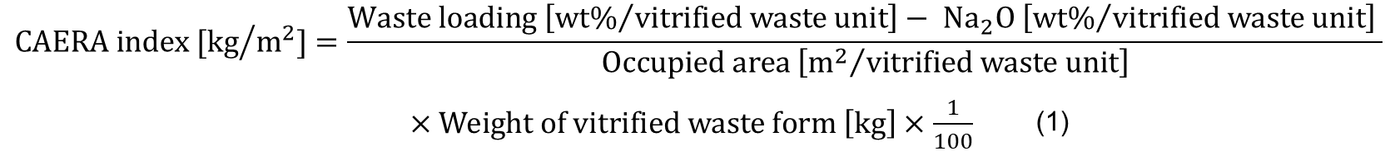

Results and discussions

Effects of MA separation on the surface temperature of buffer material in a geological repository
The results obtained by thermal analysis are shown in Fig. 1. The restricted temperature was set as 100$℃$ as mentioned above. This study is assuming vertical emplacement for spent UO₂ and spent MOX disposal with high-waste-loading to investigate the possibility of expansion of the repository capacity without significant increase in the environmental impacts, therefore, taking this restriction of temperature into consideration was necessary.
Fig. 1 (a) shows the time course of buffer surface temperature in case the disposal of vitrified waste form from 50, 100-years-cooled UO₂ SF with 30wt% waste loading. The temperature amounted to 150$℃$ around 400 years after disposal in case of 50- and 100-year-cooled SF with 0% of MA separation, and it is below 100$℃$ after 70% and 90% of MA separation. This shows that MA contributes to the heat generation rate after 400 years of disposal and separation of MA more than 70% is effective to reduce the heat generation rate. This case reveals that it is impossible to dispose of the vitrified waste without MA separation even after 100 years of cooling with high-waste-loading due to the decay heat from ²⁴¹Am, and decay heat removal by 70% of MA separation would be effective to reduce the temperature of the buffer material. 90% of MA separation contributes to a further reduction of the heat generation rate. Fig. 1 (b) shows the result in the case of 50, 100-year-cooled spent MOX fuels with 25wt% waste loading. The maximum temperature of the buffer material surface was 669$℃$ for 50-year-cooled spent MOX fuel case. In contrast, the maximum temperature of the buffer material surface was 153℃ for 50-year-cooled spent UO₂ fuels with 30wt% waste loading. It is obvious that its heat generation rate is significantly higher than that of UO₂ although reducing 5wt% of waste loading compared to UO₂ fuels. This suggests that unlike spent UO₂ fuels, the surface temperature of buffer material will not go below 100$℃$ even if 90% of MA separation for spent MOX fuels. Therefore, when considering high-waste-loading vitrified waste from spent MOX fuels, estimation of MA separation more than 90% is necessary or consideration of less loading vitrified waste is needed.

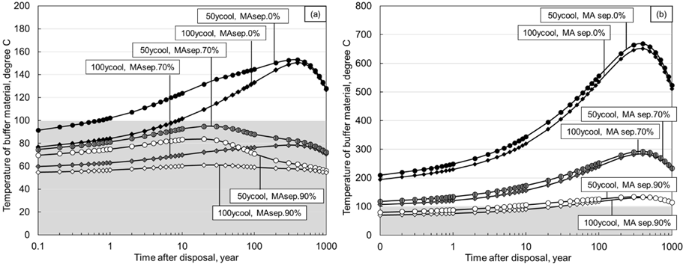
FIG. 1. Temperature of buffer material around the vitrified waste form: (a) UO₂ 30wt% waste loading (50, 100 years cooling), (b) MOX 25wt% waste loading (50, 100 years cooling)

Effects of MA separation on waste occupied area reduction
The heat generation rate and buffer material surface temperature were reduced by MA separation as shown in SECTION 3.1. However, the effects of the waste occupied area of the geological disposal cannot be determined by the results. Therefore, heat transfer calculations were conducted assuming 5 different waste occupied area: (1) 44.4m², (2) 75m², (3) 100m², (4) 200m², (5) 300m². Fig. 2 shows the results for both spent UO₂ and MOX fuels. Since UO₂ fuel and MOX fuels characteristics are different, the result of 4-year-cooled spent MOX fuels with 16wt% with no-MA separation was set as a reference case to discuss the results of spent MOX fuels (Figs. 2(c) – 2(e)). For this reference case for spent MOX fuels, the minimum waste occupied area was calculated as 125m². Fig. 2 (a) shows that 70% of MA separation is effective to reduce the heat generation of the vitrified waste and waste occupied area for spent UO₂ fuels with 25, 35wt% of waste loading except for the case of 70% of MA separation with 50-year-cooled. Fig. 2 (b) shows that 70% of MA separation is effective to reduce the heat generation amount of vitrified waste and waste occupied area for all the cases, and it reveals that all cases were possible for geological disposal. Fig. 2 (c) shows that 70% of MA separation was not effective enough to minimize the waste occupied area. 90% of MA separation was effective to reduce the heat generation. However, it was still not effective enough to minimize the waste occupied area since 3 evaluation points which showed the lower temperature than restriction showed 100, 200, and 300 m² which were larger than the reference case (44.4 m²). Fig. 2 (d) shows that 70% of MA separation was still not effective enough with 100-year-cooled spent MOX fuels to enable its disposal with the minimized waste occupied area. 90% of MA separation was effective to reduce the heat generation, however, still not effective enough to minimize the waste occupied area. Therefore, we conclude that MA separation higher than 90% is needed to expect the reduction effect of the waste occupied area for spent MOX fuels. Fig. 2 (e) shows the result of lower-waste-loading vitrified waste by considering MA separation. It revealed that 70-90% of MA separation was effective to reduce the heat generation of the vitrified waste and waste occupied area. The minimum waste occupied area was 44.4m² in case of 90% of MA separation.

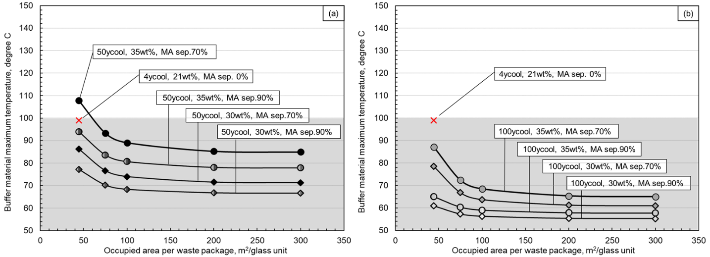

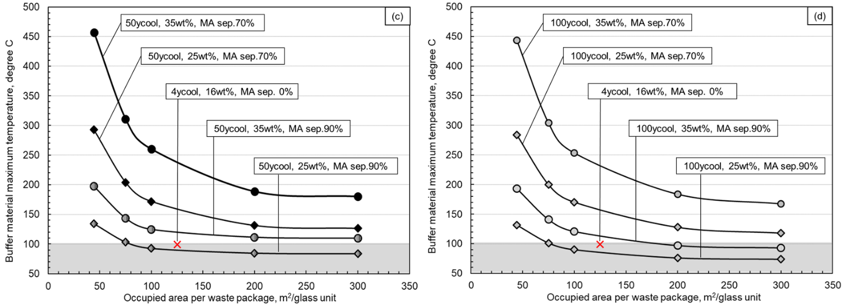

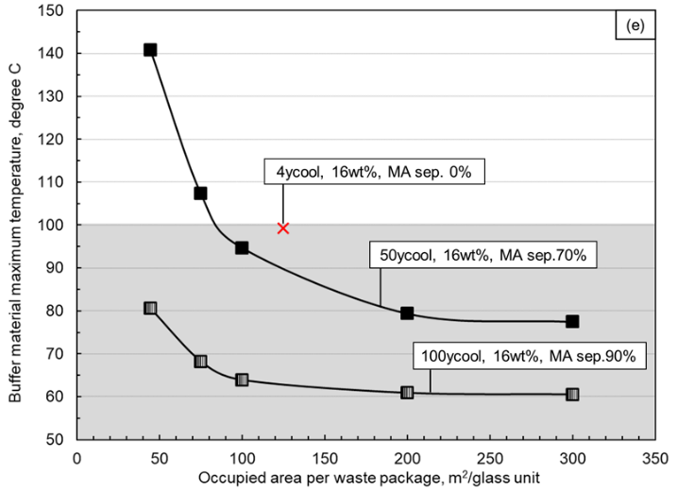
FIG. 2. Relationship between the maximum temperature of buffer material and waste occupied area per waste package: (a) UO₂ SF - 30, 35wt.% waste loading (50 years cooling), (b) UO₂ SF - 30, 35wt% waste loading (100 years cooling), (c) MOX SF - 25, 35wt.% waste loading (50 years cooling), (d) MOX SF – 25, 35wt.% waste loading (100 years cooling), (e) MOX SF - 16wt.% waste loading (50, 100 years cooling)

Effects of MA separation on waste occupied area reduction evaluated by CAERA index
To compare the reduction effect to waste occupied area between various scenarios, CAERA index was introduced. Fig. 3 shows the impact of the MA separation ratio on the geological disposal area in the case of 50- or 100-year-cooled spent UO₂ fuels with high-waste-loading. The CAERA index reached its maximum with 90% of MA separation of 50-year-cooled SF and with 70% of MA separation of 100-year-cooled SF as shown in Fig. 3(a). Fig.3(b) shows the reduction effect of waste occupied area based on the result of Fig. 3(a). It was revealed that more than 50% reduction in the waste occupied area can be expected with 70-90% of MA separation.

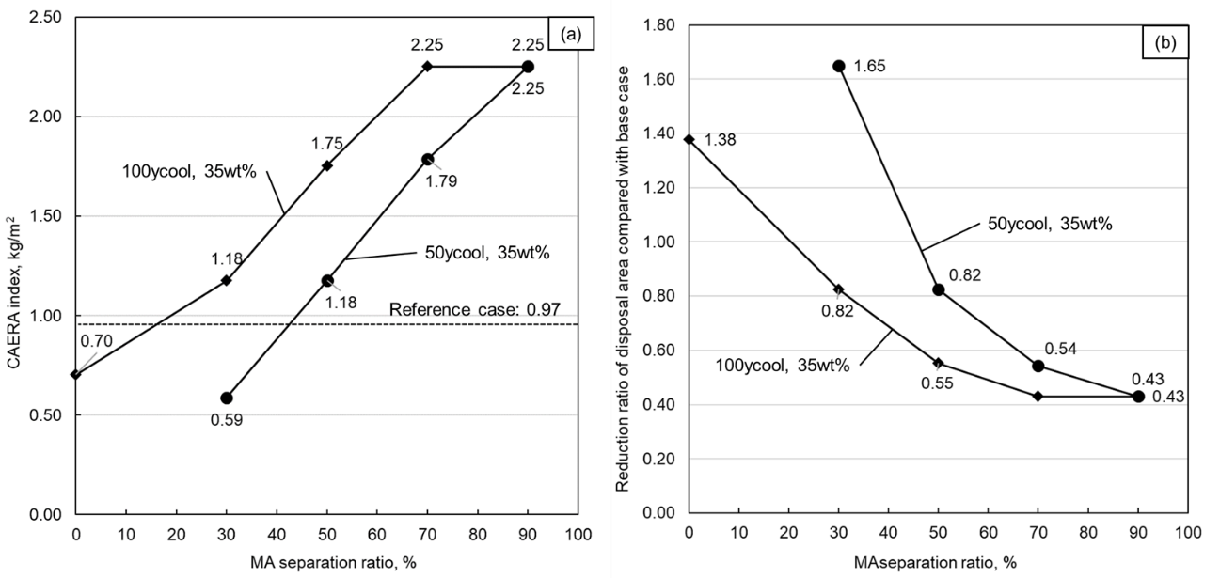
FIG. 3. Effect of MA separation on evaluation with UO₂ SF 35 wt.% of waste loading (50, 100 years cooling period) (a) Relationship between the MA separation rate and CAERA index, (b) Relationship between the MA separation rate and reduction ratio of disposal area.

Fig. 4 shows the impact on the geological disposal of 50 and 100-year-cooled spent MOX fuels with 16 wt% waste-loading. Fig. 4(a) shows that the CAERA index got maximized when 90% of MA was separated from 50- and 100-year-cooled SFs. Fig. 4(b) shows the effect by indexation of the reduction ratio using the reference case (0.97kg/m²) as 1 and it reveals that although 90% of MA separation, it was not sufficiently effective in terms of the reduction ratio of the waste occupied area.

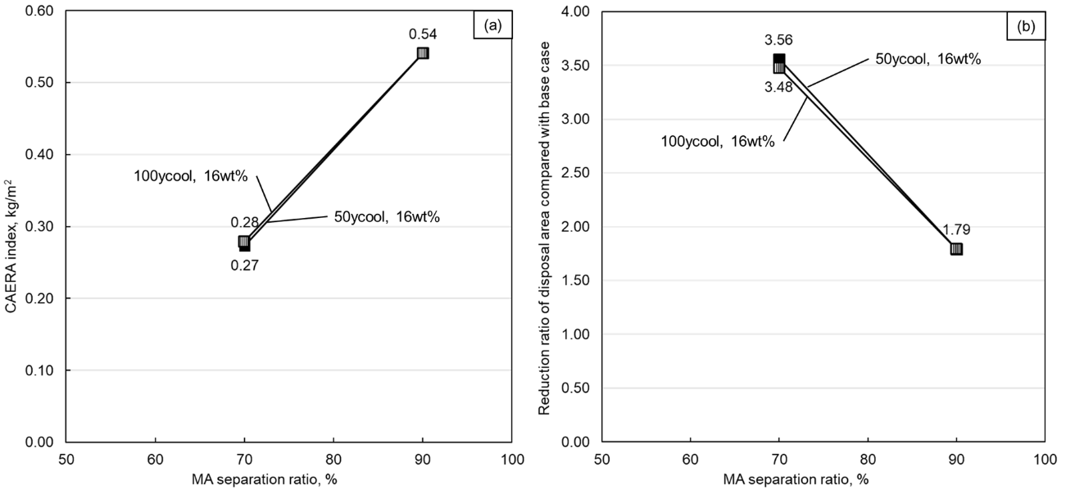
FIG. 4. Effect of MA separation on evaluation with MOX SF 16wt.% of waste loading (50, 100 years cooling period) (a) Relationship between the MA separation ratio and CAERA index, (b) Relationship between the MA separation ratio and reduction ratio of disposal area.

CONCLUSIONS
The effects of MA separation on waste occupied area reduction of spent MOX fuel and spent UO₂ fuels with prolonged cooling period were comprehensively evaluated. For UO₂ fuel with prolonged cooling period, it was revealed that more than 50% reduction of the waste occupied area can be obtained by 70-90% separation of MA and high-waste-loading. On the other hand, the results showed that introduction of MA separation to spent MOX fuels was not effective enough from the view point of the thermal property of a geological repository for fuels cooled for over 50 years with high-waste-loading vitrified waste like spent UO₂ fuels. It also indicated that for spent MOX fuels, the contribution of MA to the overall heat generation rate is more significant than those of spent UO₂ fuels. These results highlighted that UO₂ fuel and MOX fuel are different in its isotopic composition and heat generation rate, that was difficult to be directly compared according to the waste occupied area. Therefore, further discussion toward disposal would be needed to evaluate the reduction effect of the waste occupied area for realistic discussion toward MOX fuel disposal.

Illustration of the potential effects of various conditions such as fuel type, SF cooling period, weight loading and MA separation affects environmental load reduction on the nuclear fuel cycle by the introduction of CAERA index was successful. This study has the potential to apply to the safety assessment and combination with potential radiotoxicity estimation can help the development of more sophisticated nuclear fuel cycle in the future.
ACKNOWLEDGEMENTS
This research was supported in part by the Radioactive Waste Management Funding and Research Center (RWMC) and some results of this study were obtained as part of their research program “Study on the effects of advanced nuclear fuel cycle technology to the geological disposal concept”. Discussions with them have been particularly fruitful and thank you for helpful discussions.

References
- Oigawa H, Yokoo T, Nishihara K, et al. Parametric survey for benefit of partitioning and transmutation technology in terms of high-level radioactive waste disposal. J Nucl Sci Technol. (2007); 44:398–404.
- Liang F, Liu X. Analysis on the characteristics of geologic disposal waste arising from various partitioning and conditioning options. Ann Nucl Energy. (2015); 85:371–379.
- Inagaki Y, Iwasaki T, Sato S, et al. LWR high burnup operation and MOX introduction; fuel cycle performance from the viewpoint of waste management. J Nucl Sci Technol. (2009); 46:677–689.
- Second Progress Report on Research and Development for the Geological Disposal of HLW in Japan; H12 Project to Establish the Scientific and Technical Basis for HLW Disposal in Japan, Supporting Report 2: Repository Design and Engineering Technology, JNC TN1410, 2000-003, JNC, Japan (2000)
- Ludwig, S.B.; Croff, A.G. (2002) “Revision to ORIGEN2 – Version 2.2”, Transmittal memo of CCC-371/17, Oak Ridge National Laboratory. doi: (2001); 10.1044/1059-0889
- COMSOL. (2016) COMSOL Multiphysics 5.2a, Heat Transfer Module, COMSOLAB: Stockholm.
- Okumura, K.; Sugino, K.; Kojima, K.; Jin, T.; Okamoto, T.; Katakura, J. A set of ORIGEN2 cross section libraries based on JENDL4.0: ORILIBJ40, JAEA-Data /Code 2012-032, Japan Atomic Energy Agency. (2013)
- Kawai, K.; H.Sagara, K.Takeshita, et al. High burn-up operation and MOX burning in LWR; Effects of burn-up and extended cooling period of spent fuel on vitrification and disposal. J Nucl Sci Technol. (2018); 55:1130–1140.
- Japan Nuclear Cycle Development Institute. Second progress report on research and development for the geological disposal of HLW in Japan. H12 project to establish the scientific and technical basis for HLW disposal in Japan, supporting report 3: safety assessment of the geological disposal system, Report no. JNC TN1410 2000-004, Japan: Japan nuclear cycle development institute. (2000)
- Okamura T, Kawai K, Minari E, et al. Effect of Cs and Sr separation on occupied area reduction in current nuclear energy system and its evaluation by CAERA index. Separation Science and Technology. (2018); Published online
- Kawai K. Establishment of back-end systems for load reduction of geological repository. Ph. D. thesis, Tokyo Institute of Technology. (2018)

