Reduction of geological disposal area by introducing partitioning technologies under conditions of high burn-up operation and high content vitrified waste
TOMOHIRO OKAMURA
Laboratory for Advanced Nuclear Energy, Institute of Innovative Research,
Tokyo Institute of Technology
2-12-1 Ookayama, Meguro-ku, Tokyo, 152-8550, Japan
Email: okamura.t.ae@m.titech.ac.jp

ERIKO MINARI⁽¹⁾, MASAHIKO NAKASE⁽¹⁾, HIDEKAZU ASANO^{(1,2)} and KENJI TAKESHITA⁽¹⁾
⁽¹⁾ Laboratory for Advanced Nuclear Energy, Institute of Innovative Research,
Tokyo Institute of Technology
2-12-1 Ookayama, Meguro-ku, Tokyo, 152-8550, Japan
⁽²⁾ Radioactive Waste Management Funding and Research Center
Nichirei Akashicho Bldg. 12F, 6-4, Akashicho,Chuo-ku, Tokyo, 104-0044, Japan
Email: asano@rwmc.or.jp

Abstract

The thermal properties and amount of vitrified waste are major factors that determine the eventual disposal area of high-level radioactive waste deep underground. The effect of high burn-up operation of a light-water reactor with UO₂ fuel on the amount and thermal properties of vitrified waste under various nuclear fuel cycle conditions was discussed. In addition, the effect of Cs and Sr separation and high-content vitrified waste on reducing the waste-occupied area, which may affect the geological disposal area, under high burn-up conditions was quantitatively evaluated by using the Comprehensive Analysis of Effects on Reduction of disposal Area (CAERA) index. The fuel burn-up had a limited effect on the amount of vitrified waste. Furthermore, the contribution to the heat generation rate of vitrified waste for high burn-up conditions of ¹³⁷Cs, ⁹⁰Sr, and their daughter nuclides, which have relatively short half-lives, increased and contribution of ²⁴¹Am, which has a longer half-life, decreased. Therefore, high burn-up conditions reduced the waste-occupied area via Cs and Sr separation, and the maximum effect was a reduction of 74% of the waste-occupied area with a fuel burn-up of 70 GWd/tHM, 4-year spent fuel (SF) cooling period, 90% Cs and Sr separation, and 30 wt % vitrified waste loading. The results suggested that fuel burn-up, SF cooling period, partitioning technology, and vitrified waste loading are important for the geological disposal area, and it is necessary to consider the combination of these conditions for reducing the geological disposal area.

INTRODUCTION
According to Japan’s 5th Strategic Energy Plan in 2018 [1], nuclear power generation is planned to provide the base load power supply in Japan. Japan’s basic policy for nuclear energy use is based on the nuclear fuel cycle; thus, it is essential to develop and sophisticate the nuclear fuel cycle. However, when constructing the nuclear fuel cycle and sustaining nuclear energy use, it is necessary to dispose of a large amount of high-level radioactive waste (HLW). Therefore, the reducing geological disposal area and amount of HLW are required. The thermal properties and amount of vitrified waste are two major factors that determine the emplacement of the waste packages and the eventual disposal area deep underground. These two factors, in turn, depend strongly on the radionuclide inventories contained in the HLW. The inventories mainly depend on the nuclear fuel cycle conditions, which are the fuel burn-up, the spent fuel (SF) cooling period, partitioning technologies used in reprocessing, and the vitrified waste loading. Therefore, it is necessary to evaluate comprehensively and quantitatively how these conditions affect the thermal characteristics and the amount of vitrified waste generated. In particular, evaluating the effect of fuel burn-up for HLW disposal is important for improving the economic efficiency and fuel utilization rate.
In this study, we quantitatively investigated the impact on the thermal properties and amount of vitrified waste of high burn-up operation of a light-water reactor with UO₂ fuel under various fuel cycle conditions. In addition, we assumed that Cs and Sr separation processes and high-content vitrified waste were used for the current nuclear fuel cycle to reduce the amount of HLW and geological disposal area. The effect of Cs and Sr separation and high-content vitrified waste under high burn-up conditions on geological disposal area was also discussed by using Comprehensive Analysis of Effects on Reduction of disposal Area (CAERA) index.

Calculation method and conditions

Fuel burn-up conditions
The reactor operating conditions are shown in TABLE 1. The fuel burn-up, nuclide generation in SF, decay heat generation rate, reprocessing, and partitioning were calculated with Origen 2.2-upj [2], and the cross section libraries were based on JENDL-4.0 [3]. The fuel was UO₂ and its enrichments were assumed to be 4.5 and 6.5 wt % for burn-up rates of 45 and 70 GWd/tHM, respectively. The fuel was burned assuming a burn-up rate of 38 MW/tHM for 1184 and 1842 days in a 17 × 17 pressurized water reactor assembly. Fuel shuffling in the reactor operation was not considered.

TABLE 1. CALCUATION CONDITIONS FOR REACTOR OPERATION

Reactor operation | Fuel burn-up, GWd/THM | 45 | 70
 | Specific power, MW/THM | 38
 | Operation period, days | 1184 | 1842
 | Enrichment, wt% | 4.5 | 6.5

Reprocessing and partitioning conditions
The reprocessing conditions were assumed to be those for a typical PUREX process after several years of SF cooling. During reprocessing, 99.6% of U, 99.5% of Pu, and 100% of volatile elements, such as H, C, I, Cl, and noble gases (He, Ne, Ar, Kr, Xe, and Rn) were removed (TABLE 2) [4]. The high-level liquid waste (HLLW) was regarded as the residue after reprocessing. The reference case and present [5] case were studied as follows and these conditions are compared in TABLE 3.
(1) Reference case: the SF after discharge was reprocessed after a 4-year cooling period and no partitioning.
(2) Present study: the SF was reprocessed after a 4- to 50-year SF cooling period. It was assumed that 70% of Mo and PGM (Ru, Rh, and Pd) were separated from HLLW to satisfy the upper limit of MoO₃ and PGM loading in HLW to maintain the quality of vitrified waste and stable operation of the glass melter. In addition, the Cs and Sr separation from HLLW was assumed to be 90%. The separated elements were assumed to be immobilized and disposed of deep underground. However, the disposal area was not considered.

TABLE 2. CALCULATION CONDITIONS FOR REPROCESSING AND VITRIFICATION

Reprocessing | U, % | 99.6
 | Pu, % | 99.5
 | H, C, I, Cl, Noble gas, % | 100
Vitrification | Glass weight, kg/unit | 400
 | Na₂O content, kg/unit | 10
 | Heat generation rate, kW/unit | ≦ 2.3
 | MoO₃ content, wt% | ≦ 1.50
 | PGM content, wt% | ≦ 1.25

TABLE 3. COMPARISON OF SETTINGS FOR REFERENCE CASE AND PRESENT CASE

Event | Factor | Reference case | Present work
Reactor operation | Fuel burn-up, GWd/THM | 45 | 45 and 70
Reprocessing | Cooling period of SF, years | 4 | 4 and 50
 | Mo separation ratio, % | 0 | 70
 | PGM separation ratio, % | 0 | 70
 | Cs・Sr separation ratio, % | 0 | 0 to 90
Vitrification | Waste loading, wt% | 20.8 | 15 to 35
Geological Disposal | Waste occupied area, m²/vitrified waste unit | 41.7 | 13.9 to 300

Vitrification conditions
The vitrification conditions and requirements were as follows (TABLE 3).
(1) The weight of vitrified waste was assumed to be 400 kg.
(2) The loading of sodium oxide (Na₂O) was 10 wt % (corresponding to 40 kg) in the vitrified waste to maintain the appropriate viscosity of the melted glass in vitrification.
(3) The upper limit of the heat generation rate of the vitrified waste was assumed to be less than 2.3 kW per vitrified waste unit, consistent with the current requirement of Japan’s interim storage facility [6].
(4) The upper limits of the MoO₃ and PGM loading in vitrified waste were assumed to be less than 1.5 and 1.25 wt %, respectively, to prevent yellow phase formation in the vitrified waste and deposition of PGM in the bottom nozzle of the glass melter [7-9].
(5) The vitrified waste was assumed to be stored for 50 years after vitrification to reduce the heat generation rate of vitrified waste before disposal.

Geological disposal conditions
The geological disposal site and the thermal analysis were modeled with COMSOL Multiphysics code [10]. The analytical model used horizontal emplacement of the vitrified waste in crystalline rock (hard rock), as proposed elsewhere [11]. The initial temperature, geothermal temperature gradient and thermal conductivity of the materials in the analytical model have been used elsewhere [12].
The area required for disposing of one unit of vitrified waste is called the waste-occupied area, expressed by the product of the disposal tunnel spacing (xD) and waste package pitch (y). In addition, the waste-occupied area should be set to satisfy the upper temperature limit of the bentonite buffer material. In this study, the upper temperature limit was 100 °C, as used in Japan’s geological disposal programs [5], and the disposal tunnel spacing, waste package pitch, and waste-occupied area were calculated at a buffer temperature of 100 °C. The upper temperature limit of buffer, 100℃ was conservatively assumed as temperature of illitization of bentonite which is the main component of buffer. The reason is that the performances such as water sealing property and adsorption property of nuclides required for buffer are decreased by illitization. In the reference case, the waste-occupied area was 41.7 m²/glass unit (xD of 13.3 m × y of 3.13 m) for the horizontal emplacement configuration.

CAERA index
The CAERA index was introduced to evaluate the effect of waste-occupied area reduction under various nuclear fuel cycle conditions [13, 14]. The CAERA index was defined as
$${kg}/{m^{2}}=\frac{Waste loading [{wt \%}/{glass unit]} -{ Na}_{2}O [{wt \%}/{glass unit]}}{Waste occupied area [{m^{2}}/{glass unit]}}$$
$×Weight of vitrified waste \left[kg\right]×\frac{1}{100}$ (1)
This index has been used to evaluate the relationship between the effect of waste-occupied area reduction and partitioning technology in the nuclear fuel cycle quantitatively by comparison with a reference case [15, 16]. In this study, the CAERA index of the reference case was calculated as 1.04 kg/m² for a waste-occupied area of 41.7 m² and a vitrified waste loading of 20.8 wt %.

ResultS and Discussion

Effect of high burn-up operation on the amount of vitrified waste
Fig. 1 shows the relationship between fuel burn-up and the amount of vitrified waste for 4 and 50-year SF cooling and a vitrified waste loading of 20.8 wt %. The amount of vitrified waste per ton of SF (glass unit/tHM) and fuel burn-up (glass unit/GWd) are shown in Figs. 1 (a) and (b), respectively. The amount of vitrified waste per metric ton of heavy metal increased with fuel burn-up, whereas the amount of vitrified waste per gigawatt day did not change with fuel burn-up. The same trend was reported by Inagaki et al. in a similar study [17].

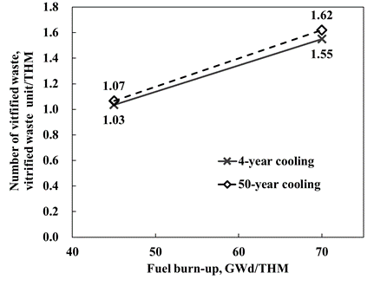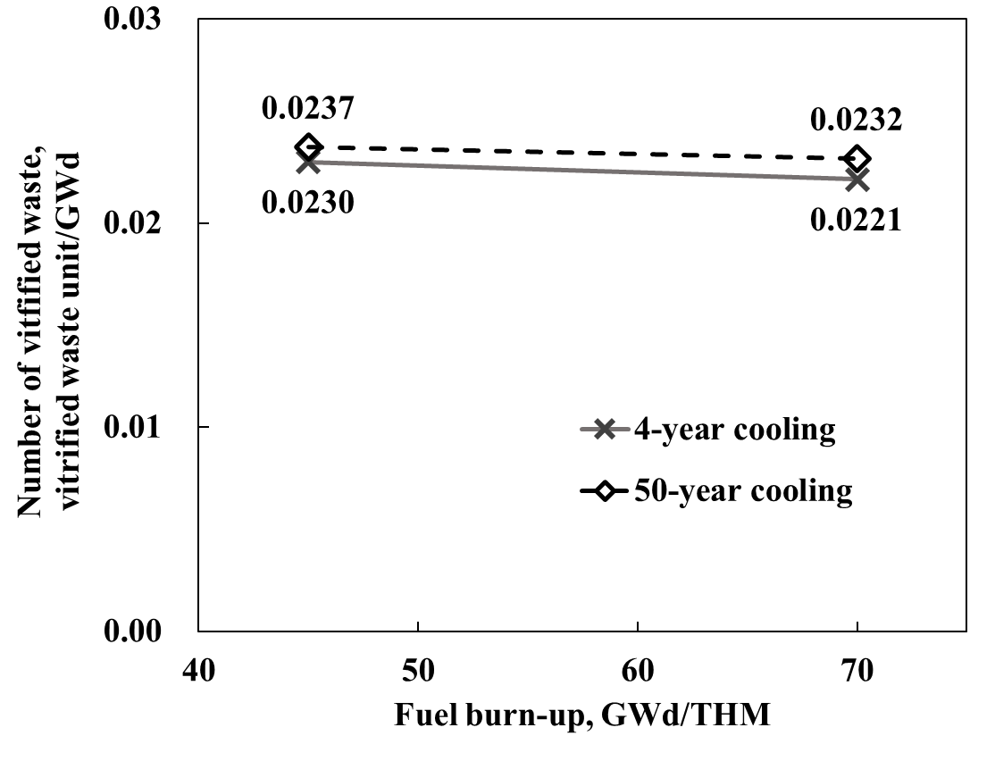
(a)
(b)
FIG. 1. Amount of vitrified waste units per (a) metric ton of heavy metal and (b) gigawatt day (SF cooling period: 4 and 50 years; waste loading: 20.8 wt %).

Effect of high burn-up operation on thermal properties of vitrified waste
Fig. 2 (a) and (b) show the heat generation of vitrified waste as a function of time from just after vitrification to disposal and after disposal, respectively, for 4- and 50-year SF cooling and 20.8 wt % waste loading. The heat generation rates of vitrified waste from just after vitrification to disposal (Fig. 2 (a)) and just after disposal (Fig. 2 (b)) were reduced by extending the SF cooling period. In contrast, more than 10 years after disposal, the heat generation rate of vitrified waste was higher for the 50-year SF cooling period than for the 4-year SF cooling period. According to Okamura et al. [15], this is because although the contribution of ¹³⁷Cs (t_{1/2} = 30.1 years), ⁹⁰Sr (t_{1/2} = 29.8 years), and their daughter nuclides to the heat generation rate of vitrified waste was decreased by the prolonged SF cooling period, the contribution of ²⁴¹Am (t_{1/2} = 432 years), which has a longer half-life than ¹³⁷Cs and ⁹⁰Sr, was increased.
The heat generation rate was not changed by high fuel burn-up for 4-year SF cooling (Fig. 2 (b)). However, for 50-year SF cooling, the heat generation rate for a fuel burn-up of 70 GWd/tHM was lower than that for 45 GWd/tHM. Fig. 3 shows the contributions of ¹³⁷Cs, ⁹⁰Sr, ^{137m}Ba, ⁹⁰Y, ²⁴¹Am, and other nuclides to heat generation immediately after disposal (50 years after vitrification) for 4-year SF cooling. The contribution of each nuclide to heat generation was different, although the total heat generation was similar. For 70 GWd/tHM, the contribution of ¹³⁷Cs, ⁹⁰Sr, and their daughter nuclides was larger and that of ²⁴¹Am was smaller than for 45 GWd/tHM. Fig. 4 (a) and (b) show the contribution of each nuclide to the heat generation rate as a function of the time period after disposal at fuel burn-up rates of 45 and 70 GWd/tHM, respectively. The contribution of each nuclide to the heat generation rate was different for each fuel burn-up rate. In addition, the contribution of ¹³⁷Cs, ⁹⁰Sr, and their daughter nuclides was still larger and that of ²⁴¹Am was smaller for the high burn-up conditions. Therefore, the contribution of ¹³⁷Cs and ⁹⁰Sr to the heat generation rate was higher under high burn-up conditions.
Fig. 5 shows the amount of ²⁴¹Am per gigawatt day in SF as a function of time after discharge from reactor for fuel burn-ups of 45 and 70 GWd/tHM. The formation path of ²⁴¹Am is

$${}_{}^{238}U(n, γ){}_{}^{239}U→{}_{}^{239}{Np}→{}_{}^{239}{Pu}\left(n, γ\right){}_{}^{240}{Pu}\left(n, γ\right){}_{}^{241}{Pu}→{}_{}^{241}{Am}$$

The amount of ²⁴¹Am was affected by ²³⁵U enrichment, based on the formation path of ²⁴¹Am and the lower weight of both nuclides at 70 GWd/tHM than at 45 GWd/tHM. In this study, the enrichment was increased to model high burn-up. The ²³⁸U content, which is the starting nuclide for ²⁴¹Am in fresh fuel, decreases with increasing fuel burn-up; thus, the amount of ²⁴¹Am should also decrease. Moreover, ¹³⁷Cs and ⁹⁰Sr, which are fission products, are produced more frequently under high burn-up conditions. Therefore, the ¹³⁷Cs and ⁹⁰Sr loading in vitrified waste increased and the contribution of these nuclides to heat generation of vitrified waste increased with fuel burn-up.

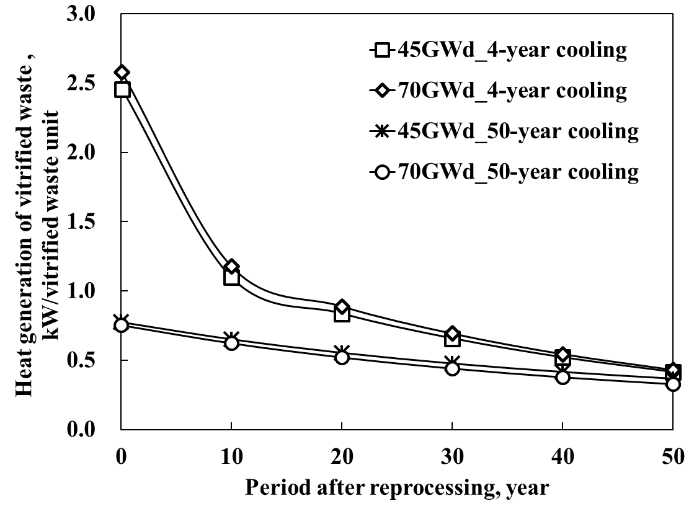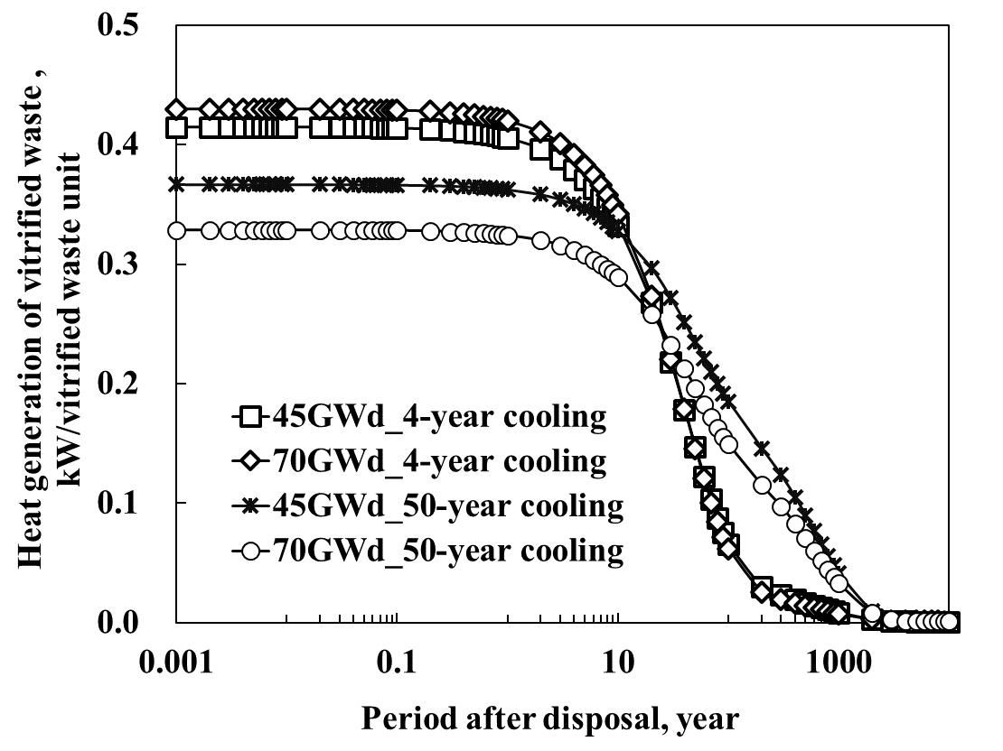
(b) Period after disposal
FIG.2. Time course of heat generation of vitrified waste (4-year and 50-year cooling of SF, Waste loading; 20.8 wt%)
(a) Period after reprocessing until disposal

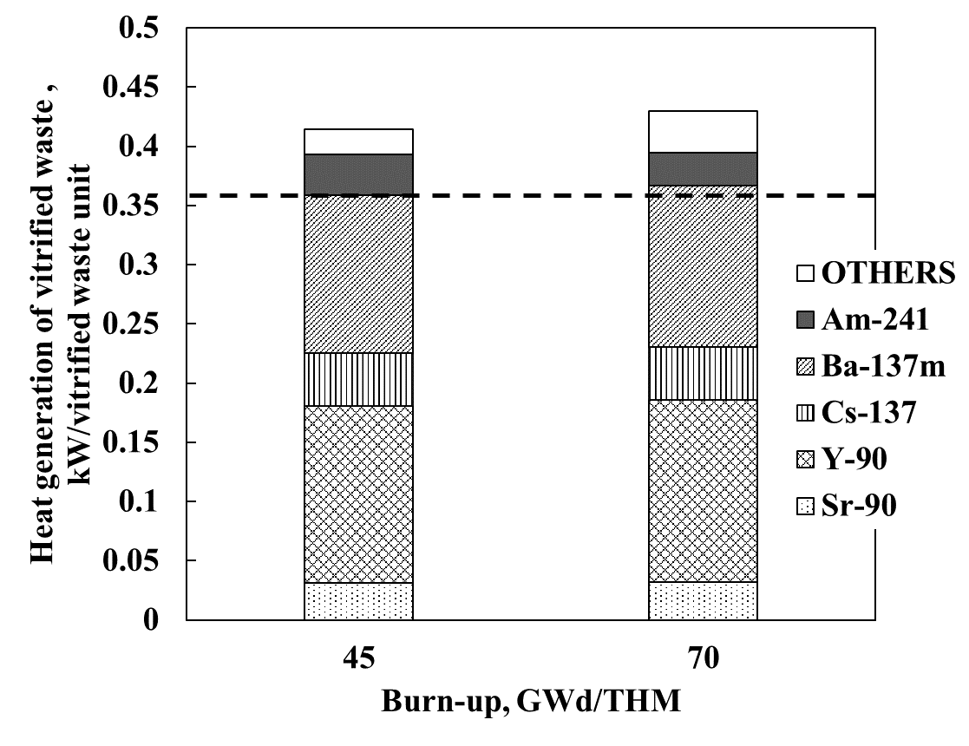
FIG. 3. Contribution of each nuclide to heat generation at disposal at fuel burn-ups of 45 and 70 GWd/tHM (SF cooling period: 4 years; waste loading: 20.8 wt %).

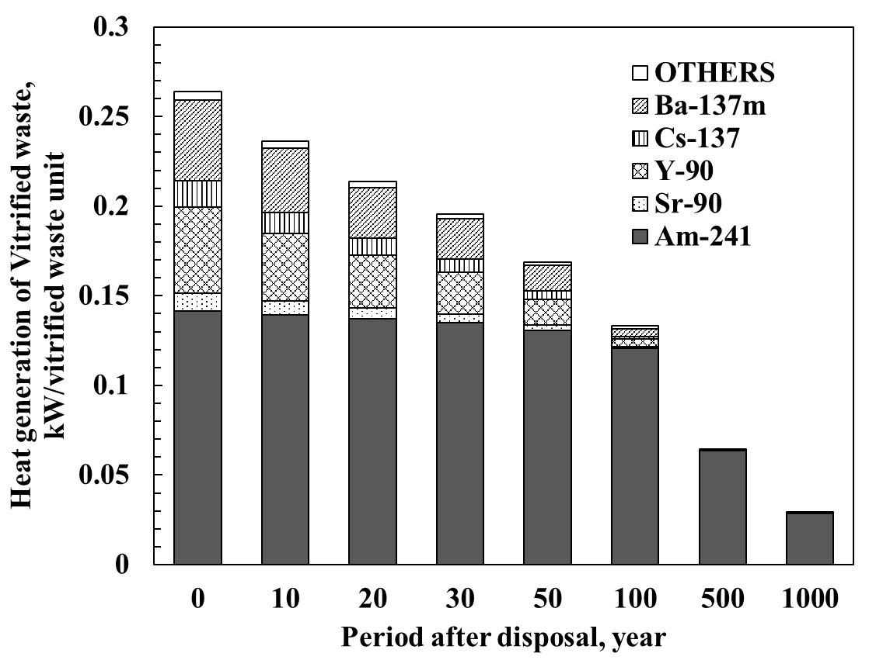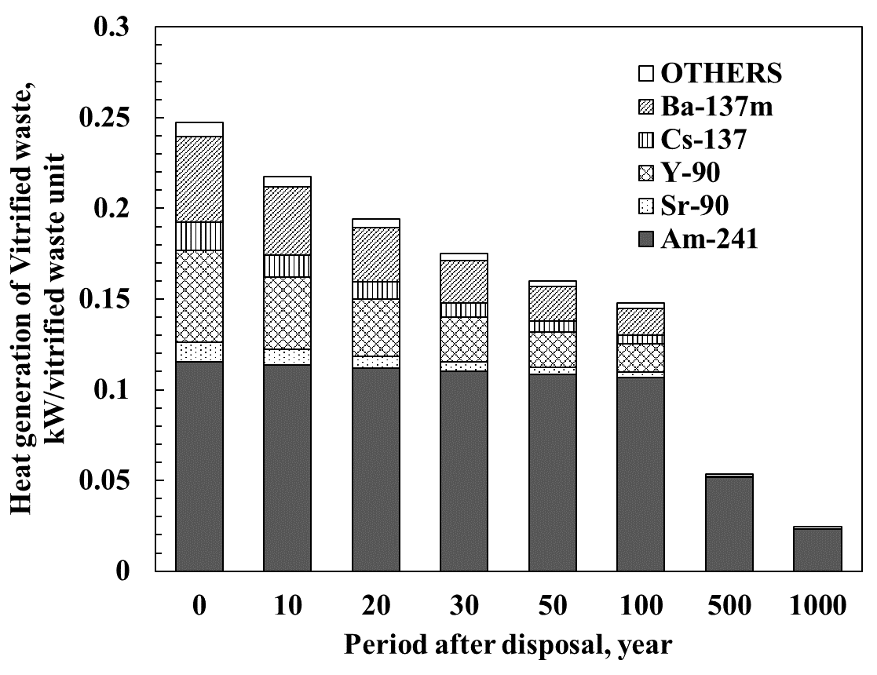
FIG. 4. Contribution of each nuclide to heat generation at fuel burn-ups of (a) 45 and (b) 70 GWd/tHM (SF cooling period: 50 years; waste loading: 20.8 wt %).
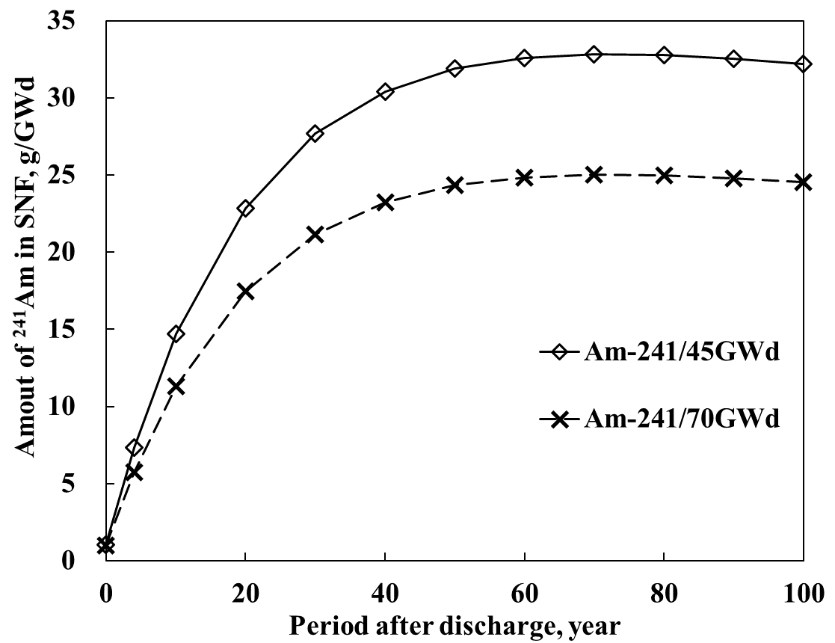
FIG. 4. Time course of amount of ²⁴¹Am in SF at fuel burn-ups of 45 and 70 GWd/tHM.

Effect of waste loading and Cs and Sr separation on waste-occupied area reduction
The effect of high burn-up operation on the amount of vitrified waste and thermal properties of vitrified waste is summarized as follows.
(1) The amount of vitrified waste is not changed substantially.
(2) The contribution of ¹³⁷Cs, ⁹⁰Sr, and their daughter nuclides to the heat generation rate is increased and the contribution of ²⁴¹Am is decreased.
(3) The contribution of ¹³⁷Cs, ⁹⁰Sr, and their daughter nuclides to the heat generation rate is reduced and the contribution of ²⁴¹Am is increased by extending the SF cooling period.
(4) It has been reported that the amount of vitrified waste can be reduced by increasing the vitrified waste loading [15].
Based on these results, we investigated the effect of introducing Cs and Sr separation and high-content vitrified waste on the CAERA index for high burn-up operation and shorter SF cooling period. Fig. 5 shows the relationship between vitrified waste loading and CAERA index for different fuel burn-ups for 4-year SF cooling and 90% Cs and Sr separation. The CAERA index was increased by Cs and Sr separation. For higher waste loading than the reference case, a substantially higher CAERA index was obtained. High burn-up operation at a burn-up of 70 GWd/tHM had a larger CAERA index than at 45 GWd/tHM. A maximum CAERA index of 4.00 kg/m² was achieved for a fuel burn-up of 70 GWd/tHM and 30 wt % vitrified waste loading. This CAERA index value indicates an approximate reduction of 74% in waste-occupied area compared with the reference case (CAERA index = 1.04 kg/m²). Therefore, high burn-up operation is effective for reducing the waste-occupied area by combining suitable Cs and Sr separation, SF cooling period, and vitrified waste loading conditions.

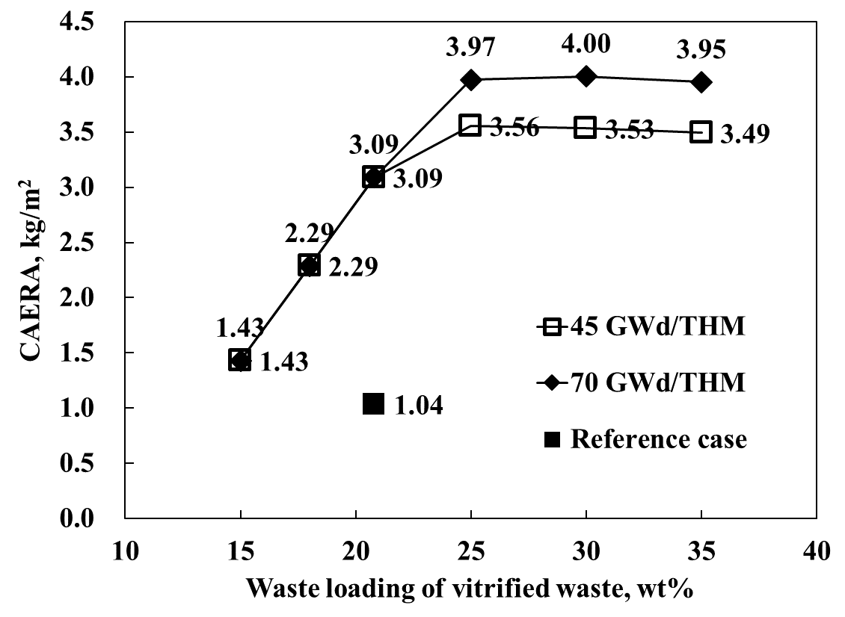
FIG. 5. Effect of Cs and Sr separation and high waste loading on CAERA index for fuel burn-ups of 45 and 70 GWd/tHM (SF cooling period; 4 years; Cs and Sr separation ratio: 90%).

SUMMARY
In this study, we analyzed the effect of high burn-up operation on the amount and thermal properties of vitrified waste. In addition, the effect of introducing Cs and Sr separation and high-content vitrified waste for reducing waste-occupied area was quantitatively evaluated by CAERA index. The conclusions can be summarized as follows.
(1) Increasing the fuel burn-up did not change the vitrified waste per fuel burn-up substantially, although the amount of vitrified waste per ton of SF increased.
(2) High burn-up operation increased the contribution of ¹³⁷Cs, ⁹⁰Sr, ^{137m}Ba, and ⁹⁰Y, and decreased the contribution of ²⁴¹Am to the heat generation rate of vitrified waste.
(3) Increasing the SF cooling period decreased the contribution of ¹³⁷Cs, ⁹⁰Sr, and their daughter nuclides and increased the contribution of ²⁴¹Am to the heat generation rate of vitrified waste.
(4) The waste-occupied area could be reduced by introducing Cs and Sr separation and high-content vitrified waste under high burn-up operation.
(5) Based on results (1)–(4), a maximum reduction in waste-occupied area of 74% could be achieved with 90% Cs and Sr separation, 30 wt % waste loading, and 4-year SF cooling.
Therefore, for high burn-up operation, it is possible to reduce the amount of vitrified waste and geological disposal area by combining suitable SF cooling period, partitioning technology, and vitrified waste loading.

ACKNOWLEDGEMENTS
This research was supported by the Radioactive Waste Management Funding and Research Center (RWMC) and some of the results in this paper were based on the joint research program between RWMC and the Tokyo Institute of Technology, entitled “Study on the effects of advanced nuclear fuel cycle technology to the geological disposal concept”. The author would like to thank Kota Kawai, who made a great contribution to this program.

References
- Agency for Natural Resources and Energy, Ministry of Economy, Trade and Industry, Strategic Energy Plan, July 3rd, (2018)
- Ludwig, S.B., Croff, A.G. “Revision to ORIGEN2 – Version 2.2”, Transmittal memo of CCC-371/17, Oak Ridge National Laboratory. (2002)
- Okumura, K., Sugino, K., Kojima, K., Jin, T., Okamoto, T., Katakura, J. (2013) A set of ORIGEN2 cross section libraries based on JENDL4.0: ORILIBJ40, JAEA-Data/Code 2012-032, Japan Atomic Energy Agency. (2013)
- Ishihara, Y., Makino, H., Ohi, T., Ishiguro, K., Miyahara, K., Umeki, H., Akasaka, H., Fujihara, H., Hashi, Y. Inventory evaluation of high level radioactive vitrified waste, JNC TN8400 99-085. (1999)
- Japan Nuclear Cycle Development Institute. Second progress report on research and development for the geological disposal of HLW in Japan. H12 project to establish the scientific and technical basis for HLW disposal in Japan, supporting report 2: safety assessment of the geological disposal system, Report no. JNC TN1410 2000-004, Japan: Japan nuclear cycle development institute. (2000)
- Japan Nuclear Cycle Development Institute. Second progress report on research and development for the geological disposal of HLW in Japan. H12 project to establish the scientific and technical basis for HLW disposal in Japan, supporting report 3: safety assessment of the geological disposal system, Report no. JNC TN1410 2000-004, Japan: Japan nuclear cycle development institute. (2000)
- Kawai, K., Sagara, H., Takeshita, K., Kawakubo, M., Asano, H., Inagaki, Y., Niibori, Y., Sato, S. High burn-up operation and MOX burning in LWR, effects of burn-up and extended cooling period of spent fuel on vitrification and disposal. Journal of Nuclear Science and Technology, 55: 1130–1140. (2018)
- Kawamura, K., Ohuchi, J. Characterization of highly waste loaded glass for HLW. Materials Research Society Symposium Proceedings, 252: 87–93. (1995)
- Igarashi, H., Kawamura, K., Takahashi, T. Effect of noble metal elements on viscosity and electrical resistivity of simulated vitrified products for high-level liquid waste. Materials Research Society Symposium Proceedings, 257: 169–176. (1992)
- COMSOL. COMSOL Multiphysics 5.2a, Heat Transfer Module, COMSOLAB: Stockholm. (2016)
- Taniguchi, W., Iwasa, K., Thermal analysis in the near field for geological disposal of high-level radioactive waste; Establishment of the disposal tunnel spacing and waste package pitch on the 2nd progress report for the geological disposal of HLW in Japan, Report no. JNC TN8400 99-051, Japan: Japan nuclear cycle development institute (1999).
- Japan Atomic Energy Agency. Improvement of the advanced geological disposal concept and performance assessment technology. Japan, 2013. in Japanese.
- Kawai, K., Okamura, T., Minari, E., Kawakubo, M., Asano, E., Takeshita, K., Technical options of radioactive waste management for the second half of the 21st Century, in consideration of Pu utilization and less environmentally impacted geological disposal; (3) Effects of various nuclear fuel cycle scenarios on property of spent fuel and waste glass, Atomic Energy Society of Japan 2018 Annual Meeting, Osaka, Mar. 26–28 (2018)
- Kawai, K. (2018) Establishment of back-end systems for load reduction of geological repository. Ph.D. thesis, Tokyo Institute of Technology.
- Okamura, T., Kawai, K., Minari, E., Nakase, M., Asano, E., Takeshita, K. Effect of Cs and Sr separation on waste occupied area reduction in current nuclear energy system and its evaluation by CAERA index, Separation and Science and Technology, published online (2019)
- Minari, E., Kawai, K., Okamura, T., Kawakubo, M., Asano, E., Takeshita, K., Technical options of radioactive waste management for the second half of the 21st Century, in consideration of Pu utilization and less environmentally impacted geological disposal; (6) Effects of MA separation on waste occupied area per waste package in the case of extended cooling period of UO₂ spent fuel, Atomic Energy Society of Japan 2018 Annual Meeting, Osaka, Mar. 26–28. (2018)
- Inagaki, Y., Iwasaki, T., Sato, S., Ohe, T., Kato, K., Torikai, S., Niibori, Y., Nagasaki, S., Kitayama, K., LWR high burn-up operation andMOX introduction; fuel cycle performance from the viewpoint of waste management. Journal of Nuclear Science and Technology, 46: 677–689.

