Effective use of ²³⁴U in ThORIUM fuel cycle

MASAHIKO NAKASE, ERIKO MINARI, TOMOHIRO OKAMURA, HIDEKAZU ASANO, HIROSHI SAGARA, MASAKI SAITO and KENJI TAKESHITA
Laboratory for Advanced Nuclear Energy, Institute of Innovative Research,
Tokyo Institute of Technology
2-12-1 Ookayama, Meguro-ku, Tokyo, 152-8550, Japan

Abstract

The Th fuel cycle is attracting interest again globally because of its advantages over the current Pu fuel cycle, such as breeding fissile ²³³U from fertile ²³²Th without using a fast reactor, lower minor actinide production and higher Pu burning. However, there are some concerns, such as the small critical mass of the bred ²³³U. Using ²³⁴U, which is not considered an important isotope, may overcome some problems with the Th fuel cycle. In this study, the effect and roles of ²³⁴U in the Th fuel cycle were surveyed from the perspectives of proliferation resistance (PR), fuel burn-up, and breeding in single and multiple cycles. Increasing the ²³⁴U isotope ratio increases bare critical mass, which in turn increases PR by increasing the heat generation and radiation dose rate from ²³²U and their daughter nuclei. The effects of the moderator-to-fuel ratio, neutron energy spectrum, and neutron flux (linear power density) on criticality were estimated. ²³⁴U was fissile in the faster neutron energy spectrum, which can increase the fuel burn-up under some conditions. A higher fuel burn-up is preferable to increase the ²³⁴U isotopic ratio. For multiple cycles, the breeding ability of ²³⁴U was higher with a softer neutron energy spectrum (33.3% at the end of the fifth cycle), but the mass balance was worse. When ²³⁴U was used with a harder neutron energy spectrum, the ²³⁴U isotopic ratio was as high as 23.6%, but the mass balance was better. The role of ²³⁴U in Th has not been thoroughly investigated until now, but this study has revealed the importance of ²³⁴U, which may lead to the development of a new Th fuel cycle.

INTRODUCTION
Despite the Fukushima Daiichi nuclear disaster, nuclear energy is still important due to environmental concerns and increasing energy demand. In Japan, we have been developing a U fuel cycle to ensure energy security. However, the Monju fast breeder reactor has been earmarked for decommissioning, meaning that the energy strategy in Japan will have to be rethought. Consequently, the use of Th is attracting interest again. In the Th fuel cycle, fissile ²³³U is generated from ²³²Th, and the ²³³U recovered from spent nuclear fuels can be used to make new fuels. The Th fuel cycle has some advantages over the U cycle and it is still being developed [1-4]. However, the Th fuel cycle also has problems. For example, ²³³U generated from ²³²Th has a much smaller critical mass, which leads to greater concerns about nuclear proliferation. Therefore, if Th is used in a closed fuel cycle, some countermeasures will be needed. In this research, the use of ²³⁴U, which has not been studied thoroughly in the Th fuel cycle, is investigated from the perspectives of proliferation resistance (PR), higher burn-up, and the controllability of ²³⁴U isotopic ratio in single and multiple cycles. These insights will help to advance the development of a new nuclear fuel cycle. The bare critical masses (BCMs) of ²³³U, ²³⁴U, and ²³⁵U are 15, 150, and 46 kg, respectively. Hence, increasing the ²³⁴U isotopic ratio can make the critical mass larger than that of pure ²³³U, which increases PR. The change in ratio increases the effects of the daughter nuclei of ²³²U, such as ²⁰⁸Tl and ²⁰⁸Pb, on the radiation dose rate and heat emission, which makes U fuel less attractive for malicious use. Furthermore, the Rossi-α, which indicates the intensity of the fission reaction, can also be decreased because the Rossi-α of ²³⁴U is 1/10 that of ²³³U. These observations indicate that the PR should be improved by increasing the ratio of ²³⁴U. Fig. 1 shows the chain reaction of Th fuel. Typically, ²³³U is produced by the chain reaction ²³²Th→²³³Th→²³³Pa→²³³U. This is similar to ²³⁹Pu production in the U-Pu cycle, ²³⁸U→²³⁹U→²³⁹Np→²³⁹Pu. The main difference between the two chains is the half-lives of ²³³Pa and ²³⁹Np. ²³⁹Np decays to ²³⁹Pu with a half-life of 2.35 days. However, the half-life of ²³³Pa to ²³³U is 26.97 days. Therefore, especially at higher neutron fluxes, there should be a considerable amount of ²³³Pa, and then the neutron capture reaction becomes important, and the contribution of the chain reaction ²³²Th→²³³Th→²³³Pa→²³⁴Pa→²³⁴U becomes more substantial. ²³⁴U can absorb neutrons to produce ²³⁵U, which may result in higher fuel burn-up under some conditions. The isotopic ratio of ²³⁴U can also be controlled by adjusting the neutron energy spectrum with the reactor type, core arrangement, and neutron flux. However, the use of ²³⁴U has not been investigated previously. Therefore, the following issues were investigated in this study.
- Effect of ²³⁴U on the critical mass, Rossi−α, and radiation dose rate, which have major effects on PR.
- Controlling the ²³⁴U isotopic ratio in spent fuels by adjusting the neutron energy spectrum and neutron flux.
- Feasibility of a multiple Th cycle.

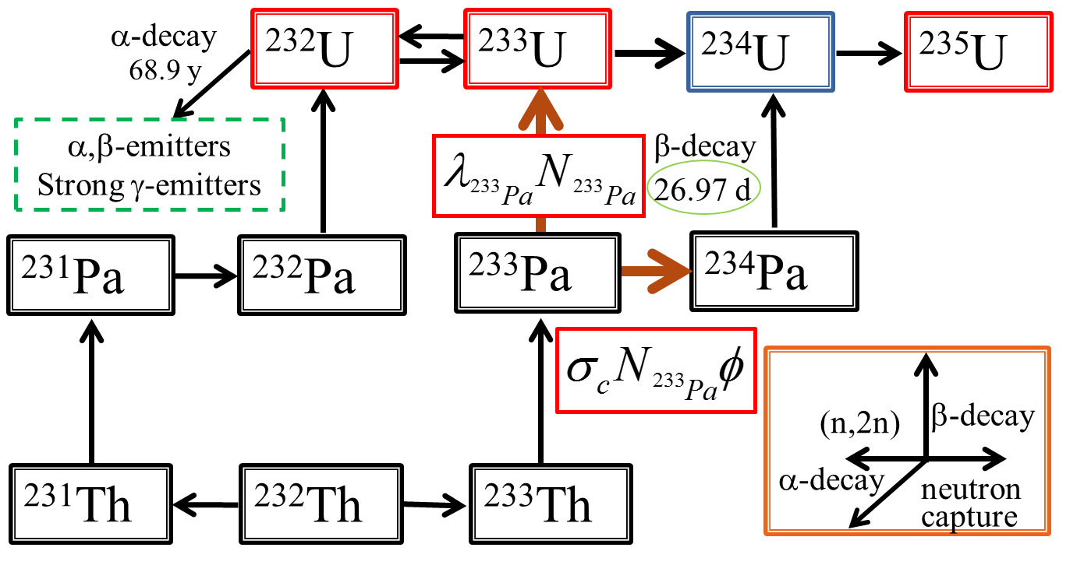

Fig. 1. Chain reaction in the Th fuel cycle and important reactions in this study.

CALCULATION METHOD and conditionS
Fig. 2 shows the pin-cell geometry for the burning calculation. SRAC2006 code was used for the calculations with the collision probability method and JENDL-3.3 as nuclear data (107 groups) [5,6]. The neutron energy spectrum was adjusted by changing the moderator-to-fuel ratio (MFR) from 0.5 to 3.0 (Fig. 2). Water was used as a coolant. In some cases, the density of the coolant was artificially decreased by up to 1/100 to reveal the effect of the neutron energy spectrum. Th oxide fuels with natural zirconium cladding were considered.

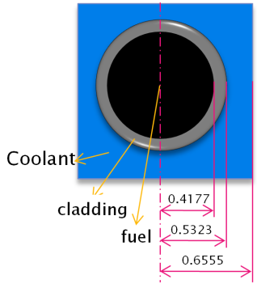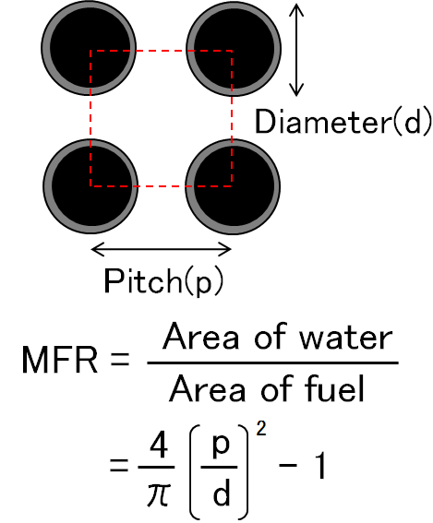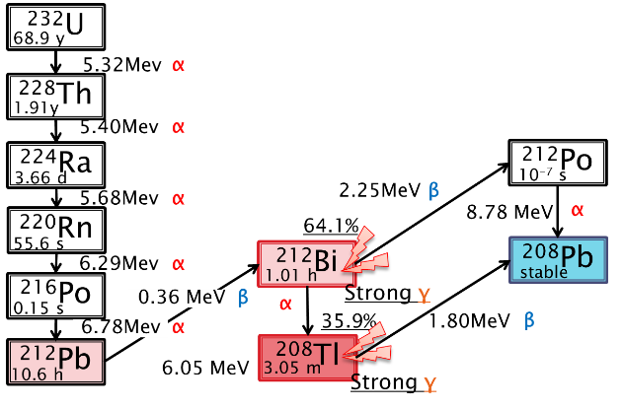
Fig. 2. Calculation geometry and MFR.
Fig. 3. Decay chain considered in the study.

MCNPX and FSXLIBJ-3.3 based on JENDL-3.3 were used for calculating BCM and Rossi-α [7-9]. Equation (1) is the definition of Rossi-α,
(1)
where k_{inf} is the infinite multiplication factor, β is the delayed neutron fraction, and l_{prompt} is the lifetime of a prompt neutron. Rossi-α was normalized with that of ²³³U to see the effect of the ²³⁴U mixture. To calculate the decay heat (Q) and radiation dose rate of the generated U, ²³²U and its corresponding daughter nuclides were considered (Fig. 3). For the heat calculation in equation (2), α and β decays were considered, and for the dose rate calculation in equation (3), γ decay was considered.
(2) (3)
Here, N_{j} is the number of nuclei and N⁰₁ is the initial number of ²³²U nuclei. Energy from γ-decay was not considered for heat generation because γ-rays penetrate the small BCM sphere. The radiation dose rate was estimated based on a literature method [10]. The intensity of the γ-rays was calculated with JENDL-4.0 [11]. Transport calculations of photons were carried out with MCNPX with CNPLIB02, and the photon fluence 1 m from the metallic sphere’s surface was estimated [12]. The correlation constants of the photon-equivalent dose rate reported in ICRP-21 were used to estimate the dose equivalent rate [13]. As reported by the International Atomic Energy Agency (IAEA), when the radiation dose 1 m from the point is above 100 rem/h (for γ radiation, the equivalent dose is 1 Sv/h), the material is self-protecting [14]. Therefore, in this paper, the PR is discussed using the IAEA-INPRO classification based on the radiation dose (TABLE 1).

TABLE 1. EVALUATION OF ATTRACTIVENESS OF RADIOACTIVE MATERIAL BY THE IAEA [9]

Evaluation  Parameter | Evaluation scale
 | VERY WEAK | WEAK | MEDIUM | STONG | VERY STRONG
²³²U conc. in ²³³U (ppm) | < 400 | 400 – 1,000 | 1,000 – 2,500 | 2,500 – 25,000 | > 25,000
Dose at 1 m far from the surface (mSv/h) | < 150 | 150 – 350 | 350 – 1,000 | 1,000 – 10,000 | > 10,000

ResultS and discussion

3.1. Increasing the PR of bred U with ²³⁴U
Fig. 4 shows the effect of the ²³⁴U isotopic ratio on BCM and Rossi-α. The Rossi-α was normalized by that of pure ²³³U. The Rossi-α decreased linearly from 1 to 0.15 and BCM increased non-linearly with the increase in ²³⁴U content. A ²³⁴U isotopic ratio of 30% in U was set as the reference. For the reference case, the Rossi-α was 25% smaller and BCM was 1.5 times larger than for pure ²³³U. The BCM for the reference case was calculated to be only 20 kg, and this indicates that the improvement of PR with respect to BCM was not sufficient.

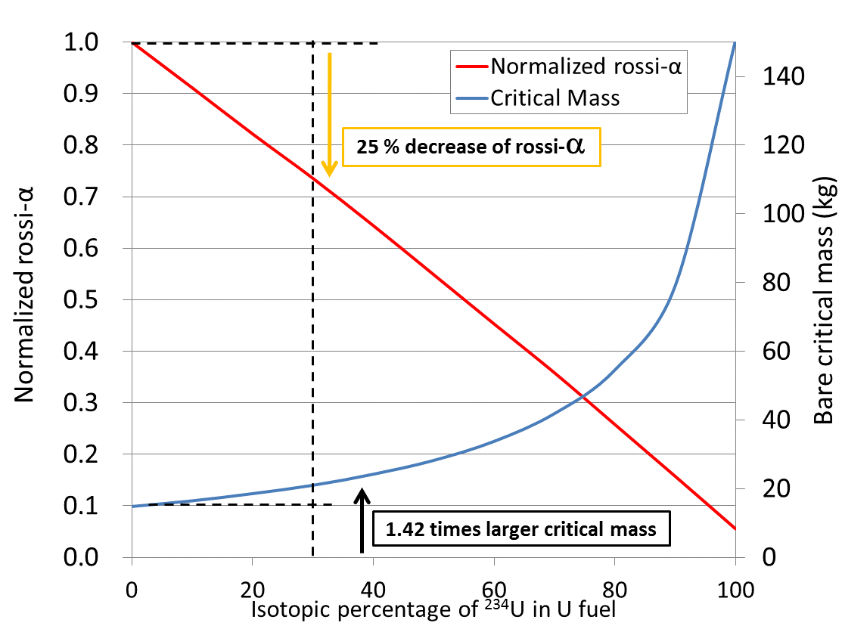
Fig. 4. Effect of ²³⁴U in ²³³U on BCM and Rossi-α.

To estimate the effect of ²³⁴U in U fuels on radiation dose and decay heat, the isotopic ratio of ²³²U was fixed to 0.2% and the ratio of ²³³U and ²³⁴U was varied (TABLE 2). The effect of ²³²U in spent fuels on radiation dose rate has been reported [10]; however, in this study, we considered the effect of ²³⁴U as well.

TABLE 2. ISOTOPIC COMPOSITION FOR BURNING CALCULATION

 |  | A | B | C | D | E | F
Isotopic ratio of ²³³U and ²³⁴U  (²³²U = 0.2 %) | ²³³U | 100 | 90 | 80 | 70 | 60 | 50
 | ²³⁴U | 0 | 10 | 20 | 30 | 40 | 50

The radiation dose rate 1 m from the surface of the BCM sphere and the heat generation are shown in Figs. 5 (1) and (2), respectively. In Fig. 5 (1), the range of attractiveness for fuels proposed by the IAEA listed in TABLE 1 is also shown. In every case in Fig. 5 (1), the radiation dose rate at the initial point was lower than the IAEA criterion for very weak PR (TABLE 1). As the ²³⁴U ratio increased, the time to reach the 1 Sv/h dose 1 m from the surface of the BCM sphere decreased. This is because the increase in ²³⁴U increased the BCM; namely, the critical radius increased, which increased the surface ratio over the volume (specific surface). The increase in absolute content of ²³²U also had an effect. In case D, with 30% ²³⁴U (reference case), the self-protection property was sustained for 1.5 to 55 years and radiation dose rate was calculated to be 1.25 times higher than that for pure ²³³U (case A). The amount of ²³²U needed to cross the boundary between the medium and strong levels, namely the criteria to exceed the self-protection level of 1 Sv/h, was 80%, which is favorable for PR. The heat generation showed a similar trend to the radiation dose (Fig. 5 (2)); the initial heat generation was small and after around 10 years, it reached a maximum due to the delayed generation of heat-emitting daughter nuclei. For comparison, heat generation from the main isotopes of Pu in BCMs except ²³⁸Pu is also shown in Fig. 5 (2). The heat generation per unit weight of ²³²U is larger than that of ²³⁸Pu, but it is difficult to exceed the IAEA level of exemption from safeguards for Pu (²³⁸Pu isotopic ratio of 80%), 6300 W/BCM (kg) at such concentrations in spent nuclear fuels. Based on this result, we concluded that decay heat is not sufficient to improve PR, and improving PR via radiation appears to be a more practical strategy.

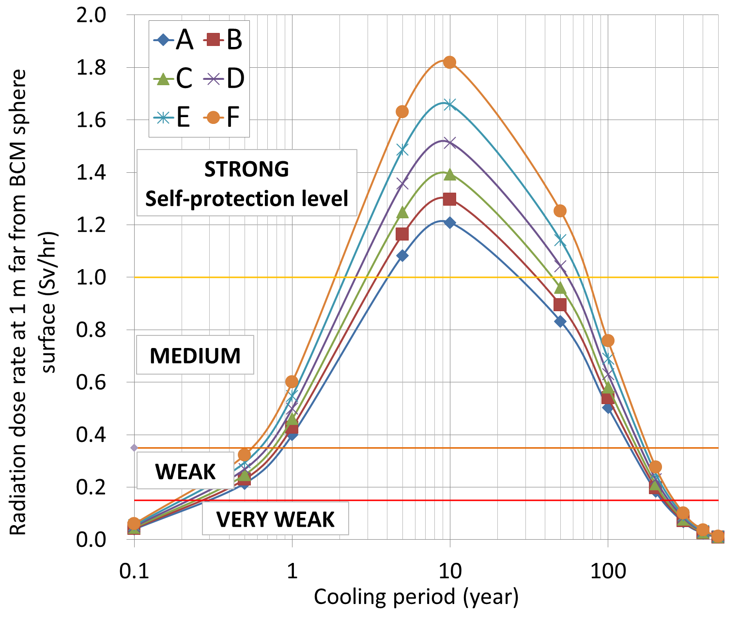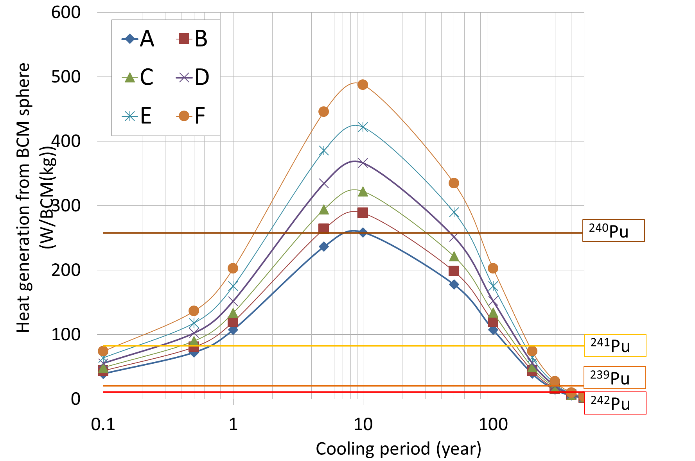
(2)
(1)
Fig. 5. Relation between cooling time and (1) radiation dose rate and (2) decay heat for different isotopic ratios of ²³³U/²³⁴U with 0.02% ²³²U and comparison with Pu isotopes.

Contribution of ²³⁴U to higher fuel burn-up
To examine the effect of ²³⁴U on criticality and fuel burn-up, three fuel cases were surveyed (TABLE 3). The infinite multiplication factor for the initial () and calculated fuel burn-up with a fast neutron energy spectrum were calculated, and the relationship between fuel burn-up and is also shown in TABLE 3. When water was used as a coolant in cases A, B, and C, the order of the fuel burn-up was A > C > B, whereas the order of was A > B > C. For cases a, b, and c, in which water with reduced density was used, the order of the fuel burn-up was c > a > b, whereas the order of was a > c > b. This is because ²³⁴U can be fissile to some extent in a harder neutron energy spectrum. Especially in case c, a mixture of 7% ²³³U and 3% ²³⁴U showed better core performance, indicating that ²³⁴U is better for a harder neutron energy spectrum. In a softer neutron energy spectrum, a higher ²³⁴U isotopic ratio causes lower fuel burn-up; hence, a harder neutron energy spectrum, namely, a fast reactor, is appropriate to achieve higher fuel burn-up for ²³⁴U-containing fuel. More detailed calculations are possible, but the general behavior of ²³⁴U-containing fuel is well understood.

TABLE 3. FUEL COMPOSITION AND CONDITIONS FOR CALCULATING THE EFFECT OF ²³⁴U CONTENT IN THORIUM FUEL

 | ²³²Th | ²³³U | ²³⁴U | Density of water |  | Burn-up  (MWD/t)
A | 90 | 10 | 0 | 1.00 | 1.588 | 1.199 × 10⁵
B | 93 | 7 | 0 | 1.00 | 1.492 | 8.518×10⁴
C | 90 | 7 | 3 | 1.00 | 1.396 | 8.60×10⁴
a | 90 | 10 | 0 | 0.01 | 1.221 | 3.199×10⁵
b | 93 | 7 | 0 | 0.01 | 0.990 | 3.089×10⁵
c | 90 | 7 | 3 | 0.01 | 1.009 | 3.260×10⁵

Controlling the ²³⁴U isotopic ratio by adjusting the neutron flux and neutron energy spectrum
We investigated controlling the ²³⁴U isotopic ratio. The linear power density was fixed as 1.79 × 10⁻⁴ MW/cm, which is typical for a light water reactor and the effect of MFR is shown in Fig. 7. The smaller MFR made the neutron energy spectrum harder and it promoted the accumulation of ²³⁴U, but the larger effect of the ²³³Pa→²³⁴Pa capture reaction due to the high neutron flux made the criticality lower. In contrast, a softer neutron energy spectrum (higher MFR) showed slow breeding of ²³⁴U against fuel burn-up, which allowed the decay reaction of ²³³Pa to ²³³U to occur more readily. This indicates that the optimum MFR is around 1 and the maximum accumulation ratio of ²³⁴U is 7.9%. Fig. 8 summarizes the isotopic ratio of ²³⁴U for neutron fluxes of 5.4 × 10¹¹ (low), 5.4 × 10¹³ (medium), and 5.4 × 10¹⁵ 1/cm² s (high) with different MFRs. An MFR of 1.5 and 5.4 × 10¹⁵ 1/cm² s, which is 100 times higher neutron flux than a typical light-water reactor, the ²³⁴U isotopic ratio reaches a maximum of 12.5%. Therefore, if a higher concentration is needed, multiple fuel cycles will be necessary.
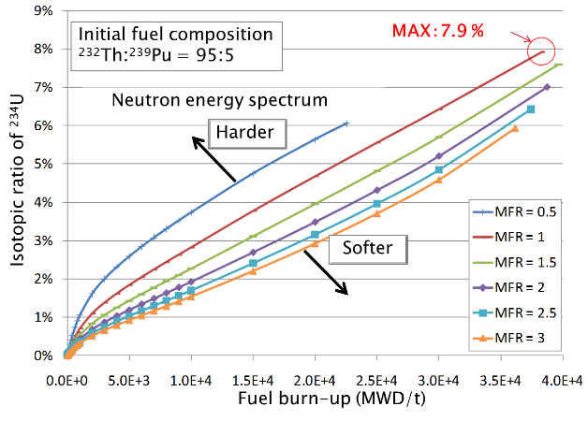
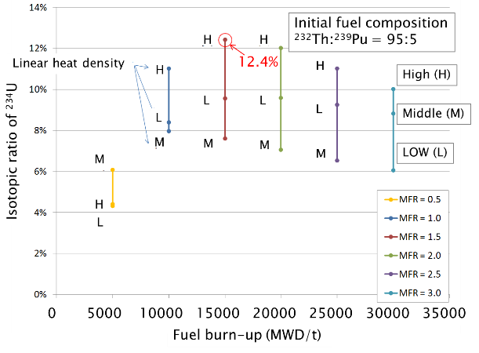
Fig. 8. Effect of MFR and linear power density (neutron flux) on ²³⁴U isotopic ratio.
Fig. 7. Effect of MFR and fuel burn-up on ²³⁴U isotopic ratio.

Effect of multiple cycles
After the first cycle, all the U isotopes, ²³³Pa, and remaining Pu isotopes were retrieved and the fissile amount was adjusted to 10%, and then the burn-up calculation was performed four more times. The initial fuel composition in the Th core contained 10% ²³⁹Pu and the mass balance was not considered in this study. ²³³Pa was considered to be ²³³U and the cooling period and decay of other actinides were not considered because the Th cycle does not generate short-lived actinides in contrast to the Pu cycle, and the cooling time makes no significant difference for fissile except for ²³³Pa. The calculation conditions and results are summarized in TABLE 4. The relationship between the number density of the U isotope and burn-up in the multiple-cycle operation is shown in Figs. 9 (1) and (2). In both cases, the amount of ²³⁴U and ²³²U increased with the increase in fuel burn-up. Comparison with cases A and B confirmed the effect of the neutron energy spectrum; a softer neutron energy spectrum increased the amount of ²³⁴U and ²³²U, and for fuel burn-up and mass balance, a faster neutron energy spectrum was better. The amount of ²³²U accumulated in the fuel was also higher with faster neutrons and the bred U fuel had a strong self-protection level (TABLE 1) from the first cycle, although the decay of ²³²U was not considered. More detailed surveys, such as core layout design and quantitative scenario analysis were beyond the scope of our conceptual study.

TABLE 4. MULTIPLE-CYCLE CALCULATION CONDITIONS AND RESULTS

 | Initial fuel composition |  | Linear Heat Rate (MW/cm) | Coolant density  (g/mL) | Isotopic ratio of ²³⁴U at end of 5th cycle (%) | ²³²U concentration at end of 5th cycle  (ppm) | Total burn-up  (MWd/t)
 | ²³²Th | ²³⁹Pu
A  B | 90 | 10 | 1.79×10⁻⁴ | 1 | 34.7 | 1.23×10⁴ | 1.22×10⁵
 |  |  |  | 0.01 | 26.0 | 6.31×10³ | 3.31×10⁵

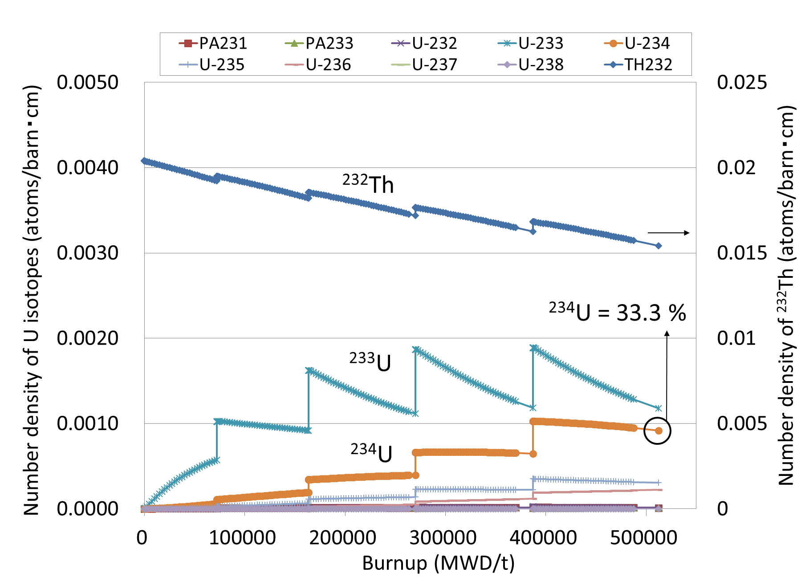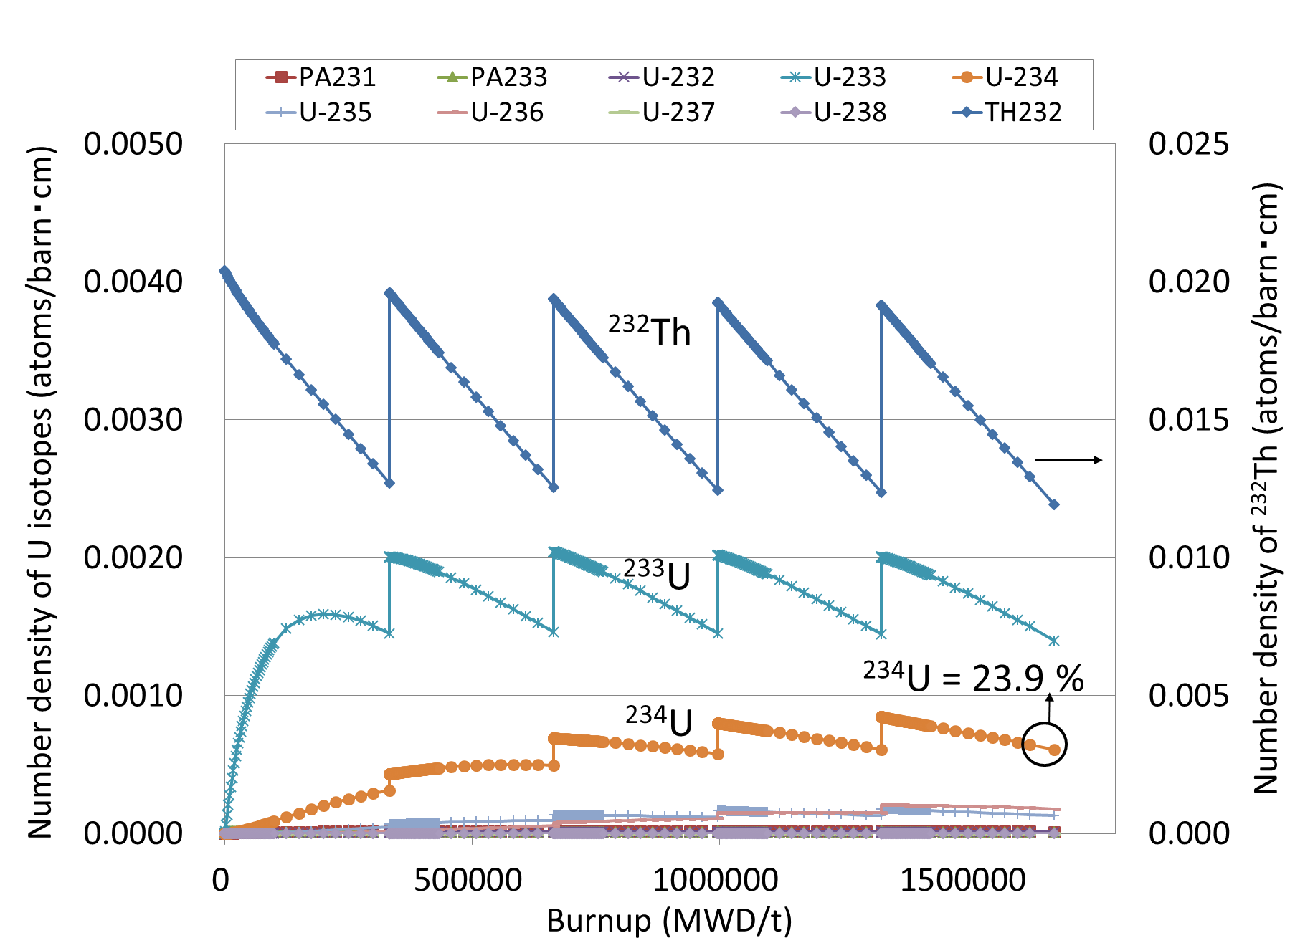
(2)
(1)
Fig. 9. Relationship between fuel burn-up up to the fifth cycle and number density of ²³²Th and U isotopes for (1) water (softer neutron energy spectrum) and (2) 1/100 water density (harder neutron energy spectrum).

Waste management and reprocessing
The back-end technology associated with the Th fuel cycle is less mature, but an extraction method similar to plutonium–uranium redox extraction (PUREX), thorium–uranium extraction (THOREX), has been studied [15,16]. In the THOREX, Acid THOREX, and Interim 23 processes, UO₂²⁺ is extracted by tri-n-butyl phosphate (TBP) with Al(NO₃)₃ and HNO₃ [17-19]. To replace TBP in the PUREX process, monoamide ligands can separate U/Th either with or without TBP [20–26]. TBP is depleted much faster in the strong radiation environment encountered in Th reprocessing. The depleted TBP can form unwanted complexes with actinides and other elements, which can make separation difficult. Therefore, monoamide ligands were studied because of their ease of synthesis, compliance with the CHON principle, and ability to extract hexavalent actinides. The other difficulty in reprocessing spent Th fuel is the requirement to work at a high dose rate. Either ligands or methods that are more robust against a radiation environment are required; therefore, strong ligands or other methods should be developed. For instance, we are developing a gel/liquid adsorption separation technique to be used in this type of radiation environment [27].
The waste management of spent Th fuel has not been examined much compared with the Pu cycle. The composition of the fission products generated from Th fuel is similar to that of U fuel, but the main difference is that minor actinides, such as Am and Cm. However, the raffinate from reprocessing Th oxide fuels contains fluoride ions and Th ions depending on the fuel cycle scenario and the manufacture of such glasses does not appear to have been reported. In addition, the safety and heat analysis of disposal sites for this type of new glass is needed. In summary, the back-end technology for the Th fuel cycle should be examined to advance the development of the Th fuel cycle. This may be the most important and challenging hurdle in Th fuel cycle development.

CONCLUSIONS
The use of ²³⁴U in Th fuel cycles for higher PR, higher fuel burn-up, and controlling the ²³⁴U isotopic ratio were surveyed in this conceptual study. Our conclusions are as follows.
- The characteristics of fuels related to PR can be improved by increasing the ²³⁴U isotopic ratio.
- Uranium fuels with 0.3% ²³²U and 30% ²³⁴U had 1.5 times heavier BCM, 25% lower Rossi-α, and 41% higher decay heat than ²³³U alone.
- The ²³²U isotopic ratio, which the IAEA suggests for fuel self-protection, can be minimized to about 20% by having a ²³⁴U isotopic ratio of 30% in U.
- Uranium fuels that contain ²³⁴U have increased burn-up with a harder neutron energy spectrum. For multiple cycles with a softer neutron energy spectrum, the ²³⁴U isotopic ratio reached 33.3% after the fifth cycle. With a harder neutron energy spectrum, a lower ²³⁴U ratio (23.6%) was obtained, but the fuel burn-up was longer. Because the mass balance was not considered, detailed simulations, such as quantitative analysis, are needed.
- The back-end technology for the Th fuel cycle is still not sufficiently mature. Breeding ²³⁴U creates more ²³²U and its daughter nuclei, producing a high-radiation environment during reprocessing and vitrification. Our work highlights the importance of upgrading back-end technology. In discussing both conventional and advanced Th fuel cycles, waste management should not be ignored.
References
- Thorium based fuel options for the generation of electricity: developments in the 1990s, IAEA-TECDOC-1155, IAEA, Vienna (2000).
- Thorium fuel optimization: option and trends, IAEA-TECDOC-1319, IAEA, VIENA (2002).
- Potential of thorium based fuel cycles to constrain plutonium and reduce long lived waste toxicity, IAEA-TECDOC-1349, IAEA, Vienna (2003).
- Thorium fuel cycle – potential benefits and challenges, IAEA-TECDOC-1450, IAEA, Vienna (2005).
- KEISUKE, O., et al., SRAC2006. JAEA-Data/Code 2007-004, 2007.
- KEIICHI, S., et al., Japanese Evaluated Nuclear Data Library Version 3 Revision-3: JENDL-3.3, J Nucl Sci Technol, 39 (2002) 1125-1136.
- PELOWITZ, D.B., et al., MCNPX, “User's Manual,Version2.6.0”, Los Alamos National Laboratory Report, LA-CP-07-1473, Los Alamos (2008).
- PELOWITZ, D.B., et al., MCNPX, 2.7.A Extensions, Los Alamos National Laboratory Report, LA-UR-08-07182, Los Alamos (2008).
- KOSANO, K., The libraries FSXLIB and MATXSLIB based on JENDL-3.3, JAERI-DATA/CODE 2003-011, Japan Atomic Energy Research Institute, Tokai (2003).
- Jungmin Kang and Frank N. von Hippel, U-232 and the Proliferation-Resistance of U-233 in Spent Fuel, Science & Global Security, 9, (2001) 1–32.
- KEIICHI, S., et al., JENDL-4.0: A New Library for Nuclear Science and Engineering, J Nucl Sci Technol 48 (2011) 1-30.
- MCNPDATA,DLC-200: RSICC, 2000.
- Data for Protection Against Ionizing Radiation from External Sources, Supplement to ICRP Publication 15. ICRP Publication 21. Pergamon Press, Oxford (1973).
- Guidance for the Application of an Assessment Methodology for Innovative Nuclear Energy Systems INPRO Manual — Proliferation Resistance, Volume 5 of the Final Report of Phase 1 of the International Project on Innovative Nuclear Reactors and Fuel Cycles (INPRO), IAEA-TECDOC-1575, IAEA, Vienna (2007).
- GRESKY, A.T., “Solvent Extraction Separation of ²³³U and Thorium from Fission Products by Means of Tributyl Phosphate, in the Peaceful Uses of Atomic Energy” (Proc Int Conf, Geneva, 1955) 9 (1956) 505-510.
- MERZ, E., Reprocessing of ²³²Th/²³³U fuels, Gmelin Handbook of Inorganic Chemistry, Thorium supplement volume A4, Springer, Berlin, Germany (1982).
- RAINEY, R.H., MOORE, J.G., Laboratory Development of the Acid Thorex Process For Recovery of Thorium Reactor Fuel, Nucl Sci Eng 10 4 (1961) 367-371.
- DHAMI, P.S., JAGASIA, P., PANJA, S., ACHUTHAN, P.V., TRIPATHI, S.C., MUNSHI, S.K., DEY, P.K., Studies on the Development of a Flow-Sheet for AHWR Spent Fuel Reprocessing Using TBP, Sep Sci Technol 45(8) (2010) 1147–1157.
- FLANARY, J.R., GOODE, J.H., KIBBERY, A.H., ROBERTS, J.T., WYMER, R.G.,Chemical Development of the 25-TBP Process, Report ORNL-1993, 1964.
- PATHAK, P.N., N,N-Dialkyl amides as extractants for spent fuel reprocessing: an overview, J Radioanal Nucl Chem 300 (2014) 7–15.
- PATHAK, P.N., PRABHU, D.R., RUIKAR, P.B., MANCHA, V.K., Evaluation of di(2-ethylhexyl)isobutyramide (D2EHIBA) as a process extraction for the recovery of ²³³U from irradiated Th, Solv Ext Ion Exch 20 3(2002) 293–311.
- ACHUTHAN, P.V., RAMANUJAM, A., Aqueous Reprocessing by THOREX Process. In: Das D., Bharadwaj S. (eds) Thoria-based Nuclear Fuels. Green Energy and Technology, 279–333, Springer, London (2013).
- KUMARI, N., PATHAK, P.N., PRABHU, D.R., MANCHANDA, V.K., Development of solvent extraction scheme for reprocessing of advanced heavy water reactor spent fuel using N,N-Dihexyl octanamide as extractant, Desalin Water Treat 38 (2012) 159–165.
- PATHAK, P.N., PRABHU, D., PRABHU, A.S., KANEKAR, A.S., MANCHANDA, V., Distribution studies on Th(IV), U(VI) and Pu(IV) using tri- n-butylphosphate and N,N-dialkyl amides, Radiochimica Acta 94 4 (2006) 193–198.
- KUMARI, N., PRABHU, D.R., KANEKAR, A.S., PATHAK, P.N., Validation of Solvent Extraction Scheme for the Reprocessing of Advanced Heavy Water Reactor Spent Fuel Using N,N-Dihexyl Octanamide as Extractant, Ind Eng Chem Res 51 (2012) 14535–14542.
- VERMA, P.K., KUMARI, N., PRABHU, D.R., PATHAK, P.N., Optimization Studies for the Recovery of Thorium from Advanced Heavy Water Reactor High Level Waste (AHWR-HLW) Solutions Using Green Solvents, Separ Sci Technol 48 4 (2013) 626–633.
- NAKASE, M., YAMAMURA, T., SHIRASAKI, K., NAGAI, M., TAKESHITA, K., Adsorption study of U and Th by N,O-hybrid donor ligand-immobilized hydrogels, Separ Sci Technol (2019).

