Development of Helium Leak Detection Methods for Canisters (Part2)
- Leak Evaluation by a Horizontal Small Canister Model -

Kosuke SHIMIZU
Hitachzosen
Osaka, Japan
Email: shimizu_ko@hitachizosen.co.jp

Hirofumi TAKEDA
Central Research Institute of Electric Power Industry
Abiko, Japan

Abstract

Long-term storage management and soundness monitoring methods of spent fuel are now receiving worldwide attention. For the metal cask, pressure monitoring between its lids is mandatory. Meanwhile, in the concrete cask, its lid is welded and high sealing property is maintained, so that a leak of helium is not monitored. However, considering long-term storage, there is concern about the loss of the sealing property due to stress corrosion cracking (SCC). To resolve this issue, we have been developing a leak detector utilizing the phenomenon that the surface temperature changes at the time of the leak. Furthermore, in order to investigate the applicability of this detector to horizontal silo storage, a leak test was conducted with a small canister model in a horizontal attitude. A basket was installed in the small canister, and 12 heater rods were installed in it. In the test, after reaching a steady state, the internal pressure was changed to 5atm, 3atm, and 1atm, and the temperature data of each position in each state was acquired. When the pressure was reduced, the canister bottom temperature and the canister side bottom temperature increased. In contrast, the temperatures of the top of the canister lid and the top of the canister side surface decreased. Therefore, it was confirmed that a highly sensitive detection method is possible with each combination using these four positions as detection points. In addition, by performing CFD analysis, the phenomena inside the canister were grasped. In this case, three-dimensional steady state CFD analysis with a polyhedral mesh using STAR-CCM+® was performed. Three kinds of internal pressure (5atm, 3atm, and 1atm) and four kinds of arrangement of the basket inside the canister were combined, which resulted in a total of 12 calculations. As a result, it was confirmed that the temperatures of the top and bottom of the canister and the top and bottom of the canister side surface vary according to the canister internal pressure as in the test results. In addition, it was also confirmed that there is significant difference in temperature distribution on the canister surface due to difference in the arrangement of the basket inside the canister.

INTRODUCTION
The total amount of spent fuel discharged from nuclear power plants is increasing year by year. In Japan, after the Fukushima accident, discussion on dry storage of extracting spent fuel from the fuel pool and storing it in the cask is becoming active. Approximately 10,000tU of spent fuel is expected by 2030, and 1,000 casks are required for storing all of it [1]. At present, only the metal casks are used in Japan, but the concrete casks have merits such as lower cost and shorter production period than the metal casks. On the other hand, for their introduction in Japan, the storage facility will be located at a coastal area, so a problem of stress corrosion cracking (SCC) on the canister remains. In recent years, the revision work of the regulations with the view to introducing the concrete cask by the Japan Society of Mechanical Engineers (JSME) is proceeding. In the United States, 90% of the dry storage uses concrete modules. As a measure against spent fuel in the future, the operation of two intermediate storage facilities that can separately store 40,000tU [2] and 70,000tU [3] of spent fuel is planned in 2020. In the concrete modules, in addition to the so-called concrete cask vertically installed, there is horizontal silo storage that the canister is laterally inserted into the concrete module and stored. Fig. 1 shows a silo structure.

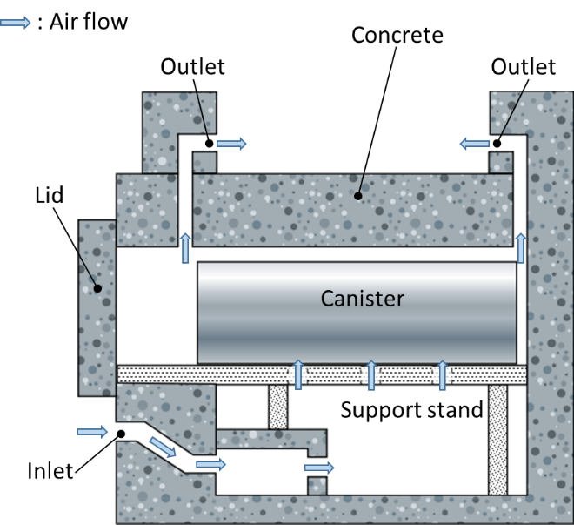
FIG. 1. Silo Structure [1].

For the concrete module storage in the United States, continuous monitoring of canister leakage is not obligated at present, but as long as long-term storage management of spent fuel is receiving worldwide attention, a monitoring technique for the loss of sealing performance of the canister is important and indispensable for aging management at the time of long-term storage. Thus, we have been developing a leak detector that utilizes the phenomenon that the temperature of the canister surface changes when the internal pressure of the canister changes in the vertical installation [4],[5]. In order to elucidate the phenomenon, a leak test using a small canister model is being carried out, and a study on the leak detector for the concrete cask [6] has been implemented. In this paper, we aimed to investigate a leak detector for the horizontal silo storage, so we conducted a leak test and test analysis on a small canister model in a horizontal attitude [7]. Tsai et al. [8] obtained analysis result that the temperature of the canister lid part decreased when the pressure decreased from 6atm to 1atm in the canister of the concrete cask. Toriu et al. [9] conducted analysis on transition in which internal gas leaked in a small rectangular canister model, and as a result, the upper temperature decreased and the bottom temperature increased as the pressure decreased. Nishimura et al. [10] carried out a heat transfer test of a canister in a 1/5 scale horizontal silo considering the similarity law.

ANALYSIS MODEL AND CONDITIONS
Analysis on the small pressure vessel (small canister model) placed in a vertical position has already been implemented [6]. In the paper, it was clarified that the influence of natural convection becomes small due to the decrease of the internal pressure of the canister, and the difference between the upper surface temperature of the canister lid and the lower surface temperature of the canister bottom becomes large.
In this paper, we conducted the test on the horizontal canister, examined the relation between pressure during the leakage and temperature at each measurement point, and compared it with the analysis [7]. Also, based on analysis results, we aimed to elucidate a phenomenon mechanism. In particular, we examined the influence of difference in contact states of a basket, heaters and the canister due to their arrangement on the phenomenon. For the analysis, three-dimensional steady state analysis was performed using a general purpose CFD code, STAR-CCM+® (ver. 11.02.010). A pressure-based solver was used for the analysis, and gas was set as an ideal gas. Fig. 2 shows a canister structure and internal temperature measurement points. There are the twelve heaters simulating spent fuel rods in the basket, and each of the heaters consists of a central heating portion and non-heating portions at its both ends. Fig. 3 shows external temperature measurement points and a picture of experimental equipment. In this study, we focused on the temperatures of four points shown in Fig. 3.

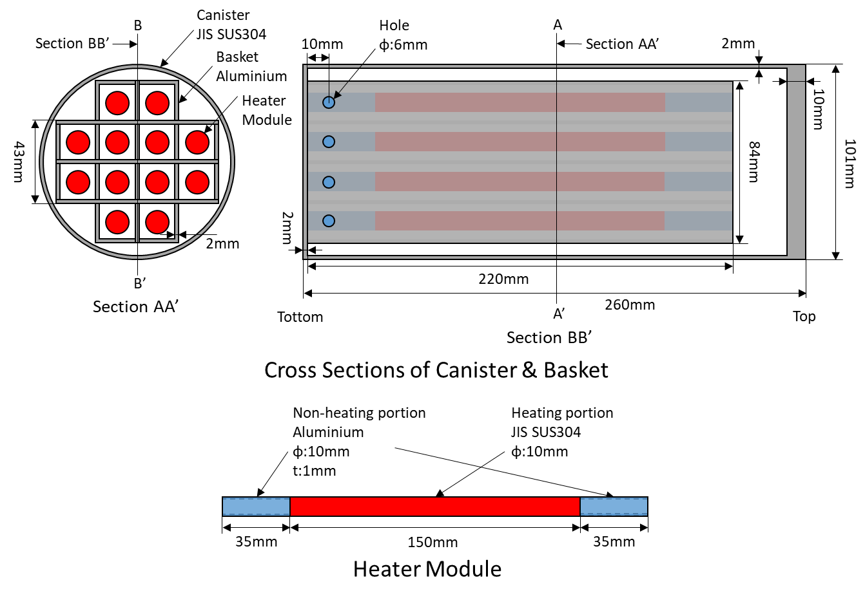
FIG. 2. Canister Structure.

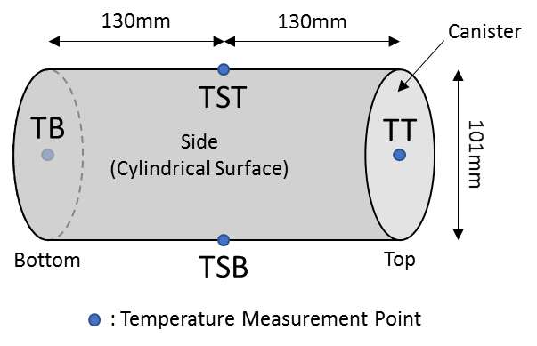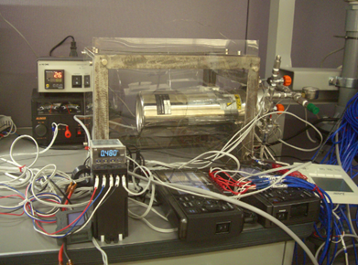
FIG. 3. External Temperature Measurement Points and Picture of Experimental Equipment.

Mesh for Analysis
Fig. 4 shows a mesh of a cylindrical section. A polyhedral mesh was used for the mesh, and the mesh number was about four million. An analysis model was the same as the previous model used in the test analysis [6] using the small canister model vertically installed, and an input direction of gravitational acceleration was changed because the attitude was shifted from vertical to horizontal.

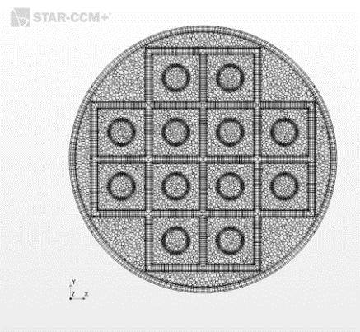
FIG. 4. Mesh of Cylindrical Section (Case1).

Numerical Model and Properties for Analysis
For the analysis, a segregated solver (SIMPLE solver) was adopted. The analysis was the three-dimensional steady state analysis. An internal fluid was air which was set as an ideal gas. The molecular weight of air was 28.9664kg/kmol. Physical properties of air and canister materials are shown in Table 1.

TABLE 1. PHYSICAL PROPERTIES [11]

 | Density  $$ρ$$ | Specific Heat  $$c_{p}$$ | Thermal Conductivity  $$λ$$ | Dynamic Viscosity  $$μ$$
Unit | kg/m³ | J/(kg·K) | W/(m·K) | Pa·s
Air 1atm 27°C | 1.17664 | 1003.62 | 2.60305 ×10⁻² | 1.855 ×10⁻⁶
Air 5atm 27°C | 5.88326
JIS SUS304 | 7930 | 570 | 16.7 | -
Aluminium | 2702 | 903 | 237 | -

Analysis cases are shown in Table 2. A heat rate was set to 36.6W. Three kinds of internal pressure (5atm, 3atm, and 1atm) and four kinds of arrangement of the basket and the heaters inside the canister were combined, which resulted in a total of 12 calculations. The heaters were always located at the center of each hole of the basket, and the bottom surfaces of the basket and the heaters were always on the same plane.
In Case 1, the center axis of the basket coincides with that of the canister, and the bottom surface of the basket is in contact with that of the canister (mesh section, Fig.4). In Case 2, changed based on Case 1, the basket and the heaters are moved in the direction of gravity, and the basket is in surface contact with the cylindrical inner surface of the canister. In Case 3, changed based on Case 2, a gap of 1 mm is provided between the basket with the heaters and the bottom surface of the canister. In this case, only the basket is in contact with the canister. In Case 4, changed based on Case 3, the basket is raised in the vertical direction and a gap of about 1 mm is provided between the basket and the cylindrical inner surface of the canister. Both the basket and the heaters are not in contact with the canister in Case 4.

TABLE 2. ARRANGEMENT IN EACH CASE

 | Basket & Heaters Relative to Canister Bottom | Basket Relative to  Canister Side | Figure (close look at contact region)
 |  |  | Canister Bottom | Canister Side
Case1 | Contact | Axisymmetric,  No contact between  basket and canister side | Contact | No contact
Case2 | Contact  (same as Case1) | Off axis,  Contact at lower parts | Contact | Contact
Case3 | 1mm gap | Off axis,  Contact at lower parts  (same as Case2) | 1mm gap | Contact
Case4 | 1mm gap  (same as Case3) | Off axis,  1mm gap between  lower parts | 1mm gap | 1mm gap

The amount of heat generated by the heaters was equally divided by 12 which was the number of the heaters, and uniformly given to each heater as a volumetric heat rate. In addition, the realizable k-ε model [11] was adopted as the turbulence model. This model eliminates the disadvantage of the standard k-ε model that the Reynolds stress becomes negative at a stagnation point, and uses the physically correct Reynolds stress. Especially, the influence of the Reynolds stress acting in the normal direction to flow can be dealt with more consistently. For handling near wall treatment, we adopted an "All Y + near wall treatment" model which is a recommended model of STAR-CCM+®. This model determines whether to use wall functions or low y+ approach according to a value of y+ for each wall adjacent cell. In the case where the wall adjacent cell existed in a buffer layer (between a viscous sublayer and a logarithmic layer) in this analysis, calculation methods of a reference velocity, turbulence generation, and dissipation were shifted from the low y+ approach to wall function control according to the distance (y+) from the wall surface [12].
Radiation was considered using the S2S (Surface-to-Surface) model in this analysis. Absorption, scattering, and reflection of radiant energy by a medium were not considered. The emissivities of the SUS304 and the aluminium were 0.15 and 0.85 respectively. The wavelength dependence of the emissivity was ignored, and the wall surface was treated as a gray surface. In this model, Kirchhoff's law was valid and the transmittance was 0. Thus, the sum of the emissivity and the reflectance was 1.
The turbulent heat flux is obtained from the heat transfer coefficient calculated based on the standard wall function. The wall function is a semi-empirical formula expressing the relation between flow and heat transfer in the vicinity of a wall surface. In STAR-CCM+®, the heat transfer coefficient between the wall surface and the adjacent cell is defined by the following equation (1).

 | $$q^{''}=\frac{ρ_{f}C_{P,f}u^{*}}{T^{+}}\left(T_{s}-T_{C}\right)$$ | $$⋯\left(1\right)$$

Here,$T_{s}$and$T_{C}$are wall temperature and cell temperature. Also,$ρ_{f},C_{P,f},u^{*},T^{+}$are the fluid density, the specific heat, the reference velocity, and the dimensionless temperature, respectively. The reference velocity and the dimensionless temperature are related by the standard wall function. For the heat transfer coefficient of the outer surface of the canister, the total heat rate was divided by the surface area of the canister, and the heat flux was equalized. Then, assuming that the canister surface generated heat with the equalized heat flux, CFD analysis was separately performed on the canister surface alone, and the heat transfer coefficient distribution on the canister surface was obtained as a boundary condition for the analysis.
Fig. 5 shows modified Rayleigh numbers (${Ra}^{*}$) at the heat rates of 5kW and 10kW in the actual canister, and those at 11.5W and 36.6W in the small canister model (1/18 scale canister model) using air inside the canister. In addition, the${Ra}^{*}$numbers at 36.9W and 48.9W in the small canister model using helium inside the canister are shown. The${Ra}^{*}$number is defined by the following equation (2).

 | $${Ra}^{*}={Gr}^{*}×Pr=\frac{gβqD^{4}}{λν^{2}}×Pr$$ | $$⋯\left(2\right)$$

Here,${Gr}^{*}$and$Pr$are the modified Grashof number and the Prandtl number. The${Gr}^{*}$number is composed of$g, β, q, D, λ, ν$which are the gravitational acceleration, the volumetric expansion coefficient, the heat flux on the canister surface, the canister diameter, the thermal conductivity, and the kinematic viscosity, respectively. We considered the difference in the phenomenon due to the arrangements of the basket and the heaters under the condition of 36.6W using air whose${Ra}^{*}$number was closer to that at 5kW in the actual canister as described below.

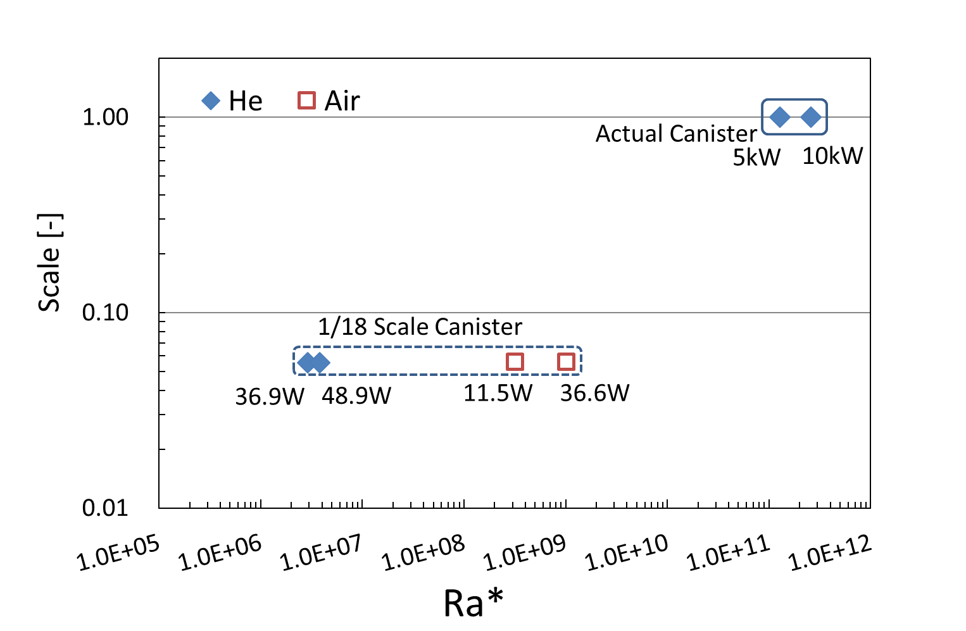
FIG. 5. Modified Rayleigh Number (Ra*) at Each Condition.

RESULTS AND DISCUSSION

Comparison between Arrangements (Air 36.6W)
Fig. 6 shows graphs of results of each arrangement for each pressure. Comparing Case 1 and Case 2 at all the pressure conditions, the temperatures except for those of TSB decreases in Case 2. On the other hand, at TSB in Case 2, marked rises are seen, which was due to the contact of the basket with the side of the canister. In Case 1, the temperatures of TST become higher than those of TSB because TST at the top of canister side could be easily heated by natural convection. Also, comparing Case 2 and Case 3, the temperatures of TB decrease greatly in Case 3, but the temperatures rise at almost all the other points. This is because the amount of heat transferred to the bottom of the canister was used to raise the whole temperature due to the gap between the basket with the heaters and the bottom of the canister. Comparing Case 3 and Case 4, the temperatures of TSB drop greatly in Case 4, and the temperatures rise overall at the other points. This is because in Case 4, the gap was formed between the lower side parts of the basket and the canister, so that the amount of heat transferred to the TSB side decreased. Also, in Case 4, there was no contact point between the basket with the heaters and the canister, so the temperature difference between the measurement points on the canister surface is the smallest. Comparing Case 1 and Case 3, the temperatures of TB in case 1 where the heaters and the bottom of the canister are in contact are higher than in Case 3, and the temperatures of TSB in Case 3 are higher than in Case 1. Thus, it was confirmed that the temperature in the vicinity of each contact portion rose. For the non-contact portions, TT has higher temperatures in Case3 than in Case1, and TST has higher temperatures in Case 1 than in Case 3. Comparing Case 1 and Case 4, TB has higher temperatures in Case 1 than in Case 4, but in Case 4, slightly higher values than in Case 1 are seen at the other measurement points. This is because the heat was largely released from the bottom surface, and then the temperatures of the other points decreased.

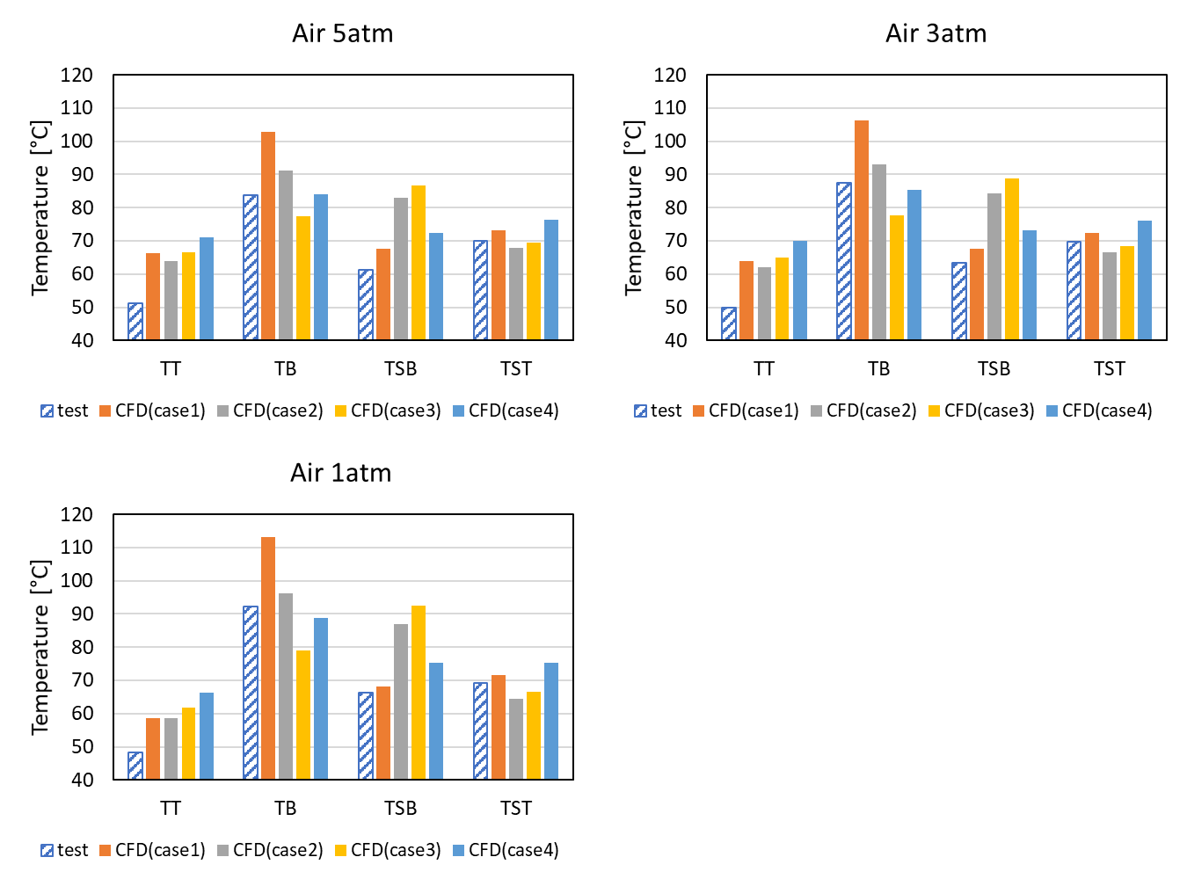
FIG. 6. Temperature at Each Measurement Point for Each Pressure.

Comparing the experimental results with the analysis results, there was a tendency that the temperatures were higher in the analysis as a whole. This was considered to be due to the difference in the heat transfer coefficient of the canister surface. In the experiment, since the canister was placed in a narrow space, it was conceivable that the flow around the canister was contracted. Therefore, there was a possibility that the flow velocity on the surface of the canister increased and the heat transfer coefficient increased in the experiment. The heat transfer coefficient used in the analysis was obtained on the assumption that the canister was equally volumetrically heated, this point seemed to be a factor of the difference between the experiment and the analysis. Also, It was considered that turbulent transition along the outer surface of the canister was occurring in both the actual canister and experimental apparatus at the${Ra}^{*}$numbers shown in Fig.5, but in the analysis, since the heat transfer rate was given as the boundary condition to the outer surface without solving the flow outside the canister, this point was not taken into account. In addition, in the analysis cases where the basket and the heaters were in contact with the canister, a large difference in temperature was observed at TB and TSB as compared with the experimental result because of a surface contact condition; however, at the other points, generally good results were obtained. From this result, it was inferred that in the experiment, the basket in the canister had small gaps with both the bottom surface and the cylindrical side surface of the canister or partially contacted with the canister.

Comparison between Internal Pressures (Air 36.6W)
Fig. 7 shows a temperature change at each temperature measurement point due to the internal pressure. Under all the arrangement conditions, the temperatures at TB and TSB rise as the internal pressure decreases. On the other hand, the temperatures at TT and TST drop as the internal pressure decreases. This is because the heat capacity of the internal gas decreased as the internal pressure decreased, and the amount of heat transferred by natural convection decreased. This tendency was consistent with the experimental result, and the leak detection using this phenomenon was considered to be available.

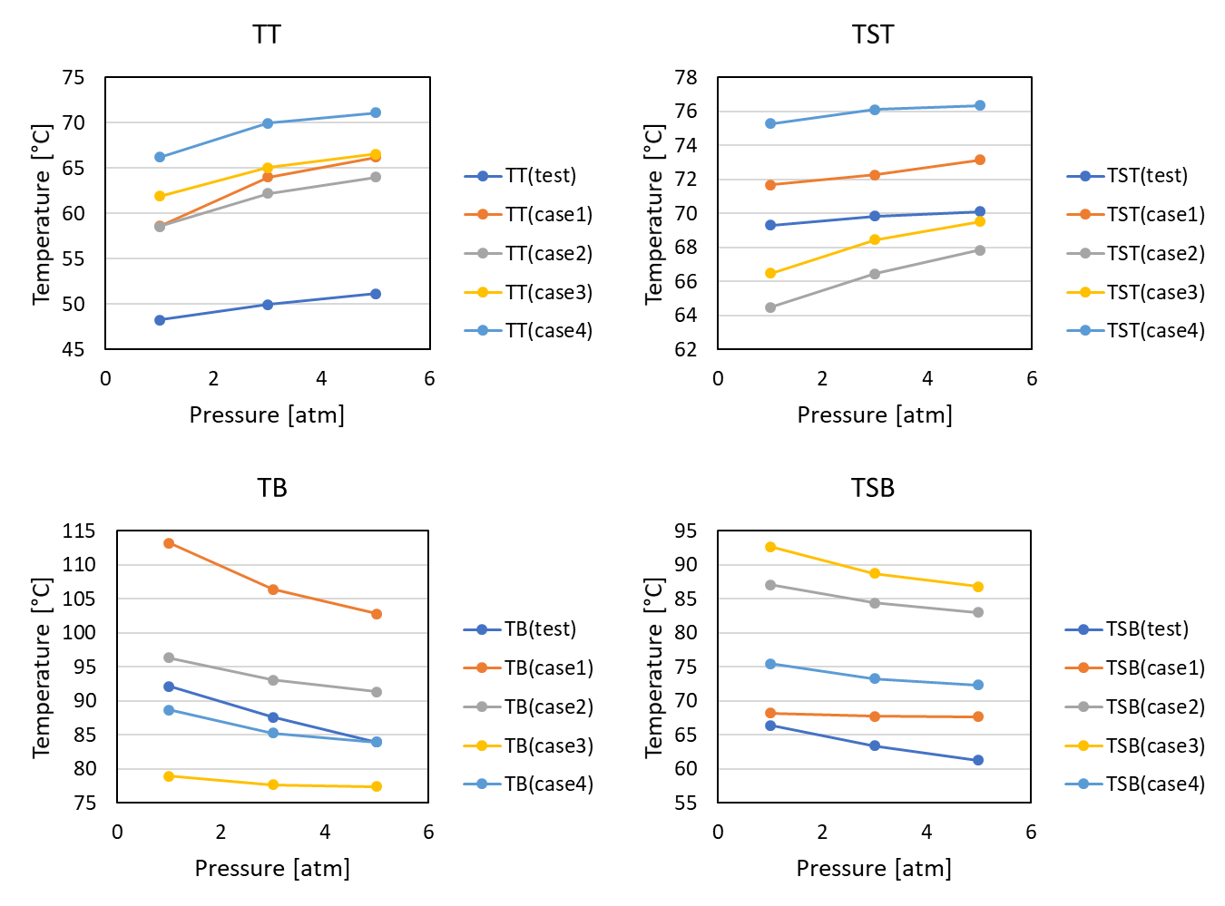
FIG. 7. Temperature Change at Each Measurement Point.

Comparison of Detection Methods (Air 36.6W)
In order to investigate the availability of the detection method, we examined the relation between the internal pressure of the canister and the temperature difference using the two points out of the four points TT, TB, TST, and TSB. Fig. 8 shows the result of the temperature difference between either TB or TSB and either TT or TST. The temperature difference increases while the pressure in the canister decreases in all the four cases of TB-TT, TB-TST, TSB-TT, and TSB-TST. From this result, it was proved that the detection method can use the detection combinations with the four points. The combination of TB-TT in the vertical canister has already confirmed to be available utilizing the same phenomenon as the horizontal canister that the effect of natural convection in the canister decreases with the internal pressure drop, resulting in the change of the temperature difference between two points [6]. Furthermore, in the case of the horizontal canister, it was shown that upper and lower two points on the cylindrical surface in addition to TT and TB can also be used for leak detection due to the difference of the posture. In the case that the internal gas is helium, the temperature difference became small because the thermal diffusivity of helium is large. But from our paper regarding the vertical cask [13], a sufficient temperature difference occurs in the condition under the${Ra}^{*}$number of the actual canister. Therefore, this method is considered to be applicable to the actual canister.

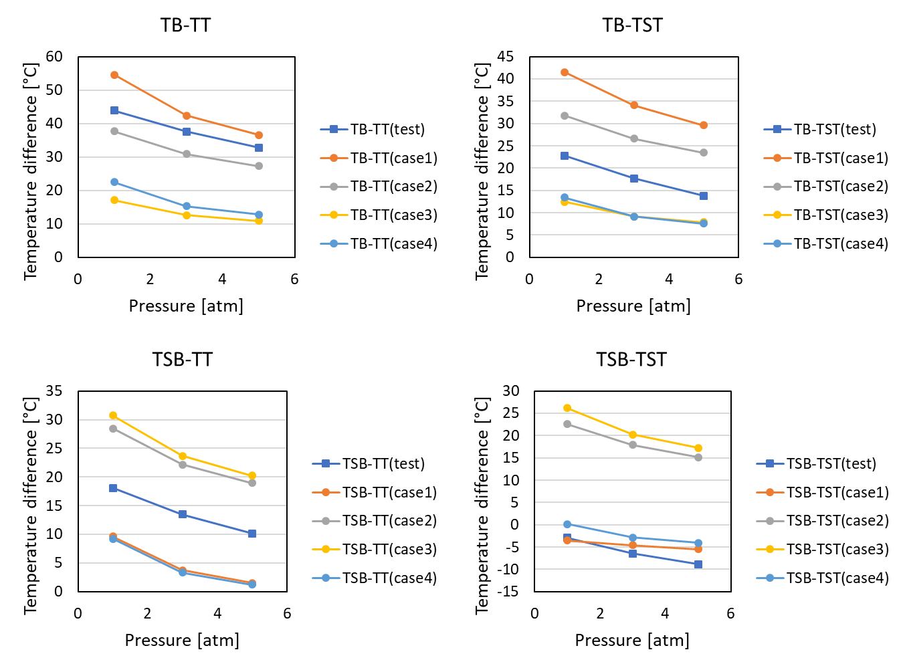
FIG. 8. Temperature Difference in Each Combination.

CONCLUSIONS
By comparing the arrangements of the basket and the heaters inside the canister under each of the conditions of 5atm, 3atm, 1atm, it was investigated how the temperature of each temperature measurement point changed. As a result, the following conclusions were obtained.

- At the time of depressurization, the effect of convective heat transfer inside the canister decreased, so the heater temperature rose. In Case 1 and Case 2, since the heaters were in contact with the bottom of the canister, the heat of them was greatly transferred to the bottom of the canister by heat conduction. Also, the basket was heated by the heat from the heaters, and in Case 2 and Case 3, the heat was transferred to the side surface of the canister by heat conduction through the contact portion between the lower side surface of the basket and the inner lower side surface of the canister. However, it was thought that the amount of this heat transfer was small as compared with at the bottom surface of the canister where the heaters were in contact or in proximity. Furthermore, in Case 4, since the basket and the heaters were not in contact with the canister, no thermal conduction occurred between them, and the temperature difference between the measurement points tended to be small.

- The temperatures at the measurement points were acquired under each analysis condition, and the combinations usable for the leak detection were investigated. In all the four combinations TB-TT, TB-TST, TSB-TT, and TSB-TST using TT, TB, TST, and TSB, the temperature difference between the two points tended to rise as the internal pressure of the canister decreased. Therefore, it was verified that the reduction of internal pressure can be detected by any of these combinations.

- The leak detection method of the horizontal canister was investigated. The combination of TB-TT in the vertical canister has already confirmed to be available utilizing the same phenomenon as the horizontal canister that the effect of natural convection in the canister decreases with the internal pressure drop, resulting in the change of the temperature difference between two points. Furthermore, in the case of the horizontal canister, it was shown that upper and lower two points on the cylindrical surface (TST and TSB) in addition to TT and TB can also be used for leak detection due to the difference of the posture.

References
- CRIEPI, “Basis of Spent Nuclear Fuel Storage”, ERC Publishing CO. LTD. (2015).
- World Nuclear News “Areva signs up for Texas storage facility” (2015),
http://www.world-nuclear-news.org/WR-Areva-signs-up-for-Texas-storage-facility-2105157.html
- World Nuclear News “Holtec to start regulatory process for New Mexico used fuel store soon” (2015).
http://www.world-nuclear-news.org/WR-Holtec-to-start-regulatory-process-for-New-Mexico-used-fuel-store-soon-30071501.html
- Takeda H., Wataru M., Shirai K. and Saegusa T., “Study on Concrete Cask for Practical Use- Development of the Detecting Method of Helium Leak from Canister -”, CRIEPI Research Report, N04031 (2005).
- Takeda H., Wataru M., Shirai K. and Saegusa T., “Development of the detecting method of helium gas leak from canister”, Nucl. Eng. Design, Vol. 238, 1220-1226 (2008).
- Takeda H., Shimaike K., “Development of Helium Leak Detector for Canister (Part.1)- Leak Evaluation Tests and Analysis by Vertical Small Canister Model -”, CRIEPI Research Report, N16005 (2016).
- Takeda H., Shimaike K., “Development of Helium Leak Detector for Canister (Part.2) - Leak Evaluation by Horizontal Small Canister Model -”, CRIEPI Research Report, N17007 (2018).
- H.Tsai, Y.Y.Liu, and J. Shuler, “Remote Area Modular Monitoring (RAMM) of Dry Cask Storage Systems”, INMM 56th Annual Meeting, Jul 12-16, Indian Wells, CA (2015).
- Toriu D., Ushijima S. and Takeda H., “Development of monitoring system of helium leakage from canister”, GLOBAL 2013, Sep 29-Oct 3, Salt Lake City, UT (2013).
- Nishimura M., Shibazaki H., Fujii S. and Maekawa I., “Natural Convection Heat Transfer in the Horizontal Dry Storage System for the LWR Spent Fuel Assemblies”, Nucl. Sci. Technol., Vol. 33, No. 11, p. 821-828 (1996).
- JSME Data Book, Heat Transfer 5th Edition (2009).
- Rodi, W., “Experience with Two-Layer Models Combining the k-ε Model with a One-Equation Model Near the Wall”, 29th Aerospace Sciences Meeting, Jan 7-10, Reno, NV, AIAA 91-0216 (1991).
- Shimizu, K., Takeda, H. and Goto, M., “Development of a Device for Detecting Helium Leaks from Canisters (Part 2): Numerical Analysis of Temperature Behavior during Gas Leaks from a Canister of a 1/4.5 Scale Cask Model”, ICONE26, Jul 22-26, London, England (2018).

