# Development of helium leak detection methodS for canisterS (part1)

- Evaluation of Minute Gas Leaks from Canisters by Small-Scale Models -

Hirofumi TAKEDA

Central Research Institute of Electric

Power Industry

Abiko, Japan

Email: takeda@criepi.denken.or.jp

Soichiro OKAZAKI

Hitachzosen

Tokyo, Japan

Masanori GOTO

Hitachzosen

Tokyo, Japan

**Abstract**

As for the concrete cask, because its canister is a welded construction, a helium leak from the canister wasn’t considered in the past. However, during long-term storage of spent fuel, stress corrosion clacking (SCC) could occur at welded parts of the canister, so that a loss of sealing performance is concerned now. To resolve this concern, we have been developing methods for detecting the leak by using a canister surface temperature change which occurs when the gas leaks from the canister. We performed leak tests using full-scale concrete cask models in 2003, and found the phenomenon that the temperature at the lid part (TT) of the canister decreases and the temperature at the bottom (TB) of the canister increases when the gas leaks from the canister. As a result, we proposed a method for monitoring the temperature difference ΔTBT (= TB-TT) instead of the internal pressure. Recently, we proposed new detection methods using only the temperature of either the lid or the bottom of the canister in consideration of easy installation and maintenance of temperature sensors. Besides, we conducted leak tests using a 1/18-scale canister model, and succeeded in the reproduction of the phenomenon that the temperature of TT decreases and the temperature of TB increases during the leak from the canister. A mechanism of this phenomenon was verified by performing numerical analysis. We also performed leak tests by using a 1/4.5-scale cask model based on the similarity law of thermal hydraulics. In the tests, air was used for an inner gas of a canister of the model, and the heat flux of the canister surface had the same value as that of the actual canister surface. Thus, the Ra* number of the model could be made to coincide with that of the actual canister. Besides, the Gr* number and Bo* number were almost equal to those of the actual canister. In these tests, we generated minute leaks of the inner air, and measured the temperatures of the canister surface and outside air at the inlet. Then, we evaluated an early leak detection method based on the correlation of those temperatures.

## INTRODUCTION

In Japan, dry storage that spent fuel is taken out of a fuel pool and put in the cask has been discussed frequently since the Fukushima accident. Also, in the case of delaying the schedule of the reprocessing, there is a possibility of generation of spent fuel of about 10,000 tU by 2030. When all the spent fuel is stored in the casks, 1,000 casks will be necessary [1]. In the concrete cask, a lid of the canister is welded, so sealing performance is deemed to be high. Therefore, the monitoring of helium leak from the canister is not obligated at present. However, a loss of the sealing performance by corrosion stress cracking (SCC) on welded parts of the canister is concerned [1] because a storage facility will be built at a coastal site in Japan and long-term storage management of spent fuel is becoming an issue in the world. Also, the monitoring of spent fuel gains attention worldwide. We performed helium leak tests using full-scale concrete cask models, and confirmed the phenomenon that the temperature at the bottom (TB) of the canister increases and the temperature at the top (TT) of the canister decreases. We proposed a leak detection method [2] by using the temperature difference ΔTBT (=TB-TT) instead of pressure monitoring. Moreover, in consideration of easiness of instalment, maintenance, and exchanging of a sensor in the case of sensor malfunction, we proposed an easier method by using temperature information on either the top part or the bottom part of the canister [3], [4]. We performed leak tests and experimental analysis by using a 1/18 scale model of the actual canister, and then a mechanism of the phenomenon was clarified [5]. Moreover, we manufactured a 1/4.5 scale model of the actual cask, which simulated a thermal hydraulics phenomenon inside the actual canister by using the similarity law. In the U.S., the canister is designed on a positive pressure condition. On the other hand, in Japan, there is a possibility to design it on a negative pressure condition. We performed leak tests in a wide internal pressure range using this test model in order to investigate the applicability of our leak detection methods. Also, we investigated the applicability of a learning type leak detection method.

## Leak detection method

We performed heat removal tests [1] by using two kinds of full-scale concrete cask models shown in figure 1. We introduced leak detection methods developed by using the test results. Here, we describe a temperature change under the condition of decreasing the internal pressure of the canister from 1.5 atm to 1 atm in the CFS cask model. Temperature measurement points at the cask and its canister are shown in figure 2.

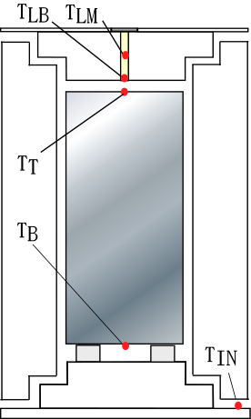

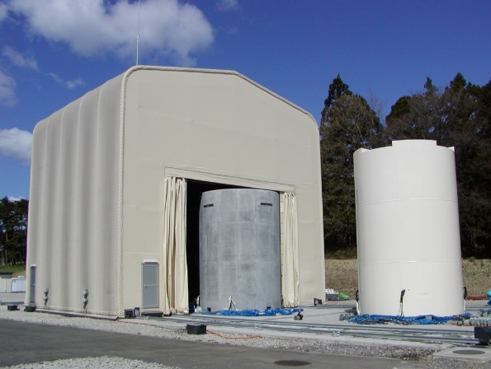

RC Cask

CFS Cask

*Fig.1 Full Scale Cask Models*　　　  *Fig.2 Tempt Measurement Points*

### ΔTBT Method

Figure 3 shows a time change of the temperatures at the top (TT) and the bottom (TB) of the canister before and after the leak. Also, Figure 4 shows a time change of the temperatures of the canister surface for the height of the canister. As shown in this figure, the temperature of TB increases and the temperature of TT decreases after the leak. We proposed a ΔTBT method which uses a value (ΔTBT) obtained by subtracting TT from TB based on this phenomenon [2].

### TT Method

We proposed a leak detection method by using the temperatures only in the vicinity of the upper part of the canister [3], [4]. We call this method a TT method. Figure 5 shows a time change of the temperatures of the inside (TLM) and the bottom (TLB) of the cask lid. The difference between both the temperatures widens after the leak. The TT method uses a time change of the temperature difference obtained by subtracting TLB from TLM. A way to get the temperature information is boring a small hole and inserting a stick which has thermocouples at its top and middle into the cask lid. The top of the stick may touch the canister lid (TT).

### TB Method

Figure 6 shows a time change of the temperatures of TB and air at the inlet (TIN). Because the bottom of the canister was exposed to air which flew in from the inlet, the temperature of TB was largely influenced by a change of the supply air temperature. In this figure, after the leak, the temperature of TB increases with a fluctuation in synchronization with that of the temperature of TIN. A TB method uses the temperature difference obtained by subtracting TIN from TB; however, how the fluctuation of the temperature of TIN is excluded is a future issue.

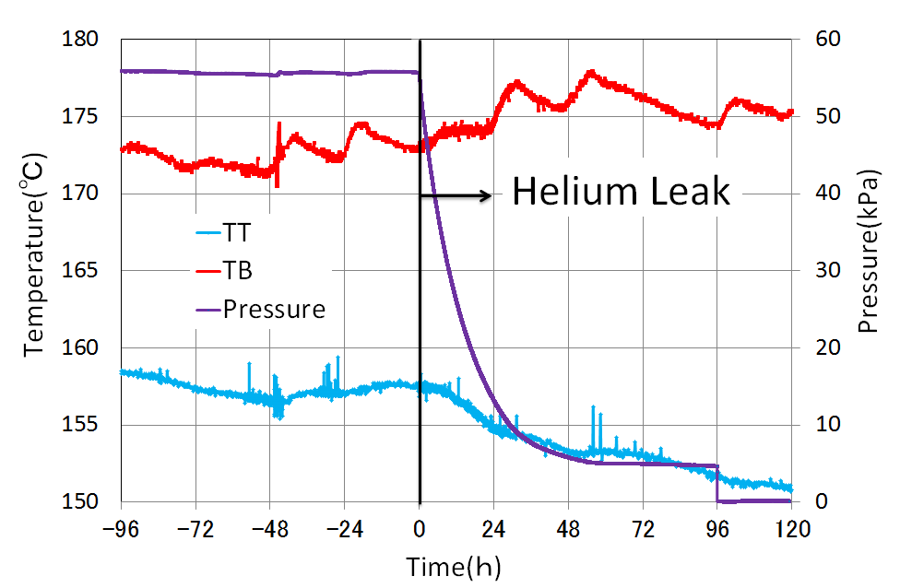　

*Fig.3 Temps. of TT and TB, and Pressure　　 　 Fig.4 Canister Surface Temperature*

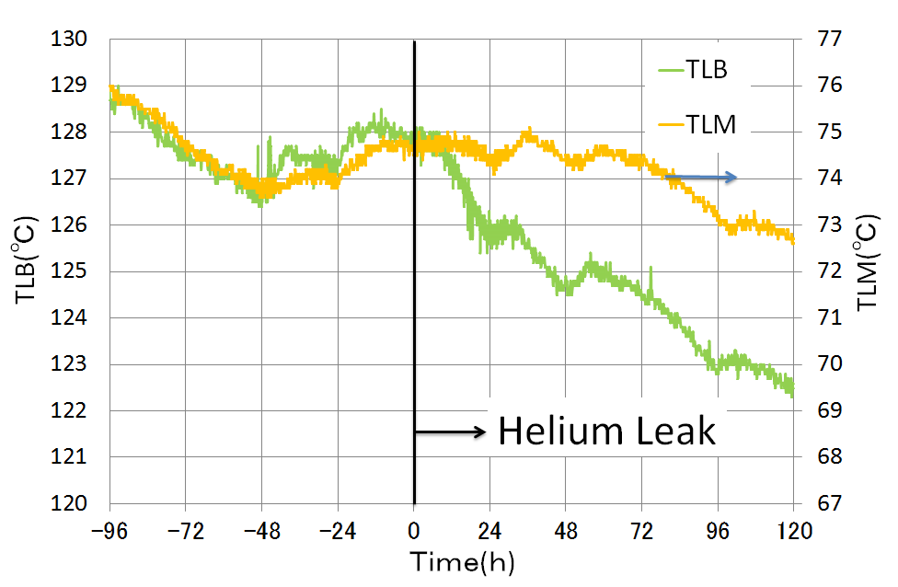　　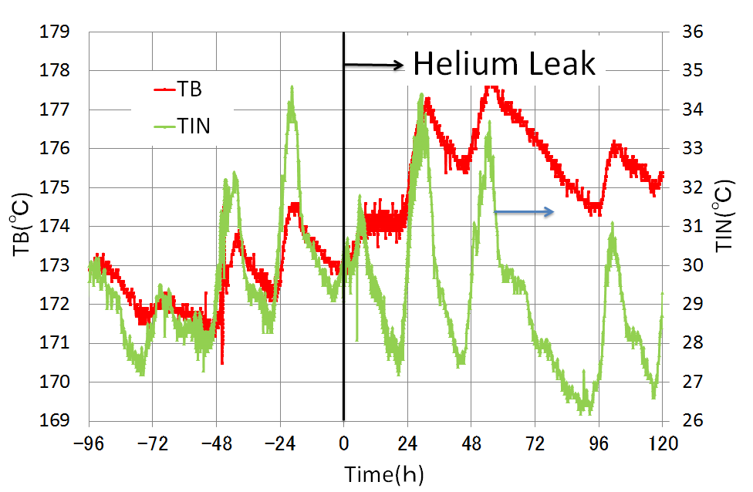

*Fig.5 Temps. of Inside and Bottom of Cask Lid　　　 Fig.6 Temps. of TB and TIN*

## clarification of phenomenon mechanism

### Test Model and Test Results

### We performed leak tests by using a 1/18 scale model and numerical analysis in order to clarify a mechanism of the phenomenon [5]. A test model is shown in Figure 7. 12 electric-heater rods are installed in a canister. In the leak test, first, the inside of the canister was pressurized, and put into a steady state. Then, a valve of the test model was opened for depressurization, and the temperature of each point was measured. Figure 8 shows the temperature of each point under the condition that the internal pressure decreases from 5atm, 3atm to 1atm step-by-step. The temperatures of the heater rod (THC) and TB increase and the temperature of TT decreases when the pressure decreases.

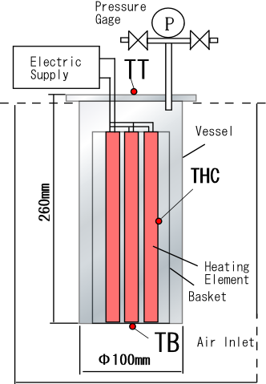　　　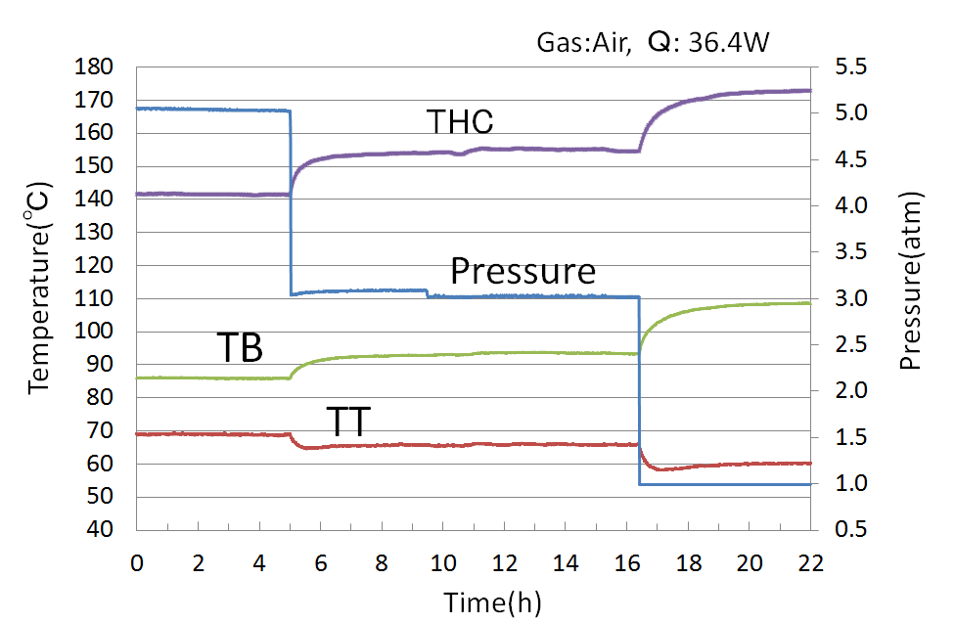

*Fig.7 1/18 Scaled Model　　 　　Fig.8 Pressure and Temp.at Each Point (test)*

### Numerical Analysis Results

Figure 9 shows analysis results by using a CFD analysis code (STAR-CCM+®). The analysis results simulate the phenomenon that the temperature of TB increases and the temperature of TT decreases with drop of the pressure as seen in the tests.

**TB**

**TT**

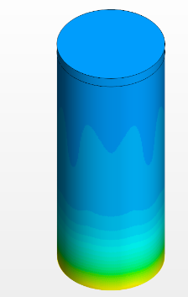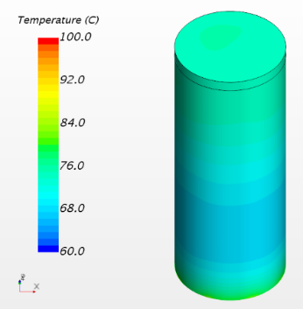

**5atm**

**1atm**

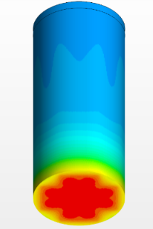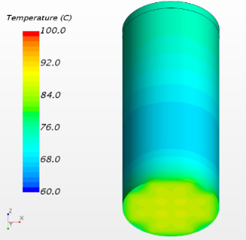

**1atm**

**5atm**

*Fig.9　Temp. of Canister Surface (analysis)*

### Phenomenon Mechanism

In the case of high pressure in the canister, the heat of the heater rods was removed by convection effect. On the other hand, in the case of low pressure, the effect decreased, and then the temperature of THC increased. The heater rods contacted with the bottom of the canister, so that the temperature of TB increased. However, the whole heat rate didn't change before and after the leak, so that heat release from the upper part decreased relatively, and the temperature of TT decreased.

## 1/4.5 Scale Cask Tests

We manufactured a 1/4.5 scale cask model which could simulate a thermal hydraulics phenomenon inside the actual canister by using the similarity law[6], [7], and performed leak tests. Figure 10 shows the relation of modified Rayleigh (Ra*) numbers of the actual canister and the 1/4.5 scale and 1/18 scale models. The Ra* number in the actual canister is about 1.0×1013. Helium is used for the inner gas in the actual canister. On the other hand, the 1/4.5 scale model used air for the inner gas, so that the Ra* numbers of the model could coincide with those of the actual canister. To simulate the thermal hydraulic phenomenon of the actual canister in this model experiment, it was necessary to make both modified Grashof (Gr*) numbers and modified Boussinesq (Bo*) numbers of the actual canister and the 1/4.5 models coincide with each other. Figure 11shows the Gr* and Bo* numbers of the actual canister and the two models. Because Pr numbers of helium and air are almost the same, and there are the relations of Bo*=Ra*×Pr and Gr*=Ra*/Pr, both the Gr* and Bo* numbers of the actual canister and the model could coincide with each other in the 1/4.5 scale model tests using air.

  *Fig.10 Ra* (actual canister and models)　 Fig.11 Bo*and Gr* (actual canister and models)*

The flow of cooling air between the actual canister and cask is natural convection. Then, natural convection was adapted for the condition of flow in the model test.

### Test Model

A vertical section view of the test model and temperature measurement points are shown in figure 12 (a). Figure 12 (b) shows a horizontal section view of the model. 12 heater rods which simulate spent fuel are installed in a canister of the model. The diameter of the heater rod is 16mm, and the length is 900 mm. The heater rod has two non-heating areas at the upper part (100mm length) and at the lower part (80mm length). Also, six solid aluminium pipes with 885 mm diameter and 16 mm length are installed around each heater rod. Therefore, the heat of heater rods propagates through the aluminium pipe, and the whole area of heater rods was heated, and then the canister bottom was heated. The cask model is installed in a manner to enclose the canister, and a cooling flow channel is formed between the canister and the cask. Also, the cask model has four air outlets and four air inlets at the upper part and the lower part, respectively.

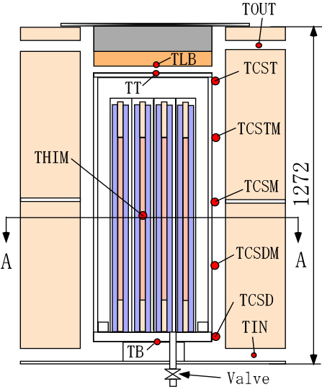　 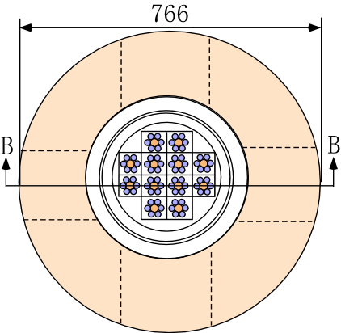

*Fig.12(a) Vertical Section View (BB of Fig. 12(b))　 Fig.12(b) Horizontal Section View (AA of Fig. 12(a))*

### Test Conditions and Test Method

Test conditions are shown in Table 1. It is known that the temperature of the lower part of the canister surface decreases to below 100 °C under the condition of 10kW in the actual canister [1]. This study aimed at the leak caused by SCC, so that heat rates in the tests were set to values equivalent to 10kW in the actual canister. When the heat rate is 10 kW in the actual canister, the heat rate in the model are 494 W under the condition of the same surface heat flux in the actual canister and the model.

We set a heat rate and initial pressure as parameters. In negative pressure tests, air was mixed into helium contained in the canister from the start. In the tests, after it was confirmed that the whole temperature in the model reached a steady state, a valve of the model was opened and the leak was started.

TABLE 1 TEST CONDITIONS

|  |  |  |  |  |
| --- | --- | --- | --- | --- |
| Case　No. | Initial Gas | Heat Rate(W) | Initial Pressure(atm) | Inlet Temp. |
| Case 1 | Air | 491.2 | 6 | 21.7 |
| Case 2 | Air | 244.4 | 6 | 21.8 |
| Case 3 | Air | 498.0 | 0.8 | 21.7 |
| Case 4 | Air | 365.4 | 6 | 19.9 |
| Case 5 | He | 492.0 | 0.8 | 18.4 |
| Case 6 | He | 489.8 | 0.5 | 19.1 |
| Case 7 | He | 492.3 | 0.1 | 19.6 |
| Case 8 | He | 494.1 | 6 | 17.2 |
| Case 9 | No Gas | 494.7 | 0 | 16.6 |

### Results and Discussion

#### 4.3.1. Tests Using Single Gas

*(1) Positive Pressure Tests*

A time change of the temperature of each point during depressurization from 6atm to 1atm is shown in Figure 13. The temperatures of the heater rods (THIM) and TB increase and the temperature of TT decreases with the pressure drop. As shown in Figure 14, the temperature of THIM increased because heat removal effect by convection decreased with the pressure drop, and the temperature of TB increased because the heater rods contacted with the bottom of the canister, then the temperature of TT decreased relativity.

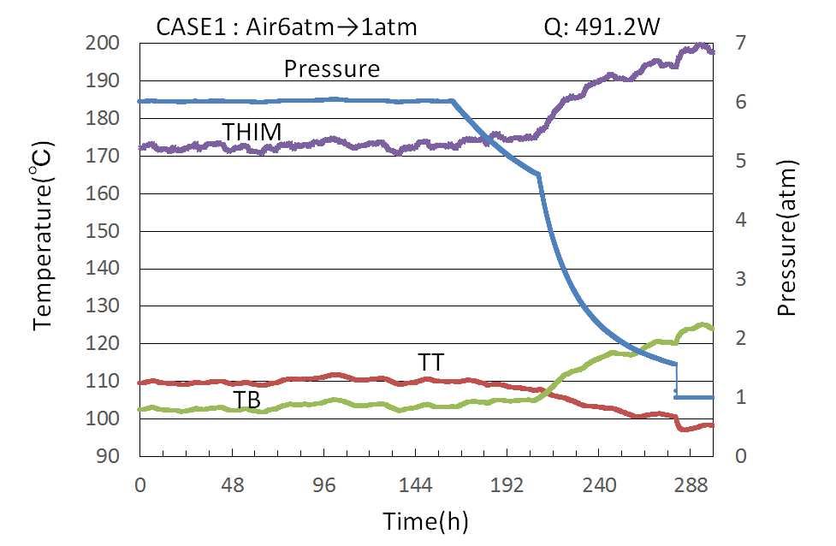

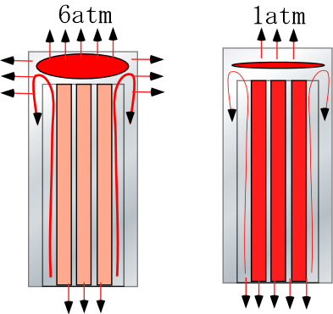

*Fig.13 Pressure and Temp. at Each Point　　 Fig.14 Phenomenon Mechanism (positive pressure)*

Furthermore, we developed a new leak detection method using a self-learning technique. Here, we introduce an example of application of this technique to the ΔTBT method. In the technique, a ΔTBT value in the future (ΔTBTf) is predicted based on ΔTBT data, atmospheric temperature data, and temperature data of heater rods in a no-leak state. ΔTBTf performs the prediction using the data from the start of learning to the start of prediction as shown in Figure 15 (a). A detailed comparison between this predicted value (ΔTBTf) and the actual value (ΔTBT) is shown in figure 15 (b). The upper limit of the predicted value is decided by a statistical method. When ΔTBT exceeds the upper limit of ΔTBTf, the leak is determined to occur. As shown in Figure 15(b), the leak occurred at a solid (vertical) line and the leak was determined at the time in a red circle. By using this learning-type detection method, a leak quantity of 8.3kP could be detected within about 2 hours. Therefore, it was clarified that this detection method has sufficiently high accuracy.



**(℃)**



**(℃)**

*Fig.15(a)* *Actual and Predicted values ofΔTBT　 Fig.15(b) Actual and Predicted values ofΔTBT (enlarged)*

*(2) Negative Pressure Tests*

A temperature change of each point during influx of air into the canister from 0 atm to 1 atm is shown in Figure 16. The temperature of THIM decreases with the rise of the pressure. Also, the temperature of TB decreases, and the temperature of TT increases. Figure 17 shows a mechanism of the phenomenon. At 0 atm, because there was no medium which removed the heat of the heater rods, the heat was not removed enough. When air as a medium transferring the heat flew in, heat conduction effect and convection effect appeared with the increase of the pressure. Thus, the temperature of THIM decreased, which resulted in the decrease of the temperature of TB and the increase of the temperature of TT. As a result, this phenomenon was opposite to that on the positive pressure condition.

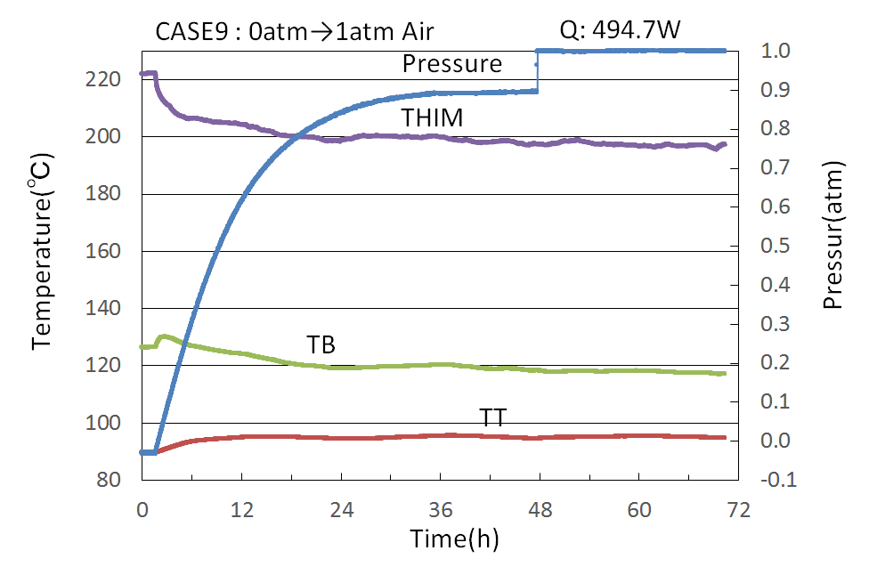

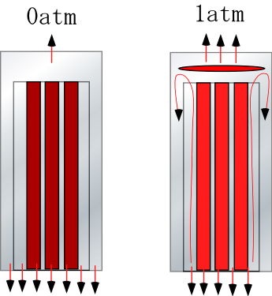

*Fig.16 Pressure and Temp. at Each Point　　 Fig.17 Phenomenon Mechanism (negative pressure)*

#### 4.3.2. Tests Using Mixture of Helium and Air

We performed mixture tests that air flew in so as to be mixed into helium included in the canister from the start at the negative pressure. Case5 to Case7 shown in Table 1 were set as the conditions. A negative pressure degree was adopted as a parameter. Here, we introduce two test cases of 0.8 atm and 0.1 atm.

1. *0.8atm of Helium in Initial Condition*

A temperature change of each point during a pressure change from 0.8 atm to 1 atm is shown in Figure 18. When air with small thermal conductivity is mixed in after 24 hours, the temperature of THIM increases. According to this, the temperatures of TB and TT increase and the temperature of the canister side surface (TCSM) decreases. A mechanism of the phenomenon is shown in Figure 19. At 1 atm, helium with small density is accumulated in the upper part of the canister, and the heat of the heater rods is transferred to the lid part of the canister, so that the temperature of TT increases.

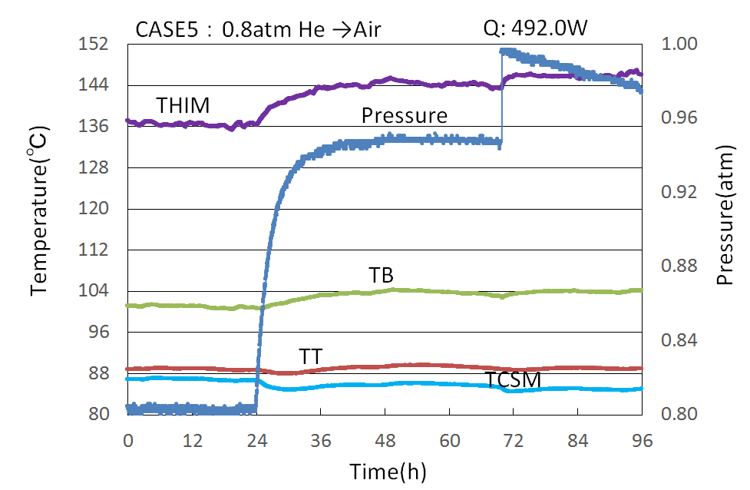

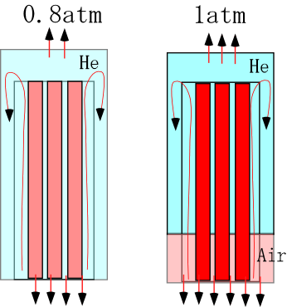

*Fig.18 Pressure and Temp. at Each Point (0.8atm) Fig.19 Phenomenon Mechanism (0.8→1atm)*

1. *0.1atm of Helium in Initial Condition*

A temperature change of each point during a pressure change from 0.1 atm to 1 atm is shown in Figure 20. The degree of temperature increase of THIM is larger compared with that in the previous test started from 0.8 atm, and the temperature change of the other points is also remarkably large. A mechanism of the phenomenon is shown in Figure21.This is because the amount of influx of air with small thermal conductivity was large.

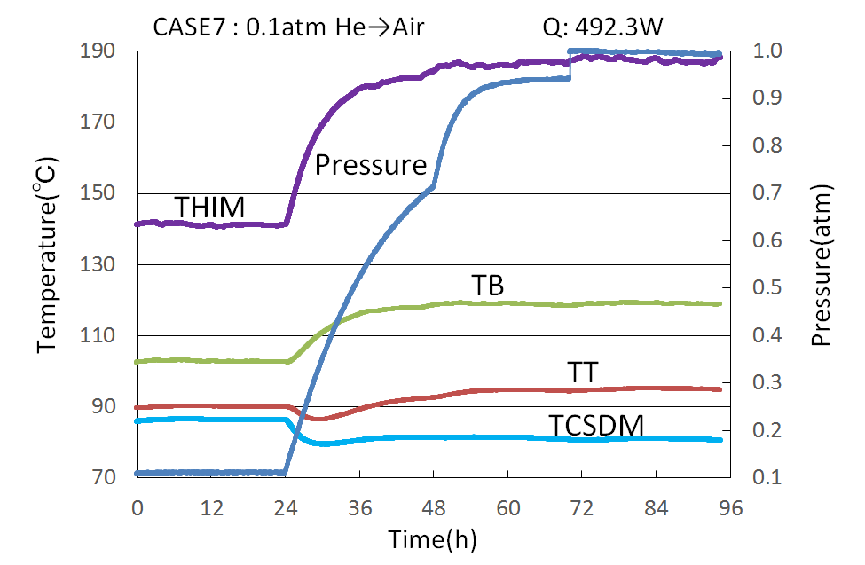

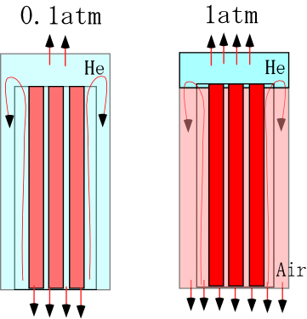

*Fig.20 Pressure and Temp. at Each Point (0.1atm) Fig.21 Phenomenon Mechanism (0.1→1atm)*

#### 4.3.3. Temperature Behavior of Single and Mixed Gases

Figure22 shows the maximum temperatures of THIM at the initial internal pressure. In a vacuum state (0atm), the temperatures of THIM have the maximum values; however, regardless of the kind of gas, air or helium, they decrease significantly when a small amount of the gases exist. Especially, when helium exists, the drastic decrease is seen compared with air. In the negative pressure state, heat removal effect by convection is not seen much. On the other hand, in the positive pressure state, heat removal effect increases as the pressure increases. Figure 23 shows the largest temperature difference change on the canister surface during a pressure change from initial to atmospheric (1atm). In both the cases of helium and air, the temperature difference change increases as the initial pressure increases in the positive pressure state. In the case of air, the phenomenon in the negative pressure state is opposite to that in the positive pressure state. Also in this case, the largest temperature difference change on the canister surface is ΔTBT in all the pressure states. On the other hand, in the test that air is mixed into helium in the negative pressure state, the surface temperature difference change increases as the negative pressure degree increases, which is opposite to the result of the single gas test with air. In this test case, the largest temperature difference is a value obtained by subtracting the temperature of TCSD or TCSDM from the temperature of TB.

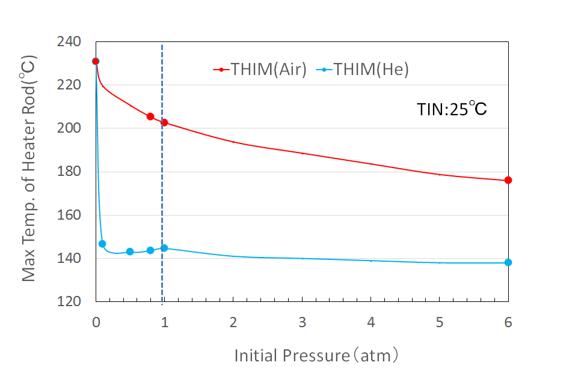 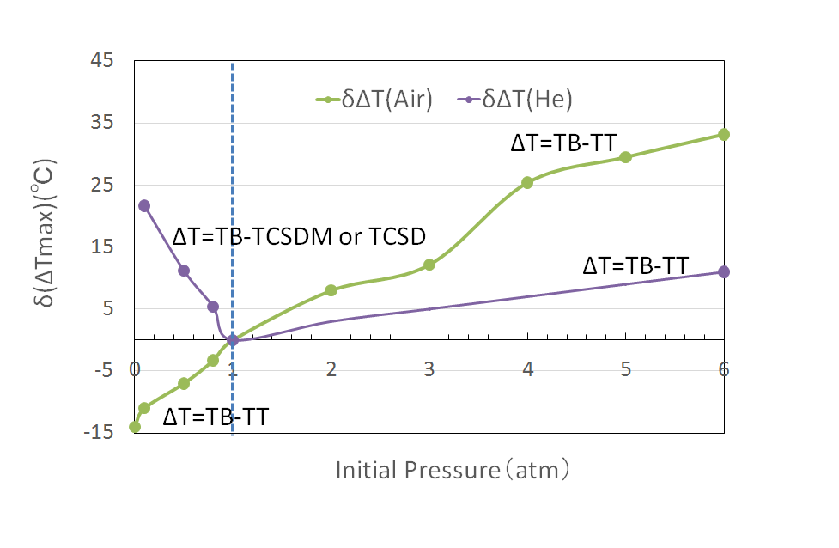

*Fig.22 Max. Temps. of THIM　　　　　 Fig.23 Temp. Change after Leak*

Figure 24 shows the amount of temperature increase of THIM from the negative pressure at which helium is previously in the canister to atmospheric pressure at which air is mixed in. The higher the negative pressure degree is, the larger the temperature increase of THIM is. Also, Figure 25 shows a canister surface temperature change on the same condition as that in Figure 24. The surface temperature change increases as the negative pressure degree increases. Therefore, it was clarified that when the surface temperature change is used for the leak detection, the higher negative pressure degree is more useful. In doing so, the negative pressure degree will be decided depending on an allowable degree of temperature increase of THIM.

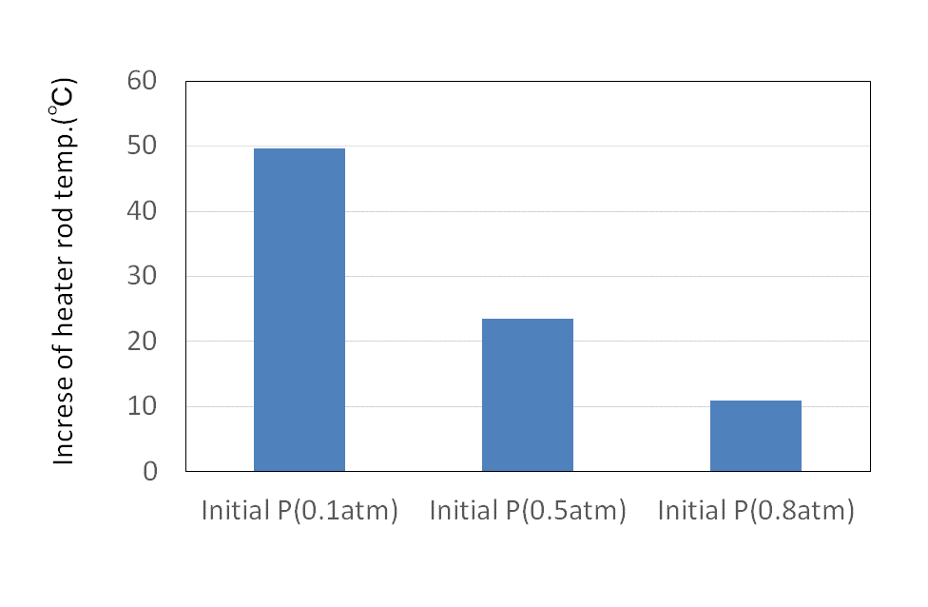　 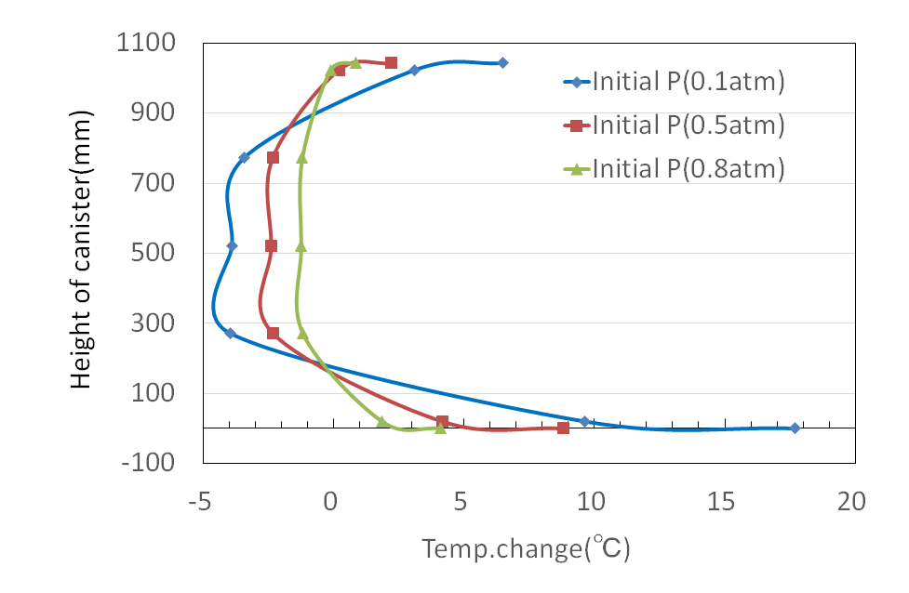

*Fig.24 Temp. Increase of THIM　　 Fig.25 Temp. Change of Canister Surface*

## conclusions

We investigated the helium leak detection methods by using the change of temperature of the canister surface, and drew conclusions from the leak tests as follows.

(1) We performed the leak tests and the experimental analysis by using the 1/18 scale model of the actual canister. Then, the mechanism of the phenomenon that the canister surface temperature changes according to the pressure change during the leak was clarified. In the case of high pressure in the canister, the heat of heater rods was removed by convection effect. On the other hand, in the case of low pressure, the effect decreased, and then the temperature of THC increased. The heater rods contacted with the bottom of the canister, so that the temperature of TB increased. However, because the whole heat rate did not change before and after the leak, the heat release from the upper part decreased relatively, so that the temperature of TT decreased.

(2) We developed the new leak detection method using the self-learning technique to predict the ΔTBT value in the future based on the existing ΔTBT data, the atmospheric temperature data, and the temperature data of THIM. In this method, the upper limit value of the predicted value is decided by the statistical method, and when the actual value exceeds the upper limit value, the leak is determined to occur. The method could detect a leak quantity of 8.3kP within about 2 hours in the leak test by the 1/4.5 scale model. Therefore, the availability of this method was verified.

(3) We performed the mixture tests that air flew in so as to be mixed into helium included previously in the negative pressure state by using the 1/4.5 scale model. It was found that the temperature of THIM increases when air with small thermal conductivity is mixed in. As the negative pressure degree increased, the degree of temperature increase of THIM increased, so that the detection using this phenomenon was determined to be effective. Here, since helium was used in the initial condition, the tests by using the scale model did not completely satisfy the similarity law. Thus, the verification by analysis on the actual cask will be necessary for quantitative evaluation in the future.

References

1. CRIEPI, 2015. “Basis of Spent Nuclear Fuel Storage”, ERC Publishing CO. LTD.
2. Takeda H., Wataru M., Shirai K., Saegusa T. [2008], “Development of the detecting method of helium gas leak from canister”, Nucl. Eng. Design, Vol. 238, pp.1220-1226.
3. Takeda H., Toriu D. ,Ushijima S. [2015], ”Development of Evaluation Method of Long-term Confinement Performance for Canister (Part 2) –Helium Leak Analysis and Proposal of Simpler Helium Leak Detection Method– “, CRIEPI Research Report, N15006, (In Japanese)
4. Takeda H. [2016], “Development of Helium Leak Detector for SCC of Welded Canister”, 4th Nuclear Materials Conference 2016, Montpellier, France.
5. Goto M, Takeda H, Shimizu K, Shimaike K, 2017. “Development of Device for Detecting Helium Leaks from Canisters-Analytical Study for Temperature Behaviour during Gas Leaks from Small Pressurized Vessels- “ ICHMT International Symposium on Advances in Computational Heat Transfer **,** May 28-June 1, 2017, Napoli, Italy
6. Takeda H., Koga T., Watanabe O. [1993],”Experimental and computational simulation for natural circulation in an LMFBR” Nucl. Eng. Design, Vol. 140, pp.331-340.
7. Takeda H, Goto M, 2018.”Development of a Device for Detecting Helium Leaks from Canisters (Part1): Experiment on Temperature Behaviour during Gas Leaks from a Canister of a 1/4.5 Scale Cask Model” ICONE26, July 22-26, 2018, London, England.

NOMENCLATURE

g : Gravity acceleration (m/s2)

L : Representative length (m) (The length corresponds to a canister height.)

Q : Heat rate (W)

q : Heat flux (W/m2)

β : Coefficient of volume expansion (1/℃)

ν : Kinematic viscosity coefficient (m2/s)

λ : Thermal conductivity (W/m/℃)

Bo*: () Modified Boussinesq number (-)

Gr*: () Modified Grashof number (-)

Pr : Prandtl number (-)

Ra*: () Modified Rayleigh number (-)