DETERMINATION OF OUT-CORE FUEL BURNUP IN TRIGA PUSPATI REACTOR

S. HASHIM
Department of Physics, Faculty of Science, Universiti Teknologi Malaysia,
81310 UTM Skudai, Johor,
Malaysia
Email: suhairul@utm.my

M.A.S. HUSAIN
Atomic Energy Licensing Board, 43800 Dengkil, Selangor, Malaysia

M.H. RABIR
Malaysia Nuclear Agency, Bangi 43000 Kajang, Selangor, Malaysia

N. ZAKARIA
Malaysia Nuclear Agency, Bangi 43000 Kajang, Selangor, Malaysia

M.R.M.ZIN
Malaysia Nuclear Agency, Bangi 43000 Kajang, Selangor, Malaysia

Abstract

The investigation is made of the out-core neutron flux and burn-up at irradiated fuel stored in TRIGA PUSPATI research reactor tank. This is required to examine whether the thermal and/or fast neutron flux can influence burn-up of the irradiated fuel stored in the same vicinity of the reactor core, the fuel rack being located 1 m above the core. MCNPX code was used to simulate fast and thermal neutron flux for the reactor operating at 750 kW. In this work, the computational model was created using MCNPX version 2.7 with the evaluated nuclear data file for thermal neutron scattering law data (ENDF7) cross-section data library and using a 10 cm × 10 cm × 10 cm mesh model. The results show the axial distribution for thermal neutrons occurred at energy lower than 1 × 10⁻⁶ MeV. Thermal neutron travels at the maximum distance of 78 cm due to thermalization by moderator. Based on the maximum distance travels by the thermal neutron, the thermal neutron does not reach the storage rack located 1 m from the core, hence there is no burn-up occurring at the irradiated fuel since burn- up can only occur in the thermal neutron region. For fast neutron, the axial distribution energy is higher than 1 × 10⁶ MeV and travels more than 158 cm. The reaction time for the fast neutron is too short to result in burn-up due to its fast travel.

- INTRODUCTION

The PUSPATI TRIGA Mark II reactor (typically referred to by the acronym RTP, Reactor TRIGA PUSPATI) at the Malaysian Nuclear Agency, Malaysia, is the one and only research reactor in Malaysia. TRIGA stands for Training Research Isotopes, General Atomics while PUSPATI stands for Tun Dr. Ismail Center for Atomic Energy Research. The reactor achieved its first criticality on June 28, 1982, and since then has operated for an average of 500 hours per year. The RTP isloaded with 3 types of standard TRIGA UZrH fuels of differing uranium composition: 8.5 wt %, 12 wt %, and 20 wt %. In terms of the design, the RTP is a custom model that allows storage of the irradiated fuel in the reactor tank, at the out-core. In other words, the fuel storage rack is located 1 m from the core, in the vicinity of the reactor tank.

The research reactor is built as a pool-type reactor. The core is immersed in an open water-pool 2 m in diameter, 6.5 m deep and lined with aluminum. The thickness of the reactor wall is 2.5 m, made from high-density concrete. The reactor uses light water as the moderator and for cooling. The cylindrical core is surrounded by a graphite reflector. Other in-core assemblies include the central thimble (CT), pneumatic transfer tube (PTS), dry tube (DT), delayed neutron activation-bare (DNA-bare) and Neutron activation-cadmium (DNA-CD) monitors. The RTP is also equipped with a rotary rack and thermal column. The out of core facilities comprise 4 beam ports, referred to as beam port 1, 2, 3 and 4. Fig.1 shows a cross-sectional view and the internal components of the RTP.

The present core configuration is represented by core No.15, assembled in 2012. This configuration achieved power up to a maximum of 750 kW. This core consists of 114 fuel elements, arranged in six concentric rings, referred to as rings A to F. Fig. 2 shows a cross-sectional view of core configuration No.15.

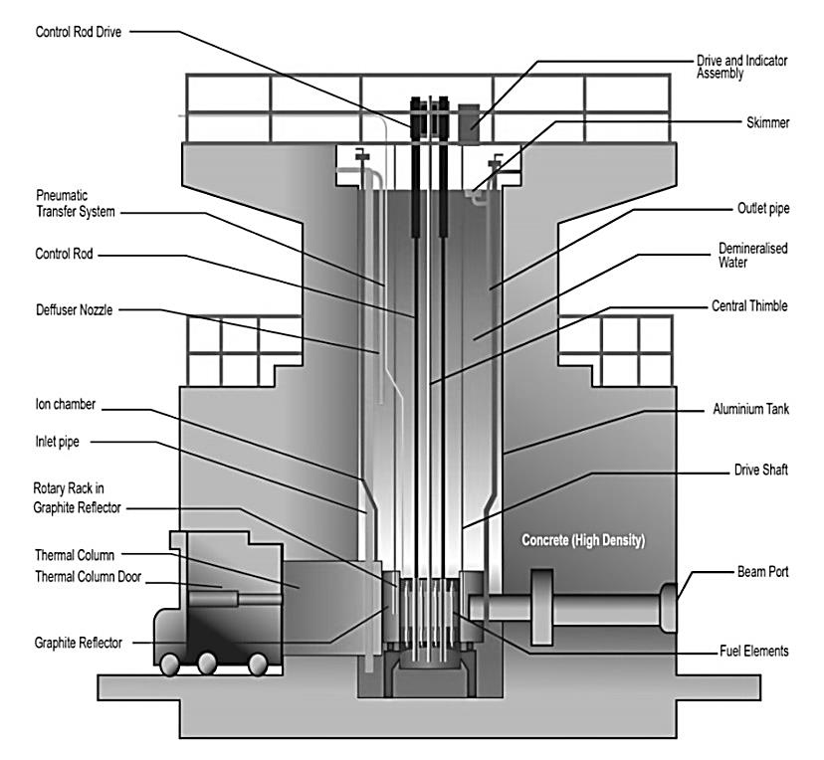
FIG.1. Cross-sectional view, showing internal components of the RTP

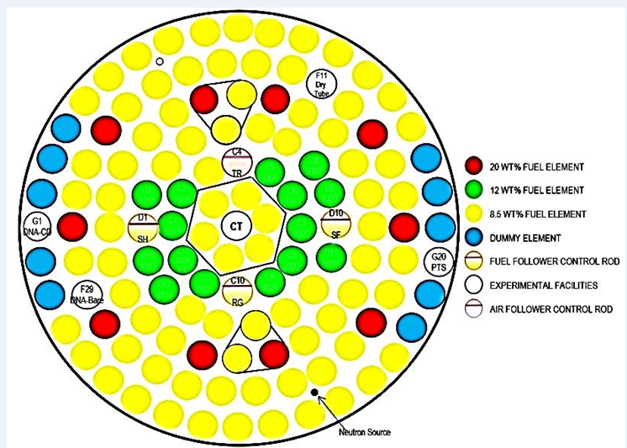
FIG. 2. Cross-sectional view of Core Configuration No. 15
Nuclear fuel utilization in a reactor is referred to as burn-up. The burning of the nuclear fuel is a neutronic process, depending on neutron-induced fission. In the RTP, an americium-beryllium (Am-Be) source is used as the neutron source in order to initiate the fission process. The fission process emits more neutrons from the fuel in the form of fast neutron, epithermal/intermediate neutrons and thermal neutrons [7]. These neutrons are subjected to migration, diffusion and slowing-down process. Neutrons are moderated and then diffused in thermal energy region and finally absorbed in surrounding media. It is assumed that there are leaked neutrons i.e neutrons that escape from the vicinity of the fissionable material in the reactor core; that travel relatively far distance from the core, hence there is a possibility of the fast neutron being thermalized and absorbed by irradiated fuels stored at the storage rack and induce fission.

The objectives of this work are two-fold; to determine thermal neutron flux around irradiated fuel in the core and to determine the burn-up of the stored fuel. In other words, this work investigates whether the thermal and/or fast neutron flux could influence the burn- up of the irradiated fuel stored at the storage rack in the same vicinity of the reactor core. The neutron flux (φ) is a measure of the intensity of neutron radiation, determined by the rate of flow of neutrons. The neutron flux value is calculated as the neutron density (n) multiplied by neutron velocity (v), where n is the number of neutrons per cubic centimeter (expressed as neutrons/cm³) and v is the distance the neutrons travel in 1 second (expressed in cm/s). The unit for neutron flux is n.cm².s⁻¹. The flux shape is the term applied to the density or relative strength of the flux as it moves around the reactor core.

A method to solve the neutron transport equation is by using Monte Carlo method which is a stochastic statistical simulation method. According to [2], Monte Carlo N-Particle (MCNP) code is capable to provide the correct representation of detailed geometry, transport effects, and continuous energy cross sections. It is a favored choice because of its general modeling capability, the correct representation of detailed geometry, transport effects and continuous energy cross-sections. There are numerous codes that use the Monte Carlo method, the widest spread being used is Monte Carlo N-Particle Extended (MCNPX) utilized to calculate the interrogating neutron flux and predict acquired spectra accounting for the interrogation geometry and detector effect [5]. Table 1, adapted from work by [1], summarizes the neutron flux profile at the RTP calculated using MCNPX.

TABLE 1. RECORDED AVERAGE THERMAL NEUTRON FLUX AND EPITHERMAL NEUTRON FLUX

Study | Year | Thermal neutron flux  (× 10¹²  n cm⁻² s⁻¹) | Epithermal neutron flux  (× 10¹¹  n cm⁻² s⁻¹)
Liew | 2010 | 2.26 ± 0.10 | 1.11 ± 0.11
Alnour | 2012 | 2.33 ± 0.08 | 1.23 ± 0.02

Burn up refers to the utilization of nuclear fuel in the reactor. According to [9], the burn-up parameters can be obtained from measurement of the neutron flux produced by the burn- up dependent neutron source in a spent fuel bundle. Several works on burning up the determination of TRIGA fuel in the core were conducted by many researchers [3, 6; 8]. However, there has been no discussion on burning up for out-core fuel.

- METHODOLOGY

In this work, the computational model was created using MCNPX version 2.7 with the evaluated nuclear data file for thermal neutron scattering law data (ENDF7) cross-section data library. Core 15 configuration is used in the calculation. Tallies F1, F4 and F8 are the most important output data, which refers to counts of particles passing a given surface (F1), mapping of thermal neutron travel through the moderator in the reactor pool (F4) and radiation pulses (F8). The MCNP model developed in this study is a full 3D model as shown in Fig. 3. The mesh size adopted for this model is 10 cm × 10 cm × 10 cm.

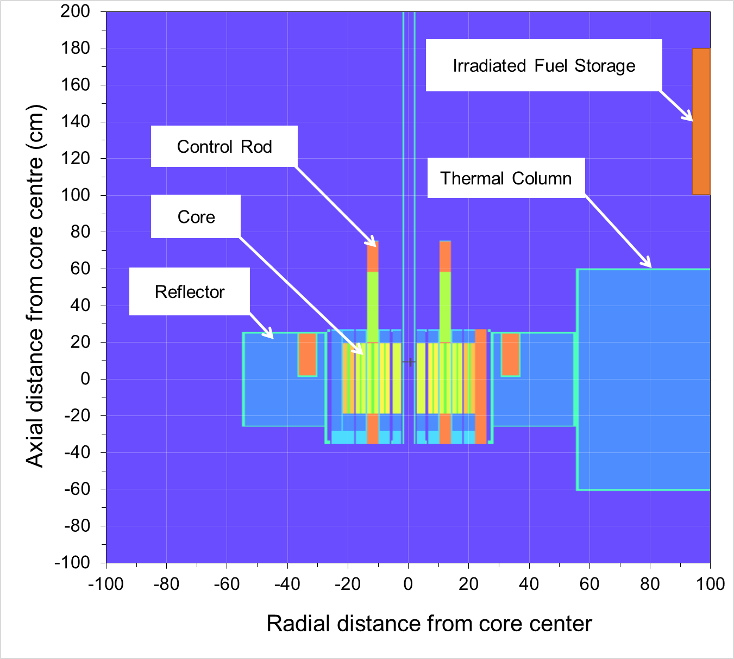

FIG.3. Axial view of the MCNPX model for RTP

- RESULTS AND DISCUSSION

The path of neutron distribution, representing the distance a neutron travels between interactions, depends on both the type of material and the energy of the neutron. After each collision, the energy is decreased and the neutron path length is affected accordingly. The axial thermal neutron flux at 750 kW core power level has been simulated using MCNPX and is presented in Fig. 4. The behavior of the thermal neutron flux distributions displays the typical ‘bell-shaped” for the positions between -100 cm to +100 cm, while a rapid decline of the flux occurs from the position +100 cm up to +200 cm from the core. According to [10], the reactivity is larger at the center of the core.

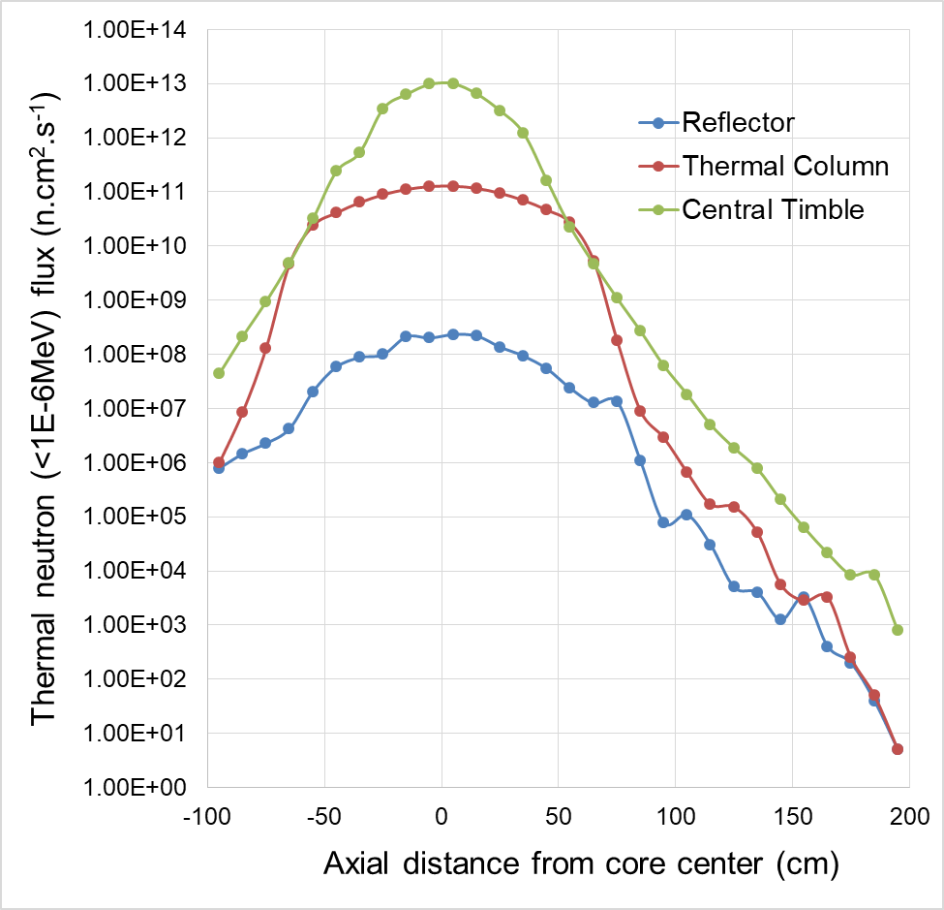

FIG.4. Axial thermal neutron (< 1 × 10⁻⁶ MeV) flux (n.cm².s⁻¹) profile at full core power of 750 kW.

As indicated in Fig. 4, the thermal neutron flux is greatest at the position of the central thimble, at 1 × 10¹³ n.cm².s⁻¹ while the maximum neutron fluxes at the thermal column and at the reflector are greatly reduced to 1 × 10¹¹ n.cm². s⁻¹ and 4 × 10⁸ n.cm². s⁻¹ respectively as a result of elastic and inelastic neutron-nucleus scattering collisions. The results are consistent with previous work by [7], in which the thermal and fast neutron flux was reported to be concentrated at the central thimble while there was a significant reduction of the flux particularly at the position of the DNA-Cd monitor due to the thermal neutrons being absorbed by the cadmium.

The fast neutron (neutrons of energy higher than 1 × 10⁻⁶ MeV) travel profile is also analyzed in this work. A similar pattern to that for the thermal neutrons is obtained for the fast neutrons shown in Fig.5, with a ‘bell-shaped’ flux distribution occurring between +100 cm and -100 cm from the core. The fast neutron flux then shows a declining trend from +100 cm up to +200 cm
.

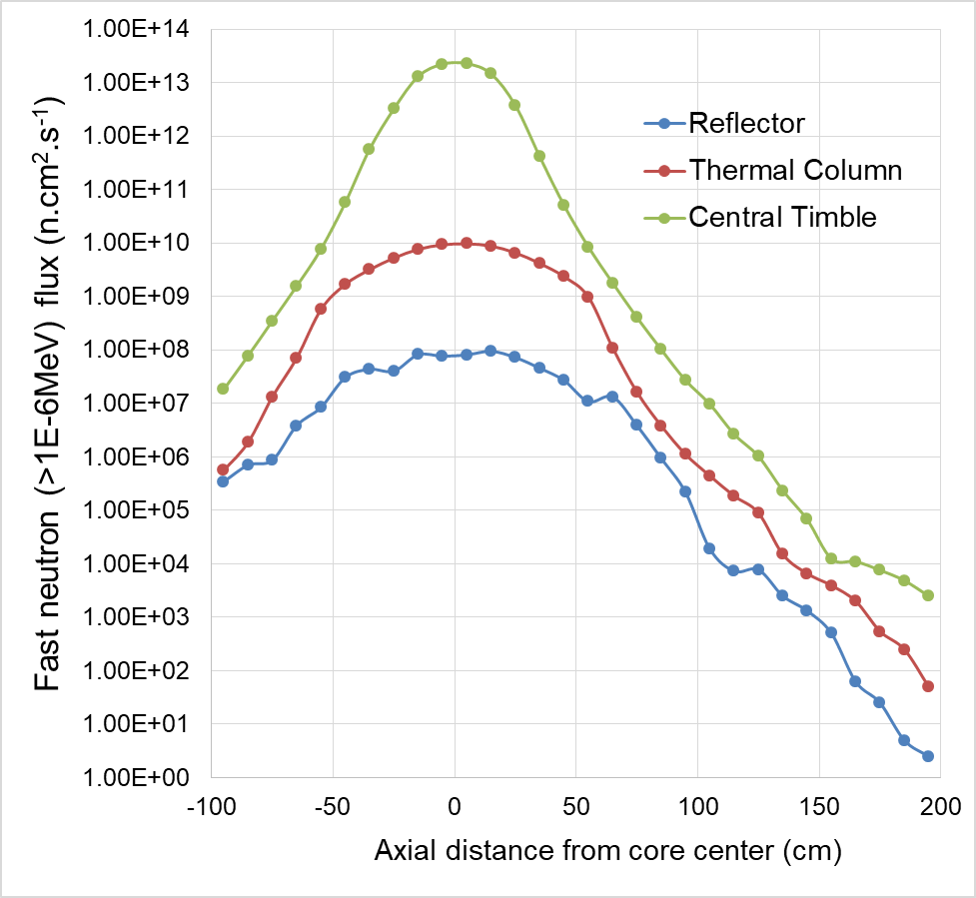

FIG.5. Axial fast neutron (>1 × 10⁻⁶ MeV) flux (n.cm².s⁻¹) profile at full core power of 750 kW.

The ‘bell-shape’ becomes less apparent for the fast neutron flux at the reflector and the thermal column as a result of attenuation due to scattering and collisions. The maximum fast neutron flux is observed to occur at the central thimble, at 5 × 10¹³ n.cm².s⁻¹ due to its central position in the core, as depicted in Fig. 2 and Fig. 3. When the neutron flux density is plotted using MATLAB on the 20 cm × 20 cm grid, one can easily determine the distance traveled by the thermal neutrons. Fig. 6 illustrates the contour of the thermal neutron flux axial distribution and the corresponding radial 3D view.

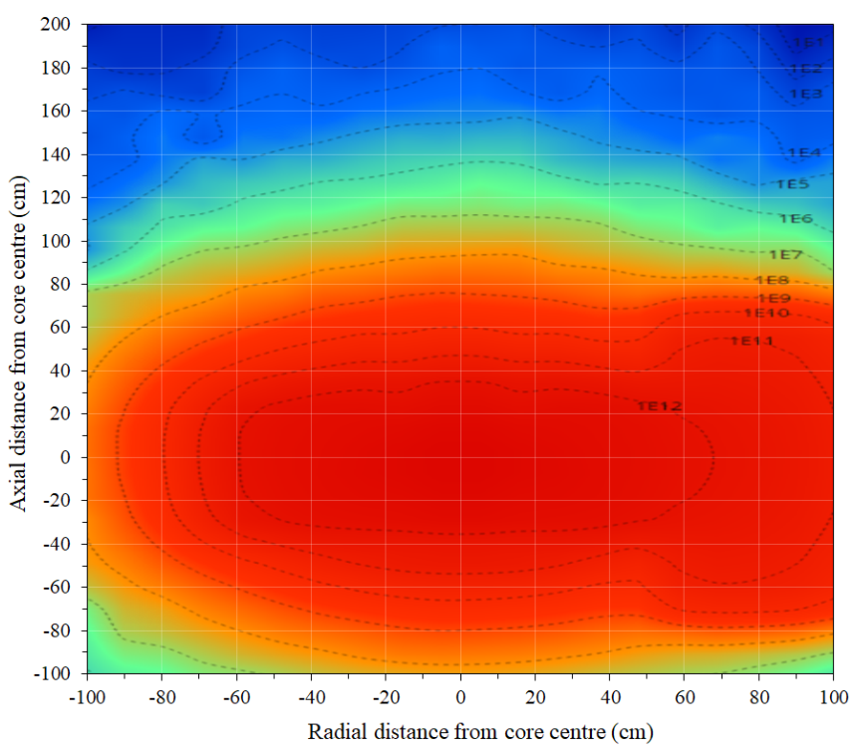

FIG.6. Axial distribution of thermal neutron contour flux at full core power of 750 kW

Fig. 6 also indicates that the thermal neutron flux of 1 × 10⁹ n.cm².s⁻¹ travels a length up to 78 cm. When Fig. 6 is interpreted with Fig. 7, the results suggest the epithermal region of the neutron flux starts at distance 78 cm up to 158 cm from the core. In brief, the higher of thermal neutron flux is 1 × 10¹³ n.cm².s⁻¹ while the greatest fast neutron flux is 5 × 10¹³ n.cm².s⁻¹ shown in Fig.7

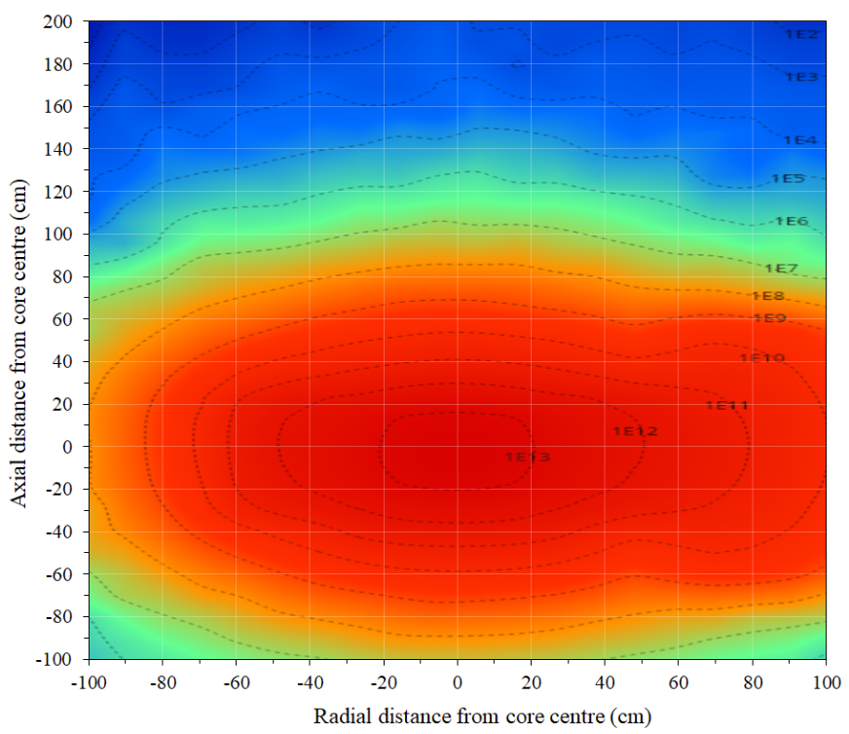

FIG.7. Axial distribution of fast neutron flux contour at full core power of 750 kW

The fast neutron start thermalized at a distance of 158 cm from the core. The thermalization is mainly due to water moderation but to a certain extent, it is also due to the graphite at the thermal column. Mitsui and Sugiyama were reported that the decay constant of neutron flux in graphite to be 2341/s and graphite thermalization to occur in 250 µs to 750 µs depending on the degree of graphite buckling [4].

The axial flux distribution contour for fast neutrons is illustrated in Fig. 8 together with the corresponding radial 3D view of the flux in Fig. 9. The trend line in Fig. 8 indicates that the thermalization process in this region occurs rapidly, water being an effective moderator, with hydrogen being of similar size to the neutron. The observation shows that the thermal neutron is thermalized at 78 cm. The green region plots the thermal neutron with fluxes between 1 × 10⁵ and 1 × 10⁹ n.cm².s⁻¹. The red region indicates a contour profile for thermal neutrons with fluxes between 1 × 10⁹ n.cm².s⁻¹ and 1 × 10¹² n.cm².s⁻¹

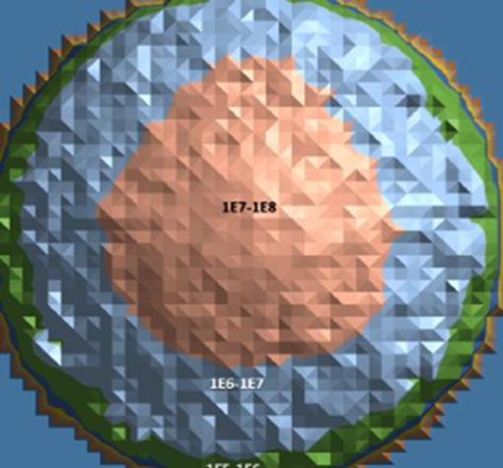

FIG.8. Radial Distribution of Thermal Neutron Flux at Full Core Power of 750 kW at 1 m from Irradiated Fuel Storage

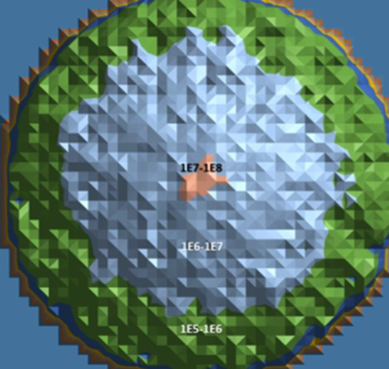

FIG.9. Radial Distribution of Fast Neutron Flux at Full Core Power of 750 kW at 1 m from Irradiated Fuel Storage

The red region in Fig. 9 indicates the contour profile of fast neutron’s distribution for fluxes between 1 × 10⁷ n.cm².s⁻¹ and 1 × 10¹³ n.cm².s⁻¹.The grey region in Fig. 9 represent the energy of neutron distribution. The green region maps fluxes between 1 × 10² 10¹³ n.cm².s⁻¹ and 1 × 10⁹ n.cm².s⁻¹.

TABLE 2. IRRADIATION OF A SINGLE FUEL IN THE CORE AND IN THE FUEL RACK ABOVE THE CORE

Fuel Location | At 750 kW Core Power Level |  |  | At 1 kW Core Power Level
Fuel Location | Fission Rate (#/s) | Energy Release (Watt) | U-235 burned (in g) from 38 g initial mass after 1 day | Fission-Rate (#/s) | Energy Release (Watt) | U-235 burned (in g) from 38 g initial mass after 1 day
Fuel in-core | 3.18 × 10¹⁴ | 1.02 × 10⁴ | 1.26 × 10⁻² | 4.24 × 10¹¹ | 1.36 × 10 | 1.68 × 10⁻⁵
Irradiated fuel in storage rack (out-core) | 1.51 × 10⁷ | 4.84 × 10⁻⁴ | 6.01 × 10⁻¹⁰ | 2.02 × 10⁴ | 6.46 × 10⁻⁷ | 8.01 ×10⁻¹³

As indicated in Table 3, the simulation shows the fission-rate of the fuel in the core to be 3.18 × 10¹⁴ particle/s compared to 1.51 × 10⁷ particle/s in the irradiated fuel in the storage rack. This indicates the fission-rate in the storage rack to be negligible compared to the fission-rate at the core, implying that to any practical extent the neutron does not induce burn up of the irradiated fuel at the storage rack.

This is consistent with the flux distribution results shown in Fig. 4 to Fig. 5. Assuming the irradiated fuel is to be stored in the storage rack for the next 30 years, with continuous 24/7 exposure to a power level of 750 kW, the simulation confirms that the level of the associated burn-up would be negligible, as depicted in Table 2. Only some 7 µg of U-235 is projected to be consumed throughout this span of storage time, representing an insignificant quantity. Based on these results, it is concluded that the thermal neutron flux density at the storage rack is very small and the level of burn-up of these fuels is negligible.

TABLE 3. BURN-UP RATE OF ONE FUEL ELEMENT LOCATED AT STORAGE RACK

Years of RTP operation at full power 750 kW | U-235 burned (g) from 38 g mass | Burn-up [%]
1 | 2.19 × 10⁻⁷ | 1 × 10⁻⁶
2 | 4.39 × 10⁻⁷ | 1 × 10⁻⁶
3 | 6.58 × 10⁻⁷ | 2 × 10⁻⁶
4 | 8.77 × 10⁻⁷ | 2 × 10⁻⁶
5 | 1.10 × 10⁻⁶ | 3 × 10⁻⁶
6 | 1.32 × 10⁻⁶ | 3 × 10⁻⁶
7 | 1.53 × 10⁻⁶ | 4 × 10⁻⁶
8 | 1.75 × 10⁻⁶ | 5 × 10⁻⁶
9 | 1.97 × 10⁻⁶ | 5 × 10⁻⁶
10 | 2.19 × 10⁻⁶ | 6 × 10⁻⁶
20 | 4.39 × 10⁻⁶ | 1.2 × 10⁻⁵
30 | 6.58 × 10⁻⁶ | 1.7 × 10⁻⁵

- CONCLUSIONS

MCNPX code was used to simulate fast and thermal neutron flux for the reactor operating at 750 kW, using a 10 cm × 10 cm × 10 cm mesh model. For fast neutron, the axial distribution energy is higher than 1 × 10⁻⁶ MeV and travels more than 158 cm indicating that the fast neutron can travel far distance reaching the area of the fuel rack. The reaction time for the fast neutron is too short to result in burn-up due to short interaction time. Thermal neutron in-core travels the maximum distance of 78 cm due to thermalization by moderator, thus it is confirmed that the thermal neutron from the core does not reach to the storage rack located 1 m from the core. The axial distribution of thermal neutrons occurred at energy lower than 1 × 10⁻⁶ MeV. Above this energy, the neutrons are regarded as epithermal and/or fast neutrons. The fission reaction of the irradiated fuel in the fuel rack is 7 order of magnitude lower than the fission rate at the core, indicating very small to negligible fission reaction of these fuels and the burn up of stored irradiated fuel can be neglected.

ACKNOWLEDGEMENTS
The authors wish to thank to Physics Reactor group, Malaysian Nuclear Agency especially for the support and grant permission to use the reactor facility to accomplish the research works. This work was partially supported by the Ministry of Education Malaysia and Universiti Teknologi Malaysia through Research University Grant Scheme (No. 17H79).

REFERENCES
[1] ALNOUR I.A, WAGIRAN H., IBRAHIM N. HAMZAH S., WEE B.S, ELIAS M.S. KARIM J.A. Journal Radioanalytical Nuclear Chemistry, vol. 296(3), (2013) 1231-1237.
[2] BAKKARI B. EL, BARDOUNI T. EL, NACIR B., YOUNOUSSI C. EL, BOULAICH Y., BOUKHAL H., ZOUBAIR M. Fuel burn up analysis for the Moroccan TRIGA research reactor, Annals of Nuclear Energy, vol. 51, (2013) 112-119.
[3] DALLE.H.M, JERAJ.R, TAMBOUGI.E, Characterization of Burned Fuel of the TRIGA IPR – R1 Research Reactor Using Mont burns Code (2015), https://www.researchgate.net/publication/266233653
[4] MITSUI J. AND SUGIYAMA K. Neutron thermalization in graphite, Journal of Nuclear Science and Technology, vol. 10(1), (1973) 1-9.
[5] PELOWITZ D.B. ET AL. “MCNPXTM User’s Manual. Version 2.60,” Los Alamos National Laboratory, USA, 2008.
[6] RABIR M.H, USANG M. D, HAMZAH N. S, ABDUL KARIM J AND SALLEH M.A.S, Determination of Neutronic Parameters of RTP Core Using MCNP Code, Jurnal Sains Nuklear Malaysia, vol. 25 (1), (2013) 46-60.
[7] RABIR M.H AND USANG M. D., Neutron Flux and Power in RTP Core-15, AIP Conference Proceeding 1706 (2015), pg. 050018
[8] SNOJ.L, TRKOV.A, JAC´IMOVIC.R., ROGANA.P, ZEROVNIK.G, RAVNIK.M, Analysis of neutron flux distribution for the validation of computational methods for the optimization of research reactor utilization, Applied Radiation and Isotopes, vol. 69, (2011) 136-141.
[9] UEDA M, KIKUCHI S., KIKUCHI T. AND KUMANOMIDO H., Basic studies on neutron emission-rate method for burnup measurement of spent light-water-reactor fuel bundle, Journal of Nuclear Science and Technology, vol. 41(4), (1993) 48-59.
[10] MATSUMOTO T., Benchmark Analysis of Criticality Experiments in the TRIGA Mark II Using a Continuous Energy Monte Carlo Code MCNP, Journal of Nuclear Science and Technology, vol. 35(9), (1998) 662-670.

